| **NAME:** | DHANYASRI P K |
| --- | --- |
| **ROLL NUMBER:** | 7376221EC143 |
| **SEAT NUMBER:** | 355 |
| **PROJECT ID:** | 35 |
| **PROBLEM STATEMENT:** | OPEN INNOVATION CATEGORY |

1. **INTRODUCTION:**

Creating a responsive project registration portal for students using LAMP Stack. The LAMP stack is a widely-used open-source software bundle for web development. It consists of Linux as the operating system, Apache as the web server, MySQL as the database management system, and PHP as the programming language. LAMP provides a reliable and scalable environment for building dynamic websites and web applications, making it a popular choice for developers. This website comprises of four modules (Login page, Home Page, Registration page and Queries site).Login Page for logging in the page using student’s individual bitsathy email id, Home Page for posting and viewing ideas in the forum, Registration page for registering student’s innovative project ideas and Queries site for posting queries.

* 1. **PURPOSE:**

The Purpose of this document is to provide a detailed description of a portal where students can post their innovative project ideas in the forum and can register for project review by submitting details and documents and get approved by faculties based on their novelty and details about the projects. Through this document, we can understand the purpose and novelty of the project.

* 1. **REQUIREMENTS:**

1. Linux OS
2. Apache HTTP Server
3. MySQL Database Server
4. PHP,HTML,CSS,Javascript(Visual Studio Code/Sublime Code Editor) interpreter in the Linux OS System

**1.3 SCOPE OF THE PROJECT:**

* It is an open portal for students to post their innovative project ideas and get reward points according to the novelty and creativeness of the project. Once their project ideas get approved they receive email.
* Administrators have the power of approving and rejecting project ideas. They approve according to the novelty, detailed description, and flowchart of the project. If they provide insufficient details, then the administrator have the power of rejecting the projects. Once the project is rejected, then they send email to the respective team leader.

**1.4 SYSTEM OVERVIEW:**

**Users:**

1. **Students:**

Students have to login the page using their bitsathy email address. Students have the facility to post ideas at their open forum to get reward points. Students have the ability to register for the open innovation category by providing sufficient details and submitting prior documents for the approval of the project. They will know their status of the project through the email.

1. **Admin:**

Admin have the power of approving and rejecting project based on the novelty provided and the technology usage in the project. If there is any lagging or insufficient details provided then they have the right to reject those projects. They intimate the status of the submission of project ideas to the students through email.

* 1. **PROJECT FLOW:**
* This Project opens with a user authentication (Login credential).
* If it pass user authentication (i.e. If the given mail id and password are correct) , then the php running in the login page will automatically direct into a home page where we can see our reward points details and it consists of navigation bar holding the domain of project. Each Domain has its own registration form.
* If the user authentication fails (i.e. If the given mail id or password is wrong), then an error message pops at the login page (“Invalid username or password”).
* After user authentication, an interactive forum opens where students can post ideas.
* At the Navbar we can find the register option where we can submit our ideas.After submission, a unique id will be created and the status of submission will be intimated to students via email.
* According to Admin’s point of view, They have the power to view the registered project idea details using php and have the power to approve or reject the project ideas (whenever Admin views or checks any details, They have the power to click the check boxes of the viewed contents) .
* If there is any lack of not selecting the checkboxes, it will automatically leads to the rejection of the project ideas.
* After Admin’s side, the status of submission of project ideas will be intimated to students through email (whether it is approved or rejected).
* After that, the BOM Submission page opens where approved students can submit list of components needed.
* Then they have the ability to book slot for their project review and they also have a queries page where they can post their queries if there is any.

1. **FUNCTIONAL REQUIREMENTS:**

**Login Credentials:** Login the login page using **Bitsathy email address** and password. Secure password hashing and storage.

**Home Page:** Home Page holds an interactive forum where they can also post their innovative ideas post questions and get connected with peers. According to their interaction,they will awarded with rewards points.

**Registration Site:** User provides necessary details given in the registration site and submits the form. Make sure to provide all necessary details. This includes,

* Team leader name
* Team leader’s department
* Team size(if necessary)-Size limit up to 5
* Team member’s details

1. Team member1 name
2. Team member1 department
3. Team member2 name
4. Team member2 department and so on(according to the team size)

* Domain
* Title
* Objective(within 150 words)
* Detailed Description(within 150 words)
* 3D Model/Flowchart(Submit only with pdf format)
* Novelty(within 100 words)

After Submission, a unique id will be created to the students.

**Queries Page:** If Students have any queries like they didn’t receive any mail regarding the status of submission. They can post there. Admin’s have the access to view the queries page and rectify the queries posted by students.

**Admin’s Authority:** Admin have the power to approve or reject project ideas. Evaluation occurs based on the details provided. If insufficient details provided, then they have the power to approve or reject projects. They send the mail to the team leader regarding the status of the submission.

**Email Communication:** After Admin’s evaluation, Student will receive the mail whether their project idea gets approved or not. After rejection, they have the ability to reupload documents and fill the necessary details.

**BOM and Slot Booking Site:** After receiving email, BOM Site and Slot Booking Site will open to those Students whose id has been approved.

**3.1 WORKING MECHANISM:**

This Project uses a Linux-Based Server System which hosts the LAMP Components. In this project, Linux is preferred over Windows because it is designed to handle high workloads and can operate continuously without requiring frequent reboots. The Working Mechanism of this website includes,

1. When we write the Site Name in the Search bar, then Apache Server receives the HTTP request and starts running the PHP based on the on the requested site or URL.
2. After that, A Login Page pops which needs user authentication (like the Login system opens when we sign in with our Bitsathy email id).
3. When the given Email Id and Password are correct then the PHP running in the login site will automatically direct into a home page in which we have a facility to view Individual’s Reward Points.
4. If the user email or password is wrong, then the error message will pops at the login site which is triggered by the JavaScript.
5. When the user authentication succeeds, a Home page will appear which consists of an forum.
6. At the corner of the Page, a Navbar is located which consists of Domain. According to the Domain, the registration site will appear.
7. It also consists of a queries section, in which we can post their queries if there is any. The Queries will store at a specific Database.
8. After Students Submission of Details and Documents, The Details and Documents will store in a specific database (mysql database).
9. For evaluation, Admin’s have the power to view the Details and have the power to approve and reject the project ideas by clicking the checkboxes after verifying all the given details.
10. By using Laravel Framework and RESTFUL API – Admin’s utilize a specific email Library, through which message content are send to those who submitted the form.
11. After Email receiving, The BOM Submission site and Slot Booking Site open to those students whose id has been approved.
    1. **WORKFLOW CHART:**

**User Interface:**

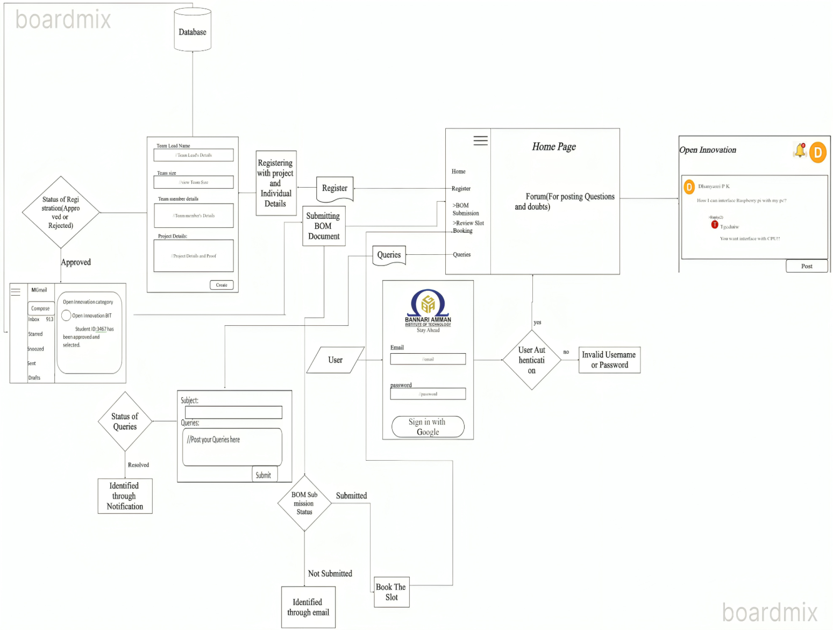

**Admin’s Interface:**

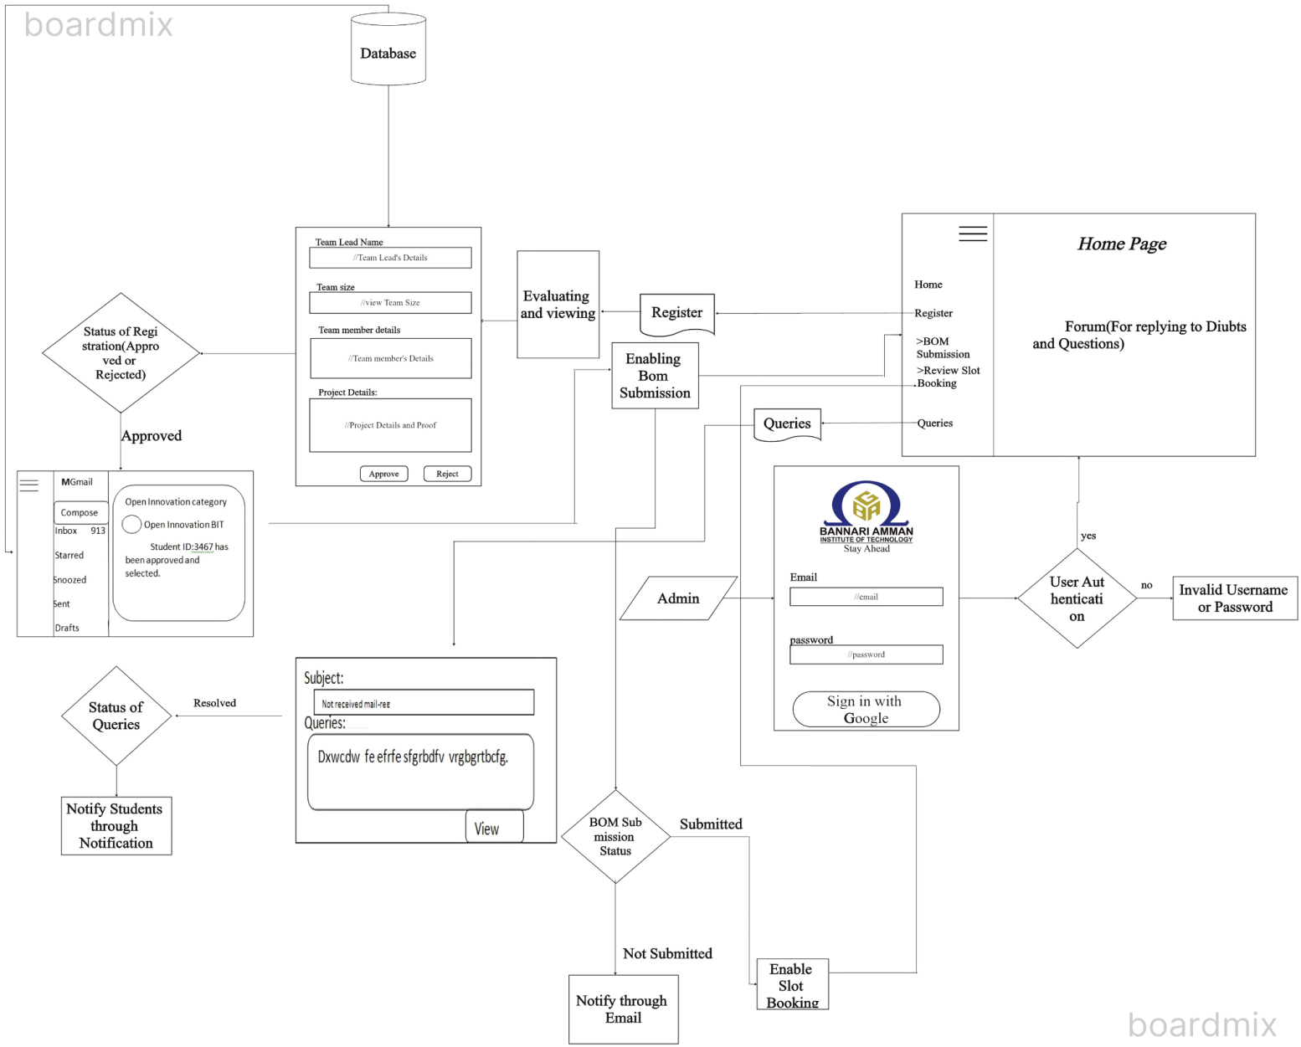

**USER:**

**Login Credential:**

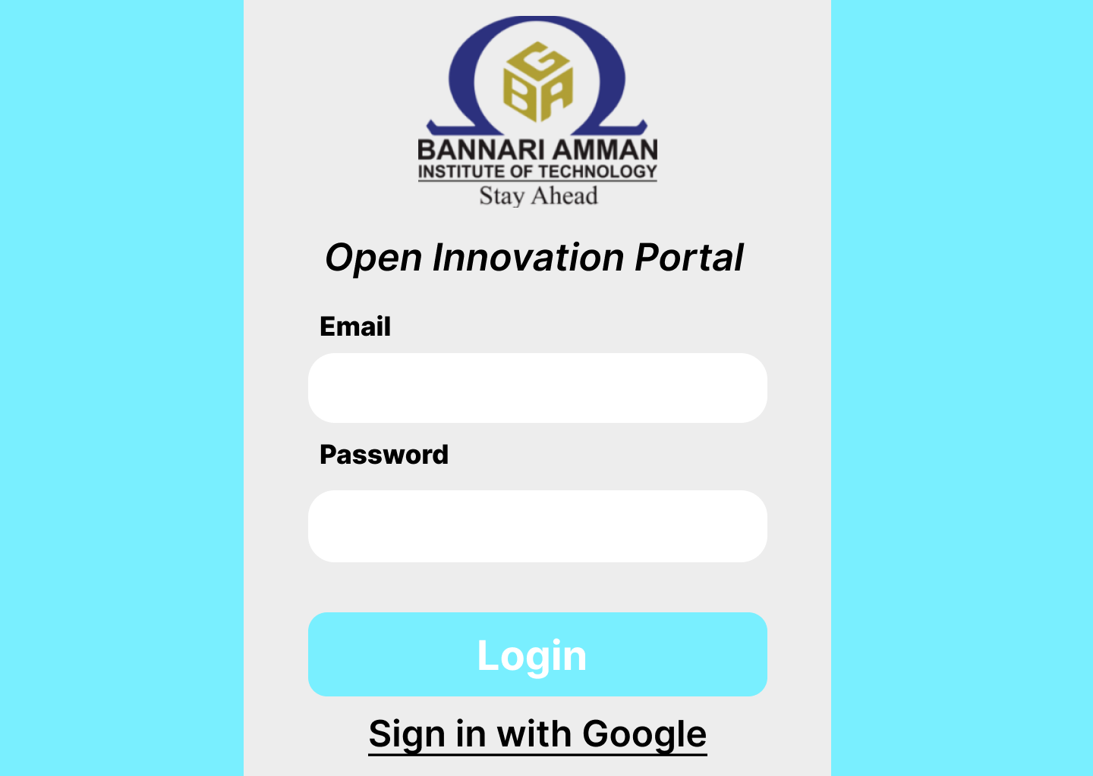**Home Page:**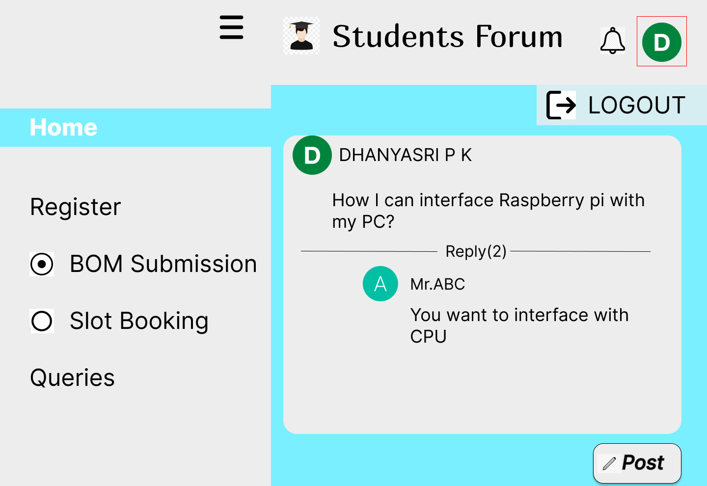

**Registration Site:**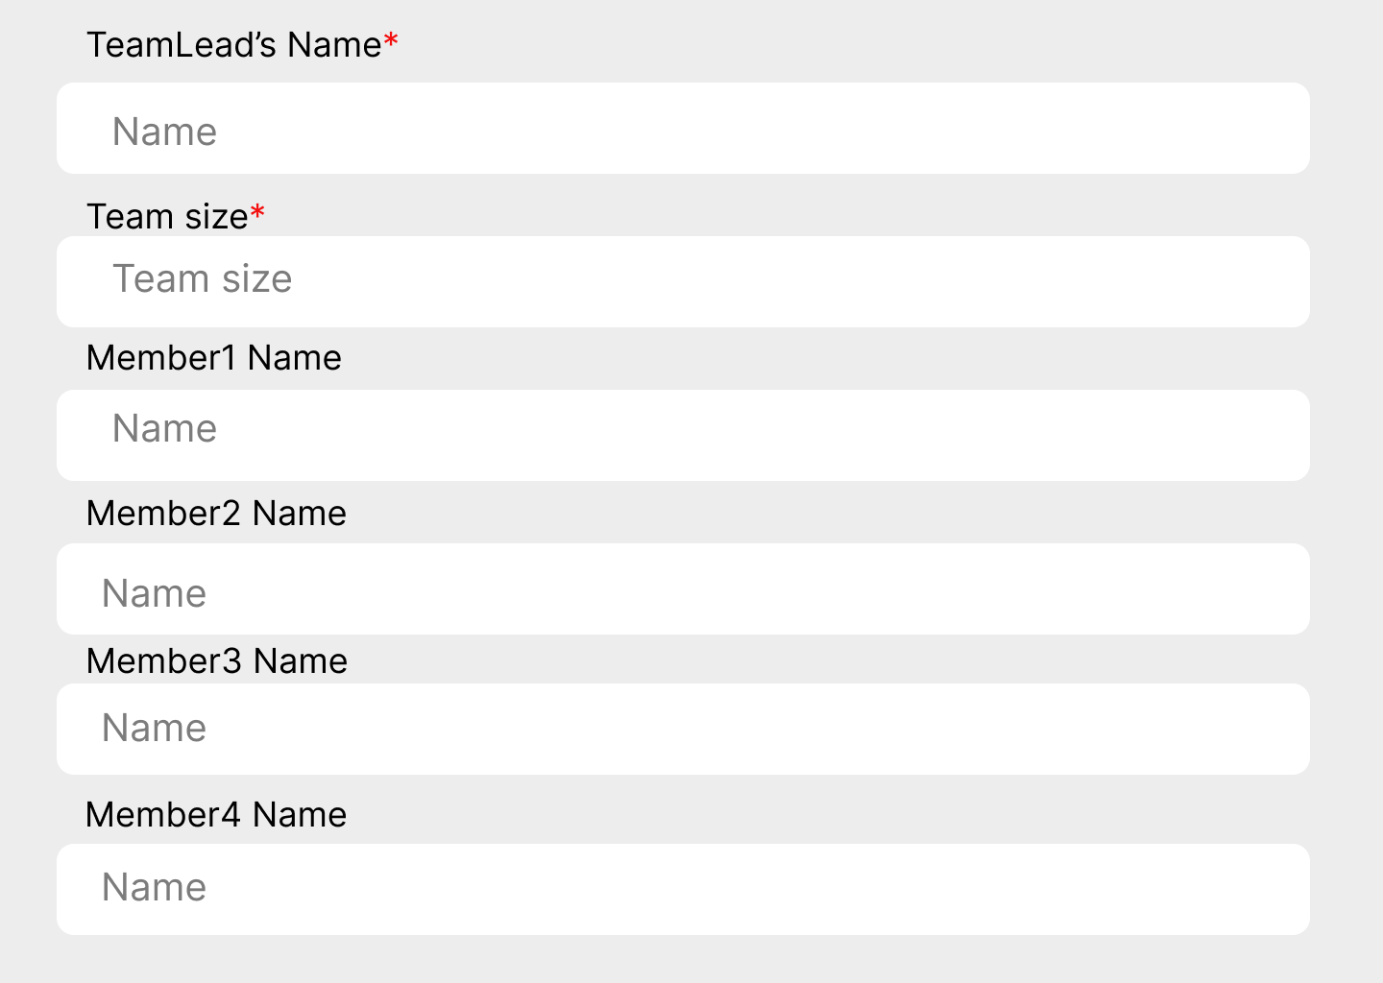

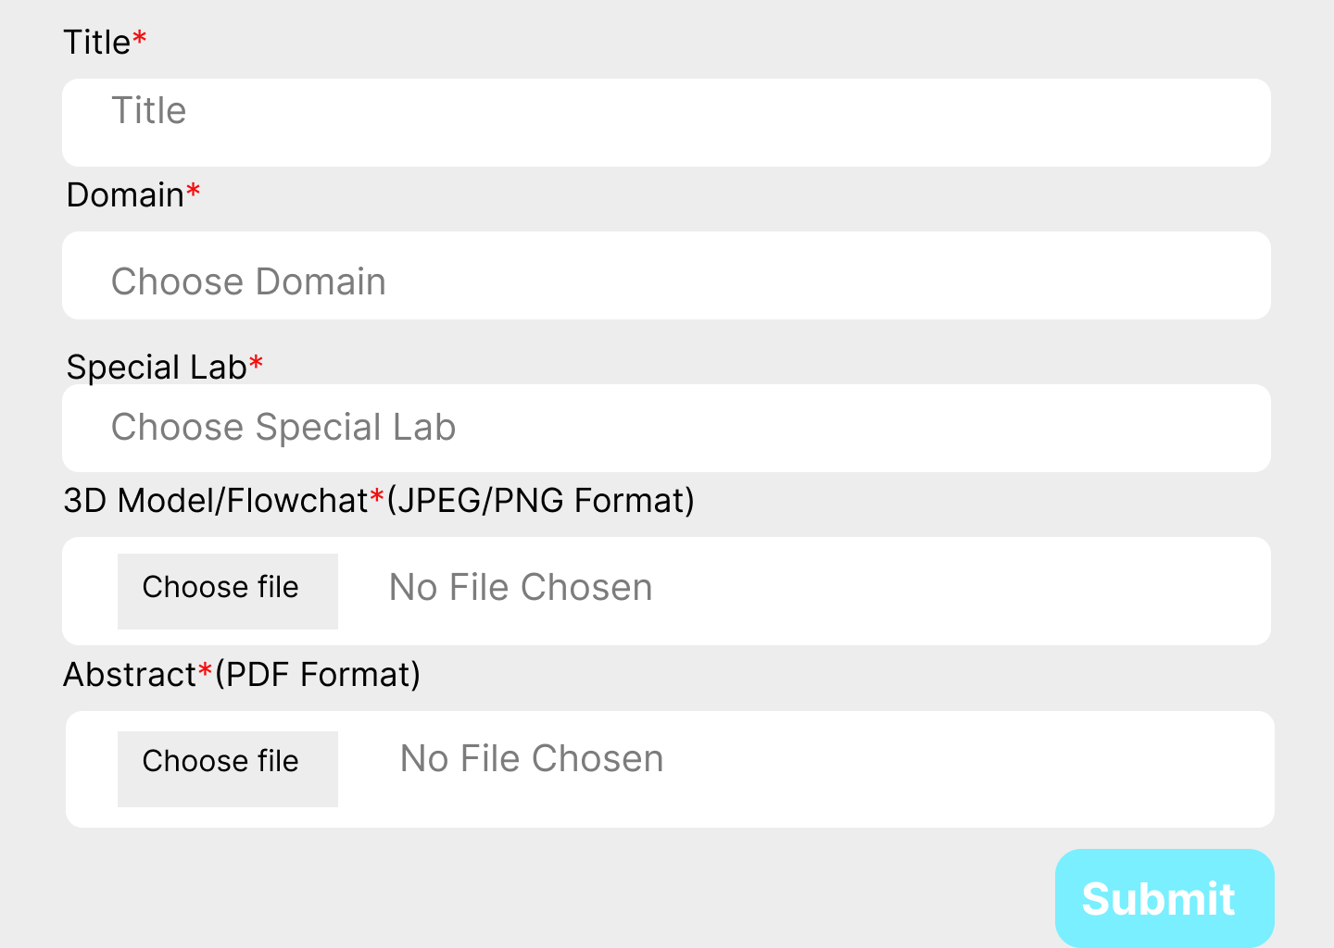

**BOM Submission and Slot Booking:**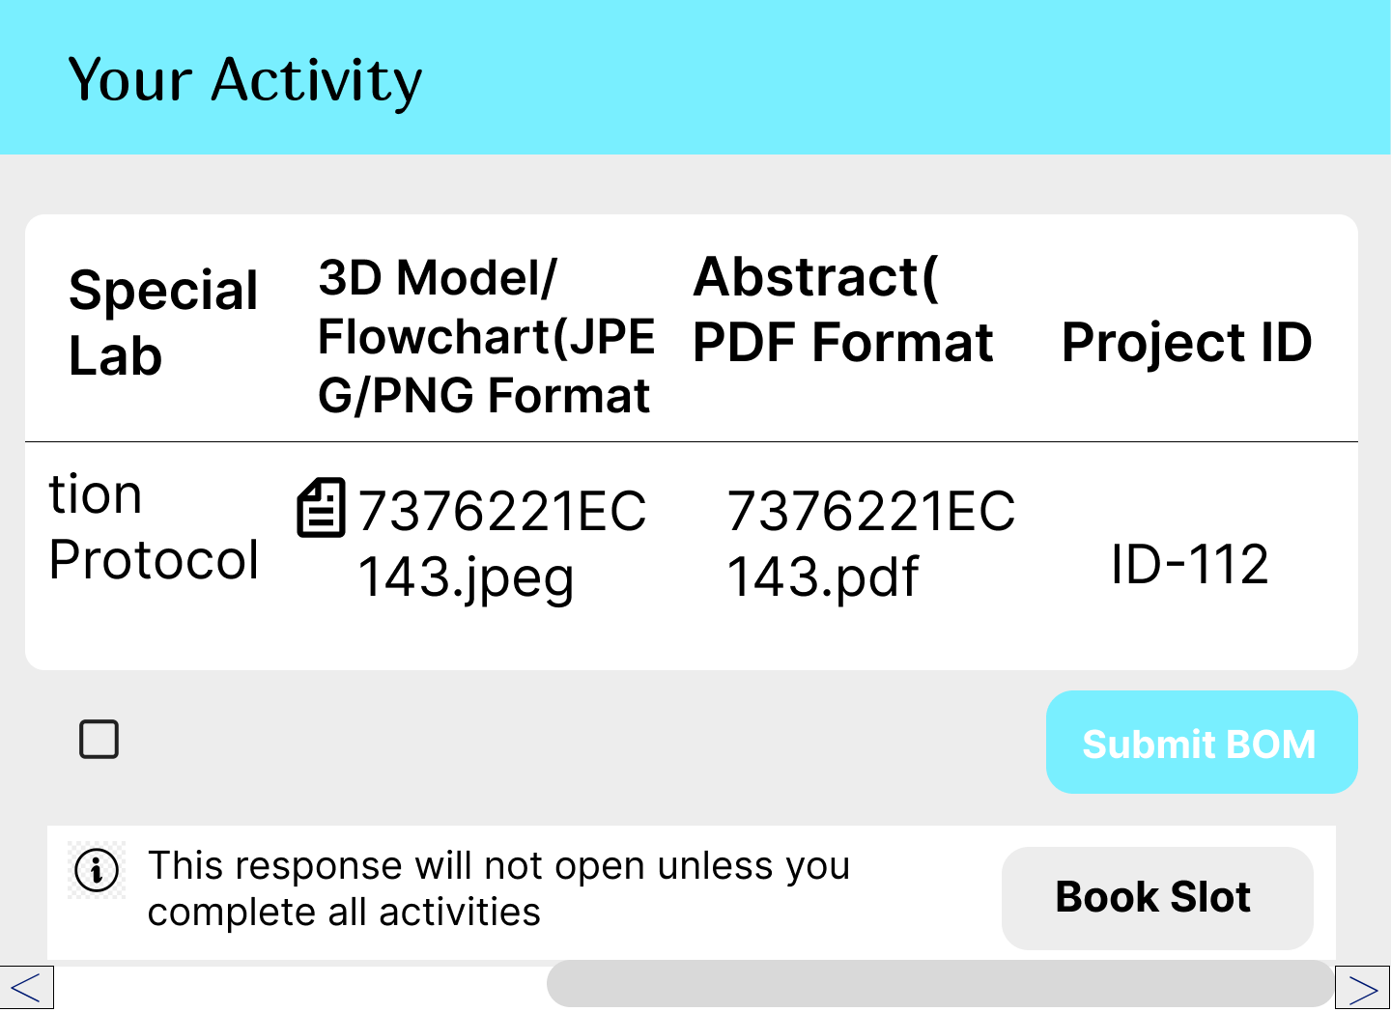

**Queries Page:**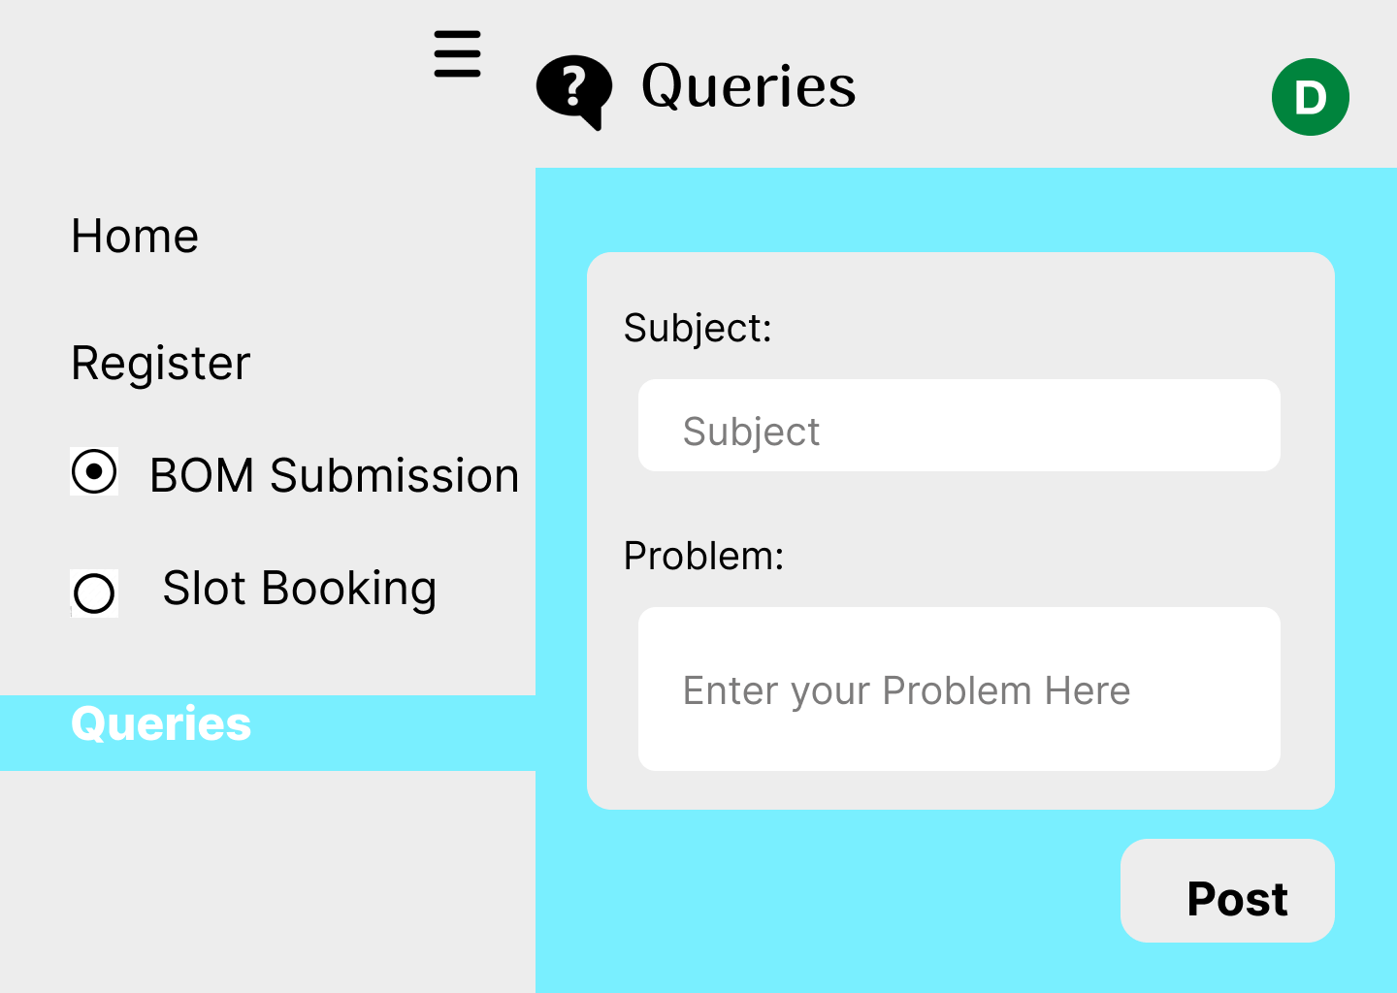

**ADMIN:**

**Login credential:**

**Home Page:**

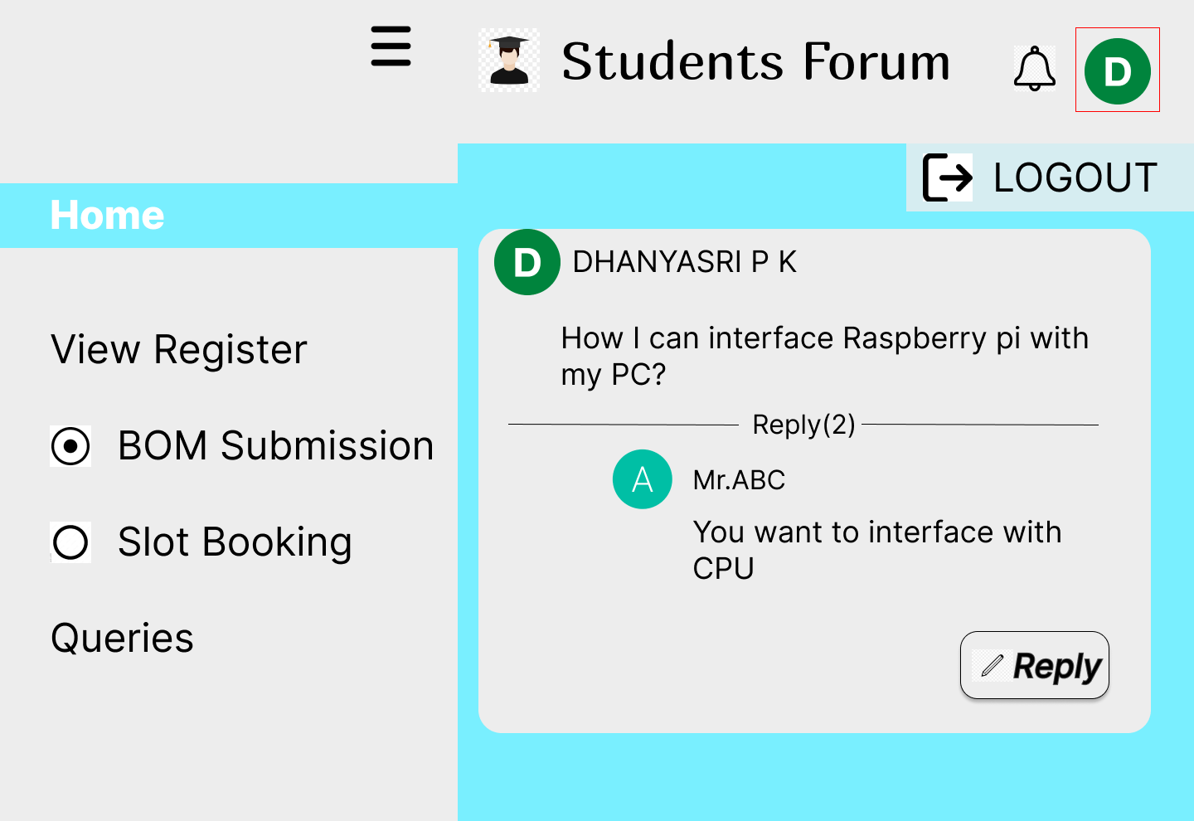

**Registration Site:**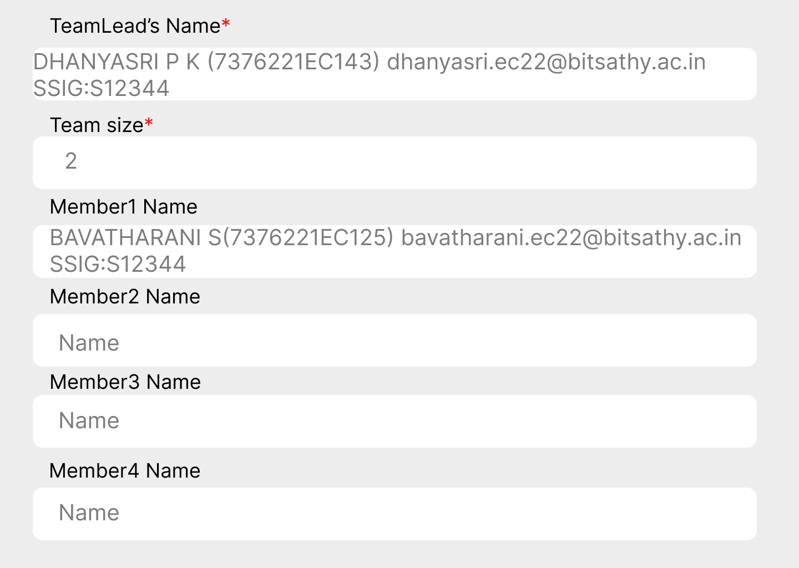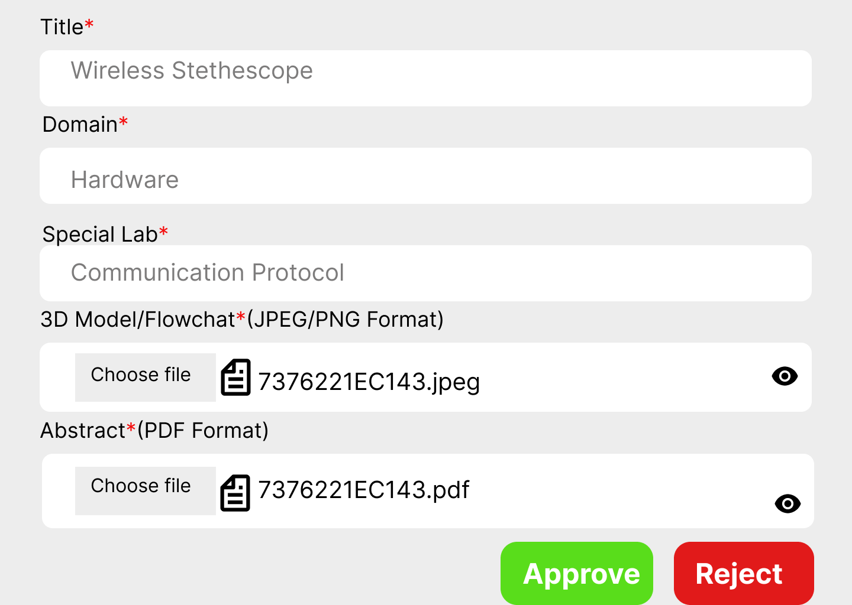

**BOM Submission and Slot Booking: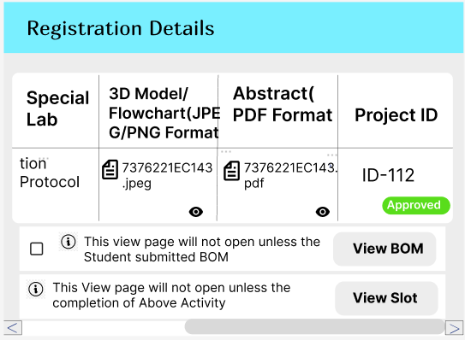Queries Page:**