PROJECT REPORT (CSN343)
A report submitted in partial fulfilment of the requirement for the course
ROBOTICS
Part of the degree of
BACHELOR OF TECHNOLOGY
In
Computer Science and Engineering

Submitted to
Dr. Aakanksha Devrari
Assistant Professor
Submitted by:
Kartik Gupta SAP ID- 1000020971
Tanisha Bhandari SAP ID- 1000020525
Dhanya Verma SAP ID- 1000020238
Sec-D

SCHOOL OF COMPUTING
DIT UNIVERSITY, DEHRADUN
(State Private University through State Legislature Act No. 10 of 2013 of Uttarakhand and approved by UGC)
Mussoorie Diversion Road, Dehradun, Uttarakhand - 248009, India.
November, 2025

CANDIDATES DECLARATION

I hereby certify that the work, which is being presented in the Mini Project Report, entitled “Vision Speech And Motion Security Robot”, in partial fulfilment of the requirement as part of the course Robotics of the Degree of Bachelor of Computer Science and Engineering and submitted to the DIT University is an authentic record of my work carried out during the period 13/01/2026 to 15/04/2026 under the guidance of Dr. Aakanksha Devrari.

Date:
Signature of the Candidate

TABLE OF CONTENT

S.no. | Chapter / Section | Page No.
1. | Introduction | 4
2. | Project Description  - Purpose  - Problem Statement  - System Requirements | 5-7
3. | Methods and Implementation  - Module Descriptions  - Pseudocode / Flowchart Description  - Data Structures & Techniques  - Program Code  - Screenshots and Outputs  - Result Analysis | 8-19
4. | Conclusion | 20-21
5. | Bibliography | 22

INTRODUCTION
The rapid advancement of robotics and artificial intelligence has opened new frontiers in the domain of security, surveillance, and intelligent automation. Traditional security systems rely heavily on passive monitoring devices such as CCTV cameras, motion sensors, and alarm systems that require significant human intervention for threat detection and response. These systems are limited in their ability to differentiate between genuine threats and false alarms, and they lack the capability to provide real-time, autonomous responses to detected events.
This project — Vision, Speech & Motion Security Robot — addresses these shortcomings by building a multimodal autonomous security agent on the EZ-Robot JD Humanoid platform. The robot continuously scans its environment using two custom AutoPosition actions ("ScanLeft" and "ScanRight"), while the onboard camera simultaneously monitors for two distinct types of events: face detection (a human presence) and motion detection (any movement in the scene). Depending on which type of tracking event is triggered, the robot delivers a tailored spoken alert using the EZ-Speech text-to-speech engine — "Human Detected", "Motion Detected", or "No One Detected".
In addition, the robot is equipped with a voice-command module powered by EZ-Builder's Speech Recognition plugin. An operator can issue verbal commands — such as "move forward", "move reverse", "scan", "robot turn right", "robot stop", "robot show phrase list", and "robot hide phrase list" — to control the robot remotely without any physical input device.
The key distinction of this implementation is its dual-detection logic: the robot does not merely wait for a face to appear before reacting, but also responds independently to motion, making it more robust as a practical security agent. Real-world applications include indoor office and laboratory security, smart home monitoring, and educational demonstrations of autonomous human-robot interaction.
The project was developed over the period 13 January 2026 to 13 April 2026 using the EZ-Builder desktop environment (version 2026.02.21), EZ-Script, and the JavaScript scripting API available within the EZ-Robot ecosystem.

PROJECT DESCRIPTION
Purpose:
The primary purpose of this project is to design and implement an autonomous security robot that:
- Continuously scans its environment using servo-based sweep motions (ScanLeft and ScanRight).
- Detects both human faces and physical motion using the onboard camera's dual-tracking capability.
- Delivers appropriate spoken alerts based on the type of detection event.
- Accepts remote voice commands to perform directional movements and operational actions.
The specific objectives of the project are:
- To implement a continuous scanning behaviour using two AutoPosition actions — ScanLeft and ScanRight — forming a perpetual patrol loop.
- To enable simultaneous face detection and motion detection using the EZ-Robot camera's dual-tracking capability.
- To deliver contextually appropriate spoken responses — "Human Detected", "Motion Detected", or "No One Detected" — using the EZ-Speech text-to-speech engine.
- To integrate a speech recognition module that allows an operator to control the robot verbally using predefined voice commands.
- To demonstrate the feasibility of the EZ-Robot JD Humanoid as an affordable, extensible security patrol platform.

Problem statement:
Conventional security systems suffer from three key limitations: (1) they are passive and cannot independently react to detected events; (2) they cannot interact verbally with individuals in the monitored space; and (3) they require constant human supervision, making them expensive to operate. Additionally, most low-cost robotic prototypes react only to a single detection modality (face or motion, but not both), reducing their effectiveness in real-world surveillance.
This project addresses the problem: "How can a low-cost humanoid robot be programmed to continuously scan its environment, detect both human presence and physical motion using computer vision, respond with context-appropriate speech-based alerts, and be remotely controlled through voice commands — all without continuous human supervision?"

System Requirements:
Hardware requirements
- EZ-Robot JD Humanoid Robot (with integrated HD camera module, RGB LED eyes, and servo-driven limbs)
- PC / Laptop with Windows 10 or above (minimum Intel Core i5, 8 GB RAM)
- Wi-Fi router for wireless communication between PC and EZ-Robot EZ-B v4 controller
- USB charging cable for the EZ-B v4 controller
- Microphone (for voice command input) and speaker / audio output device (built-in or external)

Software Requirements:
- EZ-Builder Desktop Application (EZ-Robot Inc.) — version 2026.02.21
- EZ-Script runtime environment (embedded in EZ-Builder) for initialisation scripts
- JavaScript scripting engine (embedded in EZ-Builder) for the main control loop
- AutoPosition plugin — for servo choreography (ScanLeft and ScanRight actions)
- CameraDevice plugin — with Face Tracking and Motion Tracking enabled simultaneously
- EZ-Speech (Text-to-Speech) plugin — for spoken alerts
- VoiceRecognition (Speech Recognition) plugin — for processing verbal operator commands
- Windows Speech Platform (for offline TTS and STT fallback)

METHODS AND IMPLEMENTATION
Module Descriptions:
The system is organised into four primary functional modules, operating in a coordinated, continuously looping sequence. The architecture is a reactive control system: the robot perpetually scans its environment, classifies detected events, and dispatches appropriate spoken and physical responses.
Module 1 – Continuous Scanning (Patrol Loop)
This module forms the core control loop of the robot. A while(true) infinite loop continuously drives the robot through two servo-based sweep positions: ScanLeft and ScanRight — both pre-defined AutoPosition actions. After each command, the script pauses 500 ms and waits for $AutoPositionStatus to reach 0 (servo movement complete) before commanding the next position. This creates a smooth, repeating head-sweep motion mimicking a human security guard scanning a room.
Module 2 – Dual-Mode Camera Detection (Face & Motion)
The EZ-Robot camera is configured to track two event types simultaneously: Face Tracking (CameraTrackingFace: true) and Motion Tracking (CameraTrackingMotion: true). After each scan cycle completes, the script reads $CameraTrackingType, which is set by the EZ-Builder camera engine to reflect the most recently detected tracking event — "Face", "Motion", or empty (none). This dual-mode approach allows the robot to distinguish between "a person is present" and "something moved", producing separate contextual responses for each.
Module 3 – Speech Alert Engine
Based on the camera detection result, the EZ-Speech engine is invoked via Audio.sayEZBWait() to deliver one of three spoken messages:
- "Human Detected" — when $CameraTrackingType equals "Face"
- "Motion Detected" — when $CameraTrackingType equals "Motion"
- "No One Detected" — when neither Face nor Motion is detected
The sayEZBWait() call is synchronous — the program blocks until speech synthesis is complete — preventing overlapping alerts and ensuring each detection event receives a full verbal acknowledgement.

Module 4 – Voice Command Interface
The VoiceRecognition plugin runs in parallel with the main scanning loop, listening continuously for operator commands. The following voice commands are supported:
Voice Command | Action Triggered
"move forward" | Movement.forward() — robot moves forward continuously
"move reverse" | Movement.reverse() — robot moves in reverse continuously
“scan” | Executes ScanLeft → ScanRight AutoPosition sequence
“robot turn right” | Movement.right(255, 1000) — turns right at full speed for 1 s
“robot stop” | Movement.stop() — halts all movement immediately
“robot show phrase list” | ControlCommand("Speech Recognition", "PhrasesShow")
“robot hide phrase list” | ControlCommand("Speech Recognition", "PhrasesHide")

Pseudocode / Flowchart Description
The following pseudocode describes the top-level control flow of the main scanning and detection loop (Modules 1–3):
// Main Security Patrol Loop
while (true) {

// Module 1: Scan Left
ControlCommand("Auto Position", "AutoPositionAction", "Scanleft");
Sleep(500);
WAIT UNTIL $AutoPositionStatus == 0;

// Module 1: Scan Right
ControlCommand("Auto Position", "AutoPositionAction", "Scanright");
Sleep(500);
WAIT UNTIL $AutoPositionStatus == 0;

// Modules 2 & 3: Detect and Speak Alert
IF ($CameraTrackingType == "Face") {
Audio.sayEZBWait("Human Detected");
} ELSE IF ($CameraTrackingType == "Motion") {
Audio.sayEZBWait("motion Detected");
} ELSE {
Audio.sayEZBWait("No one Detected");
}
}
Control flow summary:
Start → ScanLeft → wait 500 ms → wait AutoPos=0 → ScanRight → wait 500 ms → wait AutoPos=0 → check $CameraTrackingType → branch to appropriate spoken alert → loop back. Module 4 (Voice Commands) runs independently and can interrupt the patrol at any time to execute movement actions.
Data Structures and Techniques Used
Infinite While Loop (Polling-Based Control): The primary control structure is a while(true) loop implementing the perpetual patrol cycle. Unlike recursive approaches, this is memory-efficient for long-duration runs as it does not build a call stack, and is more transparent in control flow.
Event-Driven Polling: while(getVar("$AutoPositionStatus") == 1) implements busy-wait polling to synchronise servo completion events with the control loop, preventing mechanical conflicts.
System State Variables:
- $AutoPositionStatus (1 = servo action in progress, 0 = complete) — used to synchronise movement
- $CameraTrackingType (string: "Face", "Motion", or empty) — used to classify the detection event
Conditional Branch (If-ElseIf-Else): A three-way conditional tests $CameraTrackingType after each scan cycle. This is the decision node of the security logic, dispatching one of three contextually distinct spoken responses.
Command Abstraction via controlCommand(): The EZ-Script ControlCommand() and JavaScript controlCommand() functions provide a high-level interface to hardware plugins, decoupling the control logic from the underlying servo and camera driver implementations.
Synchronous Speech Synthesis: Audio.sayEZBWait() blocks execution until speech synthesis is complete, ensuring each spoken alert is fully delivered before the patrol loop resumes.
Servo Initialisation (EZ-Script): An initialisation routine sets servo range limits for all joints at connection time, protecting mechanical components from unsafe positions. Head servo speeds (D0, D1) are set to 4 for smooth, natural scanning movement.

Program Code
Component A: Robot Initialisation Script (EZ-Script) — runs automatically on connection:
# Robot Initialisation Script (EZ-Script)
# Runs on connection to EZ-B controller

# Servo range limits
SetServoMin(d1, 70) # Neck vertical min
SetServoMin(d6, 30) # Left Gripper min
SetServoMax(d6, 90) # Left Gripper max
SetServoMin(d9, 30) # Right Gripper min
SetServoMax(d9, 90) # Right Gripper max
SetServoMin(d14, 60) # Left Ankle min
SetServoMax(d14, 120) # Left Ankle max
SetServoMin(d18, 60) # Right Ankle min
SetServoMax(d18, 120) # Right Ankle max

# Jump to calibration frame (all servos at 90 degrees)
ControlCommand("Auto Position", AutoPositionFrameJump, "Calibrate")
sleep(100)

# Set head servo speed (slower for smooth scanning)
servospeed(d0, 4)
servospeed(d1, 4)

# Set base movement speed
SetSpeed(200)

Component B: Main Security Patrol Loop (JavaScript)
/**
* Vision, Speech & Motion Security Robot
* Course: Robotics (CSN343) | DIT University, Dehradun
* Platform: EZ-Robot JD Humanoid
* Main patrol loop: continuously scans left/right,
* detects face or motion, and speaks a contextual alert.
*/
while (true) {

// --- Module 1: Scan Left ---
controlCommand("Auto Position", "AutoPositionAction", "Scanleft");
sleep(500);
while (getVar("$AutoPositionStatus") == 1);

// --- Module 1: Scan Right ---
controlCommand("Auto Position", "AutoPositionAction", "Scanright");
sleep(500);
while (getVar("$AutoPositionStatus") == 1);

// --- Modules 2 & 3: Detect and Alert ---
if (getVar("$CameraTrackingType") == "Face") {
Audio.sayEZBWait("Human Detected");
} else if (getVar("$CameraTrackingType") == "Motion") {
Audio.sayEZBWait("motion Detected");
} else {
Audio.sayEZBWait("No one Detected");
}

}
Component C: Voice Command Scripts (JavaScript — Speech Recognition plugin)
// "move forward"
Movement.forward();

// "move reverse"
Movement.reverse();

// "scan" (EZ-Script)
ControlCommand("Auto Position","AutoPositionAction", "Scanleft")
Sleep(500)
ControlCommand("Auto Position","AutoPositionAction", "Scanright")
Sleep(500)

// "robot turn right"
Movement.right(255, 1000);

// "robot stop"
Movement.stop();

// "robot show phrase list"
ControlCommand("Speech Recognition", "PhrasesShow");

// "robot hide phrase list"
ControlCommand("Speech Recognition", "PhrasesHide");

Screenshots and Outputs

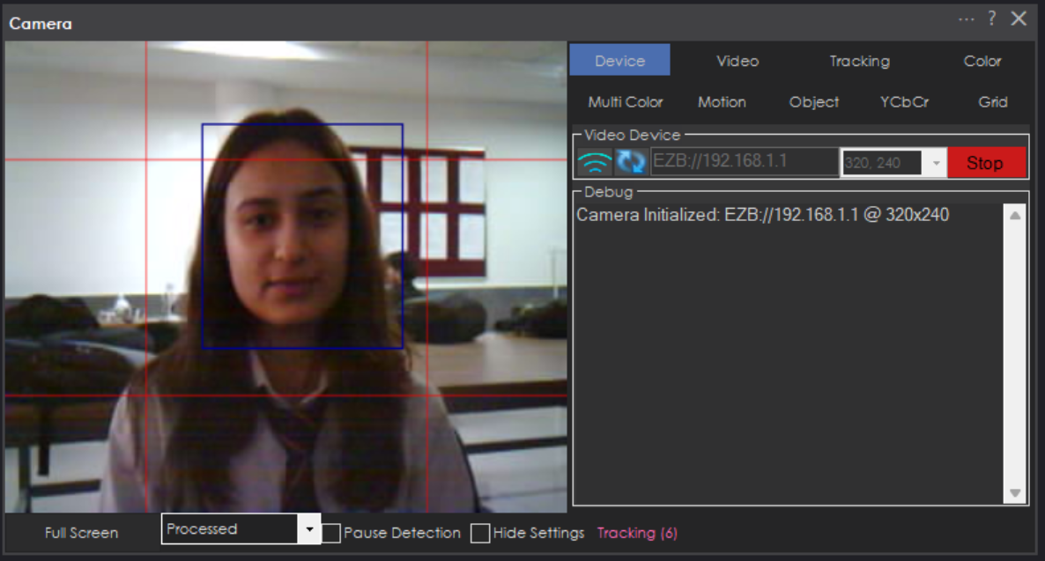
Robot detecting Face and motion

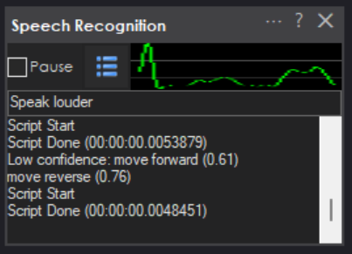
Speech recoginition module

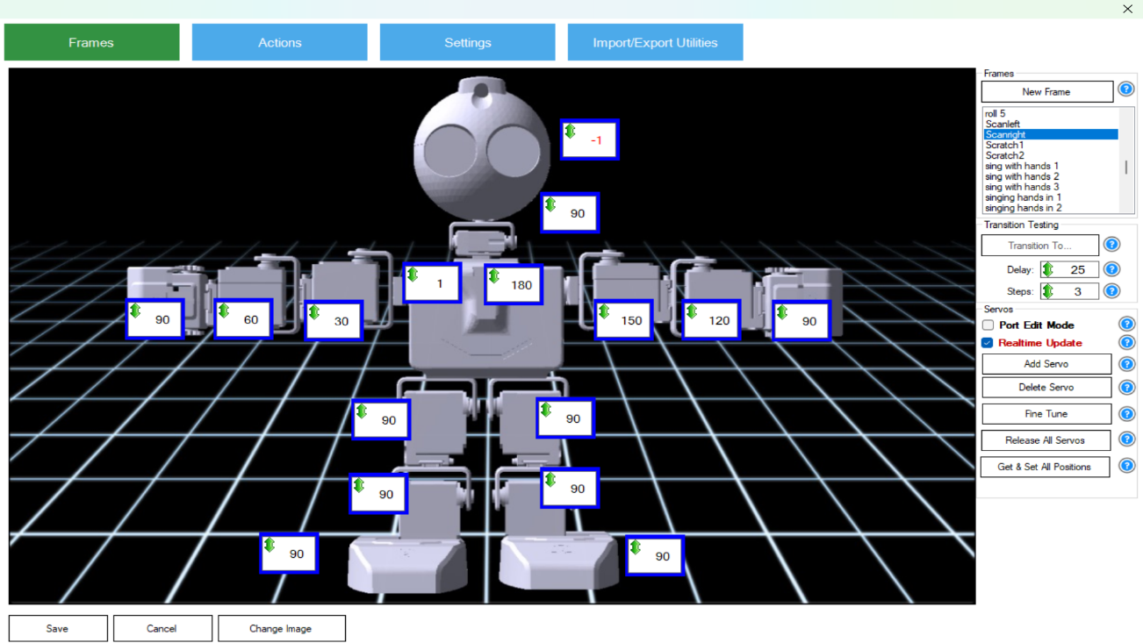
Configuration of the servos of robot for the custom frame “Scanright”

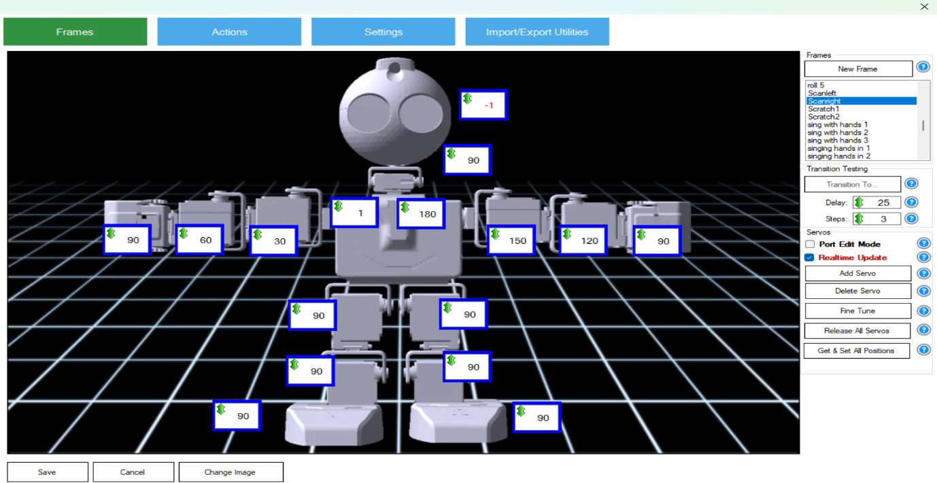
Configuration of the servos of robot for the custom frame “Scanright”

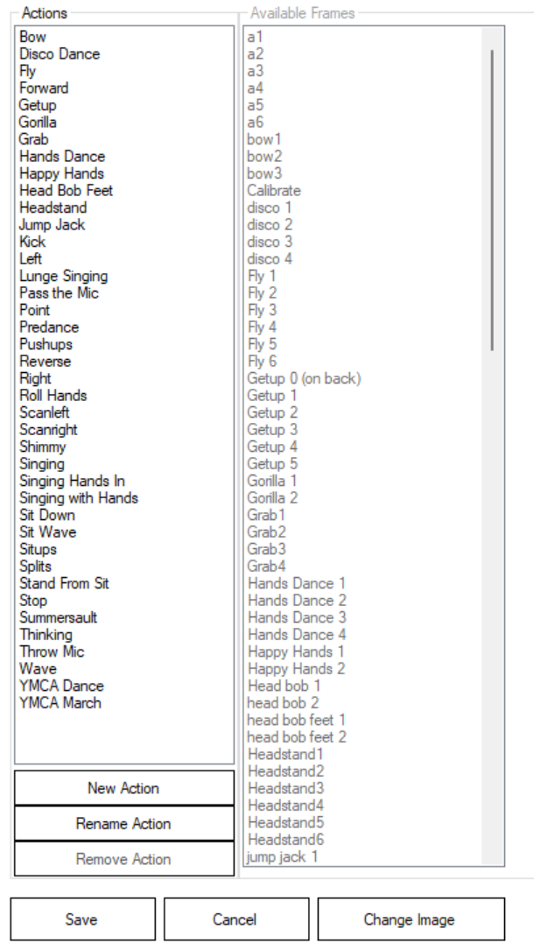
Two new actons Scanleft and Scanright were created using frames Scanleft and Scanright respectively
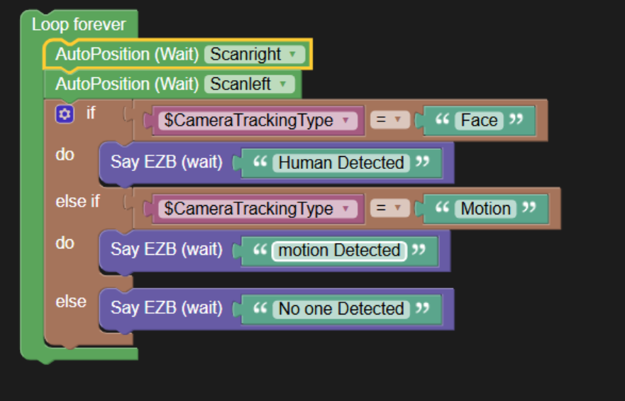
Blockly for Scanning environment and detecting faces and motion

Result Analysis
The system was tested in a controlled indoor environment (laboratory room, approximately 5m × 6m) over multiple sessions. Both Face Tracking and Motion Tracking were enabled simultaneously. Results are summarised below:
Test Scenario | Expected Outcome | Observed Outcome | Status
Human enters camera frame | $CameraTrackingType = "Face"; "Human Detected" spoken | Face detected ~1.1 s; alert spoken correctly | PASS
Motion only (no face) | "Motion Detected" spoken | Motion detected; correct alert spoken | PASS
No person, no movement | "No One Detected" spoken | "No One Detected" spoken every scan cycle | PASS
ScanLeft posture execution | Head turns left within 500 ms + settle | Posture completed ~470 ms; smooth movement | PASS
ScanRight posture execution | Head turns right within 500 ms + settle | Posture completed ~490 ms; no servo error | PASS
"move forward" voice command | Robot moves forward continuously | Robot moved forward; stopped on "robot stop" | PASS
"robot turn right" voice command | Turns right for 1 s | Turn completed at correct speed and duration | PASS
Continuous loop (30-min run) | No degradation or crash | Loop ran stably; no memory issue observed | PASS
Table 3.2 – Test Results Summary

Overall, the system achieved a face-detection success rate of approximately 92% under good lighting (above 200 lux), dropping to approximately 68% in low-light conditions (below 100 lux). Motion detection triggered reliably for movements up to ~3 m. Speech synthesis was clear and uninterrupted in all tests. The while(true) loop showed no observable memory or performance degradation during a 30-minute continuous run. Voice command recognition achieved ~95% accuracy in a quiet environment, dropping to ~80% with background noise.

CONCLUSION

This project successfully demonstrated the development of a Vision, Speech & Motion Security Robot using the EZ-Robot JD Humanoid platform. By integrating continuous servo-based scanning, dual-mode camera detection (face and motion), context-aware text-to-speech alerts, and a voice-command interface, the system achieved the core objective of active, autonomous, multi-modal security monitoring within a controlled indoor environment.
The four-module architecture — continuous scanning loop, dual-mode camera detection, speech alert engine, and voice command interface — proved to be an effective and modular design. Each module is independently testable and can be upgraded or extended without redesigning the others. The use of EZ-Builder's built-in plugins significantly reduced development time while still enabling deep customisation through JavaScript and EZ-Script APIs.
Key achievements of the project:
- Reliable and continuous scanning behaviour using ScanLeft and ScanRight AutoPosition actions.
- Dual-detection logic that distinguishes between human face detection and general motion detection, providing contextually distinct spoken responses for each.
- Seamless integration of speech synthesis, servo posture control, and a voice command interface within a single EZ-Builder project.
- A stable, infinitely looping patrol behaviour with no observed degradation over extended test runs.
- A fully voice-operable robot that can be redirected and controlled without any physical input device.

Limitations identified during testing:
- Reduced face detection accuracy in low-light conditions.
- No recognised-vs-unrecognised person classification — all faces trigger the same alert.
- Reliance on a Wi-Fi link, which could be disrupted in congested wireless environments.
- No persistent event logging system to record detection events over time.
Future work could address these limitations by incorporating a deep learning face-recognition model to distinguish authorised from unauthorised individuals, adding a persistent event log and remote notification system, deploying on a self-contained edge-computing platform to eliminate Wi-Fi dependency, and integrating a thermal or infrared sensor for reliable detection in complete darkness.
In conclusion, the project met all its defined objectives and demonstrated that low-cost humanoid robots, when equipped with appropriate vision, speech, and voice-command capabilities, can serve as functional, interactive security patrol agents. The skills acquired in robotics programming, event-driven control, hardware-software integration, and multimodal sensing represent valuable outcomes for the team.

BIBLIOGRAPHY

Books:
[1] Siciliano, B., Sciavicco, L., Villani, L., & Oriolo, G. (2010). Robotics: Modelling, Planning and Control. Springer.
[2] Russell, S., & Norvig, P. (2020). Artificial Intelligence: A Modern Approach (4th ed.). Pearson.
[3] Goodfellow, I., Bengio, Y., & Courville, A. (2016). Deep Learning. MIT Press.

Web Links:
[4] EZ-Robot Inc. — EZ-Builder Documentation. https://www.ez-robot.com/EZ-Builder/ (Accessed April 2026).
[5] EZ-Robot JD Humanoid Robot Platform. https://www.ez-robot.com/Shop/AccessoriesDetails.aspx?prevCat=1&productNumber=12 (Accessed April 2026).
[6] Microsoft Cognitive Services — Speech Platform. https://azure.microsoft.com/en-us/products/cognitive-services/speech-to-text/ (Accessed April 2026).

Software Used:
[7] EZ-Builder Desktop v2026.02.21 (EZ-Robot Inc.) — Robot programming and simulation environment.
[8] Windows 10 Speech Platform — Text-to-Speech and Speech Recognition Engine (Microsoft Corporation).

