Assignment
2. Take one Domain and draw the graph (Normal distribution) (Empirical rule)

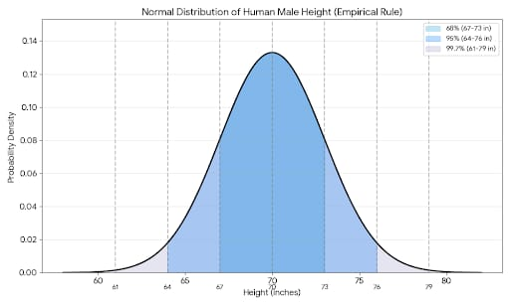

The graph below illustrates the Normal Distribution of male heights in a population, based on a mean (\mu) of 70 inches and a standard deviation (\sigma) of 3 inches.
​This visualization demonstrates the Empirical Rule (also known as the 68-95-99.7 rule):
​68% of men fall within 1 standard deviation of the mean (70 \pm 3), which is between 67 and 73 inches.
​95% of men fall within 2 standard deviations of the mean (70 \pm 6), which is between 64 and 76 inches.
​99.7% of men fall within 3 standard deviations of the mean (70 \pm 9), which is between 61 and 79 inches.
​The shaded regions in the plot represent these probability intervals, showing how the data clusters around the average height of 70 inches.
To dive deeper into the Empirical Rule (also known as the 68-95-99.7 Rule), it’s helpful to understand how these specific percentages are derived and what they imply about data consistency in the real world.
​1. Breaking Down the Percentages
​The percentages represent the area under the "Bell Curve." Because the total area under the curve is always equal to 1 (or 100\%), we can determine exactly how much of a population falls into specific buckets:
​The 68% (1 \sigma): This is the "average" range. In our height example, most men you meet will be between 5'7" and 6'1".
​The 95% (2 \sigma): This is often used in statistics to define "normal" behavior. Anything outside this range (shorter than 5'4" or taller than 6'4") is considered statistically significant or unusual.
​The 99.7% (3 \sigma): This covers almost everyone. Being outside this range makes you an "outlier." For heights, this would be someone under 5'1" or over 6'7".
​2. Symmetry and the Mean
​In a perfectly normal distribution:
​**Mean = Median = Mode: The average, the middle value, and the most frequent value are all the same (70 inches).
​Symmetry: The curve is a mirror image. This means 50\% of the population is taller than 70 inches, and 50\% is shorter.
​Asymptotic: The "tails" of the curve get closer and closer to the horizontal axis but theoretically never touch it, implying there is a non-zero (though microscopic) chance of someone being extremely tall or short.
​3. Why This Matters (Beyond Height)
​The Normal Distribution isn't just for biology; it is the backbone of many fields because of the Central Limit Theorem, which states that the sum of many independent random variables tends toward a normal distribution.
​Real-World Applications:
​Quality Control: Manufacturers use the "Six Sigma" method to ensure that 99.99966\% of their products are defect-free.
​Standardized Testing: SAT and IQ scores are mapped to a normal distribution so that a score of 100 (IQ) or 500 (SAT sections) represents the exact middle.
​Finance: Portfolio managers use it to estimate the probability of a stock's return falling within a certain range.
​
4. Calculating Z-Scores
​If you want to find out exactly where a specific height sits, you use a Z-score. This formula converts any "raw" score into a standard measurement of how many standard deviations it is from the mean:

