Does a Smart Greenhouse Change Plant Growth?
A data analysis and machine-learning portfolio project
Abdulsobur Abiola Oladapo (Dapo) | Portfolio: abdulsobur-oladapo.lovable.app
Summary
I analysed a 30,000-record plant-growth dataset from a university study to answer one question: do plants grown in a smart (IoT-controlled) greenhouse grow differently from plants in a traditional one? Along the way I found that the dataset is much smaller in practice than it looks, and that the near-perfect machine-learning accuracy it first produced was misleading. I rebuilt the analysis to hold up under scrutiny and state clearly what the data can and cannot support.
Key results
- Real differences were found. Smart-greenhouse plants had about 40% more leaf area, 29% more leaves and 26% longer roots, and about 15% lower chlorophyll.
- 30,000 records were really 18 groups. Records inside each group are near-copies, so I tested at the group level instead of overstating the evidence.
- A “perfect” 100% model was a warning sign. Under a stricter, realistic test its accuracy fell to 33–67% for the finer groups. I reported this rather than hiding it.

Dataset | Advanced IoT Agriculture 2024 (Kaggle), from a Tikrit University (Iraq) master’s thesis | Size | 30,000 records, 12 plant measurements, 6 classes, 3 replicates
Question | Do smart-greenhouse plants differ from traditional-greenhouse plants? | Tools | Python: pandas, SciPy, scikit-learn, seaborn
1. Data quality and cleaning
The raw file was never overwritten (the dataset owner asks that it is not altered); all cleaning was done on a copy. No rows were removed.
What I found | What I did
Column names had hidden leading and double spaces | Standardised to short, consistent names (for example PHR for plant height rate) and wrote a data dictionary
No missing values, duplicates or impossible values | Nothing to fix; all 30,000 records kept
About 5% unusually high values in two root measurements | Traced to two entire classes, not errors, so they were kept
Labels not documented (“Random”, S/T, A/B/C) | Split the class label into greenhouse (S/T) and sub-group (A/B/C); treated “Random” as a replicate (batch) label; recorded each assumption
Signs the data is simulated or augmented | Flagged near-constant leaf counts in one class and the tight clusters of records, and designed the analysis around them
2. Analysis and findings
I examined the distribution of every measurement, compared the six classes, mapped relationships between measurements (three strongly related pairs, such as root diameter and root weight) and plotted the data to look for natural groupings. The two charts below summarise the main results.
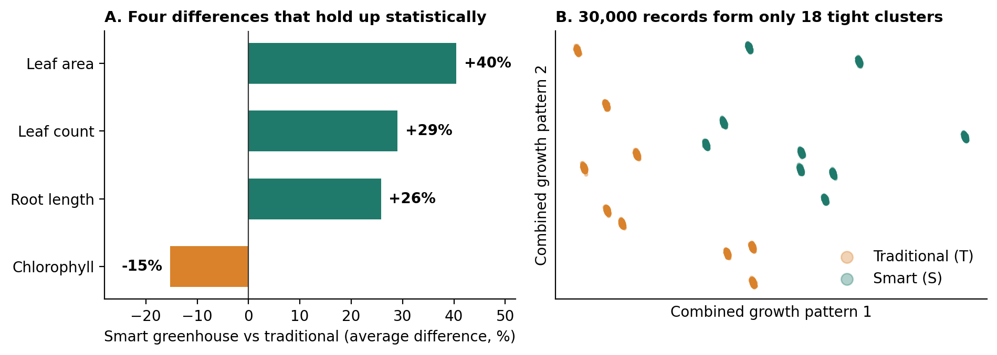
Figure 1. (A) Average difference in a smart versus traditional greenhouse for the four measurements that remain significant after correcting for multiple tests. (B) Each dot is a plant record; the 30,000 records collapse into 18 tight clusters (6 classes × 3 replicates).
- The two greenhouse types differ. Leaf area, leaf count and root length were higher in the smart greenhouse and chlorophyll was lower. Root weight was also about two-thirds higher, but with so little independent data that result is suggestive, not conclusive.
- The data is effectively 18 groups, not 30,000 plants. Knowing a record’s class and replicate explains 99.6–100% of the variation in every measurement. Treating each row as independent would have inflated the evidence, so I compared the 18 group averages and applied a correction for running many tests.
- A “perfect” model was a warning sign, not a success. Three models classified plants with about 100% accuracy, and even a single measurement was enough. A random split lets a model see near-copies of what it is later tested on, like a student who has seen the exam questions in advance. So I tested again by holding out an entire replicate:
Test | Six-class accuracy | Smart vs traditional accuracy
Standard random split (original approach) | about 100% | about 100%
Hold out one whole replicate (stricter, realistic) | 33–67% | 100% (random forest)

In plain terms: the models reliably tell the two greenhouse types apart, but cannot reliably separate the finer A/B/C groups. Between 99% and 100% of the mistakes were confusions inside the same greenhouse.
3. Skills demonstrated
Skill | Evidence in this project
Data cleaning and quality assessment | Systematic checks, documented assumptions, raw data left untouched
Statistical analysis | Effect sizes, group-level testing, multiple-comparison correction, post-hoc tests
Machine learning | Logistic regression, random forest, gradient boosting, cross-validation
Critical thinking | Spotted over-counted data and misleading accuracy, then validated honestly
Communication and reproducibility | Plain-language reporting; documented notebook with relative paths on GitHub
4. Limitations and next steps
- Likely simulated or augmented data. Results describe this dataset, not real plants in the field.
- Labels are my interpretation. S = smart and T = traditional is inferred from the study context; the author does not define S/T or A/B/C.
- Small effective sample. Only 18 groups (9 per greenhouse), and no units, dates or plant IDs, limit what can be concluded.
Next steps: confirm the label definitions with the dataset author, repeat the analysis on genuinely measured data, and build a small interactive app to explore the results.
Data: Advanced IoT Agriculture 2024, Kaggle (wisam1985), from a master’s thesis at Tikrit University, Iraq (M. I. Lifta, supervised by W. D. Abdullah). Attribution given as requested by the dataset owner. Full code and notebook are in the accompanying GitHub repository.

