Detecting Mastitis from Milk Measurements
Is machine learning even needed? A data science portfolio project
Abdulsobur Abiola Oladapo (Dapo) | Portfolio: abdulsobur-oladapo.lovable.app
Summary
I analysed milk measurements from 800 dairy cows (169 with mastitis) to see how well the disease can be detected, and whether the 100% accuracy in my first machine-learning model could be trusted. It could not: every measurement separates healthy from sick cows almost perfectly, a single threshold rule does as well as machine learning, and the data shows clear signs of being simulated. The project shows how to test a “perfect” result instead of simply reporting it.
Key results
- Mastitis milk looks very different: about 2.5 °C warmer, 45% higher conductivity, four times the somatic cell count and 54% lower yield.
- Detection is trivially easy, even without cell counts. Four milk measurements give zero errors in 800 cows; any single one reaches 98.6–99.7% accuracy (an “always healthy” guess scores 78.9%).
- A one-line rule works as well as a model: “milk temperature above 36.8 °C” makes one mistake in 800 cows.
- The data is almost certainly simulated: within each group the measurements are unrelated to each other (average correlation 0.05), whereas real physiology keeps them linked.

Dataset | Cow milk mastitis dataset (Kaggle download): 800 cows, one row each, 9 columns | Target | Mastitis (1) or healthy (0); 21% of cows have mastitis
Questions | What distinguishes mastitis milk, and can the 100% accuracy be trusted? | Tools | Python: pandas, SciPy, scikit-learn, seaborn
1. Data quality and cleaning
The raw file was never changed and no rows were removed. Each check below shaped how the models were built and judged.
What I found | What I did
Target column called class1 | Renamed to Mastitis (1 = mastitis, 0 = healthy)
No missing values or duplicates; each cow appears once | Nothing to fix; a random split cannot put the same cow in both training and test data
Only 21% of cows have mastitis: always guessing “healthy” is 78.9% accurate | Reported recall (share of sick cows caught) and precision alongside accuracy
Pooled outlier checks flag 54–166 cows per measurement | These are the sick cows forming a higher cluster, not errors, so all values kept
Clotting flag: every clotting cow has mastitis, but 18% of mastitis cows do not clot | Treated as a second label (a clinical sign), so excluded from the predictors
A “Day” column (1–30) with no documented meaning and no link to mastitis (r = −0.002) | Excluded from the analysis
Units not documented | Assumed °C, mS/cm, thousands of cells/mL and litres/day; conclusions use only relative differences
2. What distinguishes mastitis milk
Measurement | Healthy (average) | Mastitis (average) | Difference | Effect size (Cohen’s d)
Temperature (°C) | 35.54 | 38.05 | +7% | 5.1
pH | 6.65 | 7.11 | +7% | 4.5
Conductivity (mS/cm) | 4.69 | 6.78 | +45% | 5.0
Somatic cell count | 148 | 598 | +304% | 4.8
Milk yield (L/day) | 20.15 | 9.35 | −54% | −4.2
An effect size above 0.8 counts as large; every measurement here is above 4. The two groups barely overlap: only 5 to 13 cows fall in the overlap zone for temperature, conductivity and cell count.
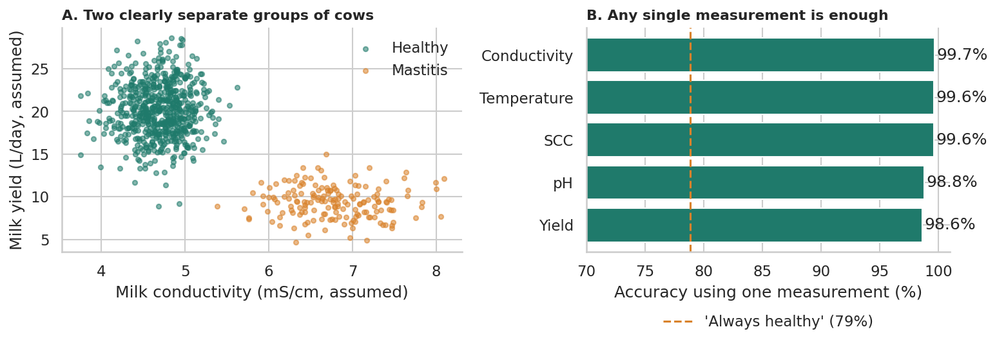
Figure 1. (A) Each dot is a cow; healthy and mastitis cows form two separate groups. (B) Accuracy using one measurement only, against the 79% “always healthy” baseline.
3. Can the 100% accuracy be trusted?
The original notebook used one 80/20 split (160 test cows, only 34 with mastitis) and reported perfect accuracy. It also suspected that somatic cell count (SCC), a standard diagnostic measure, was “leaking” the answer, and removed it. I replaced the single split with 5-fold cross-validation repeated 3 times and tested several feature sets:
Model and measurements | Accuracy | Recall | Precision
Logistic regression, all 5 measurements | 100% | 100% | 100%
Logistic regression, 4 without cell count | 100% | 100% | 100%
Random forest, 4 without cell count | 99.9% | 100% | 99.4%
Temperature alone | 99.6% | 98.8% | 99.4%
Conductivity alone | 99.7% | 98.4% | 100%
Cell count alone | 99.6% | 98.2% | 100%
pH alone | 98.8% | 95.8% | 98.5%
Milk yield alone | 98.6% | 96.8% | 96.7%
“Always healthy” guess | 78.9% | 0% | n/a

- Removing cell count changes nothing. The original instinct was reasonable, but it fixed the wrong problem: every other measurement is just as informative. The whole dataset is too separable, not one column.
- Simple rules match the models. “Temperature above 36.84 °C” gives 0 missed cases and 1 false alarm in 800 cows; “conductivity above 5.66” gives 1 missed case and 0 false alarms. A rule like this is easier to explain, audit and use on a farm.
- Missed cases cost more than false alarms, so a real deployment should tune the cut-off to catch every sick cow, even at the price of some extra checks.
4. Is the data realistic?
In real animals, temperature, pH, conductivity and cell count stay correlated within a health group, because inflammation drives them all. Here they do not:
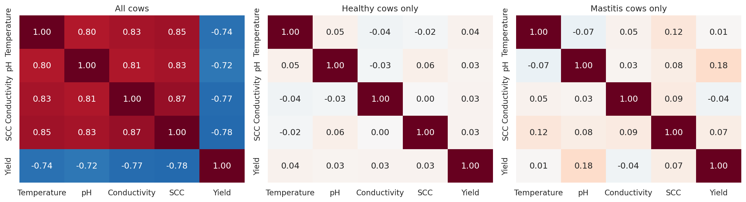
Figure 2. Correlations between measurements: strong overall, but near zero inside each group.
The average correlation is 0.80 overall but only 0.05 within a group: all the relationship comes from the label itself. Together with very tight spreads (milk temperature varies by only 0.49 °C within each group) and perfect separation, this is the signature of simulated data. Published work on real herds reports that conductivity thresholds struggle with low specificity and farm-to-farm variability, which makes this dataset’s clean separation unusual.
5. What I would tell a farm manager
- If these numbers were real, use a simple threshold rule (for example on temperature or conductivity), tuned to catch every case, rather than a black-box model.
- Do not quote 100% accuracy. It shows that the label and the measurements were generated together, not that a model has learned mastitis.
- Validate on real herd data with repeated measures per cow and a hold-out of whole farms before trusting any detector.
6. Skills demonstrated
Skill | Evidence in this project
Machine learning with sound validation | Stratified repeated cross-validation, recall and precision for an imbalanced target, baseline comparison
Critical thinking | Challenged a perfect score, tested the leakage explanation, found the real cause (separable, simulated data)
Statistics | Effect sizes, Mann-Whitney tests, within-group correlation analysis
Domain knowledge | Interpreted SCC, conductivity, clotting and error costs in dairy mastitis terms
Communication | Plain-language summary, honest limitations, simple deployable rule
7. Limitations and next steps
- The data looks simulated, so no accuracy figure here describes real herd performance.
- One measurement per cow, with undocumented units and no breed, farm or lactation-stage information; early detection and generalisation across farms cannot be tested.
- Clinical and subclinical mastitis are not distinguished, and the source of the label is unknown.
Next steps: repeat the analysis on real farm data with repeated measures, compare thresholds and models on recall at a fixed false-alarm rate, study early detection, and wrap the rule in a small farm-facing app.
Data: cow_milk_mastitis_dataset.csv (Kaggle download). Full code and notebook are in the accompanying GitHub repository. Background: Pan et al., Frontiers in Veterinary Science (2025), doi:10.3389/fvets.2025.1671186.

