**Email Scheduler Application**

**Introduction:**

Email Scheduler is a Standalone Application created with the scope of helping users by reducing manual effort and human error with different functionalities included.

**Methods:**

Email Scheduler Application is developed with Python as programming language and PowerShell to manage Exchange Server. Python offers a package called **Tkinter** useful for creating the Front-End of the application.

**Use:**

Before the development of this application End-Users expected to have minimal technical knowledge to run the PowerShell and Python scripts also users need to manually check the users accounts created or not and change the Time Zone and Language for newly created mailbox. Now with the development of the Email Scheduler Application any users can schedule email by just knowing the path on which the files are present and they will be constantly notified with appropriate status messages about their action.

**Application Overview:**

Email Scheduler Application has 3 different functions. The functions are as follows,

1. Create User Accounts

* Which will allow users to create a User Account’s in Exchange Server.

1. Initial Email Setup

* Which will allow users to send Initial Emails to the Available Users in the Exchange Server.

1. Session Email Setup

* Which will allow users to send Response Emails with a delay.

**Application Design:**

**Create user account:**

* Create user account Initially have two Label namely “File path” and “Status”, a default message as “No New Users Created”, and two buttons namely “Select File” and “Create Accounts”.
* “Select File” button will allow users to choose the file from any path in system.
* The Application designed to accept only CSV file as input which should have User’s “First Name”, “Last Name”, “User_ID”, and “Password” with which New user can log in to Exchange server.
* Once the File is chosen, the path of the file will appear in the application in-order to help users verify whether they chose right file or not.
* After verifying path and file name users can click “Create Accounts” button in-order to create the new users in Exchange Server and depends on the number of users created the “No New Users Created” will change to “X number of Users Created” where X can be 0 to any number of users we created newly.

**Initial Email Setup:**

* Initial Email Setup have four labels initially “Selected Accounts”, “Selected Email Script”, “Initial Email Schedule Date”, and “Status”.
* A default message as “No Emails Scheduled” and four buttons namely “Select Accounts”, “Select Email Script”, “Set Date”, and “Schedule”.
* “Select Accounts” will allow users to choose Available Users from the Exchange Server DB to whom the mail can be sent.
* Once Users selected the selected users will be available to verify whether the correct users are selected or not.
* “Select Email Script” will allow users to choose the Email Script in the format of CSV file and once chosen the file name along with path will be available for users to verify the file is selected from correct path.
* “Set Date” will allow users to enter the date and time to schedule the mail to be send at the specified date and time. This will allow users to enter date in the format of mm/dd/yy and time as hh:mm as in military time format.
* When users click “Schedule” button application will be freeze and wait till the scheduled time and it will start sending mail at the time. After Email sent users will get notified with number of emails sent at the time given.

**Warning: Once Scheduled the action cannot be undone with that users should verify all details before clicking the Schedule button.**

**Session Email Setup:**

* Session Email Setup have five labels initially “Selected Accounts”, “Selected Email Script”, “Initial Email Schedule Date”, “Delay”, and “Status”.
* A default message as “No Emails Scheduled” and five buttons namely “Select Accounts”, “Select Email Script”, “Set Date”, “Set Delay”, and “Schedule”.
* “Select Accounts” will allow users to choose Available Users from the Exchange Server DB to whom the mail can be sent.
* Once Users selected the selected users will be available to verify whether the correct users are selected or not.
* “Select Email Script” will allow users to choose the Email Script in the format of CSV file and once chosen the file name along with path will be available for users to verify the file is selected from correct path.
* “Set Date” will allow users to enter the date and time to schedule the mail to be send at the specified date and time. This will allow users to enter date in the format of mm/dd/yy and time as hh:mm as in military time format.
* “Set Delay” will allow users to enter the delay in seconds with which mail will be sent out with the given delay time.
* When users click “Schedule” button application will be freeze and wait till the scheduled time and it will start sending mail at the time. After Email sent users will get notified with number of emails sent at the time given.

**Warning: Once Scheduled the action cannot be undone with that users should verify all details before clicking the Schedule button.**

**Procedure to Schedule the Email:**

Follow the steps below to schedule the mail,

**Step 1. Create User Accounts:**

* Click **Select File** button and Choose the CSV file named “Spring_User.csv” from the path where you installed the application

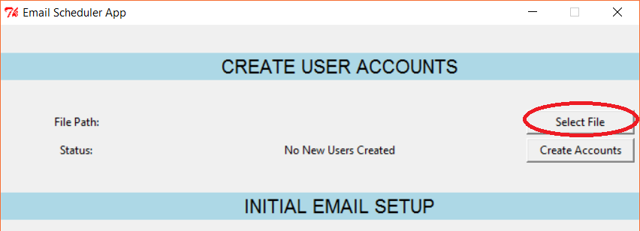

* I installed the application in the path called **C:/Email_Scheduler_App**

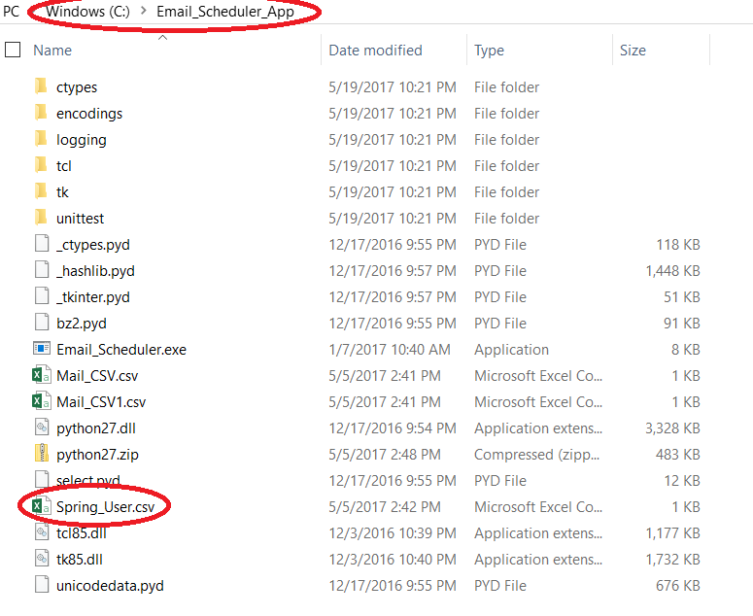

* After the File is chosen the application will display the Path from which the file is chosen in-order to verify whether correct file is chosen or not.

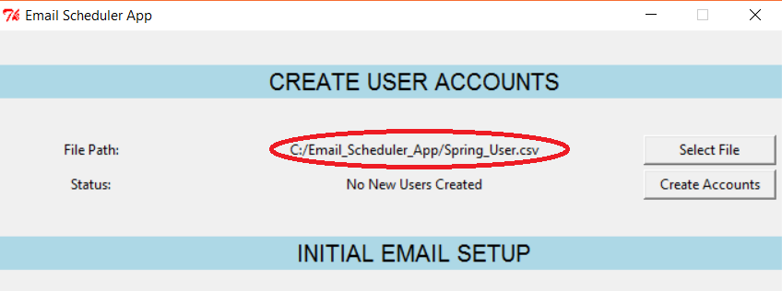

* Click Create Accounts button after the file is chosen and verified the name of file and path

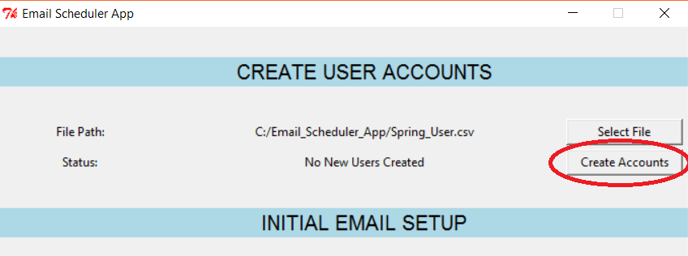

* You will be notified with a status message “Please wait User Creation In Progress” and wait for the user accounts to get created.
* When new users created the application notify you with Number of Users created

**Step 2. Initial Email Setup:**

* Click **Select Accounts** and select the users from the list of available users for whom the mail needs to be send

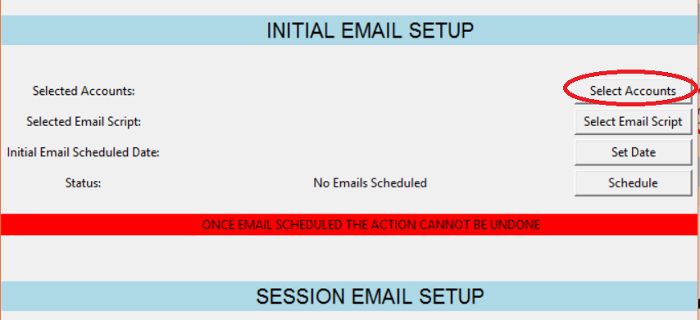

Below Figure shows the sample list of available users

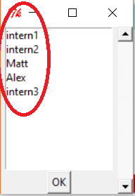

* After selecting the list of users, you want to send mail, click OK. Then the selected users will be displayed next to selected accounts to make sure whether we chose the correct users or not. If not you can click Select Accounts button again and chose the Users to whom you need to send mail

I chose intern1 and intern3 and the notification will be as like shown in below figure,

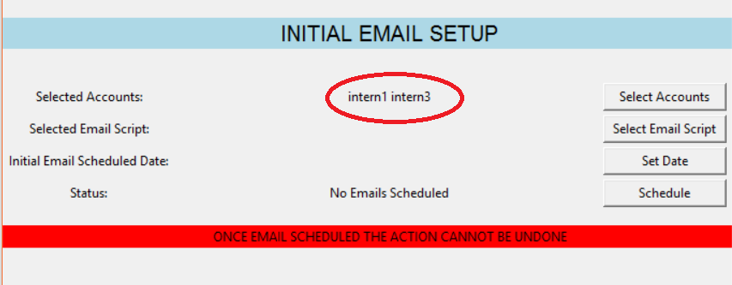

* After users have been selected, Click **Select Email Script** button and Choose the CSV file named “Mail_CSV.csv” from the path where the application is installed

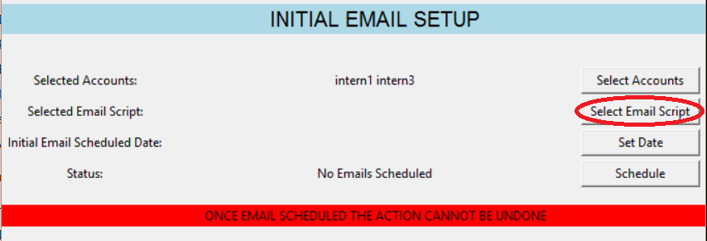

* After the File is chosen the application will display the Path from which the file is chosen in-order to verify whether correct file is chosen or not. I had my file located at **C:/Email_Scheduler_App** path

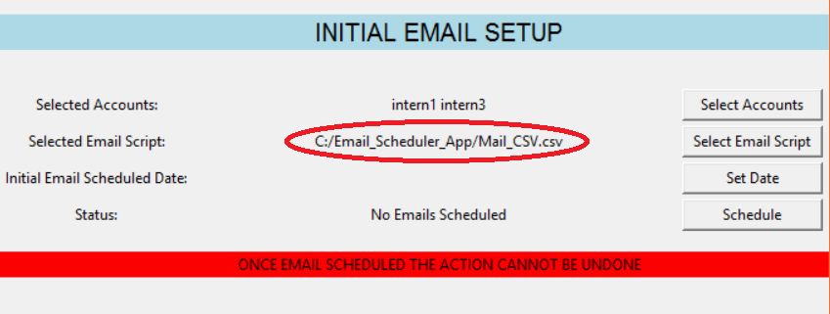

* Click **Set Date** button and provide the date and time in military time format in the box shown in below figure for the date and time the mail needs to be send and then click Ok. If your Date/Time is not valid you will get appropriate warning messages and You can’t schedule mail.

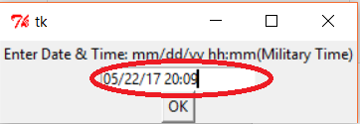

* I schedule the Mail to be sent at May 22, 2017 10:09 pm and below figure shows the notification provided by the application to the user

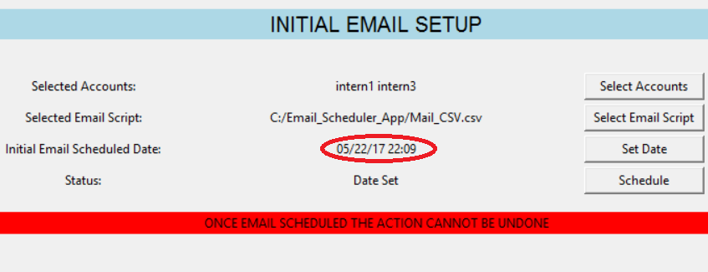

* If you decide not to schedule the Mail at this date and time you can re-schedule by clicking **Set Date** button again. Once the date and time is set the application will acknowledge you with **Date Set** status.

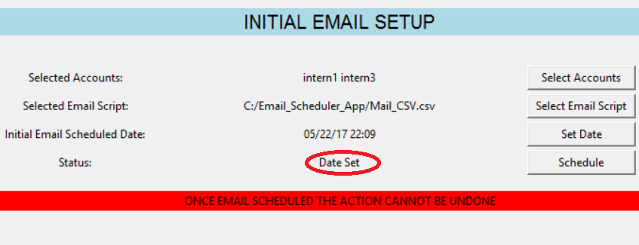

* After verifying the user(s) selected to send mail, file name, file path, date and time click **Schedule** button
* After clicking **Schedule** button, theapplication will notify you with a status message of when the emails are scheduled to send

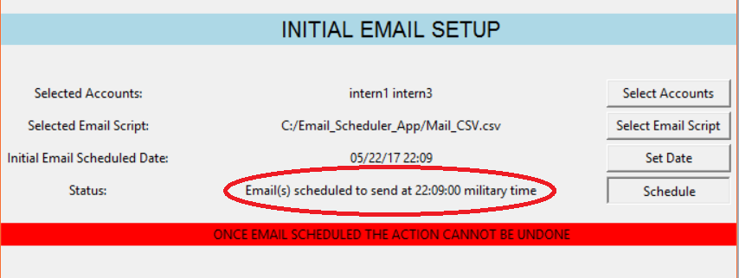

* Wait for the mail to be sent at given date & time
* After mail sent you will be notified with the number of mails sent at the given time

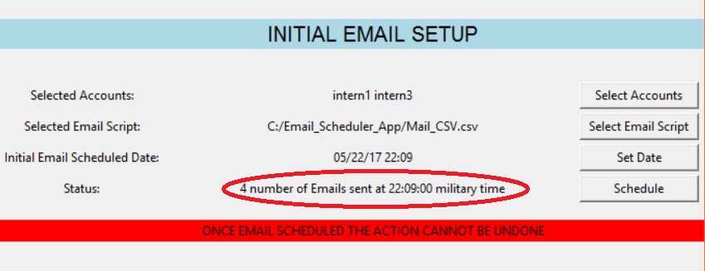

**Note: I had 2 number of mails in the Mail_CSV.csv file and I selected 2 users for the mail to send. So, the application notifying 4 number of Emails sent.**

**Step 3. Session Email Setup:**

* Click **Select Accounts** and select the users from the list of available users for whom the response mail needs to be send

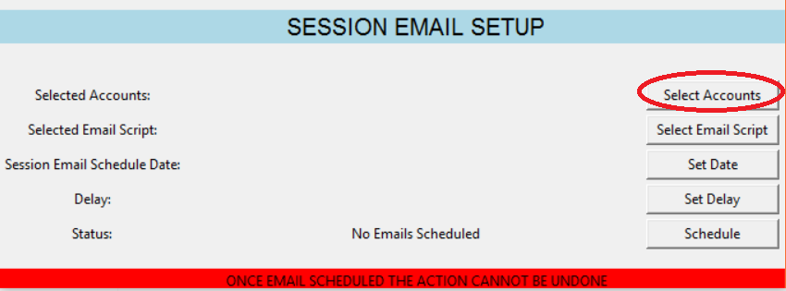

Below figure shows the available list of users



* After selecting the list of users, you want to send mail, click OK. Then the selected users will be displayed next to selected accounts to make sure whether we chose the correct users or not. If not you can click Select Accounts button again and chose the Users to whom you need to send mail
* This time I chose Matt and Alex and the display is as like shown in below figure,

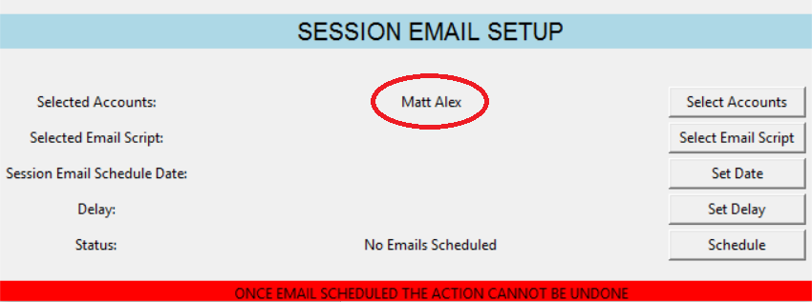

* After users have been selected, Click **Select Email Script** button and Choose the CSV file named “Mail_CSV1.csv” from the path where the application is installed
* After the File is chosen the application will display the Path from which the file is chosen in-order to verify whether correct file is chosen or not. I had my file located at **C:/Email_Scheduler_App** path

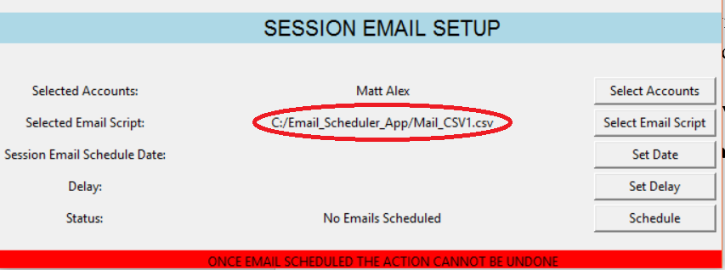

* Click **Set Date** button and provide the date and time in military time format for the date and time the mail needs to be send. If your Date/Time is not valid you will get appropriate warning messages and You can’t schedule mail
* I schedule the Mail to be sent at May 22th, 2017 10:30 pm and below figure shows the notification provided by the application to the user

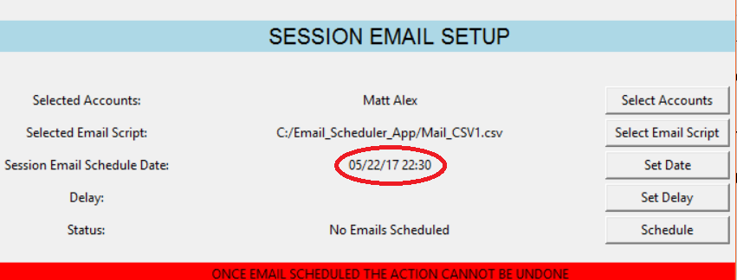

* If you decide not to schedule the Mail at this date and time you can re-schedule by clicking **Set Date** button again.
* Click **Set Delay** button and provide the delay time in seconds and then click OK in the box as like shown in below figure. If your delay is not valid you will get appropriate warning messages and You can’t schedule mail.

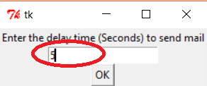

* I gave 5 seconds as delayed and same is notified for me in the application as shown in below figure for verification

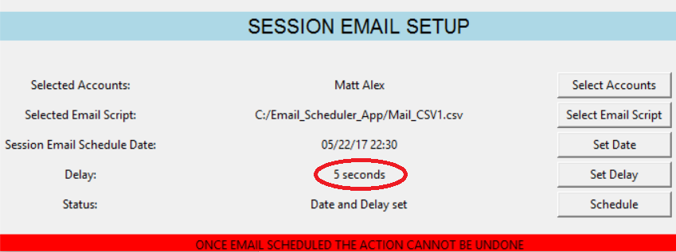

* Once you provide the date, time and delay you will be notified with status as Date and Delay set as shown in below figure

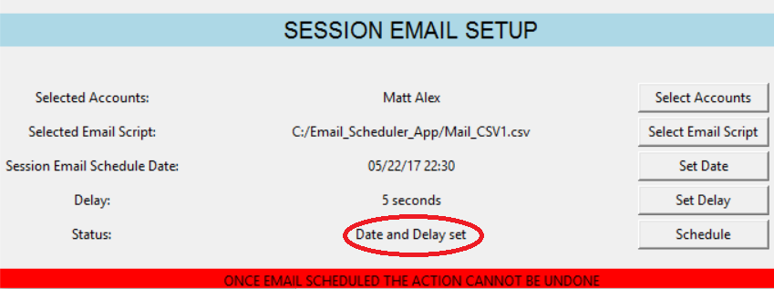

* After verifying the user(s) selected to send mail, file name, file path, date, time, and delay click **Schedule** button
* After clicking **Schedule** button, theapplication will notify you with a status message of when the emails are scheduled and with what delay it needs to be send

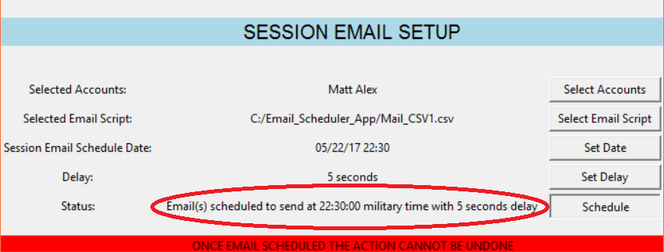

* Wait for the mail to be sent at given time
* After mail sent you will be notified with the number of mails sent at the given time along with the delay between sending mails

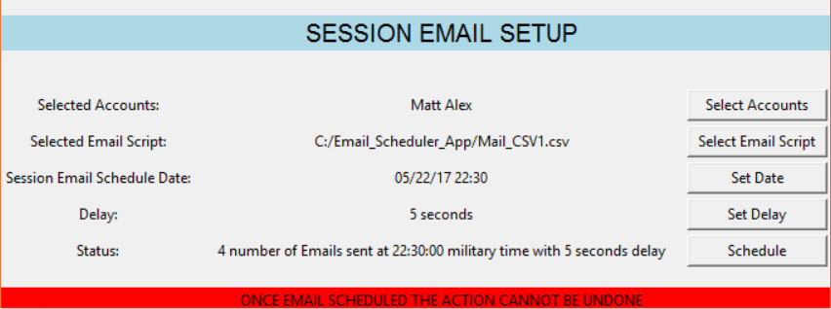

**Note: I had 2 number of mails in the Mail_CSV1.csv file and I selected 2 users for the mail to send. So, the application notifying 4 number of Emails sent along with the delay I specified.**

* To Verify the user account(s) created click the below link and steps
* Login to Outlook Web Access with the following link: <https://localhost/owa> (works only on CAS server)
* Enter user account name you had in your CSV file as domain name and password as given in CSV file
* After Log in you will see the mails received for the user accounts you selected to send mail through application

