**Module (Bootstrap Basic & Advanced) – 6**

Q.1 What are the advantages of Bootstrap?

Ans: Bootstrap is an open-source CSS framework designed to come up with mobile-friendly, responsive front-end web development. Easy to use, Great gris system,Responcive web design,Browser compatity. bili Having a website is a prerequisite for every small and big business. But having stylish and efficient websites designed in a small time frame is the need of the hour.

Q.2 What are the default Bootstrap text settings?

Ans: Bootstrap 5 uses a default font-size of 1rem (16px by default), and its line-height is 1.5. In addition, all <p> elements have margin-top: 0 and margin-bottom: 1rem (16px by default).

Q.3 What do you know about the Bootstrap Grid System?

Ans: Bootstrap Grid System allows up to 12 columns across the page. You can use each of them individually or merge them together for wider columns. You can use all combinations of values summing up to 12. You can use 12 columns each of width 1, or use 4 columns each of width 3 or any other combination.

Q.4 What is the difference between Bootstrap 4 and Bootstrap 5.

Ans: bootsrap-4

* The Bootstrap 4 form has jquery.
* Small icon collection.
* It has limited colors.

Bootsrap-5

* The jquery is not utilized in Bootstrap 5.
* Large icon collection.
* Extra colors added with the looks, A card improved color palette. there are various shades available to choose.

Q.5 What is a Button Group, and what is the class for a basic Button Group?

Ans: Button Groups” in Bootstrap is a class of name “btn-group” which is used to create a series of buttons in groups (without spaces) vertically or horizontally.

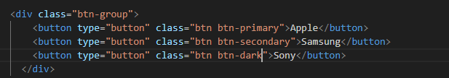

Q.6 How can you use Bootstrap to make thumbnails?

Ans: A thumbnail is a small image that represents a larger image. Bootstrap has an easy way to do this with thumbnails. Bootstrap’s *.* thumbnailclass is used to show linked images in grids ([grid system](https://www.geeksforgeeks.org/bootstrap-4-grid-system/)), a thumbnail is created using class *.* thumbnail *l* within the element [<a>](https://www.geeksforgeeks.org/html-a-tag/#:~:text=HTML%20Tag,-Difficulty%20Level%20%3A%20Basic&text=The%20tag%20(anchor,as%20its%20%E2%80%9Chref%E2%80%9D%20value.).  The class *.col-sm-\**and *.col-md-\** (where * represent number ), it is used to create grids of the images.

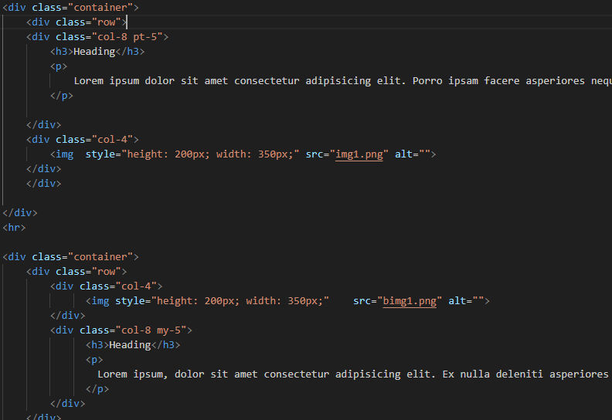

Q.7 In Bootstrap 4, what is flexbox?

Ans: Flexbox is used to quickly manage the layout, alignment and sizing of grid columns, navigation, components, and more with a full suite of responsive flexbox utilities.

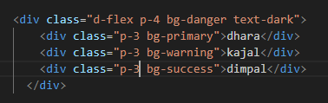

Q.8 How can one create an alert in Bootstrap?

Ans: Bootstrap Alerts are used to provide an easy way to create predefined alert messages. Alert adds a style to your messages to make it more appealing to the users.

