**Module (JQuery Basic, Effects & Advanced) – 5**

**Q.1 What is jQuery?**

**Ans:** jQuery is a fast,small, cross-platform and feature-rich JavaScript library. It is designed to simplify the client-side scripting of HTML.

* jQuery simplifies JavaScript programming and it is easytolearn.
* jQuery only works if the proper CDN is added to the HTML file in the <head> tag.

**Q.2 How to Apply CSS Using JQuery, How to Add Class and Remove Class in Jquery , JQuery Animaton ?**

**Ans:** In jQuery, we can produce various types of animation using the animate() method. This method can produce simple to complex animation in the web page. Using animation, we can change the properties of HTML elements such as background colour, changing border styles, changing navigation properties, formatting the font properties, etc.

How to apply CSS using jQuery:

Example:

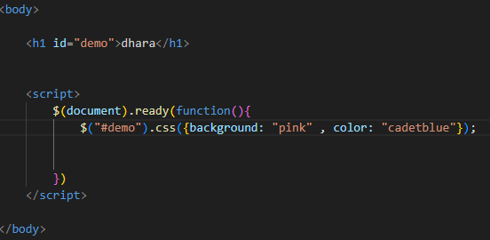

How to Add Class and Remove Class in Jquery:

Example:

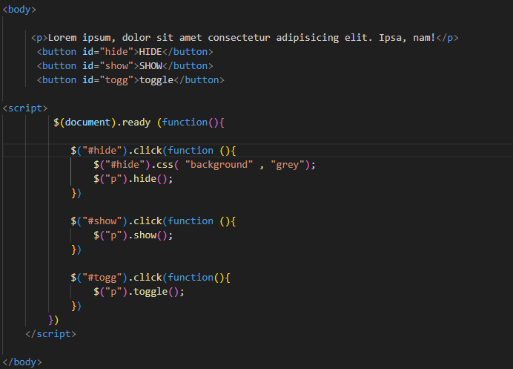

JQuery Animation:

Example:

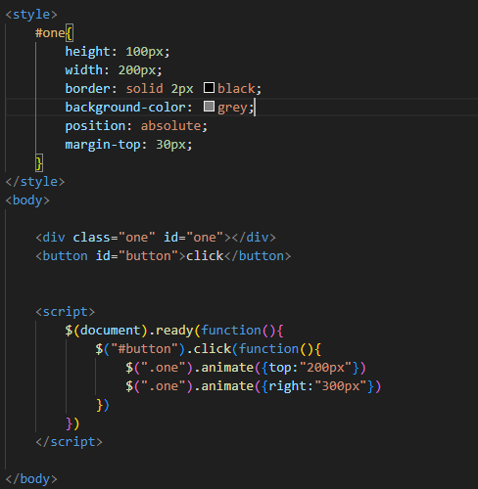

**Q.3 How to create slider with animation?**

**Ans:** Using jQuery , we can add the slide up or down effect in our web page . The slides are always present in the web page in the form of div pairs . There are three methods to add the sliding effects in our web page .These are as follows:

**slideDown() :**This method makes the element to slide down.

**slideUp() :**This method makes the element to slide up.

**slideToggle() :**This method makes the element to slide toggle.

