

Darshan University

A Project Report on

**“Phantom: Movie Streaming Website”**

Under the subject

**Software Engineering (2305CS202)**

MCA, Semester – II

Department of Computer Application

|  |  |
| --- | --- |
| Submitted By | |
| Student Name: **Dhara Maru** | Enrollment No.: **24030501025** |
| Academic Year  (2024-2025) | |
| Internal Guide  Prof. Devangi L. Kotak  Darshan University | Dean-DIET  Dr. Gopi Sanghani  Darshan University |

|  |  |
| --- | --- |
|  | **Department of Computer Application**  **Darshan University** |

**DECLARATION**

We hereby declare that the SRS, submitted along with the **Software Engineering** **(2305CS202)** for entitled **“Phantom: Movie Streaming Website”** submitted in partial fulfilment for the Semester-2 of **Master of Computer Application (MCA)** in **Department of Computer Application (DoCA)** Departmentto Darshan University, Rajkot, is a record of the work carried out at **Darshan University, Rajkot** under the supervision of **Prof. Devangi L. Kotak** and that no part of any of report has been directly copied from any students’ reports, without providing due reference.

Dhara Maru

Student’s Signature

Date: __________

|  |  |
| --- | --- |
|  | **Department of Computer Application**  **Darshan University** |

**CERTIFICATE**

This is to certify that the SRS on **“Phantom: Movie Streaming Website”** has been satisfactorily prepared by **Dhara Maru** (**24030501025**) under my guidance in the fulfillment of the course **Software Engineering (2305CS202)** work during the academic year 2024-2025.

|  |  |  |
| --- | --- | --- |
| Internal Guide  Prof. Devangi L. Kotak  Darshan University |  | Dean-DIET  Dr. Gopi Sanghani  Darshan University |

**Acknowledgement**

I wish to express my sincere gratitude to my project guide Prof. **Devangi L. Kotak** and all the faculty members for helping me through my project by giving me the necessary suggestions and advices along with their valuable co- ordination in completing this work.

I also thank my parents, friends and all the members of the family for their precious support and encouragement which they had provided in completion of my work. In addition to that, I would also like to mention the Darshan University personals who gave me the permission to use and experience the valuable resources required for the project from the University premises.

Thus, in conclusion to the above said, I once again thank the faculties and members of **Darshan University** for their valuable support in completion of the project.

Thanking You

**Dhara Maru**

**ABSTRACT**

Phantom is a next-generation OTT streaming platform that reimagines entertainment with a vast collection of movies, TV shows, and exclusive content. Designed for convenience, it provides seamless streaming across multiple devices with features like watchlists, viewing history, and personalized recommendations.

The platform ensures a secure and enjoyable experience with encrypted user data, safe payment options, and multi-language support. Accessibility features such as subtitles and adaptive streaming cater to diverse user needs, enhancing engagement for a global audience.

With a focus on performance, scalability, and user-centric design, Phantom sets a benchmark in the OTT industry. It combines innovative functionality and cutting-edge technology to deliver an immersive, reliable, and inclusive entertainment experience.

# List of Figures

|  |  |  |
| --- | --- | --- |
| **Fig. No.** | **Name** | **Pg.no.** |
| Fig. 2.1.1 | Use case diagram for Movie Streaming System | 3 |
| Fig. 2.2.1 | Activity diagram for Reviewing Movie (User) | 4 |
| Fig. 2.2.2 | Activity diagram for Uploading a Movie (Admin) | 4 |
| Fig. 2.3.1 | Swimlane diagram for Reviewing Movie (User) | 5 |
| Fig. 2.4.1 | Swimlane diagram for Uploading a Movie (Admin) | 6 |
| Fig. 2.4.2 | Positive Sequence diagram for uploading a movie | 6 |
| Fig. 2.5.1 | Negative Sequence diagram for uploading a movie | 7 |
| Fig. 2.6.1 | Positive & Negative Sequence diagram for uploading a movie | 8 |
| Fig. 2.6.2 | State diagram for Movie | 8 |
| Fig. 2.6.3 | State diagram for Subscriber | 9 |
| Fig. 3.1.1 | Class diagram for Movie Streaming System | 10 |
| Fig. 3.1.2 | DFD Level – 0 for Movie Streaming System | 11 |
|  | DFD Level – 1 for Movie Streaming System |  |
|  | DFD Level – 2 for User processes |  |
|  | Screen-1: Movie Upload Form  Screen-2: Subscriber to a Plan Form  Screen-1: Movie Review Submit Form |  |
|  |  |  |

# List of Tables

|  |  |  |
| --- | --- | --- |
| **Table no.** | **Name** | **Pg.no.** |
| Table 3.1-1 | Screen element of Movie Upload Form | 10 |
| Table 3.1-2 | Screen element of Subscriber to a Plan Form | 11 |
| Table 3.1-3 | Screen element of Movie Review Submit Form | 12 |
| Table 4.1-1 | Table: Movie | 13 |
| Table 4.1-2 | Table: User | 13 |
| Table 4.1-3 | Table: Review | 13 |
|  | Table: Subscription |  |
| Table 4.1-4 | Table: Payment | 13 |

**TABLE OF CONTENT**

|  |  |  |  |
| --- | --- | --- | --- |
| **Chapter No** | **Chapter Title** | | **Page No** |
|  | Acknowledgement | | iii |
|  | Abstract | | iv |
|  | List of Figure | | v |
|  | List of Table | | vi |
|  | Table of Contents | | vii |
| **Chapter 1** | **INTRODUCTION** | | 1 |
|  | 1.1 | Product perspective | 1 |
|  | 1.2 | Product features | 1 |
|  | 1.3 | Functional requirements | 1 |
|  | 1.4 | Non-functional requirements | 2 |
| **Chapter 2** | **DESIGN AND IMPLEMENTATION CONSTRAINTS** | | 3 |
|  | 2.1 | Use case diagram | 3 |
|  | 2.2 | Activity diagram and Swimlane diagram | 4 |
|  | 2.3 | Sequence diagram | 5 |
|  | 2.4 | State diagram | 6 |
|  | 2.5 | Class diagram | 7 |
|  | 2.6 | Data flow diagram | 8 |
|  |  | 2.6.1 Context diagram (level-0) | 8 |
|  |  | 2.6.2 DFD Level-1 | 8 |
|  |  | 2.6.3 DFD Level-1 | 9 |
| **Chapter 3** | **EXTERNAL INTERFACE REQUIREMENT (SCREENS)** | | 10 |
|  | 3.1 | Screen-1: Registration Form | 10 |
|  |  | Screen-2: Login | 11 |
|  |  | Screen-3: Add borrower book | 12 |
| **Chapter 4** | **DATABASE DESIGN** | | 13 |
|  | 4.1 | List of tables | 13 |
|  | **REFERENCES** | | 14 |

# Introduction

## Product perspective

Phantom is a movie streaming OTT platform designed to redefine entertainment with a vast library spanning genres, languages, and categories. It offers everything from classic hits to the latest blockbusters and exclusive originals, all accessible through a user-friendly interface. With adaptive video quality, multi-device compatibility, and personalized features like watchlists and curated recommendations, Phantom ensures a seamless and immersive viewing experience.

## Product features

### There are three different users who will be using this product:

* Administrator manages the platform and ensures smooth operations.
* Subscribers are registered users with access to Phantom's features.
* Guest who will request for membership.

### The features that are required for the Administrator are:

### Managing user accounts, including registration and subscription plans.

### Uploading, editing, and organizing content in the library.

### Monitoring streaming analytics and user engagement through dashboards.

### Managing secure payment gateways and processing transactions.

### Generating reports on subscriptions, viewership trends, and revenue.

### Customizing platform settings, including accessibility features like subtitles.

### Sending notifications and announcements to users.

### The features that are required for the Subscriber are:

* Browsing and searching through an extensive content library.
* Creating a personalized watchlist for future viewing.
* Resuming playback from where they left off.
* Receiving AI-driven content recommendations based on their viewing history.
* Viewing movies and shows on multiple devices with adaptive video quality.
* Providing ratings and reviews for content.
* Managing subscription plans and payment details securely.
  + 1. The features that are required for the Guest are:
* Browsing available content categories and previews.
* Viewing subscription plans and benefits.
* Requesting a subscription by registering for an account.

## Functional Requirement

### **Administrator**

### **Content Management:** Add, edit, and delete movies, shows, and other content in the library.

### **User Management:** Register new users, manage subscriptions, and maintain user records.

### **Analytics Dashboard:** Access reports on user engagement, viewership trends, and revenue.

### **Notification System:** Send alerts and updates to users.

### **Security Management:** Ensure secure transactions through payment gateways and data encryption.

### **Accessibility Settings:** Configure multi-language support, subtitles, and closed captions.

### **Recommendation System Management:** Oversee and update AI-driven content recommendations.

### **Subscriber**

* **Authentication**: Log in securely with a unique username and password.
* **Content Discovery**: Search for content using filters like genre, language, and release date.
* **Watchlist Management**: Add or remove content from a personalized watchlist.
* **Playback Control**: Resume playback from where it was paused.
* **Feedback Mechanism**: Rate and review content for others to see.
* **Subscription Management**: Update payment details and switch subscription plans.
  + 1. **Guest**
* **Browsing:** View content previews and explore available categories.
* **Subscription Request:** Register for a subscription to access premium features.

## Non-Functional Requirement

### **Usability:**

* The interface should be intuitive and easy to navigate, supporting multiple languages.

### **Performance:**

* The system should load within two seconds and adapt video quality seamlessly based on internet speed.

### **Scalability:**

* The platform should handle increased traffic and accommodate a growing user base.

### **Maintainability:**

* Updates and feature additions should be easy to implement without disrupting the service.

### **Portability:**

* The platform must be accessible on various devices, including smartphones, tablets, and smart TVs.

.

# Design and Implementation Constraints

## Use case diagram

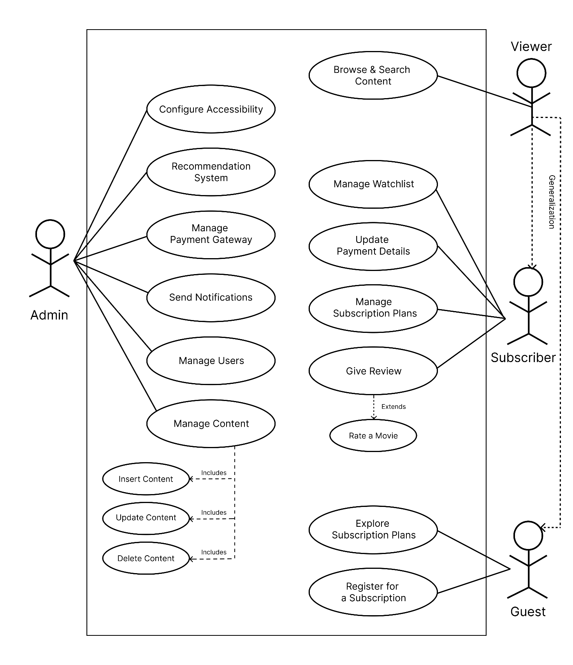

Figure 2.1‑1 Use case diagram for Movie streaming system

## Activity diagram and Swimlane diagram

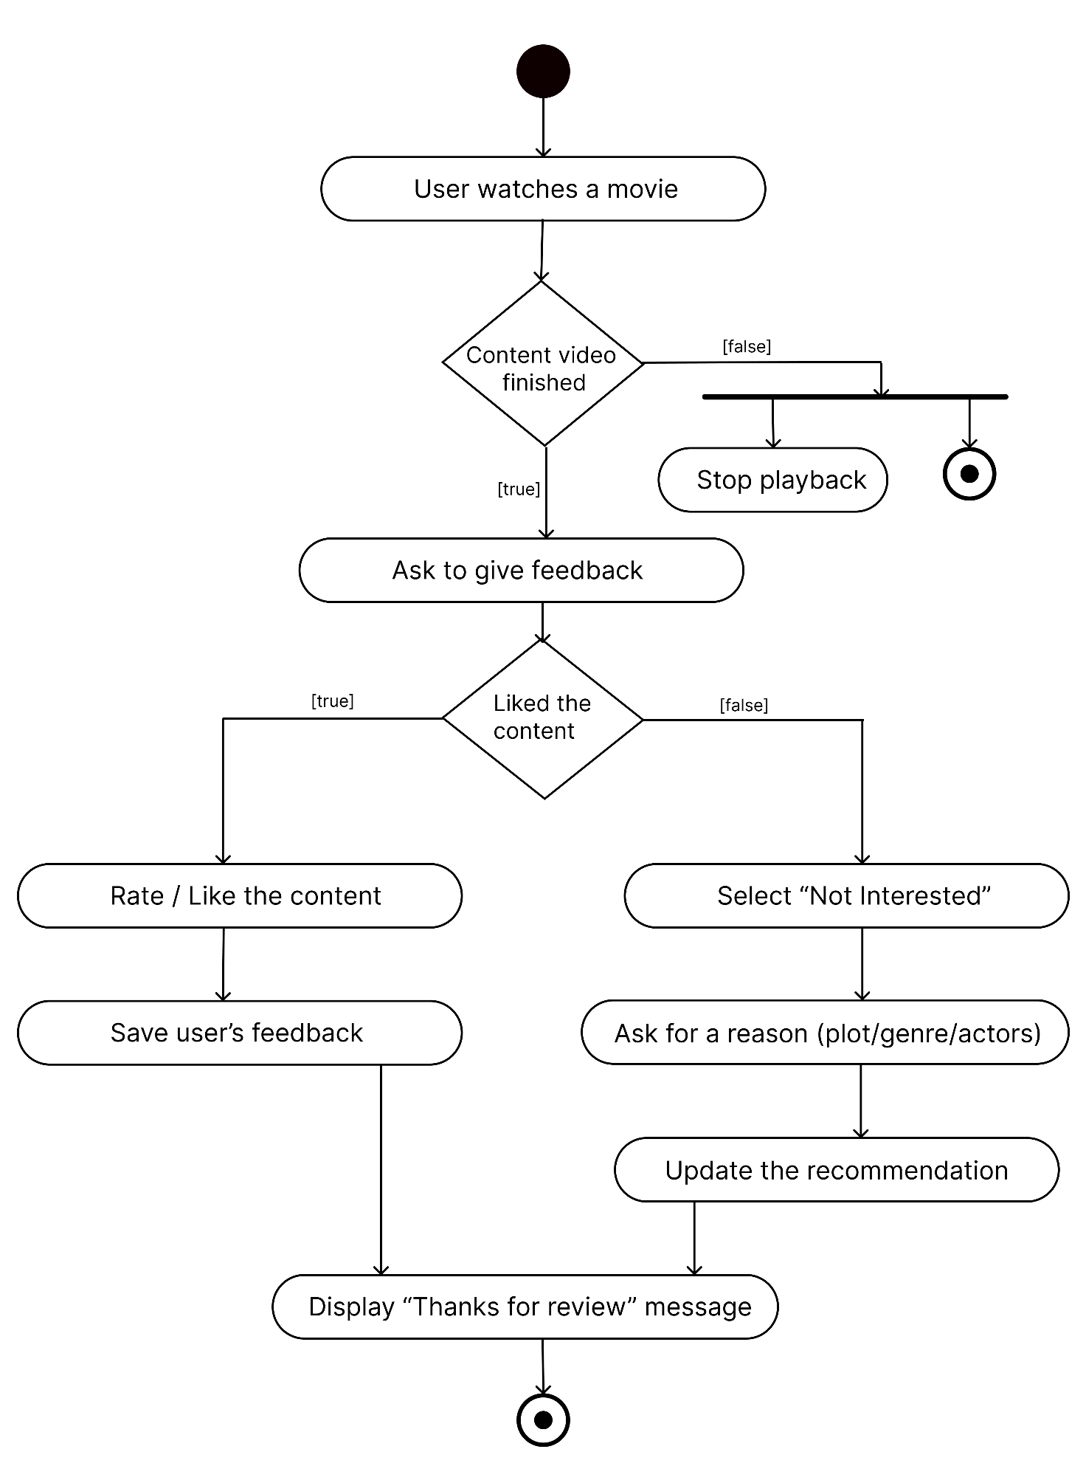

Figure 2.2‑1 Activity diagram for Reviewing a movie (User)

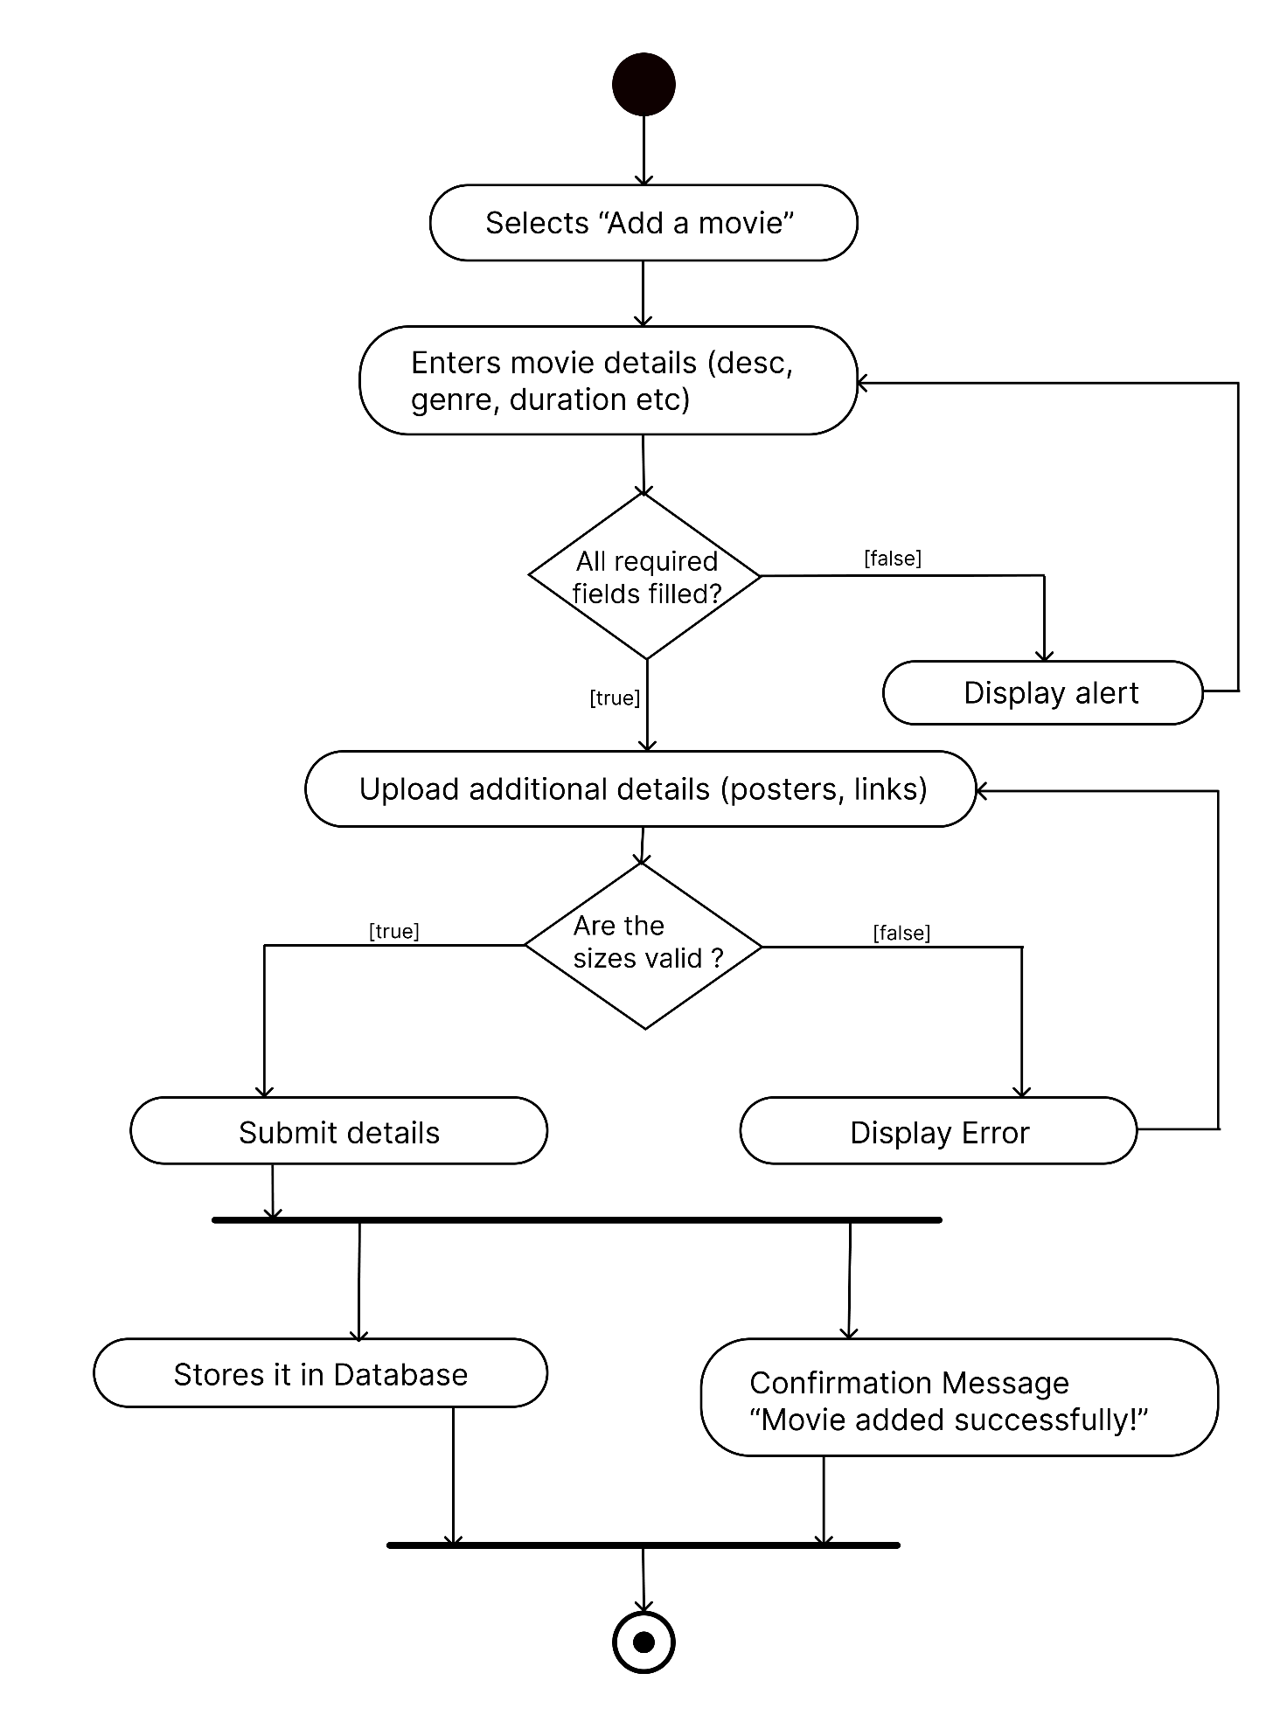

Figure 2.2‑2 Activity diagram for uploading a movie (Admin)

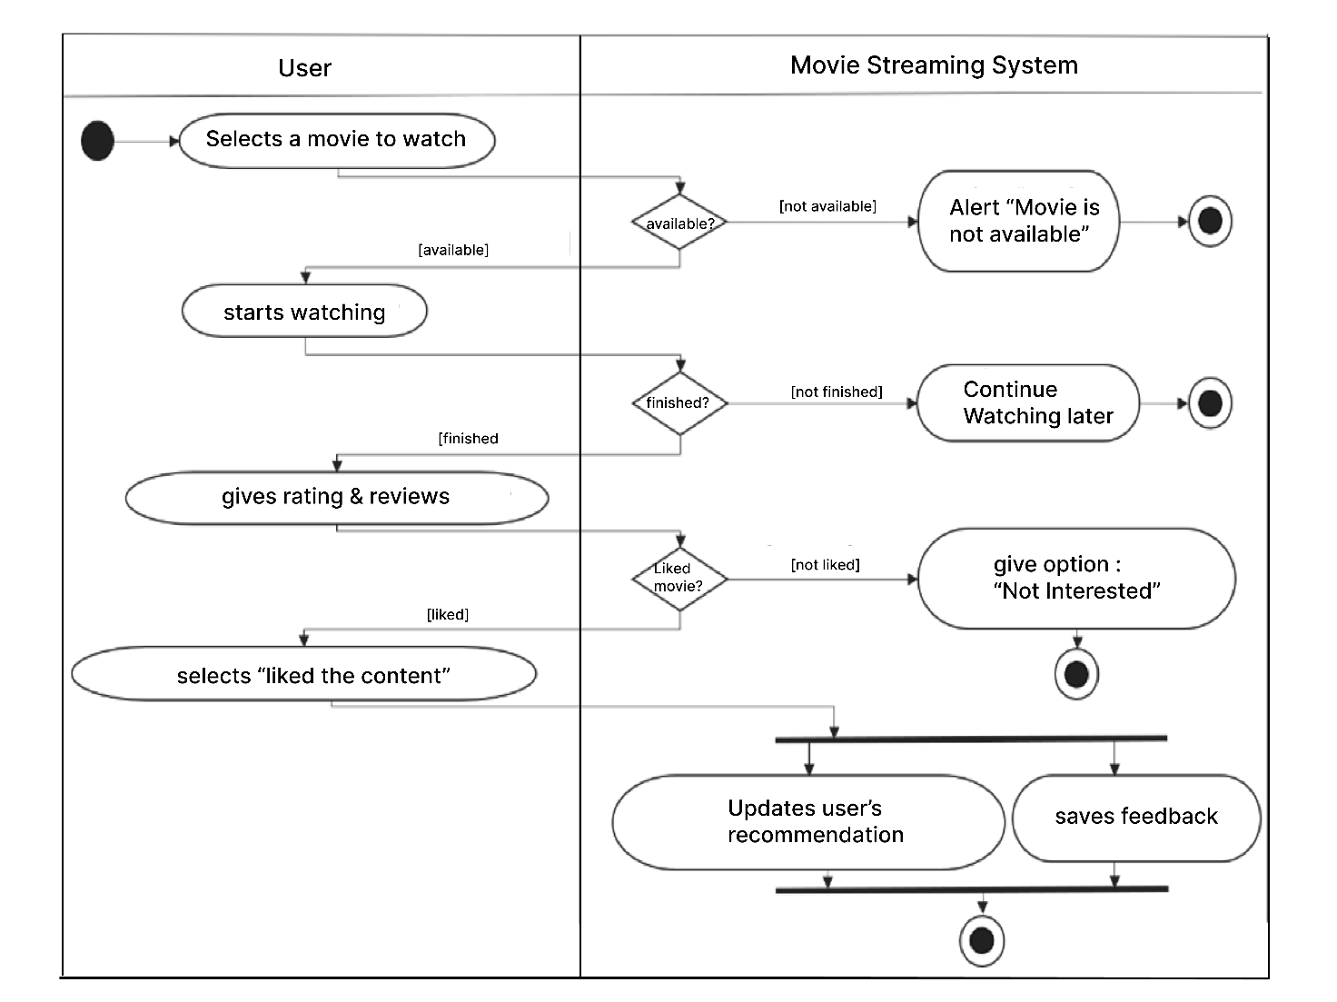

*Figure 2.2‑2 Swimlane diagram for reviewing a movie (User)*

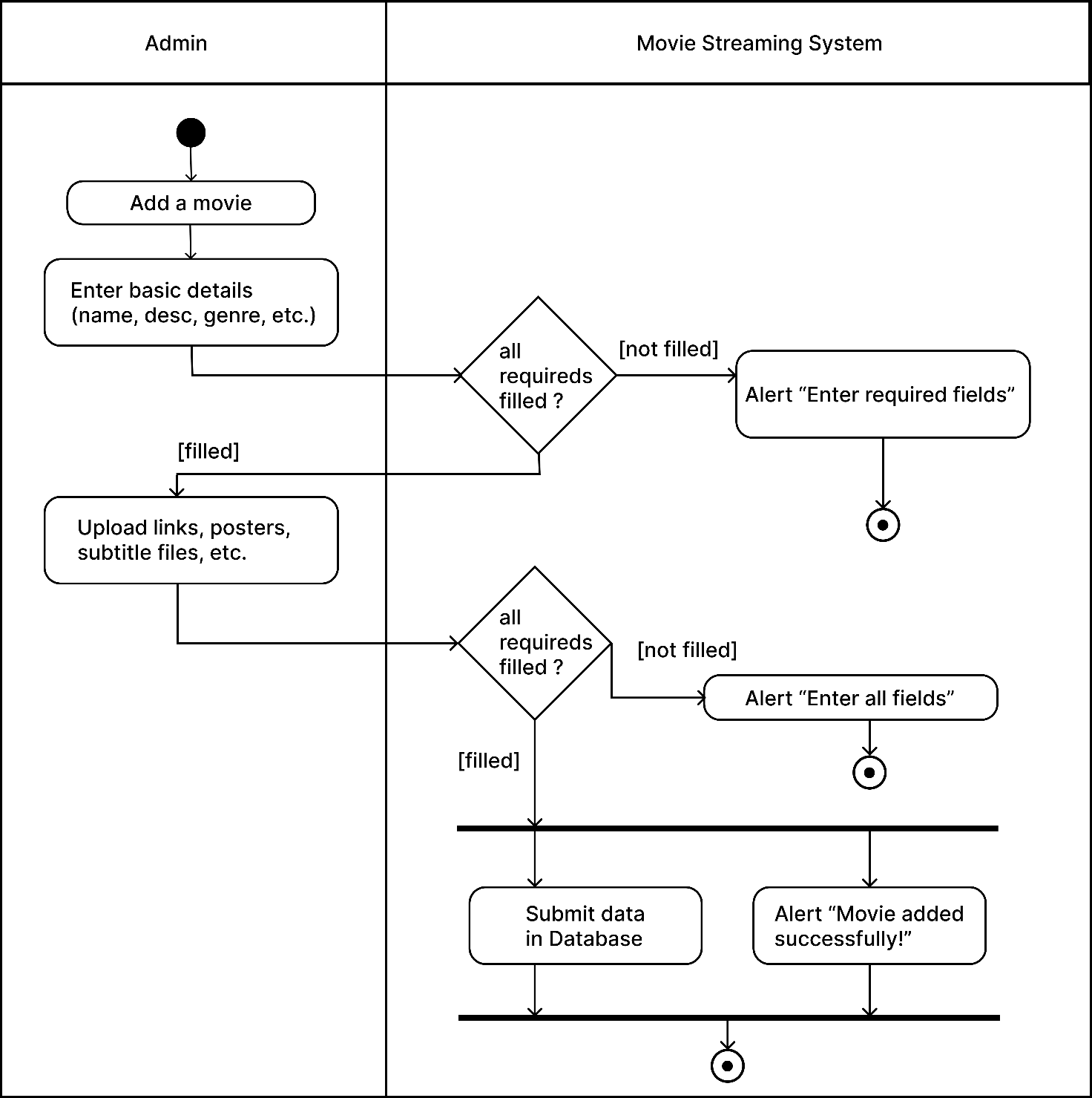

*Figure 2.2‑2 Swimlane diagram for uploading a movie (Admin)*

## Sequence diagram

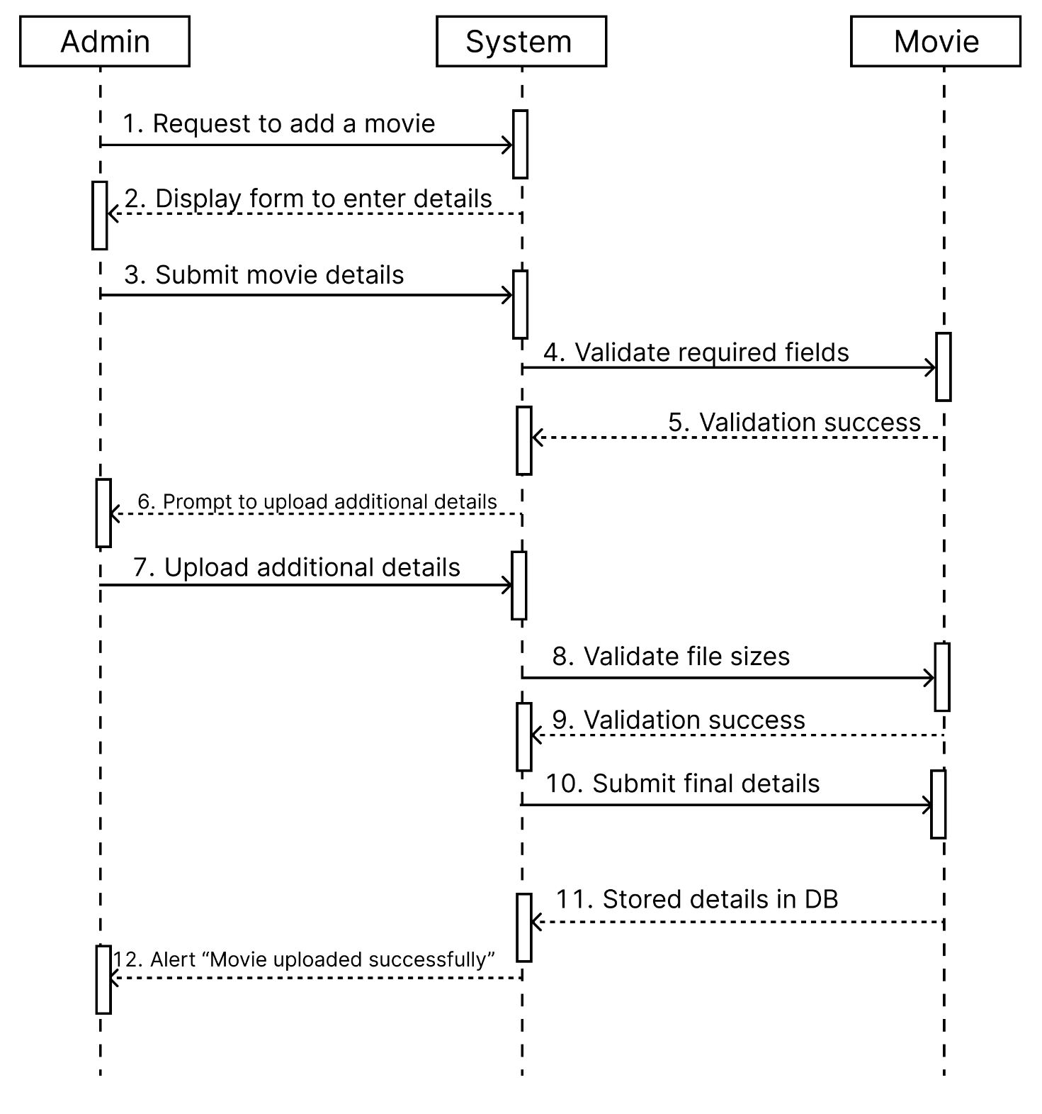

Figure 2.3‑1 Positive Sequence diagram for Uploading a movie

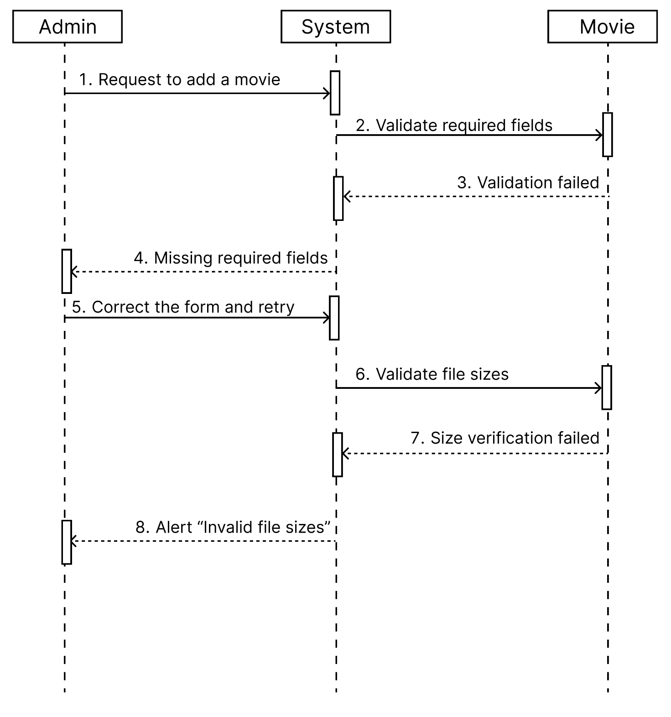

Figure 2.3‑1 Negative Sequence diagram for Uploading a movie

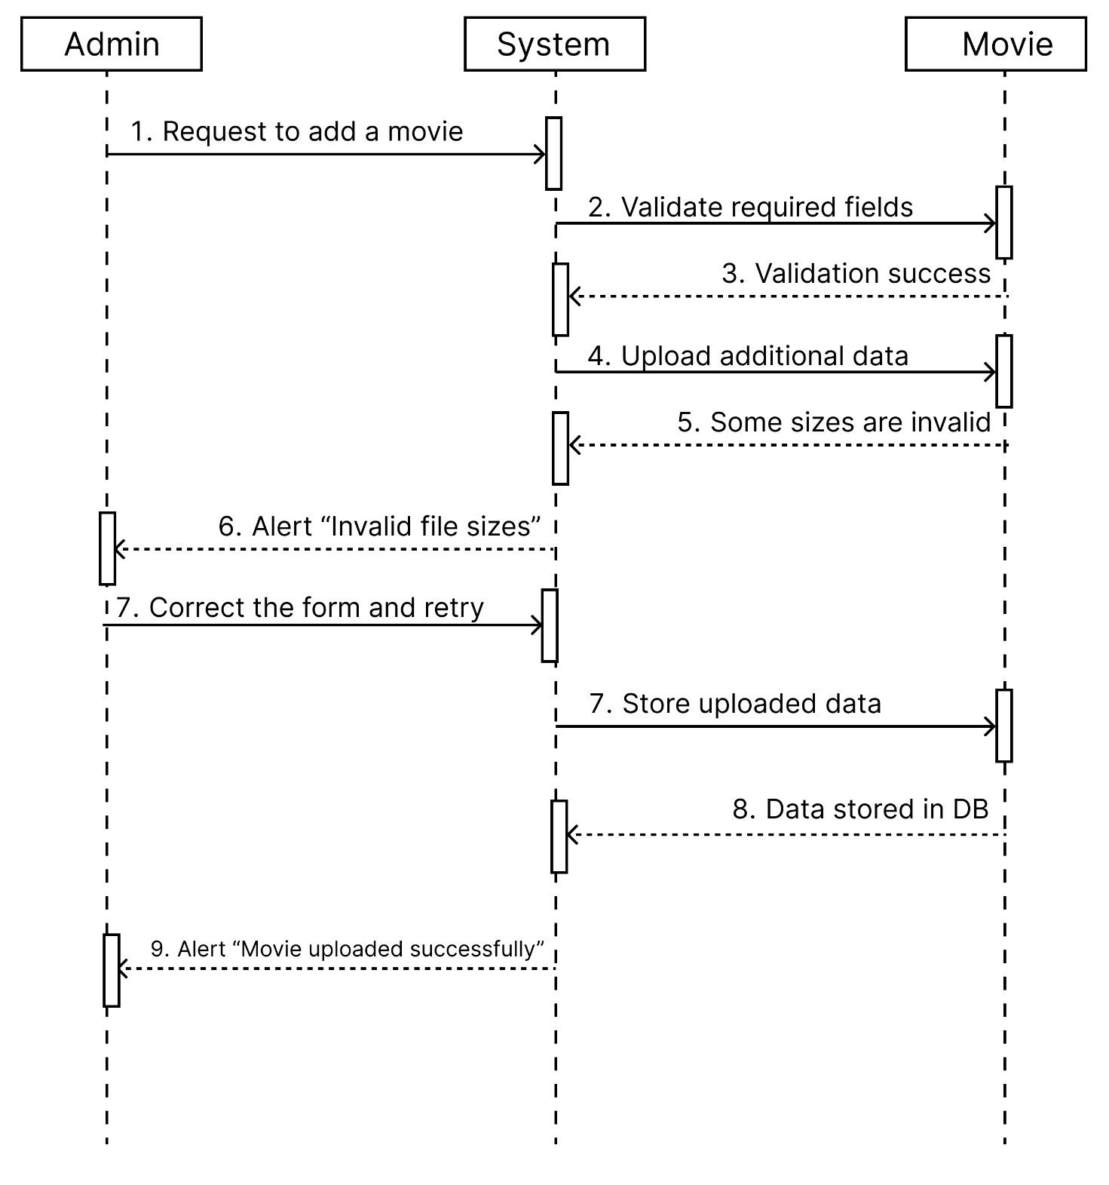

*Figure 2.3‑1 Positive and Negative Sequence diagram for Uploading a movie*

## State diagram

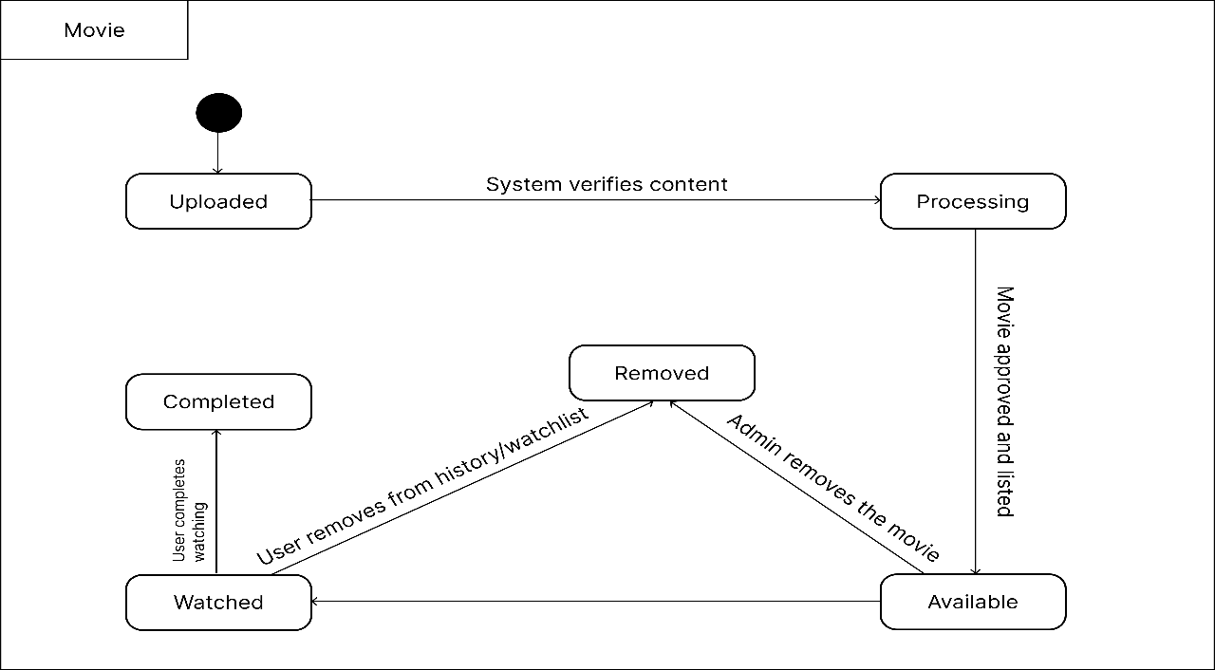

Figure 2.4‑1 State diagram of Movie

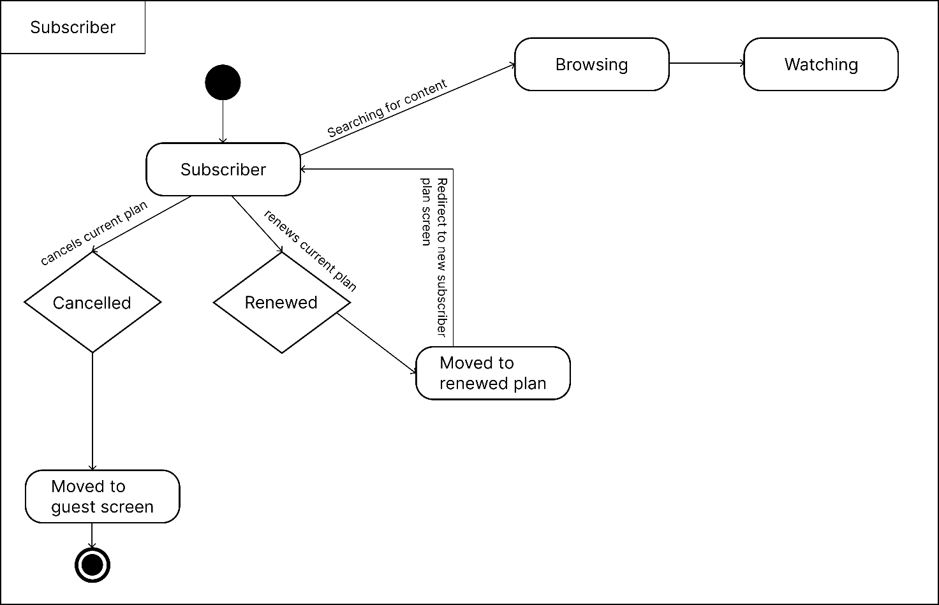

Figure 2.4‑2 State diagram for Subscriber

## Class diagram

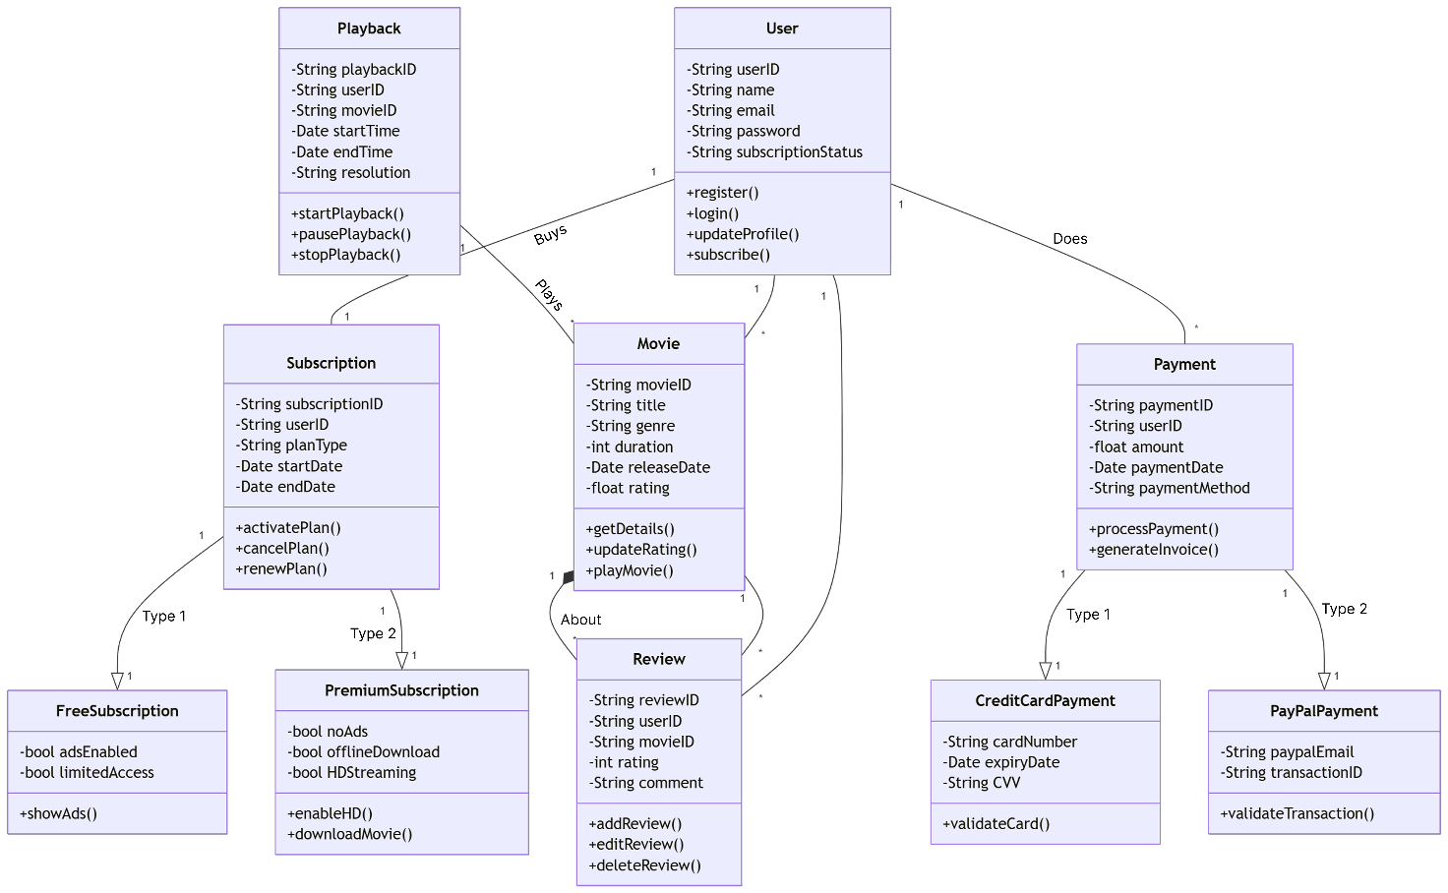

Figure 2.5‑1 Class diagram for Library management system

## Data flow diagram

### Context diagram (level-0)

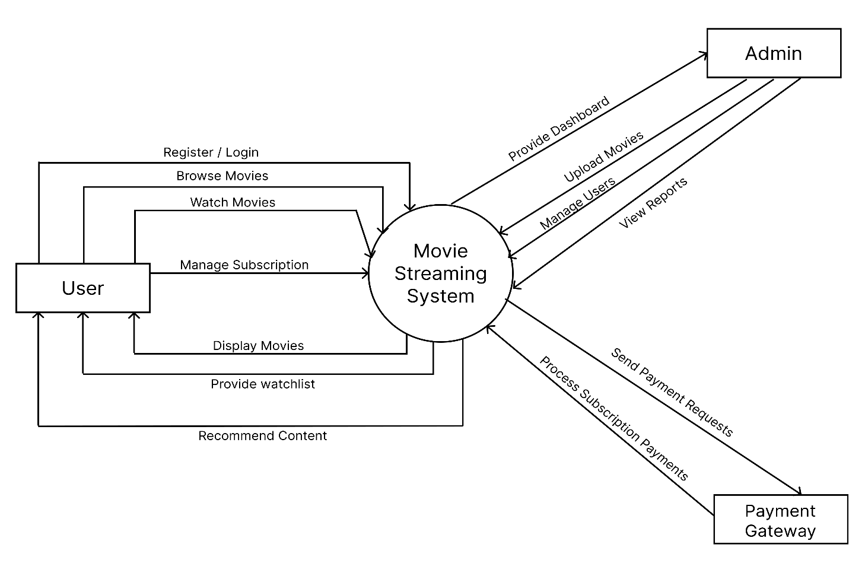

Figure 2.6‑1 Context diagram for Movie Streaming system

### DFD Level-1

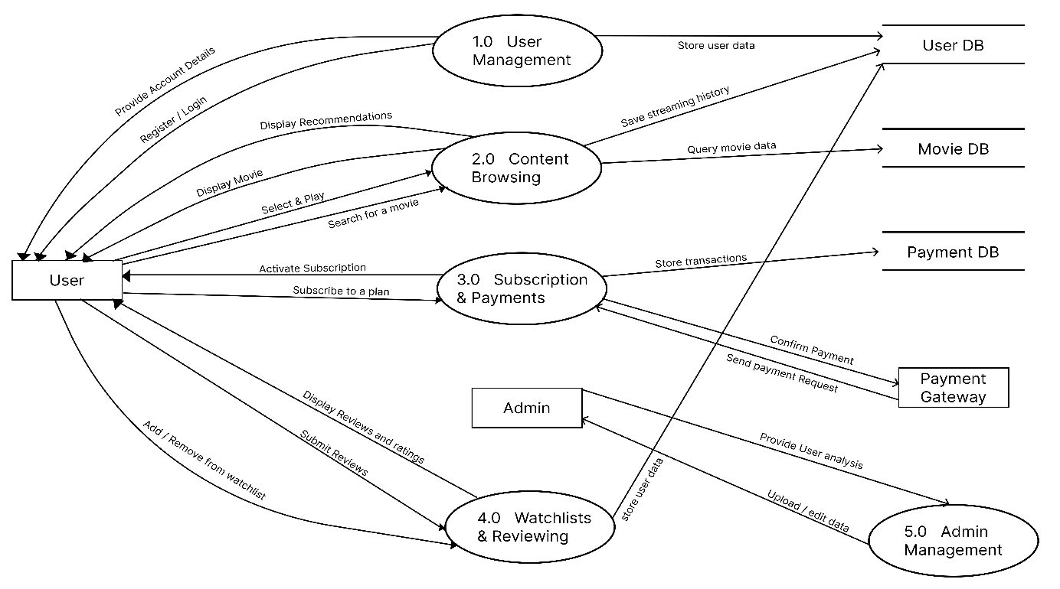

Figure 2.6‑2 DFD level-1 for Movie Streaming system

### DFD Level-2

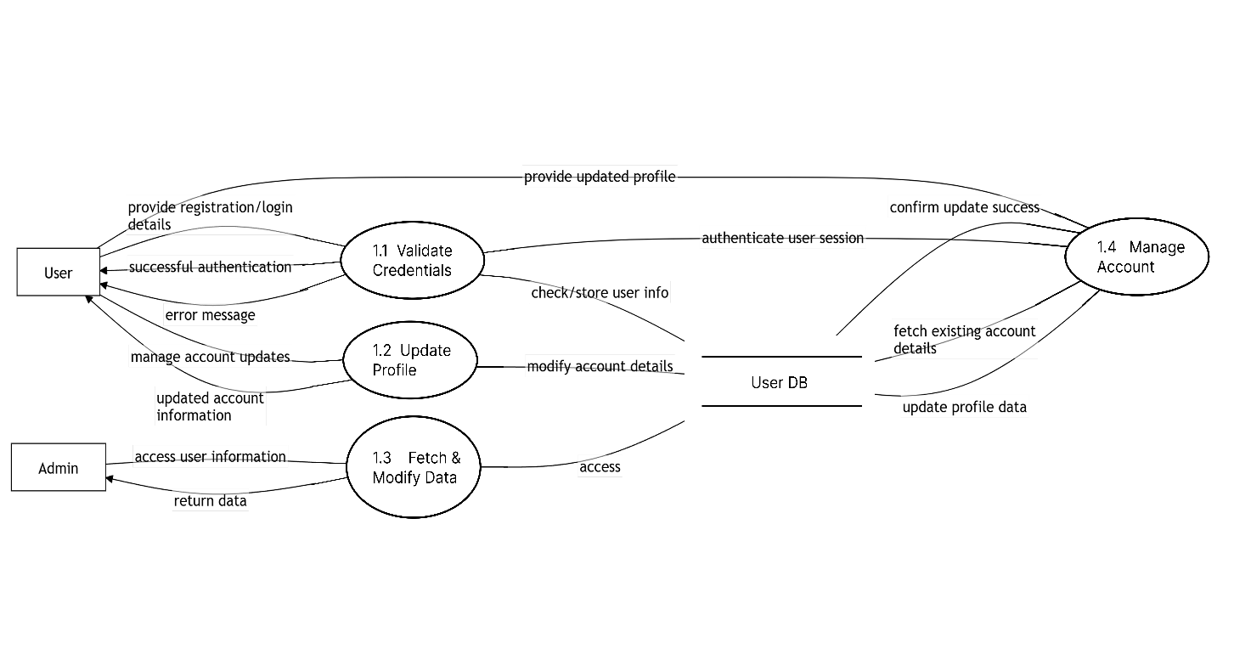

Figure 2.6‑3 DFD level-2 for User processes

# External interface requirement (Screens)

## Screen-1: Movie Upload Form

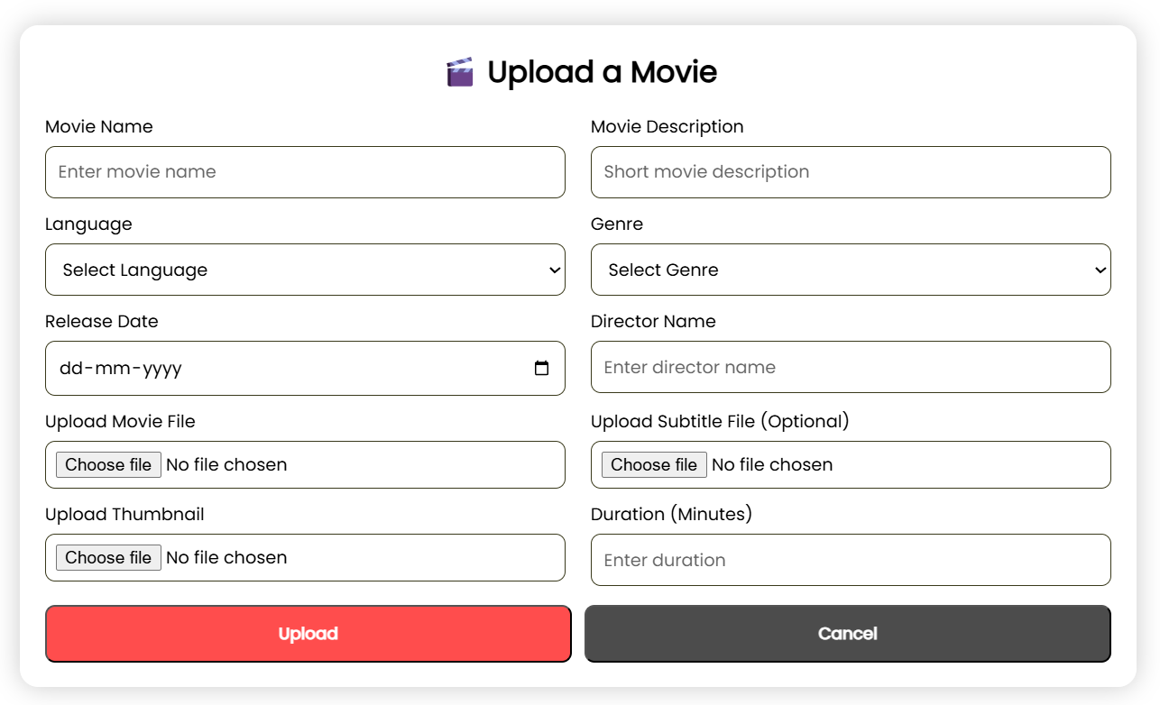

Figure 3.1‑1 Screen-1: Movie upload Form

**Purpose:** This form will allow the Administrator to upload a movie with its detail in database.

Table 3.1‑1 Screen element of Movie upload form

|  |  |  |  |  |  |
| --- | --- | --- | --- | --- | --- |
| Sr. | Screen Element | Input Type | O/M | 1/N | Description |
| 1 | Movie Name | Textbox | M | 1 | Textbox to enter the name of the movie. |
| 2 | Movie Description | Text area | M | 1 | Text area to enter a short description of the movie. |
| 3 | Language | Dropdown | M | 1 | Dropdown to select the language of the movie. |
| 4 | Genre | Dropdown | M | 1 | Dropdown to select the genre of the movie. |
| 5 | Release Date | Date Picker | M | 1 | Allows the user to select the release date (format: dd-mm-yyyy). |
| 6 | Director Name | Textbox | M | 1 | Textbox to enter the name of the movie director. |
| 7 | Upload Movie File | File Upload | M | 1 | File upload field to upload the movie file (e.g., video file). |
| 8 | Upload Subtitle File | File Upload | O | N | Optional file upload field to upload a subtitle file. |
| 9 | Upload Thumbnail | File Upload | M | 1 | File upload field to upload a thumbnail image for the movie. |
| 10 | Duration | Textbox | M | 1 | Textbox to enter the duration of the movie in minutes. |
| 11 | Upload | Button | ----- | ----- | Button to upload the movie details (highlighted in red). |
| 12 | Cancel | Button | ----- | ----- | Button to cancel the upload process (grayed out). |

## Screen-2: Subscribe to a Plan Form

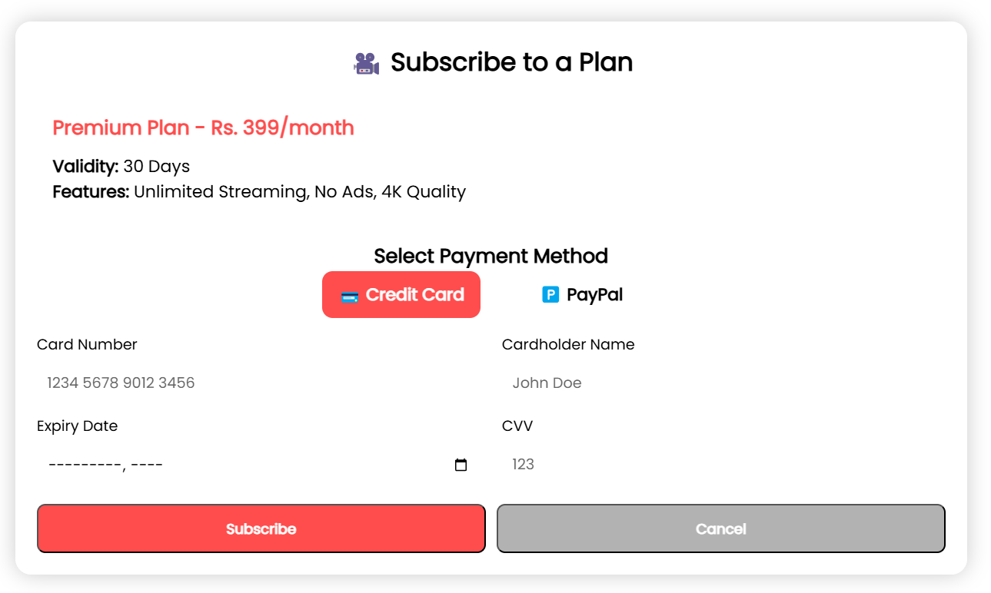

Figure 3.1‑2 Screen-2: Subscribe to a Plan Form

**Purpose:** This form is titled "Subscribe to a Plan" and includes fields for subscribing to a premium plan.

Table 3.1‑2 Screen element of Subscribe to a Plan form

|  |  |  |  |  |  |
| --- | --- | --- | --- | --- | --- |
| Sr. | Screen Element | Input Type | O/M | 1/N | Description |
| 1 | Plan Name | Text | M | 1 | Displays the plan name and price (e.g., "Premium Plan - Rs. 399/month"). |
| 2 | Validity | Text | M | 1 | Displays the validity of the plan (e.g., "30 Days"). |
| 3 | Features | Text | M | 1 | Displays the features of the plan (e.g., "Unlimited Streaming, No Ads"). |
| 4 | Select Payment Method | Button | M | 1 | Buttons to select payment method (e.g., Credit Card, PayPal). |
| 5 | Card Number | Textbox | M | 1 | Textbox to enter the credit card number (e.g., "1234 5678 9012 3456"). |
| 6 | Cardholder Name | Textbox | M | 1 | Textbox to enter the cardholder’s name (e.g., "John Doe"). |
| 7 | Expiry Date | Date Picker | M | 1 | Field to enter the card’s expiry date (format: mm-yyyy). |
| 8 | CVV | Textbox | M | 1 | Textbox to enter the card’s CVV number (e.g., "123"). |
| 9 | Subscribe | Button | ----- | ----- | Button to subscribe to the plan (highlighted in red). |
| 10 | Cancel | Button | ----- | ----- | Button to cancel the subscription process (grayed out). |

## Screen-3: Movie Review Submit Form

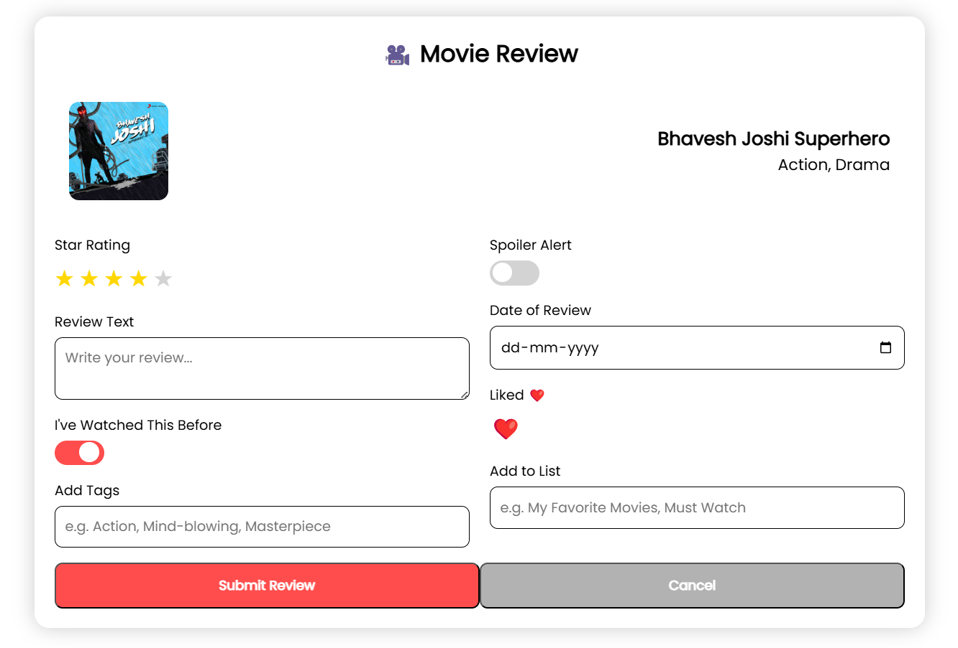

Figure 3.1‑3 Screen-3: Movie review submit form

**Purpose:** This form is titled "Movie Review" and includes fields for reviewing a movie.

*Table 3.1-3 Screen element of Add borrower book*

|  |  |  |  |  |  |
| --- | --- | --- | --- | --- | --- |
| Sr. | Screen Element | Input Type | O/M | 1/N | Description |
| 1 | Star Rating | Star Rating | M | 1 | Allows the user to rate the movie using stars (e.g., 1 to 5 stars). |
| 2 | Spoiler Alert | Toggle Switch | O | N | Toggle to mark the review as containing spoilers (default: off). |
| 3 | Review Text | Text area | M | 1 | Text area for the user to write their review of the movie. |
| 4 | Date of Review | Date Picker | M | 1 | Allows the user to select the date of the review (format: dd-mm-yyyy). |
| 5 | Liked | Button | O | N | Button to mark the movie as liked (heart icon, toggleable). |
| 6 | I’ve Watched This Before | Toggle Switch | O | N | Toggle to indicate if the user has watched the movie before (default: on). |
| 7 | Add Tags | Textbox | O | N | Textbox to add tags for the movie (e.g., "Action, Mind-blowing"). |
| 8 | Add to List | Textbox | O | N | Textbox to add the movie to a list (e.g., "My Favourite Movies"). |
| 9 | Submit Review | Button | ----- | ----- | Button to submit the movie review (highlighted in red). |
| 10 | Cancel | Button | ----- | ----- | Button to cancel the review submission (grayed out). |

# Database design

## List of Tables

* Movie
* User
* Review
* Subscription
* Payment

Table 4.1‑1 Table: Movie

|  |  |  |  |  |
| --- | --- | --- | --- | --- |
| Column | Data Type | Null | Keys & Constrains | Default Value & Description |
| MovieID | Varchar(50) | NN | PK (Auto Increment) |  |
| Title | Varchar(100) | NN |  |  |
| Genre | Varchar(100) | AN |  |  |
| Duration | Int | AN |  |  |
| ReleaseDate | Date | AN |  |  |

Table 4.1‑2 Table: User

|  |  |  |  |  |
| --- | --- | --- | --- | --- |
| Column | Data Type | Null | Keys & Constrains | Default Value Description |
| UserID | Varchar(50) | NN | PK (Auto Increment) |  |
| Name | Varchar(100) | NN |  |  |
| Email | Varchar(100) | AN | Unique |  |
| Password | Varchar(255) | AN |  |  |
| SubscriptionStatus | Varchar(50) | AN |  |  |

Table 4.1‑3 Table: Review

|  |  |  |  |  |
| --- | --- | --- | --- | --- |
| Column | Data Type | Null | Keys & Constrains | Default Value & Description |
| ReviewID | Varchar(50) | NN | PK (Auto Increment) |  |
| UserID | Varchar(50) | NN | Foreign Key (User) | Reference to User Table |
| MovieID | Varchar(50) | NN | Foreign Key (Movie) | Reference to Movie Table |
| Rating | Int | NN | Check (1 to 5) | 3 |
| Comment | Text | AN |  |  |

Table 4.1‑4 Table: Subscription

|  |  |  |  |  |
| --- | --- | --- | --- | --- |
| Column | Data Type | Null | Keys & Constrains | Default Value & Description |
| SubscriptionID | Varchar(50) | NN | PK (Auto Increment) |  |
| UserID | Varchar(50) | NN | Foreign Key (User) | Reference to User Table |
| PlanType | Varchar(50) | NN |  | Free |
| StartDate | DateTime | NN |  | CURRENT_DATE() |
| EndDate | DateTime | NN |  | NULL |

*Table 4.1‑4 Table: Payment*

|  |  |  |  |  |
| --- | --- | --- | --- | --- |
| Column | Data Type | Null | Keys & Constrains | Default Value & Description |
| PaymentID | Varchar(50) | NN | PK (Auto Increment) |  |
| UserID | Varchar(50) | NN | Foreign Key (User) | Reference to User Table |
| Amount | Decimal(8,2) | NN |  | 0.0 |
| PaymentDate | DateTime | NN |  | CURRENT_DATE() |
| PaymentMethod | Varchar(50) | NN |  | CreditCard |

# References

* <https://getbootstrap.com/docs/5.0/getting-started/introduction/>
* <https://developer.themoviedb.org/reference/intro/getting-started>
* <https://www.freecodecamp.org/news/how-to-build-a-full-stack-movie-app-with-react-express-and-mongodb/>
* <https://www.movieofthenight.com/about/api>