**Practical 1 : Introduction of “Phantom – Movie Streaming Website”**

**Abstract**

Phantom is a next-generation OTT streaming platform that reimagines entertainment with a vast collection of movies, TV shows, and exclusive content. Designed for convenience, it provides seamless streaming across multiple devices with features like watchlists, viewing history, and personalized recommendations.

The platform ensures a secure and enjoyable experience with encrypted user data, safe payment options, and multi-language support. Accessibility features such as subtitles and adaptive streaming cater to diverse user needs, enhancing engagement for a global audience.

With a focus on performance, scalability, and user-centric design, Phantom sets a benchmark in the OTT industry. It combines innovative functionality and cutting-edge technology to deliver an immersive, reliable, and inclusive entertainment experience.

**Introduction**

Phantom is a movie streaming OTT platform designed to redefine entertainment with a vast library spanning genres, languages, and categories. It offers everything from classic hits to the latest blockbusters and exclusive originals, all accessible through a user-friendly interface. With adaptive video quality, multi-device compatibility, and personalized features like watchlists and curated recommendations, Phantom ensures a seamless and immersive viewing experience.

Beyond streaming, Phantom prioritizes security and inclusivity with features like secure payment gateways, subtitles, and multi-language support. Combining innovation and functionality, it delivers a premium cinematic experience for a global audience.

**Product Features**

There are 3 different user types for Phantom:

**1. Administrator**

The administrator manages the platform and ensures smooth operation with features like:

* Managing user accounts, including registration and subscription plans.
* Uploading, editing, and organizing content in the library.
* Monitoring streaming analytics and user engagement through dashboards.
* Managing secure payment gateways and processing transactions.
* Generating reports on subscriptions, viewership trends, and revenue.
* Customizing platform settings, including accessibility features like subtitles and multi-language support.
* Sending notifications and announcements to users.

**2. Subscriber**

Subscribers are registered users with access to Phantom's features:

* Browsing and searching through an extensive content library.
* Creating a personalized watchlist for future viewing.
* Resuming playback from where they left off.
* Receiving AI-driven content recommendations based on their viewing history.
* Viewing movies and shows on multiple devices with adaptive video quality.
* Providing ratings and reviews for content.
* Managing subscription plans and payment details securely.

**3. Guest**

Guests are unregistered users exploring the platform with limited access:

* Browsing available content categories and previews.
* Viewing subscription plans and benefits.
* Requesting a subscription by registering for an account.

**Functional Requirements**

**Administrator**

* Content Management: Add, edit, and delete movies, shows, and other content in the library.
* User Management: Register new users, manage subscriptions, and maintain user records.
* Analytics Dashboard: Access reports on user engagement, viewership trends, and revenue.
* Notification System: Send alerts and updates to users.
* Security Management: Ensure secure transactions through payment gateways and data encryption.
* Accessibility Settings: Configure multi-language support, subtitles, and closed captions.
* Recommendation System Management: Oversee and update AI-driven content recommendations.

**Subscriber**

* Authentication: Log in securely with a unique username and password.
* Content Discovery: Search for content using filters like genre, language, and release date.
* Watchlist Management: Add or remove content from a personalized watchlist.
* Playback Control: Resume playback from where it was paused.
* Feedback Mechanism: Rate and review content for others to see.
* Subscription Management: Update payment details and switch subscription plans.

**Guest**

* Browsing: View content previews and explore available categories.
* Subscription Request: Register for a subscription to access premium features.

**Non - Functional Requirements**

* **Usability**: The interface should be intuitive and easy to navigate, supporting multiple languages.
* **Performance**: The system should load within two seconds and adapt video quality seamlessly based on internet speed.
* **Scalability**: The platform should handle increased traffic and accommodate a growing user base.
* **Reliability**: Ensure 99.9% uptime and minimal disruptions in service.
* **Security**: Implement robust encryption for data and transactions.
* **Accessibility**: Provide features like subtitles, multi-language support, and compatibility with assistive devices.
* **Maintainability**: Updates and feature additions should be easy to implement without disrupting the service.
* **Portability**: The platform must be accessible on various devices, including smartphones, tablets, and smart TVs.

**Practical 2 : Use-Case Diagram**

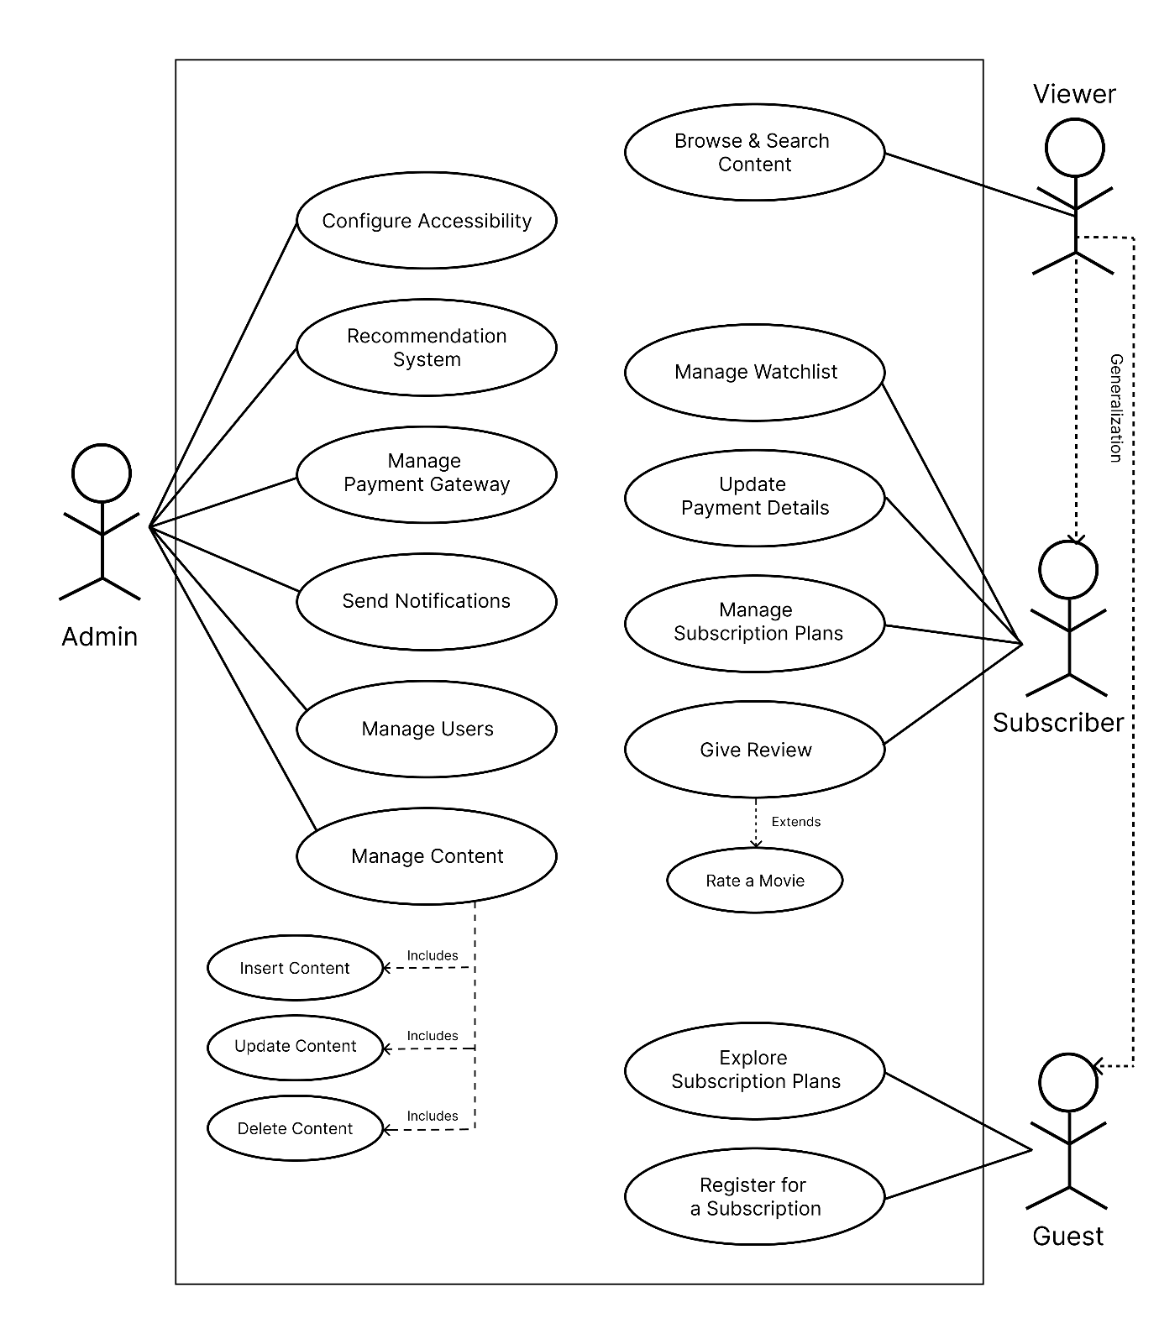

**Use – Case Diagram of Movie Streaming OTT Platform**

**Practical 3 [A] : Activity Diagrams**

* 1. **User Activity Diagram (Reviewing any content)**

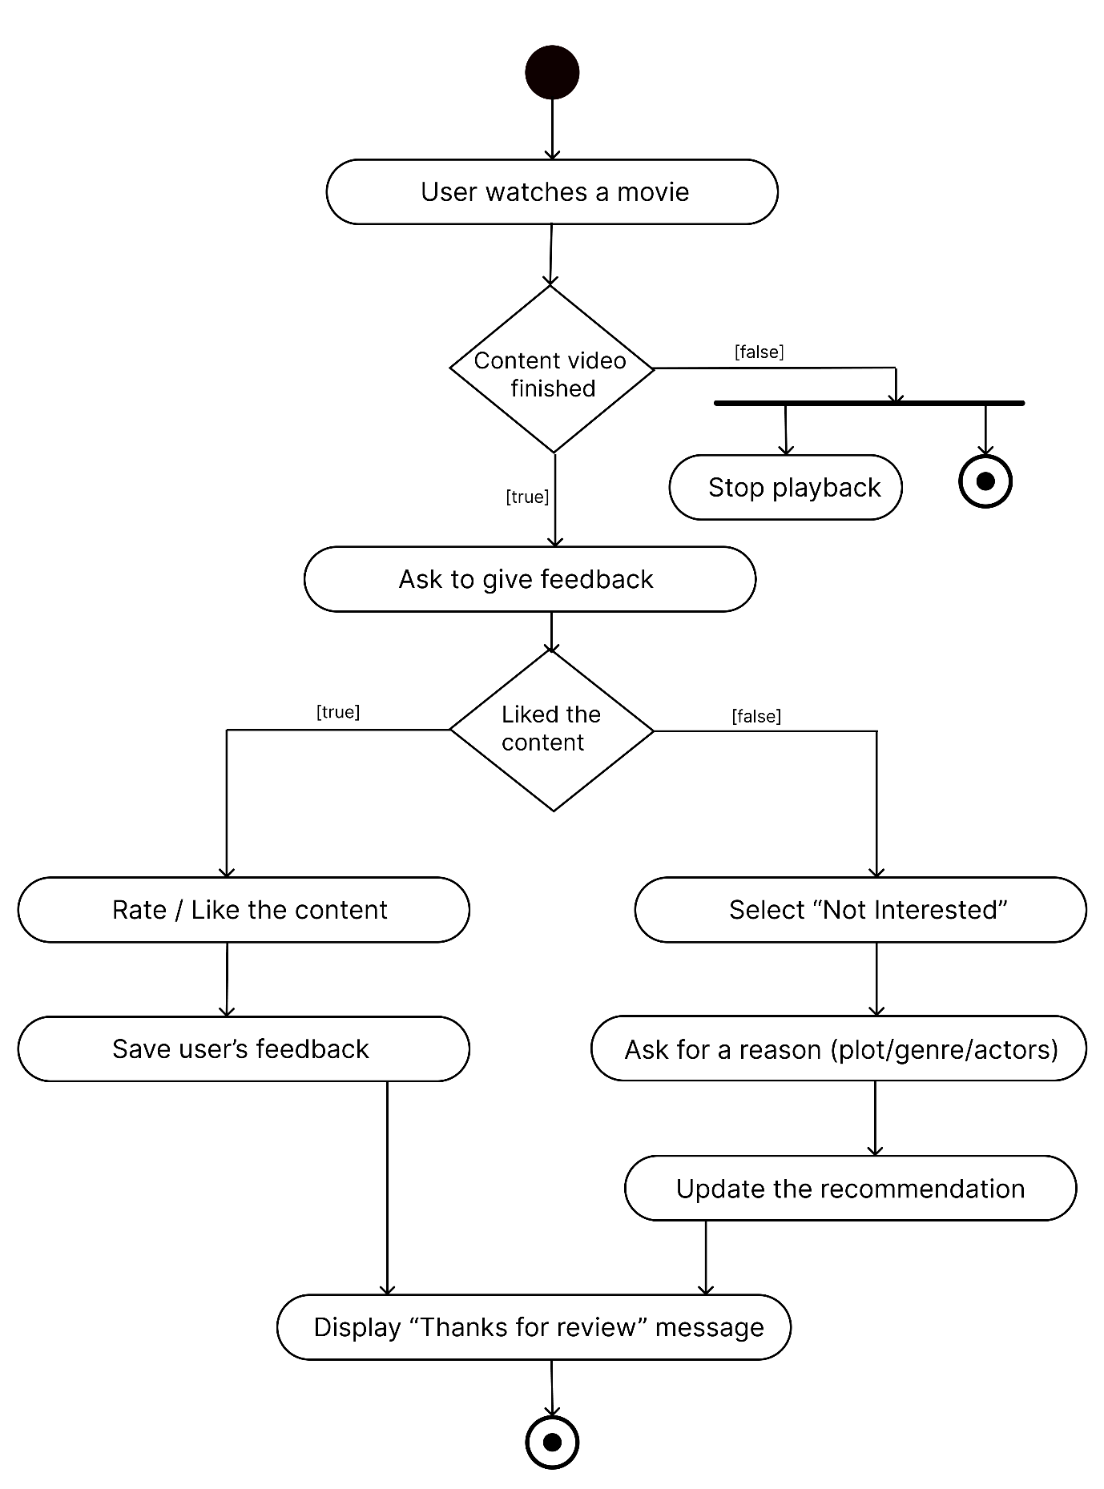

* 1. **Admin Activity Diagram (Uploading a movie to database)**

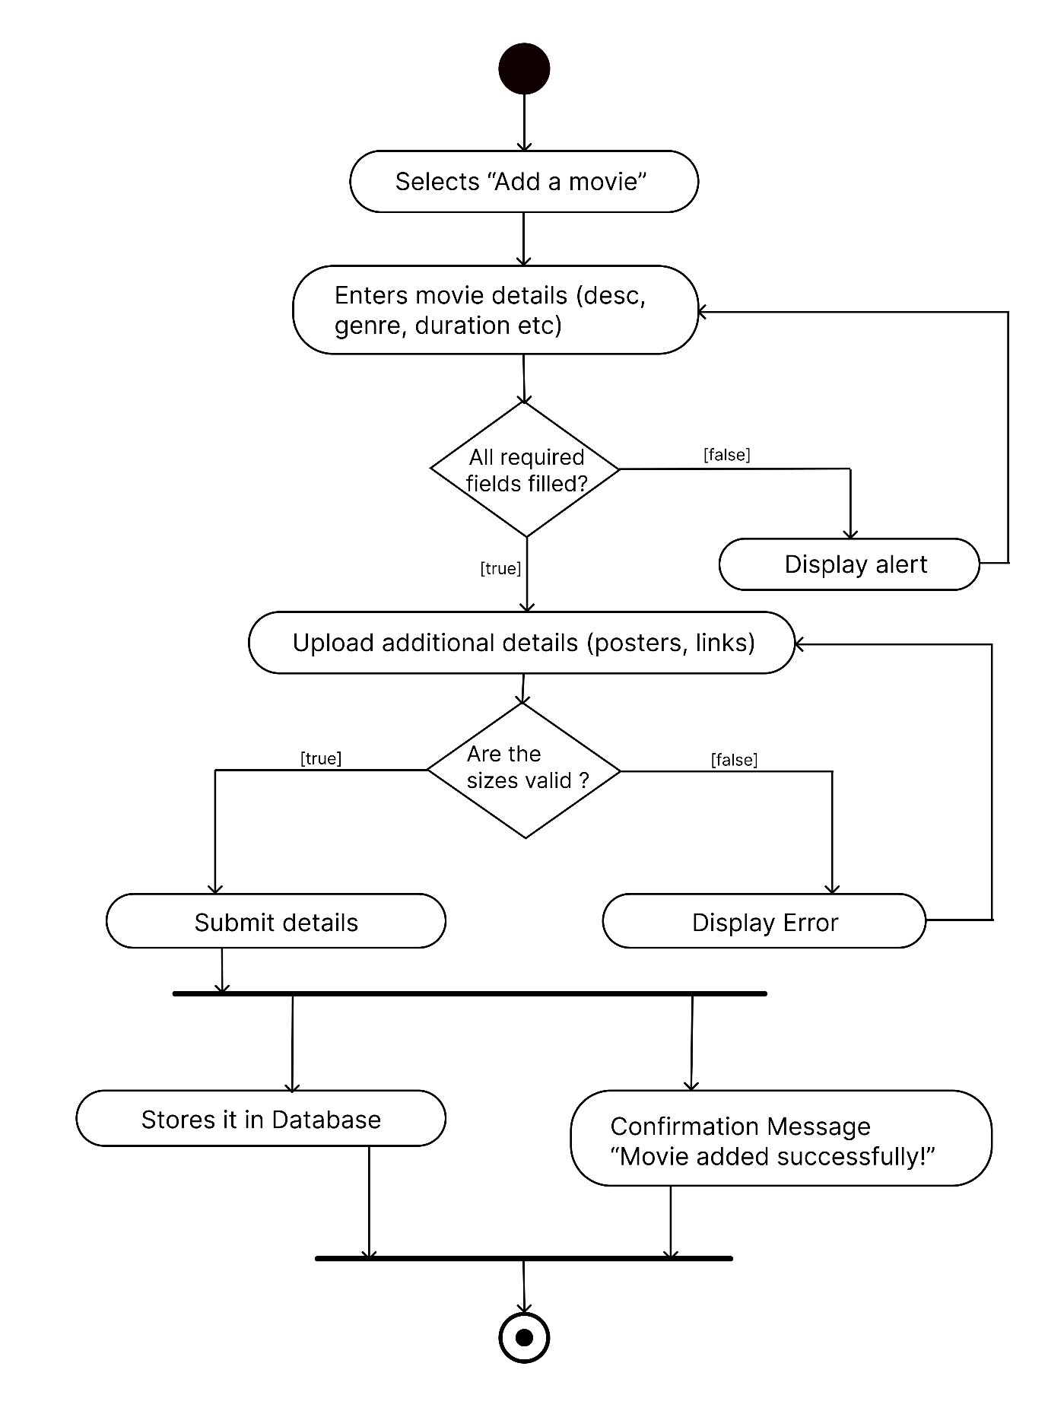

**Practical 3 [B] : Swimlane Diagrams**

* 1. **User Swimlane Diagram (Reviewing any content)**

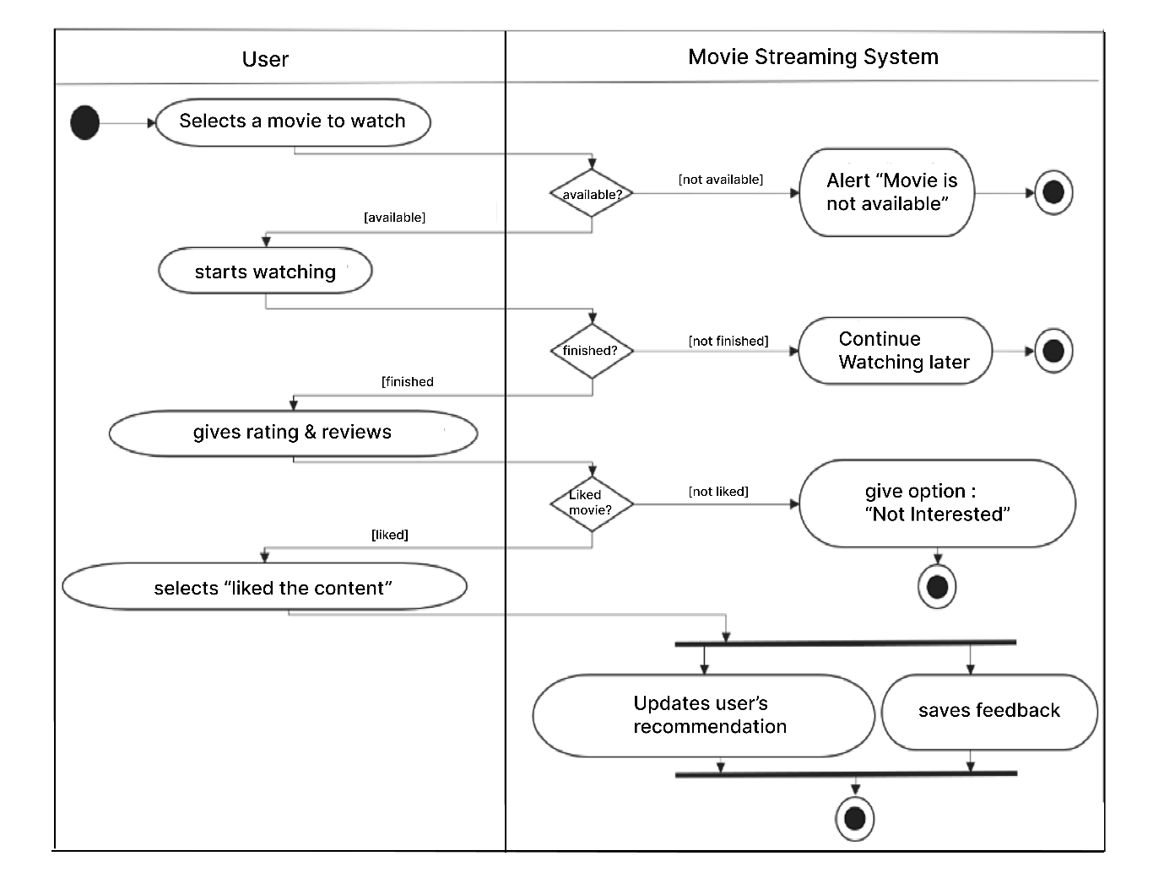

* 1. **Admin Swimlane Diagram (Adding a movie)**

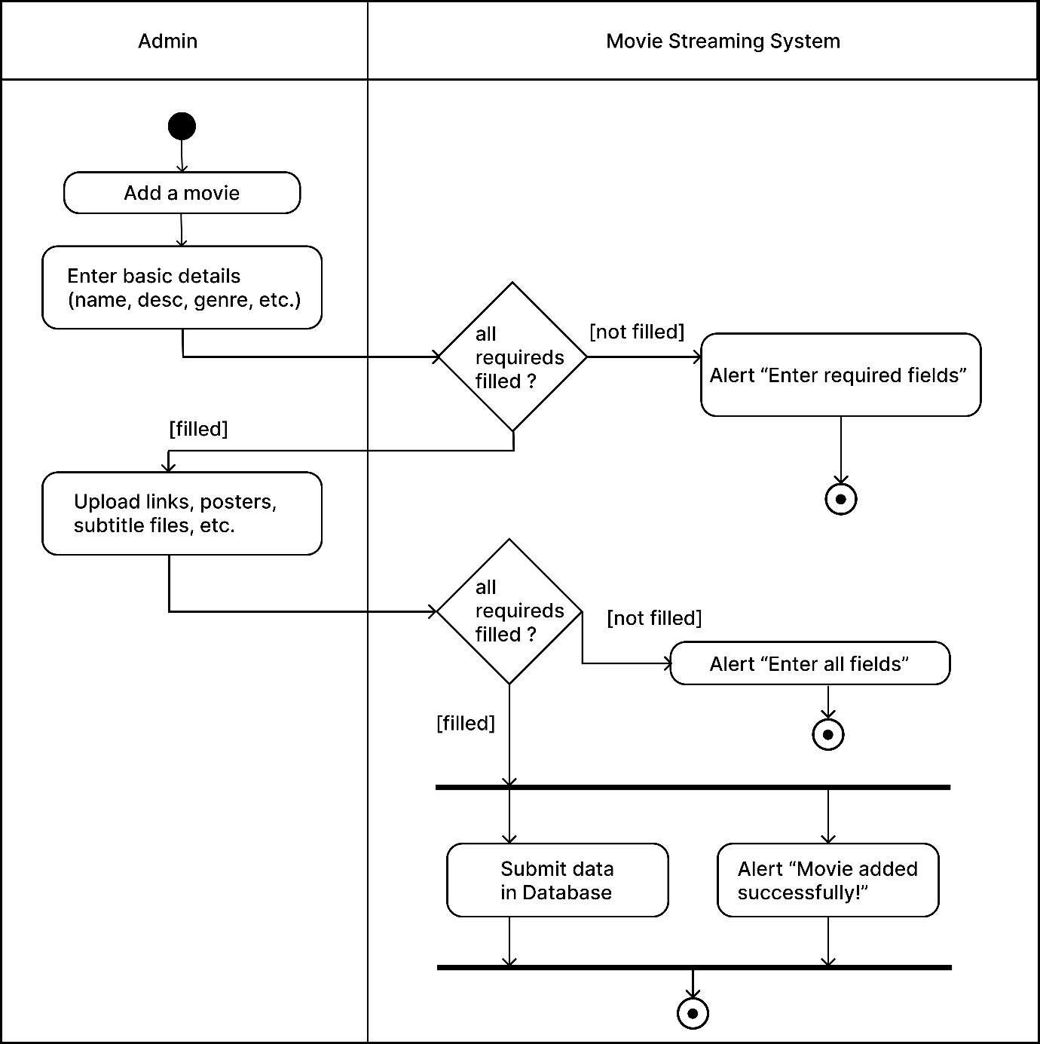

**Practical 4 : Sequence Diagrams**

**[A] : Positive Sequence Diagram for “Admin uploading a movie”**

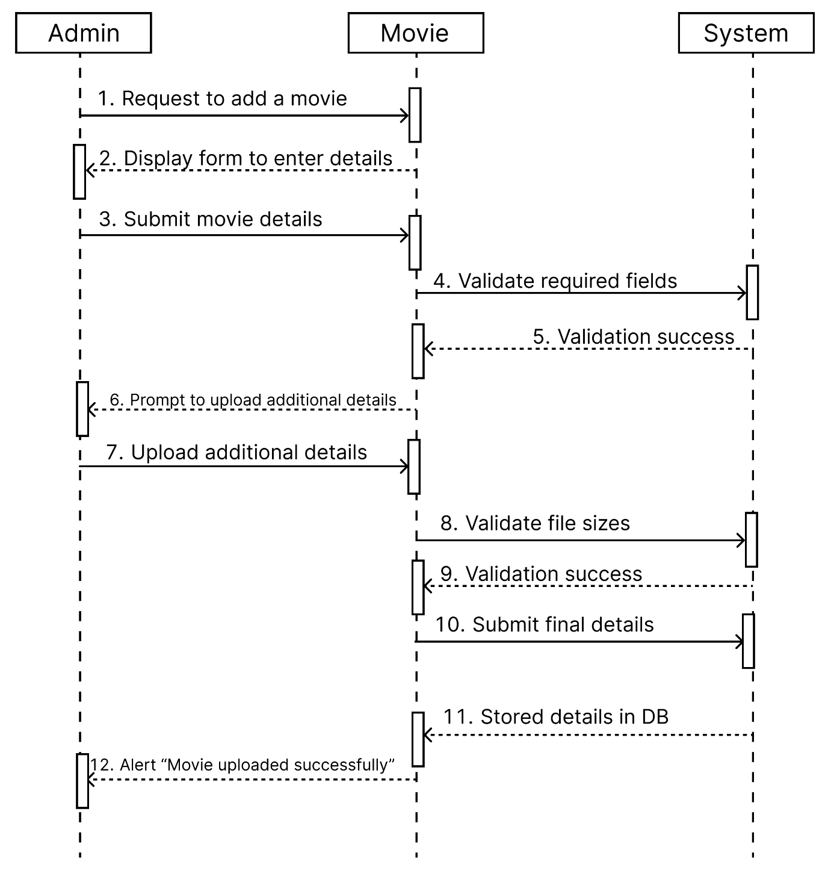

**[B]: Negative Sequence Diagram for “Admin uploading a movie”**

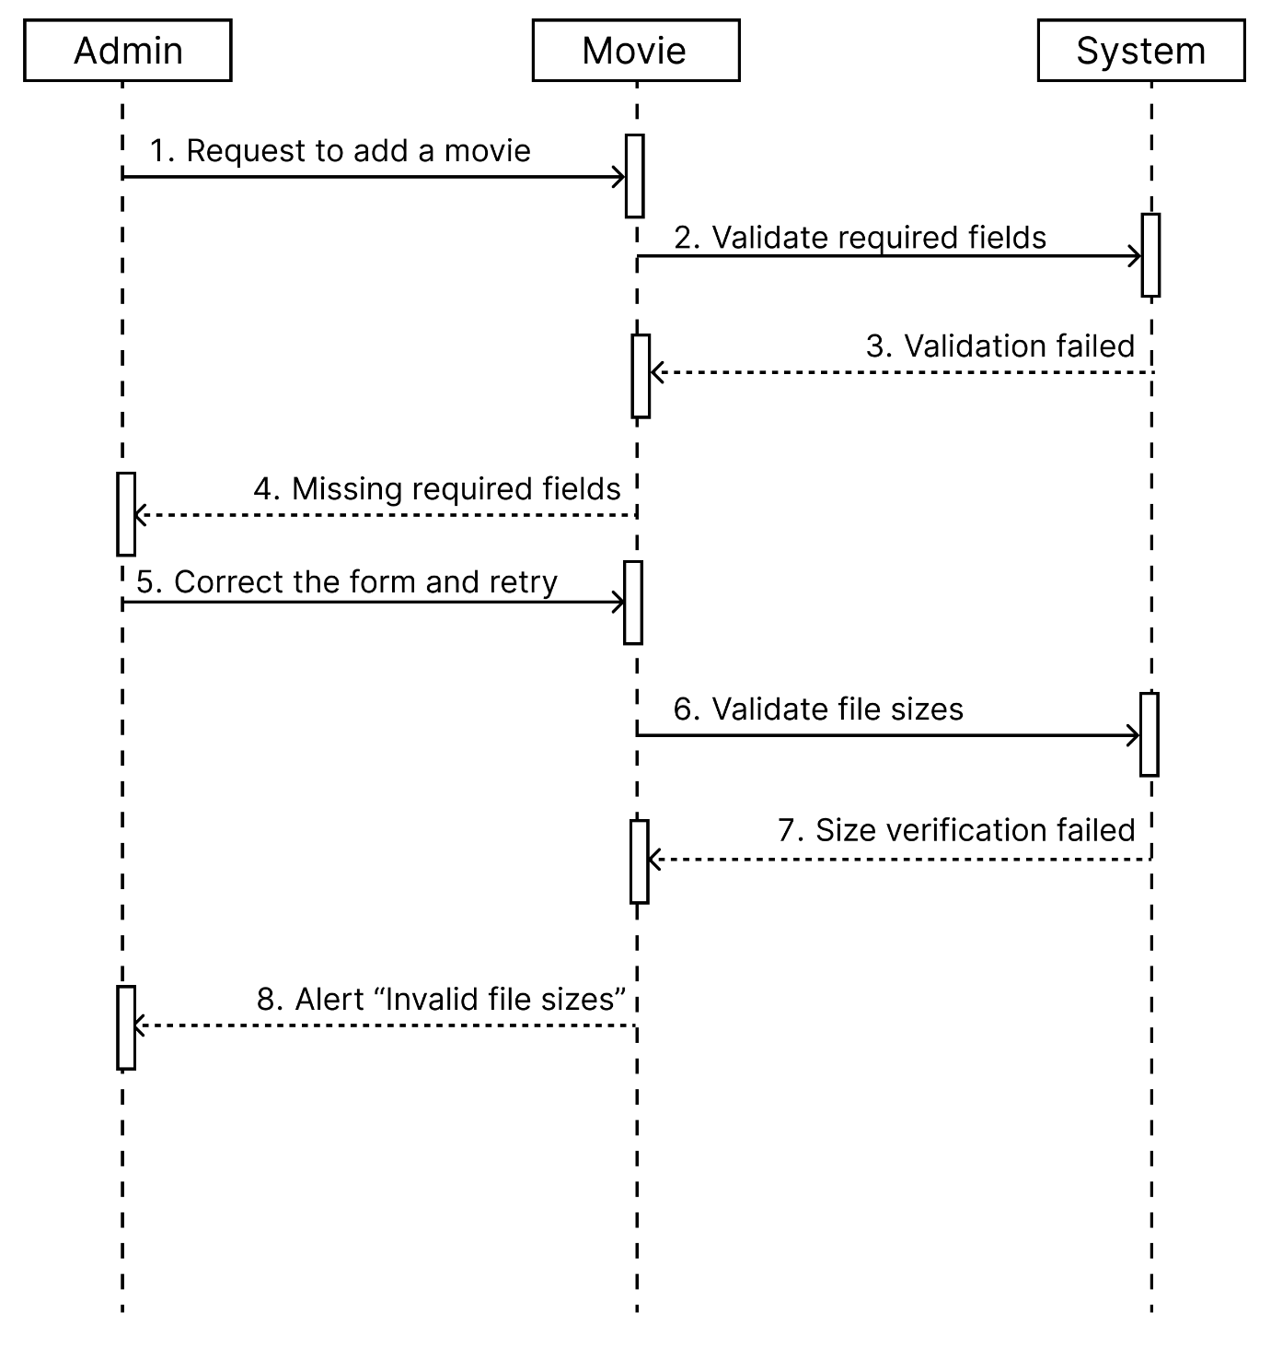

**[C] : Positive + Negative Sequence Diagram for “Admin uploading a movie”**

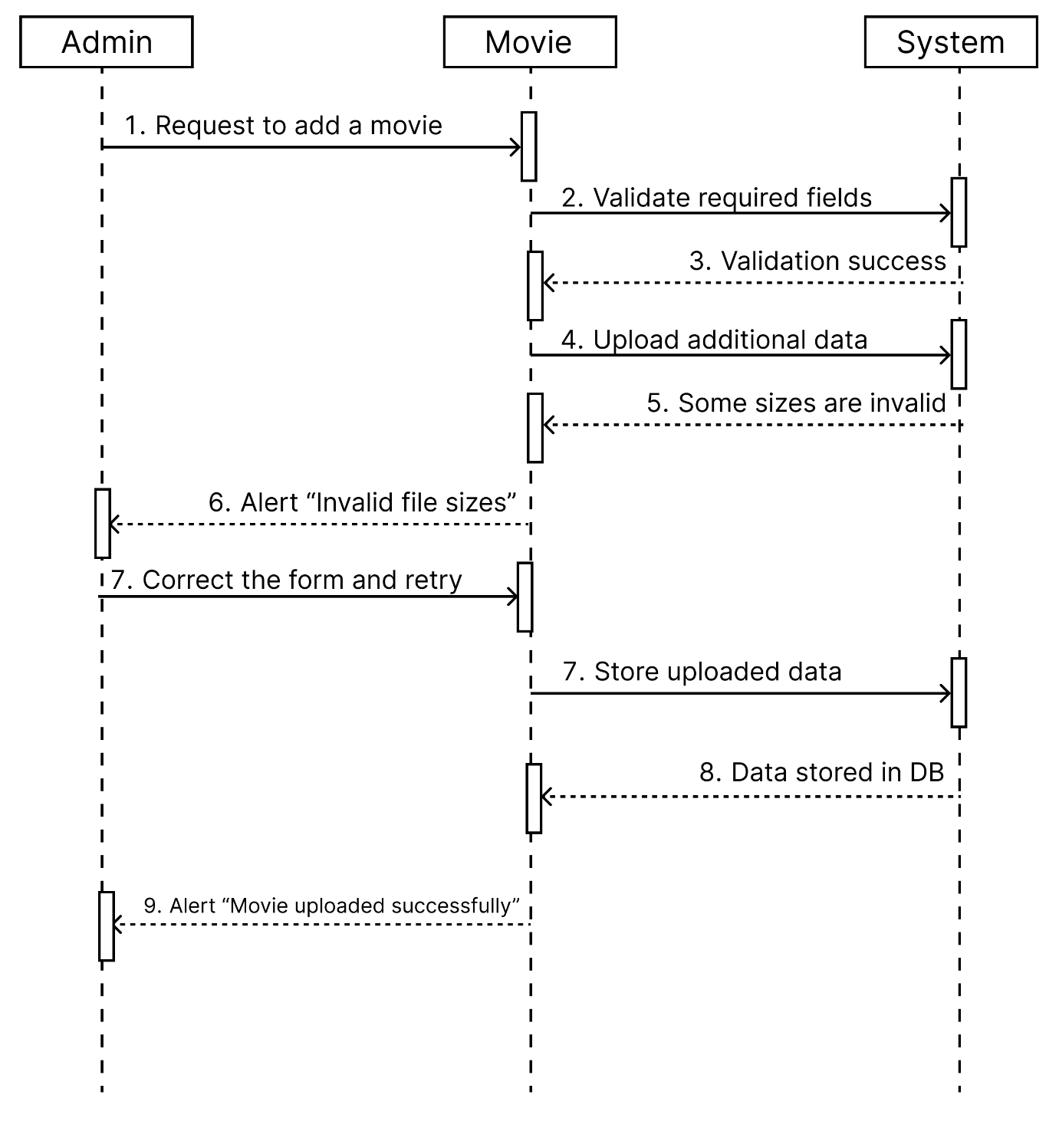

**Practical 5 : State Diagrams**

**[A] : State Diagram for MOVIE**

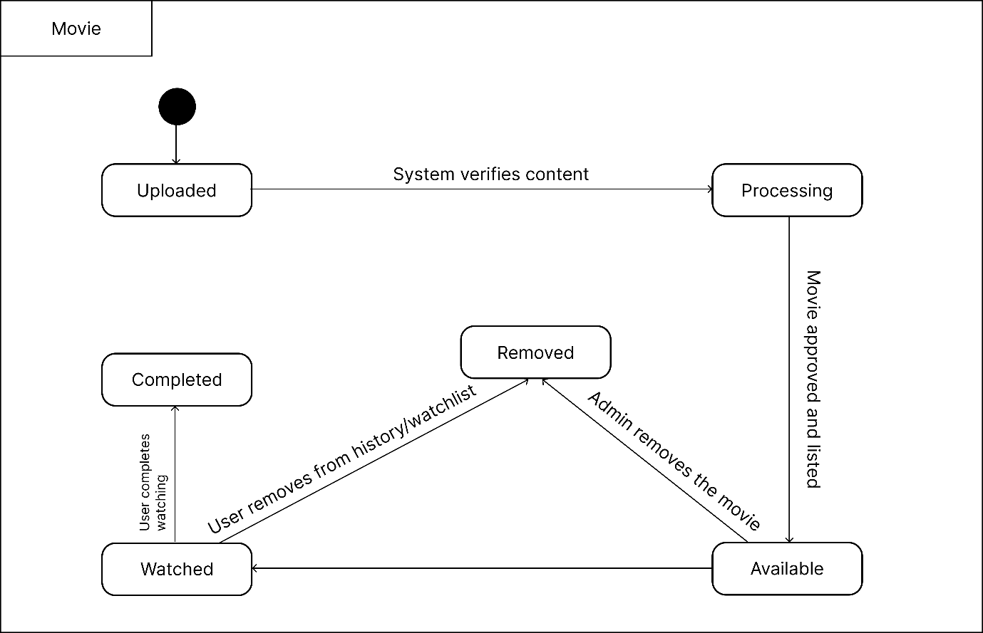

**[B] : State diagram for SUBSCRIBER**

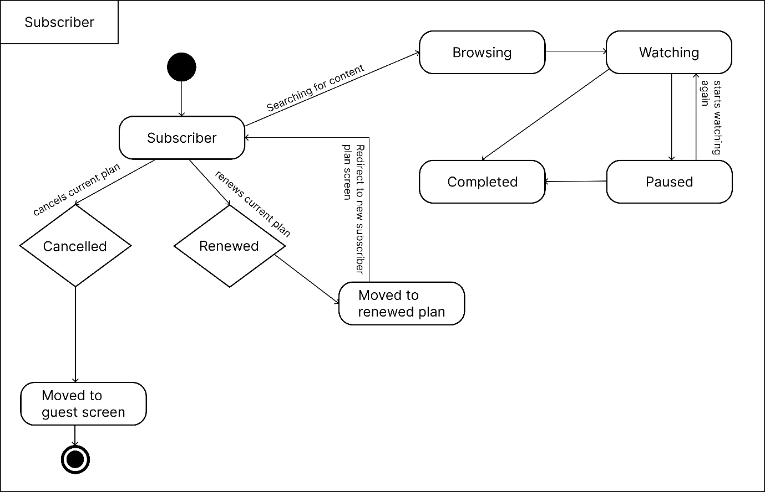

**Practical 6 : Class Diagram**

**[A] : Class Diagram for Movie streaming system**

