**How to Execute:**

**supported Browser:** Chrome and Firefox

**Mode:** regular and headless

**Steps:**

1) Copy ebay folder to local machine

2) open command prompt

3) Go to eBay Directory

**There are four ways to run program**

**1)Chrome normal mode**

command: mvn test -DBrowserName=chrome



**2) chrome with headless mode**

command: mvn test -DBrowserName=chrome -DHeadless=headless

**3)Firefox normal mode**

command: mvn test -DBrowserName=firefox

**4) firefox with headless mode**

command: mvn test -DBrowserName=firefox -DHeadless=headless

**Below screenshot show test executed to check views for 10 watches. Final report will look similar to this but with 250 watches. Highest viewed watches will be maximum 5.**

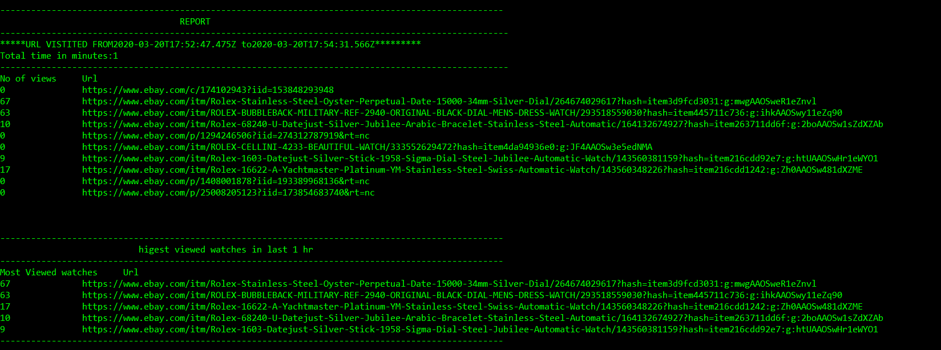

**Ran to check view for 250 watches:**

