**Talend Job deployment Steps**

**Note:** Java 8 should be installed on Server Machine

**Copy all these Folder at path “D:\DRC\Talend\BankReconciliationJob” on Server Machine**

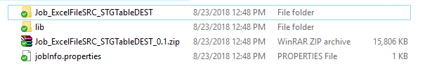

**Folder Structure for Bank File**

D:\DRC\Talend\Files\BankReconciliationETL

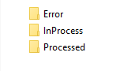

**To Run Job Manually:**

Keep the Bank Excel File in **“D:\DRC\Talend\Files\BankReconciliationETL”** path and double click on .bat file to run the Job.

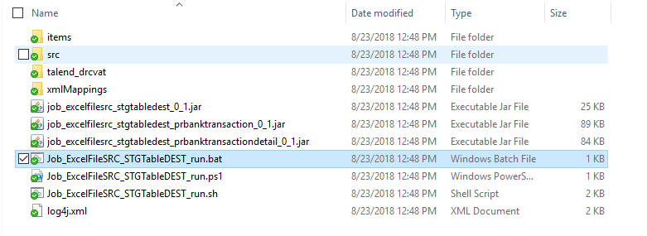

**Steps for Scheduling Jobs**

**Create Basic Task**

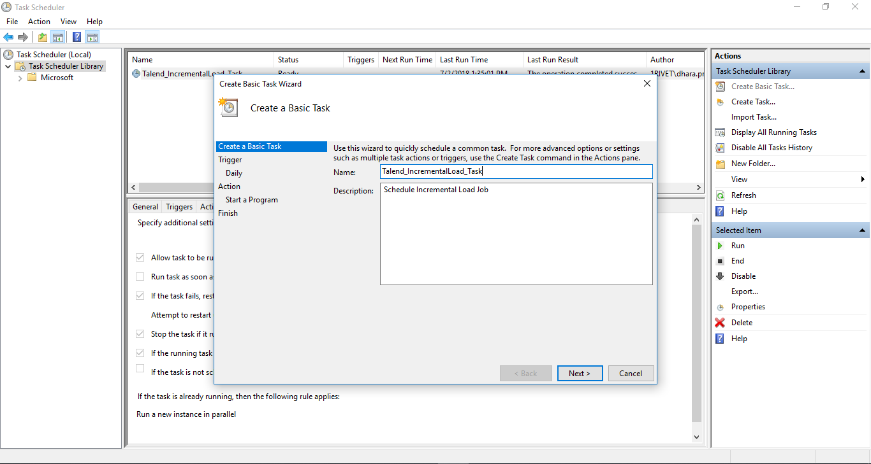

**Trigger**

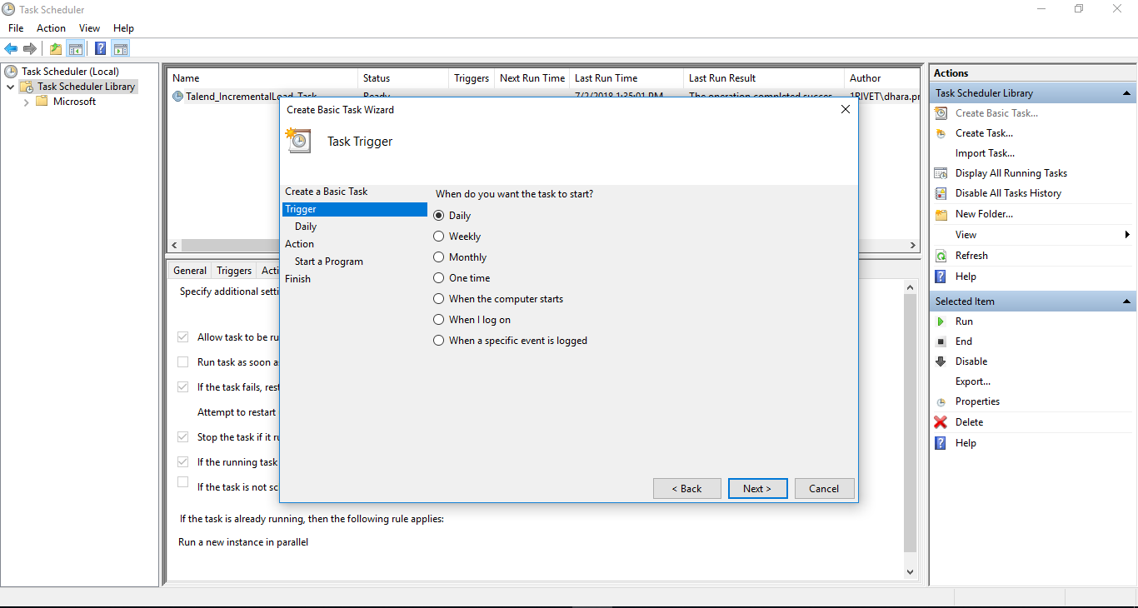

**Trigger(Daily)**

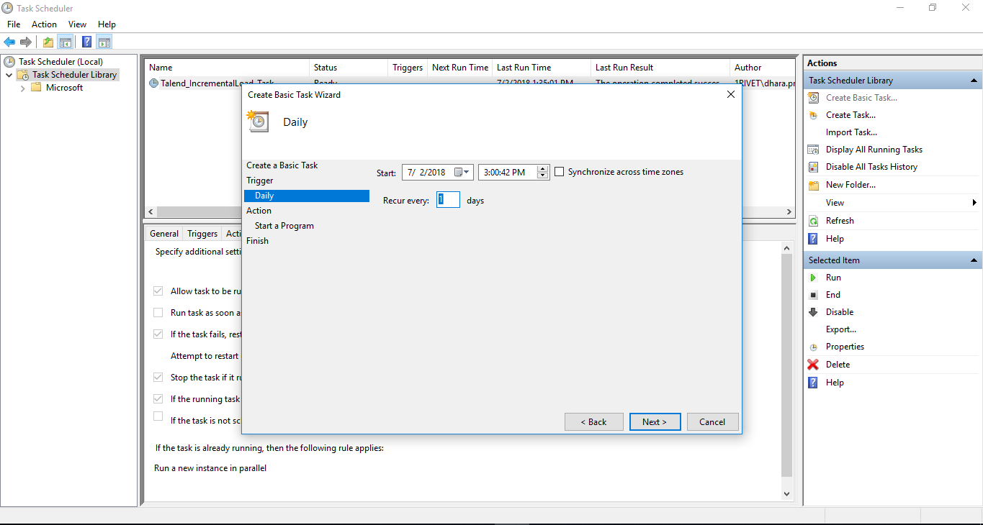

**Action**

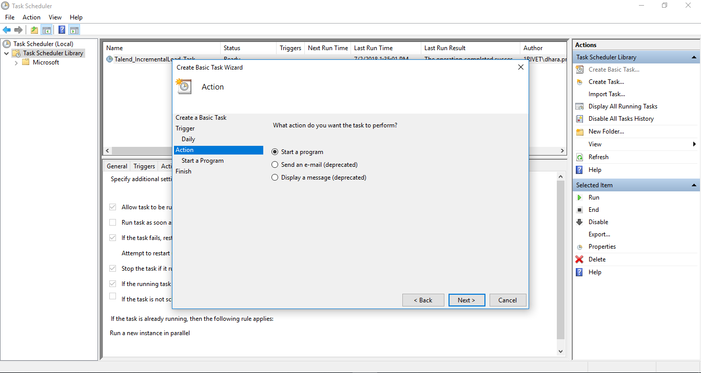

**Action(Start Program)**

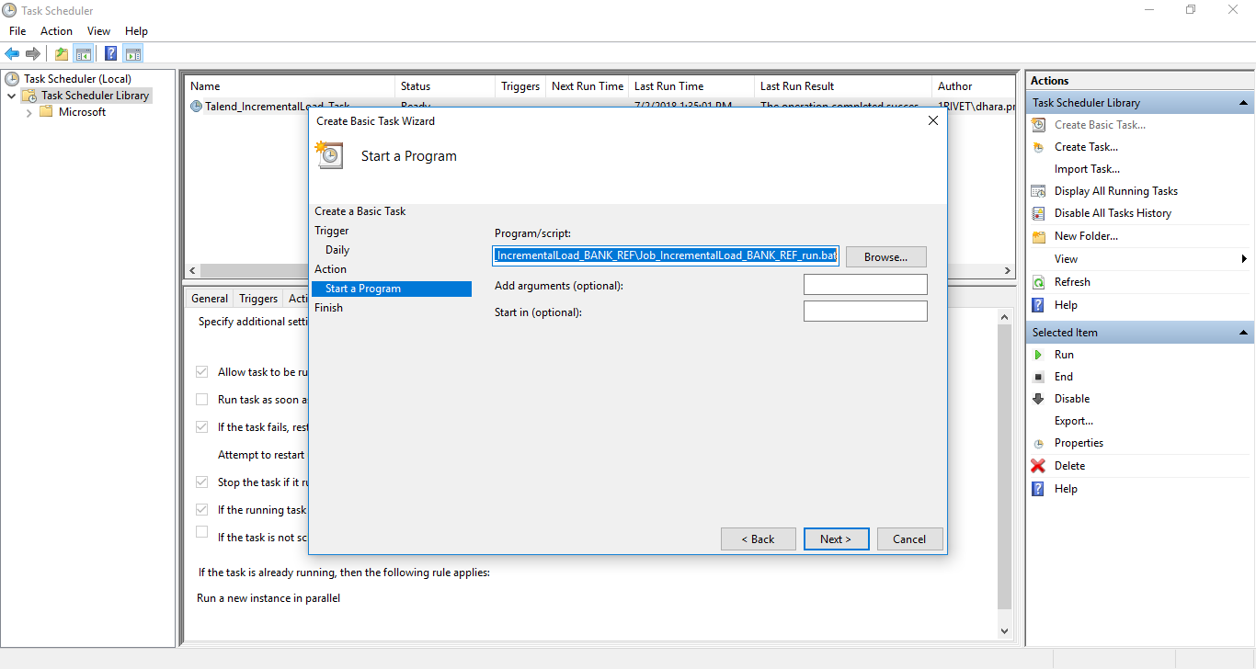

**Finish**

