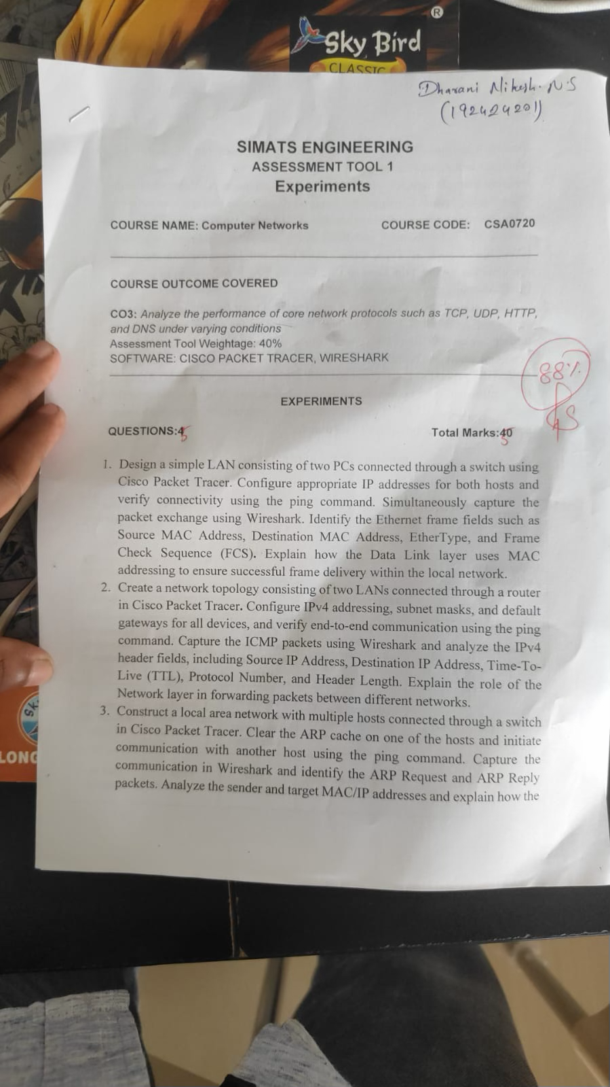
- Develop a simple network consisting of two PCs connected through a router in Cisco Packet Tracer. Configure the required IP addresses and test connectivity using the ping command. Capture the ICMP traffic using Wireshark and identify the Echo Request and Echo Reply messages. Examine important ICMP fields such as Type, Code, Identifier, and Sequence Number, and calculate the Round Trip Time (RTT). Discuss how ICMP assists in network troubleshooting and connectivity verification.
- Create a client-server network in Cisco Packet Tracer by configuring a web server and a client PC. Enable the HTTP service on the server and access the hosted webpage from the client using a web browser. Capture the communication in Wireshark and identify the TCP three-way handshake, followed by the HTTP GET request and HTTP response messages. Analyze the application-layer communication and explain how TCP provides reliable delivery for HTTP traffic through connection establishment, acknowledgments, and ordered data transfer.

Experiment 1: LAN using Switch and Wireshark

Aim
To design a simple LAN using two PCs and a switch in Cisco Packet Tracer, verify connectivity using ping, and analyze Ethernet frame fields using Wireshark.

Apparatus
- Computer
- Cisco Packet Tracer
- Wireshark
- 2 PCs
- 1 Switch
- Ethernet cables

Algorithm
- Create a LAN with two PCs and a switch.
- Assign IP addresses to both PCs.
- Connect the PCs to the switch.
- Test connectivity using ping.
- Capture the packets using Wireshark.
- Identify the Ethernet frame fields.
- Analyze MAC addressing and frame delivery.

Procedure
- Open Cisco Packet Tracer.
- Add 2 PCs and 1 switch.
- Connect both PCs to the switch using Copper Straight-Through cables.
- Configure the IP addresses:
  - PC0: 192.168.1.1
  - PC1: 192.168.1.2
  - Subnet Mask: 255.255.255.0
- Open the command prompt on PC0.

Output:
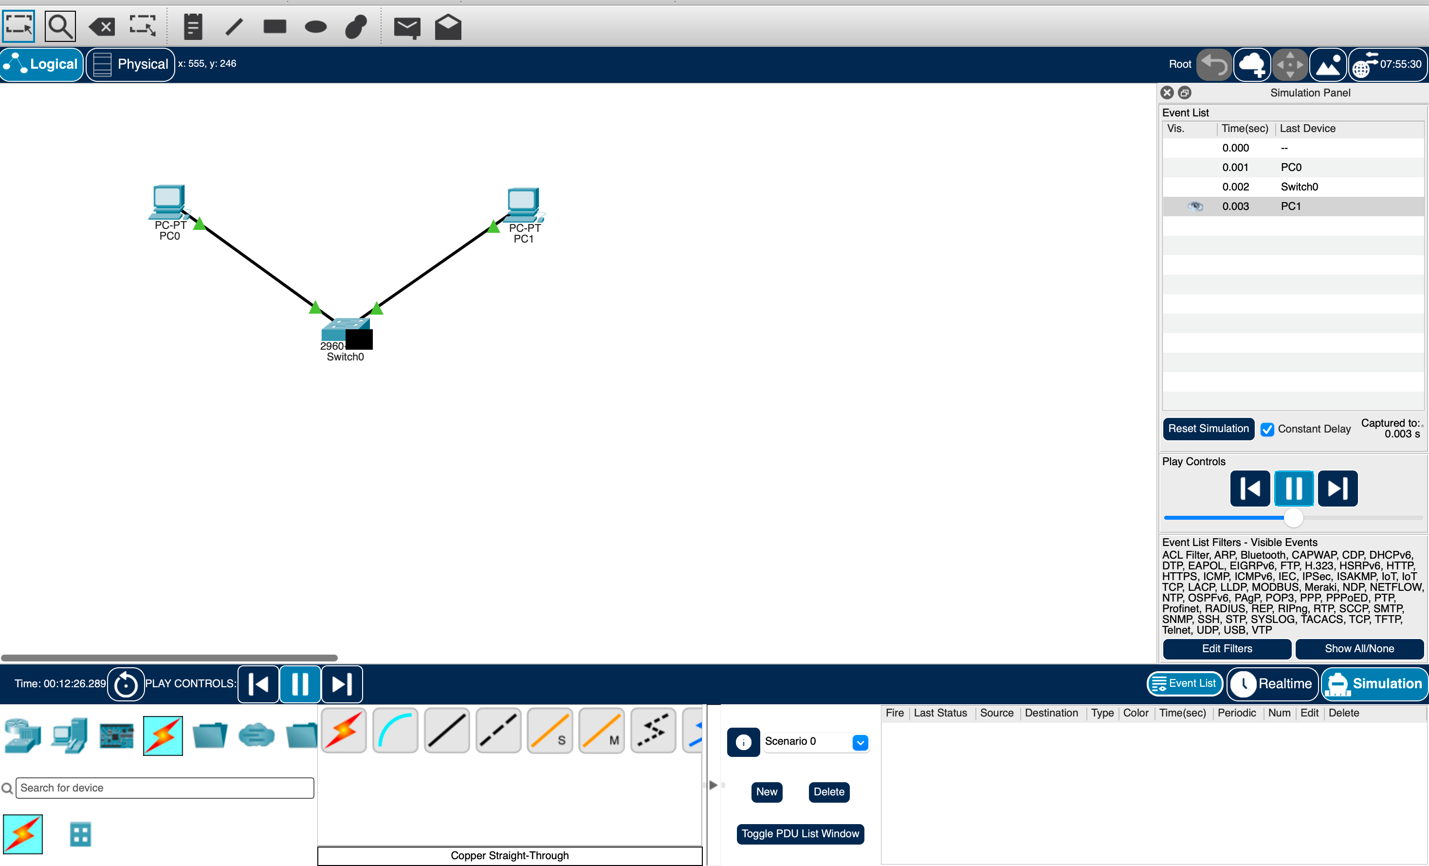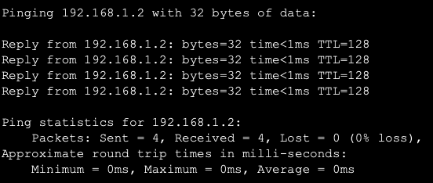

Result
Thus, a simple LAN was successfully designed using two PCs and a switch. Connectivity was verified using the ping command, and Ethernet frame fields were analyzed using Wireshark. MAC addressing was used to deliver frames between devices within the local network.

Experiment 2: Two LANs Connected Through a Router

Aim
To connect two LANs using a router in Cisco Packet Tracer, configure IPv4 addresses, and verify communication using ping.

Apparatus
- Computer
- Cisco Packet Tracer
- 2 PCs
- 2 Switches
- 1 Router
- Ethernet cables

Algorithm
- Create two LANs with PCs and switches.
- Connect both switches to the router.
- Configure IPv4 addresses and subnet masks.
- Configure router interfaces as default gateways.
- Test communication between the two LANs.
- Capture ICMP packets using Wireshark.
- Analyze the IPv4 header fields.

Procedure
- Create PC0 → Switch0 → Router → Switch1 → PC1.
- Configure PC0:
  - IP: 192.168.1.10
  - Mask: 255.255.255.0
  - Gateway: 192.168.1.1
- Configure PC1:
  - IP: 192.168.2.10
  - Mask: 255.255.255.0
  - Gateway: 192.168.2.1
- Configure the router interfaces:
G0/0 = 192.168.1.1
G0/1 = 192.168.2.1
- Enable the interfaces using no shutdown.
- From PC0, execute:
ping 192.168.2.10
- Capture the ICMP packets in Wireshark.
- Examine Source IP, Destination IP, TTL, Protocol and Header Length.

Output:
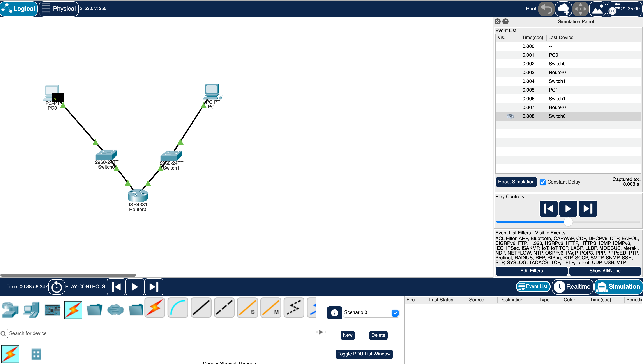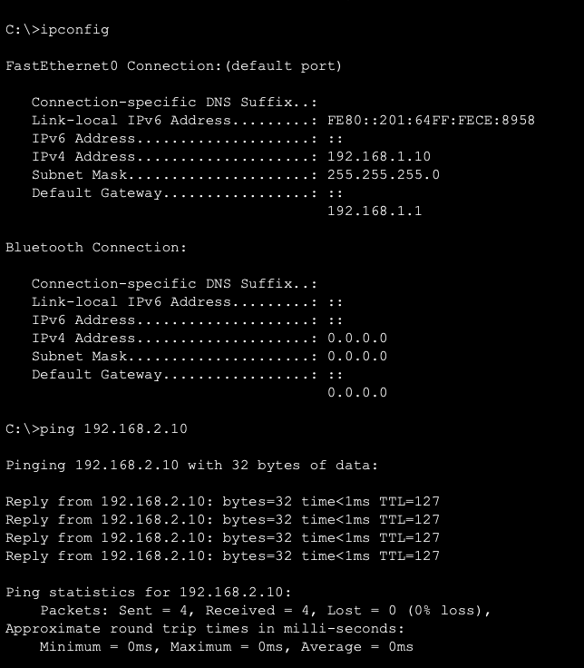

Result
Thus, two LANs were successfully connected through a router, and end-to-end communication was verified using ping. IPv4 header fields were successfully analyzed.

Experiment 3: ARP Request and Reply Analysis

Aim
To analyze ARP Request and ARP Reply packets and understand how IP addresses are resolved into MAC addresses.

Apparatus
- Computer
- Cisco Packet Tracer
- Wireshark
- 2 PCs
- 1 Switch
- Ethernet cables

Algorithm
- Create a LAN using two PCs and a switch.
- Configure IP addresses.
- Clear the ARP cache.
- Ping the destination PC.
- Capture the packets using Wireshark.
- Identify ARP Request and ARP Reply.
- Analyze sender and target MAC/IP addresses.

Procedure
- Connect two PCs to a switch.
- Configure:
PC0: 192.168.1.10
PC1: 192.168.1.20
Subnet Mask: 255.255.255.0
- Clear the ARP cache on PC0.
- Ping PC1:
ping 192.168.1.20
- Start Wireshark capture.
- Apply the filter:
arp
- Observe the ARP Request.
- Observe the ARP Reply.
- Note the sender and target MAC/IP addresses.

Output:
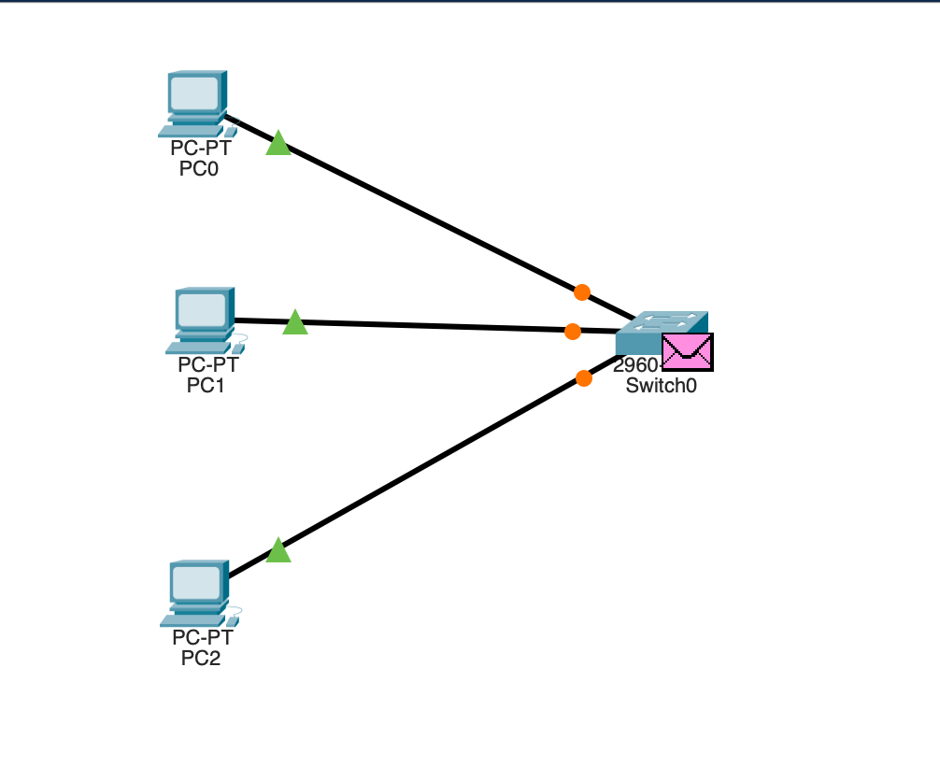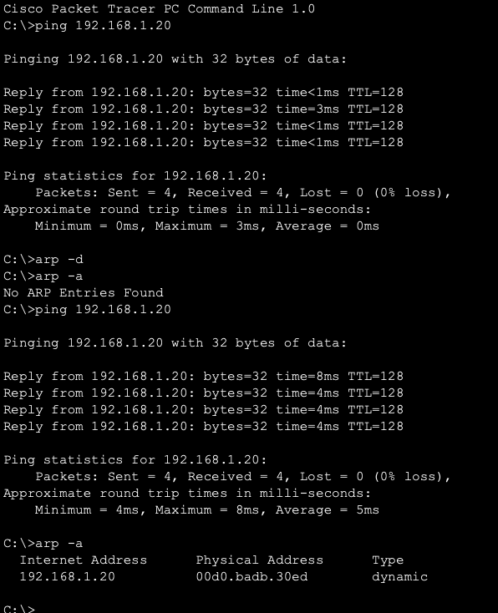

Result
Thus, ARP Request and Reply packets were successfully captured and analyzed. ARP resolved the destination IP address into its corresponding MAC address.

Experiment 4: ICMP Echo Request and Echo Reply

Aim
To analyze ICMP Echo Request and Echo Reply messages and calculate the Round Trip Time (RTT).

Apparatus
- Computer
- Cisco Packet Tracer
- Wireshark
- 2 PCs
- 1 Router
- Ethernet cables

Algorithm
- Connect two PCs through a router.
- Configure IP addresses and gateways.
- Ping the destination PC.
- Capture ICMP traffic using Wireshark.
- Identify Echo Request and Echo Reply.
- Analyze Type, Code, Identifier and Sequence Number.
- Calculate RTT.

Procedure
- Configure PC0:
IP: 192.168.1.10
Gateway: 192.168.1.1
- Configure PC1:
IP: 192.168.2.10
Gateway: 192.168.2.1
- Configure the router interfaces.
- From PC0, execute:
ping 192.168.2.10
- Capture packets in Wireshark.
- Apply:
icmp
- Identify Echo Request and Echo Reply.
- Observe Type, Code, Identifier, Sequence Number and RTT.

Output:
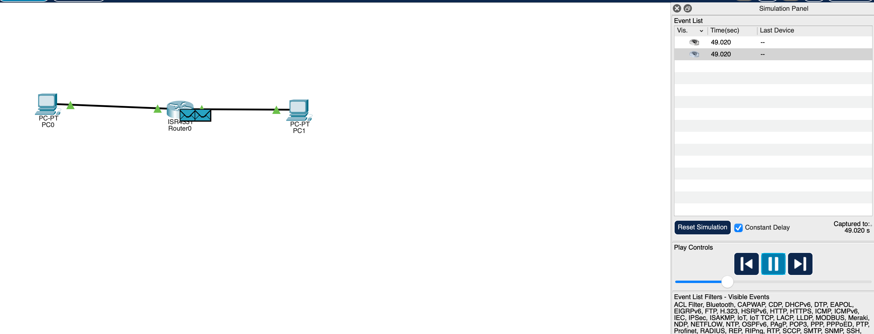
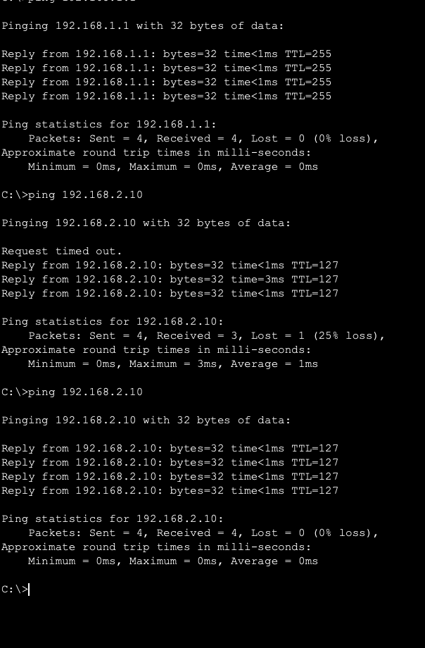

Result
Thus, ICMP Echo Request and Echo Reply messages were successfully captured and analyzed. The RTT was obtained, demonstrating the use of ICMP for connectivity testing and network troubleshooting.

Experiment 5: Client-Server HTTP Communication

Aim
To create a client-server network, access a web server from a client PC, and analyze the TCP three-way handshake and HTTP communication using Wireshark.

Apparatus
- Computer
- Cisco Packet Tracer
- Wireshark
- 1 PC
- 1 Switch
- 1 Server
- Ethernet cables

Algorithm
- Create a network with a PC, switch and server.
- Configure IP addresses.
- Enable HTTP service on the server.
- Access the webpage from the client.
- Capture packets using Wireshark.
- Identify TCP three-way handshake.
- Identify HTTP GET and HTTP response.

Procedure
- Connect PC → Switch → Server.
- Configure PC:
IP: 192.168.1.10
Subnet Mask: 255.255.255.0
- Configure Server:
IP: 192.168.1.20
Subnet Mask: 255.255.255.0
- Open Server → Services → HTTP.
- Turn HTTP ON.
- Open the PC's Web Browser.
- Enter:
http://192.168.1.20
- Verify that the webpage loads.
- Capture the traffic using Wireshark.
- Analyze SYN → SYN-ACK → ACK, followed by HTTP GET → HTTP Response.

Output:
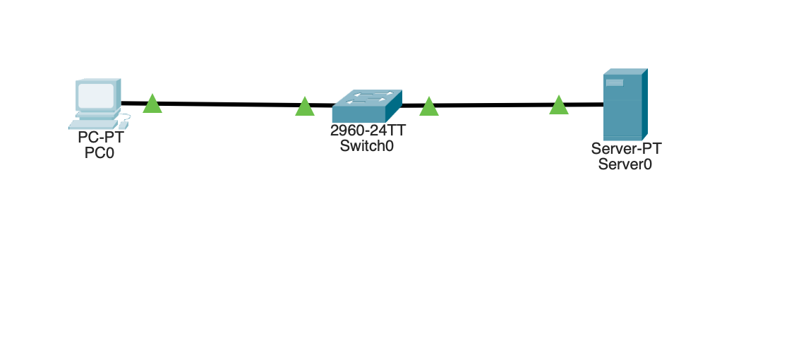
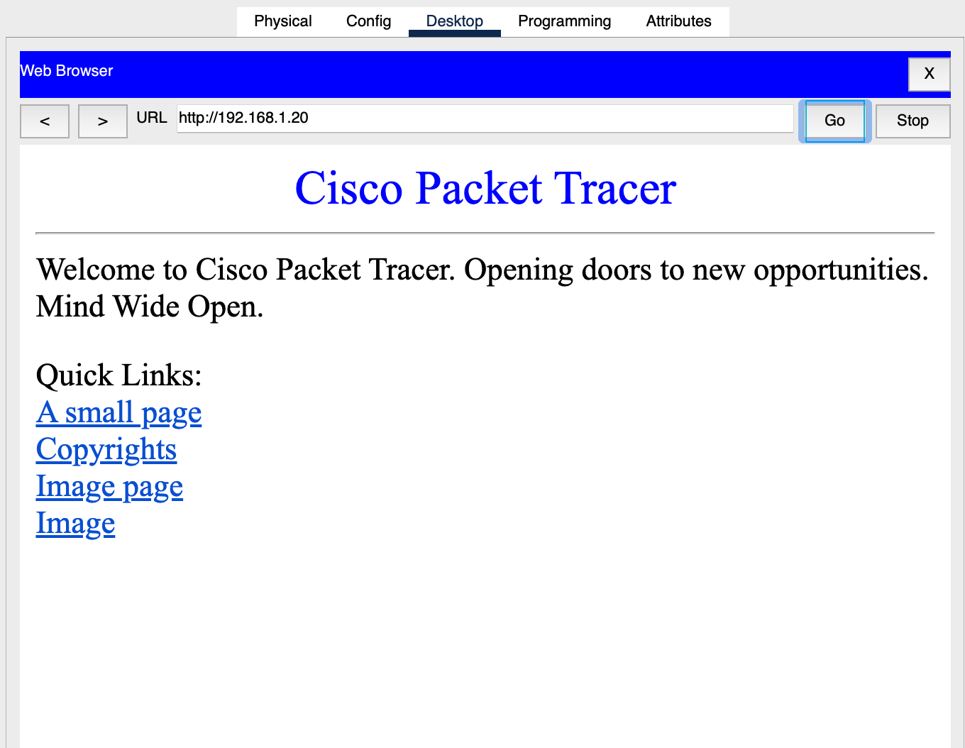

Result
Thus, the client-server HTTP network was successfully configured. The TCP three-way handshake, HTTP GET request, and HTTP response were captured and analyzed, demonstrating reliable TCP communication.

RUBRICS FOR CALCULATION

Criteria | Weightage | Level 4 – Exemplary | Level 3 – Proficient | Level 2 – Developing | Level 1 – Beginning
Understanding of Concepts | 25 | Demonstrates thorough understanding and effectively integrates multiple concepts/technologies | Good understanding with proper integration of most concepts | Basic understanding; limited or partial integration | Poor understanding; unable to integrate concepts
Experimental Design | 30 | Well-planned, systematic implementation with optimal solution | Correct implementation with minor issues | Basic implementation with errors or inefficiencies | Incorrect or incomplete implementation
Use of Tools | 20 | Effective and advanced use of tools/technologies with proper configuration | Appropriate use of tools with correct execution | Limited or inconsistent use of tools | Incorrect or minimal use of tools
Analysis of Results | 15 | Insightful analysis with accurate interpretation and validation of results | Good analysis with reasonable interpretation | Basic analysis with limited insights | Poor or incorrect analysis of results

