Assignment 6
Technical Analysis using R, Visualization Phase
Portfolio Technical Analysis Dashboard (R Shiny)
Student Name: Dharaben Patel

Repository: https://github.com/dharadhara1995/TechnicalAnalysis/tree/main/Assignment6

AI Assistance Declaration: I used Claude (Claude Opus 5.5, claude.ai) to help write and explain the Shiny app and this document. Prompts used: I verified the app by running it in RStudio, trying each chart type, time frame, indicator and trading rule, and checking that the Buy/Sell markers are on the bars where the lines actually cross. I am responsible for the accuracy and originality of this work.

Project Description
This is the final stage of my three-part Technical Analysis project. I built an interactive portfolio dashboard in R Shiny that fetches stock data from Yahoo Finance and shows it as a candlestick, line or area chart. Technical indicators (moving averages, RSI, MACD and volume) can be turned on and off and are drawn as layers on the chart. The dashboard applies a trading rule chosen by the user and annotates the bars with Buy and Sell signals. The indicators use my own functions from Assignment 5, and the stock list comes from my portfolio.txt from Assignment 2.

How to Run
- Install the packages once in the RStudio Console: install.packages(c("shiny", "ggplot2", "quantmod", "patchwork"))
- Open app.R from the Assignment6 folder and click Run App (top right of the editor).
- Choose a stock, date range, time frame, chart type, indicators and trading rule in the sidebar. The chart updates automatically.
- An internet connection is needed for Yahoo Finance. If it is not available, the app shows the last saved copy of the data, or a CSV file can be uploaded.

How the App Meets Each Requirement

Step 1: Data Collection and Setup
- Data source: Yahoo Finance through quantmod::getSymbols(). Two backups: every successful download is saved to a data_cache folder and used automatically if Yahoo cannot be reached, and the user can upload a CSV file instead.
- Packages: shiny, ggplot2, quantmod and patchwork (patchwork stacks the price, RSI, MACD and volume panels into one chart).
- Error handling: invalid symbols, no internet, empty date ranges and bad settings (for example short MA longer than long MA) show a clear message instead of crashing. Rows with missing prices are removed and the number removed is shown in the status line.
- Extra history is downloaded before the start date, so the moving averages are already calculated at the first bar on the chart.

Step 2: Visualizing Stock Data
- Shiny app skeleton with a sidebar for the controls and tabs for Chart, Signals, Portfolio and Data.
- Widgets: stock symbol (pick from my portfolio or type any symbol), date range, time frame (Daily, Weekly, Monthly), and chart type (Candlestick, Line, Area).
- Weekly and monthly bars are made with to.weekly() and to.monthly() from quantmod.

Step 3: Overlay Technical Indicators
- Moving averages (SMA or EMA, adjustable short and long periods) are drawn on the price chart.
- RSI (adjustable period and oversold/overbought levels), MACD with histogram (adjustable periods) and volume are added as panels under the price chart with the same date axis.
- Each indicator has its own checkbox to turn it on or off.

Step 4: Trading Rules and Annotations
Rule | Buy | Sell
MA Crossover | Short MA crosses above long MA | Short MA crosses below long MA
MACD Crossover | MACD crosses above signal line | MACD crosses below signal line
RSI Reversal | RSI rises back above oversold level | RSI falls back below overbought level
MA + RSI Filter | MA cross up, only if RSI is below overbought | MA cross down, or RSI falls back below overbought

All other bars are Hold. Buy and Sell bars are marked with green and red arrows and labels. Optional settings label every bar (H = Hold) and shade the background green or red depending on whether the short MA is above the long MA. The PDF example labels every bar Buy or Sell based on which MA is higher; I mark the bar where the cross actually happens, because that is the point where a trader would act, and the shading option shows the same above/below information for every bar. The Signals tab lists every signal and compares the strategy's return with buying and holding.

Screenshots
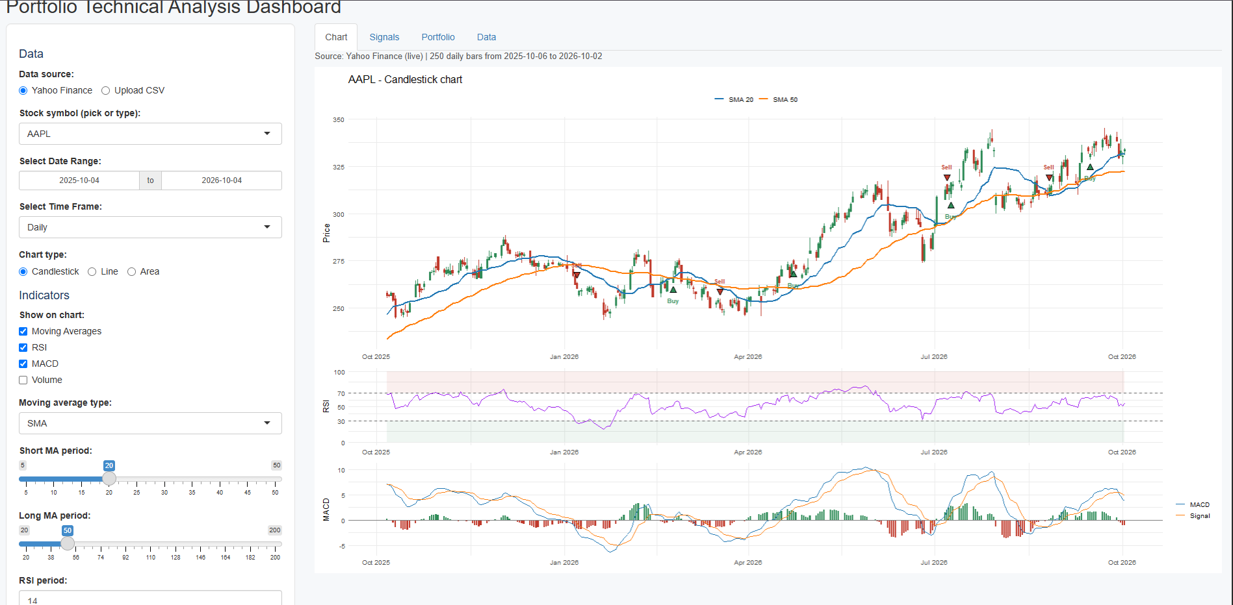
Figure 1: Candlestick chart with moving averages, RSI, MACD and Buy/Sell annotations
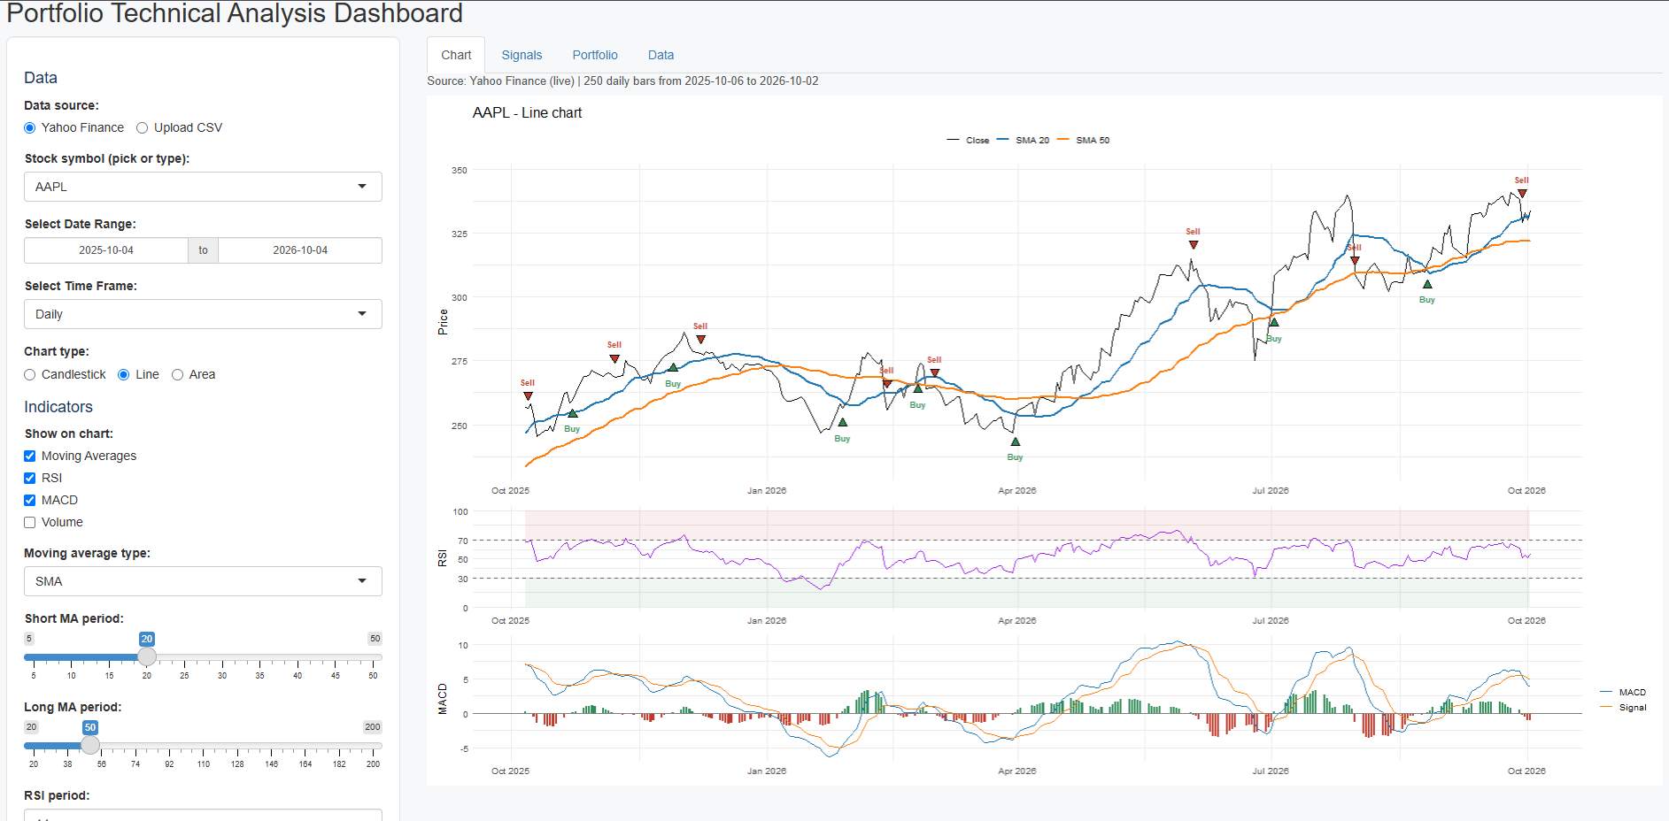
Figure 2: Line chart with a different trading rule
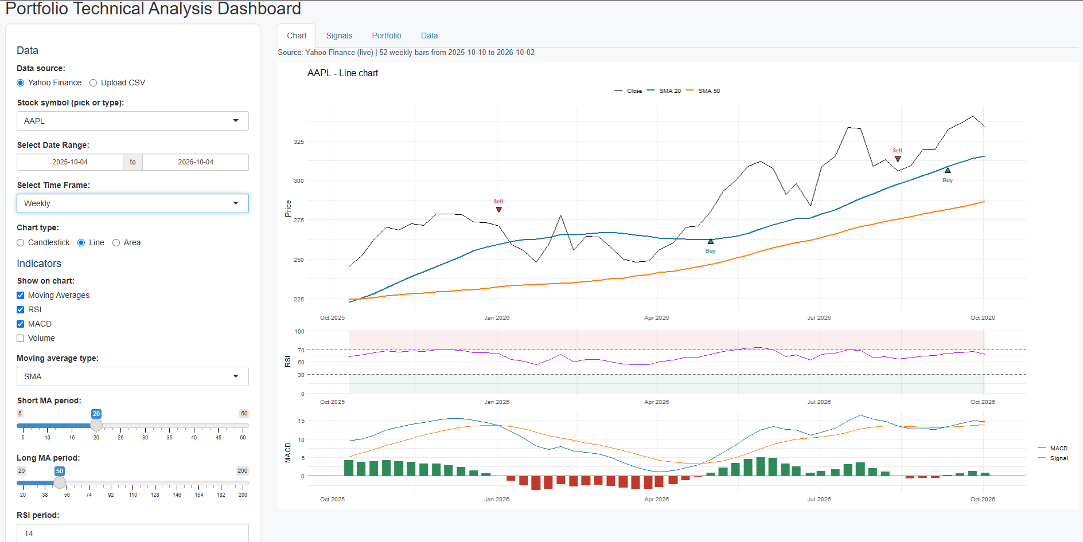
Figure 3: Weekly time frame
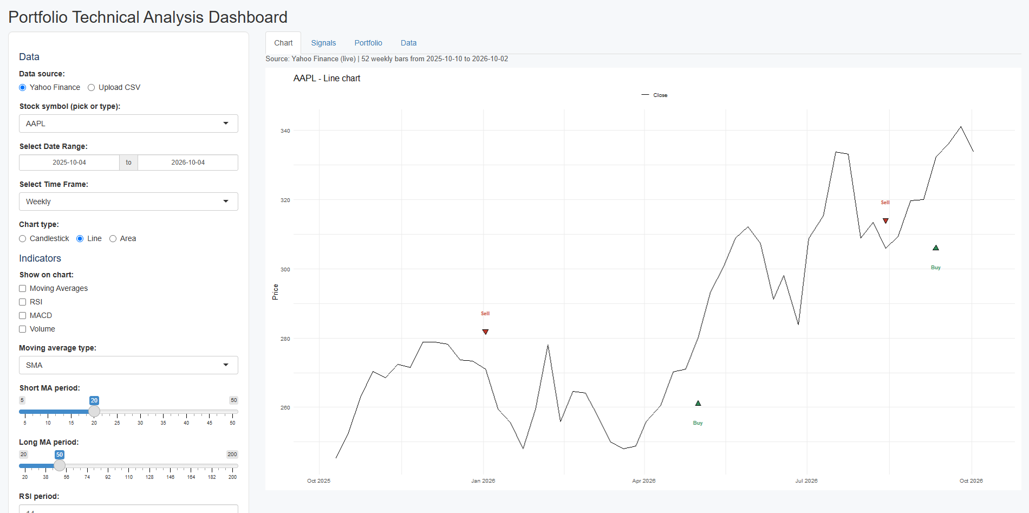
Figure 4: Indicators turned off (only the price chart)
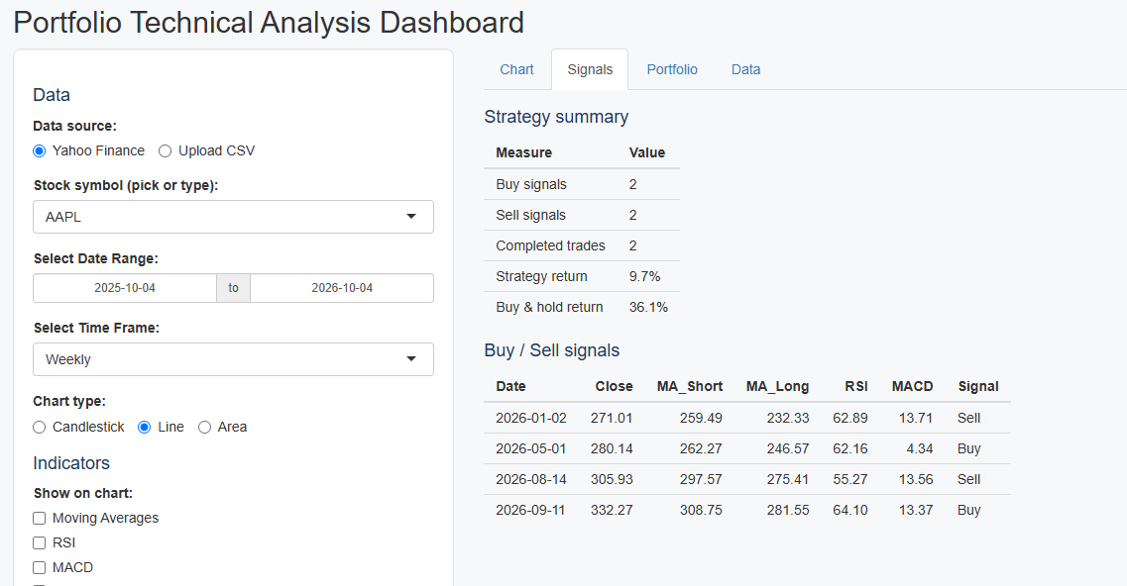
Figure 5: Signals tab with strategy summary and signal list
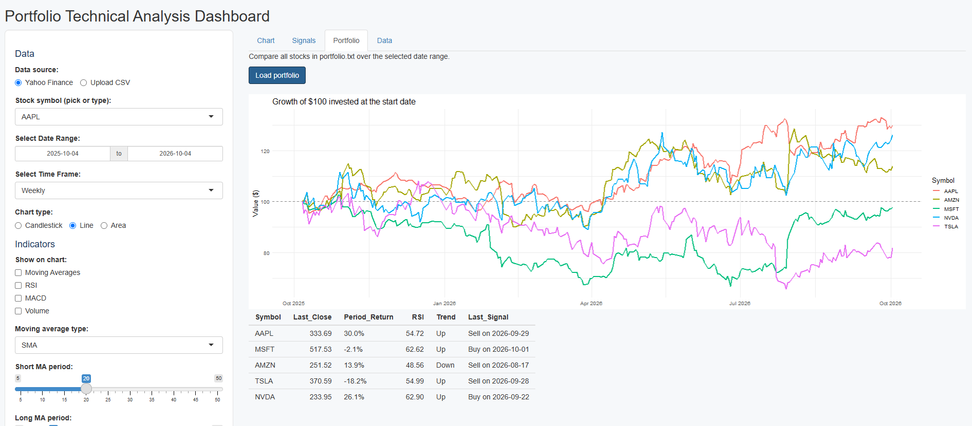
Figure 6: Portfolio tab comparing all stocks

Repository Link
https://github.com/dharadhara1995/TechnicalAnalysis/tree/main/Assignment6

