Assignment 5
Technical Analysis using R, Development Phase
Student: Dharaben Patel

Repository: https://github.com/[username]/TechnicalAnalysis/tree/main/Assignment5

AI Assistance Declaration: I used Claude (Claude Opus 5.5, claude.ai) to help write and explain the R functions, the test file and this document. Prompts used: I asked Claude to prepare the indicator functions following the assignment templates and pseudocode, a test file, and this report. I verified the outputs by running test_indicators.R in RStudio (all tests pass), checking results against independent base R calculations (mean, sd, lm), and checking some values by hand. I am responsible for the accuracy and originality of this work.

1. Overview
In this assignment I implemented nine technical analysis functions in R using only base R (no packages): SMA, EMA, MACD, standard deviation, linear regression, RSI, Stochastic RSI, crossover and crossunder. Each function is in its own R file and uses the exact function name and arguments from the template. I also wrote a test file that checks every function, and a demo script that applies the indicators to the stocks from my portfolio.

2. Files
File | Contents
sma.R | sma(data, period)
ema.R | ema(data, period)
macd.R | macd(data, short_period, long_period, signal_period) (uses ema)
stdev.R | stdev(data)
linreg.R | linreg(regressionSource, regressionLength, regressionOffset)
rsi.R | rsi(data, period)
stoch_rsi.R | stoch_rsi(data, period, k_period, d_period) (uses rsi and sma)
crossover.R | crossover(arr1, arr2)
crossunder.R | crossunder(arr1, arr2)
test_indicators.R | Runs the examples from the instructions and 47 checks on all functions
demo_stock_analysis.R | Optional: indicators, stock filter and trading rules on real stock data
portfolio.txt | Stock symbols used by the demo (from Assignment 2)

3. How to Run the Code
- Download the Assignment5 folder and open RStudio.
- Open test_indicators.R and set the working directory to the Assignment5 folder: Session > Set Working Directory > To Source File Location (or setwd("path/to/Assignment5")).
- Click Source. The file loads all nine function files, prints the example outputs from the instructions, and shows PASS or FAIL for every check. The summary at the end should say "47 of 47 tests passed". No packages are needed.
- To use one function on its own, source its file, e.g. source("sma.R") then sma(c(10, 12, 15, 20), 3). macd.R loads ema.R automatically, and stoch_rsi.R loads rsi.R and sma.R if they are not loaded yet.
- Optional: run demo_stock_analysis.R to apply the indicators to real stock data. This needs the quantmod package (only for downloading prices, as in Assignment 2) and an internet connection.

4. Explanation of Each Implementation

4.1 Simple Moving Average (sma)
Purpose: Smooths prices by averaging the last "period" values, giving each value equal weight.
How it is calculated: For each window of "period" points, add the values and divide by the period. The window moves forward one point at a time.
Implementation notes: Stops with an error if the data is shorter than the period. Following the pseudocode, the result has length(data) - period + 1 values (no NA padding), so the first value belongs to the period-th data point.
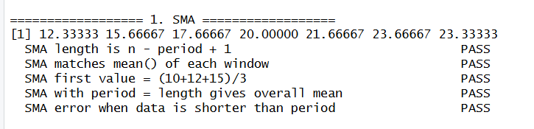
Figure 1: sma() example output and tests

4.2 Exponential Moving Average (ema)
Purpose: A moving average that gives more weight to recent prices, so it reacts faster than the SMA.
How it is calculated: multiplier = 2 / (period + 1). The first EMA is the first price. After that, EMA(i) = (price(i) - EMA(i-1)) x multiplier + EMA(i-1).
Implementation notes: Returns a value for every data point. I checked it with an independent calculation using Reduce(). By hand, with period 3 the multiplier is 0.5, so the second value is (12 - 10) x 0.5 + 10 = 11, which matches.
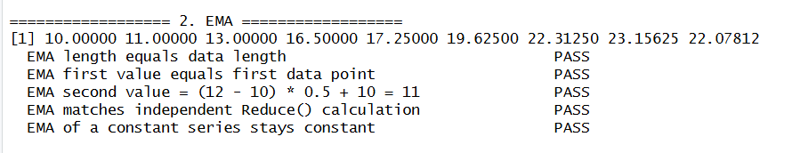
Figure 2: ema() example output and tests

4.3 MACD (macd)
Purpose: Shows trend and momentum. When the MACD line crosses above its signal line it can be a buy signal, and crossing below can be a sell signal.
How it is calculated: MACD line = EMA(short) - EMA(long). Signal line = EMA of the MACD line over signal_period. Histogram = MACD line - signal line.
Implementation notes: Reuses my ema() function and returns a list with macd_line, signal_line and histogram. In a steady uptrend the MACD is positive, which the test confirms.
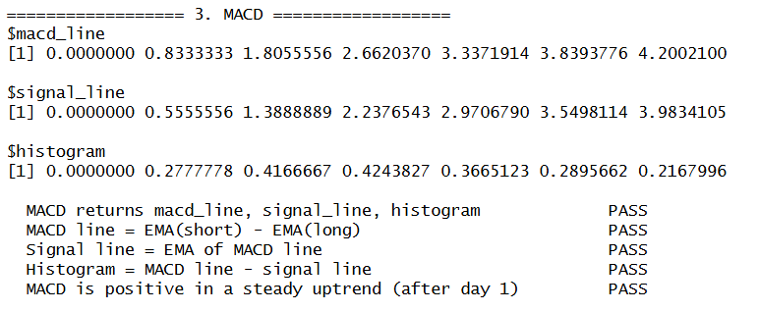
Figure 3: macd() example output and tests

4.4 Standard Deviation (stdev)
Purpose: Measures how spread out the prices are from the mean. It is often used as a measure of volatility.
How it is calculated: Find the mean, subtract it from each value, square the differences, take the mean of the squares (variance) and then the square root.
Implementation notes: This is the population standard deviation (divide by n), as in the formula given. R's sd() divides by n - 1, so my test checks that stdev(x) = sd(x) x sqrt((n-1)/n). I also tested c(2, 4, 4, 4, 5, 5, 7, 9), which is a known example with a standard deviation of exactly 2.
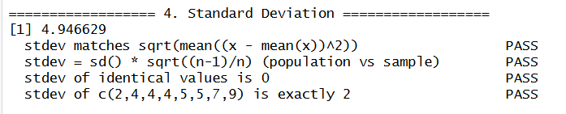
Figure 4: stdev() example output and tests

4.5 Linear Regression (linreg)
Purpose: Fits a straight trend line through recent prices. A positive slope means an upward trend.
How it is calculated: The x values are 1, 2, 3... in the window. slope = sum((x - mean x)(y - mean y)) / sum((x - mean x)^2), and intercept = mean y - slope x mean x. Predicted values = slope x x + intercept.
Implementation notes: Gives an error if regressionLength is longer than the data or if regressionOffset >= regressionLength. I found that the start index in the pseudocode (n - regressionLength + regressionOffset) picks regressionLength + 1 points when the offset is 0, and fewer points when the offset is bigger (for example, only 2 points for length 5 and offset 2). I changed it to n - regressionLength + 1 - regressionOffset so the window always has exactly regressionLength points and ends regressionOffset points before the last value. The slope, intercept and predicted values match R's lm() function.
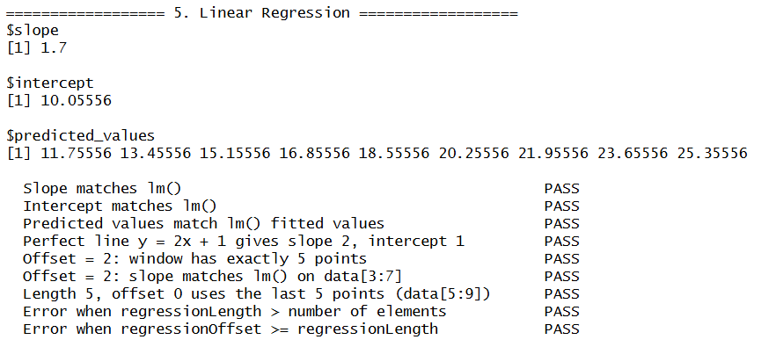
Figure 5: linreg() example output and tests (including the lm() comparison)

4.6 Relative Strength Index (rsi)
Purpose: A momentum indicator from 0 to 100. Above 70 is usually called overbought and below 30 oversold.
How it is calculated: Find the price changes, split them into gains and losses, average the first "period" gains and losses, then update the averages with Wilder's smoothing: avg = (avg x (period - 1) + new value) / period. RS = avg gain / avg loss and RSI = 100 - 100 / (1 + RS).
Implementation notes: The first "period" values are NA because there is not enough data yet. I followed the loop from the pseudocode. I also added two safety checks so the function never divides by zero: if there are no losses RSI is 100, and if prices do not move at all RSI is 50. The tests check that rising prices give 100, falling prices give 0, and flat prices give 50.
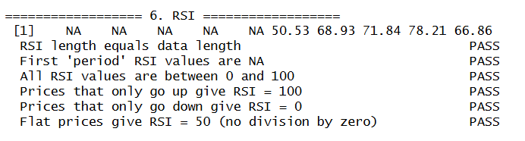
Figure 6: rsi() example output and tests

4.7 Stochastic RSI (stoch_rsi)
Purpose: Shows where the current RSI is compared to its own range, from 0 to 1. Close to 0 is oversold and close to 1 is overbought.
How it is calculated: StochRSI = (RSI - lowest RSI) / (highest RSI - lowest RSI). %K = SMA of StochRSI over k_period, and %D = SMA of %K over d_period.
Implementation notes: Follows the pseudocode, which uses the lowest and highest RSI of the whole series and ignores the NA values at the start. The example in the instructions uses period 14 with only 10 prices, so no RSI can be calculated; my function gives a clear warning and returns NA instead of crashing. If the RSI is flat (highest = lowest), it returns 0 to avoid dividing by zero.
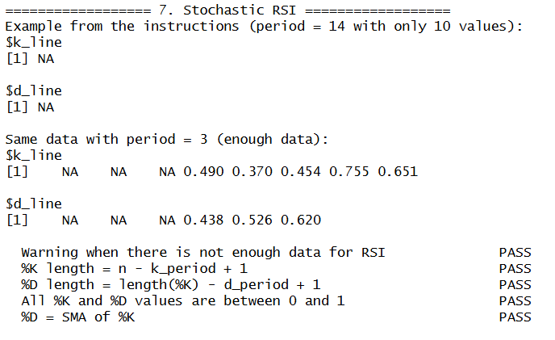
Figure 7: stoch_rsi() output (instructions example and a working example)

4.8 Crossover (crossover)
Purpose: Finds the points where one line crosses another, for example a fast moving average crossing a slow one.
How it is calculated: "Up" when arr1 was below or equal to arr2 at the previous point and is above it now. "Down" for the opposite. Otherwise "None".
Implementation notes: Returns text values "Up", "Down" and "None" as in the pseudocode (the description mentions TRUE/FALSE, so crossover(a, b) == "Up" gives a TRUE/FALSE version). Stops with an error if the arrays have different lengths, and points with NA values are treated as "None" instead of causing an error. In the example, arr1 crosses above arr2 at point 4 (15 <= 22, then 20 > 18).
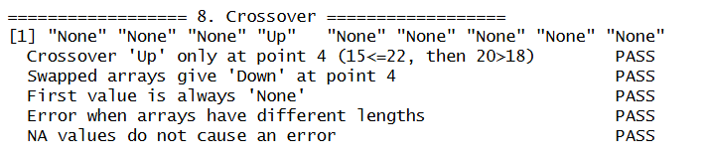
Figure 8: crossover() example output and tests

4.9 Crossunder (crossunder)
Purpose: Finds the points where arr1 drops below arr2, which is often used as a sell or exit signal.
How it is calculated: "True" when arr1 was above or equal to arr2 at the previous point and is below it now, otherwise "False". The first point is "None".
Implementation notes: Returns the same text values as the pseudocode. In the example from the instructions arr1 never crosses under arr2, so every value is "False". When the arrays are swapped there is a crossunder at point 4, which the test checks.
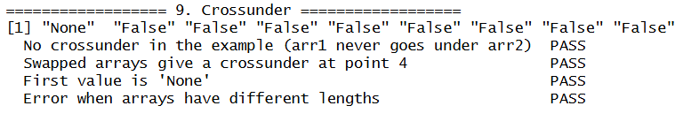
Figure 9: crossunder() example output and tests

5. Testing
test_indicators.R runs every example from the instructions and 47 checks. Where possible, results are compared with an independent calculation: mean() for SMA, Reduce() for EMA, sd() for standard deviation and lm() for linear regression. It also tests edge cases such as constant data, data shorter than the period, flat prices for RSI, arrays of different lengths, and NA values.
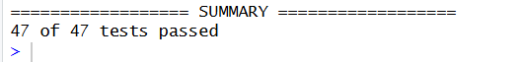
Figure 10: Test summary showing 47 of 47 tests passed

6. Demo on Real Stock Data
demo_stock_analysis.R uses the stocks in my portfolio.txt from Assignment 2. It builds a data frame for each stock (Date, Open, High, Low, Close, Volume), calculates the indicators on one year of data, and then filters the data to the last six months (time period filter). It also filters stocks with my own rule: 20-day regression slope above 0, MACD histogram above 0, and RSI below 70 (upward trend with momentum, but not overbought). The trading rules are: buy when the MACD line crosses over the signal line, and sell when it crosses under. It prints the signals and plots the price with buy/sell markers and the MACD.
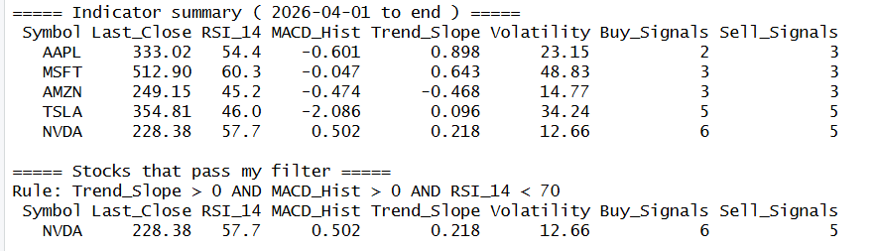
Figure 11: Demo: indicator summary table and stocks that pass the filter
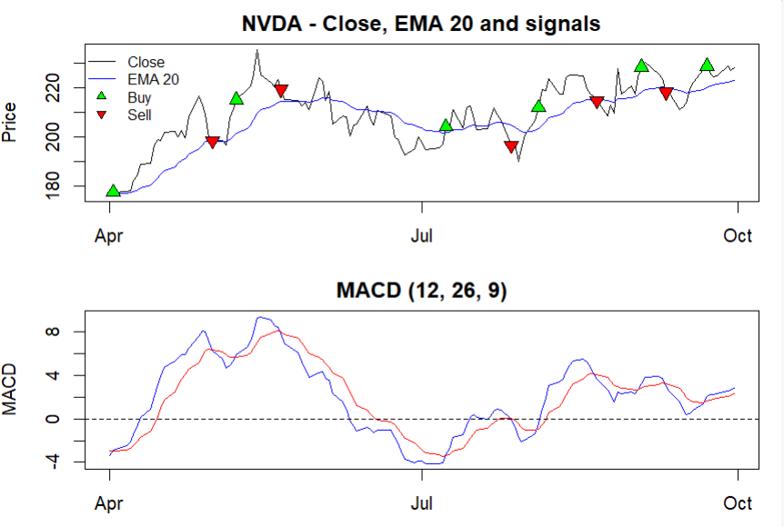
Figure 12: Demo: price chart with buy/sell signals and MACD

Repository Link
https://github.com/dharadhara1995/TechnicalAnalysis/tree/main/Assignment5

