BDA400 - Assignment 3: Prompting R Functions with AI
Reflection and Testing Report

AI Assistance Declaration: I used Claude (Claude Opus 5.5, claude.ai) to generate and revise an R function that removes outliers, to explain the code, and to help with writing. Prompts used: all prompts are listed in LastName_Appendix.docx and at the top of my R script. I verified outputs using a manual calculation in Excel, a comparison with boxplot.stats(), and edge-case tests that I ran in RStudio Desktop. All final calculations are done by myself. I am responsible for the accuracy and originality of this work.

Original Task Description
Remove outliers from a numeric vector using the 1.5 x IQR rule and report which values were removed.
An outlier is a value below Q1 - 1.5 x IQR or above Q3 + 1.5 x IQR, where IQR = Q3 - Q1. This is a common data cleaning step, for example removing a typing error like 999 from a list of sales numbers.

Step 1: AI-Generated Function
I gave the AI the seed prompt with my task description, then asked it to add comments, argument validation and a clean result, and to explain each line. The AI-generated versions (v1 and v2) and the final version are all saved in LastName_AI_RFunction_Assignment.R with a comment on every line explaining what it does. The AI's line-by-line explanation is in the Appendix.
In short, the first version (v1) used quantile() to find Q1 and Q3, calculated the IQR and the two fences, printed the removed values and returned the values inside the fences. Reading it carefully, I noticed it saved the IQR in a variable called IQR, which hides R's built-in IQR() function. It also had no input checks.

Step 2: Testing and Debugging

How I tested
- Manual expectation: I calculated Q1, Q3, the IQR and the fences for c(10, 15, 999, 20, 25) in Excel using QUARTILE.INC, which uses the same method as quantile() in R.
- Comparison to a known method: I compared the results with boxplot.stats(), on both a small synthetic vector and the built-in iris dataset.
- Edge cases: NA values, no outliers, all identical values, negative values, all NA, text input, na.rm = FALSE and an invalid coef.

Issues found and fixed
Version | Problem found in testing | How it was fixed
v1 | Error with NA: "missing values and NaN's not allowed if 'na.rm' is FALSE" | Prompt P2/P4. Missing values handled.
v2 | No error, but NA stayed in the result (10 15 NA 20 25). The "report removed values" part was also lost. | Prompt P4. NA values are removed first. Final version returns the removed values again.
v3 | Did not match boxplot.stats() for c(34, 16, 46, 37, 55, 40). My function removed 16, boxplot.stats() removed nothing. | Prompt P5. Added method = "tukey" option, which uses fivenum() like boxplot.stats().
v4 | Edge cases (empty input, very short vectors, bad arguments) not handled | Prompts P6/P7. Added warnings, clear error messages and a list result.

Test results
Test | Expected | Result
c(10, 15, 999, 20, 25) | 999 removed, matches my Excel fences | Pass
Same data with an NA | NA dropped, 999 removed | Pass
c(34, 16, 46, 37, 55, 40), method = "tukey" | Same as boxplot.stats() (no outliers) | Pass
iris$Sepal.Width, method = "tukey" | Same outliers as boxplot.stats() | Pass
No outliers / all same / negative values | Nothing removed / nothing removed / -50 removed | Pass
All NA, text input, na.rm = FALSE, coef = -1 | Warning or clear error message | Pass

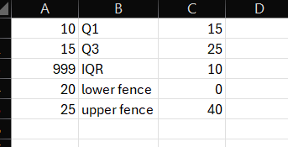
Figure 1: Excel manual calculation of Q1, Q3, IQR and fences
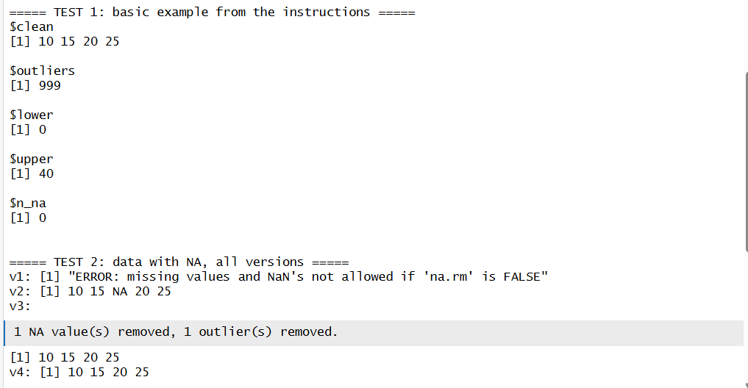
Figure 2: RStudio output for Test 1 and Test 2 (all versions with NA)
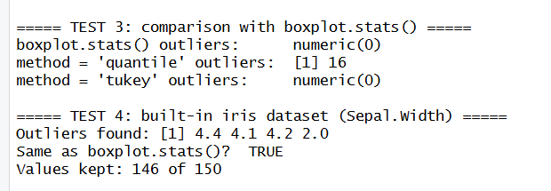
Figure 3: RStudio output for Test 3 and Test 4 (comparison with boxplot.stats)
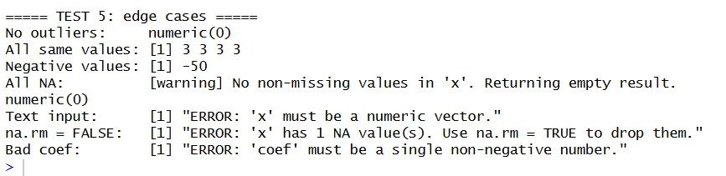
Figure 4: RStudio output for Test 5 (edge cases)

Short reflection on debugging
The AI was helpful for writing the first version quickly and for explaining why the boxplot.stats() result was different. But it did not catch its own mistakes. The NA problem in v2 only showed up when I ran my own test with an NA in the data, and I had to describe the exact output back to the AI before it fixed it. I also had to notice that the AI dropped part of my original task (reporting the removed values) and make sure it came back in the final version. Checking against Excel and boxplot.stats() was what showed me the function was really correct.

Step 3: AI-Human Collaboration

One error in the AI's code and why it happened
The clearest error was in v2. The AI added na.rm = TRUE to quantile(), so the error stopped, but the line x[x >= lower & x <= upper] still returned NA in the result. This happens because comparing NA with a number gives NA, and indexing a vector with NA returns NA instead of skipping it. The code looked correct and did not give any error, so it was easy to miss. I think the AI focused on fixing the error message, and did not check what the output actually looked like with missing data.
A second limitation was that "outlier" is not calculated the same way everywhere. quantile() (and Excel QUARTILE.INC) calculate Q1 and Q3 differently from boxplot.stats(), which uses Tukey's hinges. The AI used quantile() without mentioning this, so the result did not match the boxplot for some small datasets.

My contributions
- Wrote the task description and chose what the function should return.
- Designed the test data, including the NA case that showed the v1 and v2 problems and the small vector that showed the boxplot.stats() difference.
- Noticed that the "report removed values" part of my task was dropped in v2 and made sure the final version returns it.
- Did the manual check in Excel and the comparison with boxplot.stats() and iris.
- Decided to keep "quantile" as the default (it matches Excel) and add "tukey" as an option, and kept all versions in the script so the changes can be followed.

Final Reflection
My prompts had a big effect on the result. The seed prompt gave me a short function that worked on clean data, but it had no checks and it crashed on NA values. Each time I gave the AI a specific problem, like the NA showing up in my output or the mismatch with boxplot.stats(), the answer got much better. Vague prompts gave general answers, and specific prompts with the exact error or test data gave useful fixes.
I learned that debugging is mostly about testing with the right data. The function looked correct when I read it, and it only failed when I tried NA values, a small vector and a built-in method to compare against. I also learned that "outlier" can be calculated in more than one correct way, so checking against a known tool is important.
AI is useful in analytics because it writes the first version fast and explains the code clearly. The limitation is that it does not test its own code or think about edge cases unless I ask, so the analyst still has to check everything.

