AI Assistance Declaration: I used Claude (Claude Opus 5.5, claude.ai) to help draft and explain the R functions and to help organize this report. Prompts used: I asked Claude to prepare the R script, portfolio file and report template for this assignment and to explain each step. I verified the outputs by running the script myself in RStudio, checking that every stock loaded, and checking the mean and standard deviation for one stock by hand in the console. All installation steps and screenshots were done by me. I am responsible for the accuracy and originality of this work.

Introduction
This is the first stage of a three-part technical analysis project. In this stage I set up GitHub, installed R and RStudio on my computer, installed the packages needed for technical analysis, and wrote R functions to import stock data, calculate basic statistics and display the results. Each step below has a short explanation and screenshots.

Step 1: Setting up GitHub Account and Repository
I used GitHub to store all my assignments for this course. I followed the GitHub setup guide to install Git and created a repository named TechnicalAnalysis. Inside the repository I made a separate folder for each assignment.
- Signed in to github.com (or created an account if needed).
- Clicked the + button and selected New repository.
- Entered the name TechnicalAnalysis, chose Public, ticked Add a README file and clicked Create repository.
- Downloaded Git from git-scm.com and installed it using the default options.
- Checked the installation by running git --version in the command prompt.
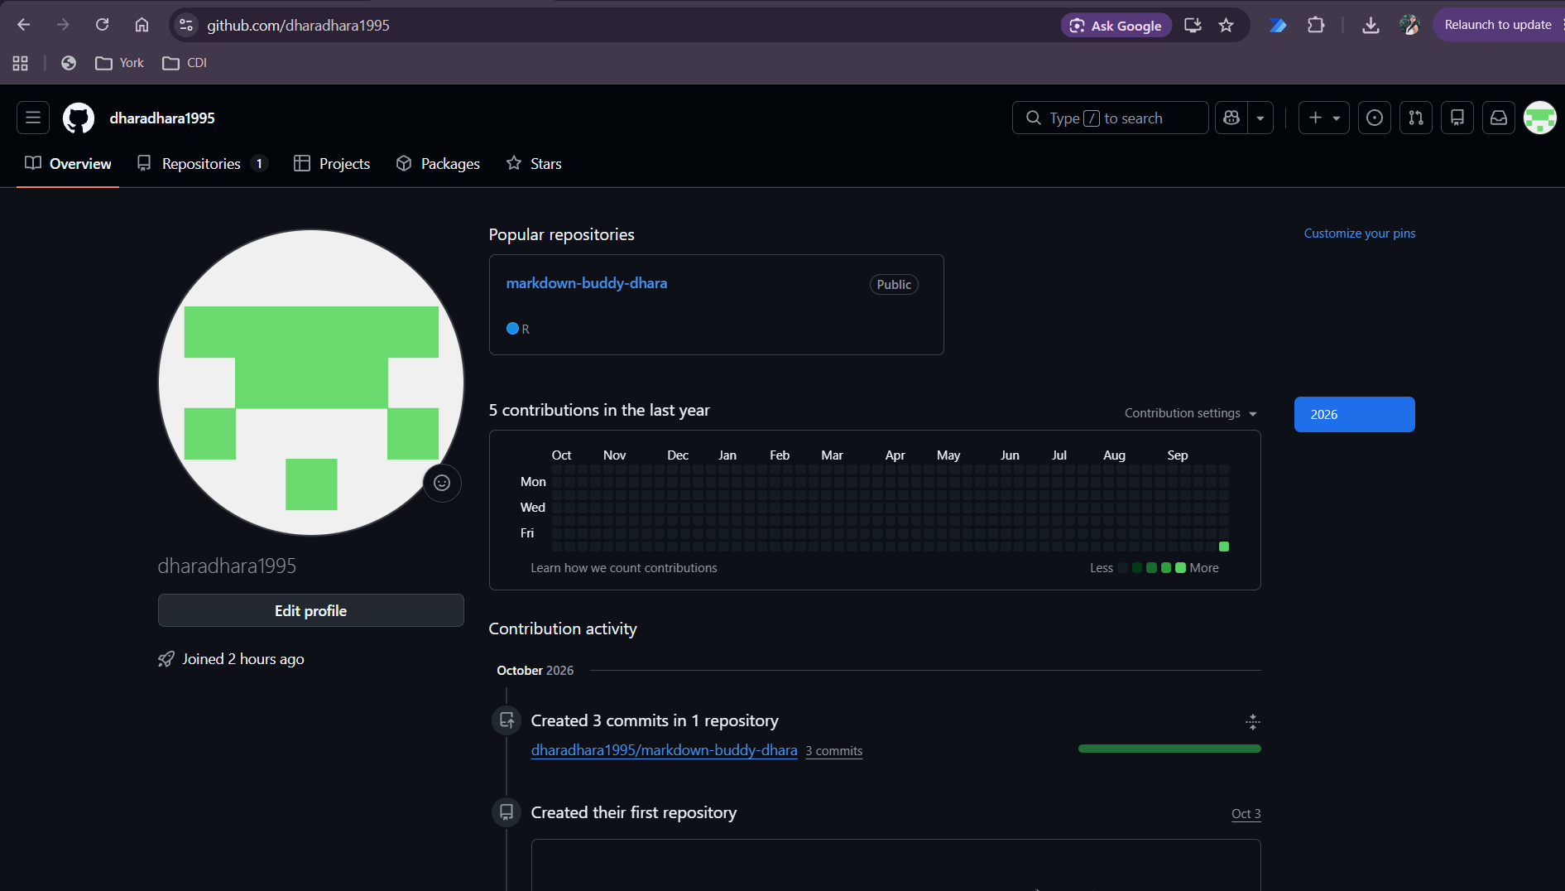
Figure 1: GitHub dashboard after signing in
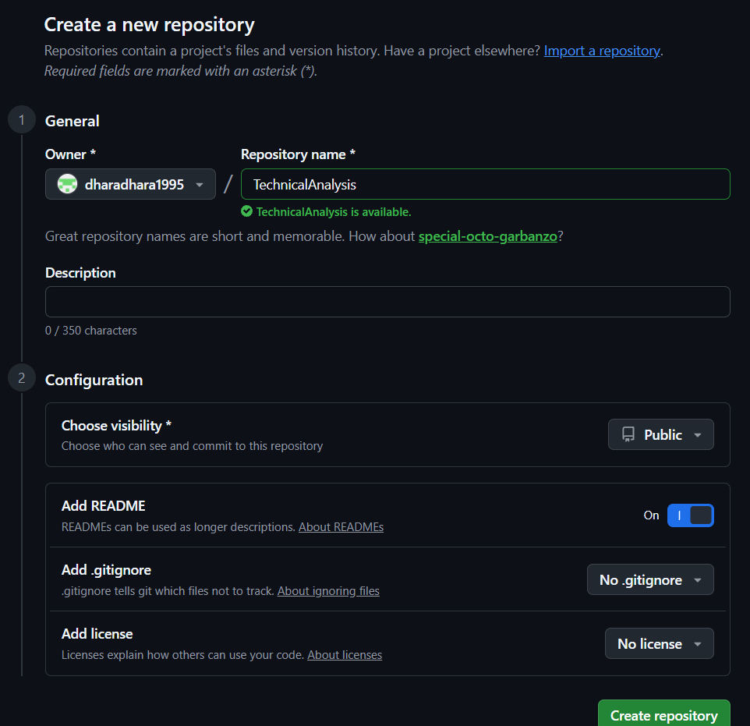
Figure 2: Creating the new repository named TechnicalAnalysis
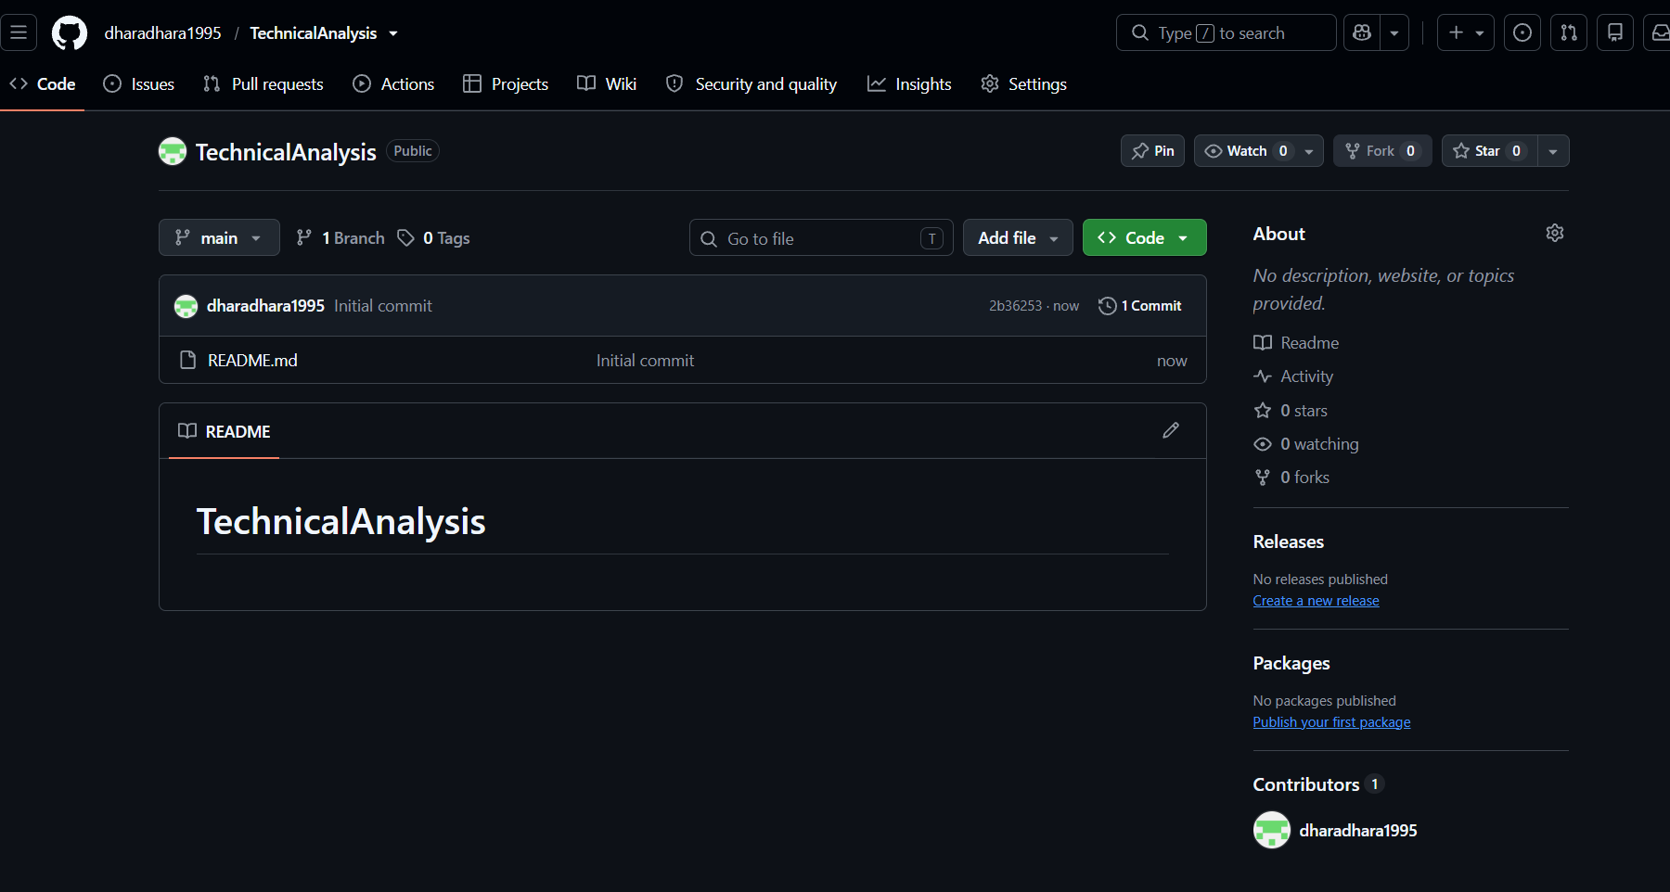
Figure 3: The new TechnicalAnalysis repository page
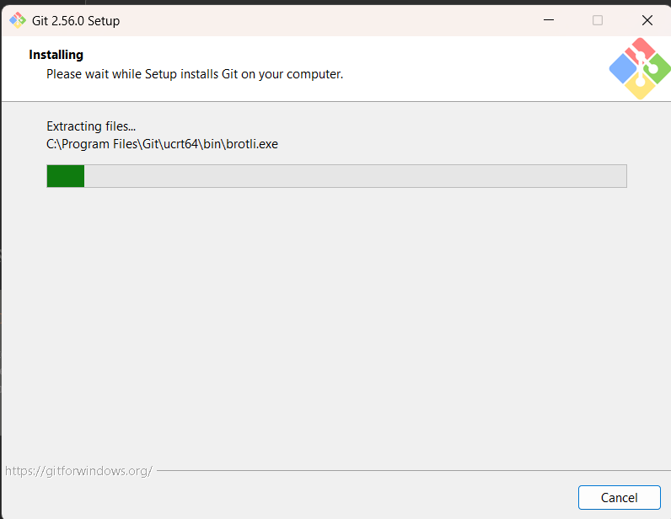
Figure 4: Git installer
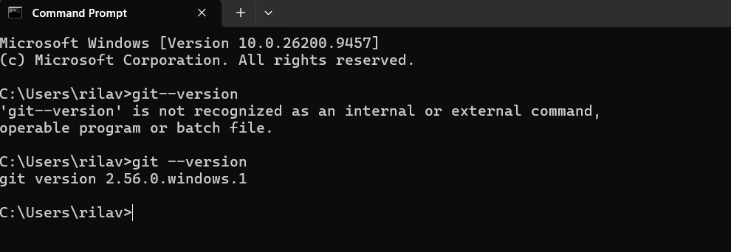
Figure 5: git --version output in the command prompt

Step 2: Installing and Configuring R and RStudio
R is the programming language and RStudio is the program (IDE) used to write and run R code. R has to be installed first because RStudio needs it to run.
- Went to cran.rstudio.com and downloaded the latest version of R for my operating system.
- Ran the R installer and kept the default settings.
- Went to the Posit website and downloaded RStudio Desktop (free version).
- Ran the RStudio installer with the default settings.
- Opened RStudio and confirmed it found R by checking the version shown in the Console.
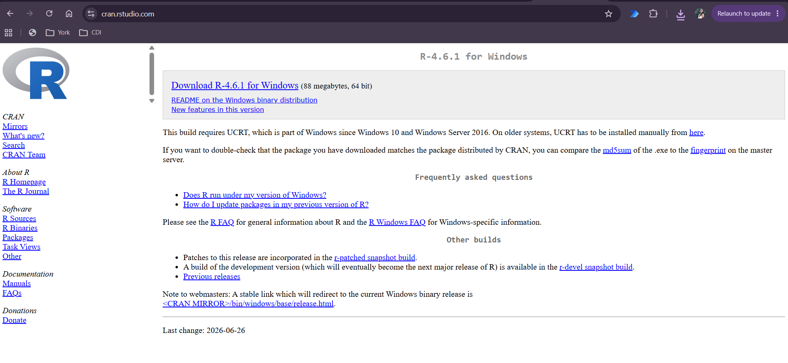
Figure 6: Downloading R from CRAN
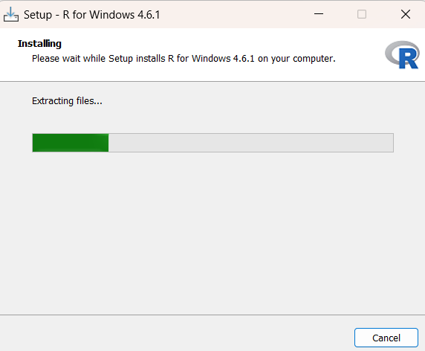
Figure 7: R installation wizard
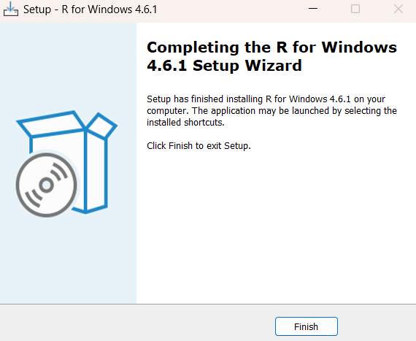
Figure 8: R installation completed
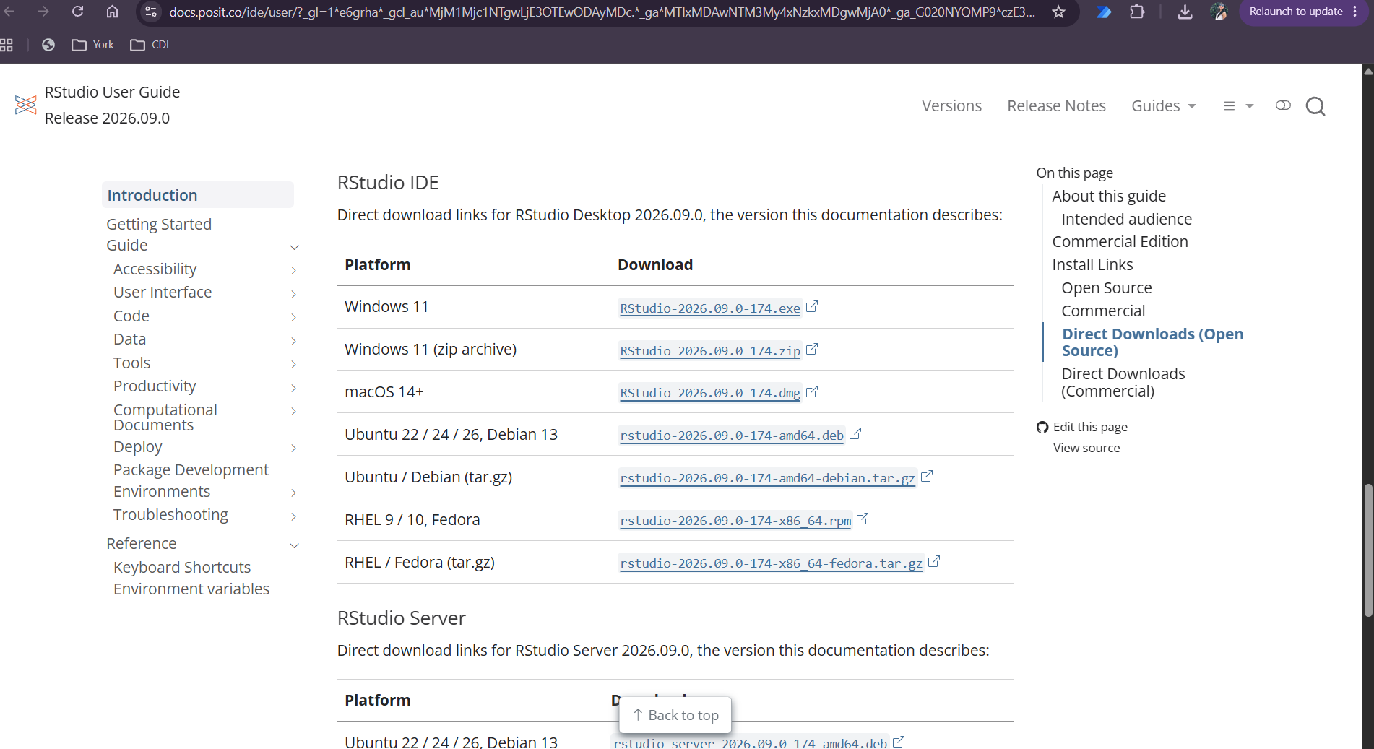
Figure 9: Downloading RStudio Desktop
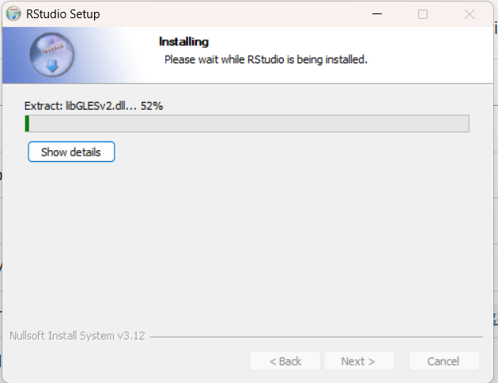
Figure 10: RStudio installation wizard
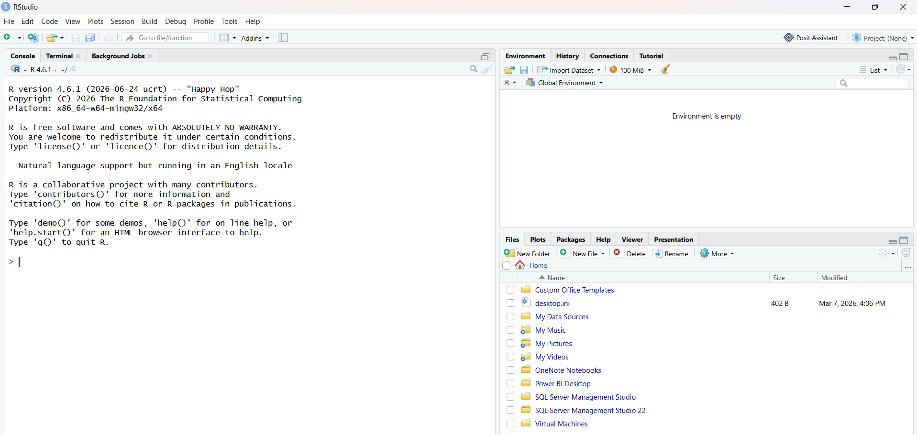
Figure 11: RStudio open with the R version in the Console

Step 3: Installing R Packages for Technical Analysis
I installed two main packages using the install.packages() function in the RStudio Console. Other packages they need, like xts and zoo, were installed automatically as dependencies.
- quantmod: downloads stock price data from Yahoo Finance and makes financial charts like candlestick charts.
- TTR (Technical Trading Rules): calculates technical indicators such as the simple moving average (SMA).
install.packages(c("quantmod", "TTR"))

library(quantmod)
library(TTR)

After installing, I loaded both packages with library() to make sure they work. No errors were shown.
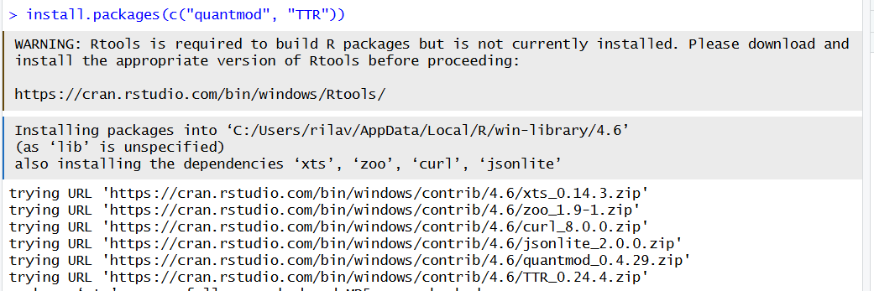
Figure 12: Running install.packages() in the RStudio Console
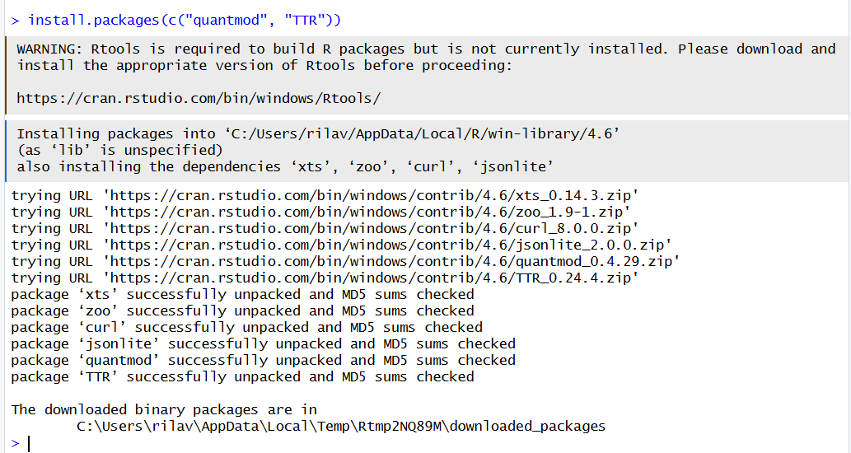
Figure 13: Packages installed successfully
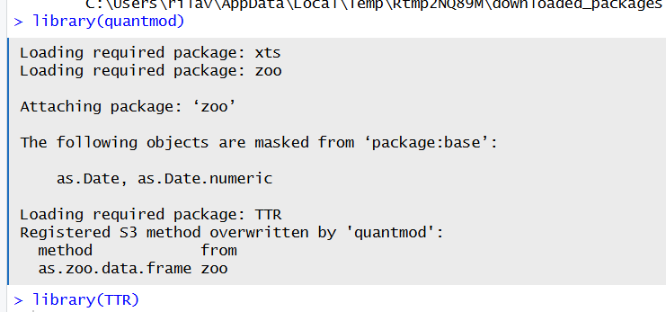
Figure 14: Loading quantmod and TTR with library() without errors
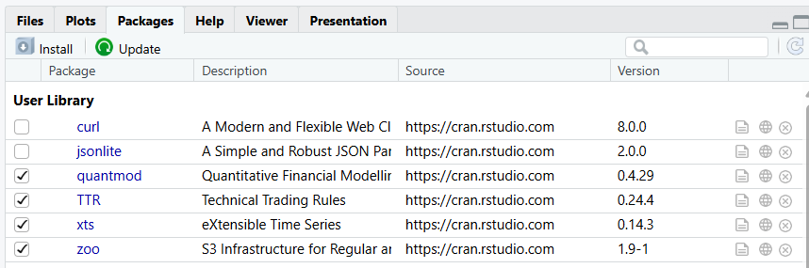
Figure 15: quantmod and TTR shown in the Packages tab

Step 4: Project Configuration and Initialization
I created a folder called Assignment2 for this assignment and a text file named portfolio.txt inside it. The file lists the stock symbols in my portfolio, one per line, in uppercase with no extra spaces. I chose five large technology and consumer companies:
AAPL
MSFT
AMZN
TSLA
NVDA

Symbol | Company
AAPL | Apple Inc.
MSFT | Microsoft Corporation
AMZN | Amazon.com Inc.
TSLA | Tesla Inc.
NVDA | NVIDIA Corporation

I also set the working directory in RStudio to the Assignment2 folder (Session > Set Working Directory > To Source File Location) so the script can find portfolio.txt.
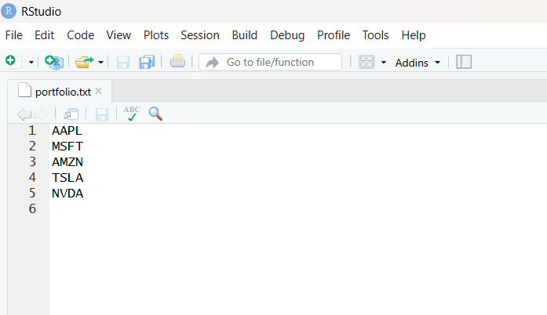
Figure 16: portfolio.txt opened in RStudio

Step 5: Function to Import and Load Stock Data
The function load_stock_data() reads portfolio.txt and downloads the data for each symbol from Yahoo Finance using getSymbols() from quantmod. I used one year of daily data (October 1, 2025 to October 1, 2026). Each stock is converted from xts format to a normal data frame with the columns Date, Open, High, Low, Close, Volume and Adjusted.
The function returns a list with one data frame per stock. It also saves each one as its own data frame (for example AAPL_df and MSFT_df), so every stock is stored separately and can be seen in the Environment pane. I used tryCatch() so that if one symbol fails to download, the script shows a message and keeps going with the other stocks.

load_stock_data <- function(file = portfolio_file,
from = start_date, to = end_date) {
symbols <- read_portfolio(file)
stock_list <- list()
for (sym in symbols) {
stock_xts <- getSymbols(sym, src = "yahoo", from = from,
to = to, auto.assign = FALSE)
stock_df <- data.frame(Date = index(stock_xts), coredata(stock_xts))
stock_list[[sym]] <- stock_df
}
return(stock_list)
}

(Shortened version. The full function with error handling is in technical_analysis.R.)
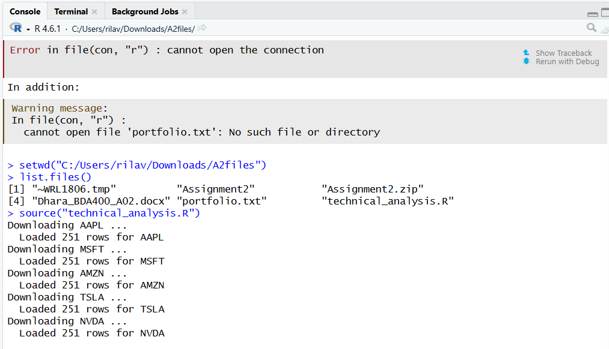
Figure 17: Console messages showing each stock downloaded and the number of rows
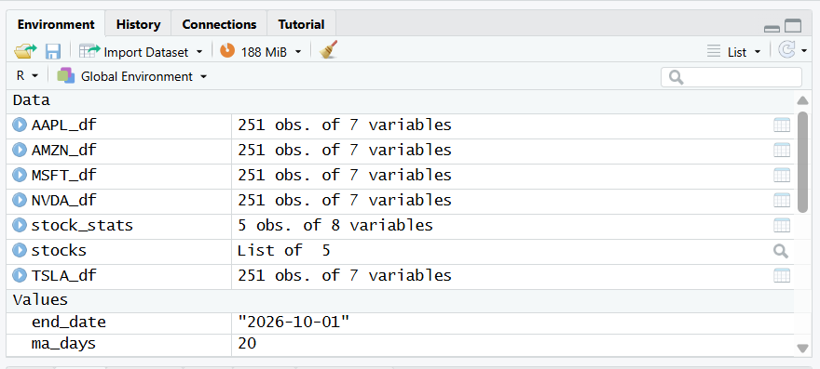
Figure 18: Environment pane showing a separate data frame for each stock

Step 6: Functions to Compute Basic Statistics
The function calculate_statistics() takes one stock data frame and calculates the statistics on the closing price. The function calculate_all_statistics() runs it for every stock and puts the results in one data frame, with one row per stock.
Statistic | How it is calculated
Moving average | 20-day simple moving average using SMA() from TTR. The latest value is shown in the table.
Mean | mean() of the closing prices
Median | median() of the closing prices
Mode | Custom get_mode() function (explained below)
Standard deviation | sd() of the closing prices, which shows how much the price moved around

Base R does not have a function for mode, so I wrote get_mode(). Stock prices almost never repeat exactly because they have cents (for example 231.47), so I rounded the prices to the nearest dollar first and then found the price level that appeared the most times.
get_mode <- function(x) {
x_rounded <- round(x, 0)
counts <- table(x_rounded)
as.numeric(names(counts)[which.max(counts)])
}

To check the function, I calculated the mean and standard deviation for AAPL directly in the Console with mean(AAPL_df$Close) and sd(AAPL_df$Close) and compared them to the statistics table.
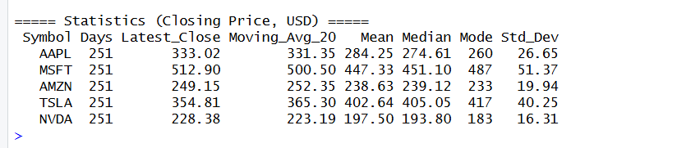
Figure 19: Statistics table for all five stocks
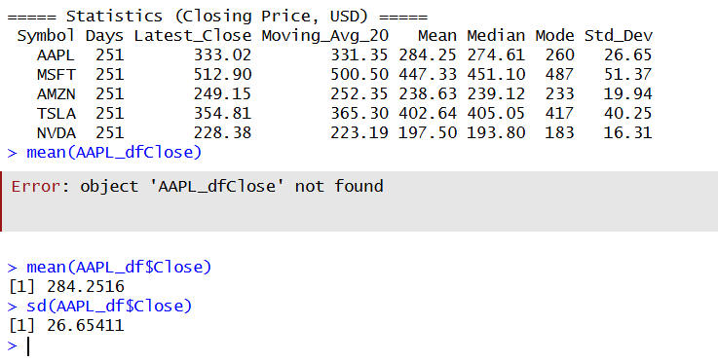
Figure 20: Checking AAPL mean and standard deviation in the Console

Step 7: Utilities to Display Output
After looking at how Yahoo Finance shows stock data (a price table, a line or candlestick chart, volume, and key statistics), I wrote these display functions:
- display_stock_data(): prints the date range, the number of trading days, and the first and last 5 rows of each stock.
- display_statistics(): prints the statistics table rounded to 2 decimals.
- plot_price_with_ma(): line chart of the closing price with the 20-day and 50-day moving averages and the mean.
- plot_candlestick(): candlestick chart with volume and a 20-day moving average, similar to Yahoo Finance.
- plot_statistics(): bar chart comparing the mean price of each stock, with standard deviation error bars.
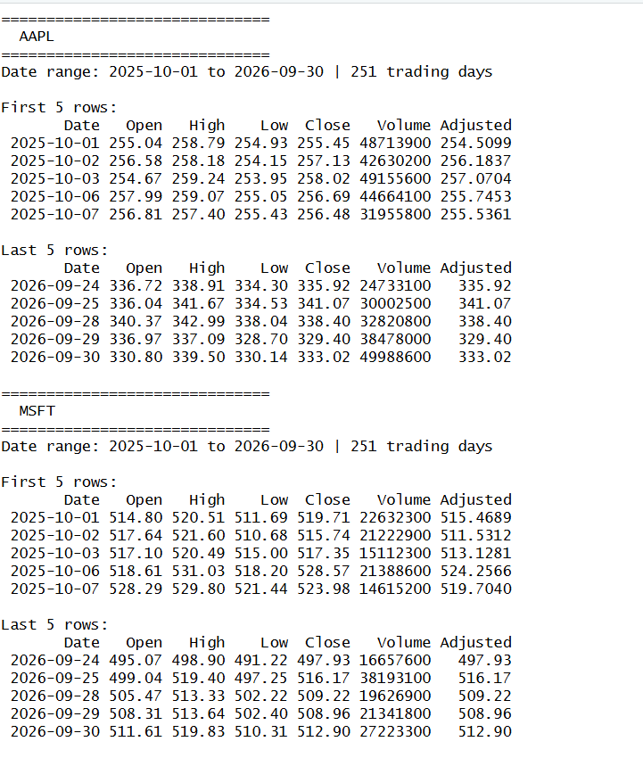
Figure 21: display_stock_data() output for the stocks in the Console
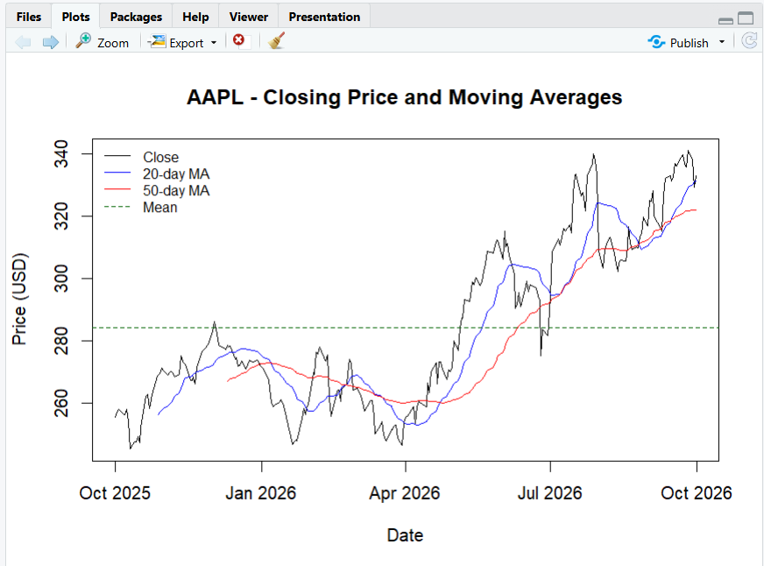
Figure 22: Line chart with moving averages for one stock
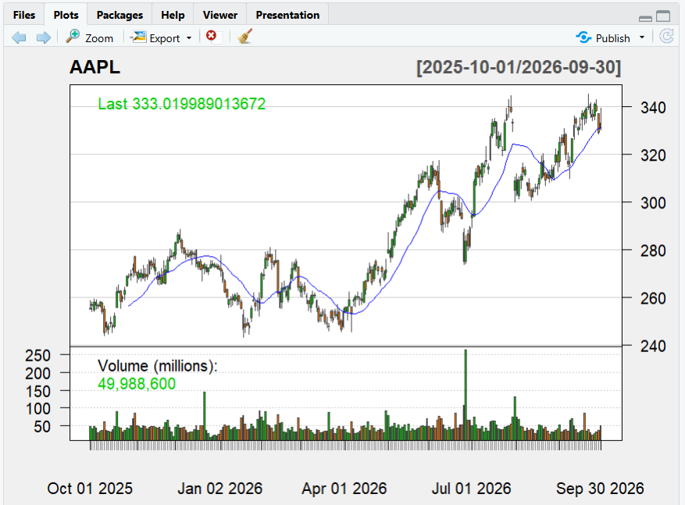
Figure 23: Candlestick chart with volume for one stock
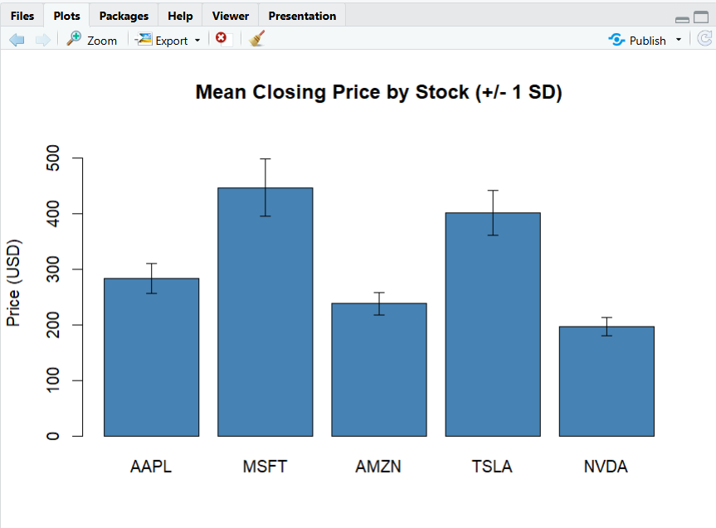
Figure 24: Bar chart comparing mean closing price of all stocks
The charts for every stock can be viewed by using the arrows in the RStudio Plots pane.

Step 8: Uploading Files to GitHub
I uploaded my files to the Assignment2 folder in the TechnicalAnalysis repository:
TechnicalAnalysis/
├── README.md
└── Assignment2/
├── portfolio.txt
├── technical_analysis.R
└── [Your file name]_BDA400_A02.docx

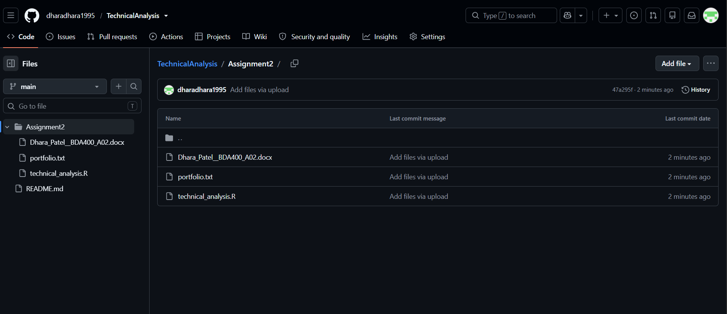
Figure 25: Assignment2 folder in the GitHub repository

Conclusion
In this assignment I set up the tools needed for the technical analysis project. The script reads my portfolio, downloads one year of data for each stock, calculates the moving average, mean, mode, median and standard deviation, and shows the results in tables and charts. The hardest part was the mode, since stock prices almost never repeat, so I had to round them first. This setup will be used in the next two stages of the project.

GitHub Repository Link
https://github.com/dharadhara1995/TechnicalAnalysis

