XYZ co-ordinate in open-layers or in-fact any XYZ mapping system follows below convention.

* It is also referred as slippy map numbering.
* Images are served through a web server, with URL like <http://.../Z/X/Y.png>, where z is zooming level. X /y are co-ordinate of tiles.
* X goes from top left edge to top right edge as x= 0 to x=2z-1
* Y goes from top edge to bottom edge as y=0 to y=2z-1
* Each Tiles is image of 256x256 pixels.
* At the outer most zoom level,x=0,y=0 z= 0, the entire image with pixel density as 256\*256.
* Each zoom level doubles in both dimensions, so a single tile is replaced by 4 tiles.

I will explain with example here with a dummy example. Consider below image.

Zoom level =0, x=0,y=0 we will send below image. For over case we will send an entire image mandelbot image with pixel density of 256\*256.

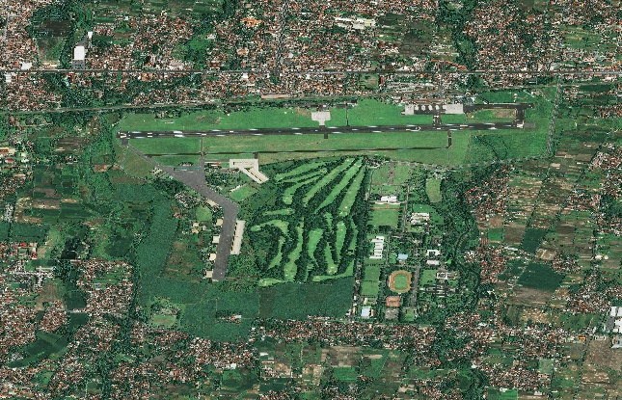

When user zoom in at level z=1. Above image is replaced by four images y,x =00,01,10,11, with z=1. 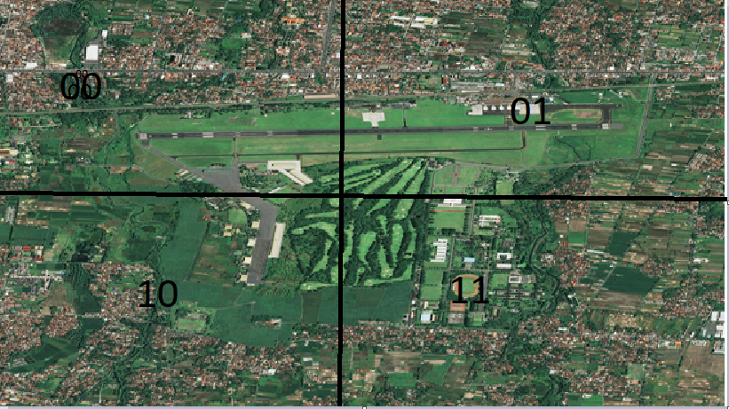

If server get request z=1,x=0,y=0 he will send left most tile of with pixel density as 256 \*256.



