EXTENSIVE GUIDE

TO USE THE PROPOSED SYSTEM

Brief Introduction to Our Proposed System 3

1.1 AES 4

1.2 How AES encryption works 4

2.2 AES Algorithm Description 5

How to use this system 7

3.1 Technical user 7

3.1.1 Technical Feasibility 7

3.1.2 Operational Feasibility 8

3.1.3 Unit testing 8

3.1.5 Functional vs Non-Functional Requirements 8

3.2 Non-Technical User 9

3.2.2 Encryption of data using tool 9

3.2.3 Uploading of data 9

3.2.4 Decryption of data 9

4.1 Prevention’s measures 10

4.2 Different Possible attacks 10

4.2.1 Phishing 11

4.2.2 Stick phishing 11

4.2.3 Vishing 11

4.2.4 Pretexting 11

4.2.5 Scareware 11

4.2.6 Redirection robbery 11

4.2.7 Compensation 11

4.2.8 Honey snare 11

4.2.9 Closely following 12

4.2.10 Dumpster plunging 12

4.2.11 Pharming 12

1**SECTION**

# Brief Introduction to Our Proposed System

To improve the security of user data in the proposed framework, a particular symmetric key Ks will be used by the user to encrypt the file before data moving to cloud server. A local data encryption (LDE) mechanism/interface will use the cryptography through cryptographic protocols. First the symmetric key will be introduced in the system. With help of symmetric cryptography called AES (Advanced Encryption Standard) a symmetric key will be provided to authorised user. This is more advanced encryption algorithm than RC4 and DES that is more sustainable and secured. The high level of AES model.

The local data encryption take place at the end system. The data encryption can be built with the help of the AES algorithm. The National Institute of Standard sand Technology (NIST)started development of AES in 1997 that is based on symmetric key. This algorithm used for encryption as well as for decryption as it complies of block of data with generated key sequence. It is widely used for data encryption in the network security, Secure Socket Layer (SSL) and in Transport Layer Security (TLS) protocols. On the other hand, in 2003 and 2013, severe vulnerabilities were traced by attackers thus the RC4 algorithm is not suitable to implement in a system directly. Therefore, various modified versions of RC4 are proposed by researchers. The proposed MRC4 modified RC4 encryption algorithm to overcome the weakness of RC4.

## 1.1 AES

The Advanced Encryption Standard (AES) is a symmetric square code picked by the U.S. government to ensure grouped data.

AES is executed in programming and equipment all through the world to encode delicate information. It is fundamental for government PC security, network safety and electronic information assurance. The National Institute of Standards and Technology (NIST) began improvement of AES in 1997 when it declared the requirement for an option in contrast to the Data Encryption Standard (DES), which was beginning to become defenceless against savage power assaults. NIST expressed that the more current, progressed encryption calculation would be unclassified and should be "fit for ensuring touchy government data well into the [21st] century." It was expected to be not difficult to execute in equipment and programming, just as in confined conditions - - like a shrewd card - - and offer nice guards against different assault methods.

AES was made for the U.S. government with extra intentional, free use in broad daylight or private, business or non-commercial projects that give encryption administrations. Notwithstanding, nongovernmentalassociationsdecidingtoutilizeAESaredependentuponconstraints made by U.S.

## 1.2 How AES encryption works

AES incorporates three square codes: AES-128 utilizations a 128-cycle key length to scramble and decode a square of messages. AES-192 utilizations a 192-piece key length to encode and unscramble a square of messages. AES-256 utilizations a 256-bit key length to scramble and unscramble a square of messages. Each code encodes and unscrambles information in squares of 128 pieces utilizing cryptographic keys of 128, 192 and 256 pieces, separately.

Symmetric, otherwise called secret key, figures utilize a similar key for encoding and unscrambling. The shipper and the recipient must both know - - and use - - a similar mystery key.

The public authority characterizes data in three classifications: Confidential, Secret or Top Secret. Everything key lengths can be utilized to ensure the Confidential and Secret level. Highly classified data requires either 192-or 256-digit key lengths.

There are 10 rounds for 128-bit keys, 12 rounds for 192-piece keys and 14 rounds for 256-digit keys. A round comprises of a few handling steps that incorporate replacement, interpretation and blending of the information plaintext to change it into the last result of ciphertext.

AES utilizes 128-, 192-or 256-bit keys to scramble and decode information. The AES encryption calculation characterizes various changes that are to be performed on information put away in a cluster. The initial step of the code is to place the information into an exhibit, later which the code changes are rehashed over various encryption adjusts.

The main change in the AES encryption figure is replacement of information utilizing a replacement table. The subsequent change shifts information columns. The third blends sections. The keep going change is performed on every section utilizing an alternate piece of the encryption key. Longer keys need more adjusts to finish.

The following provides you with the preamble to use AES and different algo of AES.

**2.1 Difference between AES vs. DES?**

The U.S. government made DES computations north of 40 years preceding assurance government systems by and large used something basically the same, secure standard to work with interconnectivity.

DES filled in as the vital piece of government cryptography for quite a while until 1999, when experts broke the computation’s 56-digit key using an appropriated PC structure. In 2000, the U.S. government chose to use AES to get portrayed information. DES is at this point used in specific events for in invert closeness. DES used to be a normal encryption estimation. It was uprooted by AES in 2001.

2

**SECTION**

AES

The two rules are both symmetric square codes, but AES is even more mathematically capable. The chief benefit of AES lies in its key length decisions. The time expected to break an encryption estimation is clearly associated with the length of the key used to get the correspondence 128digit, 192-pieceor256-cyclekeys. Consequently, AESissignificantlymoregroundedthanthe56cycle key of DES. AES encryption is similarly generally faster, so it is incredible for applications, firmware and hardware that require low idleness or high throughput.

## 2.2 AES Algorithm Description

As per the AES, the AES calculation utilizes a 128-cycle symmetric, or single-key, block figure that encodes and unscrambles data. The AES encryption process makes ciphertext, which is an ambiguous, successfully incomprehensible change of plaintext information, the variant of data that people can peruse and comprehend. The result of the encryption cycle, the AES ciphertext, can’t be perused until a mystery AES key is utilized to unscramble it.

The encryption and decoding cycles can utilize 128-, 192-, and 256-digit key lengths to change over plaintext into ciphertext and ciphertext into plaintext. These cycles are known as encryption and decoding, individually.

In AES-encoded correspondences, a shipper and beneficiary are given a similar AES secret key, which is utilized to change over data into ciphertext just as into coherent plaintext. In the event that this data was to be captured by a programmer, the individual in question wouldn’t have the option to peruse it without the AES secret key, which, ideally, would just be known by the clients sending and getting encoded data. Here’s awe is taking example of what AES encryption ciphertext actually looks like:

Plaintext message: The acting president was diagnosed with a potentially terminal illness.

Cipher text message: bWhVOg5IxuiUw1TKrEjFD4CCw9r30KcSp8LU49JXX89i5+K/Z55QeNgPnEoDtK90bbUjpbQZ

Best of luck attempting to extrapolate from the ciphertext that the acting president may be kicking the bucket.

You’d have to have an AES secret key to decode it.

Along these lines, in this model, just a source or beneficiary with the AES secret key, accepting a programmer can’t take or get familiar with the substance of the key through different means, would have the option to discover that the acting president has been determined to have a possibly terminal sickness. To start, data is isolated into blocks, which are 128 pieces in size, or four-by-four sections of 16 bytes. There are eight pieces in a byte, and 16 increased by eight makes a square size of 128 pieces.

You’re still with me, correct? I trust so. You may have to lock in going ahead. We’ve worked on the AES encryption process however much as could reasonably be expected and incorporated an infographic to assist per users with bettering get what’s going on.

During AES encryption, later the information is isolated into squares of 128pieces, it goes through the accompanying changes:

Key extension, which makes new keys, known as round keys, for each resulting round of encryption, utilizing Rijndael’s key timetable. Round key option, during which the underlying round key is included with the blend of information that has been separated. Byte replacement, which substitutes each byte with an alternate byte dependent on the Rijndael S-box replacement box. Column moving, which moves each line of the partitioned information one space to one side for the subsequent line, two spaces to one side for the third line, and three spaces to one side for the fourth line. Section blending, which utilizes a pre-set-up lattice to increase the isolated information’s segments and make another square of code. Round key option, during which one more round key is added to the combination of sections. Later this underlying round, the cycle is rehashed nine, 11, or multiple times, contingent upon whether the AES calculation is utilizing a critical length of 128 pieces, 192 pieces, or 256 pieces. 128-cycle AES encryption goes through 10 change adjusts; 192-piece AES encryption goes through 12 change adjusts; and 256-bit AES encryption goes through 14 change adjusts. The means recorded above comprise one round, so there are nine, 11, and 13 adjusts left to go for 128-cycle AES encryption, 192-piece AES encryption, and 256-digit AES encryption, separately.

AES encryption can likewise be joined with other NIST-gave cryptographic calculations to upgrade and reinforce the encryption insurances for a business or alternately association’s delicate or characterized data, making an invulnerable cryptography mixed drink that repels autonomous and country state entertainers endeavouring to get too touchy and arranged data.

3**SECTION**

# How to use this system

## 3.1 Technical user

The technical user must care of the following parameter:

### 3.1.1 Technical Feasibility

A specialized attainability study evaluates the subtleties of how you expect to convey an item or administration to clients. Figure materials, work, transportation, where your business will be found, and the innovation that will be important to unite this. It’s the strategic or strategic arrangement of how your business will create, store, convey, and track its items or administrations. A specialized attainability study is a phenomenal device for both investigating and long haul arranging. It can fill in as a flowchart of how your items and administrations develop and travel through your business to genuinely arrive at your market. In Technical Feasibility current assets both equipment programming alongside required innovation are investigated/surveyed to foster task. This specialized attainability concentrate on gives report whether there exists right required assets and advances which will be utilized for project improvement. Alongside this, attainability concentrate likewise dissects specialized abilities and capacities of specialized group, existing innovation can be utilized or not, support and up-degree is simple or not for picked innovation and so forth

### 3.1.2 Operational Feasibility

In Operational Feasibility level of offering support to necessities is broke down alongside how much simple item will be to work and upkeep later organization. Alongside these other functional extensions are deciding ease of use of item, determining proposed arrangement by programming improvement group is adequate or not and so forth

### 3.1.3 Unit testing

Unit testing can save you a cerebral pain not too far off by getting issues before you notice them creating some issues. Assuming that a structure as of now has underlying unit testing, this can save you some time. Set aside some effort to explore that it is so natural to fabricate custom unit tests assuming you think you will exploit unit testing.

**3.1.4 Are there any realized security issues?**

This might seem like an easy decision; however, you wouldn’t believe how effectively this can sneak past. Possibly you’re investigating choices utilizing more established data or articles, and an answer that would have been favoured two years prior has been discovered to have issues.

Set aside the effort to investigate this ahead of time so you don’t get bushwhacked later

### 3.1.5 Functional vs Non-Functional Requirements

Prerequisite’s investigation is extremely basic interaction that empowers the accomplishment of a framework or programming task to be surveyed. Necessities are for the most part parted into two sorts: Functional and Non-useful prerequisites.

Functional Requirements: These are the prerequisites that the end client explicitly requests as essential offices that the framework should offer. This large number of functionalities should be fundamentally joined into the framework as a piece of the agreement. These are addressed or expressed as contribution to be given to the framework, the activity performed and the result anticipated. They are fundamentally the prerequisites expressed by the client which one can see straightforwardly in the end result, in contrast to the non-useful necessities.

Non- Functional Requirements: These are essentially the quality requirements that the framework should fulfil as indicated by the undertaking contract. The need or degree to which these variables are executed shifts from one task to other.

## 3.2 Non-Technical User

**3.2.1 Installation of Encryption tool**

First of all, a user needs to install an encryption tool.

### 3.2.2 Encryption of data using tool

User need to encrypt all their data using encryption tool before uploading to the server. when encryption completed a user need to store their encryption Key before uploading data to the server. because without the encryption key the data will not be decrypt and without key the data is of no use.

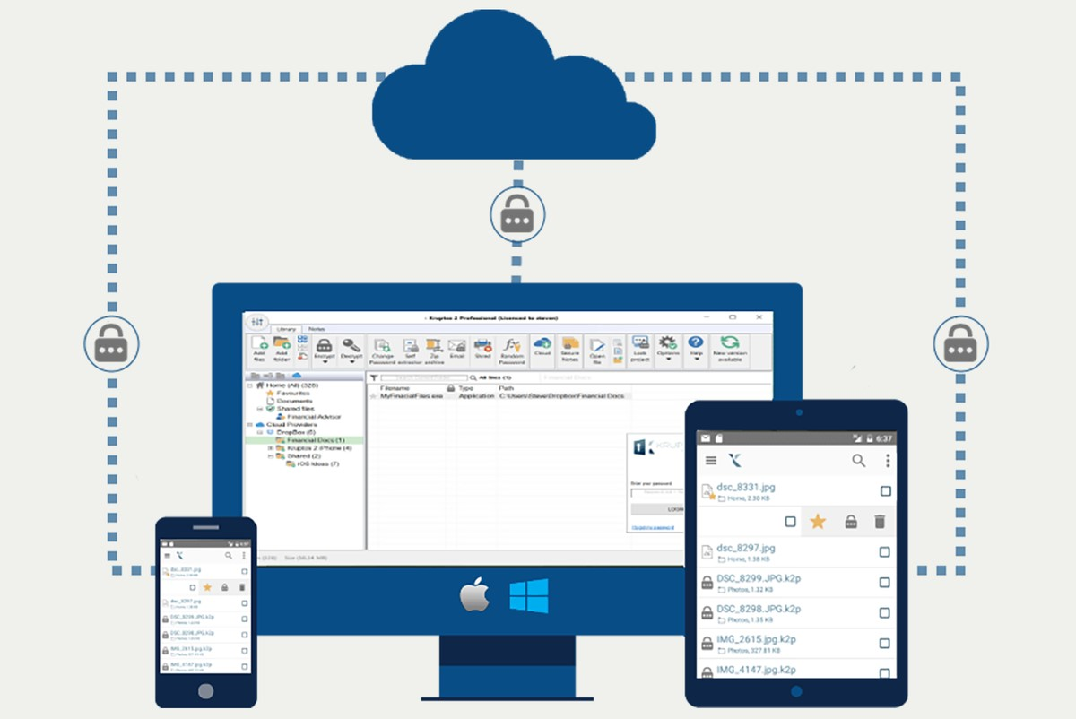

Figure 1: Work flow

### 3.2.3 Uploading of data

After that the user can upload the data to the server and now user is happy to upload the secure data to server with no worries.

### 3.2.4 Decryption of data

The user can decrypt the data again for their use using the encryption key provided while the encryption process.

## 

## 4.1 Prevention’s measures

Ensure data innovation divisions are routinely doing infiltration testing that utilizes social designing methods. This will assist heads with realizing which kinds of clients represent the most danger for explicit sorts of assaults, while likewise distinguishing which workers require extra preparing. Start a security mindfulness preparing program, which can go quite far toward forestalling social designing assaults. Assuming clients know what, social designing assaults resemble, they will be less inclined to become casualties. Execute secure email and web entryways to check messages for malevolent connections and channel them out, in this manner lessening the probability that a staff part will tap on one. Keep anti malware and antivirus programming forward-thinking to help forestall malware in phishing messages from introducing itself. Keep awake to date with programming and firmware patches on endpoints. Monitor staff individuals who handle touchy data, and empower progressed verification measures for them. Carry out 2FA to get to scratch accounts, e.g., an affirmation code by means of instant message or voice acknowledgment. Guarantee representatives don’t reuse similar passwords for individual and work accounts. In the event that a programmer executing a social designing assault gets the secret phrase for a worker’s online media account, the programmer could likewise get to the representative’s work accounts. Carry out spam channels to figure out which messages are probably going to be spam. A spam channel may have a boycott of dubious Internet Protocol locations or shipper IDs, or they may identify dubious records or connections, just as dissect the substance of messages to figure out which might be phony.

4

**SECTION**

Prevention’s

## 4.2 Different Possible attacks

Goading. An assailant leaves a malware-contaminated actual gadget, for example, a Universal Serial Bus streak drive, in a spot it makes certain to be found. The objective then, at that point, gets the gadget and additions it into their PC, inadvertently introducing the malware.

### 4.2.1 Phishing

At the point when a noxious party sends a deceitful email camouflaged as an authentic email, regularly indicating to be from a confided in source. The message is intended to fool the beneficiary into sharing monetary or individual data or tapping on a connection that introduces malware.

### 4.2.2 Stick phishing

This resembles phishing, yet the assault is custom-made for a particular individual or association.

### 4.2.3 Vishing

Otherwise called voice phishing, vishing includes the utilization of social designing via telephone to accumulate monetary or individual data from the objective. Whaling. A particular sort of phishing assault, a whaling assault targets high-profile representatives, like the CFO or CEO, to fool the designated worker into uncovering touchy data.

### 4.2.4 Pretexting

One party misleads one more to get close enough to advantaged information. For instance, a pretexting trick could include an aggressor who professes to require monetary or individual information to affirm the personality of the beneficiary.

### 4.2.5 Scareware

This includes fooling the casualty into thinking their PC is contaminated with malware or has incidentally downloaded illicit substance. The aggressor then, at that point, offers the casualty an answer that will fix the counterfeit issue; truly, the casualty is basically fooled into downloading and introducing the assailant’s malware. Watering opening. The assailant endeavours to think twice about explicit gathering of individuals by contaminating sites they are known to visit and entrust determined to acquire network access.

### 4.2.6 Redirection robbery

In this kind of assault, social designers stunt a conveyance or dispatch organization into going to some unacceptable pickup or drop-off area, subsequently catching the exchange.

### 4.2.7 Compensation

This is an assault wherein the social specialist professes to give something in return to the objective’s data or help. For example, a programmer calls a choice of irregular numbers inside an association and claims to be a specialized help expert reacting to a ticket. Ultimately, the programmer will observe somebody with a genuine tech issue whom they will then, at that point, claim to help. Through this cooperation, the programmer can have the objective sort in the orders to send off malware or can gather secret phrase data.

### 4.2.8 Honey snare

In this assault, the social designer professes to be an alluring individual to cooperate with an individual on the web, counterfeit a web-based relationship and accumulate delicate data through that relationship.

### 4.2.9 Closely following

Once in a while called piggybacking, closely following is the point at which a programmer strolls into a protected structure by following somebody with an approved admittance card. This assault assumes the individual with genuine admittance to the structure is adequately polite to hold the entry way open for the individual behind them, accepting they are permitted to be there. Rebel security programming. This is a kind of malware that fools focus into paying for the phony evacuation of malware.

### 4.2.10 Dumpster plunging

This is a social designing assault by which an individual ventures an organization’s waste to track down data, for example, passwords or access codes composed on tacky notes or pieces of paper, that could be utilized to penetrate the association’s organization.

### 4.2.11 Pharming

With this sort of online extortion, a cybercriminal introduces malignant code on a PC or server that consequently guides the client to a phony site, where the client might be fooled into giving individual data.