* **1.Single Layer Perceptron:**
* Number of Epochs: 977
* Accuracy: 100%
* Confusion Matrix:

|  |  |  |  |
| --- | --- | --- | --- |
|  | 10 | 0 |  |
|  | 0 | 10 |  |

* Decision Surface

* MATLAB Code

clc;clearvars;close all;

infile = 'Perceptron_single_target.xlsx';

datatable = readtable(infile);

headers = datatable.Properties.VariableNames; headers(:,end)=[];

inputs = datatable.Variables; clear datatable;

target = inputs(:,end); inputs(:,end)=[];

[no_of_instances,no_of_features] = size(inputs);

inputs = [ones(no_of_instances,1),inputs];

weights = zeros(no_of_features+1,1);

max_epoch = 1000;

target_accuracy = 95;

total_classifications = no_of_instances;

for epoch = 1:max_epoch

for instance_number = 1:no_of_instances

instance_vector = inputs(instance_number,:);

z = instance_vector*weights;

y_predicted = signum_activation(z);

y_actual = target(instance_number);

error = y_actual - y_predicted;

weights = weights + error*instance_vector';

end

Y_predicted = signum_activation(inputs*weights);

error_all = target-Y_predicted;

misclassifieds = sum(abs(error_all));

accuracy = (total_classifications-misclassifieds)/total_classifications*100;

if accuracy >= target_accuracy

break;

end

end

confusion_matrix=zeros(2);

for instance_number = 1:no_of_instances

y_predicted = Y_predicted(instance_number);

y_actual = target(instance_number);

m = y_predicted+1; n = y_actual+1;

confusion_matrix(m,n)=confusion_matrix(m,n)+1;

end

confusion_matrix,accuracy, epoch

for i=1:100

for j=1:100

instance_vector = [1 i j];

z = dot(weights,instance_vector);

if z<0

plot(i,j,'*r')

else

plot(i,j,'*g')

end

hold on

end

end

function neuron_outputs = signum_activation(neuron_inputs)

[no_of_neurons,no_of_instances] = size(neuron_inputs);

neuron_outputs = ones(no_of_neurons,no_of_instances);

neuron_outputs(neuron_inputs < 0)= 0;

end

* **2.Multi-Layer Perceptron:**
* Number of Epochs: 6
* Accuracy: 92.5%
* Confusion Matrix:

|  |  |  |  |
| --- | --- | --- | --- |
|  | 20 | 0 |  |
|  | 3 | 17 |  |

* Class Prediction Plots:

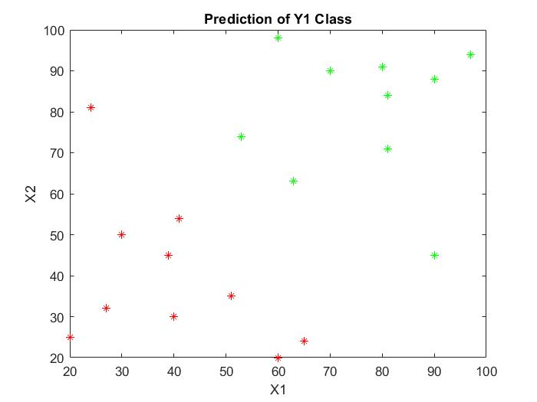

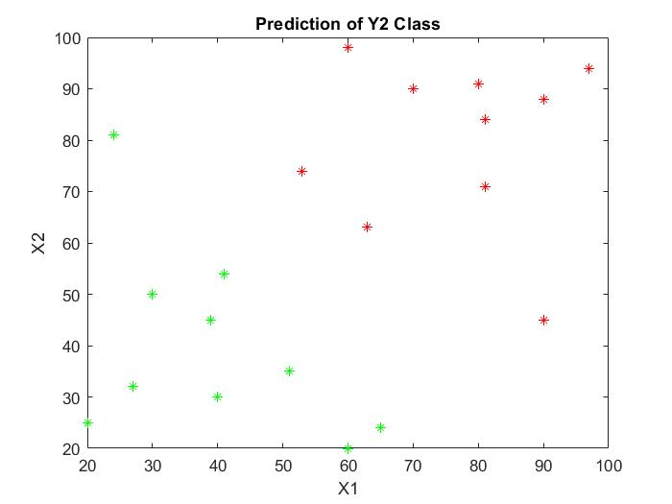

* MATLAB Codes:

clc;clearvars;close all;

infile = 'Perceptron_multi_target.xlsx';

no_of_targets = 2;

datatable = readtable(infile);

headers = datatable.Properties.VariableNames; headers(:,end)=[];

inputs = datatable.Variables; clear datatable;

targets = inputs(:,end-no_of_targets+1:end);

inputs(:,end-no_of_targets+1:end)=[];

[no_of_instances,no_of_features] = size(inputs);

inputs_normalized = (inputs-mean(inputs))./std(inputs);

inputs_normalized = [ones(no_of_instances,1),inputs_normalized];

weights = zeros(no_of_features+1,no_of_targets);

learning_rate = 0.01;

max_epoch = 10000;

target_accuracy = 90;

total_classifications = no_of_instances*no_of_targets;

for epoch = 1:max_epoch

for instance_number = 1:no_of_instances

instance_vector = inputs_normalized(instance_number,:);

z = instance_vector*weights;

y_predicted = signum_activation(z);

y_actual = targets(instance_number,:);

error = y_actual - y_predicted;

weights = weights+learning_rate*(transpose(instance_vector)*error);

end

Y_predicted = signum_activation(inputs_normalized*weights);

error_all = targets-Y_predicted;

misclassifieds = 0.5*sum(sum(abs(error_all)));

accuracy = (total_classifications-misclassifieds)/total_classifications*100;

if accuracy >= target_accuracy

break;

end

end

confusion_matrix = zeros(2);

for target_number = 1:no_of_targets

for instance_number=1:no_of_instances

y_predicted = Y_predicted(instance_number,target_number);

y_actual = targets(instance_number,target_number);

m = 0.5*(y_predicted+1)+1; n = 0.5*(y_actual+1)+1;

confusion_matrix(m,n)=confusion_matrix(m,n)+1;

x1=inputs(instance_number,1);x2=inputs(instance_number,2);

if y_predicted==-1

plot(x1,x2,'*r')

else

plot(x1,x2,'*g')

end

hold on

end

figure;

end

function neuron_outputs = signum_activation(neuron_inputs)

[no_of_neurons,no_of_instances] = size(neuron_inputs);

neuron_outputs = ones(no_of_neurons,no_of_instances);

neuron_outputs(neuron_inputs < 0)= -1;

end