* **Problem 1: KNN Clustering Analysis - Part 1**

|  |  |  |  |  |  |  |  |  |  |  |
| --- | --- | --- | --- | --- | --- | --- | --- | --- | --- | --- |
| CLUSTERS | CENTROIDS OF CLUSTER GROUP: | | | | | | | | | |
| **G1** | | **G2** | | **G3** | | **G4** | | **G5** | |
| C1 | C2 | C1 | C2 | C1 | C2 | C1 | C2 | C1 | C2 |
| **2** | 2.3 | 2.1 | 19.9 | 22.1 | **\*** | **\*** | **\*** | **\*** | **\*** | **\*** |
| **3** | 2.3 | 2.1 | 22.3 | 26.3 | 19.2 | 20.9 | **\*** | **\*** | **\*** | **\*** |
| **4** | 2.3 | 2.1 | 23.5 | 27.0 | 19.9 | 18.0 | 19.0 | 22.5 | **\*** | **\*** |
| **5** | 19 | 22.5 | 1.3 | 1.3 | 23.5 | 27.0 | 3.5 | 3.1 | 19.9 | 18.0 |

* + **Plots:**

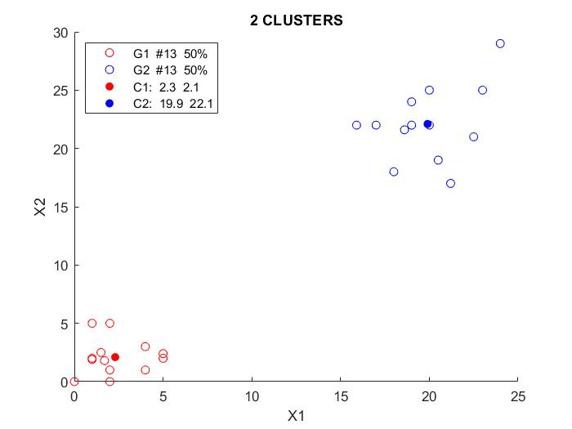

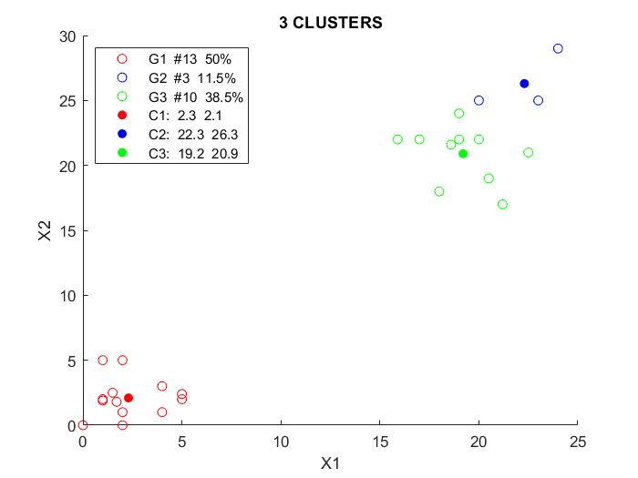

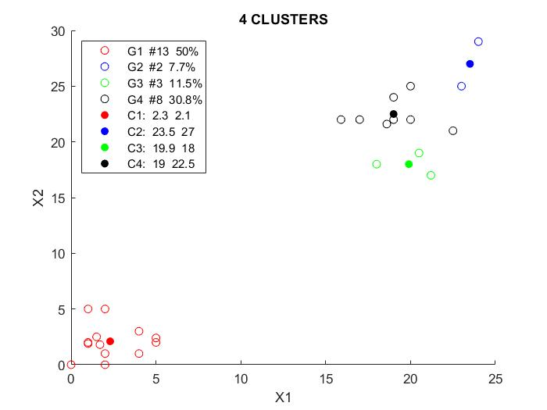

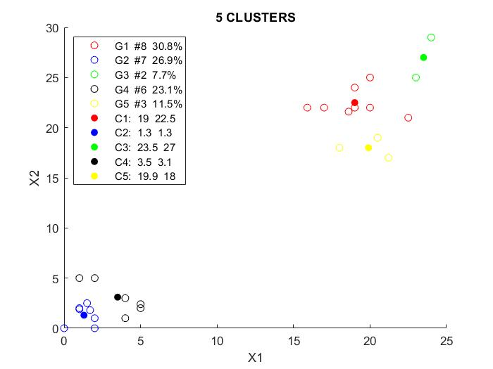

* **Problem 1: KNN Clustering Analysis - Part 2**

|  |  |  |  |  |
| --- | --- | --- | --- | --- |
| Clusters with Initial Centroids | Cluster Centroids | | | |
| **G1** | | **G2** | |
| C1 | C2 | C1 | C2 |
| **Using KNN++** | 2.3 | 2.1 | 19.9 | 22.1 |
| **With (5,5) & (8,8)** | 2.3 | 2.1 | 19.9 | 22.1 |

* + **Plots:**



* MATLAB Code

clc;clearvars;close all;clear figure;

infile = 'clust_data.xlsx';

%% Reading data

datatable = readtable(infile);

headers = datatable.Properties.VariableNames; headers(:,end)=[];

data = datatable.Variables; clear datatable;

%% Calling Clustering function

no_of_clusters = 2;

intial_centroids=[5,5;8,8];

%clusters = KNNplus_clustering(data,no_of_clusters);

clusters = KNNplus_clustering(data,no_of_clusters,intial_centroids);

%% Plot the final clusters

color = ['r','b','g','k','y'];

lgd_txt=strings(1,no_of_clusters*2);

plots=gobjects(no_of_clusters*2,1);

centroids=round(clusters.centroids,1);

K=no_of_clusters;

for i = 1:K

Xc= centroids(i,1);

Yc= centroids(i,2);

X = data(clusters.cluster_nos==i,1);

Y = data(clusters.cluster_nos==i,2);

no= strcat('#',string(clusters.numbers(i)));

pe= strcat(string(clusters.percentage(i)),'%');

lgd_txt(i)=strcat('G',string(i),{' '},no,{' '},pe);

tx= string(centroids(i,1));

ty= string(centroids(i,2));

lgd_txt(i+K)=strcat('C',string(i),':',{' '},tx,{' '},ty);

hold on

plots(i)=scatter(X,Y,color(i));

plots(i+K)=scatter(Xc,Yc,color(i),'filled');

end

title_text = strcat(string(no_of_clusters),{' '},'CLUSTERS');

xlabel('X1');ylabel('X2');title(title_text);

legend(plots,lgd_txt,'Location','northwest');

hold off

-------------------------------------------------------------------------

function clusters = KNNplus_clustering(data,no_of_clusters,varargin)

%data = (data-mean(data))./std(data);

[nI,nF] = size(data);

%% Parameters defination

K = no_of_clusters;

if K==1

clusters.cluster_nos = ones(nI,1);

clusters.numbers = nI;

clusters.percentage = 100;

clusters.centroids = mean(data);

diff = data-clusters.centroids;

clusters.variance = 0.5*sum(diff.*diff,'all')/nI;

return;

end

dist_old = 10^6;

termination_threshold = 10^-8;

%% Parameters Initiazation

cluster_nos = zeros(nI,1);

numbers = zeros(K,1);

percentage = zeros(K,1);

threshold = 100;

iterations = 0;

%% Initial centroids

if isempty(varargin) %for default, use KNN++ approach

centroids = zeros(K,nF);

centroids(1,:) = data(randi(nI),:);

dist=zeros(nI,1);

for i=2:K

for m = 1:nI

instance = data(m,:);

delta = centroids(1:i-1,:)-instance;

euclid = sqrt(sum(delta.*delta,2));

dist(m) = min(euclid);

end

[~,n]=max(dist);

centroids(i,:)=data(n,:);

end

elseif length(varargin)==1

[nC,nDc] = size(varargin{1});

if or(nC~=K,nDc~=nF)

disp('clustering unsuccessful:centroid dimensions do not match');

return;

else

centroids = varargin{1};

end

else

disp('clustering unsuccessful:too many inputs');

return;

end

%% Clustering

while threshold > termination_threshold

% Finding Euclidean distance of data points

dist_new=0;

if iterations~=0

for j=1:K

instances = data(cluster_nos==j,:);

centroids(j,:)= mean(instances,1);

end

end

for i=1:nI

instance = data(i,:);

delta = (centroids-instance);

euclid = sqrt(sum(delta.*delta,2));

[min_dist,cluster_nos(i)]=min(euclid);

dist_new = dist_new+min_dist;

end

% Finding new centroids

threshold = (abs(dist_old-dist_new)/dist_old);

dist_old = dist_new;

iterations = iterations+1;

end

disp(iterations);

clusters.cluster_nos = cluster_nos;

clusters.numbers = zeros(K,1);

clusters.percentage = zeros(K,1);

clusters.centroids = centroids;

clusters.variance = zeros(K,1);

for j=1:K

instances = data(cluster_nos==j,:);

delta = instances-centroids(j,:);

clusters.numbers(j) = size(instances,1);

clusters.percentage(j)= round(clusters.numbers(j)/nI*100,1);

clusters.variance(j) = 0.5*sum(delta.*delta,'all')/clusters.numbers(j);

end

end

-------------------------------------------------------------------------

* **Problem 2: Radial Basis Neural Network**

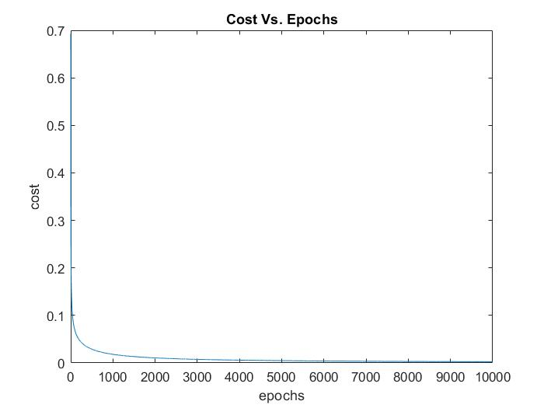

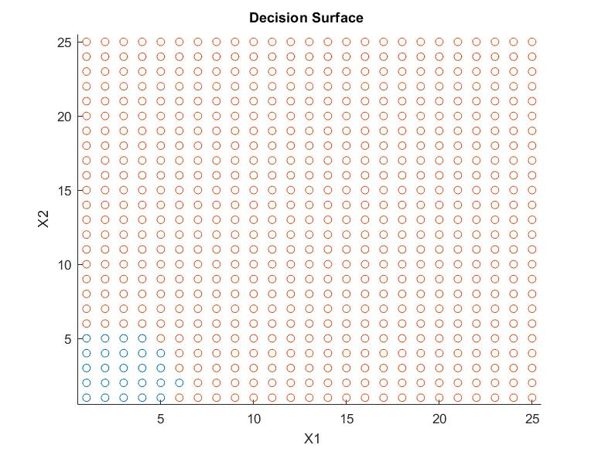

* MATLAB Code

clc;clearvars;close all;

infile = 'Clust_data_RBFNN.xlsx';

datatable = readtable(infile);

headers = datatable.Properties.VariableNames; headers(:,end)=[];

training_data = datatable.Variables; clear datatable;

network_architecture.learning_rate = 5;

network_architecture.max_epoch = 10000;

network_architecture.receptors = [1,1]; %no. of receptors for each class

trainedNeuralNetwork = RadialBasisClassifier(network_architecture,training_data);

cost = trainedNeuralNetwork.cost;

max_epoch = network_architecture.max_epoch;

plot(1:max_epoch,cost);

title('Cost Vs. Epochs');xlabel('epochs');ylabel('cost');

no_of_class = length(network_architecture.receptors);

data=zeros(25*25,2);k=1;

for i=1:25

for j=1:25

data(k,:)= [i j];

k=k+1;

end

end

predicteds=predictoutput_rbfnn(trainedNeuralNetwork,data);

figure;

for k=1:no_of_class

class_instances=data(predicteds==k,:);

scatter(class_instances(:,1),class_instances(:,2));

hold on

end

-------------------------------------------------------------------------

function trainedNeuralNetwork = RadialBasisClassifier(network_architecture,data)

trainedNeuralNetwork.network_architecture=network_architecture;

learning_rate = network_architecture.learning_rate;

max_epoch = network_architecture.max_epoch;

receptors = network_architecture.receptors;

no_of_receptors = sum(receptors);

no_of_class = length(receptors);

%%data = transpose(data);

inputs = data(:,1:end-1);

targets = data(:,end); clear data;

[no_of_instances,no_of_features] = size(inputs);

cost = zeros(max_epoch,1);

weights = zeros(no_of_class,no_of_receptors+1);

n=1;

centroids=zeros(no_of_receptors,no_of_features);

variance=zeros(no_of_receptors,1);

for class_num = 1:no_of_class

class_data = inputs(targets==class_num,:);

no_of_clusters = receptors(class_num);

m = no_of_clusters+n-1;

clusters = KNNplus_clustering(class_data,no_of_clusters);

centroids(n:m,:)= clusters.centroids;

variance(n:m,:) = clusters.variance;

n = m+1;

end

phi=zeros(no_of_instances,no_of_receptors);

for r=1:no_of_receptors

diff=inputs-centroids(r,:);

phi(:,r)=exp(-0.5*sum(diff.*diff,2)/variance(r));

end

phi = transpose([ones(no_of_instances,1),phi]);

indices = sub2ind([no_of_class,no_of_instances],targets,(1:no_of_instances)');

for epoch = 1:max_epoch

netinputs = weights*phi;

predicteds = softmax_activation(netinputs);

cost(epoch,1)= sum(-log(predicteds(indices)))/no_of_instances; %cross entropy

delta = predicteds; clear predicted;

delta(indices)=delta(indices)-1;

gradient = delta*transpose(phi)/no_of_instances;

weights = weights - learning_rate*gradient;

end

trainedNeuralNetwork.weights=weights;

trainedNeuralNetwork.cost =cost;

trainedNeuralNetwork.receptors.centroids=centroids;

trainedNeuralNetwork.receptors.variance=variance;

end

-------------------------------------------------------------------------

function activations = softmax_activation(netinputs)

activations = exp(netinputs);

activations = activations./sum(activations);

end

-------------------------------------------------------------------------

function predicteds = predictoutput_rbfnn(trainedNeuralNetwork,inputs)

receptors = trainedNeuralNetwork.network_architecture.receptors;

weights = trainedNeuralNetwork.weights;

centroids = trainedNeuralNetwork.receptors.centroids;

variance = trainedNeuralNetwork.receptors.variance;

no_of_receptors = sum(receptors);

no_of_instances = size(inputs,1);

phi=zeros(no_of_instances,no_of_receptors);

for r=1:no_of_receptors

diff=inputs-centroids(r,:);

phi(:,r)=exp(-0.5*sum(diff.*diff,2)/variance(r));

end

phi = transpose([ones(no_of_instances,1),phi]);

netinputs = weights*phi;

activations = transpose(softmax_activation(netinputs));

[~,predicteds] = max(activations,[],2);

end

-------------------------------------------------------------------------