Unit III — Graphs & Isomorphism
Bipartite Knowledge Graphs and Permutation-Similarity Certificates
GROUP 4 • Discrete Mathematics • August 28, 2026
Educational mathematics assignment — not medical advice.

1. Case Title (Unit III Focus)
Modeling symptom–disease knowledge as a bipartite graph and proving that two different drawings are the same knowledge base.

2. Problem Statement (Unit III)
Can we model the knowledge base faithfully as a bipartite graph G=(S∪D,E)? How do we convince a reviewer that two drawings G and G′ with different layouts are isomorphic — i.e., the same knowledge?

3. Real-world Context
Medical editors maintain symptom–disease edges in different tools. Merging edits requires proving isomorphism, not trusting layout. Bipartite structure also enables 2-hop diagnosis: patient → symptom → disease.

4. Mathematical Concept Used
Bipartite graphs, degree sequences, biadjacency matrices, permutation matrices, and the certificate A₂ = P·A₁·Pᵀ.

5. Mathematical Formulation
V = S ∪ D, S={S₁ Fever, S₂ Cough, S₃ Rash, S₄ Fatigue}, D={D₁ Influenza, D₂ Measles, D₃ Anemia}, |V|=7, E={S₁D₁,S₁D₂,S₂D₁,S₃D₂,S₄D₁,S₄D₃}, |E|=6. Second representation reorders as (S₄,S₃,S₂,S₁ | D₃,D₂,D₁).

6. Analysis / Solution
Degrees: S₁=2,S₂=1,S₃=1,S₄=2,D₁=3,D₂=2,D₃=1; sequence sorted (3,2,2,2,1,1,1), sum 12=2·|E| (handshake lemma). Both drawings share |V|=7,|E|=6,bipartiteness and the sequence — necessary conditions. Bijection f(Sᵢ)=Sᵢ′,f(Dⱼ)=Dⱼ′ preserves all six edges; with equal edge counts non-edges are preserved. With reversal perms r_S=[3,2,1,0],r_D=[2,1,0], biadjacencies satisfy A₂=P·A₁·Pᵀ.

7. Diagram / Graph / Truth Table / Algorithm
Edge list:
# | Edge | Clinical meaning
1 | S₁ — D₁ | Fever indicates Influenza
2 | S₁ — D₂ | Fever indicates Measles
3 | S₂ — D₁ | Cough indicates Influenza
4 | S₃ — D₂ | Rash indicates Measles
5 | S₄ — D₁ | Fatigue indicates Influenza
6 | S₄ — D₃ | Fatigue indicates Anemia
Invariant comparison:
Invariant | Rep.1 | Rep.2 | Match
Vertices |V| | 7 | 7 | ✓
Edges |E| | 6 | 6 | ✓
Degree sequence | (3,2,2,2,1,1,1) | (3,2,2,2,1,1,1) | ✓
Bipartite | yes | yes | ✓

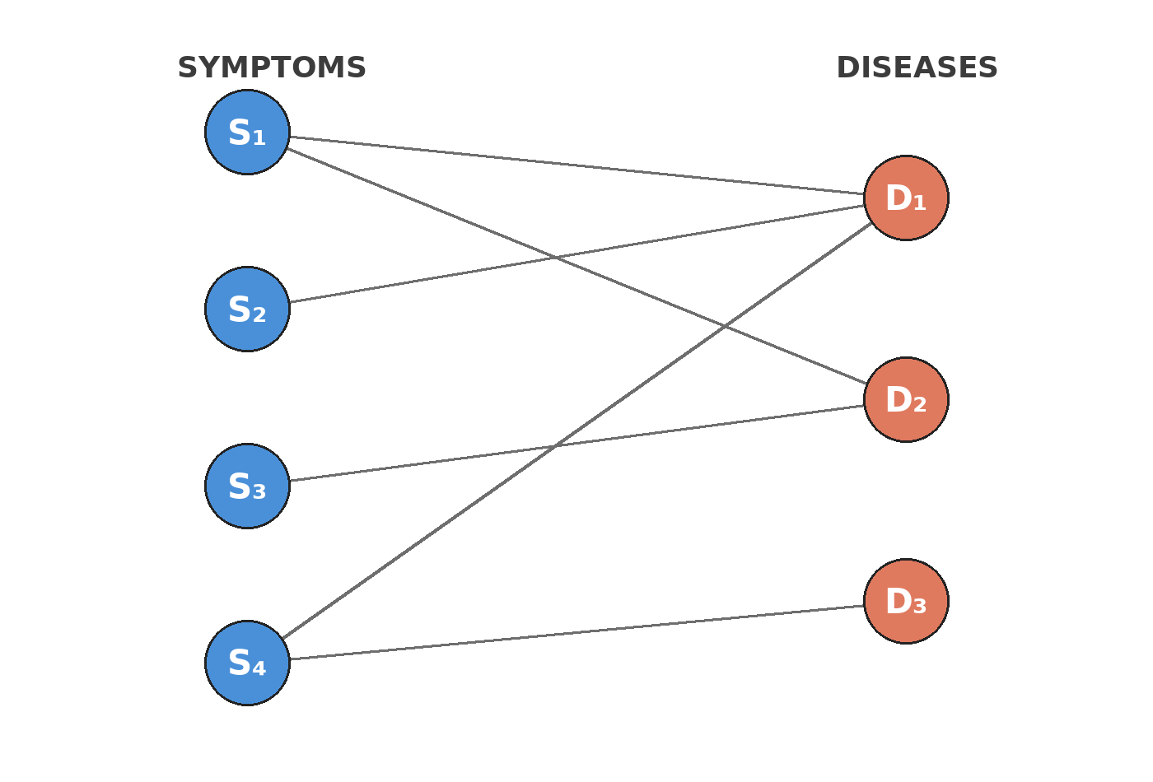
Figure 1 — Bipartite layout: symptoms left, diseases right.
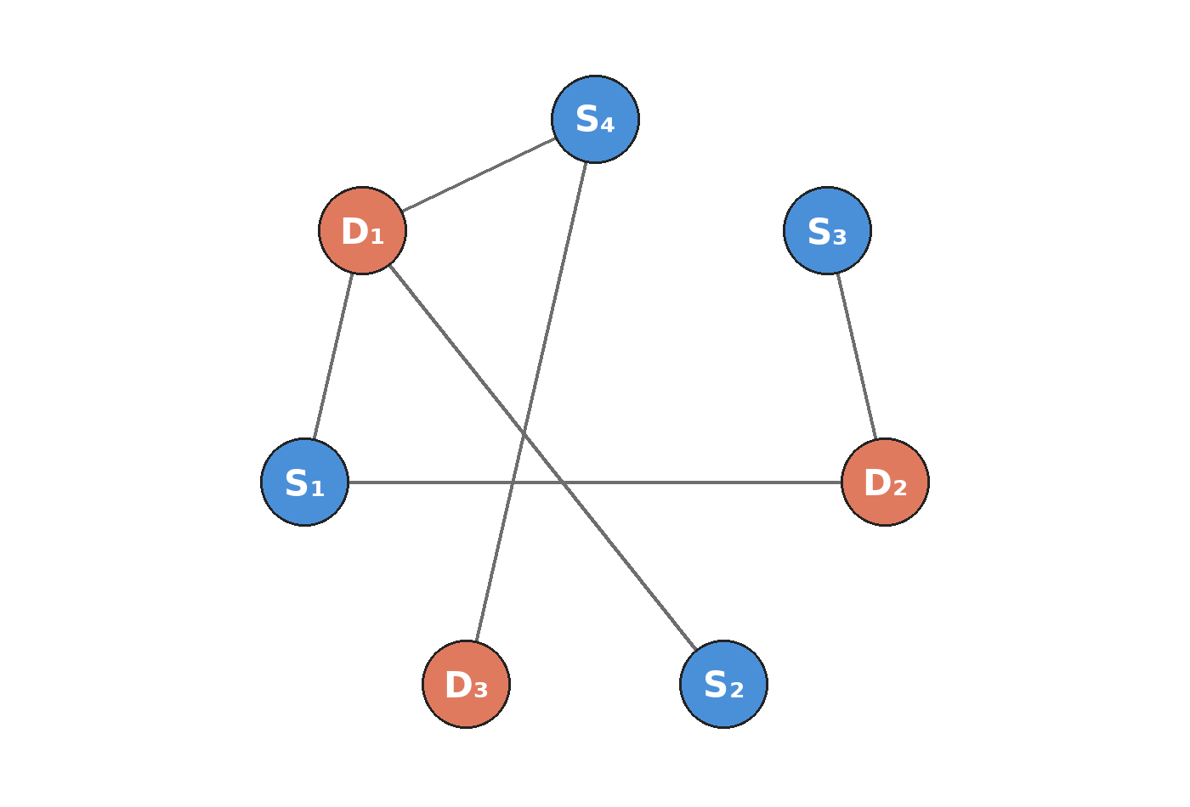
Figure 2 — Same network, circular scrambled layout. Only coordinates changed.
Biadjacency matrices:
 | D₁ | D₂ | D₃
S₁ | 1 | 1 | 0
S₂ | 1 | 0 | 0
S₃ | 0 | 1 | 0
S₄ | 1 | 0 | 1
Reordered (S₄…S₁ | D₃…D₁):
 | D₃ | D₂ | D₁
S₄ | 1 | 0 | 1
S₃ | 0 | 1 | 0
S₂ | 0 | 0 | 1
S₁ | 0 | 1 | 1
Algorithm — Merge check: compute A₁,A₂, degree sequences; if invariants differ → not isomorphic; else search for P with A₂=P·A₁·Pᵀ (exhaustive for n=7, else use canonical labeling).

8. Interpretation of Results
Identical invariants plus the exhibited P-matrix prove the drawings are one knowledge base. Layout is irrelevant; connectivity is the invariant. Practically, two editors can work in different tools and merge losslessly.

9. Practical Application
Deployed as the Isomorphism Explorer: one network, two layouts, toggle morphs bipartite↔circular with spring, clicking a vertex highlights incident edges and its degree (e.g., D₁ degree 3). Curators visualise and de-duplicate without fearing layout artefacts.

10. Innovation / Proposed Improvement
- Store the graph in a graph DB with adjacency lists; isomorphism becomes a merge tool for concurrent edits.
- Extend to a 3-partite patient–symptom–disease network for end-to-end diagnosis paths.

11. Conclusion
Bipartite modelling plus a permutation certificate turns a visual intuition (“same graph”) into a checkable artefact.

12. References
- Rosen, Chap. 10 — Graphs.
- Vite + Vitest + Playwright docs.
All counts and proofs in this report are computationally verified (see live site https://ai-medical-diagnosis-site.vercel.app).

