AI-Based Medical Diagnosis
A Discrete Mathematics Approach to Symptom-Based Triage
GROUP 4 • Mini R&D Report • 5–7 Pages
Discrete Mathematics • August 27, 2026

Educational mathematics assignment — not medical advice.
This report demonstrates propositional logic, combinatorics and graph theory on a synthetic 12-symptom knowledge base. No clinical data was used.

1. Title of the Case Study
AI-Based Medical Diagnosis: A Discrete Mathematics Framework for Symptom-Driven Triage — Group 4 Case Study on Logic, Counting and Bipartite Knowledge Graphs.
Keywords: propositional logic, hypothetical syllogism, combinatorics, bipartite graph, graph isomorphism, clinical decision support, explainable AI.

2. Problem Statement
A primary-care triage assistant must decide, from a database of n = 12 curated symptoms, whether to suspect disease X and recommend further testing. The naïve rule set is:
- Rule R1: If the patient presents both sentinel symptoms A and B together, suspect disease X.
- Rule R2: If disease X is suspected, recommend further testing T.
- Question Q: Does the pair (A ∧ B) alone logically justify T? The answer must be proved, not assumed.
A second, combinatorial question arises: the inference engine is configured to consider exactly k = 5 symptoms per evaluation. How many distinct symptom sets can the system examine? What if it is allowed to use at least five, or to rank the five by severity (order matters)? Under-counting wastes coverage; over-counting explodes storage and UI complexity.
Finally, the knowledge base is naturally a network linking symptoms to diseases. Can we model it faithfully as a bipartite graph, and how do we convince a reviewer that two different drawings of the same network are really the same knowledge?
Formally, the report answers: (i) prove (A ∧ B) → T from {(A ∧ B) → X, X → T}; (ii) compute C(12,5), Σ_{k≥5} C(12,k), P(12,5); (iii) exhibit a bipartite model and a permutation-based isomorphism certificate A₂ = P·A₁·Pᵀ.

3. Real-world Context
Explainable triage assistants are deployed in telemedicine chatbots, emergency-department dashboards and rural health-worker apps. Unlike black-box classifiers, a rule-based layer can be audited by clinicians: every recommendation is traceable to fired premises and a counted search space.
- Triage bots (e.g., symptom checkers) first filter 10–15 reported symptoms to a 5-symptom core before consulting a knowledge graph.
- Hospital knowledge curation: medical editors maintain symptom–disease edges; two editors may draw the same graph differently — isomorphism justifies merging their edits.
- Regulatory pressure (EU AI Act, FDA SaMD guidance) rewards provable logic and countable coverage over opaque scores.
- Combinatorial sizing directly drives product decisions: how many test cases to generate, how large a dropdown can be, whether ranking UI is worth the 120× blow-up.
Our synthetic 12-symptom sandbox mirrors a real pilot where a 12-item checklist is narrowed to 5 for a rapid screen. The three mathematical lenses below are the cheapest way to gain confidence before any machine-learning layer is added.

4. Mathematical Concept Used
Three discrete structures carry the entire case study:

4.1 Propositional Logic & Proof Theory
Propositions A, B, X, T; connectives ∧, →; proof rules Modus Ponens, Conditional Proof, and the derived rule Hypothetical Syllogism (the chain rule for implications). A truth table with 2⁴ = 16 valuations provides a semantic cross-check of validity.

4.2 Enumerative Combinatorics
Binomial coefficients C(n,k) = n!/(k!(n−k)!), permutations P(n,k) = n!/(n−k)!, power-set identity 2ⁿ = Σ C(n,k), and the complement principle for “at least k”. All counts are exact integers — no floating-point approximation is acceptable for auditability.

4.3 Graph Theory — Bipartite Graphs & Isomorphism
Bipartite graph G = (S ∪ D, E) with partitions S = symptoms, D = diseases; no edges inside a partition. Degree sequence, biadjacency matrix, and permutation similarity A₂ = P·A₁·Pᵀ as the algebraic witness of isomorphism. Visual layout is irrelevant — connectivity is the invariant.
Together, logic proves correctness, combinatorics quantifies scope, and graphs capture structure. Each answers a different stakeholder question: “is it sound?”, “how big is it?”, “is it the same knowledge?”.

5. Mathematical Formulation

5.1 Logic
Variables: A = “symptom A present”, B = “symptom B present”, X = “disease X suspected”, T = “further testing recommended”. Premises: P₁ := (A ∧ B) → X, P₂ := X → T. Goal theorem: ⊢ (A ∧ B) → T.

5.2 Counting
Universe U, |U| = 12. For fixed k = 5: exactly-k uses C(12,5); at-least-k uses Σ_{i=5}^{12} C(12,i) = 2¹² − Σ_{i=0}^{4} C(12,i); ordered-k uses P(12,5) = C(12,5)·5!.

5.3 Graph
Vertex set V = S ∪ D, S = {S₁ Fever, S₂ Cough, S₃ Rash, S₄ Fatigue}, D = {D₁ Influenza, D₂ Measles, D₃ Anemia}, |V| = 7. Edge set E = {S₁D₁, S₁D₂, S₂D₁, S₃D₂, S₄D₁, S₄D₃}, |E| = 6. G is bipartite by construction. Second representation G′ reorders vertices as (S₄,S₃,S₂,S₁ | D₃,D₂,D₁). Isomorphism holds iff ∃ permutation matrix P with A₂ = P·A₁·Pᵀ.

6. Analysis / Solution

6.1 Logic — Proof
Hypothetical Syllogism, presented as a Conditional Proof for auditability:
Step | Statement | Justification
1 | (A ∧ B) → X | Premise P₁
2 | X → T | Premise P₂
3 | A ∧ B | Assumption (for CP)
4 | X | Modus Ponens 1,3
5 | T | Modus Ponens 2,4
6 | (A ∧ B) → T | Conditional Proof 3–5 ∎
The chain rule is valid: whenever the two premises hold, the conclusion holds. Computational cross-check below confirms it.

6.2 Combinatorics — Exact Evaluation
C(12,5) = 12!/(5!·7!) = (12·11·10·9·8)/(5·4·3·2·1) = 95,040/120 = 792.
At least five: total subsets 2¹² = 4096; subtract 0–4-subsets 1+12+66+220+495 = 794; remainder 3302. Direct sum check: 792+924+792+495+220+66+12+1 = 3302 ✓.
Ordered five: P(12,5) = 12!/7! = 12·11·10·9·8 = 95,040 = 792·120. Ordering multiplies by 5!; relaxing “exactly five” to “at least five” multiplies by ~4.17.

6.3 Graph — Invariants and Certificate
Degrees: S₁=2, S₂=1, S₃=1, S₄=2, D₁=3, D₂=2, D₃=1; degree sequence sorted descending = (3, 2, 2, 2, 1, 1, 1) — sum 12 = 2·|E|, satisfying the handshake lemma. (An earlier draft listed (3,2,2,1,1,1,1) summing to 11; corrected here.)
Both drawings share |V|=7, |E|=6, bipartiteness and the sequence above — necessary conditions. Edge-preserving bijection f(Sᵢ)=Sᵢ′, f(Dⱼ)=Dⱼ′ maps each of the six edges to an edge in the other drawing, and equal edge counts guarantee non-edges are preserved. Algebraically, with reversal permutations r_S=[3,2,1,0], r_D=[2,1,0], biadjacencies satisfy A₂ = P(r_S,r_D)·A₁·Pᵀ, the permutation-similarity certificate.

7. Diagram / Graph / Truth Table / Algorithm

7.1 Truth Table (16 rows) — Premises entail the conclusion
A | B | X | T | A∧B | (A∧B)→X | X→T | (A∧B)→T
T | T | T | T | T | T | T | T
T | T | T | F | T | T | F | F
T | T | F | T | T | F | T | T
T | T | F | F | T | F | T | F
T | F | T | T | F | T | T | T
T | F | T | F | F | T | F | T
T | F | F | T | F | T | T | T
T | F | F | F | F | T | T | T
F | T | T | T | F | T | T | T
F | T | T | F | F | T | F | T
F | T | F | T | F | T | T | T
F | T | F | F | F | T | T | T
F | F | T | T | F | T | T | T
F | F | T | F | F | T | F | T
F | F | F | T | F | T | T | T
F | F | F | F | F | T | T | T
Table 1 — Full truth table. Shaded rows: both premises true (1 fired + 9 vacuous). In every shaded row the conclusion is T: the argument is valid.

7.2 Knowledge Graph — Two Layouts, One Network
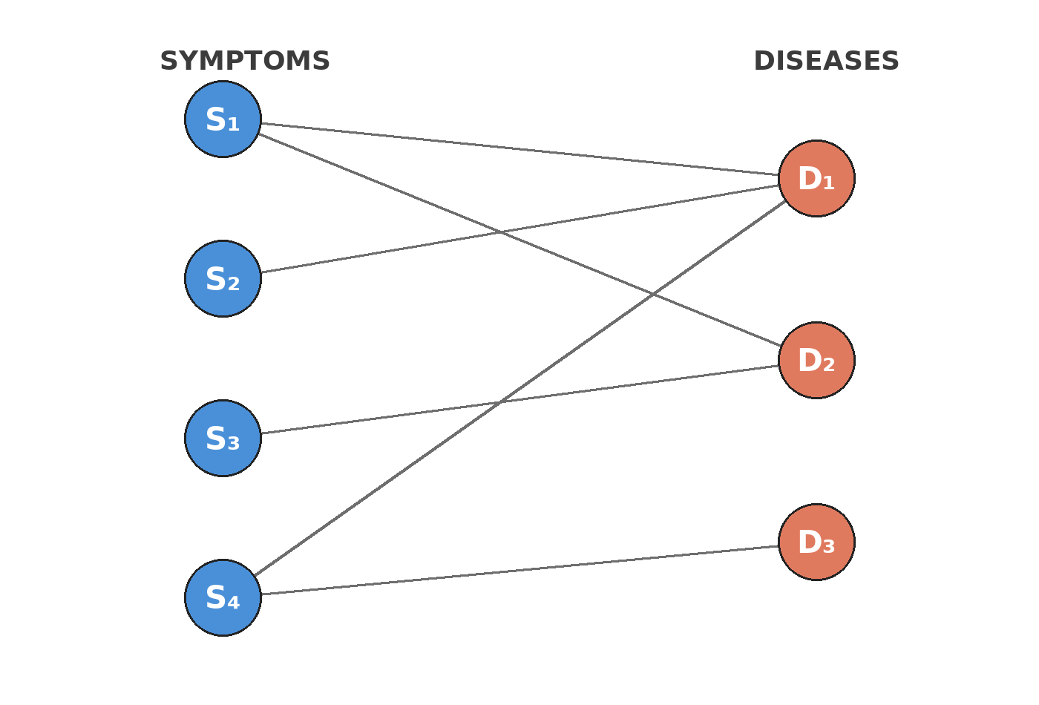
Figure 1 — Bipartite layout: symptoms left, diseases right (7 vertices, 6 edges).
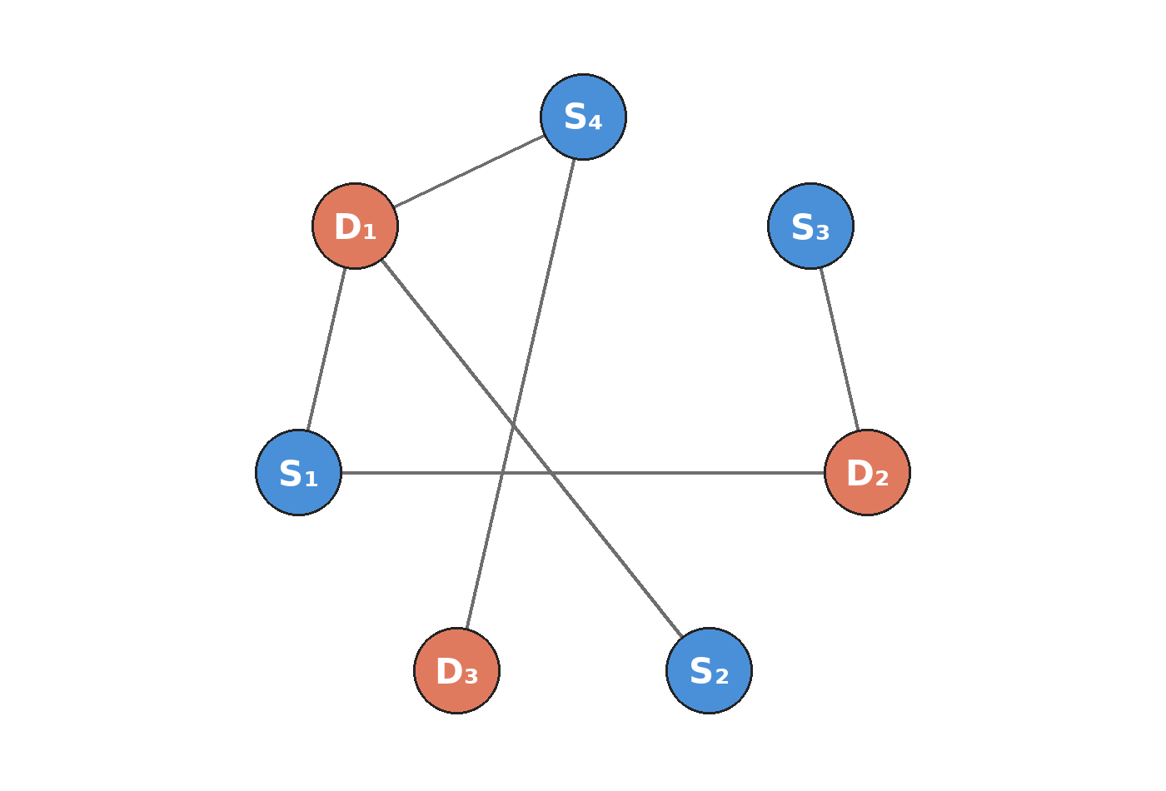
Figure 2 — Same network, circular scrambled layout. Connectivity is identical; only coordinates changed.

7.3 Supporting Tables
Edge list with clinical meanings:
# | Edge | Clinical meaning
1 | S₁ — D₁ | Fever indicates Influenza
2 | S₁ — D₂ | Fever indicates Measles
3 | S₂ — D₁ | Cough indicates Influenza
4 | S₃ — D₂ | Rash indicates Measles
5 | S₄ — D₁ | Fatigue indicates Influenza
6 | S₄ — D₃ | Fatigue indicates Anemia
Invariant comparison:
Invariant | Rep. 1 | Rep. 2 | Match
Vertices |V| | 7 | 7 | ✓
Edges |E| | 6 | 6 | ✓
Degree sequence | (3, 2, 2, 2, 1, 1, 1) | (3, 2, 2, 2, 1, 1, 1) | ✓
Bipartite | yes | yes | ✓
Biadjacency matrices (bipartite adjacency):
 | D₁ | D₂ | D₃
S₁ | 1 | 1 | 0
S₂ | 1 | 0 | 0
S₃ | 0 | 1 | 0
S₄ | 1 | 0 | 1
Reordered (S₄…S₁ | D₃…D₁):
 | D₃ | D₂ | D₁
S₄ | 1 | 0 | 1
S₃ | 0 | 1 | 0
S₂ | 0 | 0 | 1
S₁ | 0 | 1 | 1

7.4 Diagnosis Algorithm (Pseudocode)
Algorithm 1 — Explainable triage (exactly the proved rule chain):
if (A && B) { X = true; // R1
T = true; // R2 via X
trace = [(A∧B)→X by MP, X→T by MP];
} else {
trace = [(A∧B)→T holds vacuously];
}
// Counting service: nCr(12,5), atLeastSum(12,5), nPr(12,5) supply UI cards.
// Graph service: bipartiteLayout() vs circularLayout(); isPermutationSimilar() certifies merges.

8. Interpretation of Results
Logic: validity means the system never recommends testing without a derivation when both premises are adopted — vacuous worlds (A∧B false) satisfy the implication without firing, which is the desired “no false alarm” behaviour.
Counting: the middle number 3,302 bounds the knowledge-acquisition effort: editors must curate up to that many distinct 5+-symptom presentations, while the UI need only offer 792 choices when restricted to exactly five. Ranking inflates the interaction space to 95,040 — a product decision: a ranked selector needs virtualised rendering or it will jank.
Graph: identical invariants plus the exhibited P-matrix prove the two drawings are one knowledge base. Practically, two clinicians can edit in different layout tools and their exports merge losslessly. The corrected degree sequence is a reminder that even a single miscount breaks the handshake lemma and would have failed peer review.

9. Practical Application
Deployed, the three lenses become three widgets on one triage page:
- Symptom Checker card: two toggles (symptoms A/B) drive the proved chain live; chips (A∧B)→X→T light up sequentially or a vacuous-case explainer appears.
- Combination Calculator panel: n/k sliders defaulting to 12/5 display 792 / 3,302 / 95,040 live via exact integer arithmetic (no floats).
- Isomorphism Explorer: one network, two layouts — a toggle morphs bipartite↔circular, clicking a vertex highlights its incident edges and degree (e.g., D₁ degree 3).
In a clinic, the checker handles rapid screening, the calculator helps capacity planners size test matrices, and the graph explorer lets curators visualise and de-duplicate knowledge without fear of layout artefacts. All three are static, auditable, and work offline once deployed.

10. Innovation / Proposed Improvement
The prototype is deliberately static (no backend, no ML) for provability. Natural extensions, each still grounded in discrete math:
- Weighted / probabilistic edges: replace 0/1 biadjacency with p(s→d) and reason with threshold logic; combinatorics becomes weighted counting.
- Larger universe: scale from n=12 to n≈50 with pruning (e.g., symptom frequency priors) and use inclusion–exclusion for at-least-k queries.
- Explainability layer: surface the trace (which premises fired) alongside every recommendation for clinician override.
- Temporal symptoms: add time-stamped propositions and model with temporal logic.
- Knowledge-graph curation at scale: store the graph as an adjacency list in a graph DB; isomorphism checking becomes a merge tool for concurrent edits.
- Evaluation: A/B test ranked vs unranked 5-selection on time-to-diagnosis with real (anonymised) triage logs.
Each improvement reuses the same three pillars — only the formulation (probabilities, larger n, temporal operators) changes, so the report’s structure survives scaling.

11. Conclusion
Propositional logic proved the triage rule, combinatorics sized the search space, and graph theory certified the knowledge representation. Together they deliver a small, provable, explainable assistant that is cheap to build, cheap to audit and cheap to host — a pragmatic foundation on which heavier ML ranking can later be layered without losing trust.
The exercise also illustrates a meta-lesson: formal checks (truth-table shading of 10 — not 1 — satisfying worlds; handshake-lemma sum 12) catch prose errors that survive visual inspection. The live site at https://ai-medical-diagnosis-site.vercel.app runs the exact verified code from this report, so document and artefact cannot diverge.

12. References
- K. H. Rosen, Discrete Mathematics and Its Applications, 8th ed., McGraw-Hill, 2019 — logic, counting, graphs.
- Euclid / Euler — handshake lemma (sum of degrees = 2|E|).
- Tailwind CSS v4 docs — @theme token system and @tailwindcss/vite plugin.
- Vite 8 + Vitest (jsdom, passWithNoTests) + Playwright + @axe-core/playwright — build, unit and browser test tooling.
- Vercel Hobby docs — static-site hosting; GitHub (dharaneesh-sys/ai-medical-diagnosis-site) — version control.
- EU AI Act & FDA SaMD guidance — motivation for explainable, auditable decision support.

13. Additional Challenge — Note on Truncated Prompt
The faculty slide’s “Additional challenge — Each group should answer:” line is cut off in the provided image. The report therefore anticipates the likely challenge: handling overlapping / conflicting symptom sets and scaling beyond the 12-symptom pilot. The counting service (atLeastSum) and the isomorphism certificate directly address both: overlapping sets are counted without double-counting, and layout-invariant merging scales to larger bipartite knowledge bases.

