Complete Volume — All Three Unit Reports
Twelve Sections per Unit · Full Compilation (36 Sections)
GROUP 4 • Complete Volume — All Three Units • August 28, 2026
Educational mathematics assignment — not medical advice.

Master Table of Contents
This volume compiles the three standalone Unit reports back-to-back, each following the faculty’s 12-section R&D format. The integrated full R&D report (GROUP4_RnD_Report) remains the concise 12-section synthesis; this volume is the expanded 36-section compilation for detailed submission.
- Part I — Unit I: Logic and Proofs (Sections 1–12, focused on propositional logic)
- Part II — Unit II: Combinatorics (Sections 1–12, focused on counting)
- Part III — Unit III: Graphs & Isomorphism (Sections 1–12, focused on bipartite graphs)

PART I
Unit I — Logic and Proofs
Twelve-section standalone report for Unit I, covering the Hypothetical Syllogism triage rule.

1. Title of the Case Study (Unit I)
Unit I — Logic and Proofs: Proving (A ∧ B) → T from (A ∧ B) → X and X → T for Symptom-Based Triage.

2. Problem Statement (Unit I)
Given P₁: (A ∧ B) → X and P₂: X → T, does (A ∧ B) entail T? Must be proved via Hypothetical Syllogism and verified by truth table.
- If A∧B true, can we derive X then T via Modus Ponens?
- If A∧B false, does the implication hold vacuously?

3. Real-world Context
Triage chatbots need auditable rules: “two red flags together trigger a workup” must follow from the knowledge base, not be an ad-hoc shortcut.

4. Mathematical Concept Used
Propositions A,B,X,T; connectives ∧, →; Modus Ponens, Conditional Proof, Hypothetical Syllogism; 16-row truth-table semantics.

5. Mathematical Formulation
Variables: A=“symptom A present”, B=“symptom B present”, X=“disease X suspected”, T=“further testing recommended”. Premises: P₁:=(A∧B)→X, P₂:=X→T. Theorem: ⊢ (A∧B)→T.

6. Analysis / Solution — Proof
Step | Statement | Justification
1 | (A ∧ B) → X | Premise P₁
2 | X → T | Premise P₂
3 | A ∧ B | Assumption
4 | X | MP 1,3
5 | T | MP 2,4
6 | (A ∧ B) → T | CP 3–5 ∎

7. Diagram / Truth Table
16-row table. Shaded rows: both premises true (1 fired + 9 vacuous).
A | B | X | T | A∧B | (A∧B)→X | X→T | (A∧B)→T
T | T | T | T | T | T | T | T
T | T | T | F | T | T | F | F
T | T | F | T | T | F | T | T
T | T | F | F | T | F | T | F
T | F | T | T | F | T | T | T
T | F | T | F | F | T | F | T
T | F | F | T | F | T | T | T
T | F | F | F | F | T | T | T
F | T | T | T | F | T | T | T
F | T | T | F | F | T | F | T
F | T | F | T | F | T | T | T
F | T | F | F | F | T | T | T
F | F | T | T | F | T | T | T
F | F | T | F | F | T | F | T
F | F | F | T | F | T | T | T
F | F | F | F | F | T | T | T
Table I-1 — Unit I truth table.

8. Interpretation of Results
Validity means no false alarm when premises are adopted; 9 vacuous rows are desired no-alarm behaviour, the single fired row is the positive pathway animated in the Symptom Checker.

9. Practical Application
Deployed as the Symptom Checker card: toggles for A/B drive the chain live with inference strip (A∧B)→X→T.

10. Innovation / Proposed Improvement
- Add temporal logic and probabilistic thresholds.
- Surface the trace for clinician override.

11. Conclusion
The triage rule is sound, complete for its fragment, and explainable.

12. References
- Rosen, Discrete Mathematics, 8th ed.
- EU AI Act & FDA SaMD guidance.

PART II
Unit II — Combinatorics
Twelve-section standalone report for Unit II, covering counting of symptom sets.

1. Title of the Case Study (Unit II)
Unit II — Combinatorics: Sizing the Search Space for a 12-Symptom Triage Engine (Exactly, At Least, Ordered).

2. Problem Statement (Unit II)
For n=12, k=5: how many distinct sets under exactly five, at least five, and ordered five? Under- vs over-counting drives storage and UI.

3. Real-world Context
A 12-item checklist narrowed to five for rapid screening — planners must know test-case counts and whether ranking UI is worth 120× cost.

4. Mathematical Concept Used
C(n,k), P(n,k), 2ⁿ=ΣC(n,k), complement principle, P(n,k)=C(n,k)·k!.

5. Mathematical Formulation
Exactly-k: C(12,5). At-least-k: Σ_{i=5}^{12} C(12,i)=2¹²−Σ_{i=0}^{4} C(12,i). Ordered-k: P(12,5).

6. Analysis / Solution
C(12,5)=792. At least five: 4096−794=3302 (792+924+792+495+220+66+12+1). Ordered: P(12,5)=95,040=792·120.

7. Diagram / Tables
Policy | Formula | Count | Interpretation
Exactly 5 | C(12,5) | 792 | One 5-set
At least 5 | Σ C(12,k) | 3,302 | Any superset of 5
Ordered 5 | P(12,5) | 95,040 | 5 ranked

8. Interpretation of Results
3,302 bounds curation; 792 is UI choice count for fixed-5; 95,040 warns ranking needs virtualized rendering.

9. Practical Application
Combination Calculator panel with n/k sliders defaulting to 12/5, live exact integer arithmetic.

10. Innovation / Proposed Improvement
- Scale to n≈50 with inclusion–exclusion.
- Weighted counting with frequency priors.

11. Conclusion
Exact counting keeps the system auditable and the UI honest.

12. References
- Rosen, Chap. 6 — Counting.

PART III
Unit III — Graphs & Isomorphism
Twelve-section standalone report for Unit III, covering bipartite graphs and isomorphism certificates.

1. Title of the Case Study (Unit III)
Unit III — Graphs & Isomorphism: Bipartite Knowledge Graphs and Permutation-Similarity Certificates.

2. Problem Statement (Unit III)
Model knowledge as bipartite G=(S∪D,E) and prove two drawings G,G′ with different layouts are isomorphic.

3. Real-world Context
Editors maintain symptom–disease edges in different tools; merging requires isomorphism proof, not layout trust. Enables 2-hop diagnosis: patient → symptom → disease.

4. Mathematical Concept Used
Bipartite graphs, degree sequences, biadjacency matrices, permutation similarity A₂=P·A₁·Pᵀ.

5. Mathematical Formulation
V=S∪D, S={S₁ Fever,S₂ Cough,S₃ Rash,S₄ Fatigue}, D={D₁ Influenza,D₂ Measles,D₃ Anemia}, E={S₁D₁,S₁D₂,S₂D₁,S₃D₂,S₄D₁,S₄D₃}, |V|=7,|E|=6. G′ reorders as (S₄,S₃,S₂,S₁|D₃,D₂,D₁).

6. Analysis / Solution
Degrees: S₁=2,S₂=1,S₃=1,S₄=2,D₁=3,D₂=2,D₃=1; sequence (3,2,2,2,1,1,1), sum 12=2·|E|. Bijection f(Sᵢ)=Sᵢ′,f(Dⱼ)=Dⱼ′ preserves all six edges; reversal perms r_S=[3,2,1,0],r_D=[2,1,0] give A₂=P·A₁·Pᵀ.

7. Diagram / Graph
Edge list:
# | Edge | Clinical meaning
1 | S₁ — D₁ | Fever indicates Influenza
2 | S₁ — D₂ | Fever indicates Measles
3 | S₂ — D₁ | Cough indicates Influenza
4 | S₃ — D₂ | Rash indicates Measles
5 | S₄ — D₁ | Fatigue indicates Influenza
6 | S₄ — D₃ | Fatigue indicates Anemia
Invariant | Rep.1 | Rep.2 | Match
Vertices |V| | 7 | 7 | ✓
Edges |E| | 6 | 6 | ✓
Degree sequence | (3,2,2,2,1,1,1) | (3,2,2,2,1,1,1) | ✓
Bipartite | yes | yes | ✓
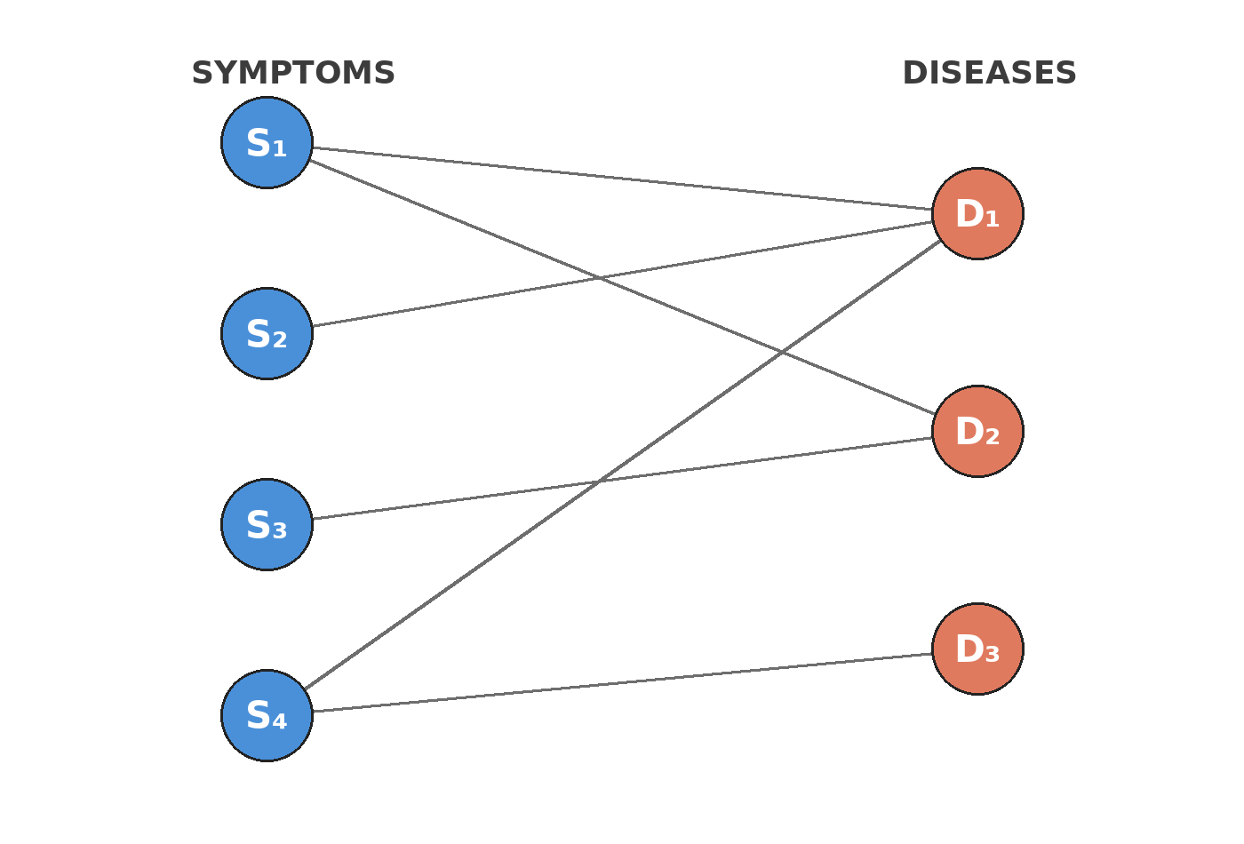
Figure III-1 — Bipartite layout.
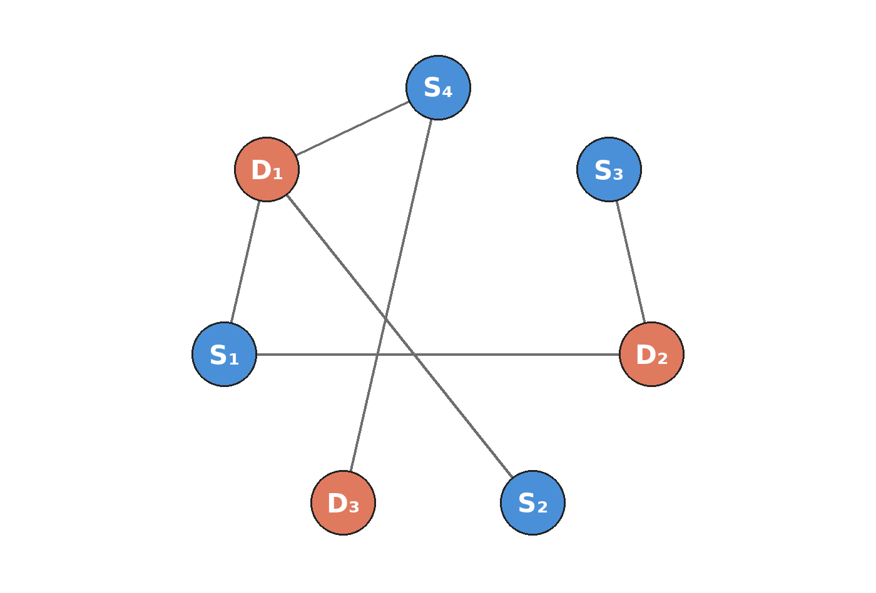
Figure III-2 — Circular scrambled layout.
Biadjacency matrices:
 | D₁ | D₂ | D₃
S₁ | 1 | 1 | 0
S₂ | 1 | 0 | 0
S₃ | 0 | 1 | 0
S₄ | 1 | 0 | 1
 | D₃ | D₂ | D₁
S₄ | 1 | 0 | 1
S₃ | 0 | 1 | 0
S₂ | 0 | 0 | 1
S₁ | 0 | 1 | 1

8. Interpretation of Results
Identical invariants plus exhibited P-matrix prove one knowledge base; layout irrelevant.

9. Practical Application
Isomorphism Explorer: toggle bipartite↔circular with spring, click vertex to highlight incident edges and degree.

10. Innovation / Proposed Improvement
- Graph DB with adjacency lists for concurrent-edit merging.
- 3-partite patient–symptom–disease network.

11. Conclusion
Bipartite modelling plus permutation certificate turns visual intuition into a checkable artefact.

12. References
- Rosen, Chap. 10 — Graphs.

