GROUP 4 — AI-Based Medical Diagnosis
Discrete Mathematics — Complete Solutions (Units I–III)
All numerical results verified computationally.

Unit I — Logic and Proofs

1.1 Propositional variables
Symbol | Statement
A | The patient has symptom A
B | The patient has symptom B
X | Disease X is suspected
T | Further testing is recommended

1.2 Translation into propositional logic
Premise 1: (A ∧ B) → X — “If the patient has symptoms A and B, then disease X is suspected.”
Premise 2: X → T — “If disease X is suspected, further testing is recommended.”
Conclusion: (A ∧ B) → T — “If the patient has symptoms A and B, further testing is recommended.”

1.3 Proof — Hypothetical Syllogism (via Conditional Proof)
Step | Statement | Justification
1 | (A ∧ B) → X | Premise 1
2 | X → T | Premise 2
3 | A ∧ B | Assumption (for Conditional Proof)
4 | X | Modus Ponens, 1, 3
5 | T | Modus Ponens, 2, 4
6 | (A ∧ B) → T | Conditional Proof, 3–5 ∎

1.4 Truth-table verification
A | B | X | T | A∧B | (A∧B)→X | X→T | (A∧B)→T
T | T | T | T | T | T | T | T
T | T | T | F | T | T | F | F
T | T | F | T | T | F | T | T
T | T | F | F | T | F | T | F
T | F | T | T | F | T | T | T
T | F | T | F | F | T | F | T
T | F | F | T | F | T | T | T
T | F | F | F | F | T | T | T
F | T | T | T | F | T | T | T
F | T | T | F | F | T | F | T
F | T | F | T | F | T | T | T
F | T | F | F | F | T | T | T
F | F | T | T | F | T | T | T
F | F | T | F | F | T | F | T
F | F | F | T | F | T | T | T
F | F | F | F | F | T | T | T
Shaded row(s): both premises true. In every such row the conclusion is also true; when A ∧ B is false the conclusion holds vacuously. Hence the argument is valid.

Unit II — Combinatorics
Database of n = 12 symptoms; the system uses r = 5. Selection is without repetition.

2.1 Exactly 5 symptoms selected (order irrelevant) — Combinations
C(12, 5) = 12! / (5! · 7!) = (12·11·10·9·8) / (5·4·3·2·1) = 95,040 / 120
C(12, 5) = 792

2.2 At least 5 symptoms selected
The system may use any subset of size 5, 6, …, 12:
∑ C(12, k), k = 5 … 12 = 792 + 924 + 792 + 495 + 220 + 66 + 12 + 1 = 3302
Shortcut (complement rule): total subsets = 2¹²; subtract subsets of size 0–4:
2¹² − [C(12,0)+C(12,1)+C(12,2)+C(12,3)+C(12,4)] = 4096 − (1+12+66+220+495) = 4096 − 794 = 3302
Answer: 3302 possible symptom sets

2.3 Order of symptoms considered — Permutations
When the sequence of the 5 chosen symptoms matters (e.g. ranked by severity):
P(12, 5) = 12! / 7! = 12·11·10·9·8 = 95,040
Consistency check: P(12,5) = C(12,5) × 5! = 792 × 120 = 95,040 ✓ — each unordered set of 5 can be arranged in 5! orders.
Answer: 95,040 ordered selections

2.4 Investigation summary
Case | Formula | Count | Interpretation
Exactly 5 | C(12, 5) | 792 | One 5-symptom set, order ignored
At least 5 | ∑ C(12, k), k=5..12 | 3,302 | Any subset of size 5 to 12
Order considered | P(12, 5) | 95,040 | Exactly 5, sequence matters
Relaxing “exactly 5” to “at least 5” multiplies the count by ≈ 4.17 (792 → 3302); additionally considering order multiplies by 5! (792 → 95,040). Order matters far more than set size.

Unit III — Graphs & Isomorphism

3.1 Graph model — Bipartite graph
G = (V, E) with V = S ∪ D, S ∩ D = ∅, where:
- S = symptoms, D = diseases (the two disjoint vertex partitions),
- edge (s, d) ∈ E iff symptom s is indicative of disease d,
- no edges within S or within D — a symptom never indicates a symptom and a disease never indicates a disease; this is exactly the bipartite property.
Patients extend this to a 3-partite (heterogeneous) network: P–S edges mean “patient exhibits symptom”, S–D edges mean “symptom indicates disease”. Diagnosis = finding disease-vertices at distance 2 from a patient-vertex through shared symptoms.

3.2 Worked example network
S = {S₁ Fever, S₂ Cough, S₃ Rash, S₄ Fatigue}; D = {D₁ Influenza, D₂ Measles, D₃ Anemia}
# | Edge | Clinical meaning
1 | S₁ — D₁ | Fever indicates Influenza
2 | S₁ — D₂ | Fever indicates Measles
3 | S₂ — D₁ | Cough indicates Influenza
4 | S₃ — D₂ | Rash indicates Measles
5 | S₄ — D₁ | Fatigue indicates Influenza
6 | S₄ — D₃ | Fatigue indicates Anemia
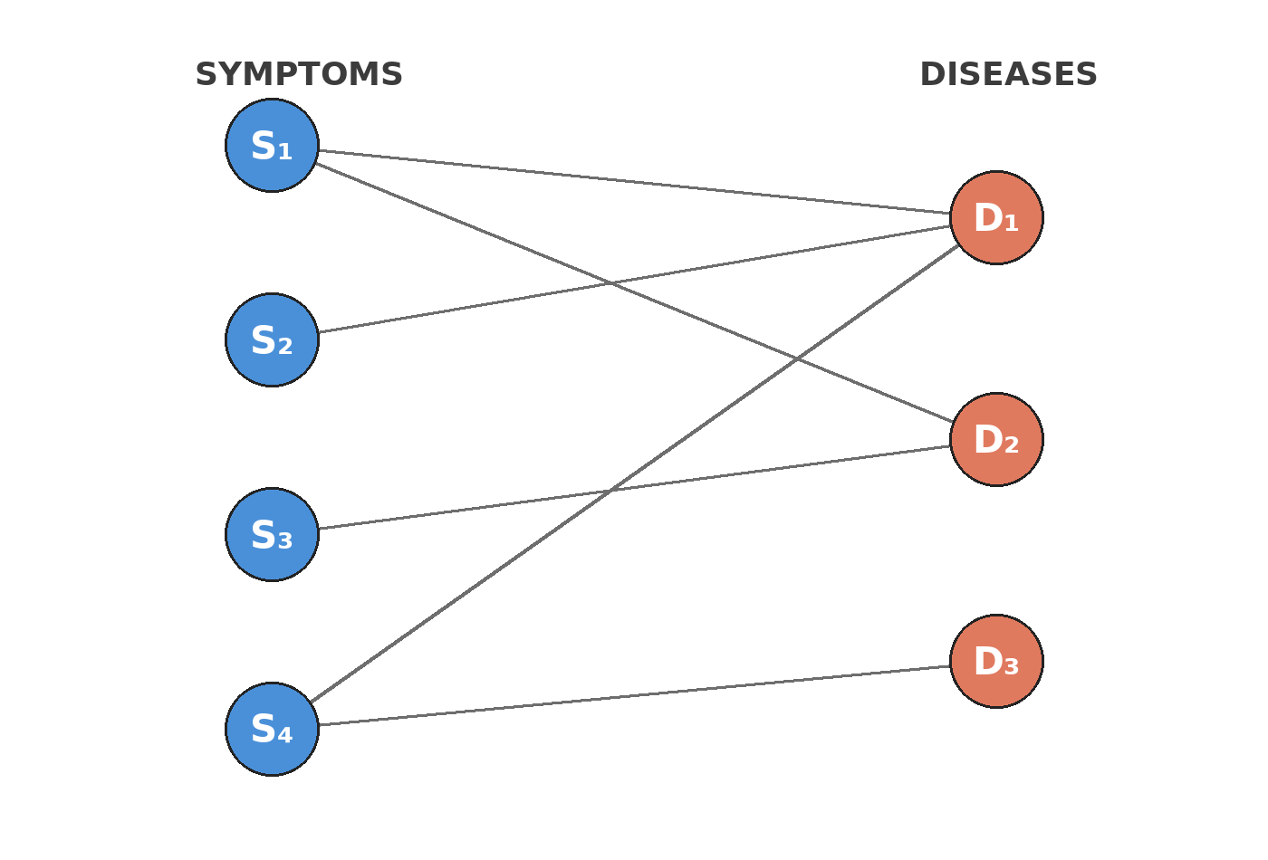
Figure 1 — Representation 1: bipartite layout (symptoms left, diseases right).
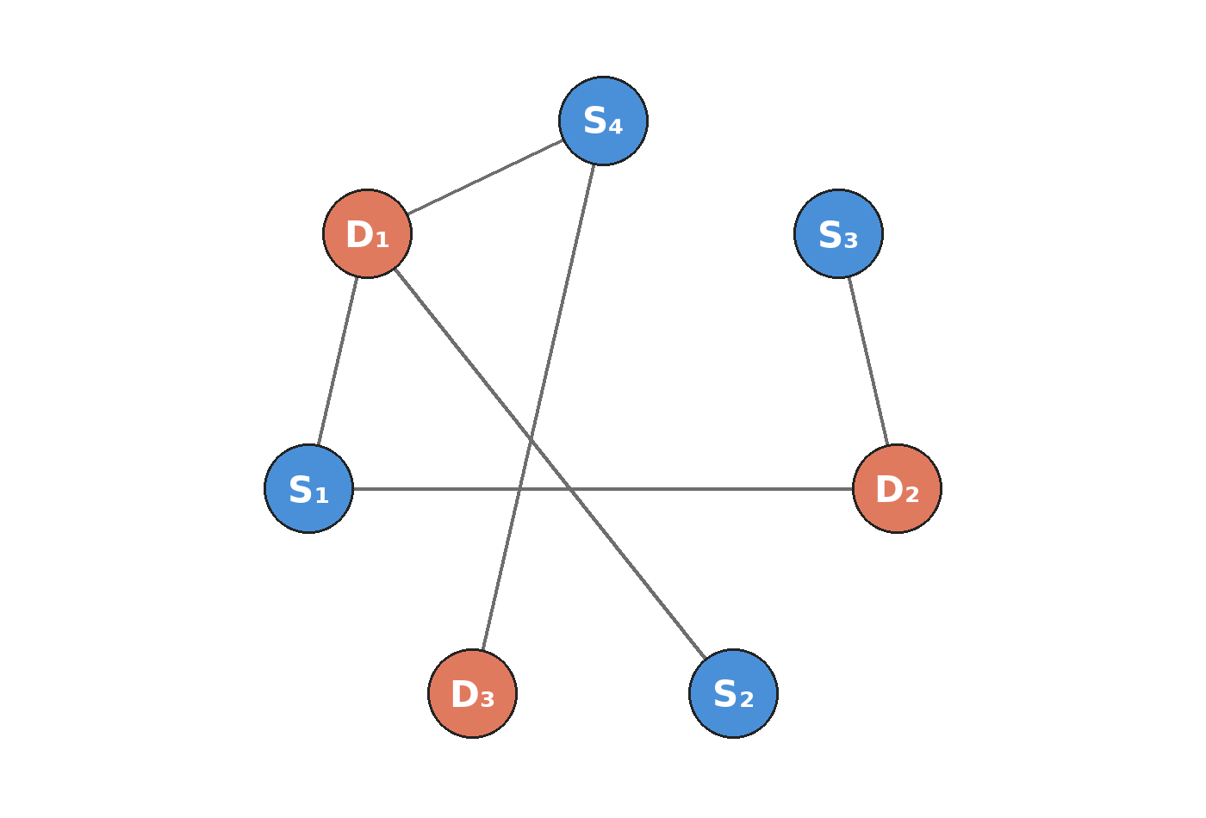
Figure 2 — Representation 2: the SAME network drawn with a different layout (circular, scrambled order).

3.3 Isomorphism analysis
Step 1 — Necessary conditions (invariants).
Invariant | Representation 1 | Representation 2 | Match
Vertices |V| | 7 | 7 | ✓
Edges |E| | 6 | 6 | ✓
Degree sequence | (3, 2, 2, 1, 1, 1, 1) | (3, 2, 2, 1, 1, 1, 1) | ✓
Bipartite | yes | yes | ✓
Degrees: S₁=2, S₂=1, S₃=1, S₄=2, D₁=3, D₂=2, D₃=1. Necessary conditions hold, but they are not sufficient — an explicit bijection is required.
Step 2 — Explicit isomorphism. Define f : V₁ → V₂ by f(Sᵢ) = Sᵢ′, f(Dⱼ) = Dⱼ′ and verify every edge maps to an edge:
Edge in G₁ | Image under f | Edge in G₂?
S₁D₁ | S₁′D₁′ | ✓
S₁D₂ | S₁′D₂′ | ✓
S₂D₁ | S₂′D₁′ | ✓
S₃D₂ | S₃′D₂′ | ✓
S₄D₁ | S₄′D₁′ | ✓
S₄D₃ | S₄′D₃′ | ✓
All 6 edges are preserved; since |E₁| = |E₂|, non-edges are preserved too. f is an isomorphism.
Step 3 — Adjacency-matrix confirmation. Biadjacency matrix of Representation 1 (rows S₁–S₄, columns D₁–D₃):
 | D₁ | D₂ | D₃
S₁ | 1 | 1 | 0
S₂ | 1 | 0 | 0
S₃ | 0 | 1 | 0
S₄ | 1 | 0 | 1
Representation 2 lists the same vertices in a different order — (S₄, S₃, S₂, S₁ | D₃, D₂, D₁):
 | D₃ | D₂ | D₁
S₄ | 1 | 0 | 1
S₃ | 0 | 1 | 0
S₂ | 0 | 0 | 1
S₁ | 0 | 1 | 1
The two matrices look nothing alike, yet both encode exactly the same 6 edges. They are related by a simultaneous permutation of rows and columns: A₂ = P A₁ P^{T}, where P is the 7×7 permutation matrix reversing both blocks (S₁↔S₄, S₂↔S₃, D₁↔D₃, D₂ fixed). Permutation-similarity of adjacency matrices is the formal algebraic certificate of graph isomorphism.

3.4 Conclusion
The two graphical representations ARE isomorphic — established three independent ways:
- Invariants match: |V| = 7, |E| = 6, degree sequence (3, 2, 2, 1, 1, 1, 1), both bipartite.
- Explicit bijection: f(Sᵢ) = Sᵢ′, f(Dⱼ) = Dⱼ′ preserves all 6 edges (and, by equal edge counts, all non-edges).
- Adjacency matrices: A₂ = P A₁ Pᵀ for a permutation matrix P.
Visual layout is irrelevant — isomorphism depends only on connectivity structure, which is identical since both drawings encode the same diagnostic network.

Summary of Results
Unit | Task | Result
I — Logic | Translate rules, prove conclusion | (A∧B)→X, X→T ⊢ (A∧B)→T by Hypothetical Syllogism — valid
II — Combinatorics | Count symptom selections | Exactly 5: 792 · At least 5: 3,302 · Order matters: 95,040
III — Graphs | Model + isomorphism | Bipartite graph (symptoms ↔ diseases, patients as 3rd partition); two representations isomorphic via bijection f and A₂ = P A₁ Pᵀ

