**Exercise 6: Library Management System**

**1. Understand Search Algorithms**

**Linear Search** checks each element in the list one by one until the desired element is found or the list ends. It works on both sorted and unsorted data, but is slow for large lists.

**Binary Search** divides the search interval in half repeatedly and compares the target with the middle element. It only works on **sorted data** and is much faster than linear search for large datasets.

**2. Analysis**

**Linear Search** has a time complexity of **O(n)** because it may need to check each element in the worst case. It’s simple and works for both sorted and unsorted lists.

**Binary Search** has a time complexity of **O(log n)**, making it much faster for large lists. However, it only works on **sorted data**. The list must be sorted first (which takes O(n log n) if not already sorted).

**When to Use Each Algorithm**

Use **linear search** when:

* The data is unsorted.
* The dataset is small.
* Simplicity is preferred over performance.

Use **binary search** when:

* The data is sorted.
* The dataset is large.
* Fast lookups are required.

**3. Output**

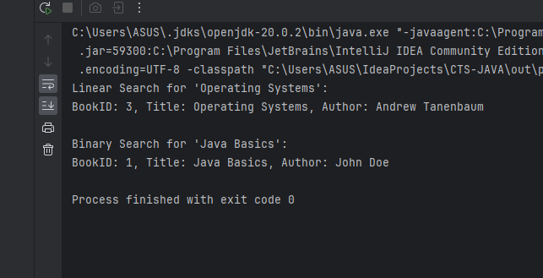

Bottom of Form