Ex.No:1

29/12/2014

***CREATING WEBSITE USING HTML.***

AIM:

To create a website using HTML tags.

TAGS USED:

**<h1> </h1> => heading tag**

Used to display the heading in different size, <h1> defines the most important heading.

**<a href> </href> =>link tag.**

A hyperlink (or link) is a group of words, or image that you can click on to jump to another document.

**<img src> =>image tag.**

Used to display image. img specifies an image and src is the source.

**<table> </table> =>table tag.**

Used to display a table and it contents.

**<form> </form> =>form tag.**

Used to describe the form.

CODE:

Home.html

<html>

<head>

<left>

<h1></b><center>ADDITIONAL CONTROLLER OF EXAMINATIONS</center></b></h1>

<right>

<h3><b><center>UNIVERSITY DEPARTMENTS<center></b></h3>

<h2><center>ANNA UNIVERSITY<center></h2>

</head>

<hr>

<body bgcolor=lightgreen>

<style>

#horizontalmenu ul{

padding:1;margin:1;list-style:none;

}

#horizontalmenu li{

float:left;position:relative;padding-right:100;dispaly:block;

border:4px solid #cc55# border-style:inset;

}

#horizontalmenu li ul{

display:none;

posotion:obsolute;

}

#horizontalmenu li:hover ul{

display:block;

background:red;

height:auto;width:8em;

}

#horizontalmenu li ul li{

clear:both;

border-style:none;

}

</style>

<div id="horizontalmenu">

<ul><li><a href="[AU.HTML](view-source:file:///C:/Users/abc/Desktop/AU.HTML)">AUPAGE</a>

</ul>

</div>

<div id="horizontalmenu">

<ul><li><a href="[#](view-source:file:///C:/Users/abc/Desktop/1234.html)">HOME</a></li>

</ul>

</div>

<div id="horizontalmenu">

<ul><li><a href="[ac.html](view-source:file:///C:/Users/abc/Desktop/ac.html)">ACOE'S DESK</a></li>

</ul>

</div>

<div id="horizontalmenu">

<ul><li><a href="[table.html](view-source:file:///C:/Users/abc/Desktop/table.html)">ACADAMICS</a></li>

</ul>

</div>

<div id="horizontalmenu">

<ul><li><a href="[table.html](view-source:file:///C:/Users/abc/Desktop/table.html)">LINKS</a></li>

</ul>

</div>

<div id="horizontalmenu">

<ul><li><a href="[f.html](view-source:file:///C:/Users/abc/Desktop/f.html)">ABOUT US</a></li>

</ul>

</div>

<br>

<hr>

<marquee behaviour="scroll"direction="LEFT"STYLE=COLOR:RED>NEW : result has been released for all four campus:CEG MIT ACT SAP</marquee>

<hr>

<form action="[11.html](view-source:file:///C:/Users/abc/Desktop/11.html)">

<li><style=list-style-type:NONE><input type="submit" name="submit" value="STUDENT SECTION"></li><br></form>

<form action="[11.html](view-source:file:///C:/Users/abc/Desktop/11.html)">

<li><input type="submit" name="submit" value="STAFF SECTION" style=width:"200px;" height:"200px;"></li><br></form>

<form action="[11.html](view-source:file:///C:/Users/abc/Desktop/11.html)">

<li><input type="submit" name="submit" value="TIME TABLE-END SEM"></li><br></form>

<form action="[11.html](view-source:file:///C:/Users/abc/Desktop/11.html)">

<li><input type="submit" name="submit" value="DOWNLOADS"></a></li</ul><br></form>

Frame.html

<html>

<frameset rows="10%,90%" frameborder="1" border="0">

<frame src="[f3.html](view-source:file:///C:/Users/abc/Desktop/f3.html)">

<frameset cols="20%,*,0%">

<frame src="[f1.html](view-source:file:///C:/Users/abc/Desktop/f1.html)">

<frame src="[f2.html](view-source:file:///C:/Users/abc/Desktop/f2.html)">

</frameset>

</frameset>

</frameset>

<html>

<body bgcolor="coral" style="font-size 15:font-family Times new Romen" >

<center><h2>ABOUT US</h2></center>

</body>

<html>

<html>

<body bgcolor=#FFCC66>

<center>

<h2><center>ADDITIONAL CONTROLLER OF EXAMINATION</center></h2>

<h3>History</h3></center>

<pre> The Additional Controller of Examinations (ACOE) shall be the Principal officer

-in-charge for the regular conduct of examinations of the University Departments and declaration

of results. ACOE shall discharge the functions under the directions and guidance of the Vice-Cha

-ncellor and the Registrar of Anna University.

This office is governed by an ACOE and Eight Deputy Controller of Examinations with the

assistance of a Chief Superintendent and other supporting staff.

The ACOE shall

Prepare and Publish the schedule of examinations

Conduct the examinations with the help of campus Chief Superintendents

Conduct central valuation

Publish results

Classify the list of UG/PG degrees

Academic Record Management System (ARMS) is in-house software, where the faculty can

enterattendance and marks of the students periodically and the faculty can obtain the final results of

the examination. ARMS is maintained with a team of experts in Data Centre.

</pre>

</html>

<center><a href="[1234.html](view-source:file:///C:/Users/abc/Desktop/1234.html)"><h4>Home</h4></a></center>

<html>

<head>

<title>About Us</title>

</head>

<body bgcolor="greenyellow">

<center><b>ADDRESS</b></center>

<pre><h4>

ACOE OFFICE

Bicentennial Building

College of Engineering,Guindy

Chennai

600 025

contact: 044-1122334

mail at:acoe.ceg@gmail.com

</h4></pre>

</body>

</html>

Login.html

<html>

<head><bold><center><italic><h1>LOGIN!</h1></italic</center></bold</head>

<title>"login page"</title>

<body style="background-color:pink">

<form action ="1234.html">

USERNAME:<br>

<input type="text" name="username">

<br><br>

PASSWORD:<br>

<input type="password" name="password">

<br>

<br>

<input type="submit" name="SUBMIT" value="SUBMIT">

<h6><center><bold>forgot password??</h6>

<h6><center><bold>update email</h6>

</form>

Table.html

<html>

<title>timetable</title>

<head><h1><center>TIMETABLE FOR END SEMESTER</center></h1>

</head>

<body>

<table style="width:100%" border="1">

<tr>

<th>SUBJECT CODE</th>

<th>SUBJECT NAME</th>

<th>DATE OF EXAMINATION</th>

</tr>

<tr>

<td><center>XT9021</center></td>

<td><center>probability and statistics</center></td>

<td><center>02/01/2015</td></center>

</tr>

<tr>

<td><center>XT9022</center></td>

<td><center>computer network</center></td>

<td><center>04/01/2015</td></center>

</tr>

<tr>

<td><center>XT9023</center></td>

<td><center>crypotography and network security</center></td>

<td><center>06/01/2015</td></center>

</tr>

<tr>

<td><center>XT9024</center></td>

<td><center>java amd internet programming</center></td>

<td><center>10/01/2015</td></center>

</tr>

<tr>

<td><center>XT9025</center></td>

<td><center>data warehousing and mining</center></td>

<td><center>13/01/2015</td></center>

</tr>

</table>

<P><l><b><h3>the exam will be held on the scheduled date.<br>

the lab practical exams will be held one week prior to the end semester</b></l></p></h3>

</body>

</html>

Au.html

<html>

<head>

<h1>SAP CAMPUS</h1>

</head>

<body bgcolor = lightblue>

<h4>School of Architecture and Planning has only B.Arch and M.Arch courses, <br>

which plays a major role in society. The students for this courses are selected <br>

from the NATO exam scores. This exam is conducted for all over TamilNadu <br>

and with particular criteria the students are taken<h4>

<img src="[C:\Users\Mr-User\Downloads\main.jpg](c:%5CUsers%5CMr-User%5CDownloads%5Cmain.jpg)" width="300" height="300">

<HTML>

<H1>WELCOME TO ANNA UNIVERSITY</H1>

<H2><a href=sap.html>COLLEGE OF ENGINEERTING</H2>

<H2><a href=sap.html>ALLAGAPPA COLLEGE OF TECHNOLOGY</H2>

<H2><a href=sap.html>SCHOOL OF ARCHITECTURE</a></H2>

<H2>><a href=sap.html>MADRAS INSTITUTE OF TECHNOLOGY</H2>

</HTML>

OUTPUT

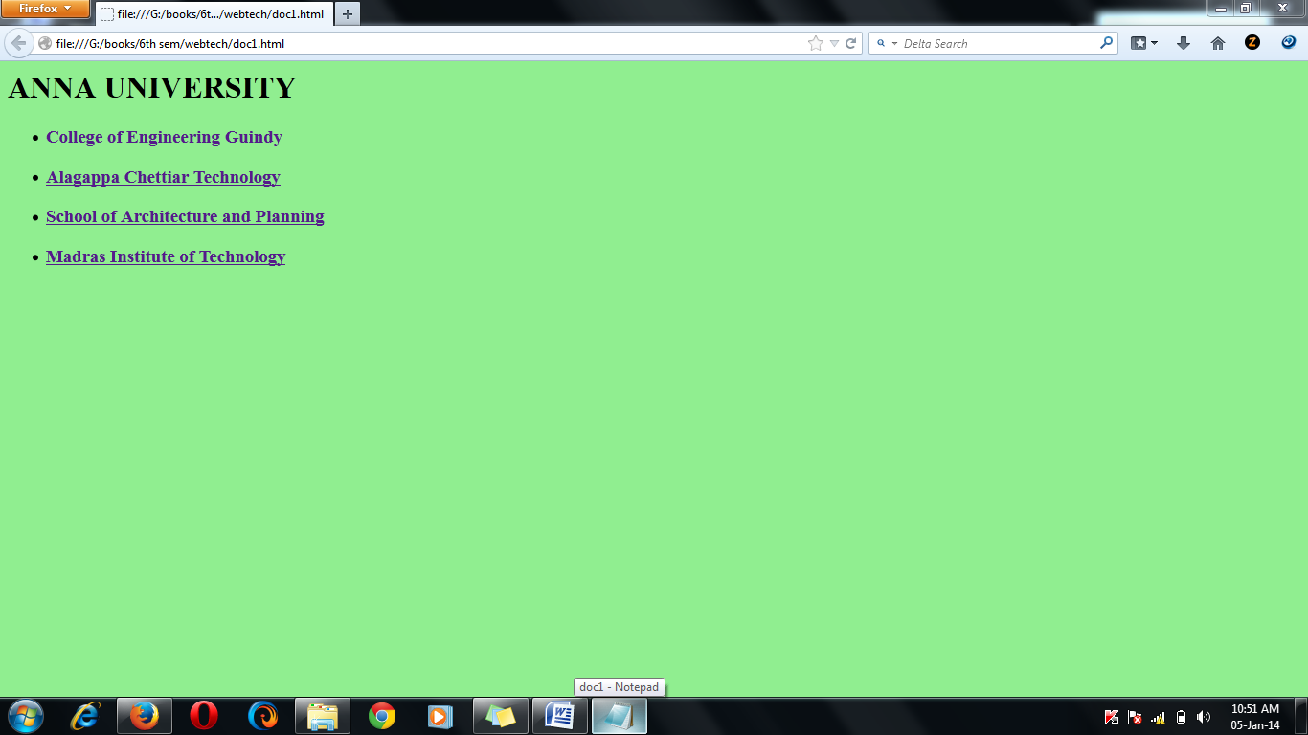

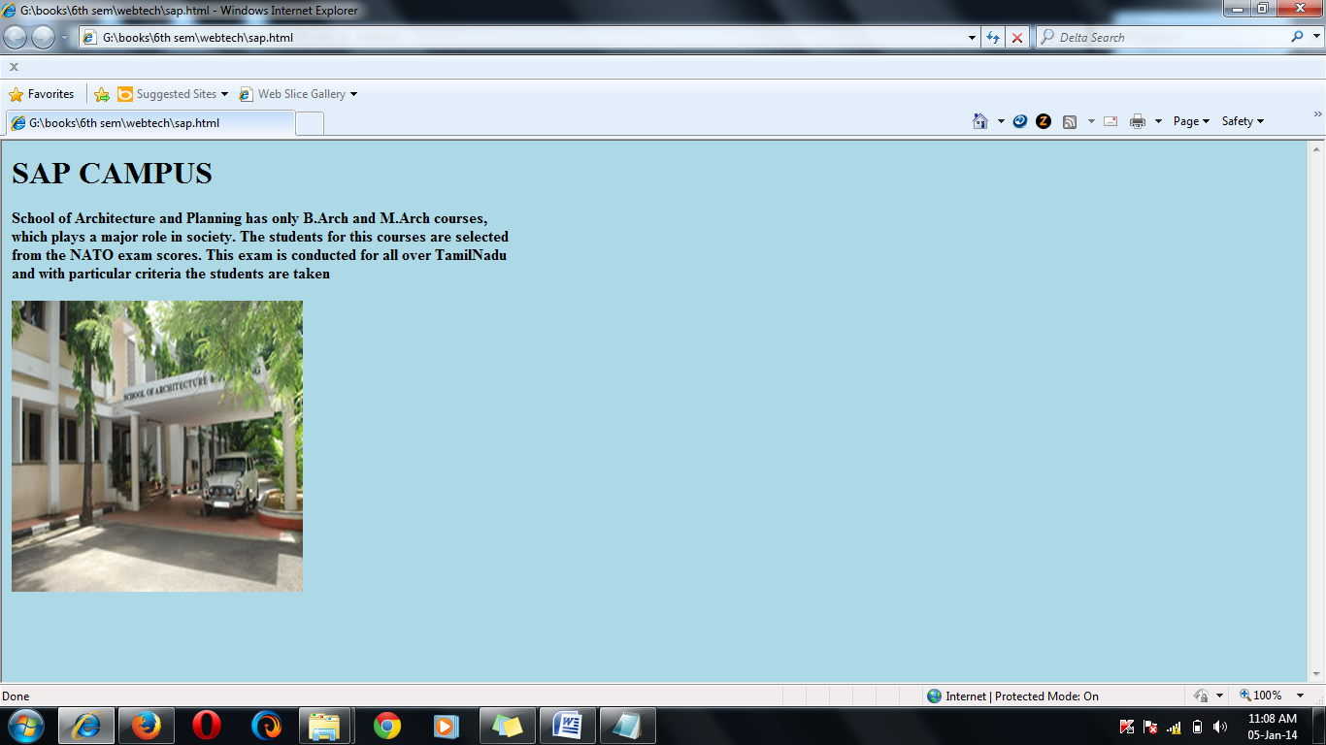

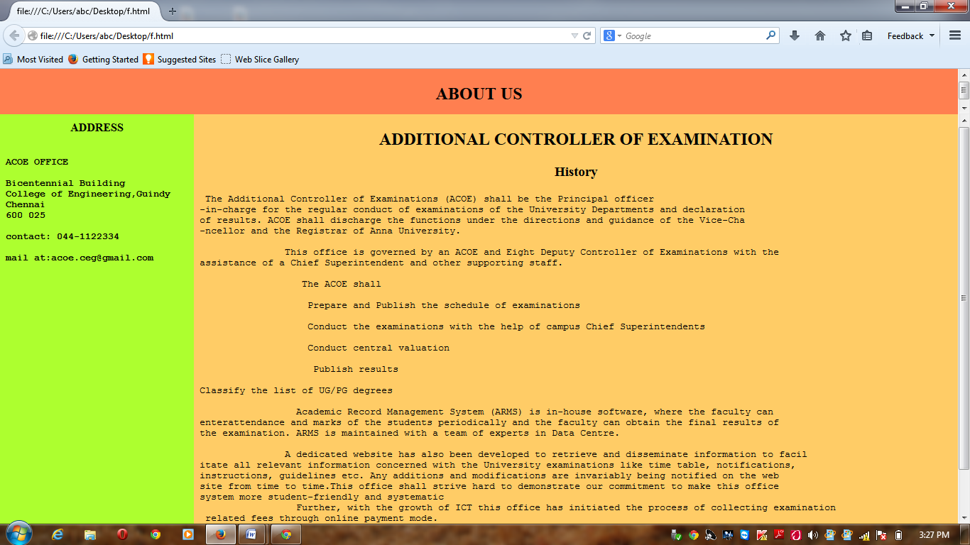

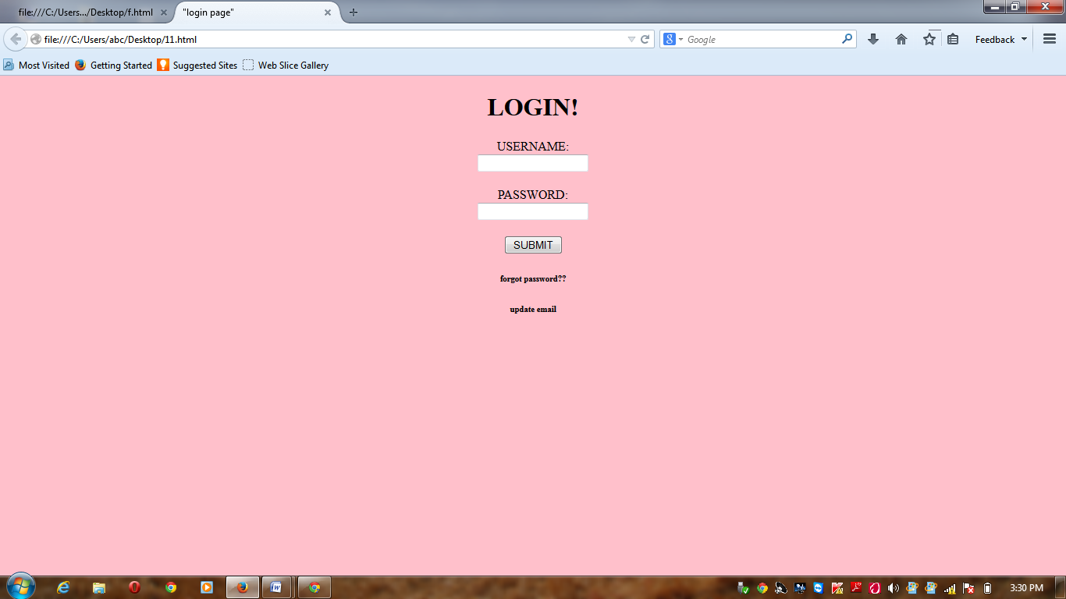

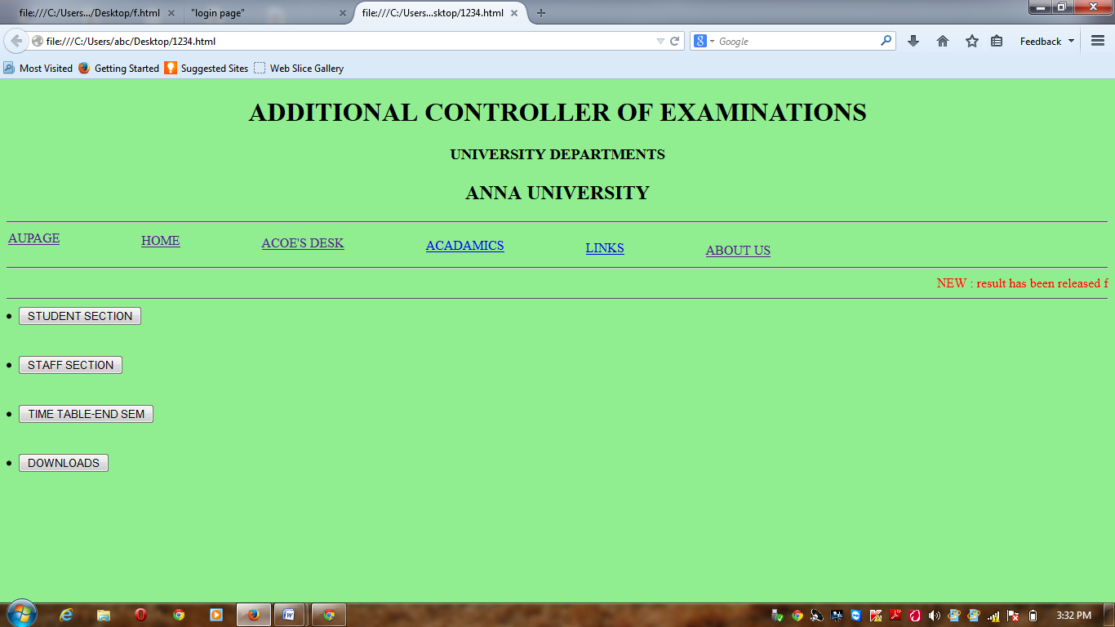

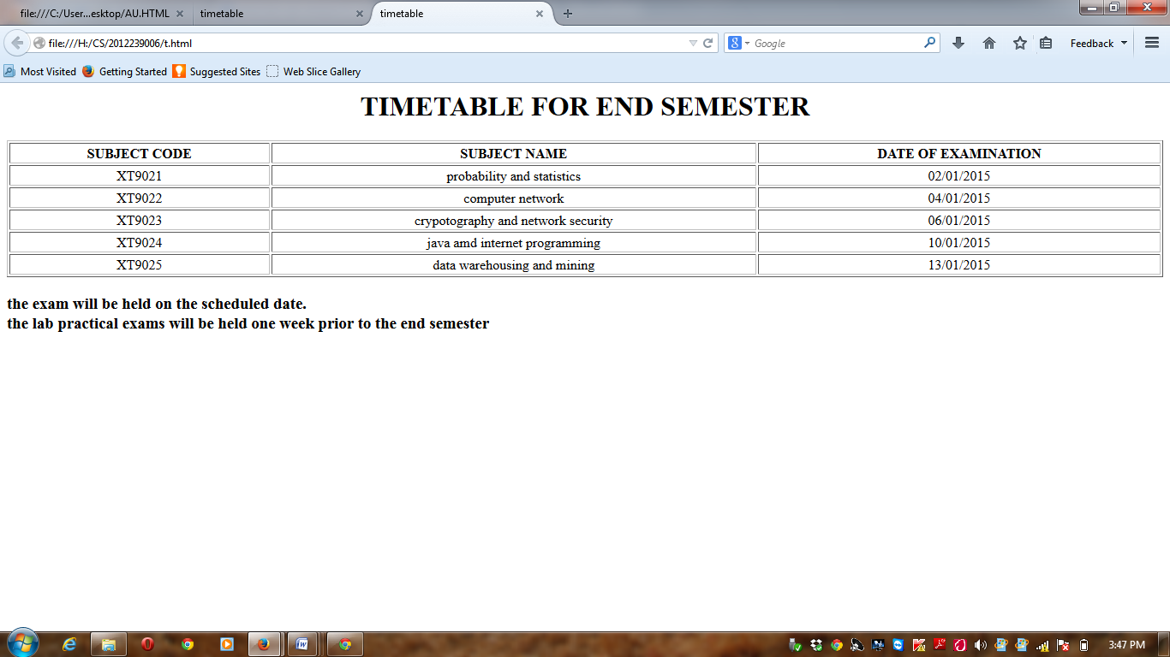

RESULT:

Thus the website with some special tags is created successfully using HTML

RESULT:

Thus the website with some special tags is created successfully using HTML