Week-1

# E-Commerce Platform Working:

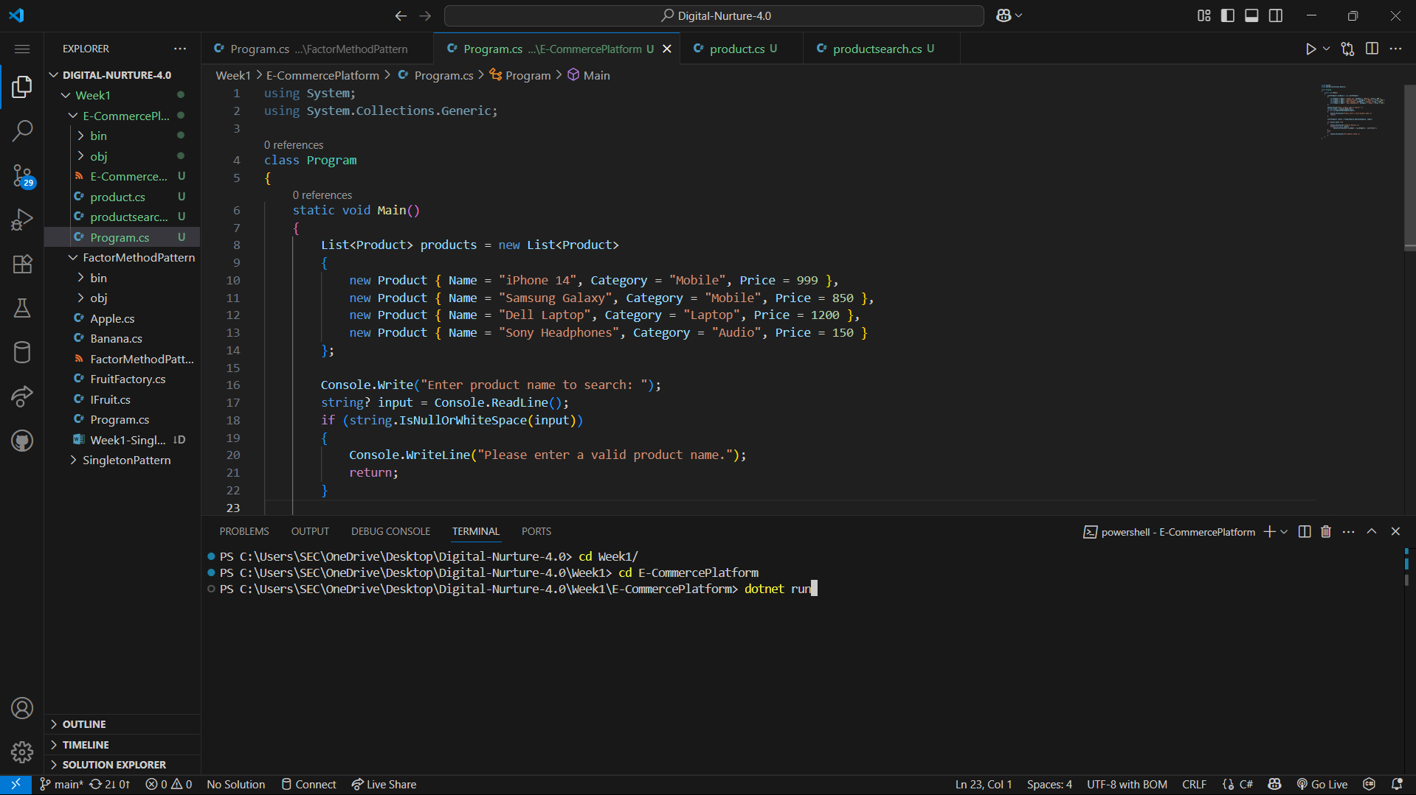

OUTPUT:

