Week-1

FactoryMethod Pattern

Working:

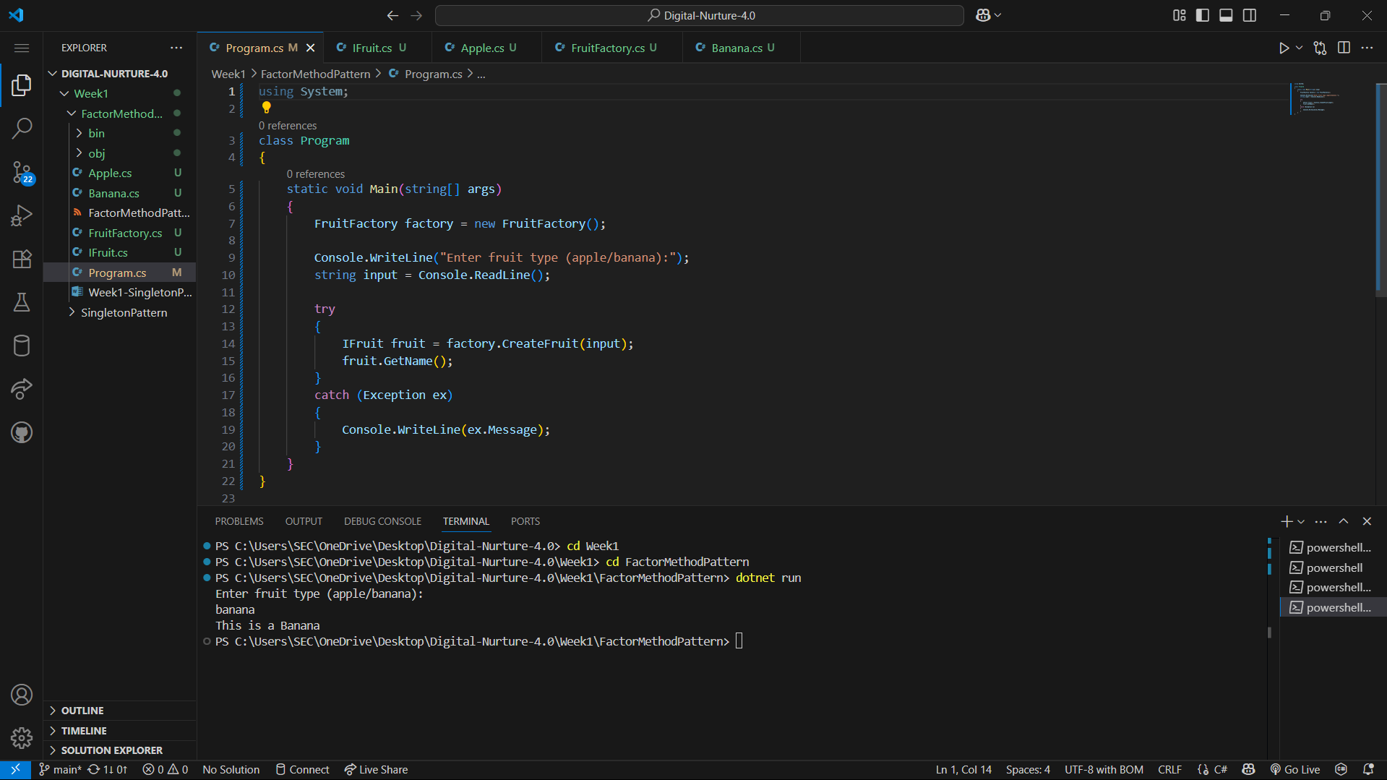

OUTPUT:

