Week-1

# SingletonPattern Working:

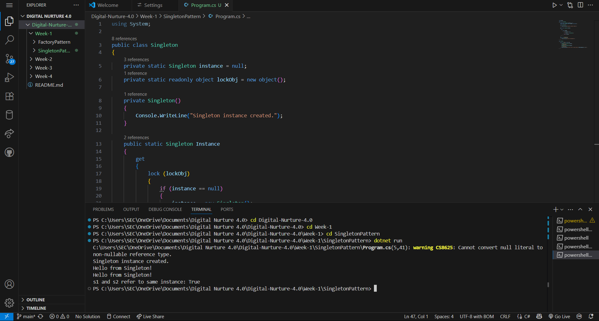

OUTPUT:

