**ENVIRONMENTAL MONITORING**

**Sensors.**

* Soil moister sensors .
* environmental sensor

**DataSets.**

With the help of IoT technologies, made up of a multitude of autonomous devices in the form of sensors capable of self-organization and working to collect information, we began to implement these devices in various environments containing several domestic plants in the mass collection process for the absolute need of information

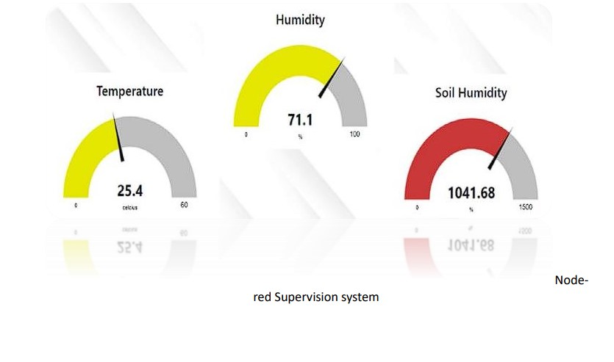

* Soil moisture data: This data is emitted by an analog sensor in a data interval between the value 0 and the value 1023, which is illustrated in the table, we notice that the minimum value is 314.47 and the maximum value is 987.83, so the average value is 384.5.
* Temperature data: These data are becoming more and more important, and they have been collected thanks to a temperature sensor which presents the state of the temperature in Celsius, we see that the average temperature during these months of the collection is 26, 34 ◦C and the minimum value is 18 ◦C without forgetting the maximum value is 39 ◦C, to subsequently overcome its limits proof of expectations.
* Air humidity data: With the same sensor that ensured the collection of temperature values, we managed to collect humidity data, for an analysis passage of these data which is as follows: the average is 66.4%, and the minimum value is 38% and the maximum value is 81.3%, while collects the massive data pass. In the race for computerization, we find the Output data: For this, we have proposed an architecture based on the peer-to-peer principle which resides in categorical data between a value “0” which means that pumping must be stopped, and a value “1” which means that pumping must be activated.To conclude, we have carried out a partial implementation of the final architecture while demonstrating the feasibility to be far from a generalized failure.

