Week-3:
TASK1:
Aim: To find the lexicographically smallest and largest substrings of length k from a given string.
Algorithm:
- Start.
- Read the input string s and integer k.
- Initialize smallest and largest with the first substring of length k.
- Loop from index 1 to (length of string – k):
- Extract substring sub of length k.
- Compare sub with smallest:
- If sub is smaller, update smallest.
- Compare sub with largest:
- If sub is larger, update largest.
- After checking all substrings, return smallest and largest.
- Print the result.
- Stop.
Program:
import java.util.Scanner;
public class Solution {
public static String getSmallestAndLargest(String s, int k) {
String smallest = s.substring(0, k);
String largest = s.substring(0, k);
for (int i = 1; i <= s.length() - k; i++) {
String sub = s.substring(i, i + k);
if (sub.compareTo(smallest) < 0)
smallest = sub;
if (sub.compareTo(largest) > 0)
largest = sub;
}
return smallest + "\n" + largest;
}
public static void main(String[] args) {
Scanner scan = new Scanner(System.in);
String s = scan.next();
int k = scan.nextInt();
scan.close();
System.out.println(getSmallestAndLargest(s, k));
}
}

Output:
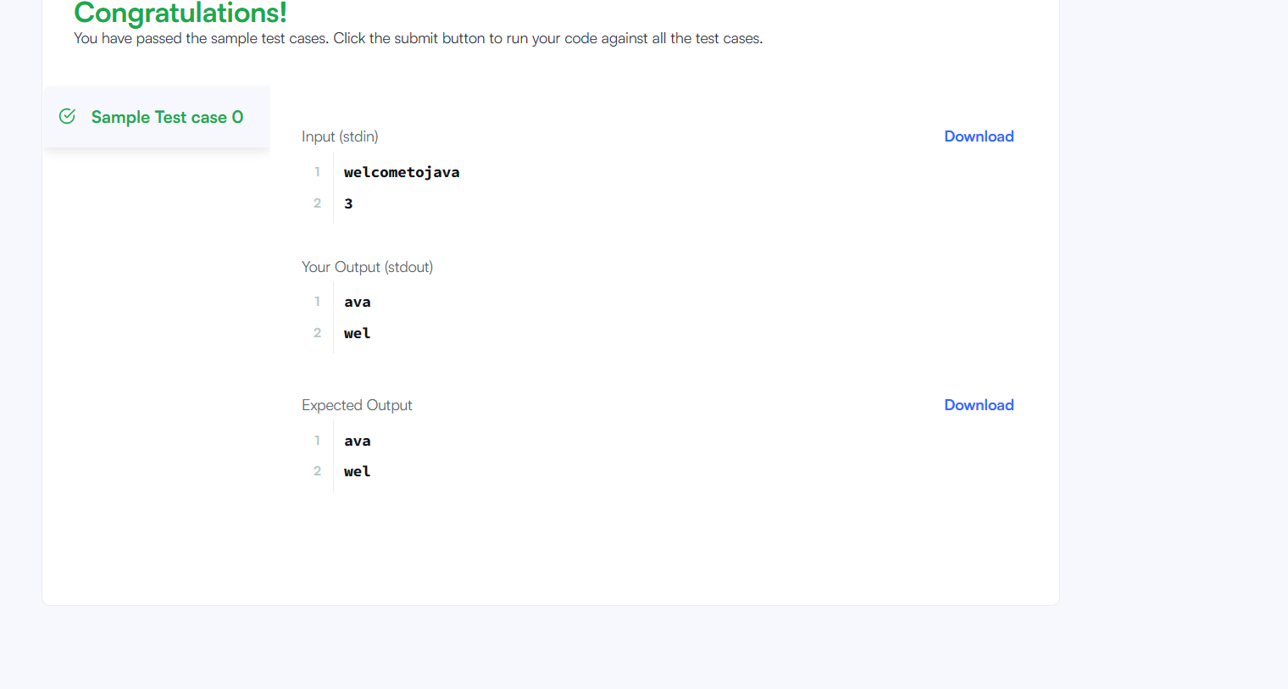

Result: The program successfully identifies and displays the smallest and largest substrings of length k from the given string using lexicographical comparison.

Task-2:
Aim: To sort Player objects in descending order based on score and, when scores are equal, in ascending alphabetical order based on name.
This ensures proper ranking with clear tie-breaking using player names.
Algorithm:
- Start.
- Receive two Player objects: a and b.
- Compare their scores:
- If a.score is not equal to b.score, return (b.score – a.score) to sort in descending order.
- If scores are equal:
- Compare a.name and b.name using compareTo() to sort alphabetically (ascending).
- Return the comparison result.
- Stop.
Program:
class Checker implements Comparator<Player> {
public int compare(Player a, Player b){
if(a.score != b.score){
return b.score - a.score;
}
return a.name.compareTo(b.name);
}

Output:
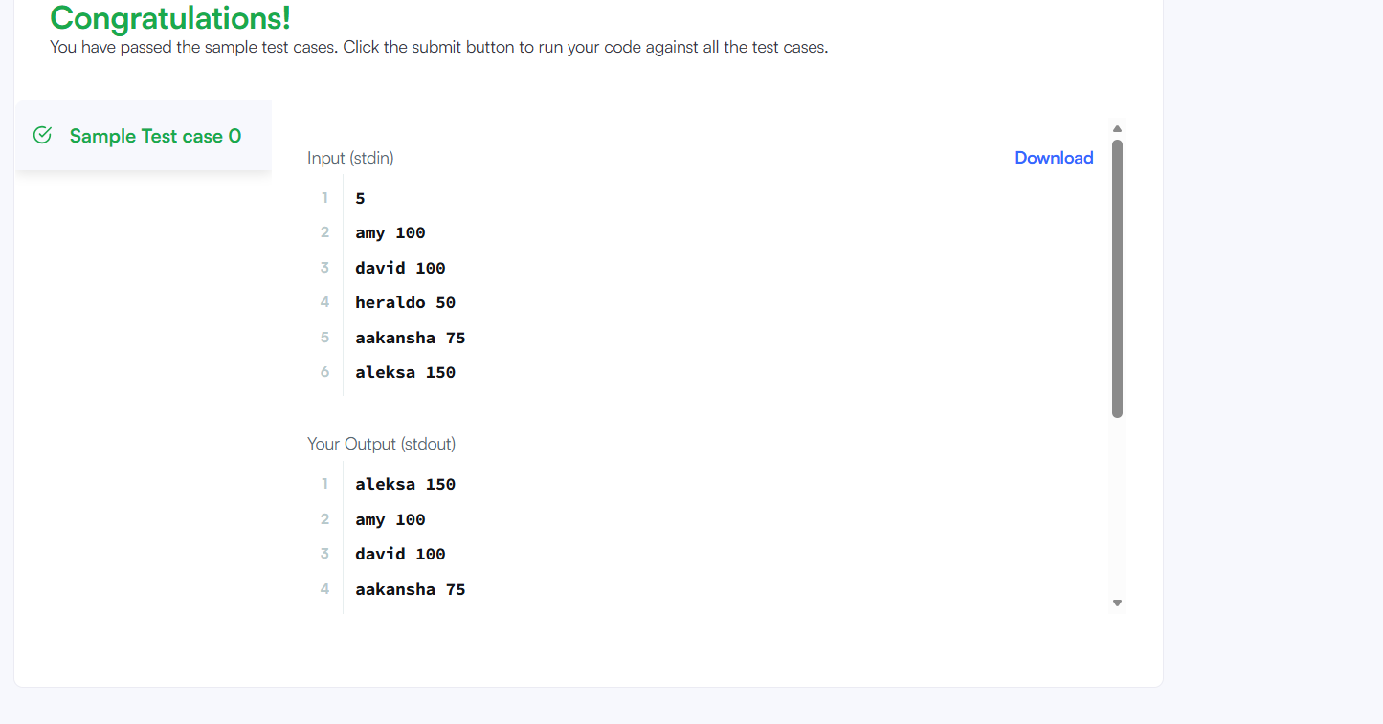

Result:
Thus, to sort Player objects in descending order based on score and, when scores are equal, in ascending alphabetical order based on name was executed successfully.
Task3:
Aim: To sort a list of students based on CGPA in descending order, first name in ascending alphabetical order, and ID in ascending order when previous values are equal.
Algorithm:
- Start the program.
- Read the number of test cases (students).
- For each student:
  - Read ID, first name, and CGPA.
  - Create a Student object and add it to the list.
- Use Collections.sort() with a custom Comparator to sort students by:
  - CGPA (descending order).
  - First name (ascending order) if CGPA is same.
  - ID (ascending order) if both CGPA and name are same.
- Display the sorted student names.
- Stop.
Program:
import java.util.*;
class Student {
int id;
String fname;
double cgpa;
public Student(int id, String fname, double cgpa) {
this.id = id;
this.fname = fname;
this.cgpa = cgpa;
}
public int getId() {
return id;
}
public String getFname() {
return fname;
}
public double getCgpa() {
return cgpa;
}
}
class Solution {
public static void main(String[] args) {
Scanner in = new Scanner(System.in);
int testCases = Integer.parseInt(in.nextLine());
List<Student> studentList = new ArrayList<Student>();
while(testCases > 0){
int id = in.nextInt();
String fname = in.next();
double cgpa = in.nextDouble();
Student st = new Student(id, fname, cgpa);
studentList.add(st);
testCases--;
}
Collections.sort(studentList, new Comparator<Student>() {
public int compare(Student s1, Student s2) {
if(s1.cgpa != s2.cgpa){
return Double.compare(s2.cgpa, s1.cgpa);
}
if(!s1.fname.equals(s2.fname)){
return s1.fname.compareTo(s2.fname);
}
return s1.id - s2.id;
}
});
for(Student st: studentList){
System.out.println(st.getFname());
}
}
}
Output:
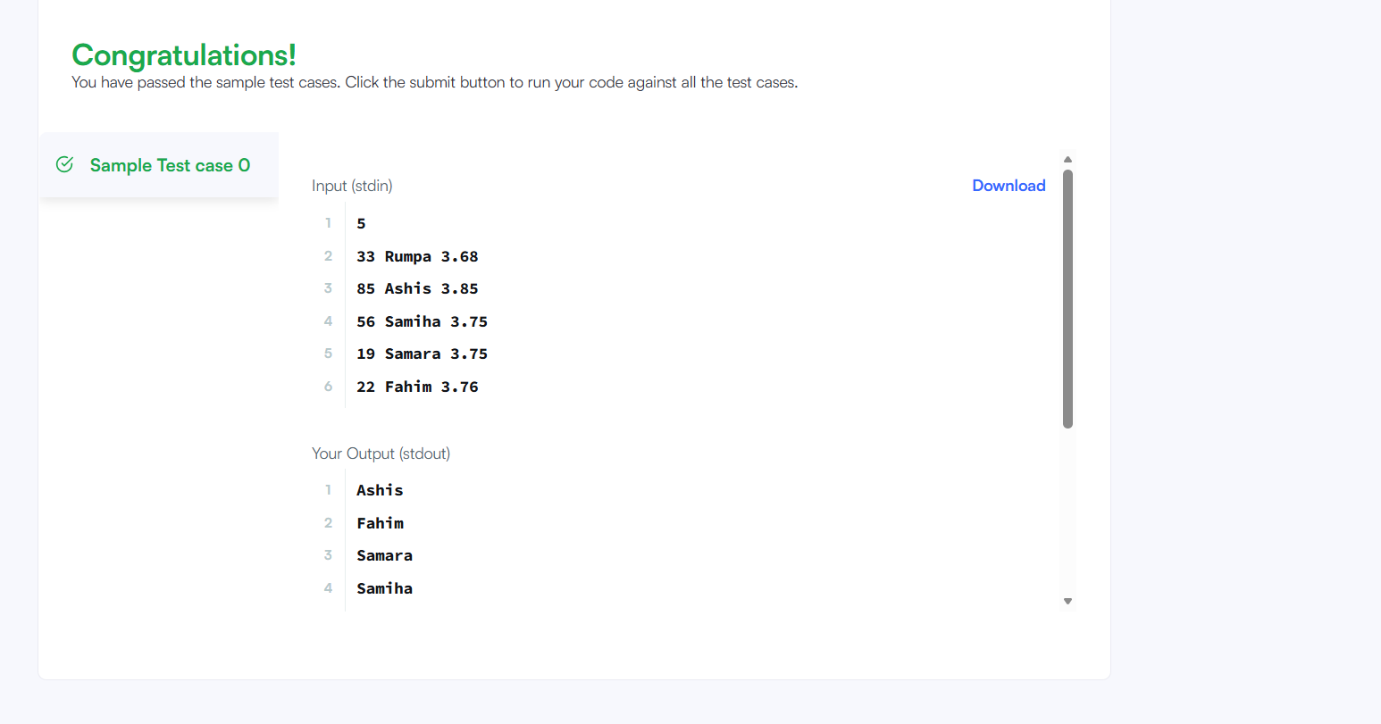

Result: Thus ,the program successfully sorts all student records according to the given priority rules and prints the students’ first names in the correct ranked order was executed successfully.
Task4:
Aim: To sort people’s names based on their heights in descending order, so that the tallest person appears first.
Algorithm:
- Start.
- Accept two arrays: names[] and heights[].
- Find the length of the heights array and store it in n.
- Use Bubble Sort to arrange heights in descending order:
  - Compare each height with the remaining heights.
  - If the current height is smaller, swap both heights.
  - At the same time, swap the corresponding names to maintain mapping.
- Repeat until all elements are sorted.
- Return the sorted names array.
- Stop.
Program:
class Solution {
public String[] sortPeople(String[] names, int[] heights) {
int n = heights.length;
for(int i = 0; i < n - 1; i++){
for(int j = i + 1; j < n; j++){
if(heights[i] < heights[j]){
int tempH = heights[i];
heights[i] = heights[j];
heights[j] = tempH;
String tempN = names[i];
names[i] = names[j];
names[j] = tempN;
}
}
}
return names;
}
}
Output:
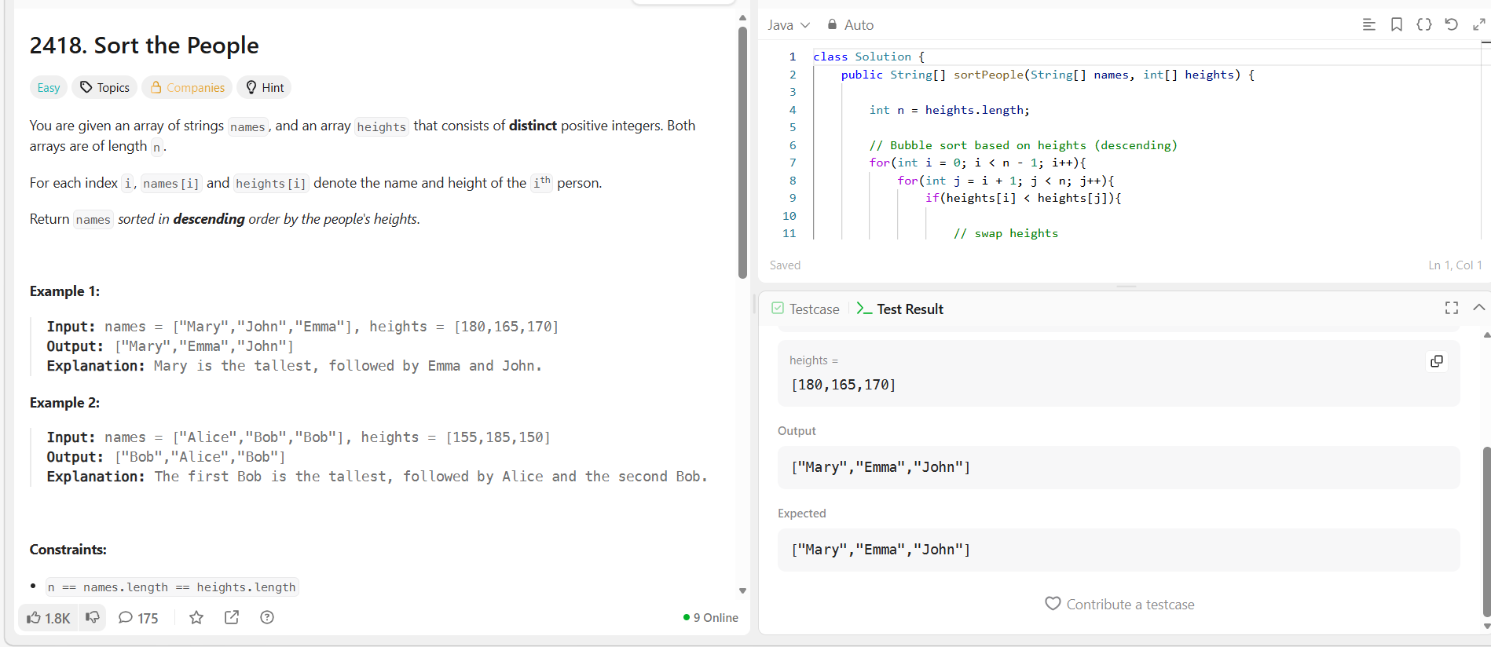

Result: The program successfully sorts the people according to their heights in descending order and returns the names in the correct order, with the tallest person listed first.
Task 6:
Aim: To find the Nth prime number using a Java program.
Algorithm:
- Start with count = 0 and num = 1.
- Increment num by 1.
- Check whether num is a prime number.
- If num is prime, increment count.
- Repeat steps 2–4 until count equals the given input (input1).
- Return num as the Nth prime number.
Program:
class UserMainCode
{
public int NthPrime(int input1){

int count = 0;
int num = 1;

while(count < input1){
num++;

if(isPrime(num)){
count++;
}
}

return num;
}

private boolean isPrime(int n){

if(n < 2) return false;

for(int i = 2; i * i <= n; i++){
if(n % i == 0)
return false;
}

return true;
}
}
Output:
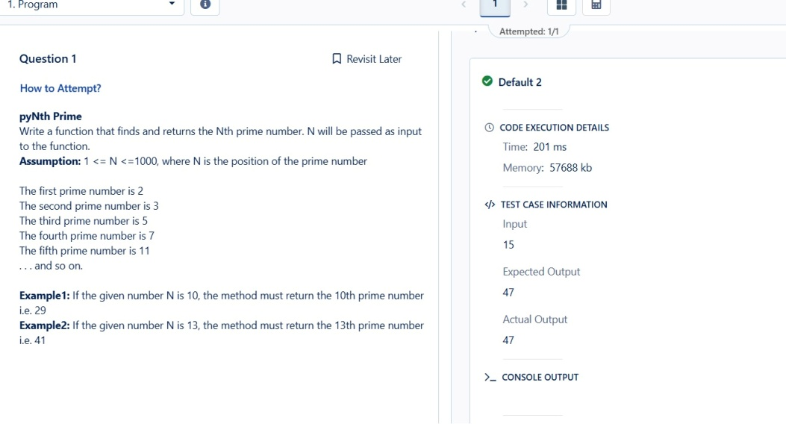

Result: The program successfully returns the Nth prime number.

Task 8:
Aim: To find the lexicographically smallest and largest substrings of length k from a given string.
Algorithm:
- Take the first substring of length k as both smallest and largest.
- Loop from index 1 to length of string − k.
- Extract each substring of length k.
- Compare the substring with smallest and largest using compareTo().
- Update smallest if substring is smaller.
- Update largest if substring is larger.
- Print the smallest and largest substrings.
Program:
import java.util.Scanner;
public class Solution {
public static String getSmallestAndLargest(String s, int k) {
String smallest = s.substring(0, k);
String largest = s.substring(0, k);

for (int i = 1; i <= s.length() - k; i++) {
String sub = s.substring(i, i + k);

if (sub.compareTo(smallest) < 0)
smallest = sub;

if (sub.compareTo(largest) > 0)
largest = sub;
}

return smallest + "\n" + largest;
}

public static void main(String[] args) {
Scanner scan = new Scanner(System.in);
String s = scan.next();
int k = scan.nextInt();
scan.close();

System.out.println(getSmallestAndLargest(s, k));
}
}
Output:
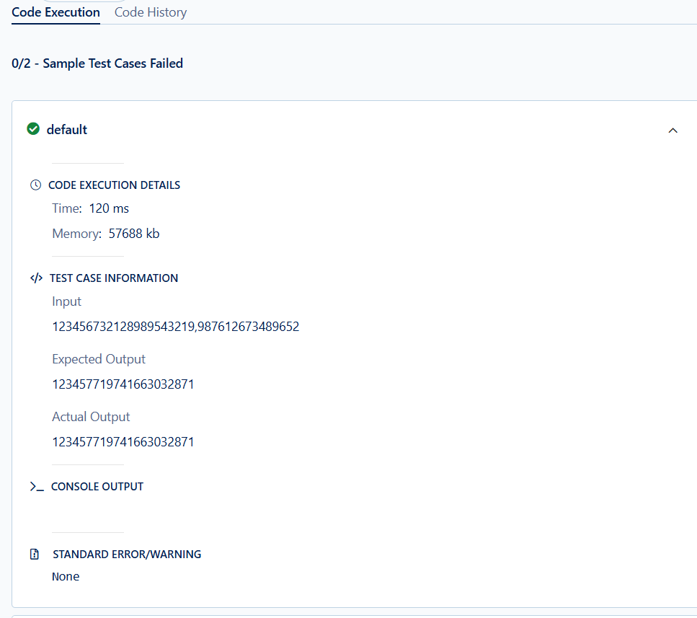
Result: The programs was successfully find the lexicographically smallest and largest substrings of length k from a given string.

Task 9:
Aim: To compute a result by performing addition and subtraction on numbers from N to 1 based on the selected option.
Algorithm:
- Read the value of N and the option opt.
- Initialize result to 0 and a boolean variable add to control addition/subtraction.
- Loop from N down to 1.
- If opt == 1:
- If opt == 2:
- Update the result in each iteration.
- Return the final computed value.
Program:
class UserMainCode
{
public int AddSub(int input1, int input2){

int N = input1;
int opt = input2;

int result = 0;
boolean add = true;

if(opt == 1){
add = true; // start with +
}else{
add = true; // opt2 also starts with +
}

for(int i = N; i >= 1; i--){

if(opt == 1){
// Pattern: + - + - ...
if(add)
result += i;
else
result -= i;

add = !add;
}
else{
// Pattern: + + - + - ...
if(i == N || i == N-1){
result += i;
}
else{
if(add)
result -= i;
else
result += i;

add = !add;
}
}
}

return result;
}
}
Output:
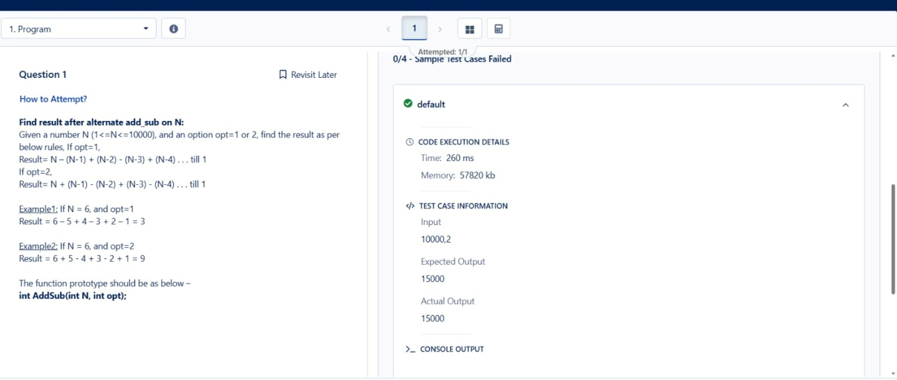

Result: The program successfully calculates the final value by applying the specified addition and subtraction pattern to the numbers from N to 1 based on the given option.

