SMART LENDER
AI Powered Loan Approval Prediction System

Project Documentation
Submitted By
Team Leader: Palli Dharani
Team Members:
• Saikiran Kudipudi
• Yarabarla Manidweep
• Sita Rama Raju Datla
• Thota Leela Sai Krishna

Department: Computer Science and Engineering
College: Vishnu Institute of Technology

Abstract
Smart Lender is a machine learning-powered web application that predicts loan approval using Decision Tree, Random Forest, KNN and XGBoost models. It helps banks make faster and more accurate lending decisions through automated creditworthiness prediction.
Introduction:
The project automates the loan approval process using machine learning. Applicant information is analyzed to classify applications as approved or rejected.
Problem Statement:
Manual loan verification is time-consuming and prone to inconsistency. The system provides a data-driven prediction model.
Objectives:
Develop an ML-based loan prediction system, preprocess data, compare multiple algorithms, deploy the best model using Flask.
Technology Stack:
Python, Flask, Pandas, NumPy, Scikit-learn, XGBoost, Matplotlib, Seaborn, HTML, CSS.
Dataset:
The dataset contains applicant demographics, income, education, loan amount, credit history and loan status.
Data Preprocessing:
Missing values are handled, SMOTE balances the dataset, scaling is applied, and data is split into training and testing sets.
Model Building:
Decision Tree, Random Forest, KNN and XGBoost models are trained and evaluated using confusion matrix, classification report and cross-validation. XGBoost performs best.
Application:
The Flask web application accepts applicant details through HTML forms and predicts loan approval using the saved model.

Entity Relationship Diagram:
Description
The ER diagram represents the core entities involved in the Loan Approval Prediction System and illustrates how they interact with each other. It provides a clear structure for organizing applicant information, loan requests, prediction results, and machine learning model outputs within the database.
Main Entities
User (Credit Officer / Applicant)
Loan_Application
Applicant_Profile
Credit_History
Model
Prediction_Result
Relationship Explanation (Simple)
User → Loan Application
A user (credit officer/applicant) can submit multiple loan applications.
Applicant Profile → Loan Application
Each applicant has a profile containing personal details linked to loan requests.
Credit History → Applicant
Each applicant has one credit history record used for prediction.
Loan Application → Prediction Result
Every loan request produces one prediction output (Approved / Rejected).
Model → Prediction Result
Multiple predictions can be generated using the same ML model (XGBoost).
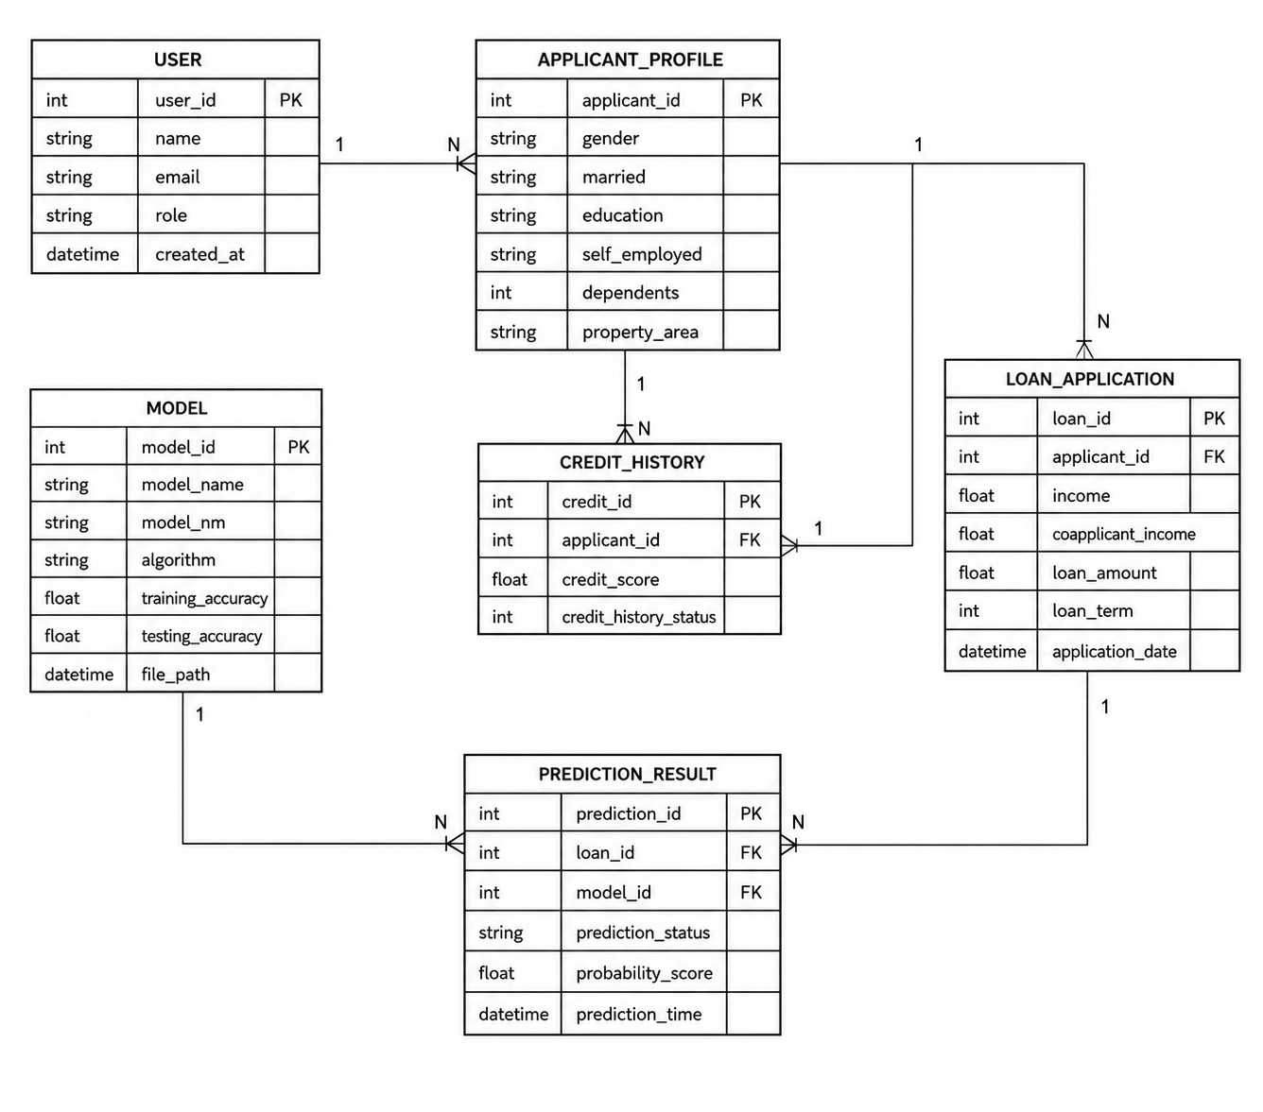
Workflow
The project is developed through a structured workflow consisting of multiple epics, covering data collection, analysis, preprocessing, model development, and deployment. Each epic focuses on a specific stage of the machine learning lifecycle to ensure systematic and efficient project execution.
Epic 1: Data Collection and Architecture Design
Story 1: Download the required dataset from the provided source and store it in the project directory.
Story 2: Define the application architecture, including data flow, machine learning workflow, and deployment structure.
Epic 2: Visualizing and Analyzing the Data
Story 1: Import and read the dataset using Pandas for further analysis.
Story 2: Perform univariate analysis to understand the distribution of individual features.
Story 3: Conduct bivariate analysis to identify relationships between two variables.
Story 4: Perform multivariate analysis to uncover patterns involving multiple features.
Epic 3: Data Pre-Processing
Story 1: Check for missing values, duplicates, and inconsistencies, and handle them appropriately.
Story 2: Balance the dataset to ensure fair representation of all target classes.
Story 3: Scale and normalize numerical features to improve model performance.
Story 4: Split the dataset into training and testing sets for model development and evaluation.
Epic 4: Model Building
Story 1: Train and evaluate a Decision Tree model on the prepared dataset.
Story 2: Build and test a Random Forest model to improve predictive performance.
Story 3: Implement a K-Nearest Neighbors (KNN) model and analyze its accuracy.
Story 4: Train an XGBoost model and compare its performance with other models.
Story 5: Evaluate all models using appropriate metrics and save the best-performing model for deployment.
Epic 5: Application Building
Story 1: Design and develop HTML pages to create a user-friendly interface.
Story 2: Build the Flask application and integrate the trained machine learning model.
Story 3: Run, test, and validate the application to ensure accurate predictions and smooth functionality.
Epic 1: Data Collection and Architecture design

Download the Dataset:
There are many popular open-source repositories for collecting data, such as Kaggle and the UCI Machine Learning Repository.
For this project, the loan prediction dataset is downloaded from Google Sheets. Please refer to the link below to download the dataset:
Link: https://drive.google.com/drive/folders/1fOen6--02V7Ka6E24R8lPAAZ8V0vnENI?usp=sharing
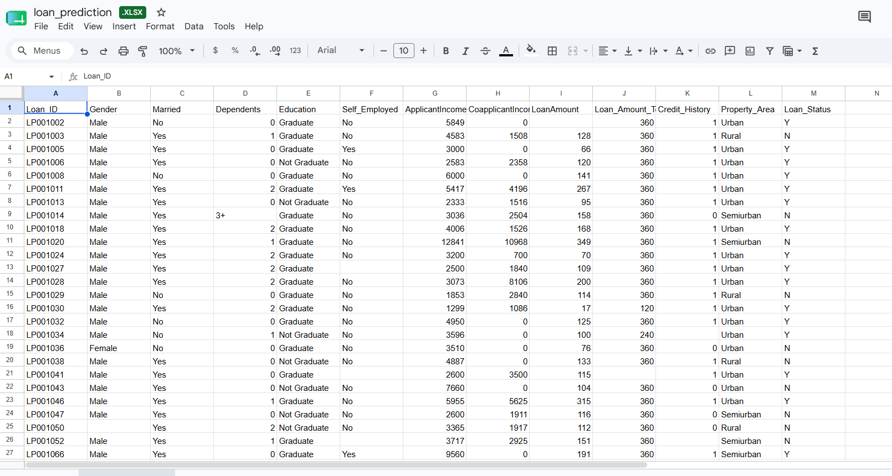

Defining the Application Architecture:
After data collection, a modular and scalable application architecture was designed to ensure separation of concerns, maintainability, and future extensibility. The system follows a three-tier architecture, consisting of the user interface, backend API layer, and AI/ML service modules. A well-structured directory hierarchy was adopted to separate frontend, backend, model, and testing components, improving code organization, development efficiency, and scalability.
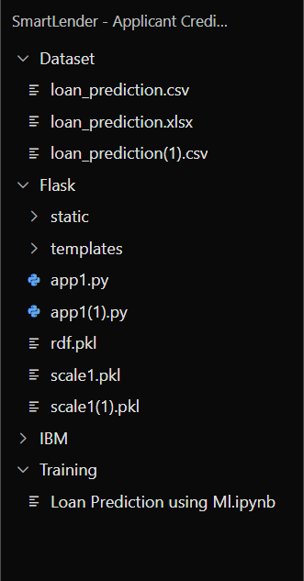
Epic 2: Visualizing and Analysing the Data

Import and Read Dataset:
Importing the Libraries
Import the necessary libraries as shown below. For this project, the visualization style five thirty-eight is used for consistent and readable plots.
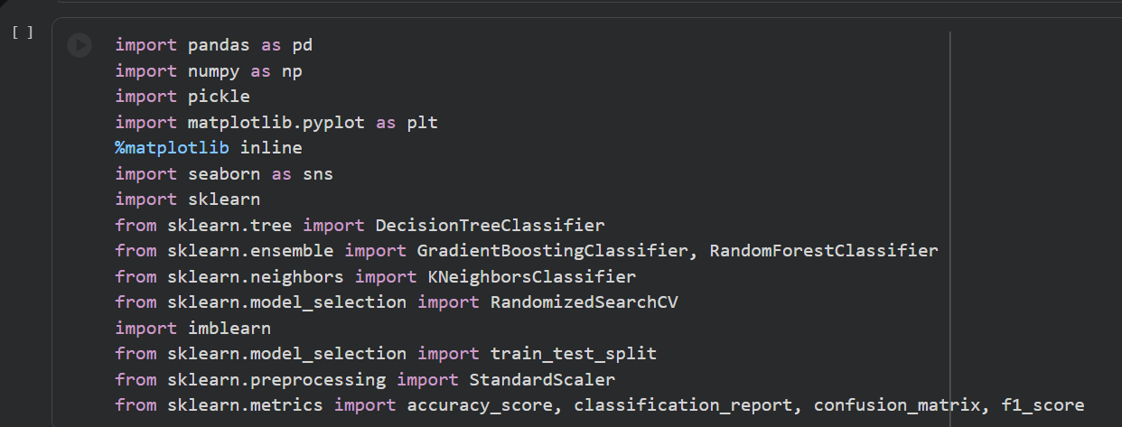
Read the Dataset
The dataset may be in .csv, Excel, .txt, or .json format. Use the pandas library to read it. The read_csv() function is used to load the dataset by passing the file directory path as a parameter.
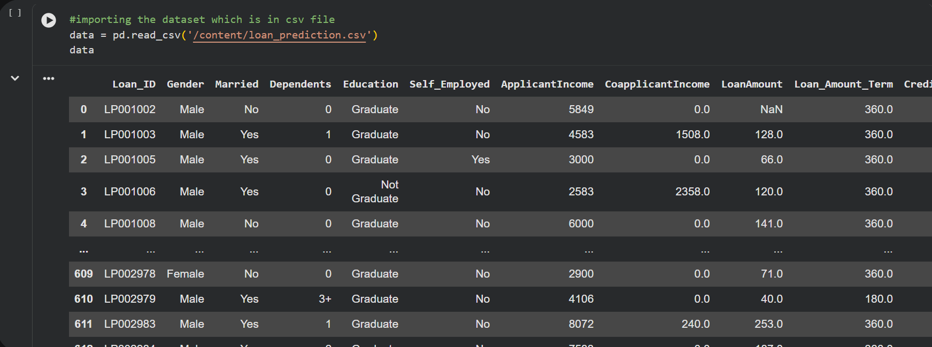

Univariate Analysis:
Univariate analysis is performed to examine the distribution and characteristics of individual features in the dataset.
Distribution plots (Distplot) are used to visualize continuous variables and understand their data distribution.
Count plots (Countplot) are used for categorical variables to display the frequency of each category.
Subplots enable multiple feature visualizations within a single figure for easier comparison.

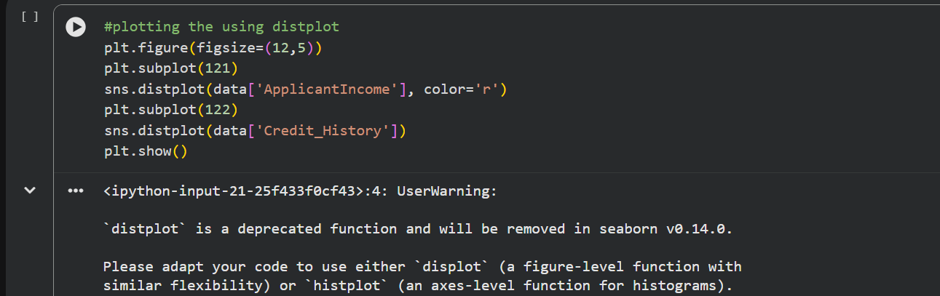
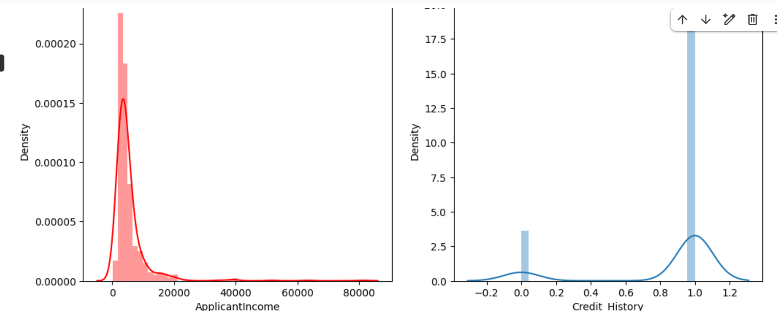
For categorical features, the countplot function is used to count and display the unique categories. A dummy DataFrame is created with categorical features and plotted using a for loop with subplot.
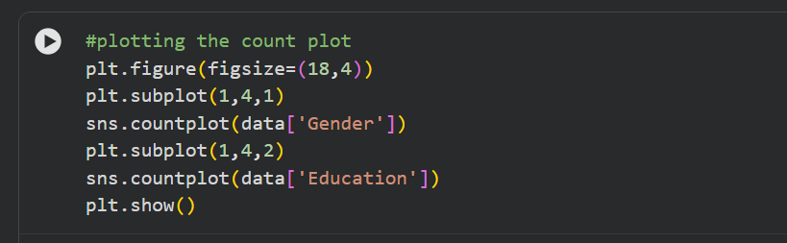
Observations:
Applicant income exhibits a left-skewed distribution.
Credit history is a binary feature with values 0 and 1.
Gender and education are categorical variables with two categories each.
The frequency of category 0 is higher than category 1 for both gender and education features.
This analysis helps identify feature patterns and distributions before proceeding with data preprocessing and model development.
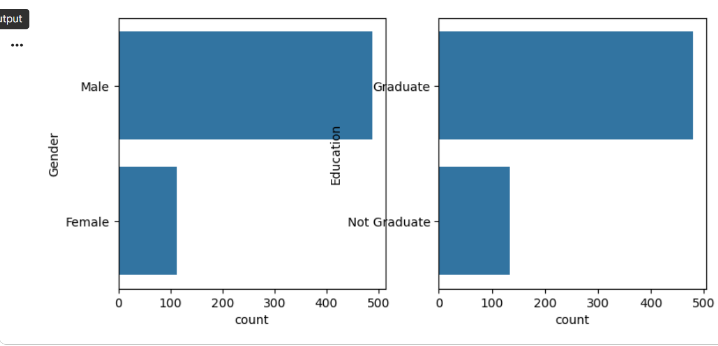
Bivariate Analysis:
Countplot: Bivariate analysis uses count plots to examine relationships between pairs of variables.
From the bivariate analysis graphs, the following insights can be drawn:
Segmenting the gender column against the married column reveals patterns in loan applications based on demographic combinations.
Segmenting education against self-employment status provides insights such as the tendency for educated applicants to be employed.
Loan amount term distributions vary based on the applicant’s property area.
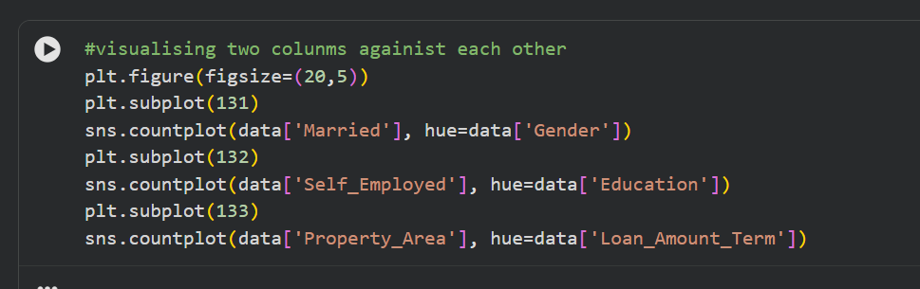

Multivariate Analysis:
Multivariate analysis examines the relationships between multiple features simultaneously. This project uses the swarmplot function from the seaborn library.
Epic 3: Data Pre-processing
Checking and Handling Values:
Handling Categorical Values
To prepare the dataset for machine learning, categorical features were converted into numerical values using encoding techniques. Columns such as Gender, Married, Dependents, Self_Employed, Credit_History, and other relevant attributes were encoded to ensure compatibility with machine learning algorithms.
The dataset was then inspected using methods such as df.shape, df.info(), and df.isnull().sum() to identify missing values and understand data types.
Missing Value Treatment:
Missing values in numerical features were replaced with the mean of the respective column. Missing values in categorical features were replaced with the mode (most frequent value).
This preprocessing step improved data quality and ensured the dataset was suitable for accurate model training and prediction.
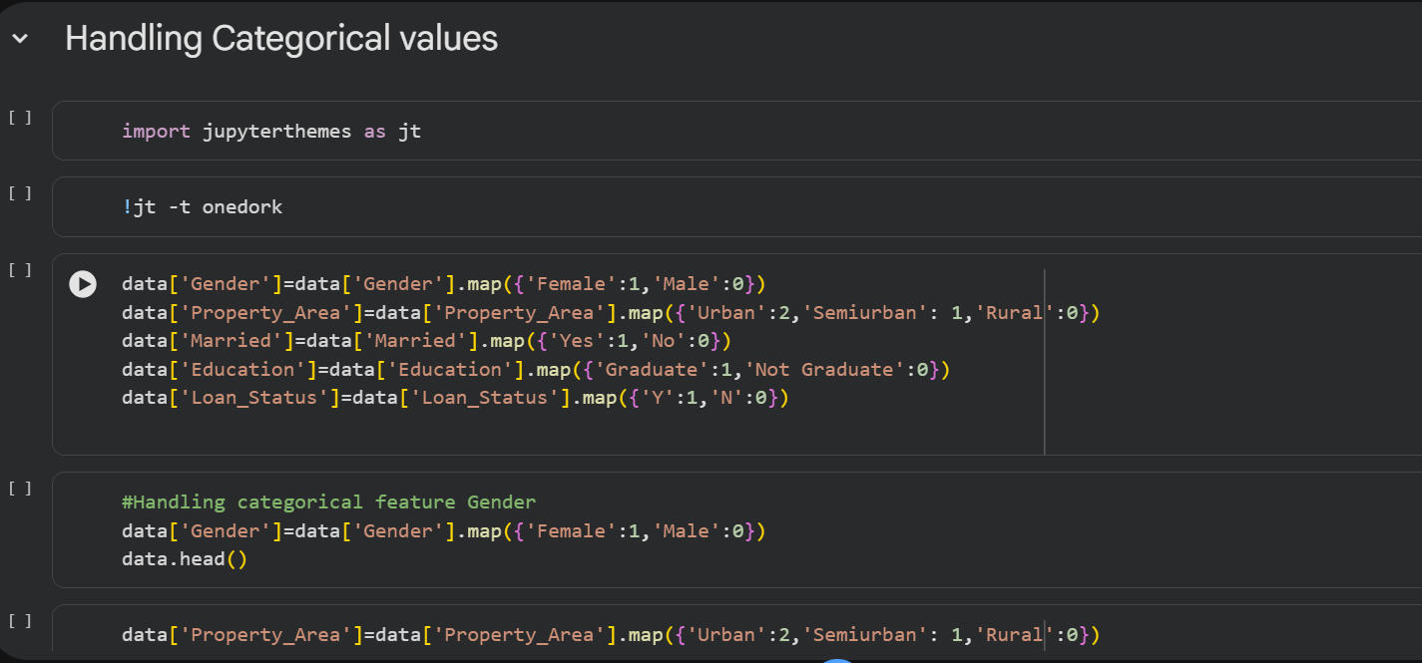
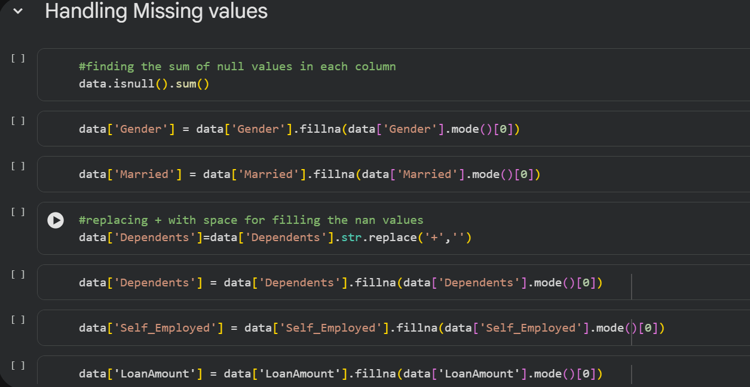
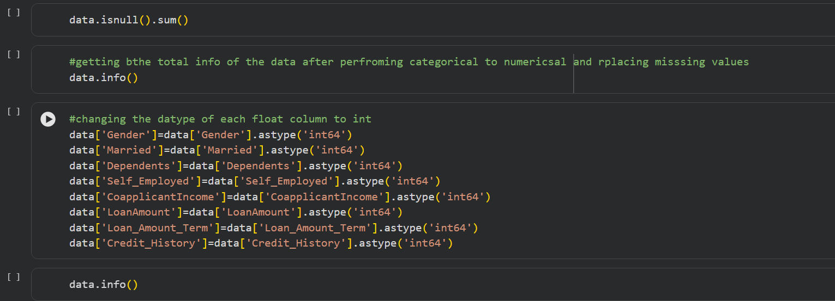
Balancing the Dataset:
Data balancing is a critical step for classification models. Training on an imbalanced dataset leads to biased predictions, where the model predominantly predicts the majority class.

This project applies SMOTE (Synthetic Minority Over-sampling Technique) to address the class imbalance. SMOTE generates synthetic data points for the minority class using the K-Nearest Neighbors (KNN) method.
After applying SMOTE, the minority class size is increased to match the majority class, resulting in a balanced dataset that enables unbiased model training.


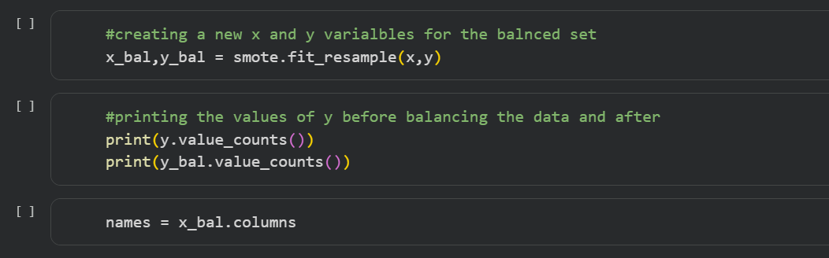
Scaling the Data:
Feature scaling is an important pre-processing step because features measured on different scales can mislead the model’s predictions.
Models such as KNN and Logistic Regression require scaled input data because they rely on distance-based methods and gradient descent optimization.
Scaling is applied only to the input features (X), not to the target variable (y).
After scaling, the data is converted into an array format and then back into a DataFrame for further processing.
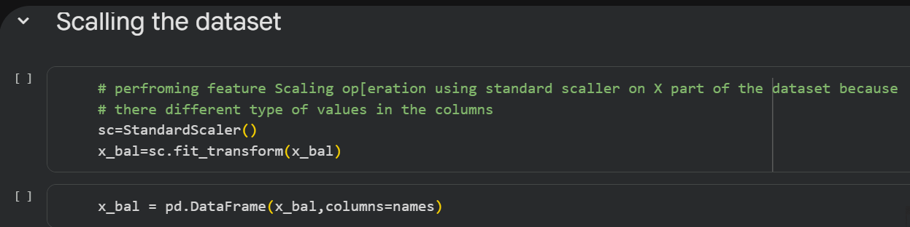
Splitting Data into Training and Test Sets:
The dataset is split into features (X) and the target variable (y). The train_test_split() function from scikit-learn is used with the following parameters:
X: Input features (all columns except the target variable)
y: Target variable (loan approval status)
test_size: Proportion of the dataset reserved for testing
random_state: Seed for reproducibility
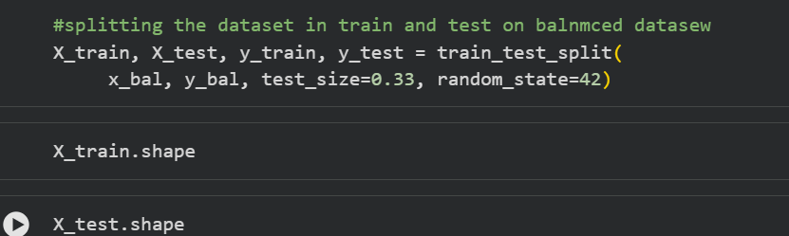

Epic 4: Model Building
Decision Tree Model:
A function named decisionTree() is created and accepts training and test data as parameters. Inside the function, DecisionTreeClassifier is initialized, trained using .fit(), and used to predict test outcomes using .predict(). Model performance is evaluated using a confusion matrix and a classification report.
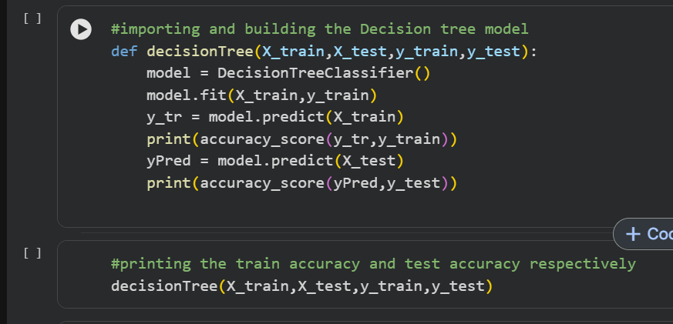
Random Forest Model:
A function named randomForest() is created with the same structure. RandomForestClassifier is initialized, trained on the training data, and tested on the test set. Performance is evaluated using the confusion matrix and classification report.
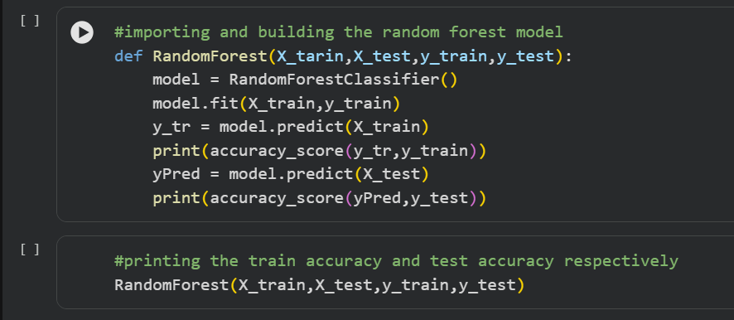
KNN Model:
A function named KNN() is created. KNeighborsClassifier is initialized, trained, and tested using the same approach. Performance metrics include the confusion matrix and classification report.

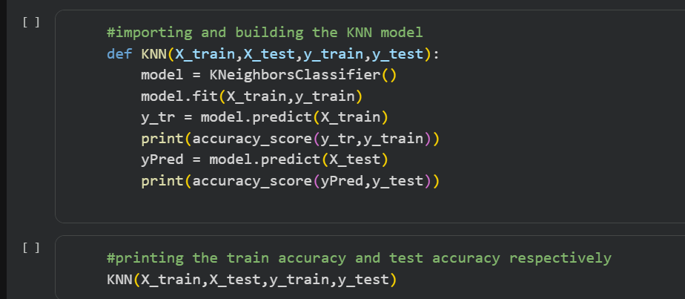
XGBoost Model:
A function named xgboost() is created. GradientBoostingClassifier is initialized, trained, and tested. The confusion matrix and classification report are used to evaluate the model.
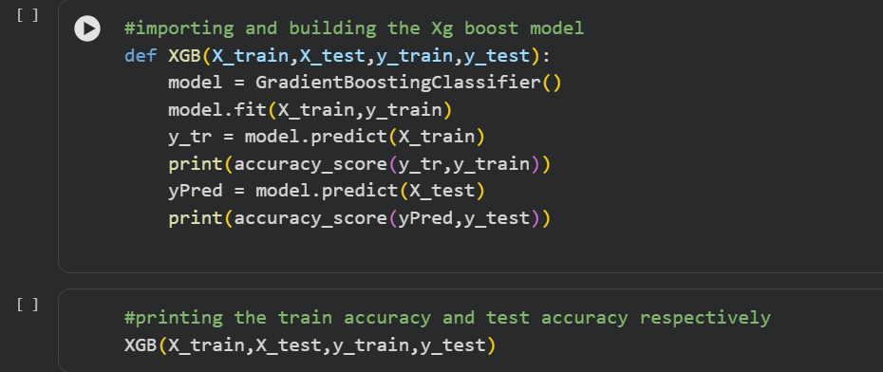
Evaluating Performance and Saving the Model:
Cross-validation is applied using cross_val_score from scikit-learn with 5-fold cross-validation (cv=5) to verify consistent model performance across different data splits.
The best model is saved using pickle.dump() to generate a .pkl file, which is later loaded for Flask integration.
To learn more about cross-validation, refer to: https://towardsdatascience.com/cross-validation-explained-evaluating-estimator-performance-e51e5430ff85
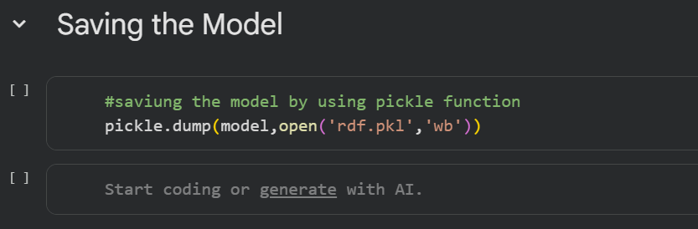
Epic 5: Application Building
Building HTML Pages:
Create three HTML files and save them in the templates/ folder:
home.html — The landing page of the application, providing a brief project overview and a Predict button.
predict.html — The form page where users enter applicant details for loan prediction. Clicking the Submit button routes to the results page.
submit.html — The results page that displays the loan approval prediction output.

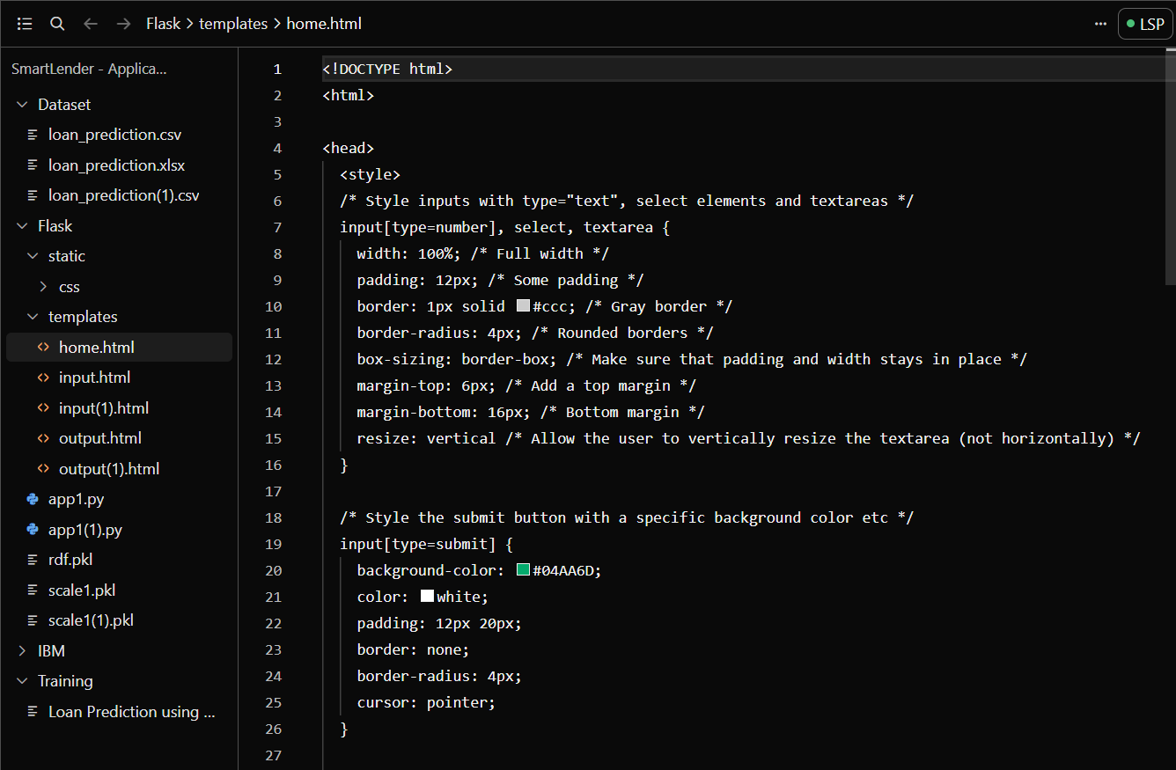
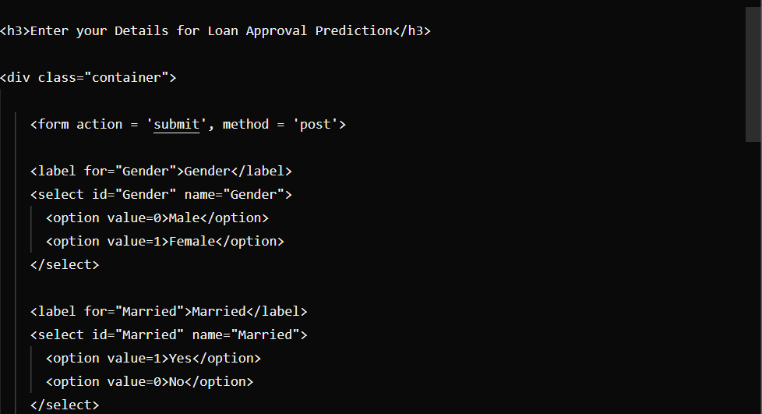
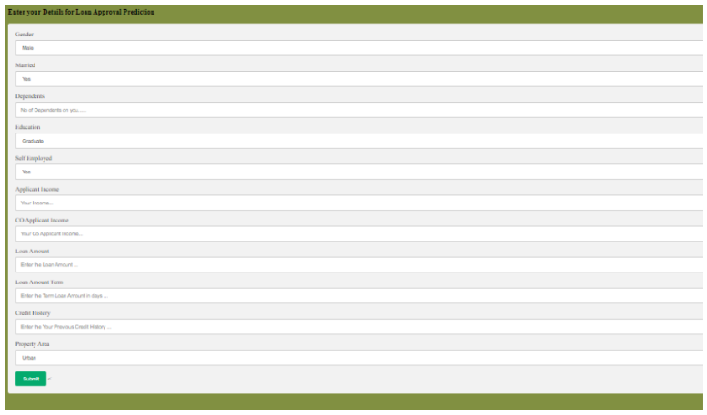
Building the Python Script:
Import the Libraries: Import Flask and all required libraries. Load the saved model file (rdf.pkl) using pickle. Create a Flask application instance using Flask(name).
Render HTML Pages: Use Flask’s routing decorator @app.route(‘/’) to bind the home URL to the home.html template. The render_template() function is used to render each HTML file.
Retrieve Values from the UI: Route the application to a predict() function. This function retrieves all input values from the HTML form using a POST request. The values are stored in an array and passed to model.predict(). The resulting prediction is rendered on the submit.html results page.
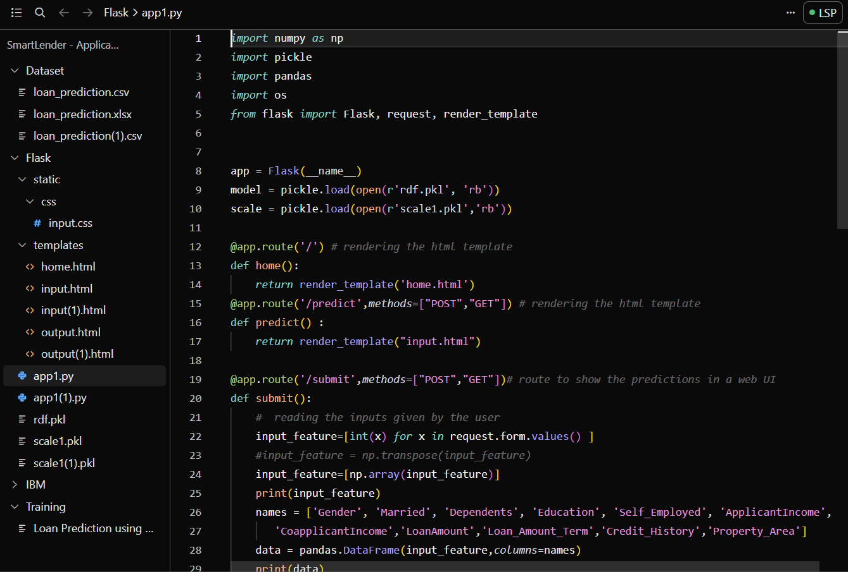
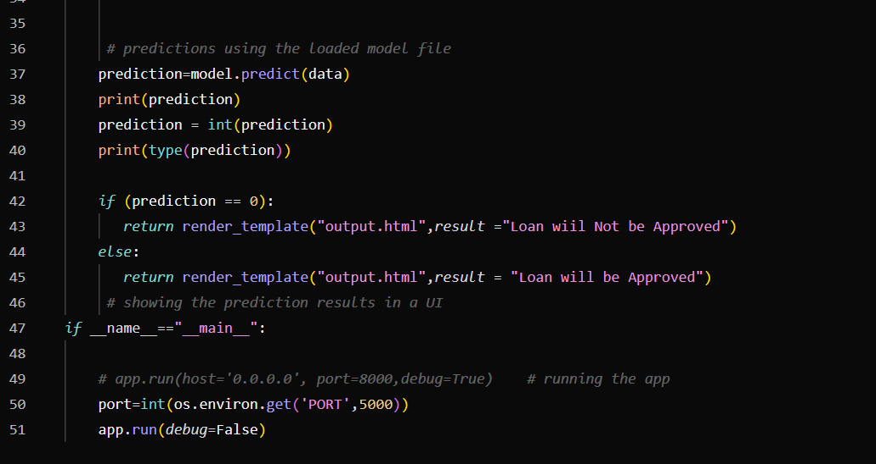

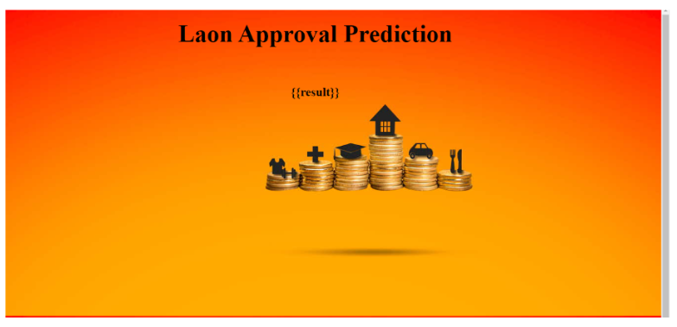
Run the Application:
Open Anaconda Prompt from the Start Menu.
Navigate to the directory containing your app.py script.
Run the application by typing: python app.py
Open your browser and navigate to the localhost URL displayed in the terminal.
Click the Predict button, enter the applicant’s details, click Submit, and view the loan approval prediction result.
Conclusion
This is the final section of a project report that summarizes the key work completed, highlights the main outcomes and findings, and provides closure to the document by reflecting on the project's overall success and future scope.

