INCIDENT LIFECYCLE AUTOMATION IN SERVICENOW
Incident Lifecycle Automation in ServiceNow
Complete Project Documentation — Five Project Phases

Document Purpose
This document consolidates the Ideation, Requirement Analysis, Project Design, Project Planning, and Project Development phases for the Incident Lifecycle Automation in ServiceNow project.

1. Ideation Phase

1.1 Introduction
The Ideation Phase establishes the business need, project vision, proposed solution, major stakeholders, and high-level value of the Incident Lifecycle Automation in ServiceNow project. The purpose of this phase is to convert an operational problem in IT incident handling into a clearly defined automation initiative.

1.2 Background
Organizations receive incidents involving network connectivity, VPN authentication, application failures, hardware problems, access issues, and other IT disruptions. When incidents depend heavily on manual categorization, prioritization, assignment, communication, and SLA monitoring, response can become inconsistent and time-consuming.

1.3 Problem Identification
The project identifies the need for a controlled and automated incident lifecycle in which ServiceNow supports agents from incident creation through resolution and closure.
- Manual or inconsistent incident assignment can delay work.
- Important incidents may not receive the required level of attention.
- SLA monitoring can be overlooked when handled manually.
- Support teams may use different approaches to incident progression and closure.
- Users and support teams need better visibility into incident status.
- Related incidents may be difficult to track without a structured relationship.

1.4 Project Idea
The proposed idea is to configure ServiceNow Incident Management so that incidents follow a standardized lifecycle. Automation and platform configuration are used to support categorization, prioritization, assignment, SLA tracking, notifications, related records, resolution, and closure.

1.5 Project Vision
To establish a reliable and traceable incident management process that reduces unnecessary manual effort, improves routing and prioritization, supports SLA compliance, and gives service agents a centralized view of incident work.

1.6 Proposed High-Level Lifecycle
Incident Creation → Categorization → Impact/Urgency → Priority → Assignment → SLA Monitoring → Investigation → Resolution → Closure

1.7 Stakeholders

1.8 Expected Value
- Faster and more consistent incident routing.
- Improved visibility of incident progress and SLA status.
- Reduced repetitive administrative work.
- More standardized incident resolution and closure.
- Better traceability of related incidents and support activity.

1.9 Ideation Deliverables
- Defined project problem statement.
- Project vision and objectives.
- High-level incident lifecycle.
- Initial stakeholder identification.
- Initial scope and proposed ServiceNow approach.
Stakeholder | Interest / Responsibility
End User | Reports an IT issue and provides required information.
Service Desk Agent | Reviews, categorizes, assigns, investigates, and communicates about incidents.
Support Group | Performs technical investigation and resolution.
Incident Manager | Monitors incident performance, escalations, and process compliance.
ServiceNow Administrator | Configures and maintains platform behavior.
Management | Reviews service performance and operational reports.

2. Requirement Analysis

2.1 Purpose
The Requirement Analysis Phase translates the project idea into measurable business, functional, technical, security, and operational requirements. These requirements provide the baseline for design, development, and testing.

2.2 Business Objectives
- Standardize the incident lifecycle from creation to closure.
- Reduce manual effort in incident routing and repetitive processing.
- Improve assignment accuracy and response time.
- Improve visibility into SLA performance.
- Provide clear ownership and accountability for incidents.
- Improve communication between users and support teams.
- Support consistent resolution and closure practices.

2.3 Functional Requirements

2.4 Example Incident Data

2.5 Non-Functional Requirements
- Security: access and modifications must follow ServiceNow roles and access controls.
- Reliability: automation should execute consistently under defined conditions.
- Performance: routine incident operations should be processed efficiently.
- Maintainability: rules and flows should be documented and easy to update.
- Auditability: incident updates and ownership changes should remain traceable.
- Scalability: the design should support increasing incident volume.

2.6 Stakeholder Requirements

2.7 Acceptance Criteria
- A valid incident can be created and receives a unique incident number.
- Required incident information is captured correctly.
- Configured categorization and assignment behavior works as intended.
- Priority is consistent with the configured impact/urgency logic.
- Applicable SLA information is visible in the incident's related records.
- Related child incidents can be created and verified from the parent incident.
- Resolution information is captured before resolution.
- The incident can be closed only when configured closure conditions are satisfied.
ID | Requirement | Description
FR-01 | Incident Creation | Authorized users/agents must be able to create incidents with required information.
FR-02 | Incident Categorization | Incidents must support category and subcategory classification.
FR-03 | Priority Management | Impact and urgency must support appropriate priority determination.
FR-04 | Assignment | Incidents must be routed to the appropriate assignment group and agent.
FR-05 | SLA Tracking | Applicable incidents must be monitored against configured SLA targets.
FR-06 | Notifications | Important incident events should generate appropriate notifications.
FR-07 | Lifecycle Control | Incidents must move through defined states such as New, In Progress, On Hold, Resolved, and Closed.
FR-08 | Related Records | Agents must be able to view related records such as child incidents and Task SLAs where configured.
FR-09 | Resolution | Agents must record resolution information before completing the resolution stage.
FR-10 | Closure | Incidents must satisfy configured closure conditions before final closure.
Field | Example
Short Description | Unable to connect to Corporate VPN
Caller | Selected ServiceNow user
Description | User receiving VPN authentication failure error.
Category | Network
Subcategory | VPN
Impact | Based on business effect
Urgency | Based on required response
Assignment Group | Appropriate network/support group
State | New / In Progress / Resolved / Closed
Stakeholder | Key Requirement
End User | Simple incident reporting and clear status communication.
Service Desk | Fast assignment, complete incident context, and clear lifecycle states.
Support Engineer | Relevant incident information, work notes, knowledge support, and SLA visibility.
Incident Manager | Monitoring, escalation, SLA visibility, and reporting.
Administrator | Configurable and maintainable automation.

3. Project Design Phase

3.1 Design Objective
The Project Design Phase defines how the requirements will be implemented in ServiceNow. The design focuses on the Incident table, lifecycle states, assignment, priority, SLA monitoring, notifications, related records, workspace usage, and automation components.

3.2 High-Level Architecture
User / Service Desk → Incident Record → Categorization → Impact & Urgency → Priority → Assignment Group / Agent → SLA Monitoring → Investigation → Resolution → Closure

3.3 Core ServiceNow Components

3.4 Incident Data Design

3.5 Lifecycle Design

3.6 Assignment Design
Assignment logic should use defined business conditions. For example, a Network/VPN incident can be routed to the appropriate network support group. The final mapping should match the assignment groups configured in the ServiceNow instance.

3.7 Priority Design
Priority is designed around the relationship between impact and urgency. High-impact and high-urgency incidents should receive the highest appropriate priority according to the configured ServiceNow priority matrix.

3.8 SLA Design
SLA definitions should specify start, pause where applicable, and stop conditions, together with an appropriate schedule and target duration. The project should use the actual organizational SLA policy if available rather than treating example durations as mandatory.

3.9 Notification Design
- Incident creation or assignment notification.
- Important incident update notification.
- Resolution notification where required.
- SLA warning/escalation notification where configured.
- Closure communication where required.

3.10 Child Incident Design
A parent incident can be associated with child incidents when multiple user-specific incidents relate to a broader issue. This supports traceability and helps agents review related work from the parent incident's Related Records section.

3.11 Workspace Design
Service Operations Workspace provides an agent-oriented view in which an agent can open incidents, review descriptions and knowledge information, take ownership where appropriate, and inspect related records such as Task SLAs and child incidents.

3.12 Design Principles
- Use configuration before custom scripting when configuration satisfies the requirement.
- Keep automation conditions explicit and testable.
- Avoid conflicting rules that update the same fields unexpectedly.
- Keep lifecycle transitions controlled and auditable.
- Design for maintainability and future enhancement.
Component | Purpose
Incident Table | Central record for incident information and lifecycle state.
Assignment Groups | Represent teams responsible for incident work.
Assignment Rules / Automation | Support routing of incidents to appropriate groups.
Business Rules | Provide server-side logic when configured conditions occur.
Client Scripts | Control client-side form behavior where required.
UI Policies | Control field visibility, mandatory status, or read-only behavior.
Data Policies | Enforce data requirements at the platform level.
Flow Designer | Create visual automation for supported incident processes.
Notifications | Communicate important incident events.
SLAs | Measure incident response/resolution performance against targets.
Service Operations Workspace | Provides an agent-focused interface for incident work.
Related Records | Provides access to connected records such as Child Incidents and Task SLAs.
Field Group | Fields / Examples
Identification | Number, Caller
Problem Details | Short Description, Description
Classification | Category, Subcategory
Assessment | Impact, Urgency, Priority
Ownership | Assignment Group, Assigned To
Lifecycle | State
Communication | Additional Comments, Work Notes
Resolution | Resolution Code, Resolution Notes, Resolved By, Resolved Date
State | Purpose
New | Incident has been created and requires processing.
In Progress | An agent/support team is actively investigating or working.
On Hold | Work is temporarily paused because of a dependency or missing information.
Resolved | The issue has been fixed and resolution details have been recorded.
Closed | The incident has completed the configured closure process.

4. Project Planning Phase

4.1 Planning Objective
The Project Planning Phase converts the approved design into an execution roadmap. Work is divided into manageable milestones so that each capability can be configured, tested, documented, and validated before moving to the next stage.

4.2 Development Roadmap

4.3 Detailed Work Breakdown

Milestone 1 — Incident Creation
- Verify incident table and form.
- Validate caller and description fields.
- Validate category/subcategory.
- Create sample incident and record its incident number.

Milestone 2 — Assignment
- Identify support groups.
- Define routing conditions.
- Configure assignment behavior.
- Test representative incident categories.
- Verify group and assigned-to behavior.

Milestone 3 — Priority
- Define impact and urgency scenarios.
- Validate priority outcomes.
- Test high-, medium-, and low-priority examples.
- Document any instance-specific priority rules.

Milestone 4 — SLA
- Identify required SLA targets.
- Configure/validate SLA definitions.
- Verify SLA attachment.
- Review Task SLAs in Related Records.
- Test warning/breach behavior if configured.

Milestone 5 — Notifications
- Identify notification events.
- Configure recipients and conditions.
- Test assignment/update/resolution notifications.
- Validate escalation notifications where applicable.

Milestone 6 — Child Incidents
- Open a parent incident.
- Create a child incident from Related Records.
- Record the child incident number.
- Return to the parent and verify the child incident is listed.

Milestone 7 — Resolution & Closure
- Investigate incident.
- Record work notes.
- Enter resolution information.
- Move incident to Resolved.
- Verify closure conditions and close the incident.

4.4 Dependencies
- Required users and assignment groups must exist.
- Incident fields and categories must be available.
- SLA definitions must be available for SLA testing.
- Notification recipients must be valid.
- Required roles/permissions must be configured.
- Test data must represent realistic incident scenarios.

4.5 Risk Management

4.6 Planned Deliverables
- Configured incident lifecycle.
- Assignment and priority behavior.
- SLA monitoring.
- Notifications.
- Parent-child incident validation.
- Workspace validation.
- Test cases and results.
- Final project documentation.
ID | Milestone | Main Activities | Deliverable
M1 | Incident Creation | Configure/validate incident form and required fields. | Working incident creation.
M2 | Assignment Automation | Define support groups and assignment conditions. | Correct routing.
M3 | Priority Management | Validate impact/urgency and priority behavior. | Consistent priority.
M4 | SLA Management | Configure/validate SLA definitions and visibility. | SLA tracking.
M5 | Notifications | Configure and test required incident notifications. | Event communication.
M6 | Related/Child Incidents | Create and verify parent-child incident relationships. | Traceable related incidents.
M7 | Resolution & Closure | Validate resolution fields, states, and closure conditions. | Complete lifecycle.
M8 | End-to-End Testing | Execute integrated scenarios and correct defects. | Validated solution.
Risk | Impact | Mitigation
Incorrect routing condition | Incident reaches wrong group. | Use explicit conditions and test multiple scenarios.
Conflicting automation | Unexpected field changes. | Review rule order/conditions and avoid overlapping logic.
Incorrect SLA criteria | SLA does not attach or measures incorrectly. | Test start/stop/pause conditions against documented targets.
Insufficient test data | Hidden defects remain. | Use representative incident scenarios.
Permission issue | Agent cannot perform required action. | Validate roles and access before testing.

5. Project Development Phase

5.1 Development Objective
The Project Development Phase implements the approved design in the ServiceNow environment. Development in this project is primarily platform configuration and controlled automation rather than conventional standalone application coding.

5.2 Development Sequence
Incident Configuration → Assignment → Priority → SLA → Notifications → Related/Child Incidents → Workspace Validation → Resolution/Closure → Testing

5.3 Incident Configuration
Configure and validate the Incident form and its lifecycle fields. The incident should capture caller, short description, description, classification, impact, urgency, priority, ownership, state, work notes, comments, and resolution information as required by the project.

5.4 Incident Creation Test Scenario
Example scenario: create an incident with the short description 'Unable to connect to Corporate VPN'. Select an appropriate caller and enter a description such as 'User receiving VPN authentication failure error.' Save the record and note the generated incident number.
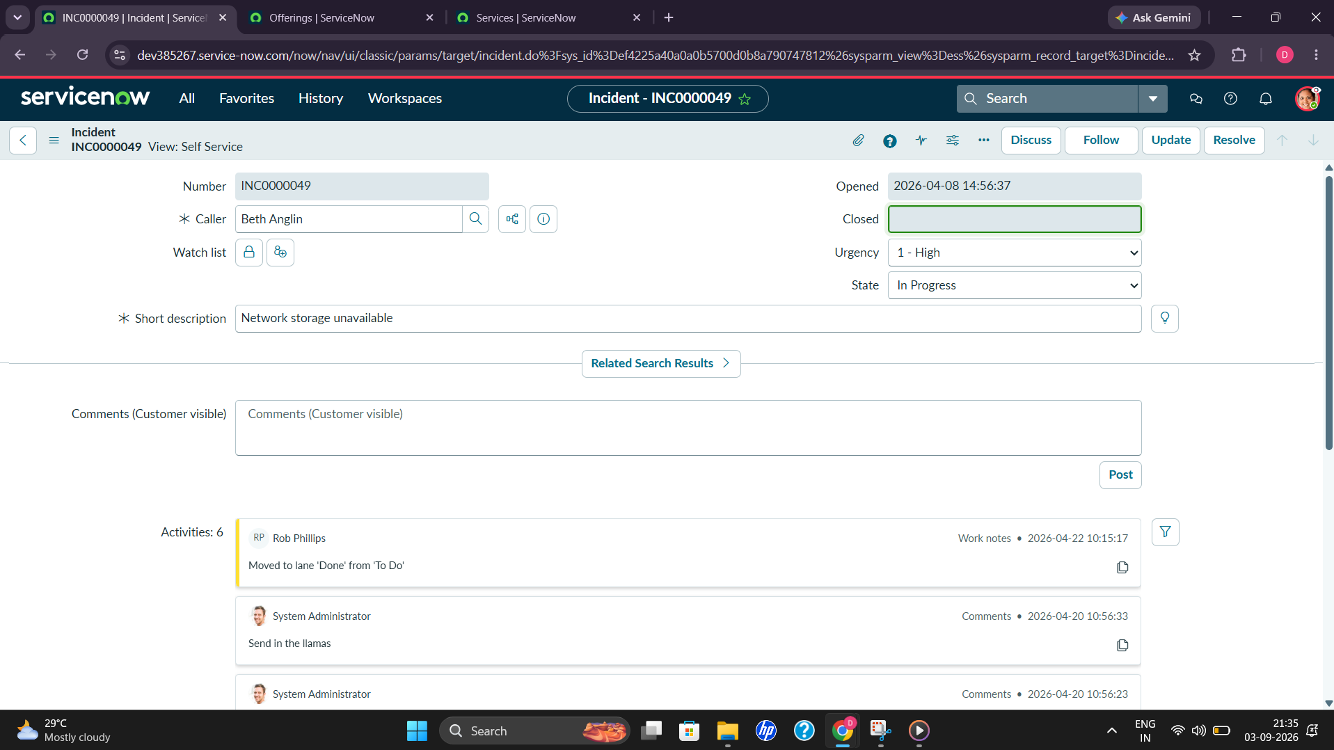
Figure 1. Incident creation and initial incident record in ServiceNow.

5.5 Assignment Automation
Configure assignment behavior using the selected ServiceNow mechanism. A representative rule may route a Network/VPN incident to the appropriate network support group. The exact group name must match the groups present in the implementation instance.
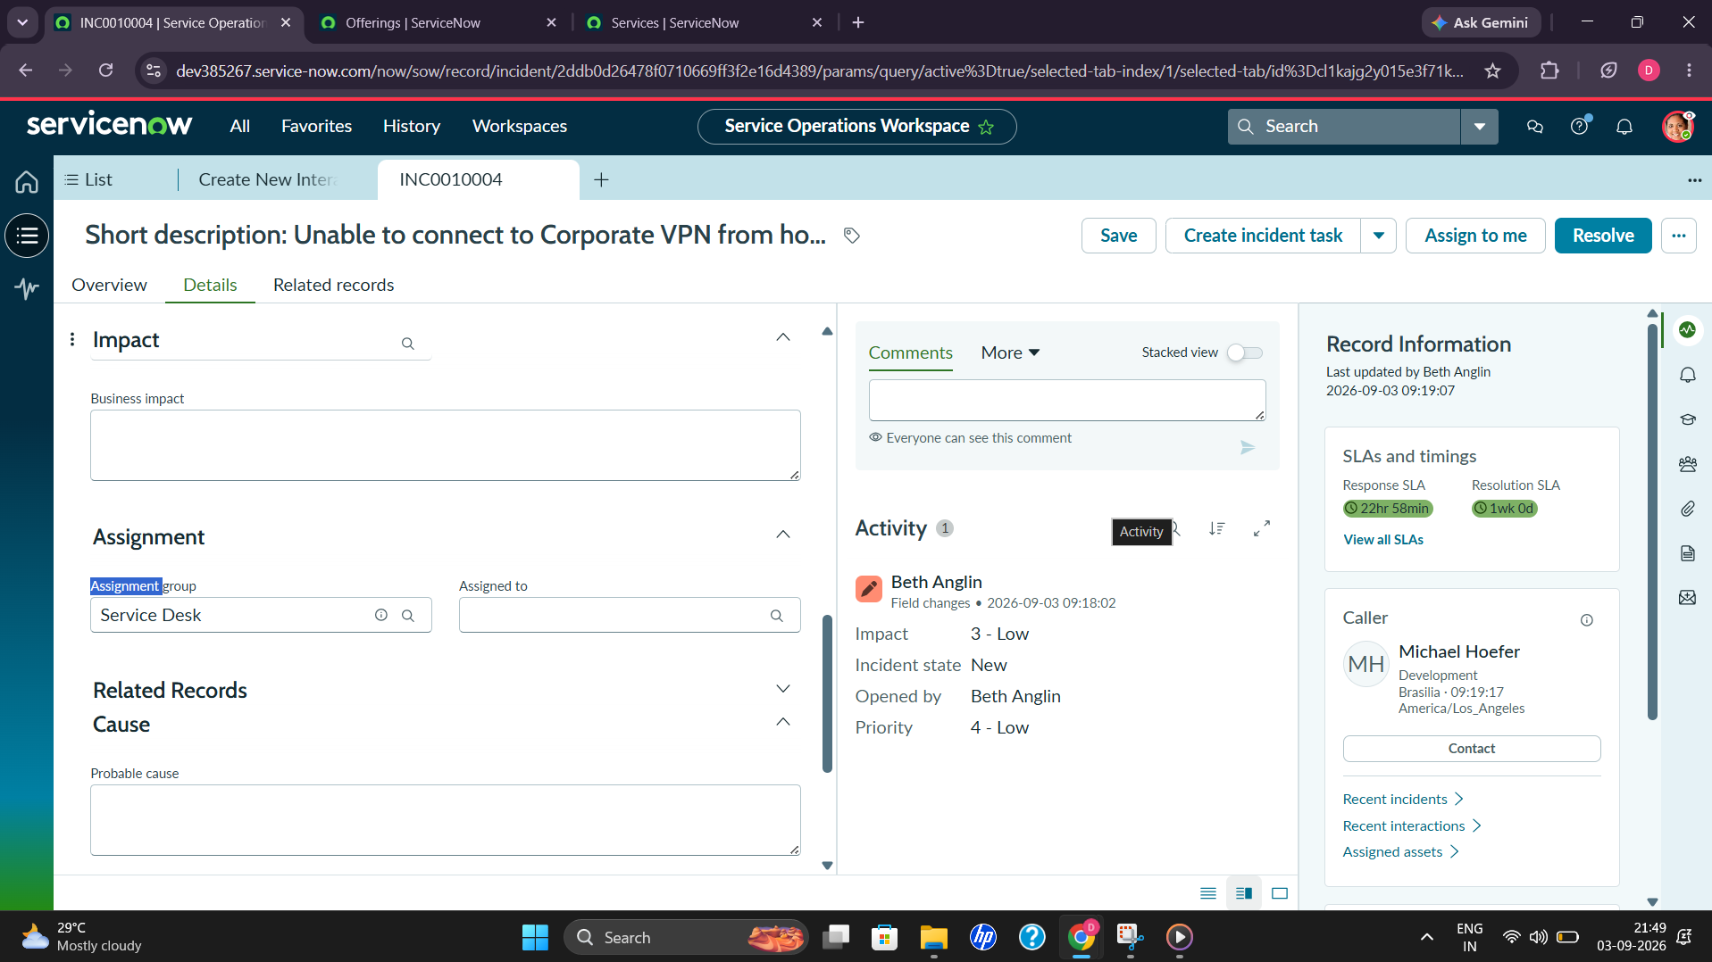
Figure 2. Incident assignment and support-group details in Service Operations Workspace.

5.6 Priority Automation
Validate the impact/urgency matrix used by the instance. Test combinations such as high impact/high urgency and lower-impact scenarios to ensure the resulting priority is consistent with the configured matrix.
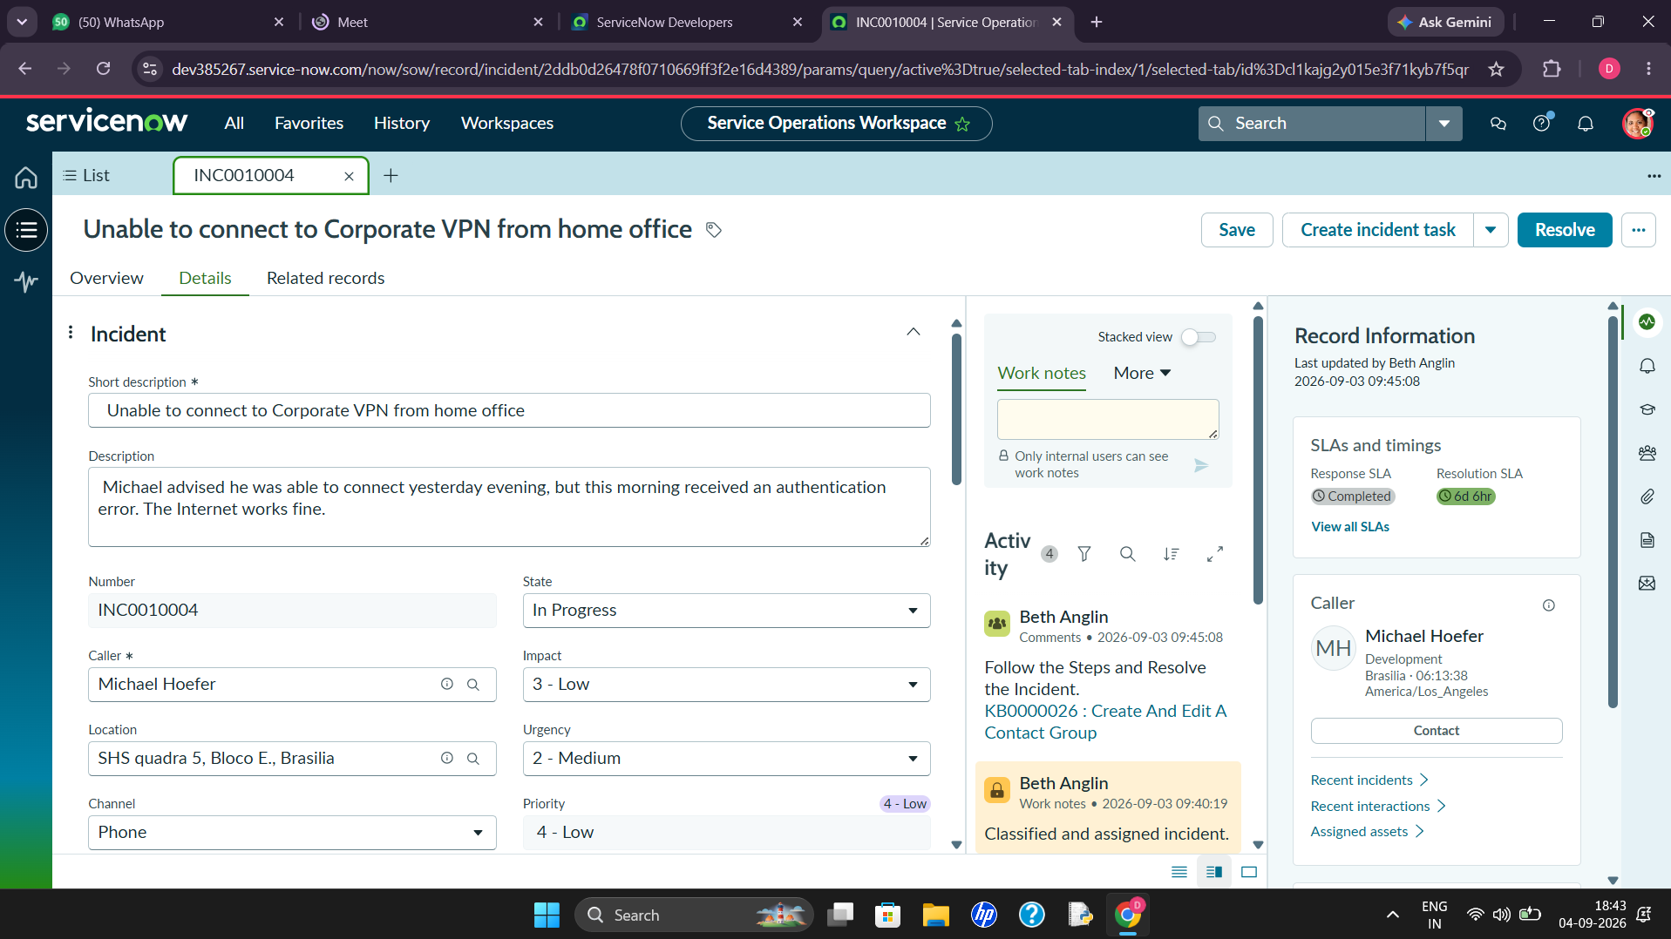
Figure 3. Incident impact, urgency, priority, state, and assignment details.

5.7 SLA Implementation
Configure or validate SLA definitions using the approved business targets. Verify that the relevant SLA is attached to an incident and that its status can be reviewed under Task SLAs in Related Records. Test pause, resume, stop, and breach behavior only when those conditions are part of the configured SLA.
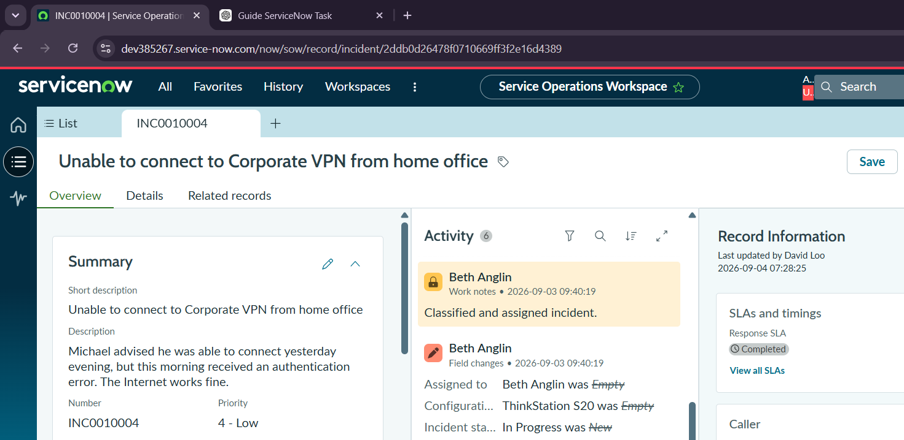
Figure 4. Incident overview showing SLA status and activity history.

5.8 Notification Implementation
- Create/validate incident creation or assignment notification.
- Create/validate important incident update notification.
- Create/validate resolution notification.
- Create/validate SLA warning or escalation notification if required.

5.9 Child Incident Implementation
From a parent incident's Related Records, create a child incident. Use a realistic scenario such as 'Unable to connect to Corporate VPN', select a caller, provide the problem description, save the record, and verify the generated child incident number. Return to the parent incident and confirm that the child appears in the Child Incidents related list.
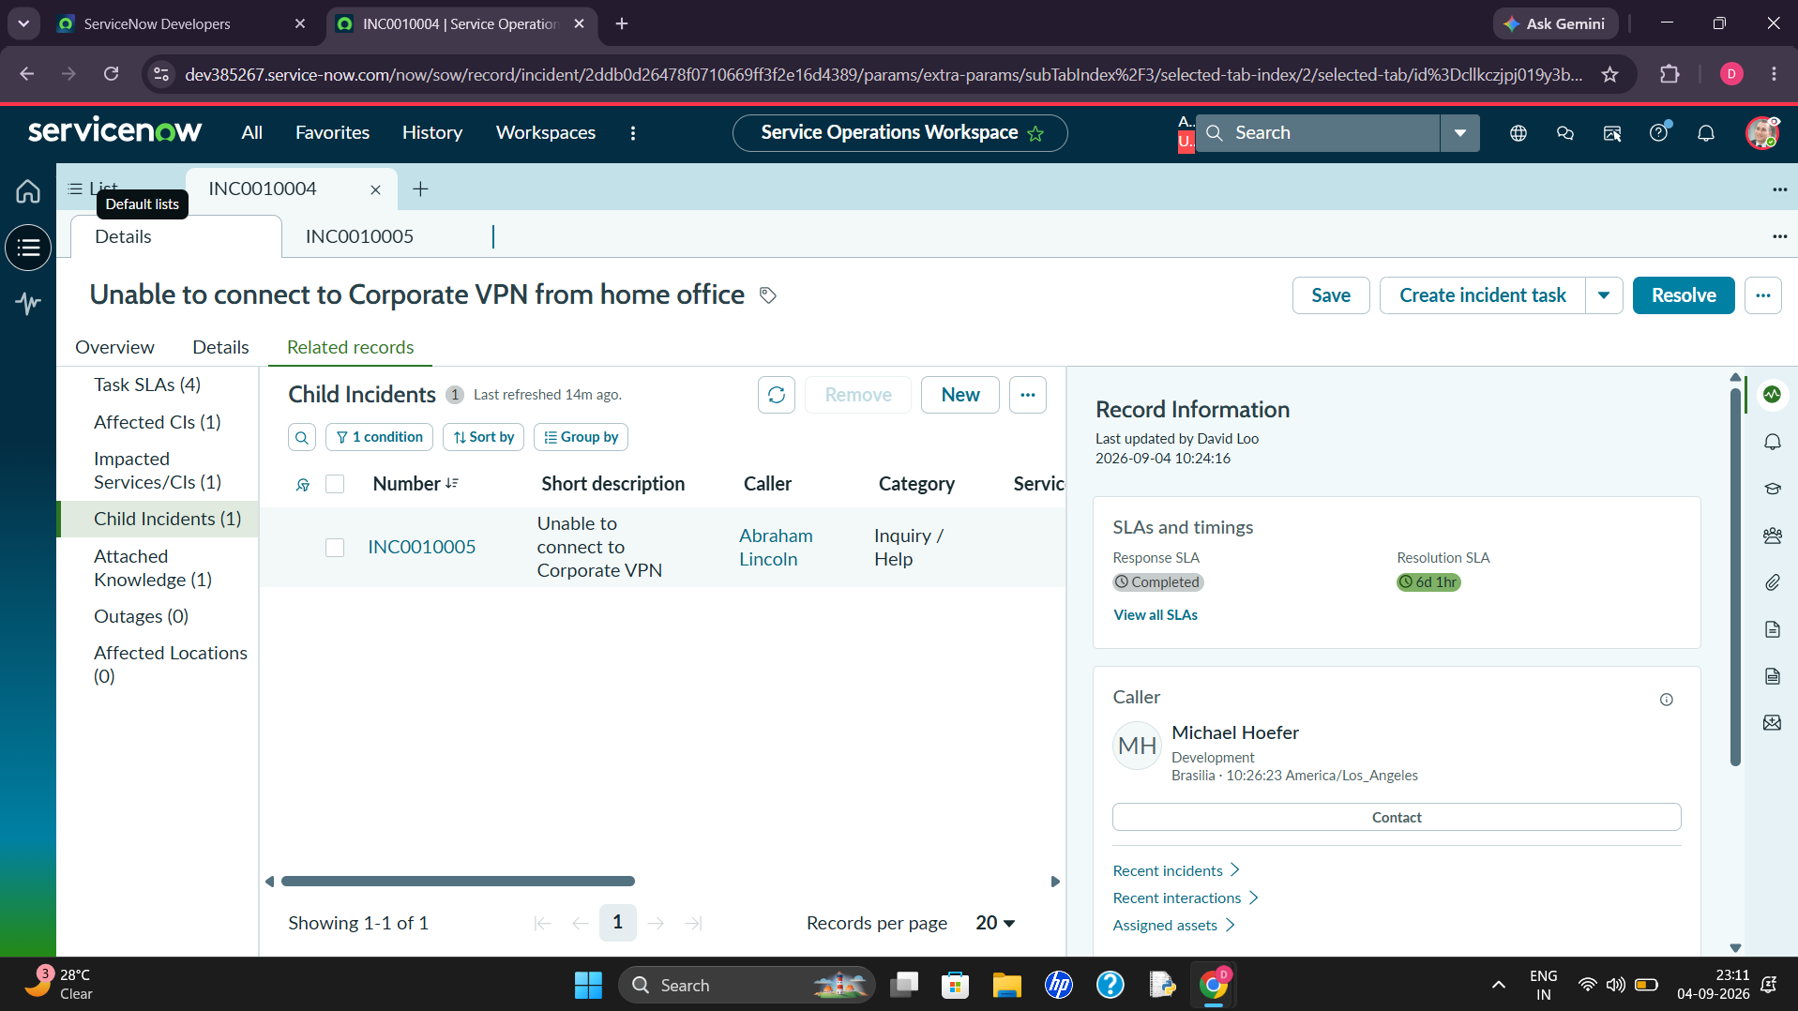
Figure 5. Child Incidents related list showing the created child incident.

5.10 Service Operations Workspace Validation
Open the relevant incident in Service Operations Workspace and validate the agent experience. The project scenario includes checking the incident description, available knowledge information, and Task SLAs under Related Records. Where supported by the configured interface, an agent can use 'Assign to me' to take ownership of an incident.
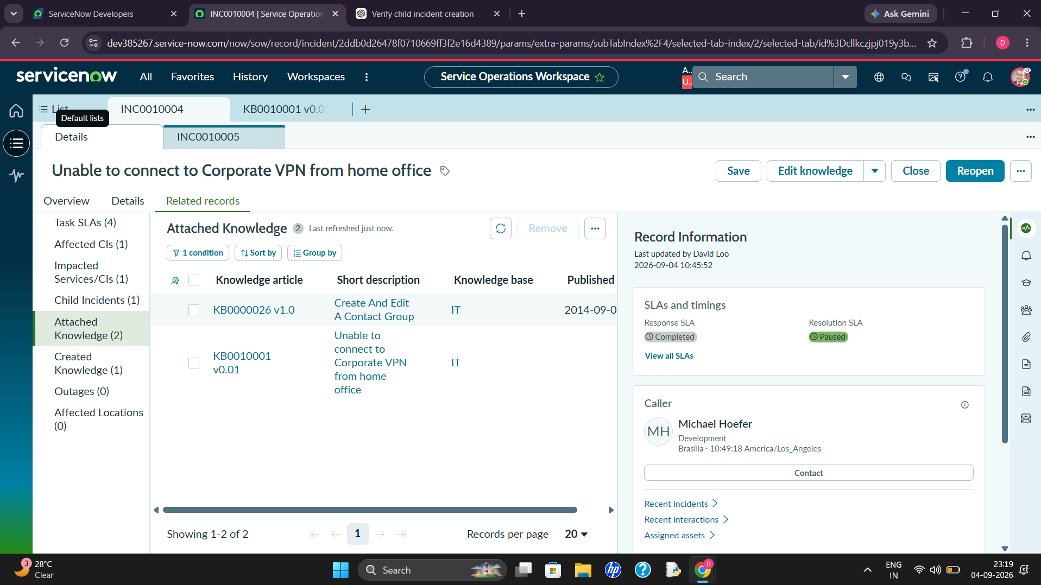
Figure 6. Attached Knowledge related list with knowledge articles associated with the incident.
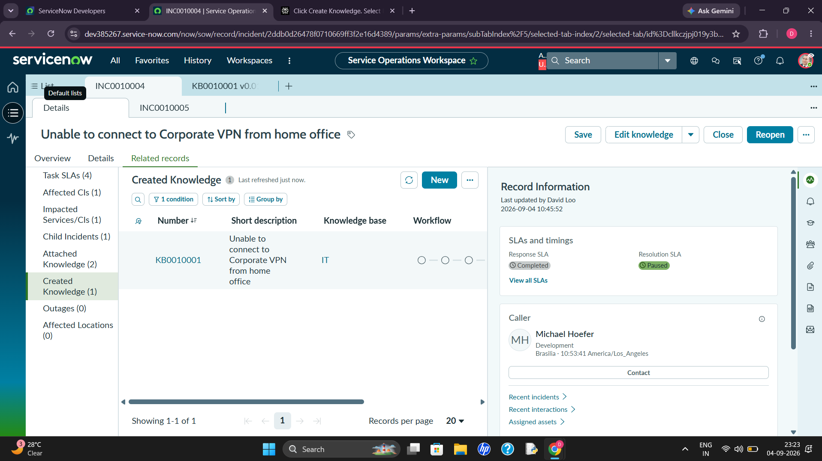
Figure 7. Created Knowledge related list showing the knowledge article created from the incident.

5.11 Resolution and Closure Implementation
- Open the assigned incident.
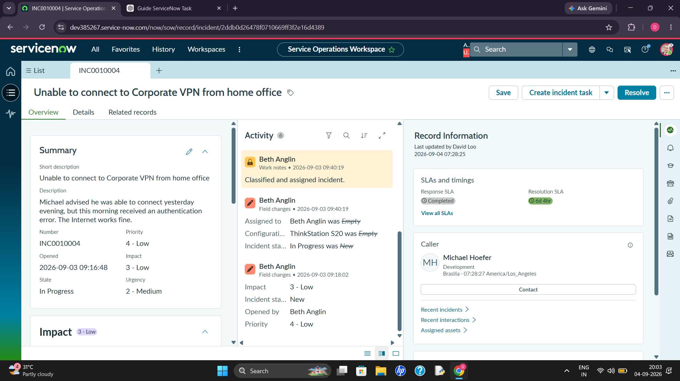
Figure 8. Incident overview and activity evidence supporting resolution and closure tracking.
- Review the description and available knowledge information.
- Investigate the issue and add work notes.
- Apply the appropriate resolution.
- Enter resolution information.
- Move the incident to Resolved.
- Verify closure prerequisites.
- Close the incident.

5.12 Testing Strategy

5.13 Example End-to-End Test
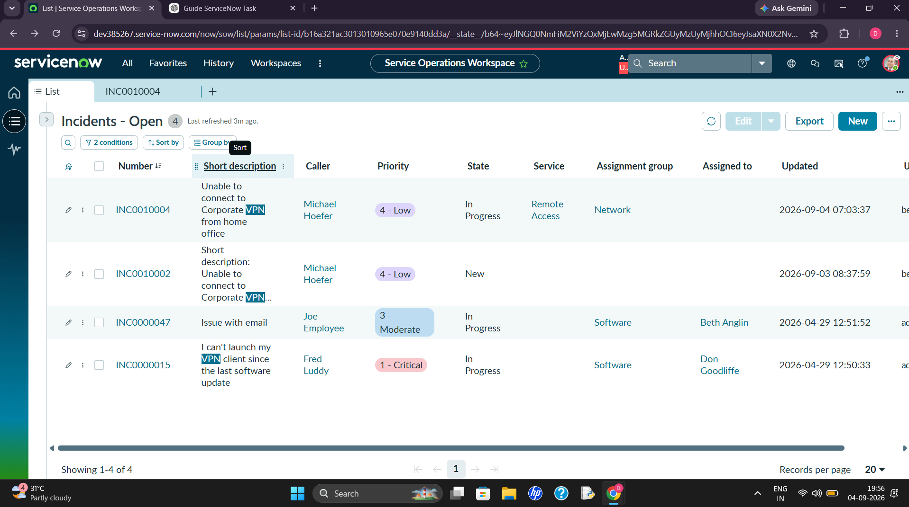
Figure 9. Open Incidents list used to validate incident records, priority, state, service, and assignment.
- Create a VPN incident.
- Select the caller and enter the problem description.
- Set category/subcategory according to the configured model.
- Set impact and urgency for the scenario.
- Verify priority.
- Verify assignment group and assigned agent.
- Open Related Records and verify Task SLAs.
- If applicable, create a child incident and verify it from the parent.
- Investigate and document work notes.
- Enter resolution details and resolve the incident.
- Complete the closure process.

5.14 Development Deliverables
- Configured Incident Management process.
- Validated assignment and prioritization behavior.
- SLA monitoring configuration.
- Notification configuration.
- Child incident relationship validation.
- Service Operations Workspace validation.
- End-to-end test evidence.
- Final implementation documentation.

5.15 Definition of Done
The development phase is considered complete when the configured incident lifecycle works end-to-end for representative scenarios, required automation behaves as designed, SLA and related records can be verified, resolution and closure are validated, and test evidence has been documented.
Test Area | Validation
Creation | Incident receives a number and required data is saved.
Assignment | Correct support group/agent is selected according to configuration.
Priority | Impact/urgency produces the expected priority.
SLA | Expected SLA is attached and visible.
Notifications | Configured recipients receive required messages.
Child Incident | Child is created and visible from parent Related Records.
Workspace | Agent can access required incident information.
Resolution | Resolution data is captured and state changes correctly.
Closure | Incident closes only after required conditions are met.

