ServiceNow Incident Automation Documentation
Business Rules / Flow Designer

8.5 Business Rules / Flow Designer
Automation can be implemented using Business Rules or Flow Designer. The following screenshots document the incident workflow and the related ServiceNow records used in the process.
Example Flow
Incident Created
↓
Check Category
↓
Determine Assignment Group
↓
Determine Priority
↓
Attach SLA
↓
Notify Support Group
↓
Monitor Incident
↓
SLA Warning
↓
Escalation if Required

Note: The exact SLA targets can be modified according to the organization's SLA policy.
8.5.1 Screenshots / Evidence
Existing document section – Business Rules / Flow Designer
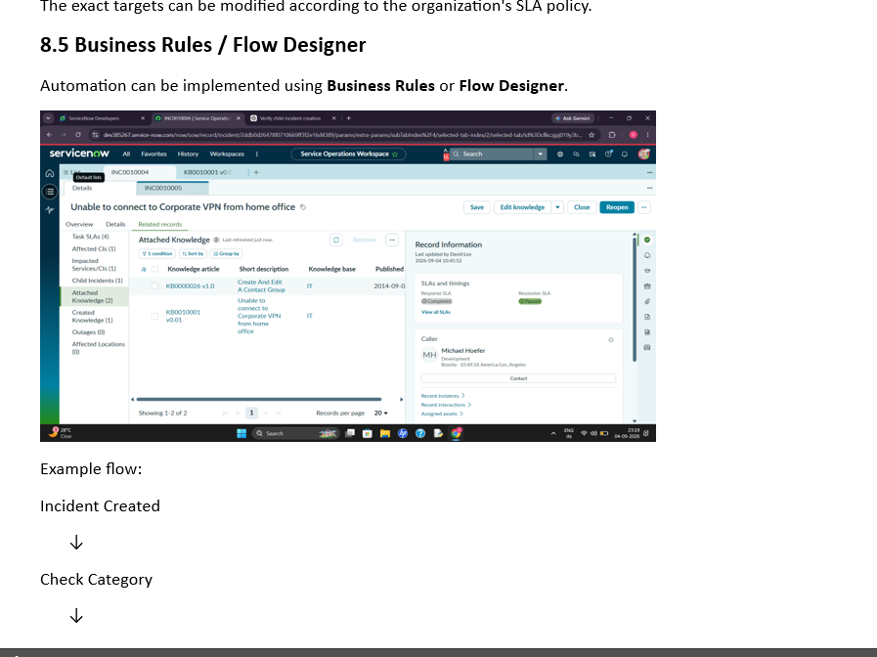
Figure 1. Existing documentation section for Business Rules / Flow Designer.
Incident record – Overview and activity
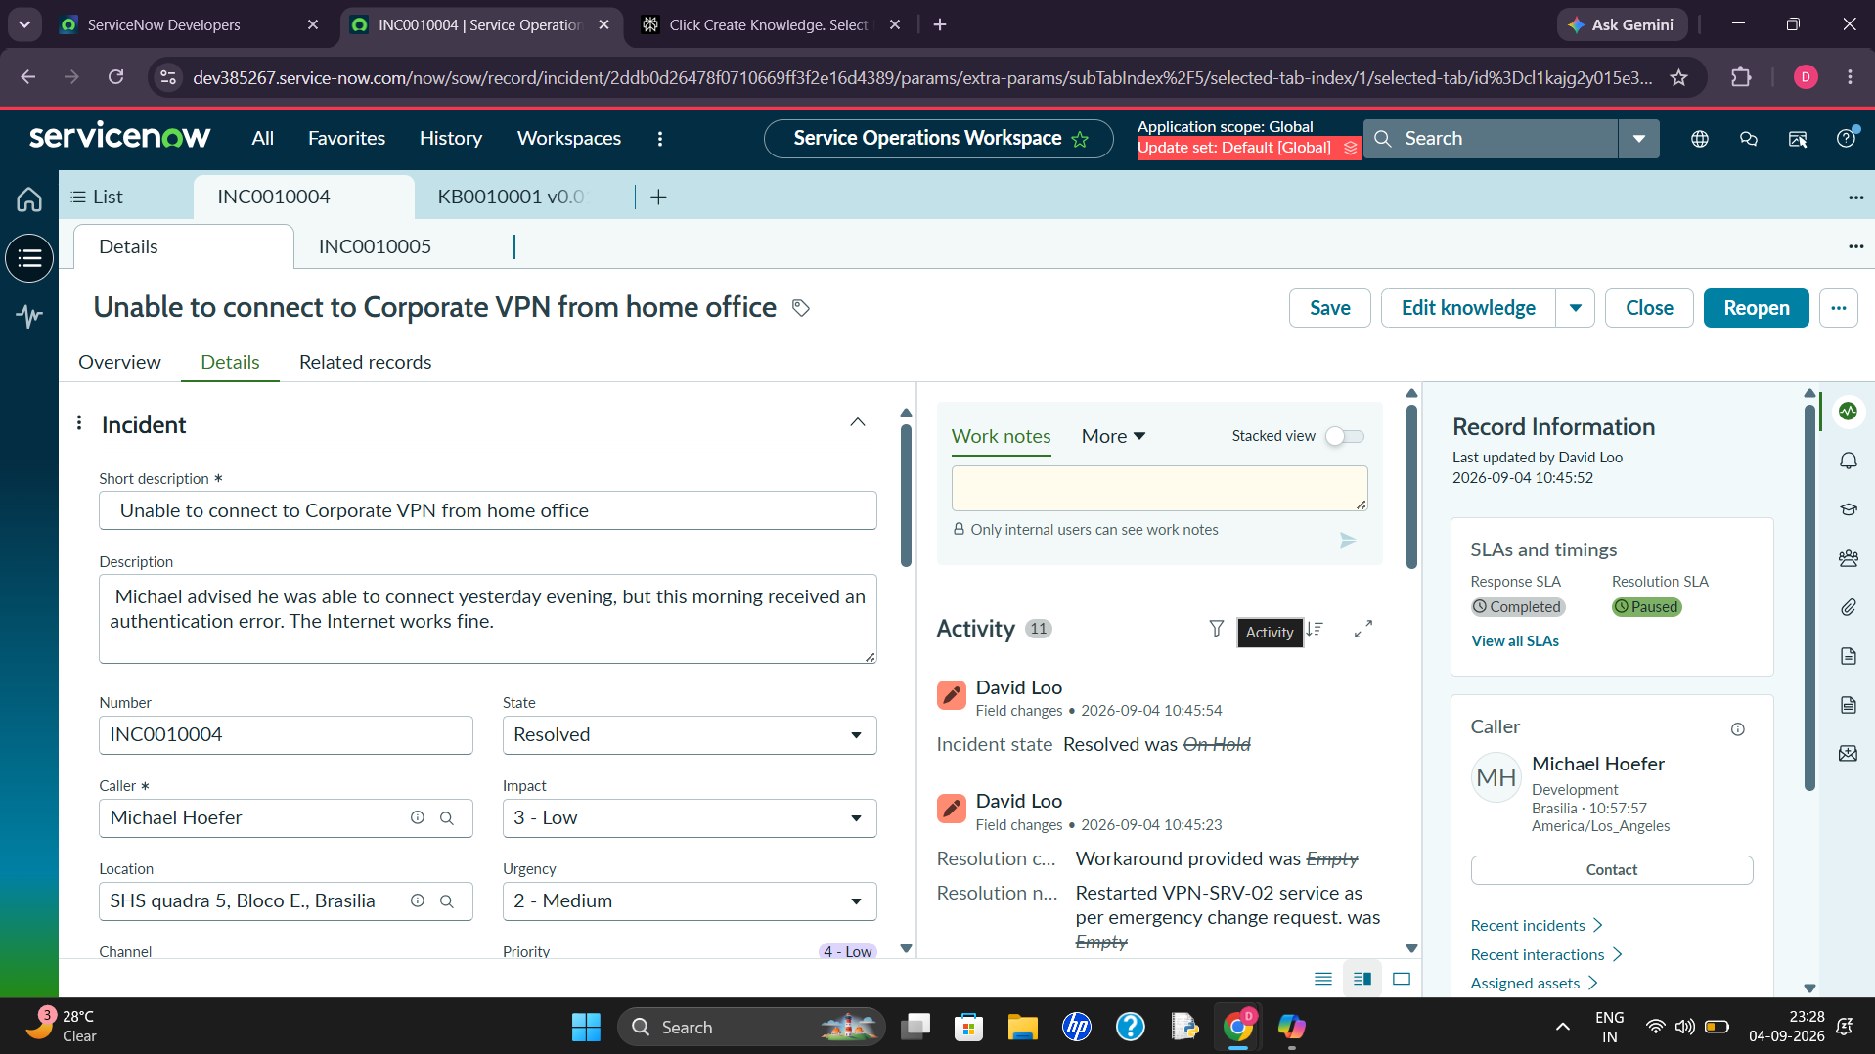
Figure 2. ServiceNow incident record showing the Overview, activity, and SLA information.
Incident record – Related Records / Attached Knowledge
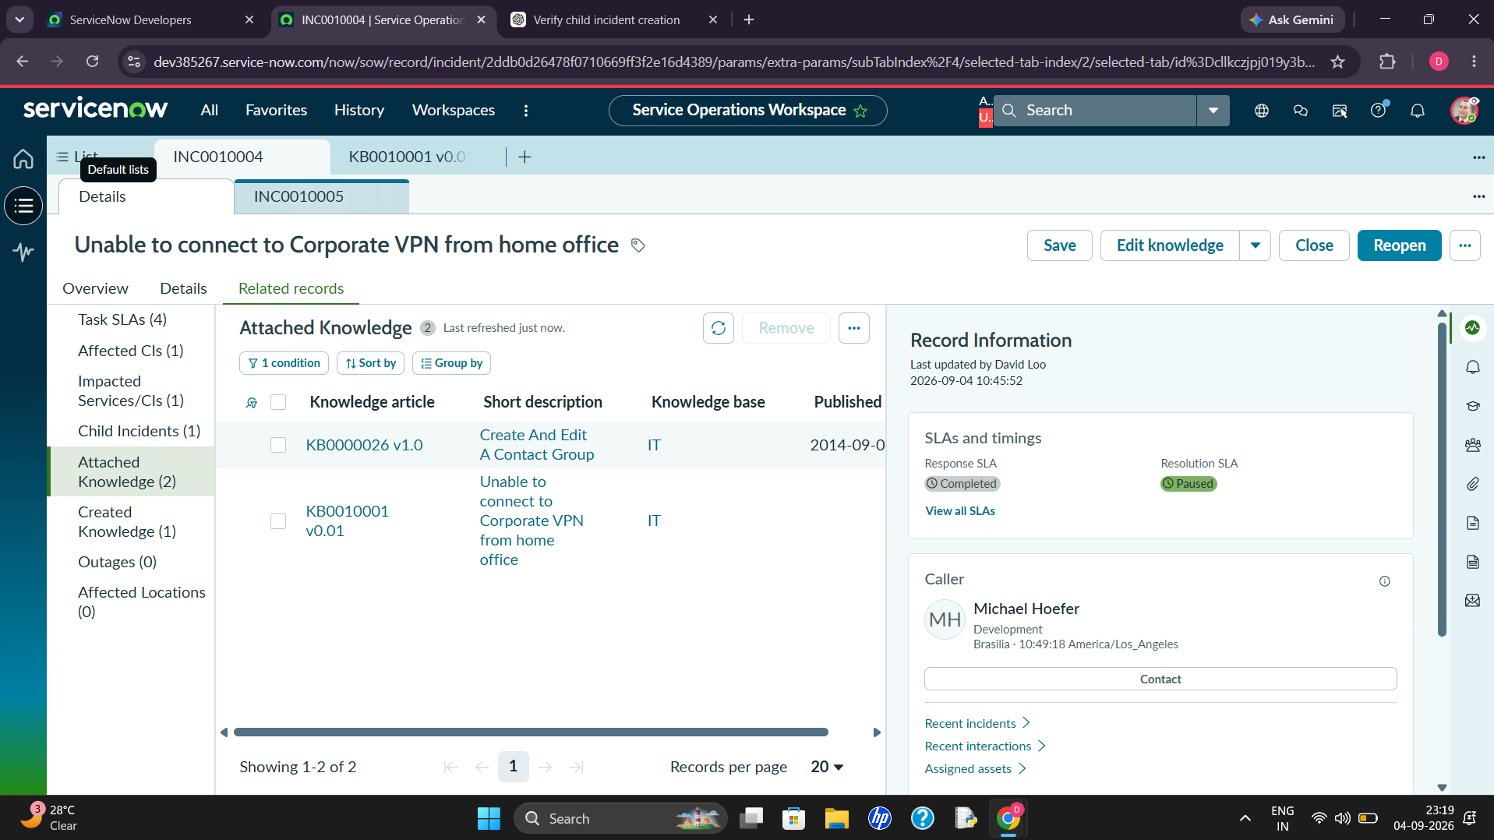
Figure 3. ServiceNow incident record showing Related Records and attached knowledge.
Incident record – Child Incidents
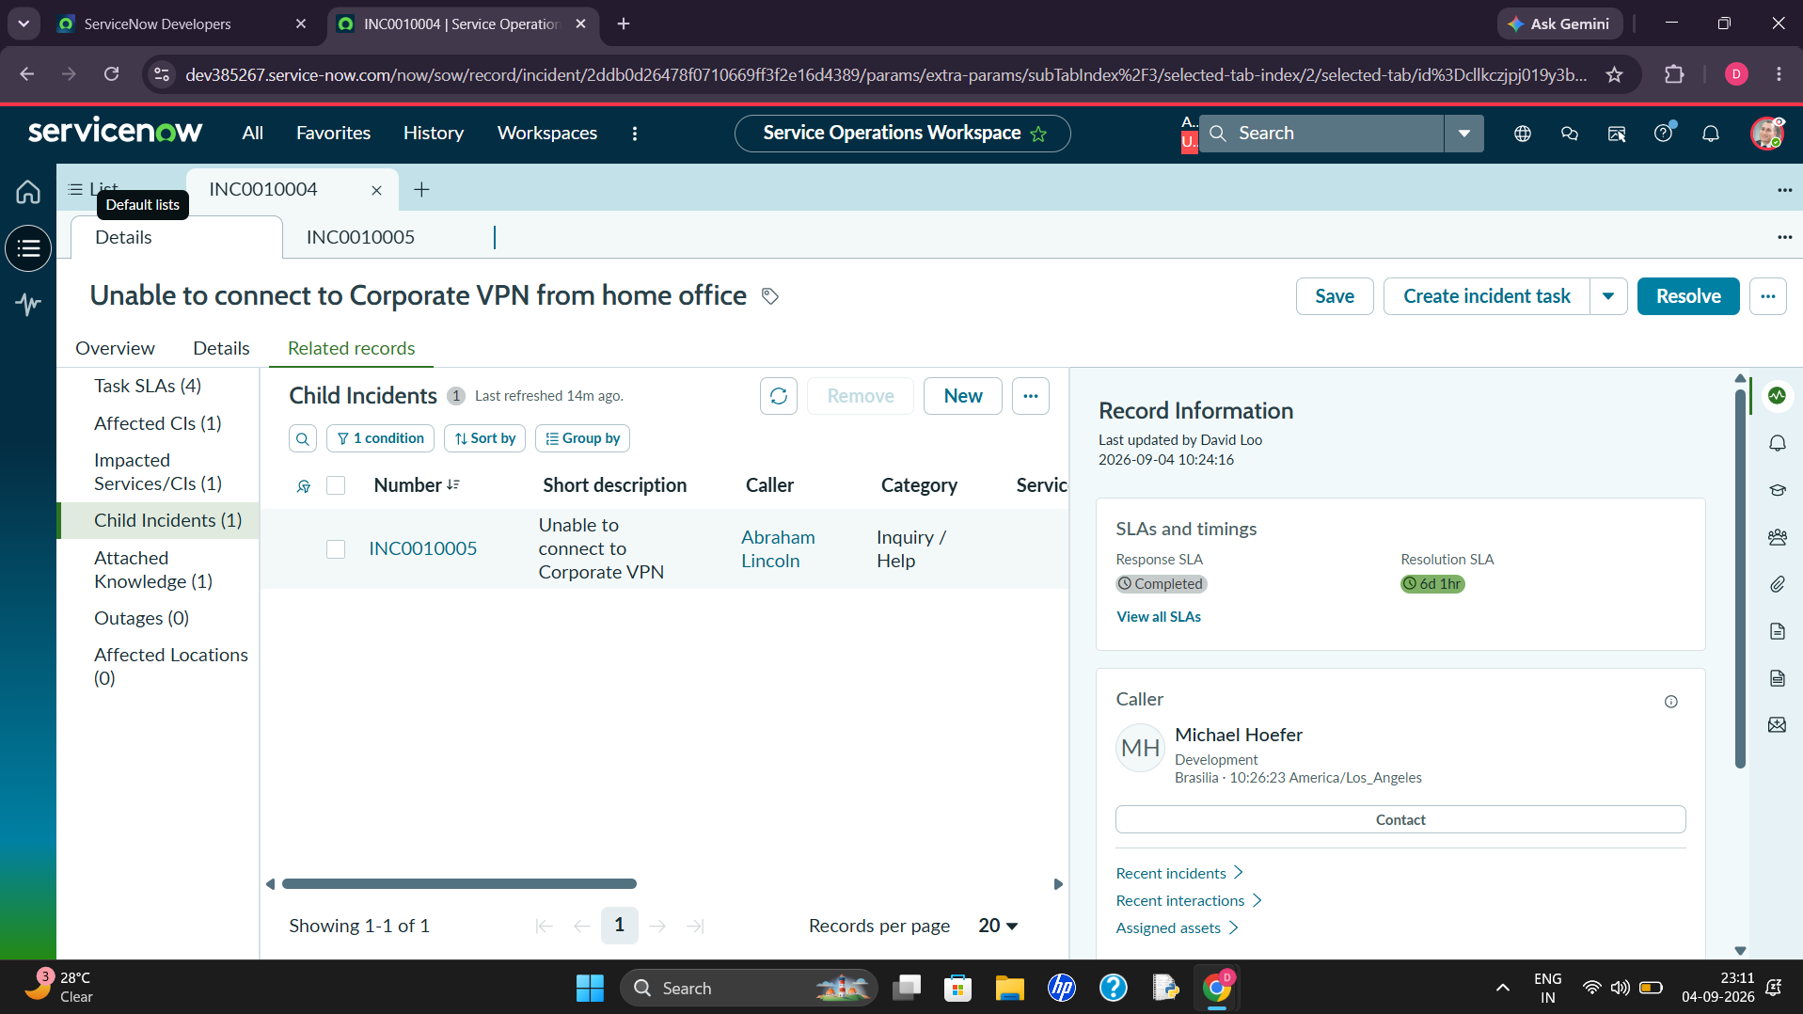
Figure 4. Child Incidents related to the parent incident.
Incident record – Child Incident details

Figure 5. Child Incident record and related information.
Incident record – Details, assignment and priority
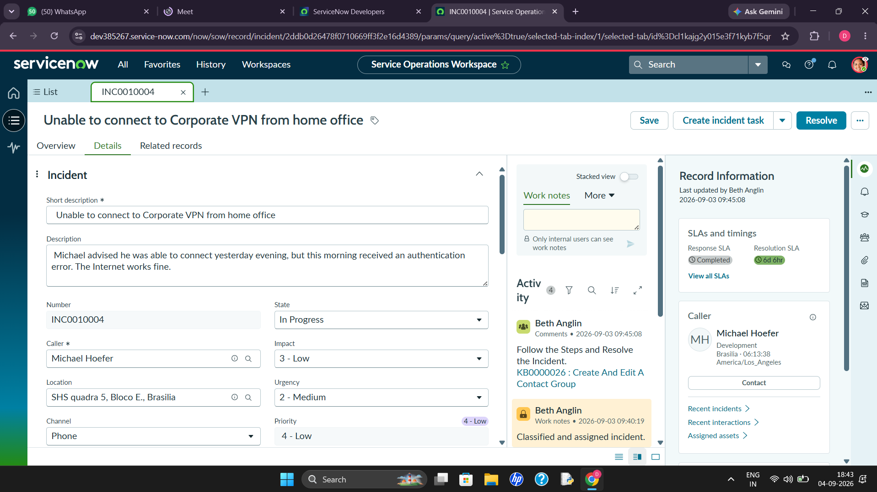
Figure 6. Incident Details showing assignment group, priority, and incident information.
Example flow – continued steps
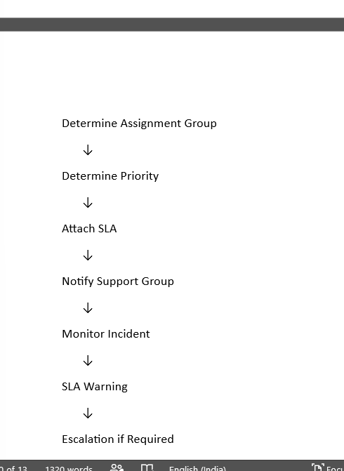
Figure 7. Continued example flow showing assignment, priority, SLA, notification, monitoring, warning, and escalation.
Implementation Summary
The documented flow starts when an incident is created, evaluates its category, determines the assignment group and priority, attaches the appropriate SLA, notifies the support group, and continues with monitoring, SLA warnings, and escalation when required.

