PROJECT DOCUMENTATION
Medical Data History
SQL Query Solutions & Database Analysis · 34 Questions
Analyst: Dharanidharan J | Database: project_medical_data_history | 2025

01 PROJECT OVERVIEW

This project demonstrates end-to-end SQL data analysis on a relational medical database, covering 34 progressively complex queries across data retrieval, filtering, aggregation, string manipulation, joins, and advanced analytical functions. The project showcases practical proficiency in extracting, manipulating, and interpreting structured healthcare data to generate actionable insights — directly applicable to real-world data analytics and business intelligence roles.

Objectives
- Extract and filter patient, admission, and doctor records using structured SQL queries
- Apply aggregate functions and grouping to summarise large medical datasets
- Leverage JOINs across multiple relational tables to produce combined, meaningful outputs
- Use string functions, pattern matching, and conditional logic to clean and transform data
- Develop advanced analytical queries including subqueries, UNION, CASE statements, and BMI calculations
- Demonstrate data interpretation skills by translating query results into business-readable insights

02 DATASET DETAILS

Database Connection Details

Database Name | project_medical_data_history
Host / Server | 18.136.157.135
User Account | dm_team4
Tables Used | patients · admissions · doctors · province_names
Domain | Healthcare / Medical Records
Query Language | MySQL (Standard SQL)

Table Schemas

Table: patients
Column Name | Data Type | Description
patient_id | INT (PK) | Unique patient identifier
first_name | VARCHAR | Patient's first name
last_name | VARCHAR | Patient's last name
birth_date | DATE | Date of birth
city | VARCHAR | City of residence
province_id | CHAR | Foreign key → province_names
allergies | VARCHAR | Known allergies (nullable)
height | INT | Height in centimetres
weight | INT | Weight in kilograms
gender | CHAR | M / F

Table: admissions
Column Name | Data Type | Description
patient_id | INT (FK) | References patients.patient_id
admission_date | DATE | Date of hospital admission
discharge_date | DATE | Date of discharge
diagnosis | VARCHAR | Primary medical diagnosis
attending_doctor_id | INT (FK) | References doctors.doctor_id

Table: doctors
Column Name | Data Type | Description
doctor_id | INT (PK) | Unique doctor identifier
first_name | VARCHAR | Doctor's first name
last_name | VARCHAR | Doctor's last name
specialty | VARCHAR | Medical specialisation

Table: province_names
Column Name | Data Type | Description
province_id | CHAR (PK) | Short province code (e.g., NS)
province_name | VARCHAR | Full province name

03 SQL QUERY SOLUTIONS

Section 3.1 — Basic SELECT & Filtering (Q1 – Q10)
Q1 Show first name, last name, and gender of patients whose gender is 'M'
SELECT first_name, last_name
FROM project_medical_data_history.patients
WHERE gender = 'M';
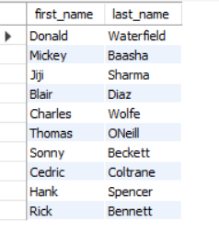
Q2 Show first name and last name of patients who do not have allergies
SELECT first_name, last_name
FROM project_medical_data_history.patients
WHERE allergies IS NULL;
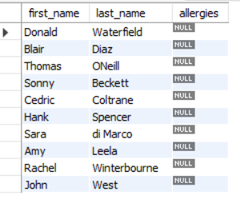
Q3 Show first name of patients that start with the letter 'C'
SELECT first_name
FROM project_medical_data_history.patients
WHERE first_name LIKE 'C%';
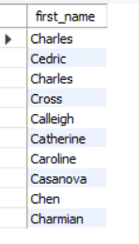
Q4 Show first name and last name of patients with weight between 100 and 120 (inclusive)
SELECT first_name, last_name, weight
FROM project_medical_data_history.patients
WHERE weight BETWEEN 100 AND 120;
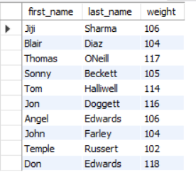
Q5 Replace NULL allergies with 'NKA' (No Known Allergies)
SELECT patient_id, first_name, last_name,
COALESCE(allergies, 'NKA') AS allergies
FROM project_medical_data_history.patients;
Technique: COALESCE() returns the first non-NULL value — a standard data-cleansing approach for handling missing values in production datasets.
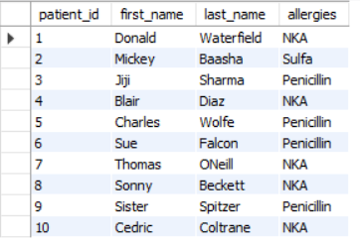
Q6 Show first name and last name concatenated as full name
SELECT CONCAT(first_name, ' ', last_name) AS full_name
FROM project_medical_data_history.patients;
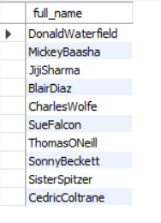
Q7 Show first name, last name, and full province name for each patient
SELECT p.first_name, p.last_name, pn.province_name
FROM project_medical_data_history.patients p
JOIN project_medical_data_history.province_names pn
ON p.province_id = pn.province_id;
Technique: INNER JOIN on a foreign key relationship between patients and province_names lookup table.
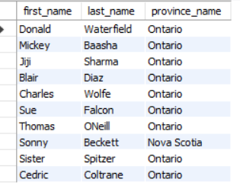
Q8 Count patients born in 2010
SELECT COUNT(*) AS total_patients
FROM project_medical_data_history.patients
WHERE YEAR(birth_date) = 2010;

Q9 Show first name, last name, and height of the tallest patient
-- Method 1: ORDER BY with LIMIT
SELECT first_name, last_name, height
FROM project_medical_data_history.patients
ORDER BY height DESC
LIMIT 1;

-- Method 2: Subquery with MAX()
SELECT first_name, last_name, height
FROM project_medical_data_history.patients
WHERE height = (SELECT MAX(height)
FROM project_medical_data_history.patients);
Two approaches demonstrated: ORDER BY + LIMIT for simplicity; subquery with MAX() for correctness when multiple patients share the same maximum height.
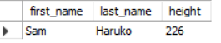
Q10 Show all columns for patients with specific patient_ids: 1, 45, 534, 879, 1000
SELECT *
FROM project_medical_data_history.patients
WHERE patient_id IN (1, 45, 534, 879, 1000);
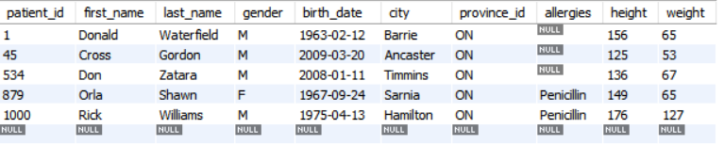
Section 3.2 — Aggregates & Admissions (Q11 – Q17)
Q11 Show the total number of admissions
SELECT COUNT(*) AS total_admissions
FROM project_medical_data_history.admissions;

Q12 Show all admissions where the patient was admitted and discharged on the same day
SELECT *
FROM project_medical_data_history.admissions
WHERE admission_date = discharge_date;
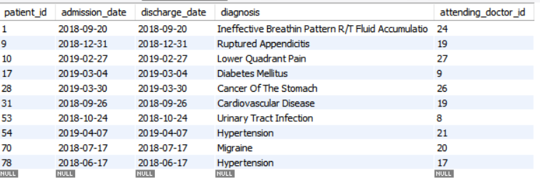
Q13 Show total admissions for patient_id 579
SELECT COUNT(*) AS total_admission
FROM project_medical_data_history.admissions
WHERE patient_id = 579;

Q14 Show unique cities where patients live in province 'NS'
SELECT DISTINCT city
FROM project_medical_data_history.patients
WHERE province_id = 'NS';
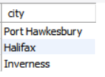
Q15 Find patients with height > 160 cm AND weight > 70 kg
SELECT first_name, last_name, birth_date, height, weight
FROM project_medical_data_history.patients
WHERE height > 160
AND weight > 70;
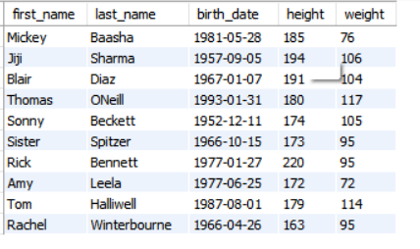
Q16 Show unique birth years ordered ascending
SELECT DISTINCT YEAR(birth_date) AS birth_year
FROM project_medical_data_history.patients
ORDER BY birth_year ASC;
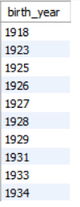
Q17 Show first names that appear only once in the patients table
SELECT first_name
FROM project_medical_data_history.patients
GROUP BY first_name
HAVING COUNT(first_name) = 1;
Technique: GROUP BY + HAVING to filter aggregated groups — essential for uniqueness analysis.
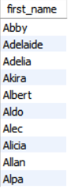
Section 3.3 — String Functions & Pattern Matching (Q18 – Q22)
Q18 Show patient_id and first_name where name starts & ends with 'S' and is ≥ 6 characters
SELECT patient_id, first_name
FROM project_medical_data_history.patients
WHERE first_name LIKE 'S%S'
AND LENGTH(first_name) >= 6;
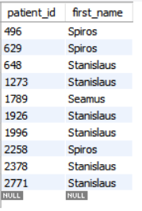

Q19 Show patient details where primary diagnosis is 'Dementia'
SELECT p.patient_id, p.first_name, p.last_name, a.diagnosis
FROM project_medical_data_history.patients p
JOIN project_medical_data_history.admissions a
ON p.patient_id = a.patient_id
WHERE a.diagnosis = 'Dementia';
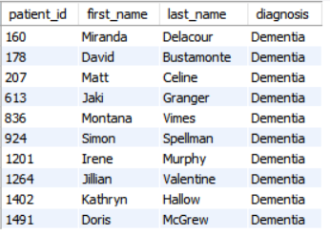
Q20 Display all patient first names ordered by name length, then alphabetically
SELECT first_name
FROM project_medical_data_history.patients
ORDER BY LENGTH(first_name), first_name ASC;
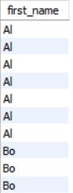
Q21 Show total male and female patients in the same row — CASE method
SELECT
SUM(CASE WHEN gender = 'M' THEN 1 ELSE 0 END) AS male_count,
SUM(CASE WHEN gender = 'F' THEN 1 ELSE 0 END) AS female_count
FROM project_medical_data_history.patients;

Q22 Show total male and female patients in the same row — Subquery method
SELECT
(SELECT COUNT(*) FROM project_medical_data_history.patients WHERE gender = 'M') AS male_count,
(SELECT COUNT(*) FROM project_medical_data_history.patients WHERE gender = 'F') AS female_count;
Two techniques compared: CASE + SUM (single-pass, efficient) vs. correlated subqueries (more readable for simple pivots).

Section 3.4 — JOINs, Grouping & Advanced Queries (Q23 – Q34)
Q23 Find patients admitted multiple times for the same diagnosis
SELECT patient_id, diagnosis
FROM project_medical_data_history.admissions
GROUP BY patient_id, diagnosis
HAVING COUNT(*) > 1;
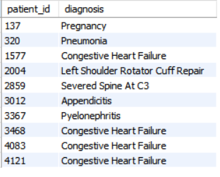
Q24 Show each city with total patients — ordered by most patients, then city name
SELECT city, COUNT(*) AS num_patients
FROM project_medical_data_history.patients
GROUP BY city
ORDER BY num_patients DESC, city ASC;
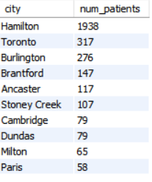
Q25 Show combined list of all patients and doctors with their role label
SELECT first_name, last_name, 'Patient' AS role
FROM project_medical_data_history.patients
UNION ALL
SELECT first_name, last_name, 'Doctor' AS role
FROM project_medical_data_history.doctors;
Technique: UNION ALL to combine result sets from two tables into a single output — a common pattern in reporting and dashboard queries.
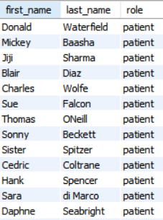
Q26 Show all allergies ranked by frequency — excluding NULL values
SELECT allergies, COUNT(*) AS total_diagnosis
FROM project_medical_data_history.patients
WHERE allergies IS NOT NULL
GROUP BY allergies
ORDER BY total_diagnosis DESC;
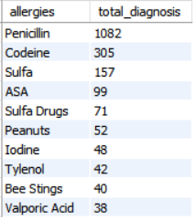
Q27 Show patients born in the 1970s, sorted from earliest birth date
SELECT first_name, last_name, birth_date
FROM project_medical_data_history.patients
WHERE YEAR(birth_date) BETWEEN 1970 AND 1979
ORDER BY birth_date ASC;
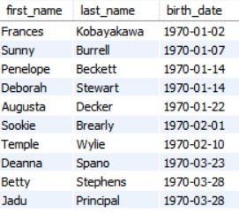
Q28 Display full name as LASTNAME,firstname — ordered by first name descending
SELECT CONCAT(UPPER(last_name), ',', LOWER(first_name)) AS full_name
FROM project_medical_data_history.patients
ORDER BY first_name DESC;

Q29 Show provinces where the total sum of patient heights ≥ 7,000 cm
SELECT province_id, SUM(height) AS sum_height
FROM project_medical_data_history.patients
GROUP BY province_id
HAVING SUM(height) >= 7000;
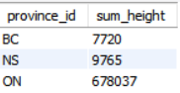
Q30 Show the weight difference (max − min) for patients with last name 'Maroni'
SELECT MAX(weight) - MIN(weight) AS weight_difference
FROM project_medical_data_history.patients
WHERE last_name = 'Maroni';
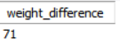
Q31 Show each day of the month with count of admissions — sorted by busiest day
SELECT DAY(admission_date) AS day_of_month,
COUNT(*) AS num_admissions
FROM project_medical_data_history.admissions
GROUP BY day_of_month
ORDER BY num_admissions DESC;
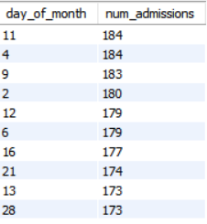
Q32 Group patients into weight bands (e.g., 100–109 → group 100) — ordered descending
SELECT FLOOR(weight / 10) * 10 AS weight_group,
COUNT(*) AS patients_in_group
FROM project_medical_data_history.patients
GROUP BY weight_group
ORDER BY weight_group DESC;
Technique: FLOOR() + arithmetic bucketing — a key data modelling pattern for discretising continuous variables into ranges for analysis.
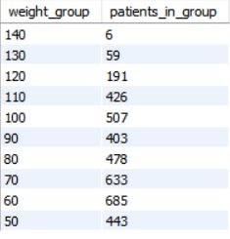
Q33 Show patient obesity flag using BMI formula — BMI = weight(kg) / height(m)² > 30 = obese
SELECT patient_id, weight, height,
CASE
WHEN weight / POWER(height / 100.0, 2) >= 30 THEN 1
ELSE 0
END AS isObese
FROM project_medical_data_history.patients;
Technique: CASE + POWER() for computed health metric derivation. POWER(height/100.0, 2) converts cm to metres before applying the WHO BMI formula.
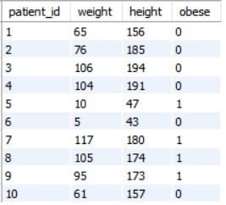
Q34 Show patients diagnosed with 'Epilepsy' attended by a doctor named 'Lisa'
SELECT p.patient_id, p.first_name, p.last_name,
d.specialty, a.diagnosis, d.first_name AS doctor_first_name
FROM project_medical_data_history.patients p
JOIN project_medical_data_history.admissions a
ON p.patient_id = a.patient_id
JOIN project_medical_data_history.doctors d
ON a.attending_doctor_id = d.doctor_id
WHERE a.diagnosis = 'Epilepsy'
AND d.first_name = 'Lisa';
Technique: Multi-table JOIN chain across 3 tables (patients → admissions → doctors) with compound WHERE filtering — a core enterprise reporting pattern.
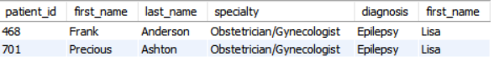

04 SQL TECHNIQUES & CONCEPTS APPLIED

SQL Technique | Application in Project
SELECT / WHERE / LIKE | Basic data extraction, filtering, and pattern matching (Q1–Q5, Q18)
BETWEEN / IN | Range and set-based filtering (Q4, Q10, Q27)
COALESCE() | NULL handling and data cleansing for missing allergy values (Q5)
CONCAT() / UPPER() / LOWER() | String manipulation and formatting (Q6, Q28)
YEAR() / DAY() / LENGTH() | Date and string function applications (Q8, Q16, Q20, Q31)
COUNT() / SUM() / MAX() / MIN() | Aggregate functions for statistical analysis (Q8, Q11, Q13, Q21, Q30)
GROUP BY / HAVING | Data grouping and group-level filtering (Q17, Q23, Q24, Q26, Q29, Q32)
INNER JOIN | Multi-table relational queries (Q7, Q19, Q34)
Multi-table JOIN chain | 3-table join across patients, admissions, doctors (Q34)
Subqueries | Nested SELECT for MAX height, correlated gender count (Q9, Q22)
UNION ALL | Combining result sets from two tables with role labels (Q25)
CASE WHEN / THEN | Conditional logic for gender pivot and obesity flag (Q21, Q33)
FLOOR() / POWER() | Mathematical functions for bucketing and BMI computation (Q32, Q33)
ORDER BY (multi-column) | Multi-criteria sorting by count, name, date (Q20, Q24, Q28)
DISTINCT | De-duplication for unique cities, birth years, names (Q14, Q16, Q17)

05 KEY OUTCOMES & INSIGHTS

- Extracted and interpreted structured medical records across 4 relational tables to produce 34 query-based analytical outputs.
- Identified same-day admission-discharge cases, flagging potential data quality issues or day-procedure patterns.
- Generated patient demographics analysis — gender distribution, city-level patient count, birth decade segmentation — to support population health insights.
- Flagged repeat diagnosis admissions for the same patient, enabling chronic condition tracking and clinical decision support.
- Applied the WHO BMI formula in SQL to compute an obesity indicator (isObese) column — a derived health metric from raw height and weight data.
- Ranked allergy prevalence across the patient population, directly applicable to medication risk stratification.
- Demonstrated two alternate approaches for each complex query (subquery vs. MAX; CASE vs. correlated subquery) — showcasing query optimisation awareness.

06 TOOLS & ENVIRONMENT

Query Language | MySQL (Standard SQL)
Database Server | Remote MySQL — Host: 18.136.157.135
Database | project_medical_data_history
Functions Used | COALESCE, CONCAT, UPPER, LOWER, YEAR, DAY, LENGTH, COUNT, SUM, MAX, MIN, FLOOR, POWER, CASE WHEN
Clauses Applied | SELECT, WHERE, JOIN, GROUP BY, HAVING, ORDER BY, UNION ALL, DISTINCT, LIMIT, IN, BETWEEN, LIKE, IS NULL
Data Domain | Healthcare — Patient Records, Hospital Admissions, Physician Data
Complexity Level | Beginner → Advanced (34 queries, progressive difficulty)

— END OF DOCUMENT —

