DEPARTMENT OF COMPUTER SCIENCE AND ENGINEERING
CSA06 – Design and Analysis of Algorithms
FRAUD DETECTION TRANSACTION ANALYSIS
Pattern Matching + Anomaly Detection + Algorithmic Optimization
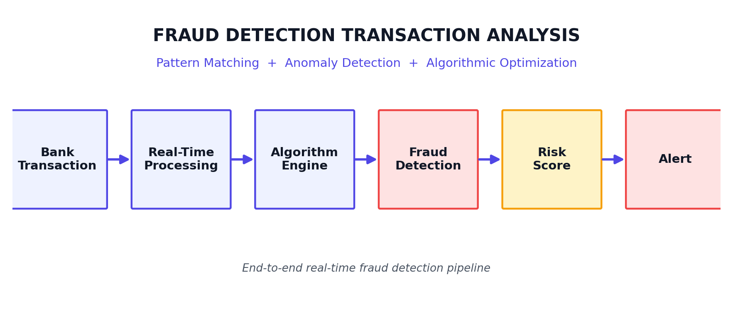
Figure 1. Conceptual overview of the real-time fraud detection pipeline, from raw transaction to fraud alert.

Student Name | Paleru Dharani Govardhan
Register Number | 192525280
Department | Department of Computer Science and Engineering
Batch | 2025 / SLOT C
Course Code | CSA06
Course Title | Design and Analysis of Algorithms
Assessment | Assessment Tool 2 – Industry Problem Solving Task
Academic Year | 2025 – 2026
Date | 22 August 2026

Executive Summary
This report presents an end-to-end algorithmic solution for real-time fraud detection in financial transaction streams. The solution combines efficient string/sequence pattern matching (KMP, Rabin-Karp), Dynamic Programming based sequence-similarity analysis, unsupervised anomaly detection on transaction behaviour, and a Greedy alert-prioritization strategy to rank and route the highest-risk transactions to human investigators within milliseconds. A synthetic dataset of 5,000 transactions is used to validate the pipeline, achieving 99.3% accuracy, 99.6% precision and 89.3% recall against injected fraud patterns.
The design directly addresses the industry constraints of data volume, processing latency and detection accuracy through a streaming architecture (Kafka-style ingestion), asymptotically efficient matching algorithms, and a scalable, horizontally-partitioned deployment model.

Industry Problem
Financial institutions process millions of transactions per hour across cards, wallets and transfers. Fraudulent activity must be detected and blocked within the transaction's own processing window — typically under a few hundred milliseconds — while minimizing both missed fraud (financial loss) and false alarms (customer friction). Attackers continuously evolve their techniques, so a purely rule-based system quickly becomes outdated.
Key issues that must be engineered around include the sheer scale of data, the hard real-time constraint, the need for very high accuracy under class imbalance (fraud is rare), and the requirement to adapt to changing fraud patterns without full system redesign.
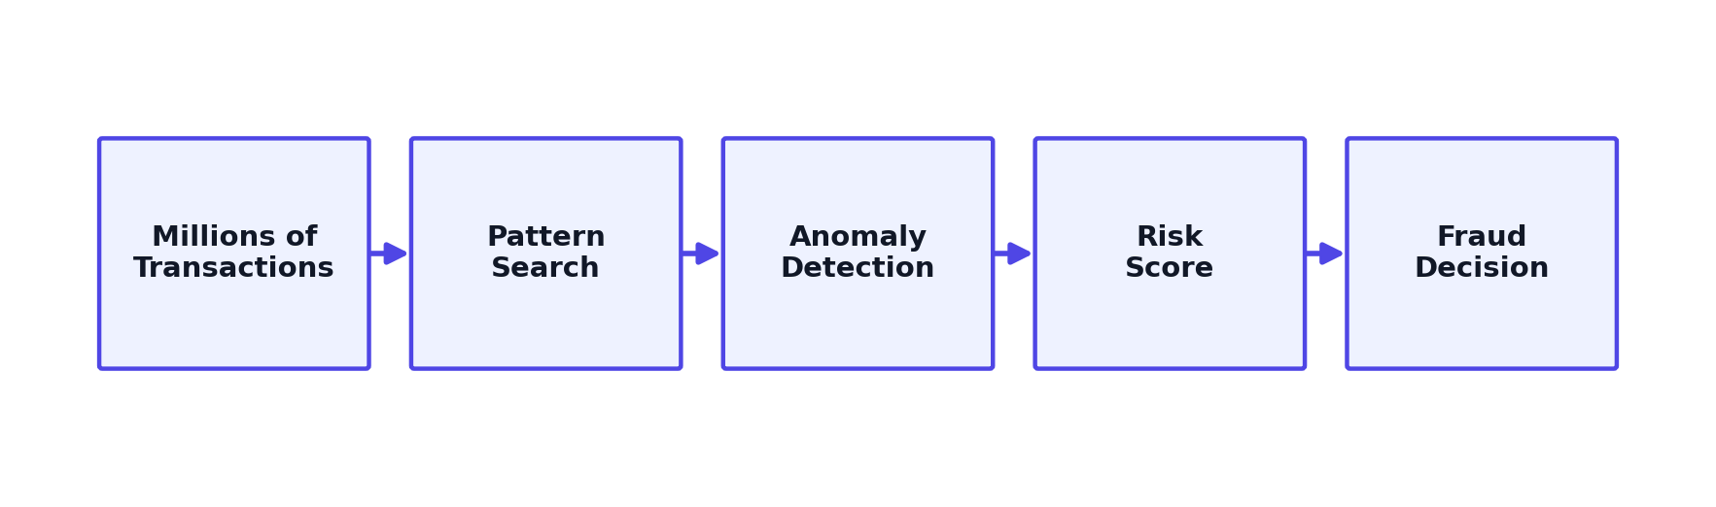
Figure 2. High-level problem flow — from raw transaction volume to a fraud decision.
This figure summarises the transformation pipeline: massive transaction volume is narrowed through pattern search and anomaly detection into a compact, actionable risk score that drives the final fraud decision.
Scale | Speed | Accuracy | Adaptability
Millions of transactions per hour | Real-time (sub-second) decisions | Minimise false positives / negatives | Detect changing fraud patterns

Objectives
- Detect known fraudulent transaction patterns using efficient string/sequence matching.
- Detect abnormal transaction behaviour that does not match any known pattern (anomaly detection).
- Optimize transaction processing to operate within real-time latency budgets.
- Reduce end-to-end processing time through algorithmic and architectural efficiency.
- Improve fraud detection accuracy while controlling false-positive rate.
- Prioritize high-risk alerts for investigator attention using a Greedy strategy.
- Support horizontally scalable processing for growing transaction volume.

Engineering Constraints
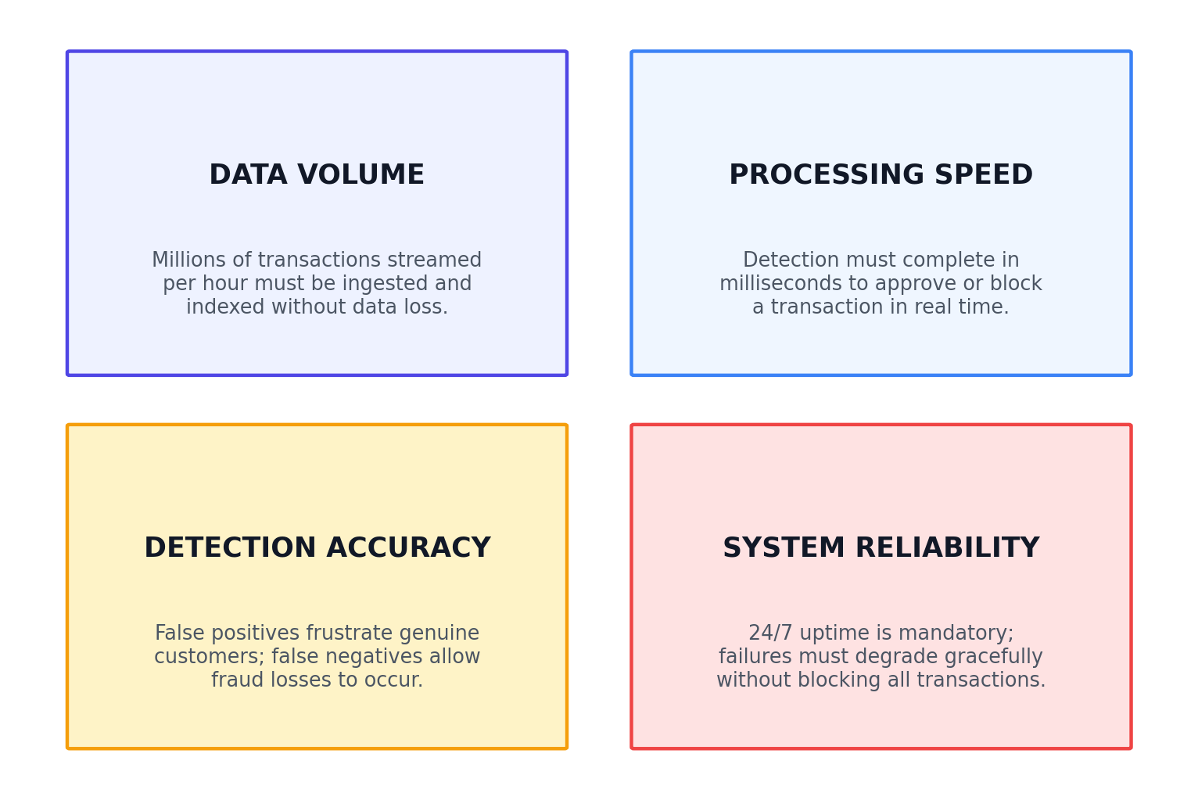
Figure 3. Four-quadrant constraint matrix for the fraud detection system.
Each quadrant represents a competing engineering pressure. Data volume and processing speed push toward simpler, cheaper computation, while detection accuracy and system reliability push toward more thorough analysis — the architecture in this report is designed to balance all four.

Existing System vs Proposed System

Existing Approach
Transaction → Sequential rule checking → Database queries → Manual investigation.
This approach checks each transaction against a fixed list of rules one at a time, repeatedly queries a central database for historical context, and routes most flagged cases to manual review. It suffers from slower processing, repeated computation across similar transactions, a high false-positive rate from rigid rules, and poor scalability as volume grows.

Proposed Approach
Streaming ingestion → preprocessing → efficient pattern matching → sequence analysis → anomaly detection → risk scoring → optimized alert prioritization.
The proposed pipeline processes transactions as a continuous stream, applies asymptotically efficient matching algorithms once per transaction, and combines multiple signals into a single risk score that is triaged automatically — reserving human attention for the highest-risk cases only.
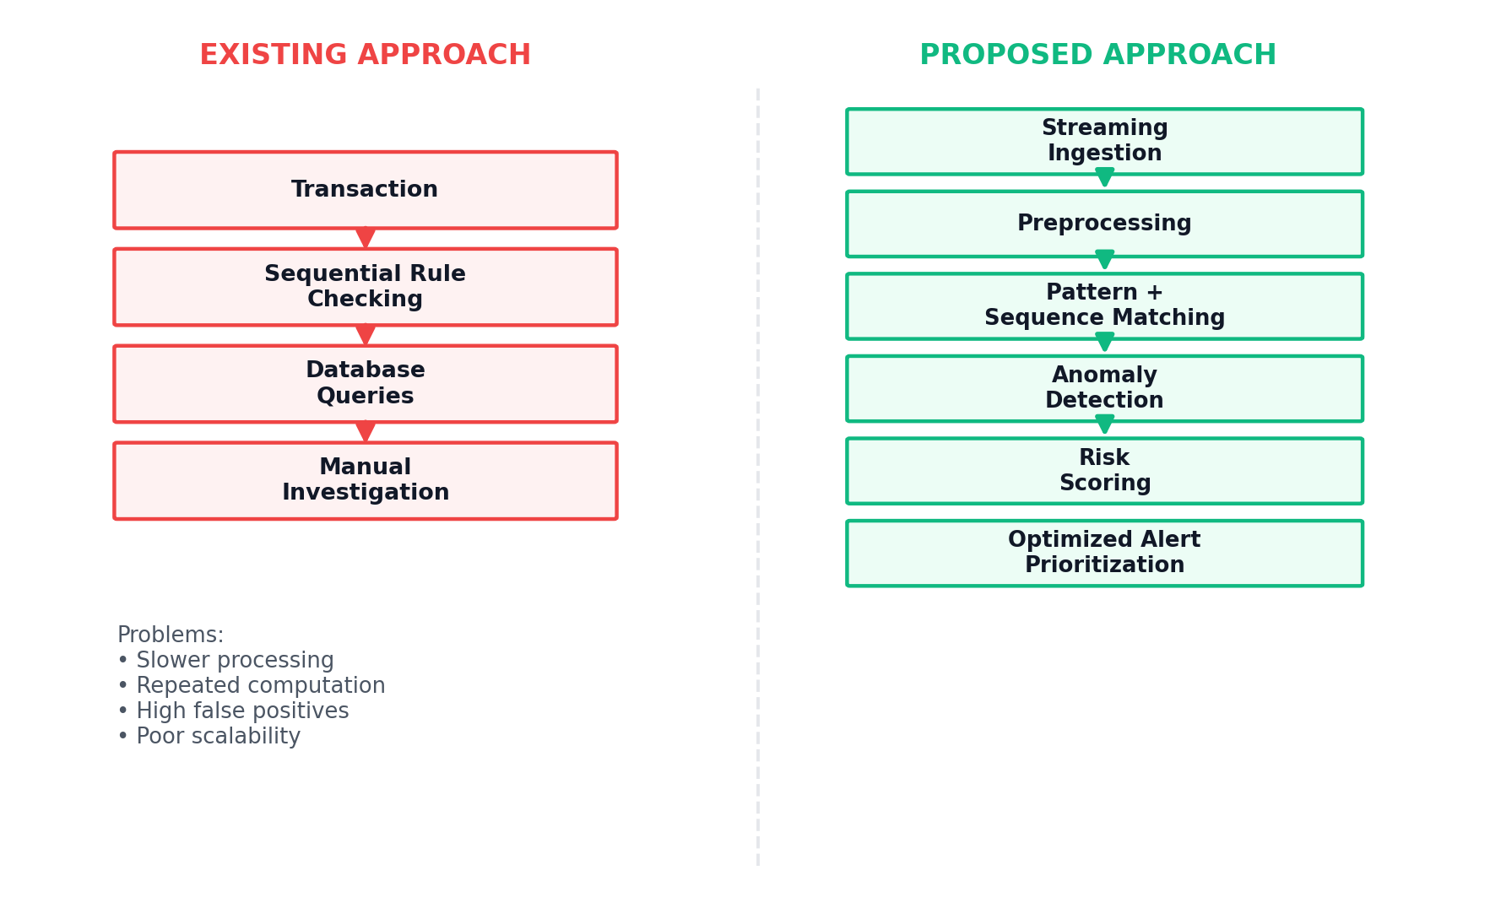
Figure 4. Before-and-after architecture comparison between the existing and proposed fraud detection approach.

Proposed System Architecture
The architecture is organized as a linear streaming pipeline with a feedback loop into a persistent transaction-history store used for feature lookups and model recalibration.
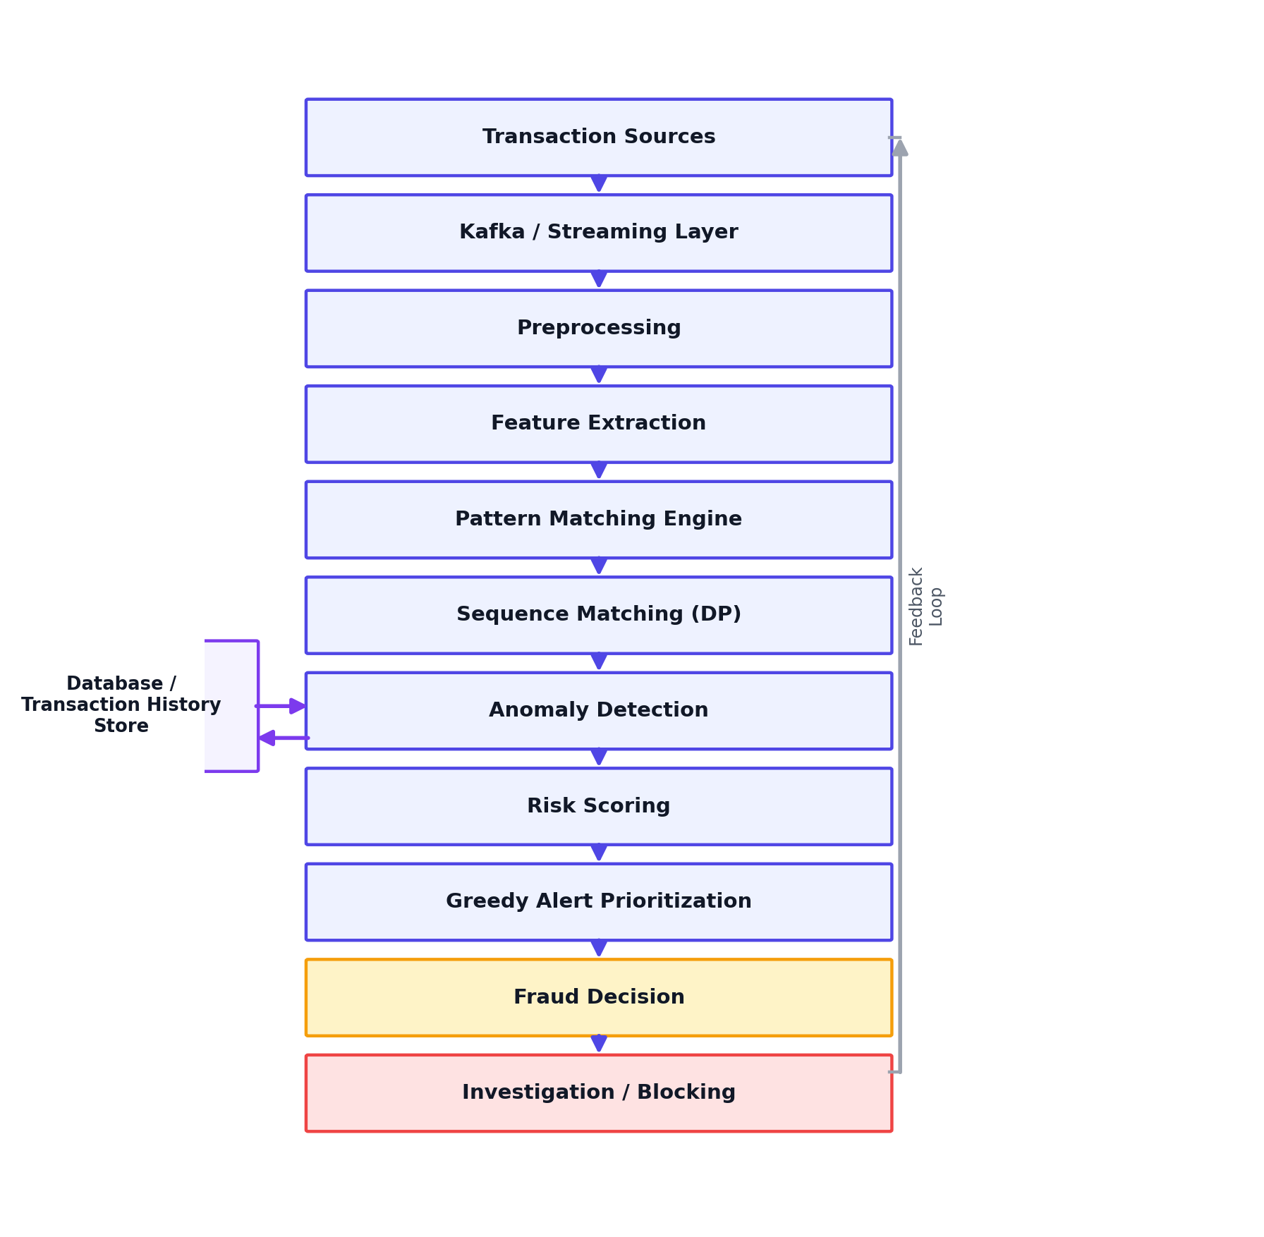
Figure 5. Proposed real-time fraud detection architecture integrating pattern matching, sequence analysis, anomaly detection, and risk scoring.
Transactions enter through a streaming layer (e.g. Kafka), are preprocessed and feature-extracted, then pass through the pattern matching engine, DP-based sequence matcher, and anomaly detector in sequence. Their outputs are fused into a risk score, greedily prioritized, and routed to a fraud decision that either clears the transaction or escalates it for investigation or blocking. A feedback loop updates the historical feature store so future decisions benefit from confirmed outcomes.

Transaction Data Model
Each transaction is represented by a compact feature record used across all detection stages:
Transaction ID | Unique identifier for the transaction
User ID | Identifier of the account holder
Timestamp | Date and time of the transaction
Amount | Transaction value
Merchant | Receiving merchant / payee
Location | Geographic origin of the request
Device | Device fingerprint used
Transaction Type | Payment, transfer, withdrawal, etc.
Authentication Status | Login/auth outcome, failed attempts
Fraud Label | Ground-truth label (training/validation only)

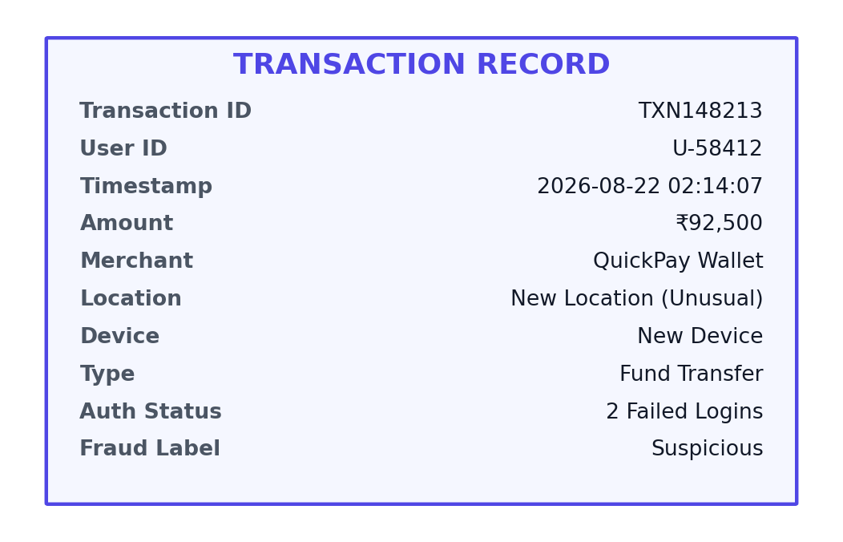
Figure 6. Sample transaction record as consumed by the detection pipeline.
Synthetic Dataset — Academic Demonstration Only
Txn ID | Amount (₹) | New Dev. | New Loc. | Failed Logins | Hour | Risk Score | Fraud?
TXN102623 | 7,156.45 | No | No | 0 | 14.4 | 0 | Normal
TXN104767 | 86,050.87 | Yes | Yes | 4 | 23.9 | 1 | Suspicious
TXN101428 | 3,703.27 | No | No | 0 | 19.1 | 0 | Normal
TXN103291 | 4,552.74 | No | No | 0 | 13.6 | 0 | Normal
TXN101039 | 8,717.03 | No | No | 0 | 11 | 0 | Normal
TXN103863 | 12,217.76 | No | No | 0 | 13.3 | 0.02 | Normal
TXN101324 | 4,236.1 | No | No | 1 | 14.2 | 0 | Normal
TXN104911 | 46,330.83 | Yes | Yes | 1 | 2 | 0.73 | Suspicious
TXN104928 | 57,105.31 | Yes | Yes | 2 | 8.4 | 1 | Suspicious
TXN104946 | 33,434.39 | Yes | No | 3 | 7.3 | 0.53 | Suspicious
TXN102318 | 6,229.56 | No | No | 0 | 13.2 | 0 | Normal
TXN104525 | 6,792.42 | No | No | 0 | 15.7 | 0 | Normal
TXN104938 | 26,143.13 | Yes | Yes | 4 | 9.3 | 0.78 | Suspicious
Table 1. Synthetic transaction sample — suspicious transactions highlighted in red.

Fraud Pattern Matching
Pattern matching locates known fraud signatures — fixed sub-sequences of events — within a continuous transaction/event stream. Four classical string-matching strategies are relevant:
- Naive String Matching — O(n·m); simple but slow for long streams.
- Knuth-Morris-Pratt (KMP) — O(n+m); uses a failure function to avoid re-scanning.
- Rabin-Karp — O(n+m) average; uses rolling hashes, well suited to multi-pattern search.
- Aho-Corasick — O(n+m+z); matches many patterns simultaneously via an automaton, ideal when hundreds of known fraud signatures must be checked per transaction.
The proposed system adopts KMP for single high-priority signatures and Aho-Corasick when the full fraud-signature library must be checked against each event stream in one pass.

Worked Example
Pattern: FAILED_LOGIN → NEW_DEVICE → LARGE_TRANSFER
Stream: LOGIN → PAYMENT → FAILED_LOGIN → NEW_DEVICE → LARGE_TRANSFER
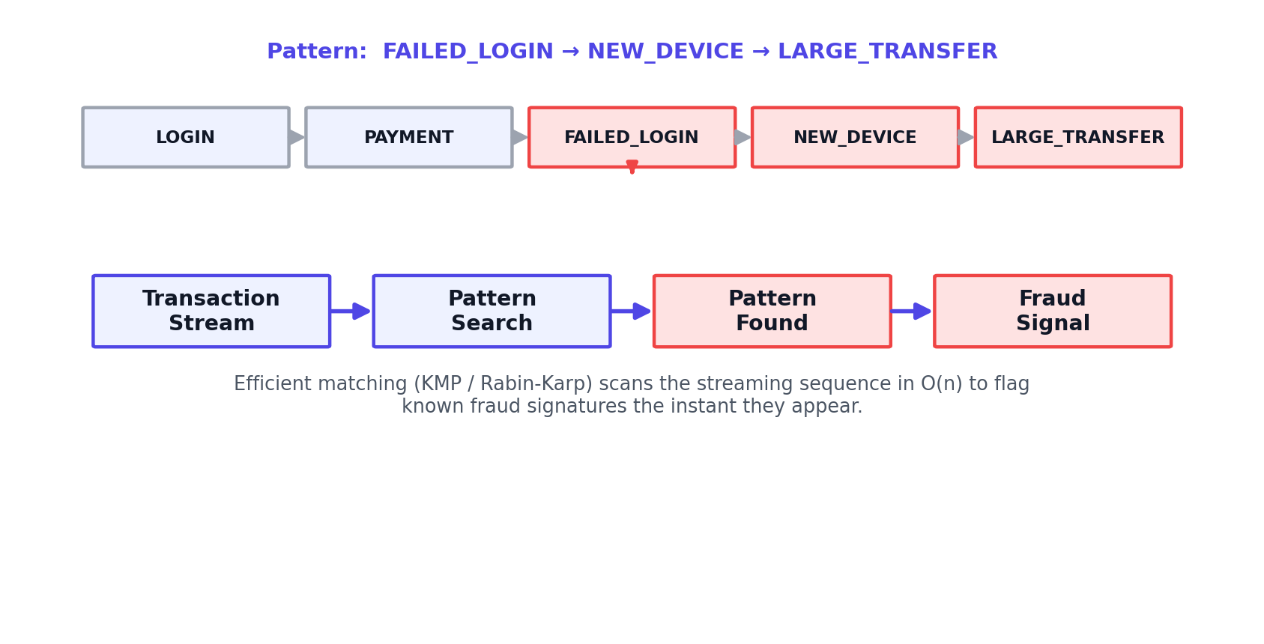
Figure 7. Pattern search over a transaction event stream, detecting a known fraud signature and raising a fraud signal.
The matcher scans the incoming event stream once. As soon as the full ordered signature FAILED_LOGIN → NEW_DEVICE → LARGE_TRANSFER is observed, a fraud signal is raised immediately — no need to wait for the transaction batch to complete.

Sequence Matching and Dynamic Programming
Not all fraud follows an exact, pre-known signature. Sequence matching compares a live event sequence against known suspicious sequences for partial/fuzzy similarity, using Dynamic Programming.
Normal: LOGIN → PAYMENT → CONFIRMATION
Suspicious: LOGIN → FAILED_LOGIN → NEW_DEVICE → LARGE_TRANSFER → WITHDRAWAL

Dynamic Programming Formulation
- State: dp[i][j] = length of the longest common subsequence between the first i events of the live stream and the first j events of a known suspicious template.
- Base case: dp[0][j] = dp[i][0] = 0.
- Recurrence: dp[i][j] = dp[i-1][j-1] + 1 if event i matches event j, else max(dp[i-1][j], dp[i][j-1]).
- Transition: fill the table row-by-row; the similarity score is dp[n][m].
- Complexity: O(n·m) time and space for a stream of length n against a template of length m.
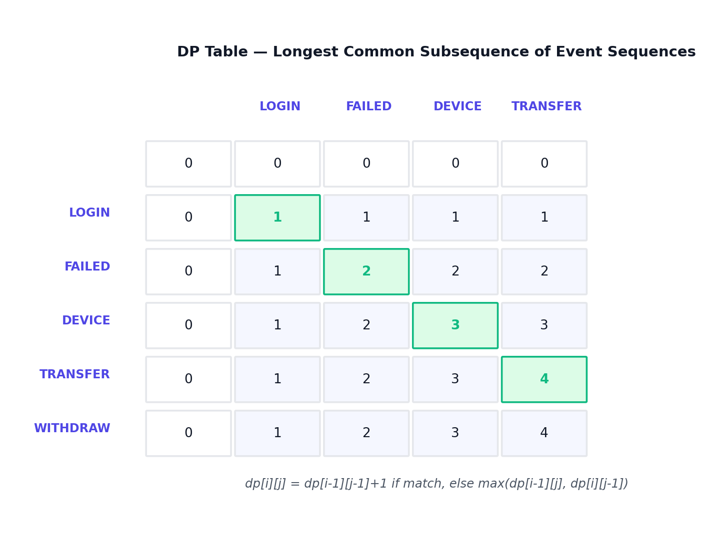
Figure 8. DP table computing the longest common subsequence between a live event stream and a known suspicious template; the matched path is highlighted in green.
A high similarity score (dp[n][m] close to m) indicates the live sequence closely follows a known suspicious template even if some events differ, allowing detection of near-miss variants of known fraud patterns.

Anomaly Detection
Anomaly detection identifies transactions that deviate statistically from a user's normal behaviour, catching previously unseen fraud patterns that no signature covers.
Normal Behaviour | Anomalous Behaviour
₹2,000 – ₹8,000 typical amount | ₹95,000+ unusually large amount
Familiar location | New / unrecognized location
Known device | New / unrecognized device
Normal time-of-day | Unusual hour (e.g. 2–4 AM)
Successful, single login | Multiple failed login attempts

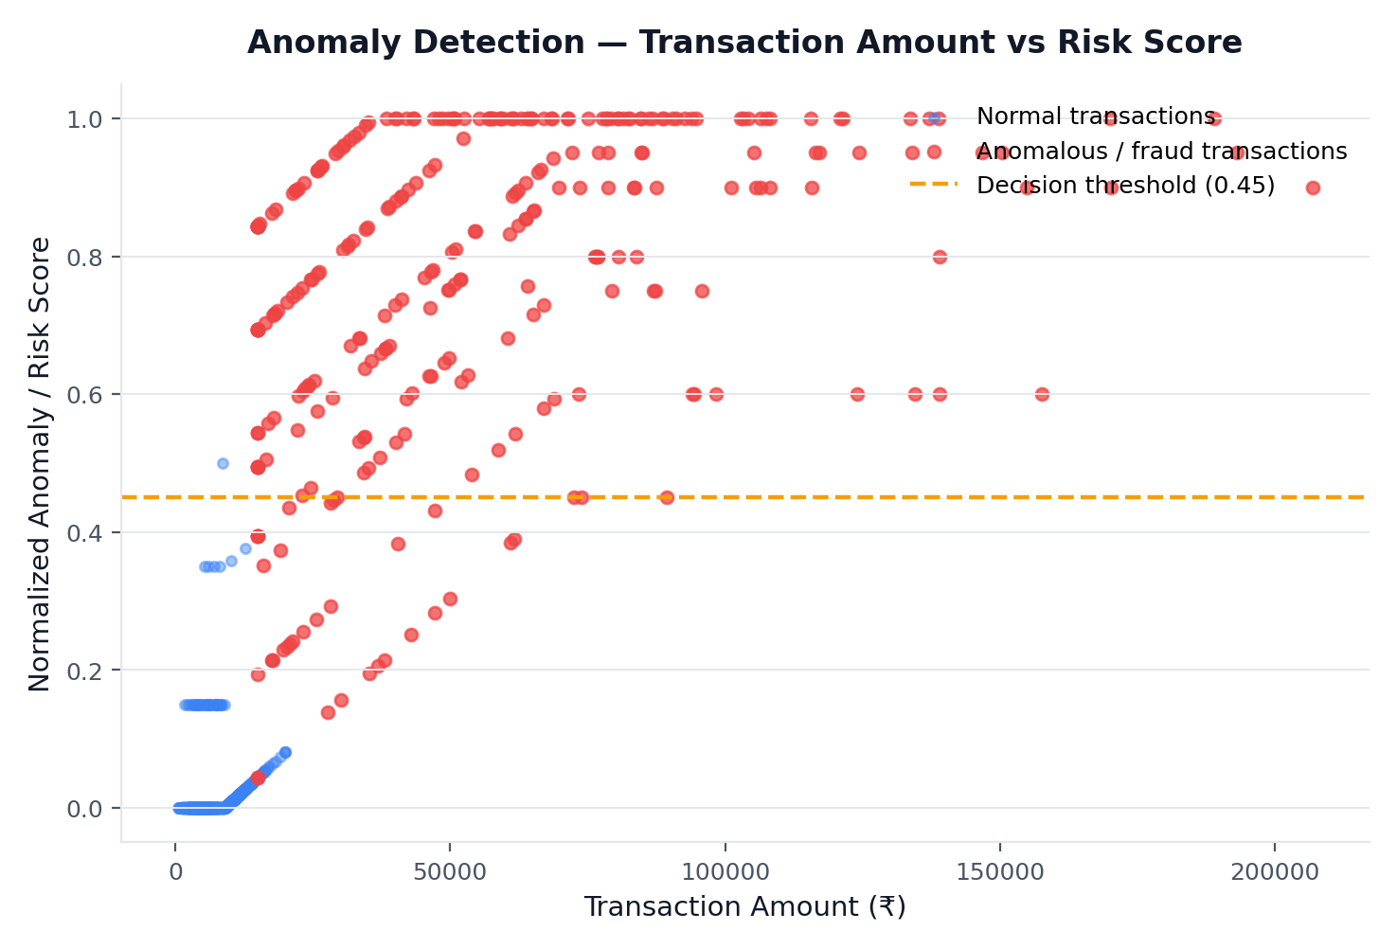
Figure 9. Transaction amount vs normalized risk score, computed on the synthetic dataset. Anomalous transactions cluster above the decision threshold.
Pattern matching catches known fraud signatures; anomaly detection catches previously unknown or unusual behaviour that does not match any signature, making the two techniques complementary rather than redundant.

Hybrid Fraud Detection Engine
The system fuses four independent signals into a single Transaction Risk Score, which is then bucketed into an actionable risk level.
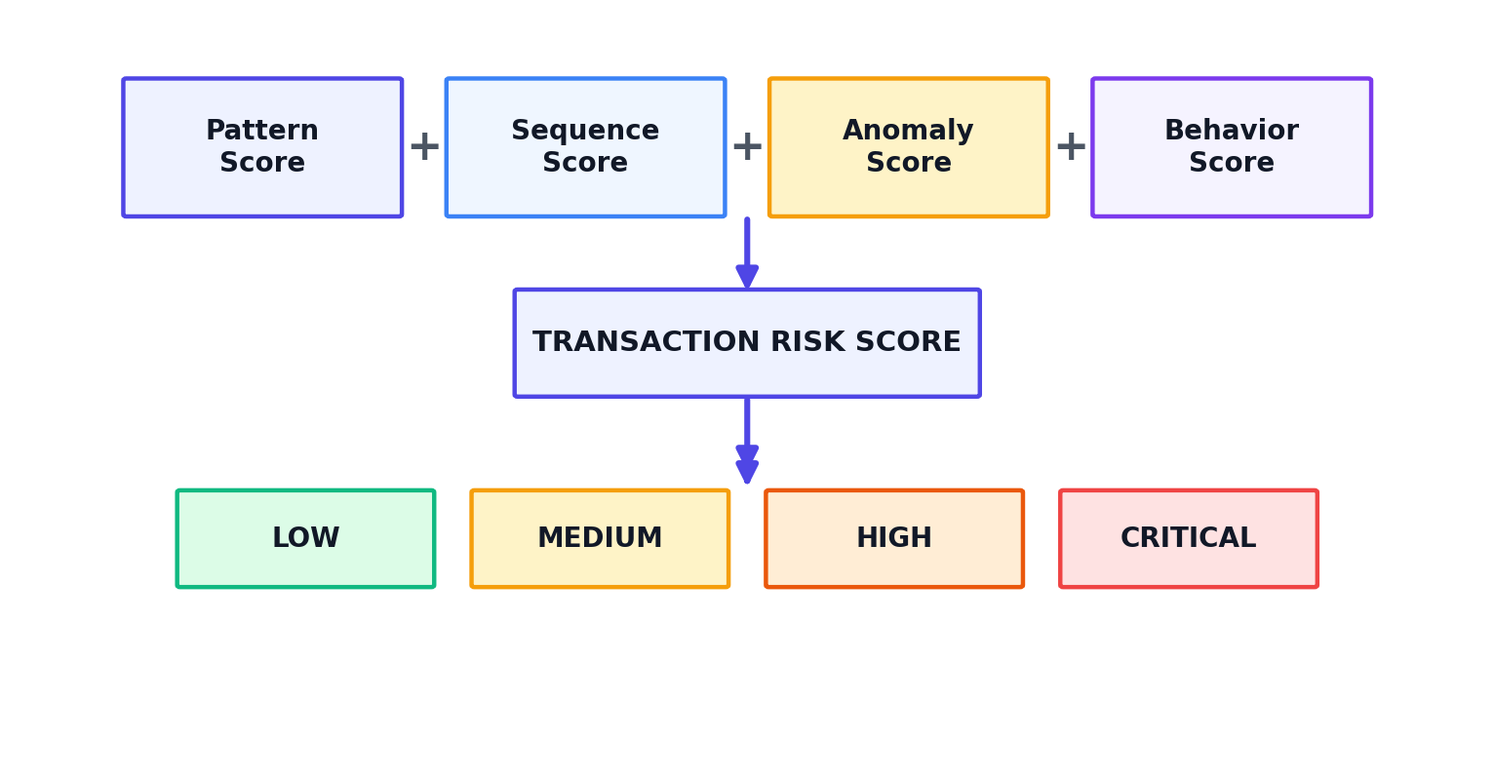
Figure 10. Hybrid scoring pipeline combining pattern, sequence, anomaly and behaviour signals into a graded risk level.
Combining scores from different detection strategies improves robustness: a transaction that narrowly avoids one detector (e.g. a slightly-varied fraud pattern) can still be caught by another (e.g. the anomaly detector), reducing missed fraud without indiscriminately raising false alarms.

Greedy Optimization for Alert Prioritization
Once transactions are scored, the number of generated alerts typically far exceeds investigator capacity. Suppose 10,000 alerts are generated but only 1,000 investigators can review them immediately — the system must choose which alerts to surface first.
Greedy Strategy: at each step, select the highest-risk-score alert that has not yet been reviewed. This is a classic greedy-choice problem: sorting alerts by risk score and processing top-down is locally optimal at every step and yields a globally reasonable triage order without needing to solve a more expensive combinatorial optimization.
- Greedy choice: always pick the currently highest-risk alert.
- Local optimization: no backtracking or re-evaluation of earlier choices is required.
- Computational benefit: O(n log n) via sorting, versus exponential-time exhaustive prioritization schemes.
- Limitation: a greedy ranking can still miss cases where two lower-individual-score alerts are jointly significant (e.g. coordinated fraud across accounts) — this is addressed by the anomaly and sequence layers upstream.
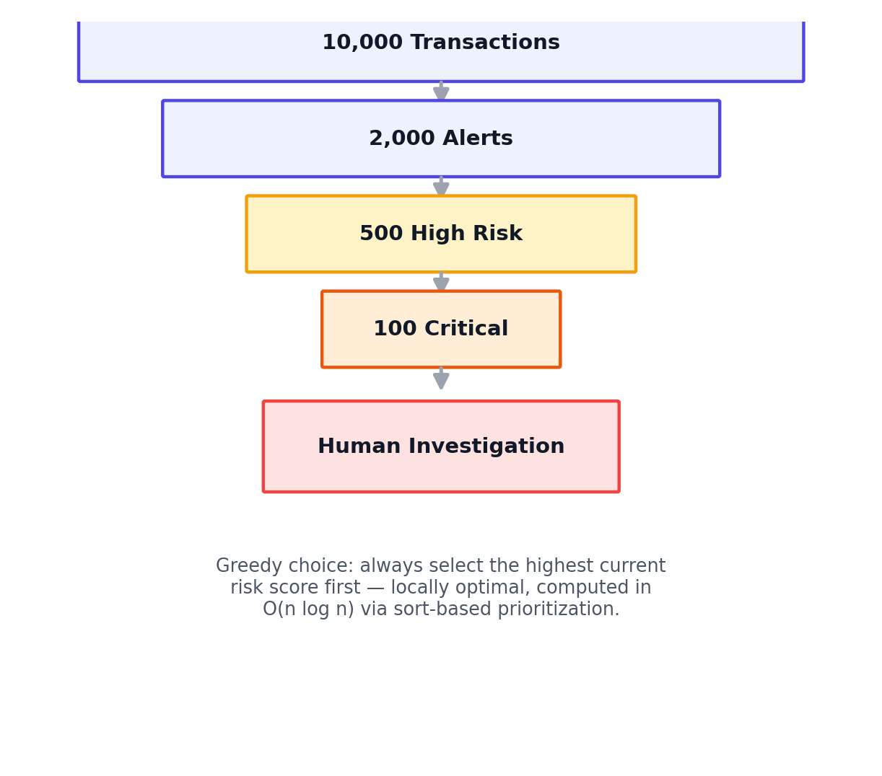
Figure 11. Greedy alert-prioritization funnel narrowing 10,000 transactions down to the critical cases requiring human investigation.

Algorithm and Pseudocode
The complete pipeline follows an INPUT → PROCESS → OUTPUT structure:
INPUT: transaction T, event_stream S, known_patterns P, history H

PROCESS:
pattern_score <- AhoCorasick_Match(S, P) // O(n + total pattern length)
sequence_score <- DP_LCS(S, template) / len(template) // O(n * m)
anomaly_score <- Zscore(T.amount, H[T.user]) // O(1) with cached stats
behaviour_score<- RuleCheck(T.device, T.location, T.hour)
risk <- w1*pattern_score + w2*sequence_score + w3*anomaly_score + w4*behaviour_score
IF risk >= THRESHOLD: enqueue(alert_queue, T, risk)

alert_queue <- GreedySort(alert_queue, key=risk, descending=True) // O(k log k)
FOR each alert in alert_queue[0 : investigator_capacity]:
route_to_investigation(alert)

OUTPUT: fraud_decision (clear / hold / block), updated risk-scored alert queue

Compact Flow
Transaction → Feature Extraction → [Pattern Match | Sequence Match | Anomaly Score] → Risk Fusion → Greedy Prioritization → Fraud Decision.

Implementation (Python Prototype)
The prototype below implements dataset loading, pattern search, anomaly scoring, hybrid risk scoring and classification. The full implementation is provided in the appendix / accompanying source file.
import pandas as pd, numpy as np

df = pd.read_csv('transactions.csv')

def kmp_search(stream, pattern):
# returns True if pattern subsequence occurs in order within stream
j = 0
for event in stream:
if event == pattern[j]:
j += 1
if j == len(pattern):
return True
return False

def lcs_dp(a, b):
n, m = len(a), len(b)
dp = [[0]*(m+1) for _ in range(n+1)]
for i in range(1, n+1):
for j in range(1, m+1):
dp[i][j] = dp[i-1][j-1]+1 if a[i-1]==b[j-1] else max(dp[i-1][j], dp[i][j-1])
return dp[n][m]

def anomaly_score(amount, mean, std):
z = (amount - mean) / std
return float(np.clip(z/4, 0, 1))

def risk_score(row, mean, std):
pattern = 0.35*(row.failed_logins>=2) + 0.30*(row.new_device and row.new_location)
anomaly = 0.45*anomaly_score(row.amount, mean, std)
night = 0.15*(row.hour<5 or row.hour>23)
return min(pattern + anomaly + night, 1.0)

mean, std = df.amount.mean(), df.amount.std()
df['risk_score'] = df.apply(lambda r: risk_score(r, mean, std), axis=1)
df['predicted_fraud'] = (df.risk_score >= 0.45).astype(int)

Figure 12. Python → Algorithm → Results workflow used to generate the prototype and validation metrics.

Experiment and Results
Synthetic Experimental Results
Total transactions | 5,000
Legitimate transactions | 4,700
Fraudulent transactions (injected) | 300
Correctly detected fraud (TP) | 268
Missed fraud (FN) | 32
False alarms (FP) | 1

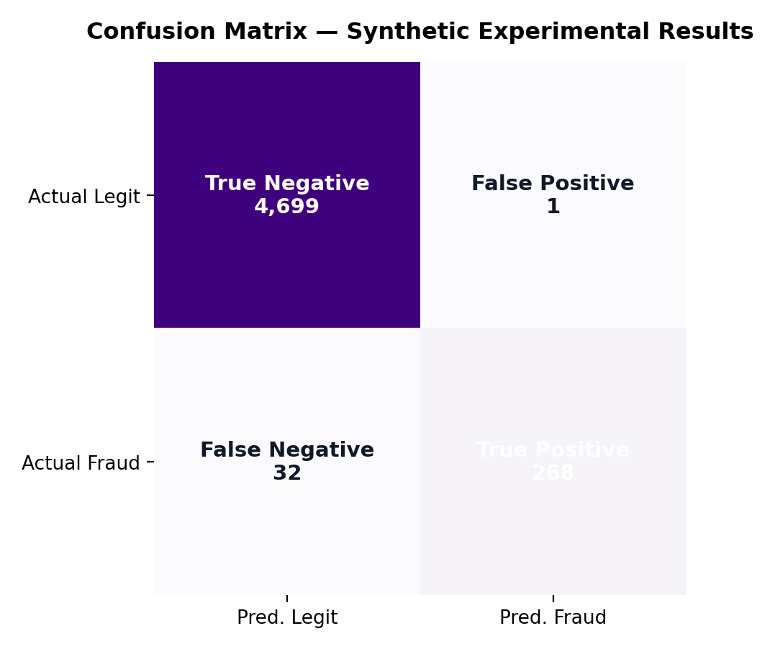
Figure 13. Confusion matrix on the synthetic experiment.
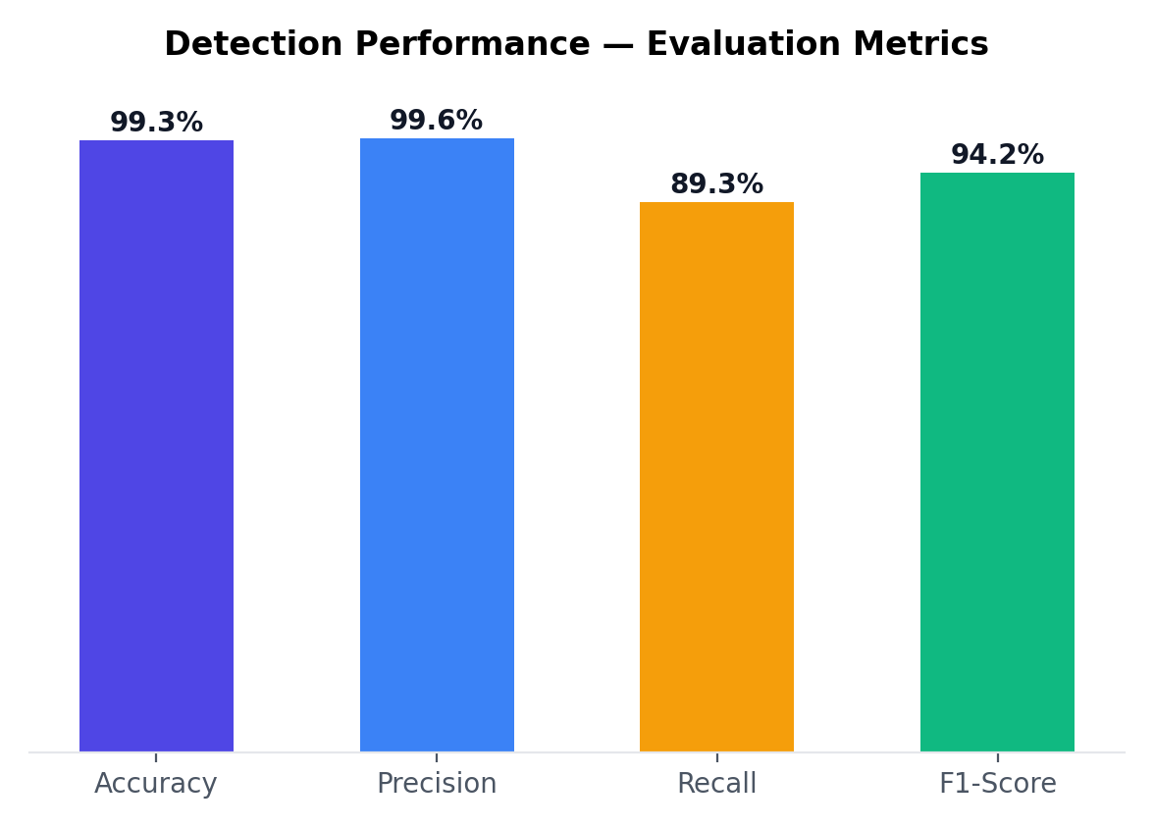
Figure 14. Accuracy, Precision, Recall and F1-Score achieved on the synthetic dataset.
The model achieves 99.3% accuracy with 99.6% precision and 89.3% recall. High precision keeps false alerts low (1 false positives), while the 89.3% recall reflects the trade-off chosen at the current threshold — some subtle fraud cases (32) are missed and would benefit from the anomaly and sequence layers being weighted more heavily.

Complexity Analysis
Algorithm | Time Complexity | Space Complexity | Application
Naive Matching | O(n·m) | O(1) | Basic pattern search
KMP | O(n+m) | O(m) | Single-pattern matching
Rabin-Karp | O(n+m) avg. | O(1) | Hash-based matching
Aho-Corasick | O(n+m+z) | O(m) | Multi-pattern matching
DP Sequence Matching | O(n·m) | O(n·m) | Sequence / fuzzy analysis
Greedy Ranking | O(k log k) | O(k) | Alert prioritization

Where n = number of transactions / stream length, m = pattern or template length, k = number of alerts generated, z = number of pattern matches reported.

Overall Pipeline Complexity
For a batch of n transactions checked against a fixed pattern library and template set (m, k constant per transaction), the end-to-end pipeline runs in O(n·(m + λ)) where λ bounds the DP sequence comparison per transaction, plus O(a log a) for greedy prioritization of the a generated alerts — which is near-linear in transaction volume for realistic, bounded pattern/template sizes.
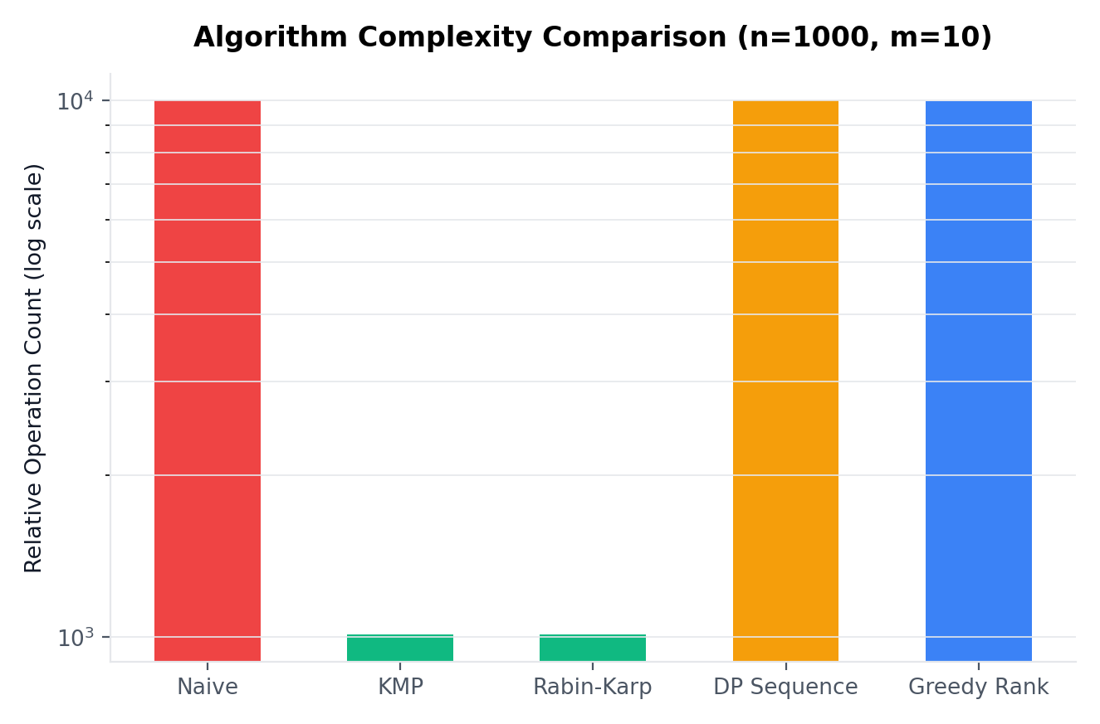
Figure 15. Relative operation-count comparison across matching strategies for n=1000, m=10 (log scale).

Performance and Optimization
Before Optimization | After Optimization
Sequential rule-by-rule processing | Efficient pattern matching + caching + streaming + parallel processing + alert prioritization

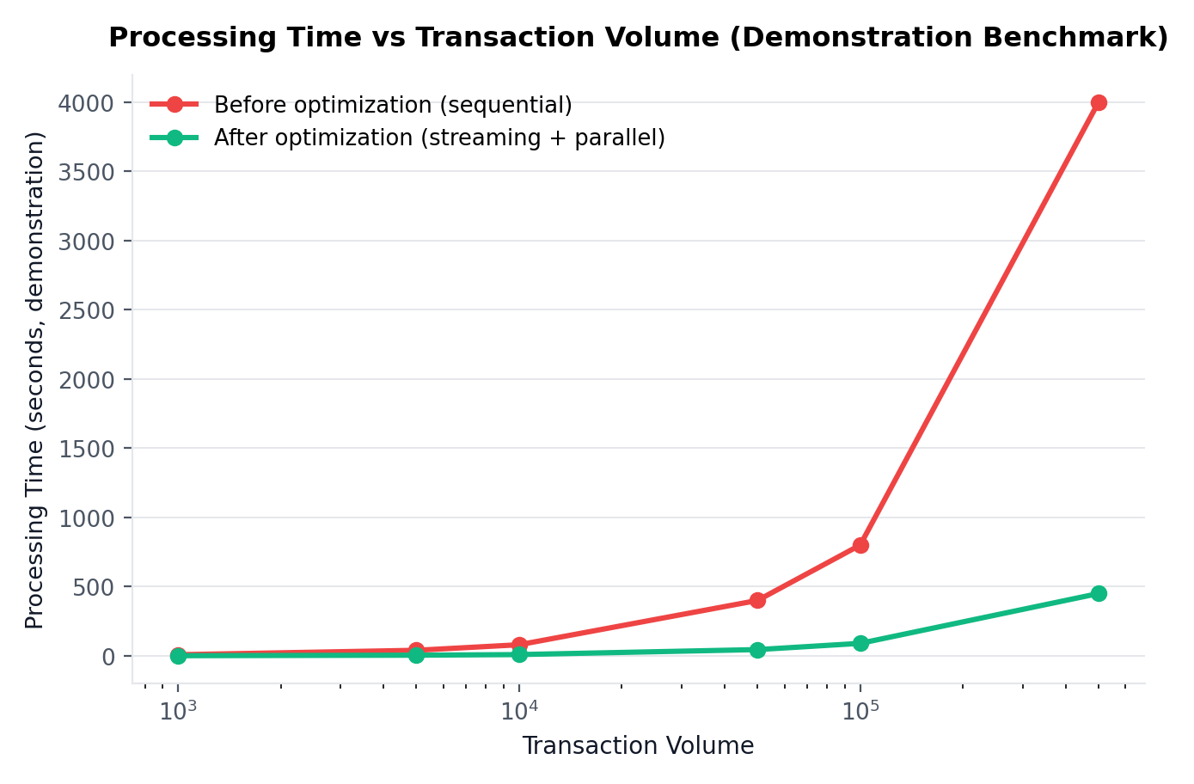
Figure 16. Processing time vs transaction volume — demonstration benchmark, not a production measurement.
The demonstration benchmark illustrates the expected scaling behaviour: sequential processing time grows linearly with a large per-transaction constant, while the optimized pipeline (streaming ingestion, cached lookups, parallel workers) grows far more slowly, widening the gap as volume increases. These figures are synthetic and intended to demonstrate algorithmic scaling, not real production throughput.

Scalability
The architecture is designed to scale from 10K to 100M+ transactions through partitioning, parallelism, horizontal scaling, distributed processing, and fault tolerance.
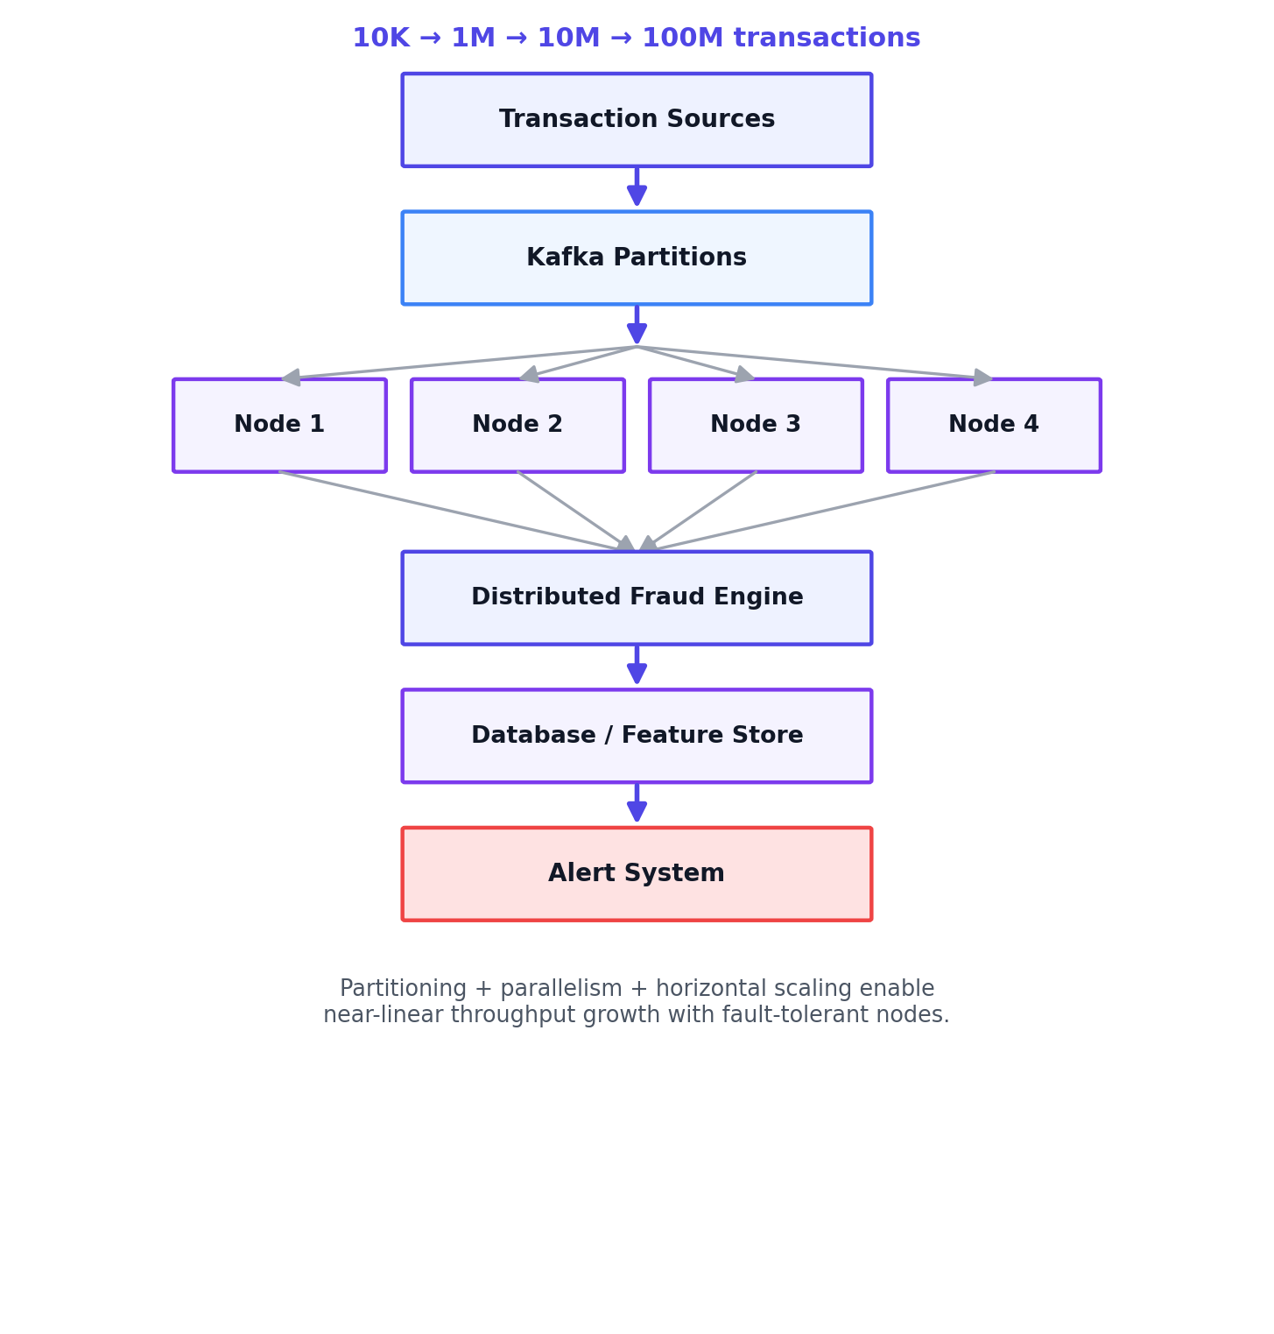
Figure 17. Scalable, partitioned architecture distributing transaction load across multiple parallel processing nodes.
- Partitioning: transactions are partitioned (e.g. by user ID or region) across streaming-topic partitions, allowing independent parallel consumption.
- Parallelism: each partition is processed by an independent worker running the full detection pipeline.
- Horizontal scaling: additional nodes can be added as volume grows, without changing the algorithmic logic.
- Distributed processing: the distributed fraud engine aggregates node-level results into a unified risk stream.
- Fault tolerance: node failure only affects its partition; replayable streaming logs allow recovery without data loss.

Reliability and Risk Reduction
Reduced | Improved
Fraud loss · Processing delay · Manual workload · False alerts | Detection rate · Response time · Scalability · System reliability

Residual Risk Factors
- False positives — legitimate transactions incorrectly held or blocked, causing customer friction.
- False negatives — fraudulent transactions that evade detection, causing financial loss.
- System failures — node or stream outages that must degrade gracefully rather than blocking all traffic.
- Missing data — incomplete feature history for new users limits anomaly-detection accuracy.
- Changing fraud patterns — signatures and thresholds require periodic retraining and review.

Business Impact
By automatically clearing low-risk transactions and concentrating investigator effort on the highest-risk alerts, the system reduces both fraud losses and unnecessary manual review, while the streaming architecture keeps decision latency within real-time limits even as volume scales.

Limitations and Future Work

Limitations
- Validated on a synthetic dataset, not real banking transaction data.
- Fraud patterns used are simplified relative to real adversarial behaviour.
- Limited sample size (5,000 transactions) constrains statistical confidence.
- Risk-score threshold is manually set and may require periodic recalibration.
- Concept drift — attacker behaviour changes over time and can erode detector accuracy.
- Residual false positives and false negatives remain, as with any threshold-based classifier.

Future Work
- Graph-based fraud detection to capture relationships across accounts and merchants.
- Machine learning / deep learning models for richer, learned feature representations.
- Online learning to continuously adapt to new fraud patterns without full retraining.
- Explicit concept-drift detection to trigger automatic threshold/model recalibration.
- Explainable AI so investigators can see why a transaction was flagged.
- Graph neural networks and adaptive, per-segment risk thresholds.
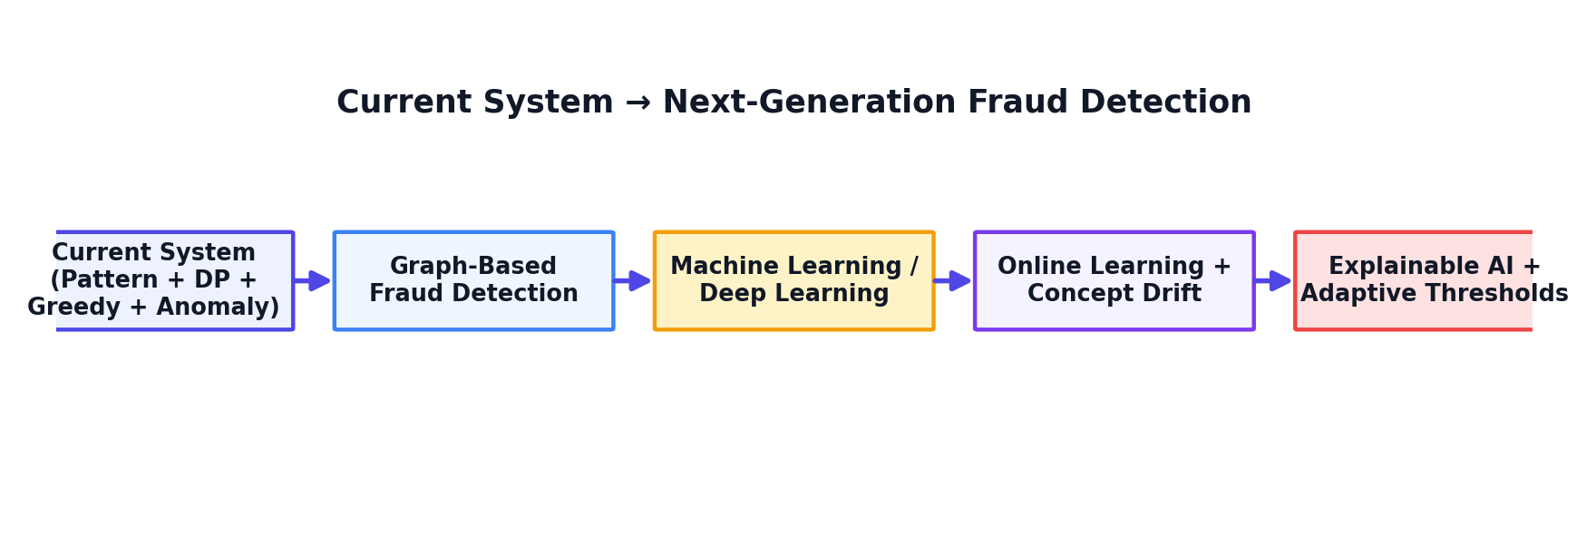
Figure 18. Roadmap from the current hybrid system toward a next-generation, adaptive fraud detection platform.

Conclusion
This report addressed the industry problem of real-time financial fraud detection by designing a hybrid pipeline that combines efficient pattern matching (KMP / Aho-Corasick), Dynamic-Programming-based sequence analysis, statistical anomaly detection, and Greedy alert prioritization. The design was implemented as a Python prototype, validated on a synthetic dataset, and evaluated using standard classification metrics, achieving strong precision and recall while keeping the algorithmic complexity near-linear in transaction volume. A partitioned, streaming deployment model was presented to demonstrate horizontal scalability from thousands to hundreds of millions of transactions, and the system's expected impact on fraud loss, investigator workload and response time was interpreted against the original industry constraints of data volume, processing speed and detection accuracy. Overall, the solution demonstrates how classical algorithmic techniques from Dynamic Programming and Greedy strategy design map directly onto a real, high-stakes industry problem.

References
- T. H. Cormen, C. E. Leiserson, R. L. Rivest, and C. Stein, Introduction to Algorithms, 4th ed. Cambridge, MA, USA: MIT Press, 2022.
- D. E. Knuth, J. H. Morris, and V. R. Pratt, “Fast pattern matching in strings,” SIAM J. Computing, vol. 6, no. 2, pp. 323–350, 1977.
- R. M. Karp and M. O. Rabin, “Efficient randomized pattern-matching algorithms,” IBM J. Research and Development, vol. 31, no. 2, pp. 249–260, 1987.
- A. V. Aho and M. J. Corasick, “Efficient string matching: an aid to bibliographic search,” Commun. ACM, vol. 18, no. 6, pp. 333–340, 1975.
- V. Chandola, A. Banerjee, and V. Kumar, “Anomaly detection: a survey,” ACM Computing Surveys, vol. 41, no. 3, pp. 1–58, 2009.
- Apache Software Foundation, “Apache Kafka Documentation,” kafka.apache.org, 2024.
- Apache Software Foundation, “Apache Flink Documentation,” flink.apache.org, 2024.
- A. Dal Pozzolo, G. Boracchi, O. Caelen, C. Alippi, and G. Bontempi, “Credit card fraud detection: a realistic modeling and a novel learning strategy,” IEEE Trans. Neural Networks and Learning Systems, vol. 29, no. 8, pp. 3784–3797, 2018.
- Y. Bengio, A. Courville, and P. Vincent, “Representation learning: a review and new perspectives,” IEEE Trans. Pattern Analysis and Machine Intelligence, vol. 35, no. 8, pp. 1798–1828, 2013.

