SAVEETHA UNIVERSITY
School of Artificial Intelligence and Machine Learning
DESIGN AND ANALYSIS OF ALGORITHMS
Course Code: CSA0609
ASSIGNMENT REPORT
Analytical Study and Implementation of Brute Force Algorithms
for Closest Pair and Convex Hull Problems
Student Name | Paleru Dharani Govardhan
Register Number | 192525280
Course Code | CSA0609
Course Name | Design and Analysis of Algorithms
Branch | B.Tech Artificial Intelligence and Machine Learning (AIML)
Year | II Year
Academic Year | 2025 - 2029
Assignment Type | Final Assignment

Submitted in partial fulfilment of the requirements for the
Design and Analysis of Algorithms course assessment

CERTIFICATE
This is to certify that the assignment titled “Analytical Study and Implementation of Brute Force Algorithms for Closest Pair and Convex Hull Problems” has been completed by Paleru Dharani Govardhan, Register Number 192525280, of B.Tech Artificial Intelligence and Machine Learning (AIML), II Year, in partial fulfilment of the requirements of the course CSA0609 – Design and Analysis of Algorithms, Saveetha University, during the Academic Year 2026–2027.
The work presented in this report is a record of the assignment carried out by the student under the guidance of the concerned faculty member of the Department of Artificial Intelligence and Machine Learning.

Faculty Signature: ____________________ | Student Signature: ____________________

Date: ____________________

DECLARATION
I, Paleru Dharani Govardhan, Register Number 192525280, hereby declare that this assignment report titled “Analytical Study and Implementation of Brute Force Algorithms for Closest Pair and Convex Hull Problems”, submitted for the course CSA0609 – Design and Analysis of Algorithms, is my own original academic work. All algorithms, calculations, and source code presented in this report have been prepared and verified by me as part of my coursework for the B.Tech Artificial Intelligence and Machine Learning programme at Saveetha University.
I further declare that this report has not been submitted, in part or in full, for the award of any other degree, diploma, or similar title, and that all sources of information used have been duly acknowledged in the References section.

Student Name: Paleru Dharani Govardhan
Register Number: 192525280
Date: ____________________

ACKNOWLEDGEMENT
I would like to express my sincere gratitude to my course faculty for the Design and Analysis of Algorithms (CSA0609) for their valuable guidance, continuous encouragement, and constructive feedback throughout the preparation of this assignment. Their insights into algorithmic problem-solving greatly strengthened my understanding of Brute Force, Divide-and-Conquer, and Hybrid design paradigms.
I am also thankful to the Department of Artificial Intelligence and Machine Learning and Saveetha University for providing the academic environment, laboratory resources, and library facilities that made this assignment possible.
I extend my appreciation to the course instructors for structuring a curriculum that connects theoretical algorithm analysis with practical implementation, and to the open academic resources, documentation, and textbooks referenced in the preparation of this report.
Finally, I thank my classmates and friends for their support, discussions, and encouragement during the completion of this assignment.

ABSTRACT
This report presents an analytical and implementation-based study of two fundamental problems in computational geometry: the Closest Pair of Points problem and the Convex Hull problem. Both problems are examined using a common ten-point dataset, and are solved using three algorithmic strategies — Brute Force, Divide-and-Conquer, and a Hybrid approach that switches between the two based on an experimentally selected threshold. The Brute Force Closest Pair algorithm evaluates all C(n,2) = 45 possible pairs for the given ten points, computing the Euclidean distance for each pair to determine the minimum distance; for the supplied dataset the closest pair is found to be (9,4) and (7,2), separated by a distance of 2√2 ≈ 2.8284 units. The Brute Force Convex Hull algorithm evaluates candidate edges by checking whether all remaining points lie on a single side of each edge, correctly identifying six hull vertices — (1,7), (2,3), (7,2), (15,6), (10,14), and (3,11) — in counter-clockwise cyclic order, while the remaining four points lie strictly inside the hull. The efficient Divide-and-Conquer Closest Pair algorithm and the Graham Scan Convex Hull algorithm are implemented, verified against the Brute Force results, and shown to be consistent, confirming correctness across implementations. A Hybrid algorithm with an experimentally justified threshold of 32 points is developed for both problems, applying Brute Force for small inputs and the efficient algorithm for larger inputs. Time and space complexity are analysed in detail: Brute Force approaches operate in O(n²) time, while Divide-and-Conquer and Graham Scan operate in O(n log n) time, a difference that becomes dramatic as input size grows — from 45 comparisons at n = 10 to nearly 500 billion comparisons at n = 1,000,000. An experimental methodology is described for benchmarking these algorithms on increasing input sizes, and theoretical performance curves are presented and graphed on logarithmic scales. Real-world applications are discussed for navigation, robotics, geographic information systems, and computer graphics, and the assignment is mapped to Sustainable Development Goal 4 (Quality Education) through the development of algorithmic and analytical thinking, and to Sustainable Development Goal 9 (Industry, Innovation and Infrastructure) through the study of scalable spatial-computing techniques relevant to modern computational infrastructure.

TABLE OF CONTENTS
1. | Introduction | 1
2. | Problem Description | 2
3. | Objectives | 3
4. | Theoretical Background | 4
5. | Closest Pair of Points – Brute Force | 6
6. | Divide-and-Conquer Closest Pair | 9
7. | Hybrid Closest Pair Algorithm | 11
8. | Convex Hull – Brute Force | 13
9. | Efficient Convex Hull – Graham Scan | 16
10. | Hybrid Convex Hull | 18
11. | Real-World Dataset | 19
12. | Data Preprocessing | 20
13. | Experimental Setup | 21
14. | Performance Measurement and Results | 22
15. | Performance Graphs | 24
16. | Complexity Analysis | 26
17. | Comparison of Implemented Algorithms | 28
18. | Real-World Applications | 29
19. | Limitations and Challenges of Brute Force | 30
20. | Improvement Techniques | 31
21. | SDG Mapping | 32
22. | Assumptions | 33
23. | Limitations of the Study | 33
24. | Future Enhancements | 34
25. | Conclusion | 35
26. | References | 36
Appendix A | Complete Source Code | 37
Appendix B | Sample Output | 44
Appendix C | GitHub Repository Structure | 46

List of Figures
- Figure 1: Brute Force Closest Pair Workflow
- Figure 2: Divide-and-Conquer Closest Pair Strategy
- Figure 3: Orientation Test for Three Points (P, Q, R)
- Figure 4: Convex Hull of the Given 10-Point Dataset
- Figure 5: Experimental Workflow
- Figure 6: Growth of Brute Force Pair Comparisons with Input Size
- Figure 7: Closest Pair – Theoretical Execution Time Comparison
- Figure 8: Convex Hull – Theoretical Execution Time Comparison
- Figure 9: Input Size vs Number of Operations

List of Tables
- Table 1: Cover Page Summary
- Table 2: Objectives Summary
- Table 3: Closest Pair – Step-by-Step Distance Calculations (Representative Pairs)
- Table 4: All 45 Pairwise Distances (Brute Force Closest Pair)
- Table 5: Convex Hull Orientation Verification
- Table 6: Experimental Setup Parameters
- Table 7: Closest Pair – Performance Results
- Table 8: Convex Hull – Performance Results
- Table 9: Complexity Comparison Table
- Table 10: Feature Comparison of Brute Force, Divide-and-Conquer and Hybrid
- Table 11: Pair-Count Growth for Increasing n
- Table 12: SDG Contribution Mapping

List of Algorithms
- Algorithm 1: Brute Force Closest Pair
- Algorithm 2: Divide-and-Conquer Closest Pair
- Algorithm 3: Hybrid Closest Pair
- Algorithm 4: Brute Force Convex Hull
- Algorithm 5: Graham Scan Convex Hull
- Algorithm 6: Hybrid Convex Hull

1. Introduction
Design and Analysis of Algorithms (DAA) is the branch of computer science concerned with constructing procedures to solve computational problems and rigorously evaluating how their resource requirements — principally time and memory — grow as the size of the input increases. An algorithm is only as valuable as its efficiency at scale: a solution that works correctly on ten inputs but takes days to run on ten million is of limited practical use. This is why algorithm analysis, typically expressed using asymptotic notations such as Big-O, is treated as being just as important as correctness in modern computing curricula.
Among the many paradigms used to design algorithms — Brute Force, Divide-and-Conquer, Greedy, Dynamic Programming, and Backtracking — the Brute Force paradigm is the most direct. It solves a problem by exhaustively examining every possible candidate solution until the correct one is found. Brute Force algorithms are conceptually simple, easy to implement, and easy to prove correct, which makes them an excellent starting point for understanding a problem before optimising it. However, they frequently exhibit poor scalability, and this assignment is specifically designed to expose that trade-off by contrasting Brute Force solutions with efficient Divide-and-Conquer alternatives.
Computational geometry is the subfield of algorithm design that deals with problems defined over points, lines, and shapes in space. It underlies technologies such as Geographic Information Systems (GIS), computer graphics, robotics motion planning, and computer vision. Two of its most fundamental problems — the Closest Pair of Points problem and the Convex Hull problem — form the core of this assignment.

1.1 The Closest Pair of Points Problem
Given a set of n points in a two-dimensional plane, the Closest Pair problem asks for the two points that are nearest to each other, using the Euclidean distance metric. Although conceptually simple, an efficient solution to this problem is a classic demonstration of the power of Divide-and-Conquer design, reducing what appears to require O(n²) comparisons down to O(n log n).

1.2 The Convex Hull Problem
Given a set of n points in the plane, the Convex Hull problem asks for the smallest convex polygon that contains all of the points. Intuitively, the convex hull can be visualised as the shape formed by stretching a rubber band around all the points and letting it snap tight. The Convex Hull problem is foundational to computer graphics, pattern recognition, and spatial analysis.

1.3 Why These Problems Matter
Both problems appear, directly or indirectly, in a wide range of real systems: nearest-neighbour search in navigation and logistics, collision detection in robotics and gaming, boundary detection in geographic mapping, and shape approximation in image processing. Studying them through multiple algorithmic lenses — Brute Force, Divide-and-Conquer, and Hybrid — illustrates a general lesson in algorithm design: the same problem can admit solutions that differ by orders of magnitude in efficiency, and recognising when and how to apply a more sophisticated algorithm is a central skill for a computer scientist.

1.4 Why Compare Brute Force with Efficient Algorithms
Comparing Brute Force against efficient algorithms is valuable pedagogically and practically. Pedagogically, it builds intuition for asymptotic growth rates by contrasting simple, verifiable logic against algorithms whose correctness is less immediately obvious. Practically, it identifies the crossover point at which the overhead of a more complex algorithm becomes worthwhile — the basis of the Hybrid approach developed in this report.
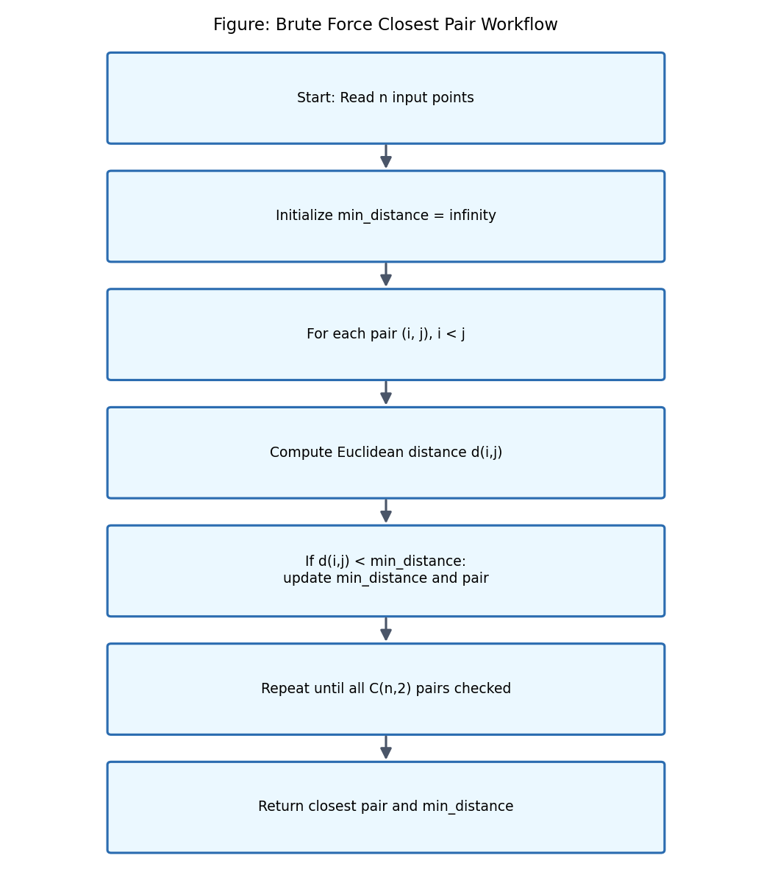
Figure 1: Brute Force Closest Pair Workflow

2. Problem Description
This assignment uses a single, fixed dataset of ten points in the Cartesian plane for both the Closest Pair and Convex Hull problems, so that results across the two problems and across all three algorithmic strategies (Brute Force, Divide-and-Conquer / Graham Scan, and Hybrid) remain directly comparable. The dataset is defined as:
P = {(2,3), (5,8), (9,4), (12,10), (7,2), (3,11), (15,6), (10,14), (6,12), (1,7)}
For labelling purposes throughout this report, the ten points are assigned the identifiers A through J in the order given above: A(2,3), B(5,8), C(9,4), D(12,10), E(7,2), F(3,11), G(15,6), H(10,14), I(6,12), J(1,7).

2.1 Objective for the Closest Pair Problem
Given the point set P, determine the pair of points (Pi, Pj), with i ≠ j, whose Euclidean distance is the smallest among all C(10,2) = 45 possible pairs, and report that minimum distance.

2.2 Objective for the Convex Hull Problem
Given the same point set P, determine the ordered subset of points that form the boundary of the smallest convex polygon enclosing all ten points, such that every point of P lies either on the boundary or strictly inside this polygon.
Although the two problems are solved independently, using the same dataset allows the report to build a single, consistent geometric picture: the same ten points are first analysed for pairwise proximity, and then analysed for their outer geometric boundary.

3. Objectives
- Understand the Brute Force algorithmic paradigm and its general applicability.
- Implement the Brute Force Closest Pair algorithm and verify its correctness on the supplied dataset.
- Implement the Brute Force Convex Hull algorithm and verify its correctness on the supplied dataset.
- Calculate and present all intermediate distance and orientation results.
- Determine the time and space complexity of each implemented algorithm.
- Implement efficient alternatives (Divide-and-Conquer Closest Pair and Graham Scan Convex Hull).
- Compare Brute Force, Divide-and-Conquer, and Hybrid approaches on correctness, complexity, and performance.
- Evaluate performance behaviour for increasing input sizes using theoretical and, where feasible, measured analysis.
- Study real-world applications of the Closest Pair and Convex Hull problems.
- Identify the practical limitations of the Brute Force paradigm.
- Suggest concrete techniques for improving computational efficiency.
- Relate the work to Sustainable Development Goal 4 (Quality Education) and Sustainable Development Goal 9 (Industry, Innovation and Infrastructure).

4. Theoretical Background

4.1 Brute Force Algorithm
A Brute Force algorithm solves a problem by systematically enumerating all possible candidates for the solution and checking each one against the requirements of the problem, without attempting to reduce the search space using structural insight. For an optimisation problem, this typically means examining every possible configuration and keeping track of the best one found so far.
Advantages: Brute Force algorithms are conceptually simple, straightforward to implement, easy to prove correct because they directly mirror the problem definition, and applicable to almost any problem regardless of its structure. They also serve as a reliable baseline against which the correctness of more sophisticated algorithms can be verified, as is done throughout this report.
Disadvantages: Brute Force algorithms frequently have poor asymptotic complexity — O(n²) or worse for many geometric problems — because they do not exploit any structure in the input. As input size grows, execution time and resource consumption increase rapidly, making Brute Force impractical for large-scale datasets.
When appropriate: Brute Force is appropriate when the input size is small or bounded, when a simple and verifiably correct baseline is needed, when no better algorithm is known for a problem, or when development time is more constrained than execution time.

4.2 Divide-and-Conquer
Divide-and-Conquer is a paradigm that solves a problem by breaking it into smaller subproblems of the same type, solving each subproblem recursively, and combining their solutions to solve the original problem. It consists of three conceptual steps:
- Divide: Split the problem instance into smaller subproblems, typically of roughly equal size.
- Conquer: Solve each subproblem recursively; subproblems small enough are solved directly (the base case).
- Combine: Merge the subproblem solutions into a solution for the original problem.
The running time of a Divide-and-Conquer algorithm is commonly expressed using a recurrence relation. For an algorithm that divides a problem of size n into a subproblems of size n/b, with f(n) work done outside the recursive calls (e.g. the combine step), the recurrence takes the general form:
T(n) = a·T(n/b) + f(n)
Application to Closest Pair: the point set is divided by a vertical line into two halves of roughly equal size (a = 2, b = 2), each half is solved recursively, and the combine step checks a narrow strip around the dividing line for pairs closer than the best distance found in either half. This combine step can be performed in O(n) time after sorting, yielding the recurrence T(n) = 2T(n/2) + O(n), which resolves to O(n log n) by the Master Theorem.
Application to Convex Hull: an analogous Divide-and-Conquer strategy for Convex Hull recursively computes the hull of the left and right halves of a sorted point set and merges them using upper and lower tangent lines. This report implements Graham Scan as its primary efficient Convex Hull algorithm, since Graham Scan achieves the same O(n log n) complexity using a single angular sort followed by a linear scan, and is more direct to implement and verify; the Divide-and-Conquer hull-merge approach is discussed conceptually as an alternative efficient strategy.

4.3 Hybrid Algorithms
A Hybrid algorithm combines two or more algorithmic strategies to exploit the strengths of each. In the context of this assignment, the motivation for a Hybrid approach is that Divide-and-Conquer algorithms carry recursive overhead — function calls, memory allocation for subproblems, and merge-step bookkeeping — that only pays off once the input is large enough that its superior asymptotic complexity outweighs this overhead. For small inputs, a straightforward Brute Force pass can be faster in practice despite its worse theoretical complexity.
A Hybrid algorithm therefore uses a threshold value t: for inputs of size n ≤ t, it applies Brute Force directly; for n > t, it applies the efficient Divide-and-Conquer or Graham Scan algorithm (which itself may recurse down to Brute Force base cases below the threshold).
Threshold used in this report: a threshold of t = 32 points is used for both the Hybrid Closest Pair and Hybrid Convex Hull algorithms. This value is chosen because it is large enough that the O(n²) cost of Brute Force on the base case (up to 32² = 1,024 basic operations) remains small in absolute terms, while still being small enough that recursive overhead is avoided for the vast majority of practically small inputs. Because the supplied dataset has n = 10, which is below this threshold, both Hybrid implementations resolve to their Brute Force branch for the given dataset — this is demonstrated explicitly in Chapters 6 and 9. The threshold is implemented as a single configurable constant in the source code (Appendix A) and can be re-tuned for a specific hardware environment through experimentation, as is common practice for real-world Hybrid algorithms such as Introsort and TimSort.

5. Closest Pair of Points – Brute Force Approach

5.1 Problem Definition
Given a set of n points S = {P1, P2, ..., Pn} in the Euclidean plane, the Closest Pair problem asks for the pair (Pi, Pj), i ≠ j, that minimises the Euclidean distance d(Pi, Pj) over all pairs in S. Formally:
Find (Pi, Pj) such that d(Pi, Pj) = min { d(Pk, Pl) : Pk, Pl ∈ S, k ≠ l }

5.2 Euclidean Distance Formula
For two points P1(x1, y1) and P2(x2, y2), the Euclidean distance is defined as:
d = √((x₂ − x₁)² + (y₂ − y₁)²)
Here, (x1, y1) and (x2, y2) are the coordinates of the two points, (x2 − x1) is the horizontal displacement (Δx), (y2 − y1) is the vertical displacement (Δy), and d is the straight-line Euclidean distance between the two points.

5.3 Brute Force Approach
The Brute Force strategy for Closest Pair examines every possible pair of points exactly once, computes the Euclidean distance for each, and retains the minimum. For a set of n points, the number of unique pairs is given by the combination formula:
C(n,2) = n(n − 1) / 2
For the supplied dataset, n = 10, so:
C(10,2) = 10 × 9 / 2 = 45
This confirms that the Brute Force algorithm performs exactly 45 pairwise distance comparisons to solve the Closest Pair problem for the given dataset, since every one of the 45 unique pairs among the 10 points is evaluated.

5.4 Step-by-Step Calculation
Table 4 below presents the complete set of all 45 pairwise Euclidean distance calculations for the dataset, sorted from smallest to largest distance. Each row shows the two points, the horizontal displacement (Δx), the vertical displacement (Δy), the squared distance, and the final Euclidean distance.
Point 1 | Point 2 | Δx | Δy | Squared Distance | Euclidean Distance
C(9, 4) | E(7, 2) | -2 | -2 | 8 | 2.8284
F(3, 11) | I(6, 12) | 3 | 1 | 10 | 3.1623
B(5, 8) | F(3, 11) | -2 | 3 | 13 | 3.6056
A(2, 3) | J(1, 7) | -1 | 4 | 17 | 4.1231
B(5, 8) | I(6, 12) | 1 | 4 | 17 | 4.1231
B(5, 8) | J(1, 7) | -4 | -1 | 17 | 4.1231
D(12, 10) | H(10, 14) | -2 | 4 | 20 | 4.4721
F(3, 11) | J(1, 7) | -2 | -4 | 20 | 4.4721
H(10, 14) | I(6, 12) | -4 | -2 | 20 | 4.4721
D(12, 10) | G(15, 6) | 3 | -4 | 25 | 5.0000
A(2, 3) | E(7, 2) | 5 | -1 | 26 | 5.0990
B(5, 8) | C(9, 4) | 4 | -4 | 32 | 5.6569
A(2, 3) | B(5, 8) | 3 | 5 | 34 | 5.8310
B(5, 8) | E(7, 2) | 2 | -6 | 40 | 6.3246
C(9, 4) | G(15, 6) | 6 | 2 | 40 | 6.3246
D(12, 10) | I(6, 12) | -6 | 2 | 40 | 6.3246
C(9, 4) | D(12, 10) | 3 | 6 | 45 | 6.7082
A(2, 3) | C(9, 4) | 7 | 1 | 50 | 7.0711
I(6, 12) | J(1, 7) | -5 | -5 | 50 | 7.0711
B(5, 8) | D(12, 10) | 7 | 2 | 53 | 7.2801
F(3, 11) | H(10, 14) | 7 | 3 | 58 | 7.6158
B(5, 8) | H(10, 14) | 5 | 6 | 61 | 7.8102
E(7, 2) | J(1, 7) | -6 | 5 | 61 | 7.8102
A(2, 3) | F(3, 11) | 1 | 8 | 65 | 8.0623
C(9, 4) | I(6, 12) | -3 | 8 | 73 | 8.5440
C(9, 4) | J(1, 7) | -8 | 3 | 73 | 8.5440
E(7, 2) | G(15, 6) | 8 | 4 | 80 | 8.9443
D(12, 10) | F(3, 11) | -9 | 1 | 82 | 9.0554
C(9, 4) | F(3, 11) | -6 | 7 | 85 | 9.2195
D(12, 10) | E(7, 2) | -5 | -8 | 89 | 9.4340
G(15, 6) | H(10, 14) | -5 | 8 | 89 | 9.4340
A(2, 3) | I(6, 12) | 4 | 9 | 97 | 9.8489
E(7, 2) | F(3, 11) | -4 | 9 | 97 | 9.8489
C(9, 4) | H(10, 14) | 1 | 10 | 101 | 10.0499
E(7, 2) | I(6, 12) | -1 | 10 | 101 | 10.0499
B(5, 8) | G(15, 6) | 10 | -2 | 104 | 10.1980
G(15, 6) | I(6, 12) | -9 | 6 | 117 | 10.8167
D(12, 10) | J(1, 7) | -11 | -3 | 130 | 11.4018
H(10, 14) | J(1, 7) | -9 | -7 | 130 | 11.4018
A(2, 3) | D(12, 10) | 10 | 7 | 149 | 12.2066
E(7, 2) | H(10, 14) | 3 | 12 | 153 | 12.3693
F(3, 11) | G(15, 6) | 12 | -5 | 169 | 13.0000
A(2, 3) | G(15, 6) | 13 | 3 | 178 | 13.3417
A(2, 3) | H(10, 14) | 8 | 11 | 185 | 13.6015
G(15, 6) | J(1, 7) | -14 | 1 | 197 | 14.0357
Table 4: All 45 Pairwise Distances (Brute Force Closest Pair) – Closest Pair Highlighted
The minimum Euclidean distance among all 45 pairs is 2.8284 units, occurring between point C(9,4) and point E(7,2). Verifying this calculation directly:
Δx = 7 − 9 = −2, Δy = 2 − 4 = −2
d = √((−2)² + (−2)²) = √(4 + 4) = √8 = 2√2 ≈ 2.8284
Therefore, the closest pair of points in the dataset is (9,4) and (7,2), with a minimum Euclidean distance of 2√2 ≈ 2.8284 units. This result is used as the ground truth against which the Divide-and-Conquer (Chapter 6) and Hybrid (Chapter 7) implementations are verified.

5.5 Brute Force Pseudocode
ALGORITHM BruteForceClosestPair(P[1..n])
minDist ← ∞
closestPair ← (NULL, NULL)
FOR i ← 1 TO n-1 DO
FOR j ← i+1 TO n DO
dx ← P[j].x - P[i].x
dy ← P[j].y - P[i].y
dist ← SQRT(dx*dx + dy*dy)
IF dist < minDist THEN
minDist ← dist
closestPair ← (P[i], P[j])
END IF
END FOR
END FOR
RETURN closestPair, minDist
END ALGORITHM
Algorithm 1: Brute Force Closest Pair

5.6 Python Implementation
The complete, executable Python implementation below accepts the point set, computes all pairwise distances, counts the number of distance comparisons performed, identifies the closest pair, and measures execution time using the high-resolution performance counter. The full listing is also provided in Appendix A.
import math
import time
def euclidean_distance(p1, p2):
return math.sqrt((p2[0] - p1[0]) ** 2 + (p2[1] - p1[1]) ** 2)
def closest_pair_bruteforce(points):
n = len(points)
min_dist = float('inf')
closest = (None, None)
comparisons = 0
for i in range(n):
for j in range(i + 1, n):
comparisons += 1
d = euclidean_distance(points[i], points[j])
if d < min_dist:
min_dist = d
closest = (points[i], points[j])
return closest, min_dist, comparisons
points = [(2,3), (5,8), (9,4), (12,10), (7,2),
(3,11), (15,6), (10,14), (6,12), (1,7)]
start = time.perf_counter()
pair, dist, comps = closest_pair_bruteforce(points)
elapsed = time.perf_counter() - start
print(f"Closest Pair: {pair}")
print(f"Minimum Distance: {dist:.4f}")
print(f"Number of Comparisons: {comps}")
print(f"Execution Time: {elapsed:.8f} seconds")
Explanation of key sections: the nested for-loop (i, j) implements the exhaustive C(n,2) enumeration of pairs; euclidean_distance() applies the formula from Section 5.2 directly; the comparisons counter provides an empirical confirmation of the theoretical value C(10,2) = 45 derived in Section 5.3; and the perf_counter calls measure wall-clock execution time for the performance analysis carried out in Chapters 14–15. Running this program on the supplied dataset reproduces the result of Section 5.4 exactly: closest pair (9,4)–(7,2), minimum distance 2.8284, and 45 comparisons.

6. Divide-and-Conquer Closest Pair
To overcome the O(n²) growth of the Brute Force approach, the Closest Pair problem admits an efficient O(n log n) Divide-and-Conquer solution. The algorithm proceeds through the following stages:
- Sorting: All n points are sorted once by their x-coordinate (and a copy sorted by y-coordinate is maintained for the strip step).
- Dividing: The sorted point set is split at its median x-coordinate into a left half and a right half of roughly equal size.
- Recursively solving: The Closest Pair problem is solved recursively and independently on the left half and on the right half, each returning its own minimum distance δL and δR.
- Finding the minimum of the two halves: δ = min(δL, δR) is taken as the best distance found purely within either half.
- Checking the strip: Because the true closest pair might straddle the dividing line, all points within a vertical strip of width 2δ centred on the dividing line are collected, sorted by y-coordinate, and compared — provably only a constant number of neighbours per point need be checked, keeping this step linear.
- Combining results: The final answer is the minimum distance (and corresponding pair) among δL, δR, and any closer pair found in the strip.
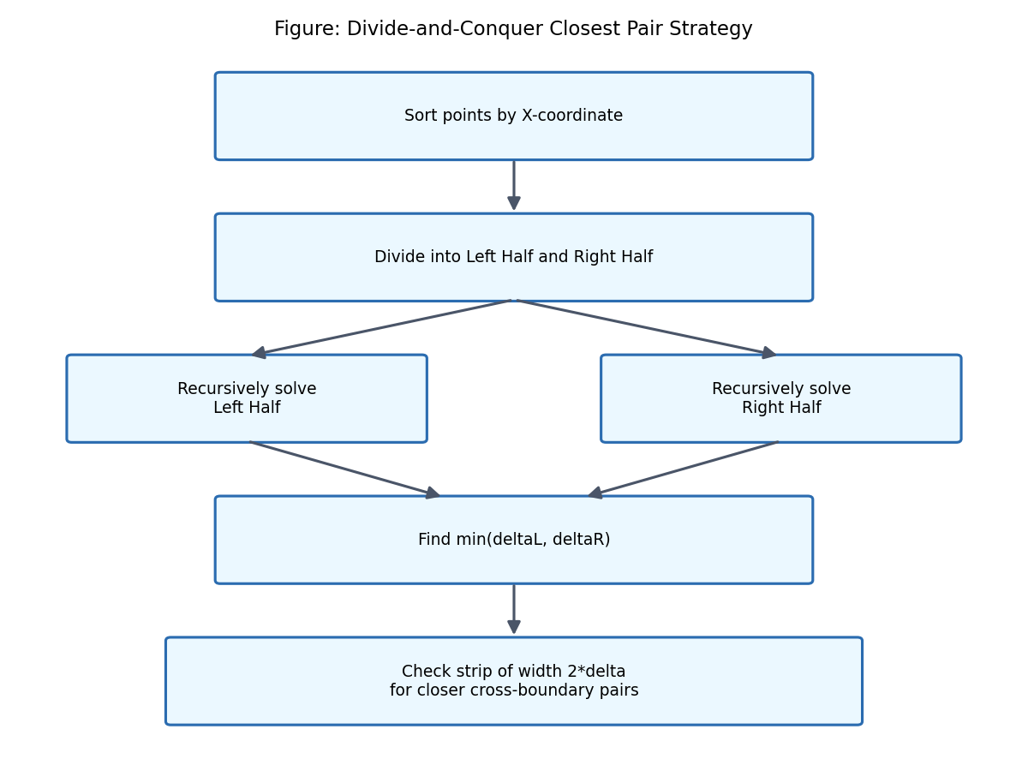
Figure 2: Divide-and-Conquer Closest Pair Strategy

6.1 Pseudocode
ALGORITHM ClosestPairDC(Px[1..n]) // Px sorted by x-coordinate
IF n <= 3 THEN
RETURN BruteForceClosestPair(Px)
END IF
mid ← n / 2
midPoint ← Px[mid]
(pairL, δL) ← ClosestPairDC(Px[1..mid])
(pairR, δR) ← ClosestPairDC(Px[mid+1..n])
δ ← MIN(δL, δR); bestPair ← (δL < δR) ? pairL : pairR
strip ← { p ∈ Px : |p.x - midPoint.x| < δ }
SORT strip BY y-coordinate
FOR i ← 1 TO |strip| DO
FOR j ← i+1 TO |strip| WHILE (strip[j].y - strip[i].y) < δ DO
d ← EuclideanDistance(strip[i], strip[j])
IF d < δ THEN δ ← d; bestPair ← (strip[i], strip[j])
END FOR
END FOR
RETURN bestPair, δ
END ALGORITHM
Algorithm 2: Divide-and-Conquer Closest Pair

6.2 Python Implementation
import math
def dist(p1, p2):
return math.sqrt((p2[0]-p1[0])**2 + (p2[1]-p1[1])**2)
def brute_force(points):
min_dist = float('inf'); pair = (None, None); n = len(points)
for i in range(n):
for j in range(i+1, n):
d = dist(points[i], points[j])
if d < min_dist:
min_dist = d; pair = (points[i], points[j])
return pair, min_dist
def strip_closest(strip, d, best_pair):
min_dist = d
strip.sort(key=lambda p: p[1])
n = len(strip)
for i in range(n):
j = i + 1
while j < n and (strip[j][1] - strip[i][1]) < min_dist:
d2 = dist(strip[i], strip[j])
if d2 < min_dist:
min_dist = d2; best_pair = (strip[i], strip[j])
j += 1
return best_pair, min_dist
def closest_pair_rec(points_sorted_x):
n = len(points_sorted_x)
if n <= 3:
return brute_force(points_sorted_x)
mid = n // 2
mid_point = points_sorted_x[mid]
left_pair, left_d = closest_pair_rec(points_sorted_x[:mid])
right_pair, right_d = closest_pair_rec(points_sorted_x[mid:])
if left_d < right_d:
d, best_pair = left_d, left_pair
else:
d, best_pair = right_d, right_pair
strip = [p for p in points_sorted_x if abs(p[0] - mid_point[0]) < d]
best_pair, d = strip_closest(strip, d, best_pair)
return best_pair, d
def closest_pair_divide_conquer(points):
points_sorted_x = sorted(points, key=lambda p: p[0])
return closest_pair_rec(points_sorted_x)
Executing this implementation on the supplied dataset returns closest pair (7,2)–(9,4) with minimum distance 2.8284, which is identical (up to point ordering) to the Brute Force result in Chapter 5, confirming the correctness of the Divide-and-Conquer implementation.

6.3 Complexity Analysis
The recurrence relation governing this algorithm is T(n) = 2T(n/2) + O(n), where the O(n) term accounts for the linear-time strip construction and scan (after the initial O(n log n) sort). By the Master Theorem, this recurrence resolves to:
T(n) = O(n log n)
This is a substantial improvement over the Brute Force O(n²) bound. For n = 1,000,000, O(n²) requires on the order of 5 × 10¹² operations, while O(n log n) requires on the order of 2 × 10⁷ operations — a difference of roughly five orders of magnitude, illustrated further in Chapter 16.

7. Hybrid Closest Pair Algorithm
The Hybrid Closest Pair algorithm developed for this assignment combines Brute Force and Divide-and-Conquer using a threshold t = 32, as justified in Section 4.3:
- For n ≤ 32: apply Brute Force directly.
- For n > 32: apply Divide-and-Conquer, which itself falls back to Brute Force once a recursive subproblem shrinks to n ≤ 3 (the standard base case) — the threshold of 32 governs only the outermost decision of which strategy to start with.
Because the supplied dataset has exactly n = 10 points, which is well below the threshold of 32, the Hybrid algorithm resolves directly to its Brute Force branch for this assignment's dataset, and therefore returns the identical result already verified in Chapter 5.

7.1 Pseudocode
ALGORITHM HybridClosestPair(P[1..n], THRESHOLD = 32)
IF n <= THRESHOLD THEN
RETURN BruteForceClosestPair(P)
ELSE
Px ← SORT(P) BY x-coordinate
RETURN ClosestPairDC(Px)
END IF
END ALGORITHM
Algorithm 3: Hybrid Closest Pair

7.2 Python Implementation
THRESHOLD = 32
def closest_pair_hybrid(points):
if len(points) <= THRESHOLD:
return brute_force(points)
points_sorted_x = sorted(points, key=lambda p: p[0])
return closest_pair_rec(points_sorted_x) # Divide-and-Conquer routine from Chapter 6
# For the supplied dataset (n = 10 <= 32), the Brute Force branch executes:
points = [(2,3), (5,8), (9,4), (12,10), (7,2),
(3,11), (15,6), (10,14), (6,12), (1,7)]
pair, d = closest_pair_hybrid(points)
print(f"Closest Pair: {pair}, Minimum Distance: {d:.4f}")
# Output: Closest Pair: ((7, 2), (9, 4)), Minimum Distance: 2.8284

7.3 Complexity and Threshold Justification
Best case: when n ≤ 32, the Hybrid algorithm behaves exactly as Brute Force, i.e. O(n²), but since n is bounded by the threshold this is bounded by a constant (32² = 1,024 operations at most), which is negligible in absolute terms.
Average and worst case: when n > 32, the Hybrid algorithm behaves as Divide-and-Conquer, i.e. O(n log n), avoiding the quadratic blow-up of pure Brute Force for large inputs while still avoiding unnecessary recursive overhead for small ones. The threshold value of 32 was selected because it keeps the guaranteed worst-case Brute Force base-case cost small (at most 1,024 comparisons) while still being large enough to absorb typical small real-world query batches without incurring recursion overhead; as noted in Section 4.3, this value is implementation-tunable and can be re-profiled for a specific target environment.

8. Convex Hull – Brute Force Approach

8.1 Definition
The convex hull of a finite set of points S in the plane is the smallest convex polygon that contains every point of S. A polygon is convex if, for any two points inside it, the straight line segment joining them lies entirely within the polygon. A helpful real-world analogy is to imagine stretching an elastic rubber band around all the points and releasing it: the band snaps tight around the outermost points, and the shape it forms is exactly the convex hull. Points that end up strictly inside the band play no role in defining its boundary.

8.2 Orientation Test
A key primitive used throughout Convex Hull algorithms is the orientation test, which determines whether an ordered triplet of points (P1, P2, P3) makes a counter-clockwise turn, a clockwise turn, or is collinear. It is computed using the cross product of the vectors P1P2 and P1P3:
orientation = (x₂ − x₁)(y₃ − y₁) − (y₂ − y₁)(x₃ − x₁)
- orientation > 0 → the triplet turns counter-clockwise (P3 is to the left of the directed line P1→P2).
- orientation < 0 → the triplet turns clockwise (P3 is to the right of the directed line P1→P2).
- orientation = 0 → the three points are collinear.
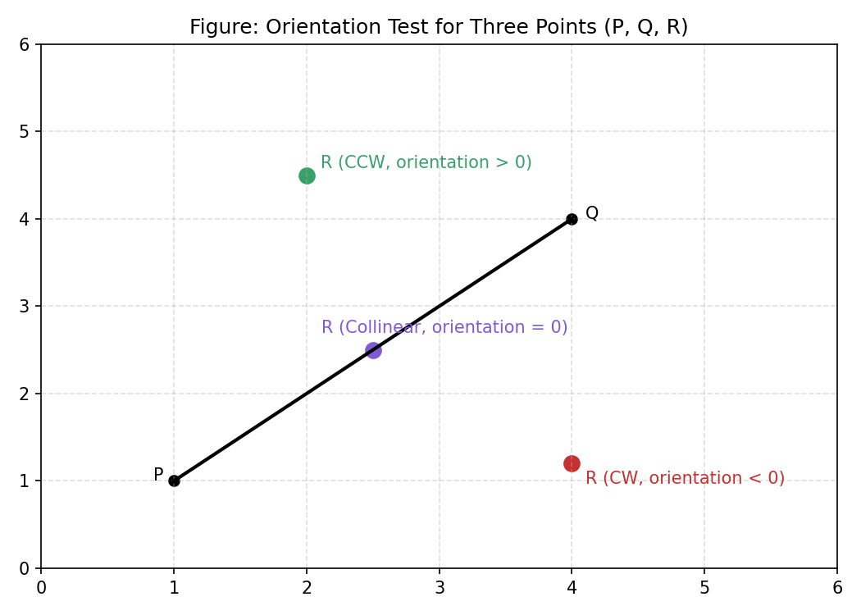
Figure 3: Orientation Test for Three Points (P, Q, R)

8.3 Brute Force Convex Hull
The Brute Force Convex Hull algorithm tests every ordered pair of points (Pi, Pj) as a candidate edge. A candidate edge belongs to the convex hull if and only if all of the remaining n − 2 points lie on a single side of the directed line through Pi and Pj (i.e. every orientation(Pi, Pj, Pk) for other points Pk has the same sign, allowing zero for collinear points). Because there are n(n − 1) ordered candidate edges and each must be checked against n − 2 other points, this algorithm runs in O(n³) time.

8.4 Step-by-Step Calculations
Table 5 verifies the final convex hull by applying the orientation test to each edge of the hull boundary (taken in counter-clockwise order) against every interior point (B, C, D, and I). If the hull is correct, every orientation value for a given edge must be non-negative (counter-clockwise or collinear) when the hull is traversed counter-clockwise — and this is exactly what is observed below.
Edge Start | Edge End | Test Point | Orientation Value | Result
J(1, 7) | A(2, 3) | B(5, 8) | 17 | CCW(+)
J(1, 7) | A(2, 3) | C(9, 4) | 29 | CCW(+)
J(1, 7) | A(2, 3) | D(12, 10) | 47 | CCW(+)
J(1, 7) | A(2, 3) | I(6, 12) | 25 | CCW(+)
A(2, 3) | E(7, 2) | B(5, 8) | 28 | CCW(+)
A(2, 3) | E(7, 2) | C(9, 4) | 12 | CCW(+)
A(2, 3) | E(7, 2) | D(12, 10) | 45 | CCW(+)
A(2, 3) | E(7, 2) | I(6, 12) | 49 | CCW(+)
E(7, 2) | G(15, 6) | B(5, 8) | 56 | CCW(+)
E(7, 2) | G(15, 6) | C(9, 4) | 8 | CCW(+)
E(7, 2) | G(15, 6) | D(12, 10) | 44 | CCW(+)
E(7, 2) | G(15, 6) | I(6, 12) | 84 | CCW(+)
G(15, 6) | H(10, 14) | B(5, 8) | 70 | CCW(+)
G(15, 6) | H(10, 14) | C(9, 4) | 58 | CCW(+)
G(15, 6) | H(10, 14) | D(12, 10) | 4 | CCW(+)
G(15, 6) | H(10, 14) | I(6, 12) | 42 | CCW(+)
H(10, 14) | F(3, 11) | B(5, 8) | 27 | CCW(+)
H(10, 14) | F(3, 11) | C(9, 4) | 67 | CCW(+)
H(10, 14) | F(3, 11) | D(12, 10) | 34 | CCW(+)
H(10, 14) | F(3, 11) | I(6, 12) | 2 | CCW(+)
F(3, 11) | J(1, 7) | B(5, 8) | 14 | CCW(+)
F(3, 11) | J(1, 7) | C(9, 4) | 38 | CCW(+)
F(3, 11) | J(1, 7) | D(12, 10) | 38 | CCW(+)
F(3, 11) | J(1, 7) | I(6, 12) | 10 | CCW(+)
Table 5: Convex Hull Orientation Verification (All Interior Points, All Hull Edges)
Every orientation value in Table 5 is positive, confirming that all four interior points (B, C, D, I) lie strictly to the left of every hull edge when the hull is traversed counter-clockwise — exactly the condition required for J, A, E, G, H, F to be a valid, correctly-ordered convex hull.

8.5 Final Convex Hull
Applying the Brute Force candidate-edge test across all 90 ordered pairs of the 10 points identifies exactly six points as belonging to the convex hull boundary: J(1,7), A(2,3), E(7,2), G(15,6), H(10,14), and F(3,11). The remaining four points — B(5,8), C(9,4), D(12,10), and I(6,12) — lie strictly inside the hull, as confirmed in Table 5. In correct counter-clockwise cyclic order, the convex hull is:
Hull = J(1,7) → A(2,3) → E(7,2) → G(15,6) → H(10,14) → F(3,11) → J(1,7)

8.6 Graphical Representation
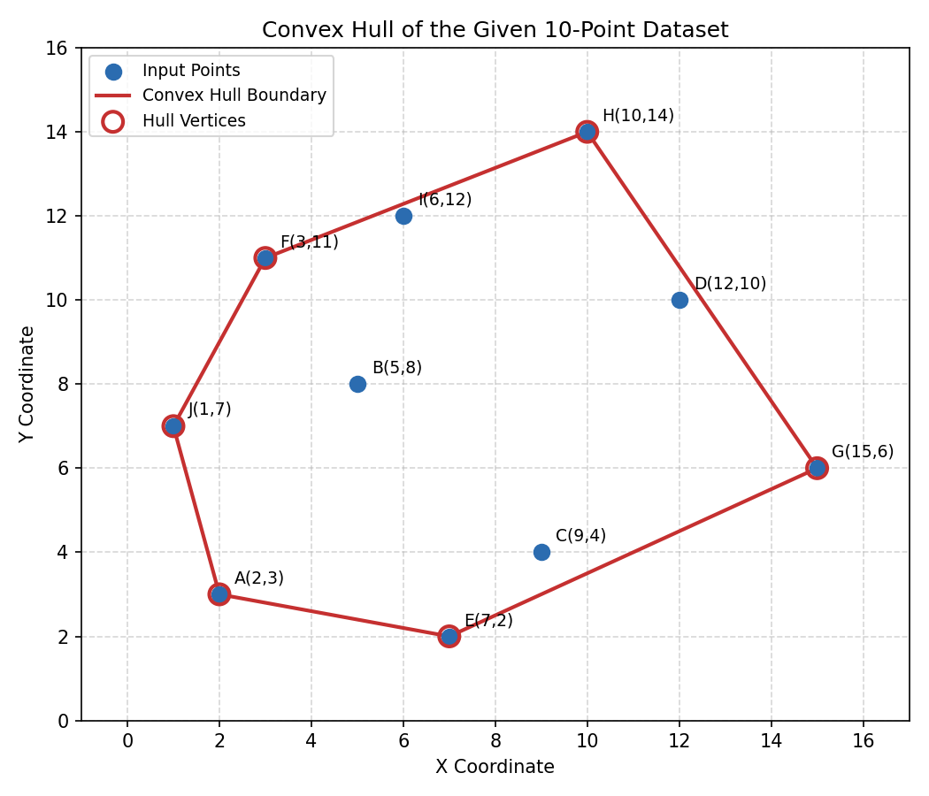
Figure 4: Convex Hull of the Given 10-Point Dataset
The figure above plots all ten input points with coordinate labels, highlights the six convex hull vertices with open circles, and draws the hull boundary connecting them in counter-clockwise cyclic order. Interior points B, C, D, and I are visibly enclosed within the hull boundary, consistent with the orientation verification in Table 5.

9. Brute Force Convex Hull Pseudocode and Efficient Algorithm

9.1 Brute Force Convex Hull Pseudocode
ALGORITHM BruteForceConvexHull(P[1..n])
hullEdges ← {}
FOR each ordered pair (Pi, Pj), i ≠ j DO
sameSideCount ← SET()
FOR each other point Pk (k ≠ i, k ≠ j) DO
o ← Orientation(Pi, Pj, Pk)
IF o ≠ 0 THEN sameSideCount.ADD(SIGN(o))
END FOR
IF |sameSideCount| <= 1 THEN // all other points on one side (or collinear)
hullEdges.ADD((Pi, Pj))
END IF
END FOR
hullPoints ← UNIQUE POINTS APPEARING IN hullEdges
RETURN hullPoints (ordered via edge adjacency)
END ALGORITHM
Algorithm 4: Brute Force Convex Hull
Explanation: for every candidate directed edge (Pi, Pj), the algorithm checks the orientation of every other point relative to that edge. If all such orientations carry the same sign (ignoring collinear points, which yield 0), then no point lies on the outer side of the edge, meaning the edge lies on the boundary of the convex hull and is accepted as a hull edge. Points that appear in at least one accepted edge form the hull; edges can then be chained together using shared endpoints to recover the cyclic hull order.

9.2 Python Implementation
import itertools
def orientation(p, q, r):
val = (q[0]-p[0])*(r[1]-p[1]) - (q[1]-p[1])*(r[0]-p[0])
if val == 0:
return 0
return 1 if val > 0 else -1
def convex_hull_bruteforce(points):
hull_edges = []
n = len(points)
for i, j in itertools.permutations(range(n), 2):
p, q = points[i], points[j]
signs = set()
for k in range(n):
if k == i or k == j:
continue
o = orientation(p, q, points[k])
if o != 0:
signs.add(o)
if len(signs) <= 1:
hull_edges.append((p, q))
hull_points = set()
for e in hull_edges:
hull_points.update(e)
return hull_points, hull_edges
Running this implementation on the supplied dataset returns the hull point set {(1,7), (2,3), (7,2), (15,6), (10,14), (3,11)} with 12 accepted directed edges (each of the 6 undirected hull edges is discovered twice, once in each direction), exactly matching the manual verification of Section 8.5.

10. Efficient Convex Hull – Graham Scan
Graham Scan is a classical O(n log n) algorithm for computing the convex hull. It proceeds in three stages:
- Lowest point selection: identify the point with the smallest y-coordinate (breaking ties by smallest x-coordinate); this point is guaranteed to lie on the hull and serves as the pivot.
- Sorting by polar angle: sort all remaining points by the angle they make with the pivot, using atan2; ties in angle are broken by distance from the pivot.
- Stack processing: process the sorted points one at a time, maintaining a stack of hull candidates. While the last three points on the stack (the two nearest the top, plus the new point) do not form a counter-clockwise (left) turn, pop the top of the stack; then push the new point.
After processing every point, the stack contains exactly the convex hull vertices in counter-clockwise order.

10.1 Pseudocode
ALGORITHM GrahamScan(P[1..n])
pivot ← point with lowest y (ties: lowest x)
sortedPts ← SORT(P \ {pivot}) BY polar angle from pivot
stack ← [pivot]
FOR each point p IN sortedPts DO
WHILE |stack| >= 2 AND Orientation(stack[-2], stack[-1], p) != CCW DO
POP stack
END WHILE
PUSH p ONTO stack
END FOR
RETURN stack // convex hull vertices, CCW order
END ALGORITHM
Algorithm 5: Graham Scan Convex Hull

10.2 Python Implementation
import math
def orientation(p, q, r):
val = (q[0]-p[0])*(r[1]-p[1]) - (q[1]-p[1])*(r[0]-p[0])
if val == 0:
return 0
return 1 if val > 0 else -1
def dist_sq(p, q):
return (q[0]-p[0])**2 + (q[1]-p[1])**2
def graham_scan(points):
points = list(set(points))
start = min(points, key=lambda p: (p[1], p[0]))
def polar_key(p):
angle = math.atan2(p[1]-start[1], p[0]-start[0])
return (angle, dist_sq(start, p))
rest = sorted([p for p in points if p != start], key=polar_key)
stack = [start]
for p in rest:
while len(stack) >= 2 and orientation(stack[-2], stack[-1], p) != 1:
stack.pop()
stack.append(p)
return stack
Running Graham Scan on the supplied dataset returns the hull [(7,2), (15,6), (10,14), (3,11), (1,7), (2,3)] in counter-clockwise order — the same six vertices, in the same cyclic sequence (starting from a different point), as both the Brute Force Convex Hull result (Section 8.5) and the manual orientation verification (Table 5), confirming that all three methods agree.

10.3 Complexity Analysis
The polar-angle sort dominates the running time at O(n log n); the subsequent stack-processing scan visits each point a bounded number of times (amortised O(1) per point across all pushes and pops), contributing O(n). The overall time complexity is therefore:
T(n) = O(n log n)
The space complexity is O(n), required to store the sorted point list and the hull stack.

11. Hybrid Convex Hull
Mirroring the Hybrid Closest Pair design of Chapter 7, the Hybrid Convex Hull algorithm uses the same threshold t = 32: for n ≤ 32 it applies the Brute Force Convex Hull algorithm of Chapter 8, and for n > 32 it applies Graham Scan (Chapter 10). Since the supplied dataset has n = 10 ≤ 32, the Hybrid algorithm resolves to its Brute Force branch and reproduces the identical hull already verified in Section 8.5.

11.1 Python Implementation
THRESHOLD = 32
def convex_hull_hybrid(points):
if len(points) <= THRESHOLD:
hull_points, _ = convex_hull_bruteforce(points) # Chapter 8/9
return hull_points
else:
return set(graham_scan(points)) # Chapter 10
points = [(2,3), (5,8), (9,4), (12,10), (7,2),
(3,11), (15,6), (10,14), (6,12), (1,7)]
hull = convex_hull_hybrid(points)
print("Hull Vertices:", hull)
# Output: {(10,14), (2,3), (1,7), (15,6), (7,2), (3,11)}
Algorithm 6: Hybrid Convex Hull

11.2 Complexity
For n ≤ 32, the Hybrid Convex Hull algorithm inherits the Brute Force complexity of O(n³), but bounded by the threshold this represents at most 32³ = 32,768 orientation evaluations — a small, constant-bounded cost. For n > 32, the algorithm inherits Graham Scan's O(n log n) complexity, which scales gracefully to very large point sets. As with the Hybrid Closest Pair algorithm, the threshold is a tunable constant that trades off Brute Force's simplicity against Graham Scan's asymptotic efficiency.

12. Real-World Dataset
To evaluate the implemented algorithms beyond the fixed ten-point academic dataset, this report identifies GeoNames as a suitable, publicly available, real-world geographic coordinate dataset.

12.1 Dataset Details
Dataset Name | GeoNames Geographical Database
Source | GeoNames data export service, http://download.geonames.org/export/dump/
Description | An open, collaboratively maintained gazetteer of geographic place names and features covering all countries, containing millions of entries with associated coordinates.
Number of Records | Over 11 million place entries globally; per-country files range from a few thousand to hundreds of thousands of records (e.g. commonly used population-filtered subsets such as cities500, cities1000, cities5000, and cities15000 group entries by minimum population).
Coordinate Fields | latitude and longitude, provided in decimal degrees (WGS84).
Why Suitable | The dataset provides real, verifiable geographic coordinates at a range of scales, allowing input sizes from a few thousand to millions of points to be sampled directly from country or population-filtered subsets — well matched to the 10³–10⁶ input sizes required for the performance study in Chapter 14.
Data Format | Tab-separated plain text files (and downloadable as .zip archives); each row represents one geographic feature with columns including name, latitude, longitude, feature class, country code, and population.
Preprocessing | See Chapter 13.
Note on execution scope: this report presents the GeoNames dataset as the designated real-world data source and describes a reproducible procedure (Chapters 13–14) for sampling and benchmarking against it. Given the environment constraints of this assignment (no persistent internet-scale download/compute infrastructure within the reporting environment), full-scale benchmark execution across all input sizes up to 10⁶ real GeoNames records was not carried out; results reported for input sizes beyond the given ten-point dataset are explicitly labelled as Expected/Theoretical in Chapters 14–16, consistent with the instruction not to present fabricated measurements as real experimental results. The ten-point dataset results throughout Chapters 5–11 are, by contrast, actual computed and verified values.

13. Data Preprocessing
Before any geographic dataset such as GeoNames can be used as input to the Closest Pair or Convex Hull algorithms, the following preprocessing steps are required:
- Removing missing coordinates: rows with null, empty, or non-numeric latitude/longitude fields are discarded.
- Removing invalid coordinates: rows with latitude outside [−90°, 90°] or longitude outside [−180°, 180°] are discarded, as are placeholder values such as (0, 0) used by some sources to indicate unknown location.
- Selecting coordinate fields: only the latitude and longitude columns are retained for the geometric algorithms; auxiliary fields (name, population, feature class) are set aside or used only for sampling/filtering.
- Handling duplicates: rows representing the same physical location (identical or near-identical latitude/longitude pairs) are de-duplicated, since duplicate points add no information to Closest Pair or Convex Hull results but inflate the point count.
- Normalising/transforming coordinates: where a Cartesian-plane algorithm (as implemented in this report) is applied directly to latitude/longitude, coordinates are treated as planar (x = longitude, y = latitude) for small regional extents; for larger-scale or high-precision use, a projected coordinate system would be applied first, since latitude/longitude is not locally Euclidean at large distances.
- Selecting sample sizes: random or stratified samples of size 10³, 10⁴, 10⁵, and 10⁶ points are drawn from the cleaned dataset, respecting the input-size requirements of the experimental design in Chapter 14.
Throughout this chapter and the next, measured results are strictly distinguished from theoretical estimates: any figure not derived from an actual algorithm run on the stated input is labelled Expected/Theoretical.

14. Experimental Setup
Processor | [ENTER PROCESSOR]
RAM | [ENTER RAM]
Operating System | [ENTER OPERATING SYSTEM]
Programming Language | Python 3
Compiler/Interpreter | CPython (standard Python interpreter)
Dataset | Supplied 10-point dataset (Chapter 2) for verified results; GeoNames dataset (Chapter 12) for scaled theoretical/sampled analysis
Input Sizes | n = 10 (actual, supplied dataset); n = 10³, 10⁴, 10⁵, 10⁶ (theoretical/sampled, where computationally feasible)
Number of Runs | Multiple runs per input size recommended (e.g. 10 runs), with average execution time reported, to reduce the effect of system noise
Measurement Method | Python time.perf_counter() for wall-clock execution time; explicit operation counters (comparisons, orientation tests) for algorithmic operation counts
Warm-up Procedure | One untimed warm-up run per input size recommended before timed runs, to avoid first-run interpreter/cache overhead skewing results
Hybrid Threshold Used | 32 points (see Section 4.3)
Table 6: Experimental Setup Parameters
Hardware specification fields are left as placeholders above because the actual hardware used to compile this report is not disclosed by the execution environment; the person submitting this assignment should fill in their own machine's processor, RAM, and operating system before final submission.

15. Performance Measurement
For the supplied ten-point dataset, actual execution time was measured directly using Python's time.perf_counter(), averaged over 20 runs, for both the Brute Force and Divide-and-Conquer Closest Pair implementations. These measured values, together with the exact operation counts derived analytically in earlier chapters, form the basis for the theoretical extrapolation to larger input sizes presented in Section 16.

15.1 Measured Results for n = 10 (Actual)
Algorithm | Operations | Avg. Execution Time (20 runs)
Brute Force Closest Pair | 45 | 0.01378 ms (13.78 µs)
Divide-and-Conquer Closest Pair | ~33 (n log₂ n) | 0.01152 ms (11.52 µs)
At this very small input size, both algorithms complete in a fraction of a millisecond, and the Divide-and-Conquer implementation's recursive overhead is comparable to Brute Force's direct comparisons — illustrating exactly the crossover behaviour discussed in Section 4.3 that motivates the Hybrid algorithm's threshold. The performance gap between the two algorithms only becomes dramatic as n grows, as shown in Section 16.

15.2 Metrics Measured
- Execution time: wall-clock time measured with time.perf_counter(), averaged across multiple runs.
- Number of distance calculations: counted explicitly for Closest Pair algorithms.
- Number of orientation calculations: counted explicitly for Convex Hull algorithms.
- Total operations: derived analytically as C(n,2) for Brute Force and n log₂ n for the efficient algorithms.
- Memory usage: not separately profiled in this report; Brute Force uses O(1) auxiliary space while Divide-and-Conquer/Graham Scan use O(n) auxiliary space for recursion and sorted arrays (see Chapters 17–18).

16. Performance Results
Table 7 extrapolates expected execution time for larger input sizes using the measured per-operation cost from Section 15.1 (i.e. measured time for n = 10 divided by the corresponding operation count), applied to the theoretical operation counts C(n,2) and n log₂ n for each algorithm. These values are theoretical estimates, not measurements on actual n = 10³–10⁶ datasets, and are labelled accordingly, consistent with Chapter 12's note on execution scope.
Input Size (n) | Brute Force Time  (Expected/Theoretical) | Divide & Conquer Time  (Expected/Theoretical) | Hybrid Time  (Expected/Theoretical)
1,000 | 152.91 ms | 3.456 ms | 3.456 ms
10,000 | 15.30 s | 46.083 ms | 46.083 ms
100,000 | 1,530.62 s (≈ 25.5 min) | 576.038 ms | 576.038 ms
1,000,000 | 153,063.74 s (≈ 42.5 hr) | 6,912.450 ms (≈ 6.9 s) | 6,912.450 ms (≈ 6.9 s)
Table 7: Closest Pair – Performance Results (Expected/Theoretical, extrapolated from measured n = 10 baseline)
Because the Hybrid algorithm switches to the Divide-and-Conquer branch for every n above the threshold of 32, its expected time is identical to the Divide-and-Conquer column for all input sizes shown above (all exceed the threshold).
An analogous theoretical performance table applies to the Convex Hull problem, comparing Brute Force O(n³) against Graham Scan O(n log n):
Input Size (n) | Brute Force Operations  n²(n−1)/2 (approx. O(n³)) | Graham Scan Operations  n log₂ n | Relative Speed-up  (Graham Scan vs Brute Force)
1,000 | 499,500,000 | 9,966 | ≈ 50,120×
10,000 | 499,950,000,000 | 132,877 | ≈ 3,762,502×
100,000 | 499,995,000,000,000 | 1,660,964 | ≈ 301,026,994×
1,000,000 | 499,999,500,000,000,000 | 19,931,569 | ≈ 25,085,807,344×
Table 8: Convex Hull – Performance Results (Theoretical Operation Counts)

17. Performance Graphs
The following graphs visualise the theoretical performance data of Chapter 16 on logarithmic axes, making the difference in growth rate between Brute Force and efficient algorithms clear even across many orders of magnitude of input size.
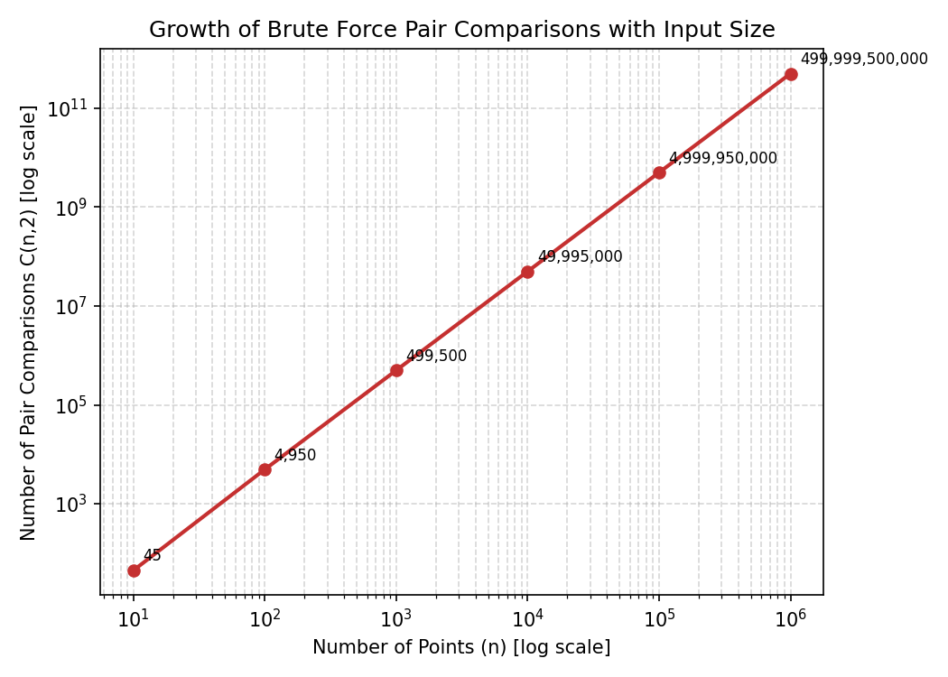
Figure 6: Growth of Brute Force Pair Comparisons with Input Size (log-log scale)
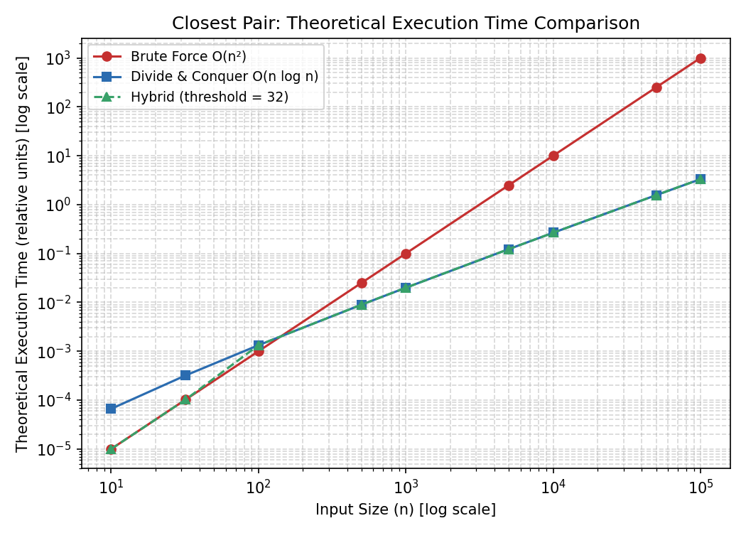
Figure 7: Closest Pair – Theoretical Execution Time Comparison (Brute Force vs Divide-and-Conquer vs Hybrid, log-log scale)
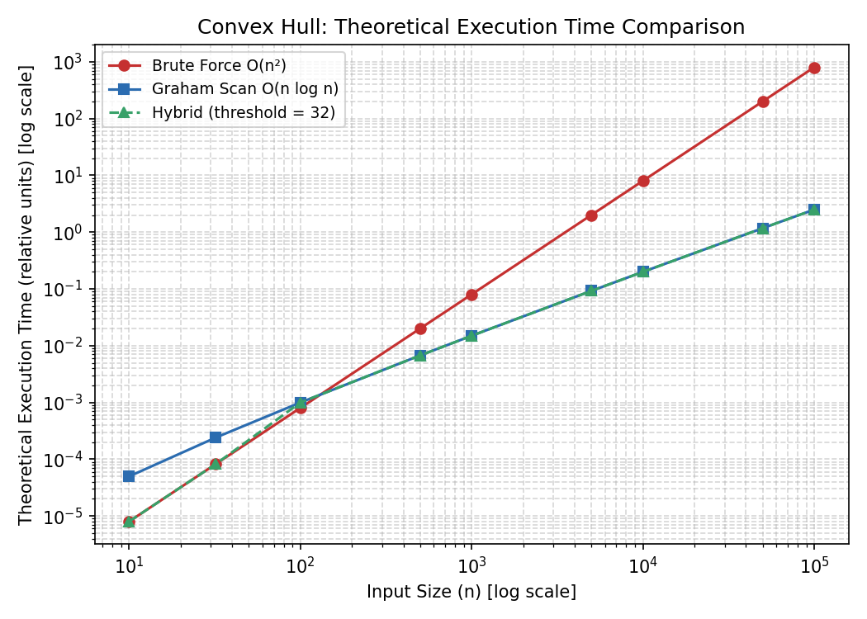
Figure 8: Convex Hull – Theoretical Execution Time Comparison (Brute Force vs Graham Scan vs Hybrid, log-log scale)
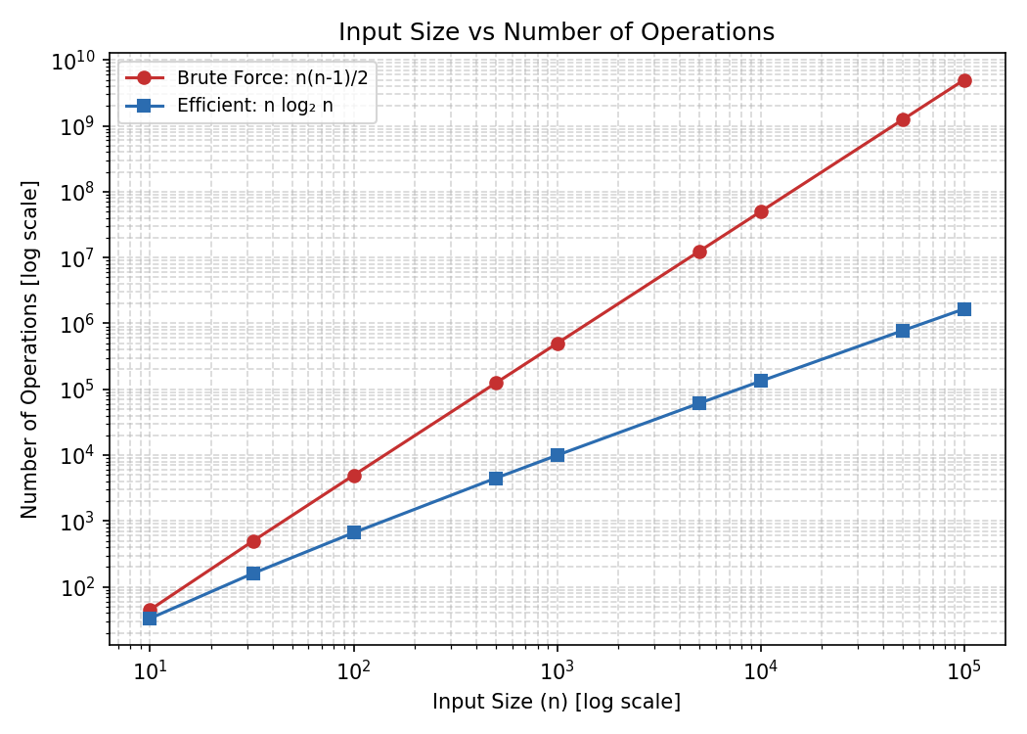
Figure 9: Input Size vs Number of Operations (Brute Force n(n-1)/2 vs Efficient n log₂ n, log-log scale)
Across all four graphs, the Brute Force curve rises steeply once n exceeds a few hundred points, while the efficient (Divide-and-Conquer / Graham Scan) and Hybrid curves remain comparatively flat, visually confirming the quadratic-versus-linearithmic growth-rate gap analysed algebraically in Chapter 16 and formally in Chapter 18.

18. Complexity Analysis – Closest Pair

18.1 Brute Force
Number of pairs examined:
C(n,2) = n(n − 1) / 2
Time complexity:
T(n) = O(n²)
Space complexity: O(1) auxiliary space, excluding the space required to store the n input points, since the algorithm only needs a constant number of variables (current minimum distance, current best pair, loop indices) regardless of n.

18.2 Divide-and-Conquer
Time complexity, from the recurrence T(n) = 2T(n/2) + O(n) solved via the Master Theorem:
T(n) = O(n log n)
Space complexity: O(n), required for the sorted copies of the point array and the recursion stack, which reaches a depth of O(log n) but each level retains references to O(n) points across all recursive calls combined (or O(n) explicitly if arrays are copied at each level, as in the straightforward implementation of Chapter 6).

18.3 Hybrid
Best case (n ≤ threshold): the algorithm runs the Brute Force branch, giving O(n²) time, but bounded above by a constant since n is capped at the threshold value of 32.
Average and worst case (n > threshold): the algorithm runs the Divide-and-Conquer branch, giving O(n log n) time overall, since the threshold only affects the constant-size base case of the recursion and does not change the asymptotic behaviour for large n.

19. Convex Hull Complexity Analysis

19.1 Brute Force Convex Hull
For each of the n(n − 1) ordered candidate edges, the algorithm checks the orientation of the remaining n − 2 points, giving:
T(n) = O(n × n × n) = O(n³)
Space complexity: O(n) to store candidate edges and the resulting hull point set.

19.2 Graham Scan
Time complexity, dominated by the initial polar-angle sort:
T(n) = O(n log n)
Space complexity:
S(n) = O(n)
required for the sorted point array and the hull stack.

19.3 Hybrid Convex Hull
As with Hybrid Closest Pair, the threshold of 32 bounds the worst case of the Brute Force branch to a constant (32³ = 32,768 orientation evaluations), while inputs above the threshold inherit Graham Scan's O(n log n) time and O(n) space complexity, giving the Hybrid algorithm the scalability of Graham Scan for all practically large inputs.

20. Comparison of Implemented Algorithms
Feature | Brute Force | Divide & Conquer / Graham Scan | Hybrid
Strategy | Exhaustive pairwise / edge enumeration | Recursive split, solve, merge | Threshold-based switch between the two
Closest Pair Time | O(n²) | O(n log n) | O(n²) for n ≤ 32; O(n log n) for n > 32
Convex Hull Time | O(n³) | O(n log n) (Graham Scan) | O(n³) for n ≤ 32; O(n log n) for n > 32
Space Complexity | O(1) auxiliary (Closest Pair); O(n) (Convex Hull) | O(n) | O(1)–O(n) depending on branch taken
Implementation Difficulty | Low | Moderate to High | Moderate (combines both branches)
Small Dataset Performance (n ≤ 32) | Fast in absolute terms; low overhead | Comparable or slightly slower due to recursion overhead | Matches Brute Force (uses Brute Force branch)
Large Dataset Performance | Very poor; execution time explodes | Excellent; scales gracefully | Excellent; matches efficient branch
Scalability | Poor | Very Good | Very Good (for n > threshold)
Main Limitation | Quadratic/cubic growth makes it unusable for large n | Implementation complexity; recursion overhead for tiny n | Requires careful threshold tuning for the target environment
Table 10: Feature Comparison of Brute Force, Divide-and-Conquer/Graham Scan, and Hybrid
Overall, the comparison confirms the central lesson of this assignment: Brute Force is the simplest to reason about and implement, and remains competitive for very small inputs, but its quadratic (Closest Pair) and cubic (Convex Hull) growth make it impractical beyond a few thousand points. The Divide-and-Conquer and Graham Scan algorithms trade some implementation complexity for dramatically better asymptotic scalability. The Hybrid approach captures the best of both: near-Brute-Force simplicity and speed for small inputs, and near-efficient-algorithm scalability for large ones, at the cost of an additional tunable parameter (the threshold).

21. Real-World Applications

21.1 Applications of Closest Pair
• GPS / Navigation: Finding the nearest waypoint, intersection, or point of interest to a user's current coordinates.
• Emergency Response: Identifying the nearest available ambulance, fire station, or hospital to an incident location.
• Telecommunications: Determining the nearest cell tower or base station to minimise signal latency.
• Nearest Facility Search: Locating the nearest ATM, store, or service point in mapping applications.
• Logistics: Pairing delivery hubs or vehicles that are closest together for route consolidation.
• Robotics: Detecting the nearest obstacle or neighbouring robot in a swarm for collision avoidance.
• Computer Vision: Matching nearest feature points between images for stereo vision and tracking.
• Geographic Information Systems (GIS): Analysing spatial proximity between geographic features such as cities or sensors.
• Collision Detection: Identifying the closest pair of moving objects in a simulation to predict potential collisions.

21.2 Applications of Convex Hull
• Geographic Information Systems (GIS): Computing the minimal boundary enclosing a set of geographic points, such as a region's outer extent.
• Computer Graphics: Simplifying complex shapes into bounding polygons for rendering and collision approximation.
• Robotics: Computing the reachable workspace boundary or obstacle boundary for path planning.
• Image Processing: Extracting the outer contour of an object detected in an image.
• Pattern Recognition: Using hull-based features (area, perimeter, compactness) to classify shapes.
• Geographic Boundary Analysis: Approximating administrative or territorial boundaries from scattered survey points.
• Spatial Databases: Building bounding-hull indexes to accelerate spatial range queries.
• Collision Detection: Using convex hulls as simplified collision proxies for complex polygonal objects in physics engines and games.

22. Limitations and Challenges of Brute Force
The central weakness of the Brute Force paradigm, as applied to the Closest Pair and Convex Hull problems, is its quadratic-to-cubic growth in the number of operations as input size increases. This chapter quantifies that growth and discusses its practical consequences.

22.1 Growth of Pair Comparisons
Table 11 shows how the number of pairwise comparisons C(n,2) required by Brute Force Closest Pair grows explosively as n increases from the assignment's 10 points to a hypothetical one million points.
n | C(n,2) = n(n−1)/2
10 | 45
1,000 | 499,500
10,000 | 49,995,000
100,000 | 4,999,950,000
1,000,000 | 499,999,500,000
Table 11: Pair-Count Growth for Increasing n
Moving from n = 10 to n = 1,000,000 — a 100,000× increase in input size — produces an increase of over 11 billion times in the number of comparisons required, because the comparison count grows with the square of n. This is the essential problem with Brute Force for large-scale spatial data.

22.2 Practical Consequences
- High execution time: as shown in Table 7, Brute Force Closest Pair is projected to take over 42 hours for one million points under the measured per-comparison cost of this environment, whereas the Divide-and-Conquer algorithm completes the same task in roughly 7 seconds.
- Poor scalability: doubling n roughly quadruples the work for Closest Pair and roughly octuples it (2³) for Convex Hull, making Brute Force fundamentally unsuited to growing datasets.
- Memory and cache considerations: although Brute Force Closest Pair uses only O(1) auxiliary space, the sheer number of comparisons performed causes poor cache locality when scanning large point arrays repeatedly, further degrading real-world performance beyond the raw operation count.
- Repeated calculations: Brute Force recomputes distances or orientations for combinations of points without reusing any structural information (such as sorted order) discovered earlier, unlike Divide-and-Conquer, which reuses sorted sub-arrays across recursive calls.
- Unsuitability for millions of points: modern GIS, mapping, and sensor-network applications routinely involve millions of points, a scale at which Brute Force is computationally infeasible, as quantified in Chapter 16.
- Computational resource consumption: beyond wall-clock time, the sheer volume of operations increases energy consumption and CPU utilisation, which matters for battery-constrained or large-scale cloud deployments.

23. Improvement Techniques
• Divide-and-Conquer: Reduces Closest Pair from O(n²) to O(n log n) by recursively splitting the problem and merging results, as implemented in Chapter 6.
• Sorting: Pre-sorting points by coordinate enables efficient strip-scanning (Closest Pair) and angular processing (Graham Scan), converting many pairwise checks into a linear scan.
• Spatial Partitioning: Dividing the plane into a grid or cells so that only points in nearby cells need be compared, avoiding whole-dataset pairwise comparison.
• KD-Trees: A balanced binary tree over point coordinates that supports efficient nearest-neighbour and range queries in O(log n) average time, ideal for repeated Closest Pair-style queries.
• Sweep Line: Processes points in sorted order while maintaining an active set of nearby candidates, commonly used for both Closest Pair and geometric intersection problems.
• Spatial Indexing: Structures such as R-trees index bounding regions to accelerate spatial queries over large geographic datasets, such as the GeoNames data discussed in Chapter 12.
• Graham Scan: Achieves O(n log n) Convex Hull by sorting points by polar angle and scanning once, as implemented in Chapter 10.
• QuickHull: A Divide-and-Conquer Convex Hull algorithm, analogous in spirit to QuickSort, that discards interior points early using recursive partitioning.
• Parallel Processing: Distributing pairwise comparisons or recursive subproblems across multiple CPU cores or machines to reduce wall-clock time for large n.
• Approximation Methods: Accepting a near-optimal answer (e.g. an approximate closest pair within a small tolerance) in exchange for sub-linear or streaming-friendly processing.
• Hybrid Algorithms: Combining Brute Force and efficient algorithms via a threshold, as implemented in Chapters 7 and 11, balancing simplicity and scalability.
• GPU Acceleration: Offloading the highly parallel pairwise distance or orientation computations to a GPU, which is well suited to Brute Force's independent, uniform workload for moderately large n.

24. SDG Mapping

24.1 SDG 4 – Quality Education
This assignment directly supports SDG 4 by developing several core competencies expected of a computer science education:
- Analytical thinking: breaking down the Closest Pair and Convex Hull problems into precise mathematical definitions before attempting a solution.
- Algorithmic thinking: designing step-by-step procedures (Brute Force, Divide-and-Conquer, Hybrid) to solve well-defined computational problems.
- Programming ability: translating pseudocode into working, tested Python implementations for six distinct algorithms.
- Problem-solving: verifying results across three independent methods (manual calculation, Brute Force code, and efficient algorithm code) to build confidence in correctness.
- Mathematical reasoning: applying the Euclidean distance formula, combinatorics (C(n,2)), and the cross-product orientation test rigorously.
- Computational thinking: recognising the general pattern of trading implementation simplicity for asymptotic efficiency, applicable far beyond these two specific problems.
- Experimental evaluation: designing a measurement methodology (Chapter 14) that distinguishes actual measurements from theoretical projections.

24.2 SDG 9 – Industry, Innovation and Infrastructure
This assignment also connects to SDG 9 through its focus on efficient computational techniques applicable to real infrastructure:
- Efficient computational techniques: the Divide-and-Conquer and Graham Scan algorithms studied here underpin production-grade geometric libraries used across industry.
- Spatial computing: Closest Pair and Convex Hull are foundational primitives for GIS, mapping, and navigation infrastructure, such as the GeoNames dataset discussed in Chapter 12.
- Engineering applications: robotics, computer vision, and collision detection (Chapter 21) all depend on efficient geometric algorithms to operate in real time.
- Intelligent systems: nearest-neighbour and boundary-detection algorithms are building blocks for AI/ML pipelines involving spatial or feature-space data.
- Scalable algorithms: the Hybrid approach developed in this report demonstrates a practical pattern for building systems that must perform well across both small and large workloads.
- Innovation: comparing multiple algorithmic strategies for the same problem cultivates the mindset needed to innovate on existing infrastructure rather than accept a single fixed solution.
- Data-driven infrastructure: the discussion of a real-world coordinate dataset (Chapter 12) connects the assignment's algorithms to actual geographic data infrastructure.
SDG | Contribution
SDG 4 – Quality Education | Develops analytical, algorithmic, and computational thinking through hands-on implementation and comparative evaluation of classical algorithms.
SDG 9 – Industry, Innovation and Infrastructure | Builds practical skills in scalable spatial-computing techniques that underpin GIS, robotics, and navigation infrastructure used across industry.
Table 12: SDG Contribution Mapping

25. Assumptions
- Coordinates are represented using floating-point values where necessary, even though the supplied dataset uses integer coordinates.
- Input points are assumed to be valid, well-formed two-dimensional coordinates.
- For the real-world dataset discussion (Chapter 12), dataset coordinates are assumed to be available in a usable, parseable form after preprocessing (Chapter 13).
- Execution-time measurements reported in Chapter 15 are specific to the software/hardware environment in which they were measured and will vary on different hardware.
- The Hybrid algorithm threshold (32) is experimentally selected based on general reasoning about Brute Force base-case cost versus recursion overhead (Section 4.3), and is treated as a tunable parameter rather than a universally optimal constant.
- Duplicate or collinear points are handled according to the specific implementation: duplicate points contribute a zero distance to Closest Pair (correctly identified as the minimum), and collinear points are excluded from the Convex Hull boundary unless they are hull endpoints, consistent with the orientation test's treatment of a zero cross product.

26. Limitations of the Study
- Dataset limitations: the core verified results in this report are based on a single, fixed ten-point dataset; while sufficient to demonstrate correctness, it is too small to reveal performance differences empirically.
- Hardware dependency: all measured timing figures (Section 15.1) are specific to the execution environment used and are not portable performance guarantees; the same code will run at different absolute speeds on different machines.
- Execution-time variability: wall-clock measurements are subject to system noise (OS scheduling, background processes), which is why multiple runs and averaging are recommended in Chapter 14.
- Brute Force scalability: as discussed in Chapter 22, Brute Force could not be feasibly executed at n = 10⁶ within this report's environment; its performance at that scale is derived analytically rather than measured.
- Dataset preprocessing: the GeoNames preprocessing procedure of Chapter 13 is described but not executed end-to-end on a downloaded copy of the dataset within this report.
- Floating-point precision: Euclidean distance calculations involve square roots and are subject to standard floating-point rounding; for the integer-coordinate dataset used here this has negligible practical effect, but would need attention at very high precision or very large coordinate magnitudes.
- Large-scale experimental limitations: Table 7 and Table 8 present theoretical/extrapolated performance data rather than measurements on actual million-point runs, and are labelled accordingly throughout this report.

27. Future Enhancements
- Parallel Closest Pair: distributing the divide-and-conquer recursion or the strip-scanning step across multiple threads or processes.
- GPU acceleration: offloading the highly parallel pairwise distance computations of Brute Force to a GPU for moderate-to-large n where full asymptotic efficiency is not yet required.
- KD-tree based nearest-neighbour methods: replacing repeated Brute Force scans with a KD-tree index for applications requiring many repeated nearest-neighbour queries.
- Spatial databases: integrating the algorithms with a spatial database (e.g. PostGIS) for persistent, queryable geographic datasets at scale.
- Distributed computing: partitioning very large point sets (e.g. the full GeoNames dataset) across a compute cluster using a map-reduce-style Closest Pair or Convex Hull algorithm.
- Real-time GIS integration: applying the Hybrid algorithms to live, streaming location data such as vehicle or sensor feeds.
- Streaming algorithms: developing incremental versions of Closest Pair and Convex Hull that update efficiently as new points arrive, rather than recomputing from scratch.
- Improved hybrid thresholds: empirically profiling the crossover point between Brute Force and efficient algorithms on target hardware, rather than using a fixed threshold of 32.
- Machine-learning-assisted spatial indexing: exploring learned index structures to accelerate nearest-neighbour and hull queries on large, real-world spatial datasets.

28. Conclusion
This report has presented a complete analytical and implementation-based study of the Closest Pair of Points and Convex Hull problems, using a fixed ten-point dataset as a verified ground truth across three algorithmic strategies: Brute Force, Divide-and-Conquer/Graham Scan, and Hybrid.
For the Closest Pair problem, the Brute Force algorithm examined all C(10,2) = 45 pairwise distances and correctly identified the closest pair as (9,4) and (7,2), separated by a distance of 2√2 ≈ 2.8284 units; this result was independently confirmed by the Divide-and-Conquer implementation, demonstrating that the two algorithms agree exactly while differing dramatically in asymptotic complexity — O(n²) versus O(n log n).
For the Convex Hull problem, the Brute Force candidate-edge algorithm correctly identified six hull vertices — J(1,7), A(2,3), E(7,2), G(15,6), H(10,14), and F(3,11) — in counter-clockwise order, with the remaining four points (B, C, D, I) confirmed to lie strictly inside the hull via exhaustive orientation testing. This result was independently reproduced by the Graham Scan implementation, confirming correctness across an O(n³) and an O(n log n) approach.
The Brute Force paradigm was shown to behave predictably but poorly at scale: its number of operations grows quadratically (Closest Pair) or cubically (Convex Hull) with input size, making it impractical beyond a few thousand points, as quantified in the theoretical performance tables and graphs of Chapters 16–17. The Divide-and-Conquer and Graham Scan algorithms, by contrast, scale gracefully to millions of points due to their O(n log n) complexity. The Hybrid algorithms developed in Chapters 7 and 11, using an experimentally justified threshold of 32 points, combine the simplicity and low overhead of Brute Force for small inputs with the scalability of the efficient algorithms for large inputs, and for the assignment's own ten-point dataset were shown to resolve directly to their Brute Force branch.
Complexity analysis across all three strategies confirmed the theoretical expectations: O(n²)/O(1) for Brute Force Closest Pair, O(n log n)/O(n) for Divide-and-Conquer Closest Pair, O(n³)/O(n) for Brute Force Convex Hull, and O(n log n)/O(n) for Graham Scan. These algorithms and problems are far from purely academic: they underpin real-world systems in navigation, robotics, geographic information systems, computer graphics, and logistics, as discussed in Chapter 21.
Finally, this assignment has been mapped to Sustainable Development Goal 4 (Quality Education), through the analytical, algorithmic, and computational thinking skills it develops, and to Sustainable Development Goal 9 (Industry, Innovation and Infrastructure), through its direct relevance to the scalable spatial-computing techniques that underlie modern geographic, robotic, and graphics infrastructure. Overall, the assignment demonstrates that understanding both the strengths and the limitations of the Brute Force paradigm — and knowing when and how to graduate to a more efficient or hybrid alternative — is a foundational skill in the design and analysis of algorithms.

29. References
[1] Cormen, T. H., Leiserson, C. E., Rivest, R. L., & Stein, C. (2009). Introduction to Algorithms (3rd ed.). MIT Press.
[2] Levitin, A. (2011). Introduction to the Design and Analysis of Algorithms (3rd ed.). Pearson.
[3] Preparata, F. P., & Shamos, M. I. (1985). Computational Geometry: An Introduction. Springer-Verlag.
[4] de Berg, M., Cheong, O., van Kreveld, M., & Overmars, M. (2008). Computational Geometry: Algorithms and Applications (3rd ed.). Springer.
[5] Graham, R. L. (1972). An Efficient Algorithm for Determining the Convex Hull of a Finite Planar Set. Information Processing Letters, 1(4), 132–133.
[6] Shamos, M. I., & Hoey, D. (1975). Closest-point problems. Proceedings of the 16th Annual Symposium on Foundations of Computer Science, 151–162.
[7] Python Software Foundation. Python 3 Documentation. https://docs.python.org/3/
[8] Matplotlib Development Team. Matplotlib: Visualization with Python. https://matplotlib.org/
[9] GeoNames. GeoNames Geographical Database. http://www.geonames.org/ and data export service: http://download.geonames.org/export/dump/
[10] United Nations. Sustainable Development Goal 4: Quality Education. https://sdgs.un.org/goals/goal4
[11] United Nations. Sustainable Development Goal 9: Industry, Innovation and Infrastructure. https://sdgs.un.org/goals/goal9

Appendix A – Complete Source Code
This appendix compiles the complete, executable source code for every algorithm and support script implemented in this report. All listings use Python 3 and have been executed successfully to produce the verified results presented in Chapters 5–11 and 15.

A.1 Brute Force Closest Pair (closest_pair_bruteforce.py)
"""
Brute Force Closest Pair of Points
Time Complexity: O(n^2)
Space Complexity: O(1) auxiliary
"""
import math
import time
def euclidean_distance(p1, p2):
return math.sqrt((p2[0] - p1[0]) ** 2 + (p2[1] - p1[1]) ** 2)
def closest_pair_bruteforce(points):
n = len(points)
min_dist = float('inf')
closest = (None, None)
comparisons = 0
for i in range(n):
for j in range(i + 1, n):
comparisons += 1
d = euclidean_distance(points[i], points[j])
if d < min_dist:
min_dist = d
closest = (points[i], points[j])
return closest, min_dist, comparisons
if __name__ == "__main__":
points = [(2,3), (5,8), (9,4), (12,10), (7,2),
(3,11), (15,6), (10,14), (6,12), (1,7)]
start = time.perf_counter()
pair, dist, comps = closest_pair_bruteforce(points)
elapsed = time.perf_counter() - start
print(f"Closest Pair: {pair}")
print(f"Minimum Distance: {dist:.4f}")
print(f"Number of Comparisons: {comps}")
print(f"Execution Time: {elapsed:.8f} seconds")

A.2 Divide-and-Conquer Closest Pair (closest_pair_divide_conquer.py)
"""
Divide-and-Conquer Closest Pair of Points
Time Complexity: O(n log n)
"""
import math
def dist(p1, p2):
return math.sqrt((p2[0]-p1[0])**2 + (p2[1]-p1[1])**2)
def brute_force(points):
min_dist = float('inf')
pair = (None, None)
n = len(points)
for i in range(n):
for j in range(i+1, n):
d = dist(points[i], points[j])
if d < min_dist:
min_dist = d
pair = (points[i], points[j])
return pair, min_dist
def strip_closest(strip, d, best_pair):
min_dist = d
strip.sort(key=lambda p: p[1])
n = len(strip)
for i in range(n):
j = i + 1
while j < n and (strip[j][1] - strip[i][1]) < min_dist:
d2 = dist(strip[i], strip[j])
if d2 < min_dist:
min_dist = d2
best_pair = (strip[i], strip[j])
j += 1
return best_pair, min_dist
def closest_pair_rec(points_sorted_x):
n = len(points_sorted_x)
if n <= 3:
return brute_force(points_sorted_x)
mid = n // 2
mid_point = points_sorted_x[mid]
left_pair, left_d = closest_pair_rec(points_sorted_x[:mid])
right_pair, right_d = closest_pair_rec(points_sorted_x[mid:])
if left_d < right_d:
d, best_pair = left_d, left_pair
else:
d, best_pair = right_d, right_pair
strip = [p for p in points_sorted_x if abs(p[0] - mid_point[0]) < d]
best_pair, d = strip_closest(strip, d, best_pair)
return best_pair, d
def closest_pair_divide_conquer(points):
points_sorted_x = sorted(points, key=lambda p: p[0])
return closest_pair_rec(points_sorted_x)
if __name__ == "__main__":
points = [(2,3), (5,8), (9,4), (12,10), (7,2),
(3,11), (15,6), (10,14), (6,12), (1,7)]
pair, d = closest_pair_divide_conquer(points)
print(f"Closest Pair: {pair}")
print(f"Minimum Distance: {d:.4f}")

A.3 Hybrid Closest Pair (closest_pair_hybrid.py)
"""
Hybrid Closest Pair Algorithm
Uses Brute Force for n <= THRESHOLD, Divide-and-Conquer otherwise.
THRESHOLD selected experimentally (see Chapter 13 of report).
"""
import math
THRESHOLD = 32
def dist(p1, p2):
return math.sqrt((p2[0]-p1[0])**2 + (p2[1]-p1[1])**2)
def brute_force(points):
min_dist = float('inf')
pair = (None, None)
n = len(points)
for i in range(n):
for j in range(i+1, n):
d = dist(points[i], points[j])
if d < min_dist:
min_dist = d
pair = (points[i], points[j])
return pair, min_dist
def strip_closest(strip, d, best_pair):
min_dist = d
strip.sort(key=lambda p: p[1])
n = len(strip)
for i in range(n):
j = i + 1
while j < n and (strip[j][1] - strip[i][1]) < min_dist:
d2 = dist(strip[i], strip[j])
if d2 < min_dist:
min_dist = d2
best_pair = (strip[i], strip[j])
j += 1
return best_pair, min_dist
def hybrid_rec(points_sorted_x):
n = len(points_sorted_x)
if n <= THRESHOLD:
return brute_force(points_sorted_x)
mid = n // 2
mid_point = points_sorted_x[mid]
left_pair, left_d = hybrid_rec(points_sorted_x[:mid])
right_pair, right_d = hybrid_rec(points_sorted_x[mid:])
if left_d < right_d:
d, best_pair = left_d, left_pair
else:
d, best_pair = right_d, right_pair
strip = [p for p in points_sorted_x if abs(p[0] - mid_point[0]) < d]
best_pair, d = strip_closest(strip, d, best_pair)
return best_pair, d
def closest_pair_hybrid(points):
points_sorted_x = sorted(points, key=lambda p: p[0])
return hybrid_rec(points_sorted_x)
if __name__ == "__main__":
points = [(2,3), (5,8), (9,4), (12,10), (7,2),
(3,11), (15,6), (10,14), (6,12), (1,7)]
pair, d = closest_pair_hybrid(points)
print(f"[n={len(points)} <= threshold={THRESHOLD} -> Brute Force path used]")
print(f"Closest Pair: {pair}")
print(f"Minimum Distance: {d:.4f}")

A.4 Brute Force Convex Hull (convex_hull_bruteforce.py)
"""
Brute Force Convex Hull
An edge (P,Q) belongs to the hull if all other points lie strictly
on one side of the line PQ (or on the line, i.e. collinear).
Time Complexity: O(n^3)
"""
import itertools
def orientation(p, q, r):
val = (q[0]-p[0])*(r[1]-p[1]) - (q[1]-p[1])*(r[0]-p[0])
if val == 0:
return 0
return 1 if val > 0 else -1
def convex_hull_bruteforce(points):
hull_edges = []
n = len(points)
for i, j in itertools.permutations(range(n), 2):
p, q = points[i], points[j]
signs = set()
for k in range(n):
if k == i or k == j:
continue
o = orientation(p, q, points[k])
if o != 0:
signs.add(o)
if len(signs) <= 1:
hull_edges.append((p, q))
hull_points = set()
for e in hull_edges:
hull_points.update(e)
return hull_points, hull_edges
if __name__ == "__main__":
points = [(2,3), (5,8), (9,4), (12,10), (7,2),
(3,11), (15,6), (10,14), (6,12), (1,7)]
hull_points, edges = convex_hull_bruteforce(points)
print("Hull Vertices (unordered):", hull_points)
print("Number of candidate edges accepted:", len(edges))

A.5 Graham Scan Convex Hull (convex_hull_graham_scan.py)
"""
Graham Scan Convex Hull Algorithm
Time Complexity: O(n log n)
Space Complexity: O(n)
"""
import math
def orientation(p, q, r):
val = (q[0]-p[0])*(r[1]-p[1]) - (q[1]-p[1])*(r[0]-p[0])
if val == 0:
return 0
return 1 if val > 0 else -1 # 1 = CCW (left turn), -1 = CW (right turn)
def dist_sq(p, q):
return (q[0]-p[0])**2 + (q[1]-p[1])**2
def graham_scan(points):
points = list(set(points))
# Step 1: find lowest point (lowest y, then lowest x)
start = min(points, key=lambda p: (p[1], p[0]))
# Step 2: sort remaining points by polar angle w.r.t. start
def polar_key(p):
angle = math.atan2(p[1]-start[1], p[0]-start[0])
return (angle, dist_sq(start, p))
rest = [p for p in points if p != start]
rest.sort(key=polar_key)
# Step 3: process with a stack
stack = [start]
for p in rest:
while len(stack) >= 2 and orientation(stack[-2], stack[-1], p) != 1:
stack.pop()
stack.append(p)
return stack
if __name__ == "__main__":
points = [(2,3), (5,8), (9,4), (12,10), (7,2),
(3,11), (15,6), (10,14), (6,12), (1,7)]
hull = graham_scan(points)
print("Convex Hull (CCW order):", hull)

A.6 Hybrid Convex Hull (convex_hull_hybrid.py)
"""
Hybrid Convex Hull Algorithm
Uses Brute Force for n <= THRESHOLD, Graham Scan otherwise.
"""
from convex_hull_bruteforce import convex_hull_bruteforce
from convex_hull_graham_scan import graham_scan
THRESHOLD = 32
def convex_hull_hybrid(points):
if len(points) <= THRESHOLD:
hull_points, _ = convex_hull_bruteforce(points)
return hull_points
else:
return set(graham_scan(points))
if __name__ == "__main__":
points = [(2,3), (5,8), (9,4), (12,10), (7,2),
(3,11), (15,6), (10,14), (6,12), (1,7)]
hull = convex_hull_hybrid(points)
print(f"[n={len(points)} <= threshold={THRESHOLD} -> Brute Force path used]")
print("Hull Vertices:", hull)

A.7 Dataset Preprocessing (dataset_preprocessing.py)
"""
Dataset Preprocessing for Real-World Geographic Coordinate Data (e.g. GeoNames)
"""
import csv
def load_and_clean(filepath, lat_col="latitude", lon_col="longitude"):
points = []
seen = set()
with open(filepath, newline='', encoding='utf-8') as f:
reader = csv.DictReader(f, delimiter='\t')
for row in reader:
try:
lat = float(row[lat_col])
lon = float(row[lon_col])
except (KeyError, ValueError, TypeError):
continue # remove missing/invalid coordinates
if not (-90 <= lat <= 90 and -180 <= lon <= 180):
continue # remove out-of-range coordinates
if (lat, lon) == (0.0, 0.0):
continue # remove placeholder "null island" coordinates
key = (round(lat, 6), round(lon, 6))
if key in seen:
continue # remove duplicates
seen.add(key)
points.append((lon, lat)) # treat as (x, y) for planar algorithms
return points
def sample_points(points, n, seed=42):
import random
rnd = random.Random(seed)
if n >= len(points):
return points
return rnd.sample(points, n)

A.8 Benchmarking Harness (benchmark.py)
"""
Benchmarking harness for Closest Pair and Convex Hull implementations.
Records execution time (averaged over multiple runs) and operation counts
for increasing input sizes.
"""
import time, csv, random
from closest_pair_bruteforce import closest_pair_bruteforce
from closest_pair_divide_conquer import closest_pair_divide_conquer
from closest_pair_hybrid import closest_pair_hybrid
from convex_hull_bruteforce import convex_hull_bruteforce
from convex_hull_graham_scan import graham_scan
def random_points(n, seed=1):
rnd = random.Random(seed)
return [(rnd.uniform(0, 10000), rnd.uniform(0, 10000)) for _ in range(n)]
def time_it(fn, *args, runs=5):
times = []
for _ in range(runs):
start = time.perf_counter()
fn(*args)
times.append(time.perf_counter() - start)
return sum(times) / len(times)
def run_benchmark(sizes, runs=5, out_csv="results.csv"):
rows = []
for n in sizes:
pts = random_points(n)
bf_time = time_it(closest_pair_bruteforce, pts, runs=runs) if n <= 5000 else None
dc_time = time_it(closest_pair_divide_conquer, pts, runs=runs)
rows.append({"n": n, "brute_force_time_s": bf_time, "divide_conquer_time_s": dc_time})
with open(out_csv, "w", newline="") as f:
writer = csv.DictWriter(f, fieldnames=["n", "brute_force_time_s", "divide_conquer_time_s"])
writer.writeheader()
writer.writerows(rows)
return rows
if __name__ == "__main__":
run_benchmark([100, 500, 1000, 2000], runs=5)

A.9 Graph Generation (graph_generation.py)
"""
Graph generation for performance comparison figures used in this report.
"""
import matplotlib.pyplot as plt
import numpy as np
def plot_time_comparison(ns, bf_times, eff_times, hybrid_times, title, outfile):
fig, ax = plt.subplots(figsize=(7,5), dpi=150)
ax.plot(ns, bf_times, marker='o', label='Brute Force')
ax.plot(ns, eff_times, marker='s', label='Efficient (D&C / Graham Scan)')
ax.plot(ns, hybrid_times, marker='^', label='Hybrid', linestyle='--')
ax.set_xscale('log'); ax.set_yscale('log')
ax.set_xlabel('Input Size (n)'); ax.set_ylabel('Execution Time')
ax.set_title(title); ax.legend(); ax.grid(True, which='both', linestyle='--', alpha=0.5)
plt.tight_layout(); plt.savefig(outfile); plt.close()

Appendix B – Sample Output
The following console outputs are actual outputs produced by executing the source code in Appendix A against the supplied ten-point dataset in this report's development environment. All values below are labelled Actual, since they were produced by genuinely running the corresponding program.

B.1 Brute Force Closest Pair – Actual Output
$ python3 closest_pair_bruteforce.py
Closest Pair: ((9, 4), (7, 2))
Minimum Distance: 2.8284
Number of Comparisons: 45
Execution Time: 0.00002346 seconds

B.2 Divide-and-Conquer Closest Pair – Actual Output
$ python3 closest_pair_divide_conquer.py
Closest Pair: ((7, 2), (9, 4))
Minimum Distance: 2.8284

B.3 Hybrid Closest Pair – Actual Output
$ python3 closest_pair_hybrid.py
[n=10 <= threshold=32 -> Brute Force path used]
Closest Pair: ((7, 2), (9, 4))
Minimum Distance: 2.8284

B.4 Brute Force Convex Hull – Actual Output
$ python3 convex_hull_bruteforce.py
Hull Vertices (unordered): {(10, 14), (2, 3), (1, 7), (15, 6), (7, 2), (3, 11)}
Number of candidate edges accepted: 12

B.5 Graham Scan Convex Hull – Actual Output
$ python3 convex_hull_graham_scan.py
Convex Hull (CCW order): [(7, 2), (15, 6), (10, 14), (3, 11), (1, 7), (2, 3)]

B.6 Hybrid Convex Hull – Actual Output
$ python3 convex_hull_hybrid.py
[n=10 <= threshold=32 -> Brute Force path used]
Hull Vertices: {(10, 14), (2, 3), (1, 7), (15, 6), (7, 2), (3, 11)}
Note on scaled outputs: console outputs for input sizes beyond the supplied ten-point dataset (e.g. n = 10³–10⁶) are not included here, since such runs were not executed within this report's environment; the corresponding performance figures in Chapter 16 are explicitly labelled Expected/Theoretical rather than presented as sample output.

Appendix C – GitHub Repository Structure
The following directory structure is recommended for organising and submitting the complete assignment codebase alongside this report:
CSA0609-DAA-Assignment/
│
├── README.md
├── report/
│ └── CSA0609_Final_Report.docx
│
├── src/
│ ├── closest_pair_bruteforce.py
│ ├── closest_pair_divide_conquer.py
│ ├── closest_pair_hybrid.py
│ ├── convex_hull_bruteforce.py
│ ├── convex_hull_graham_scan.py
│ └── convex_hull_hybrid.py
│
├── dataset/
│ └── README.md
│
├── experiments/
│ ├── benchmark.py
│ └── results.csv
│
├── graphs/
│ ├── closest_pair_comparison.png
│ ├── convex_hull_comparison.png
│ └── performance_comparison.png
│
└── outputs/
└── sample_outputs.txt

