SCHOOL OF COMPUTING
DEPARTMENT OF ARTIFICIAL INTELLIGENCE AND MACHINE LEARNING

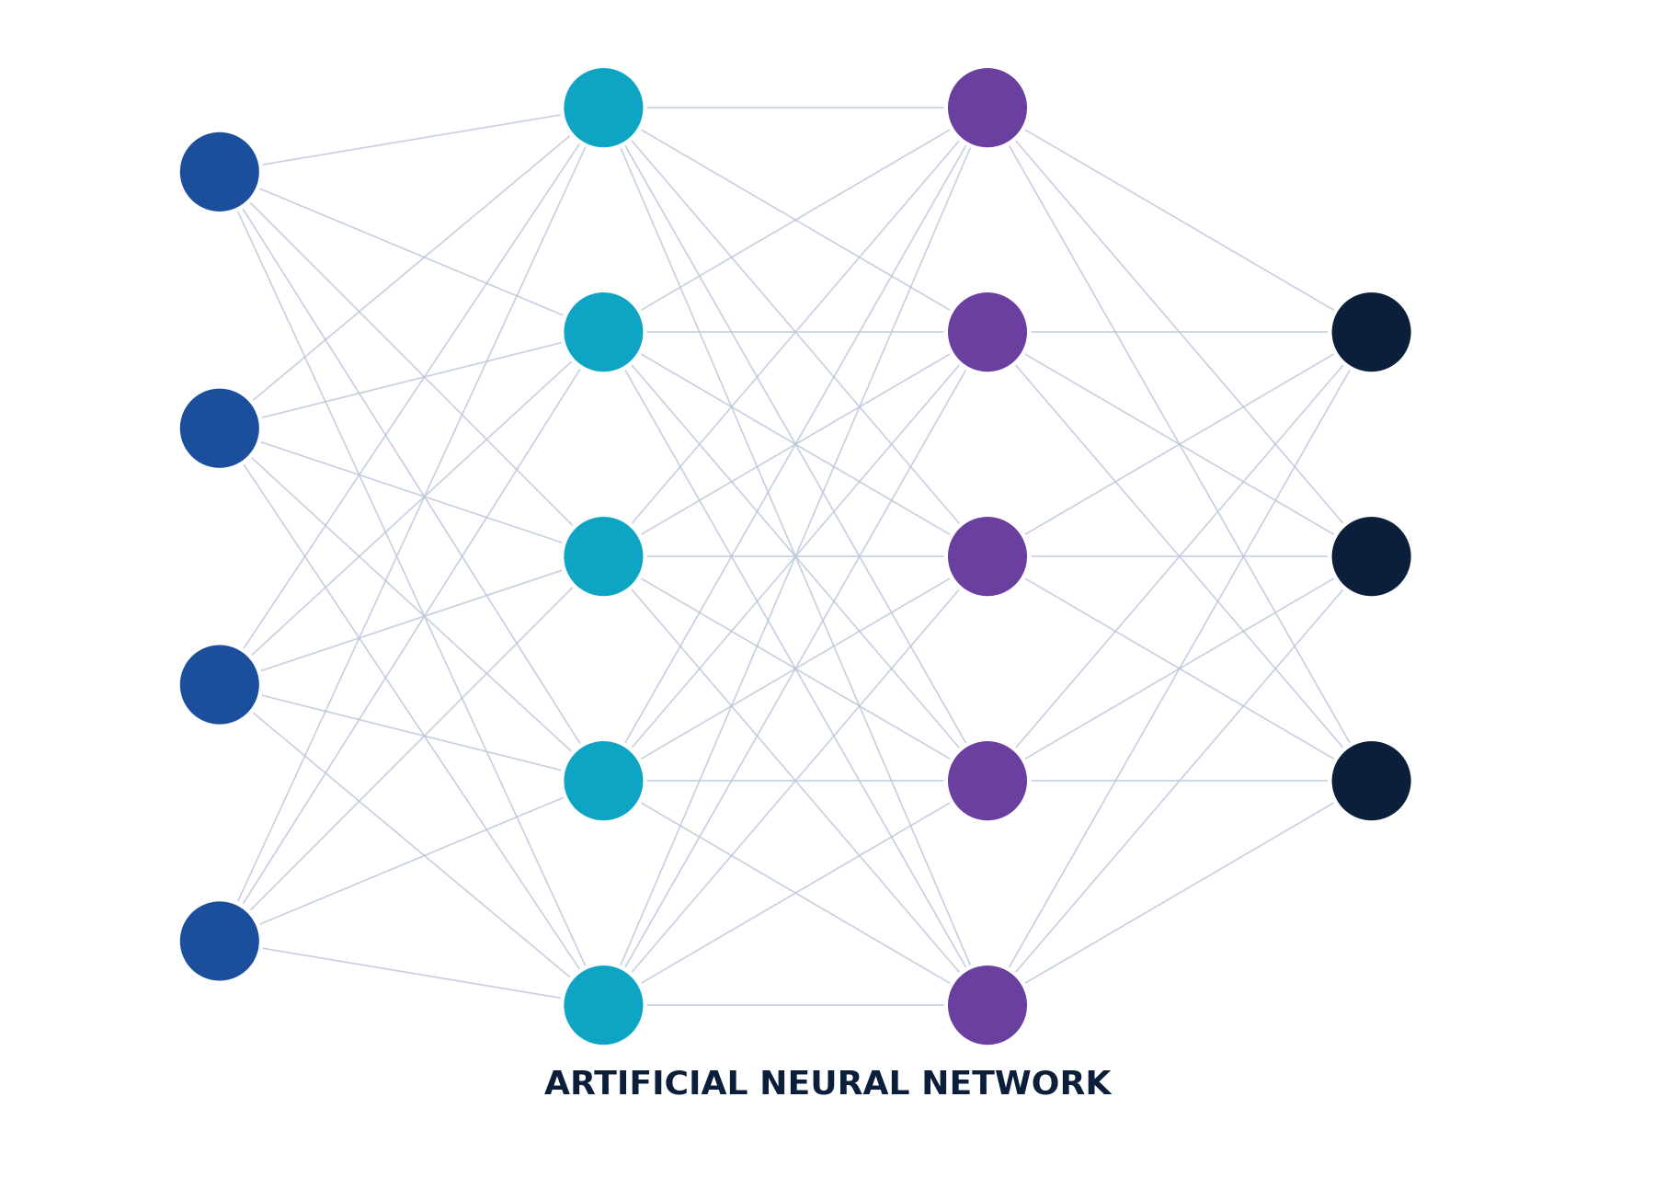
CO-2 AT-2
SCENARIO-BASED ASSESSMENT
ACTIVATION FUNCTIONS
Deep Neural Networks for Student Pass / Fail Classification

Student Name | Paleru Dharani Govardhan
Register Number | 192525280
Department | Artificial Intelligence and Machine Learning
Course | Deep Learning
Assessment | CO-2 AT-2
Topic | Scenario-Based Assessment – Activation Functions

Submitted in partial fulfilment of the requirements of the Deep Learning course

Abstract
This report presents a scenario-based academic analysis of activation functions in deep neural networks, developed in the context of a college placement problem: classifying students as Pass or Fail using internal marks, attendance, and assignment marks as input features. The assessment investigates a 3 → 4 → 1 neural network architecture and evaluates the behaviour of three widely used activation functions — Sigmoid, ReLU, and Leaky ReLU — within its hidden and output layers.
Two specific problems are examined. First, the use of Sigmoid in the hidden layer is shown to cause slow learning due to the vanishing gradient problem, where gradients shrink drastically for large positive or negative inputs, slowing weight updates during backpropagation. Second, the use of ReLU in the hidden layer is shown to occasionally cause the dying ReLU problem, in which certain neurons persistently output zero and stop contributing to learning.
The report recommends Sigmoid for the output layer, since it compresses the network output into the range 0 to 1, allowing it to be interpreted as the probability that a student will pass. For the hidden layer, ReLU is recommended as the primary choice due to its computational efficiency and strong gradient flow, with Leaky ReLU proposed as the corrective alternative whenever dying neurons are observed. Complete numerical calculations, comparative tables, and applied diagrams are provided to connect each theoretical concept to the student Pass/Fail prediction task.

Introduction
Educational institutions increasingly rely on data-driven methods to identify students who are at risk of failing a course, so that timely academic support can be provided. The scenario addressed in this report involves a college that wishes to build a Deep Learning classification model capable of predicting whether a student will Pass or Fail, based on three numerical indicators of academic performance: internal assessment marks, attendance percentage, and assignment marks.
A neural network is well suited to this task because the relationship between these three factors and the final outcome is unlikely to be purely linear — a student with moderate marks but excellent attendance and assignment performance may still pass, while a student with high marks but very poor attendance may not. Neural networks, through layers of neurons connected by weights and non-linear activation functions, can learn such complex, non-linear decision boundaries directly from data. The choice of activation function at each layer directly determines how effectively the network learns these relationships and how meaningfully its output can be interpreted.
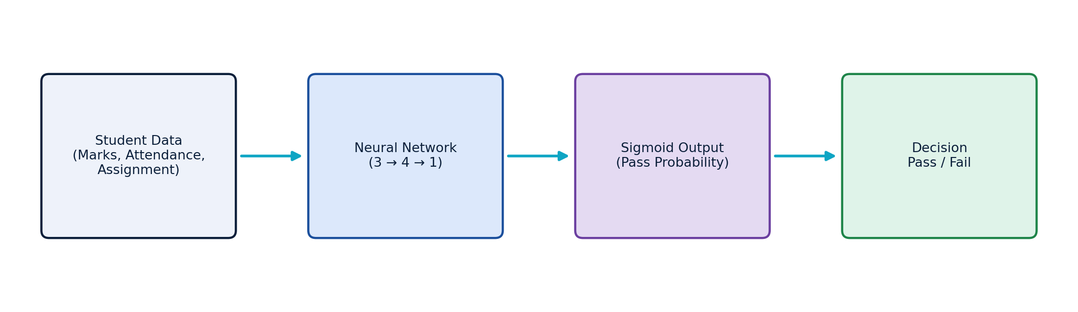
Figure 1: Conceptual Flow — Student Data → Neural Network → Pass Probability → Pass/Fail Decision
The remaining sections of this report formally define the problem, describe the neural network architecture, explain the theory of activation functions in depth, and apply that theory to resolve the two specific issues observed during testing — slow learning with Sigmoid and dead neurons with ReLU.

Problem Statement
A college wants to build a Deep Learning model that classifies students into Pass and Fail categories using three academic performance indicators. This can be formally stated as a binary classification problem:
Input Features (x)
- x1 — Internal Marks (continuous, e.g. out of 100)
- x2 — Attendance Percentage (continuous, 0–100%)
- x3 — Assignment Marks (continuous, e.g. out of 100)
Output (y)
- y ∈ {0, 1} — where 1 represents "Pass" and 0 represents "Fail", predicted as a probability P(Pass | x1, x2, x3) ∈ [0, 1]
The neural network specified for this task has an input layer of 3 neurons (one per feature), a hidden layer of 4 neurons that learns intermediate feature representations, and an output layer of 1 neuron that produces the final pass probability. During testing, two issues were observed: slow convergence when Sigmoid was used in the hidden layer, and neurons permanently outputting zero when ReLU was used. This report analyses both issues and recommends a complete activation-function strategy for the network.

Objectives
The academic objectives of this scenario-based assessment are as follows:
- Understand activation functions — their definition, purpose, and role in a neuron's computation.
- Analyse the limitations of Sigmoid — particularly the vanishing gradient problem and its effect on learning speed.
- Understand ReLU — its formula, advantages, and reasons for widespread use in hidden layers.
- Identify the dying ReLU problem — its causes and consequences for network training.
- Understand Leaky ReLU — as a corrective activation function for dead neurons.
- Select an appropriate output-layer activation — for binary probability prediction.
- Apply activation functions mathematically — through step-by-step numerical computation on a sample neuron.

Neural Network Architecture
The classification model uses a fully connected feed-forward architecture, labelled 3 → 4 → 1, as illustrated below. Every neuron in one layer connects to every neuron in the next layer through a weighted connection, and each connection contributes to the weighted sum computed at the receiving neuron.
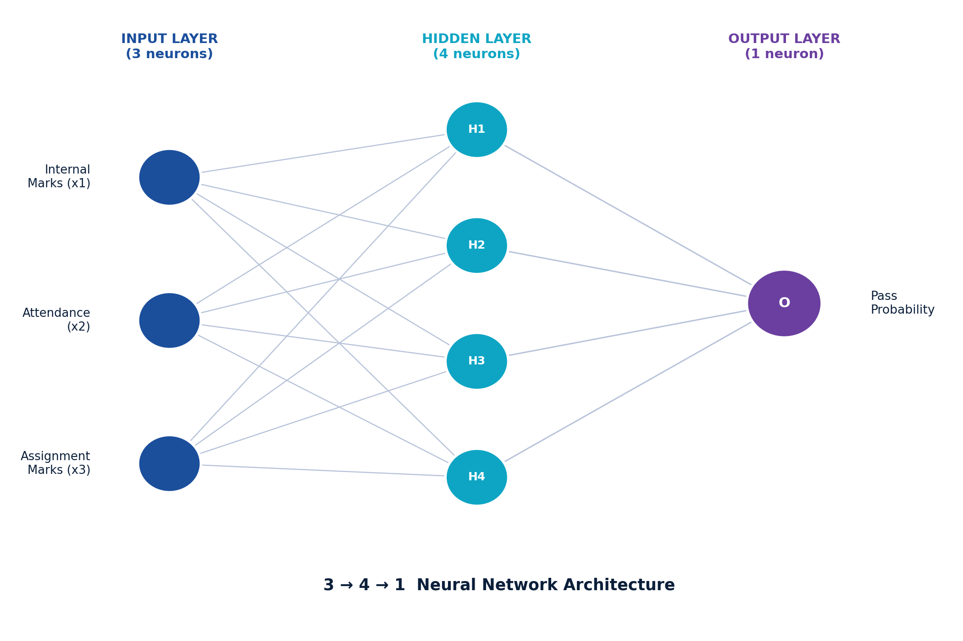
Figure 2: Detailed Architecture — 3 Input Neurons, 4 Hidden Neurons, 1 Output Neuron

Layer-by-Layer Description
- Input Neurons (3): Internal Marks, Attendance, and Assignment Marks are fed directly into the network without any transformation.
- Weights (w): Each connection between neurons carries a weight that scales the influence of the input on the receiving neuron. Weights are learned during training.
- Bias (b): An additional learnable constant added to the weighted sum, allowing the neuron's decision boundary to shift independently of the inputs.
- Weighted Sum (z): The linear combination of inputs, weights, and bias computed at each neuron before activation.
- Activation Function (f): A non-linear function applied to z to produce the neuron's final output.
- Output (a): The transformed value passed forward to the next layer, or, in the output layer, the final prediction.

Core Neuron Equations
Every neuron in the network performs two sequential steps — a linear weighted summation, followed by a non-linear activation:
z = w₁x₁ + w₂x₂ + w₃x₃ + b
a = f(z)
Here, x₁, x₂, x₃ are the neuron's inputs, w₁, w₂, w₃ are the corresponding weights, b is the bias term, z is the weighted sum, f(·) is the chosen activation function, and a is the neuron's activated output. This two-step computation is repeated at every neuron in the hidden and output layers, allowing the network to progressively transform raw student data into a final pass/fail prediction.

What Is an Activation Function?

Definition
An activation function is a mathematical function applied to the weighted sum (z) of a neuron's inputs, producing the neuron's final output. It determines whether, and to what extent, a neuron should "fire" and pass information to the next layer.

Purpose of Activation Functions
- Introduce non-linearity: allowing the network to model complex, curved decision boundaries rather than only straight lines.
- Enable deep representation learning: stacking many linear layers without activation would collapse into a single linear transformation, regardless of depth.
- Control output range: certain activation functions (e.g., Sigmoid) constrain outputs to a specific interval, useful for probability estimation.
- Support gradient-based learning: activation functions must be differentiable so that gradients can propagate backward during training (backpropagation).

Why Non-Linearity Matters: Decision Boundaries
The Student Pass/Fail problem is unlikely to be perfectly separable by a straight line in three-dimensional feature space. Non-linear activation functions allow the hidden layer to bend and combine decision boundaries, enabling the network to correctly classify students whose outcome depends on a non-linear interaction between marks, attendance, and assignments.
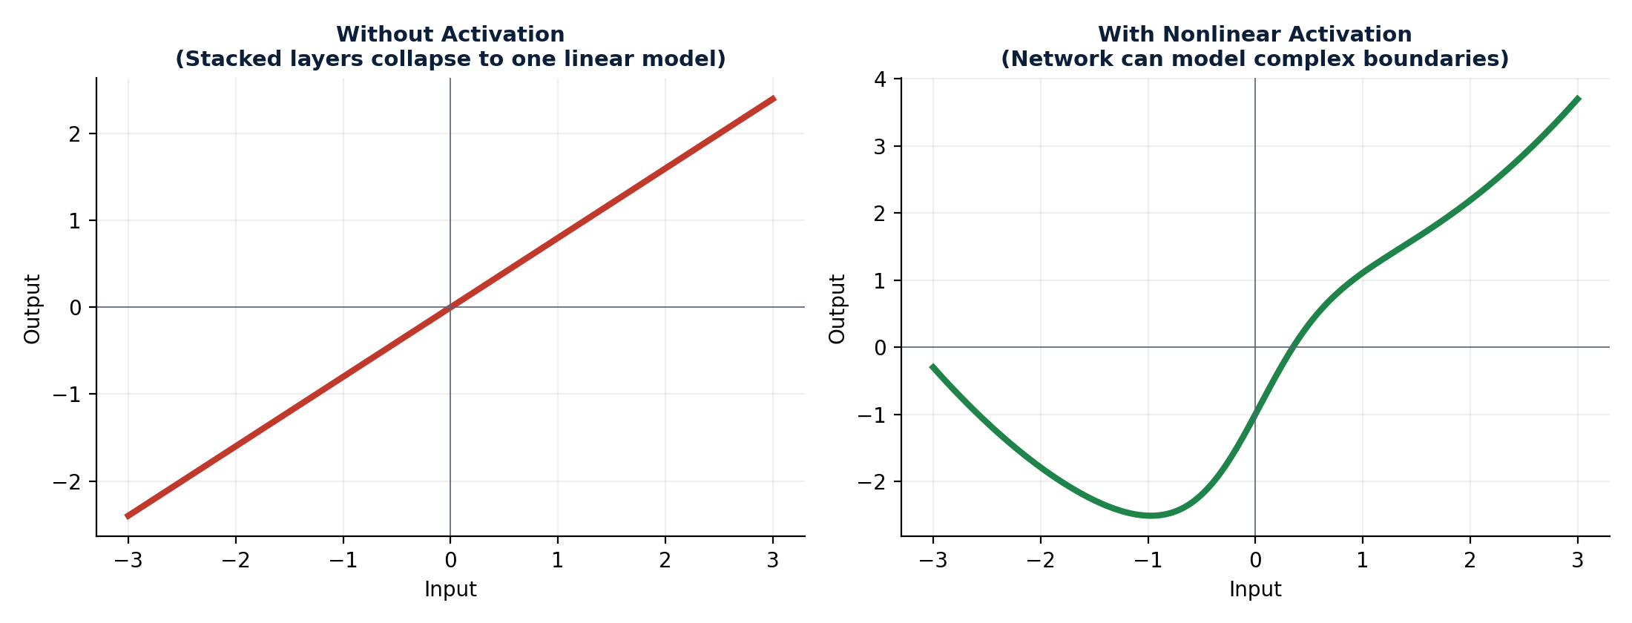
Figure 3: Linear Model (No Activation) vs Deep Non-Linear Model (With Activation)

Gradient Propagation
During training, the network learns by computing the gradient of the loss function with respect to each weight, using the chain rule of calculus (backpropagation). Because the activation function is part of this chain, its derivative directly affects how much each weight is updated. An activation function whose derivative becomes very small will cause very small weight updates — this is the root cause of the slow-learning issue explored in this report.

The Basic Neuron Computation
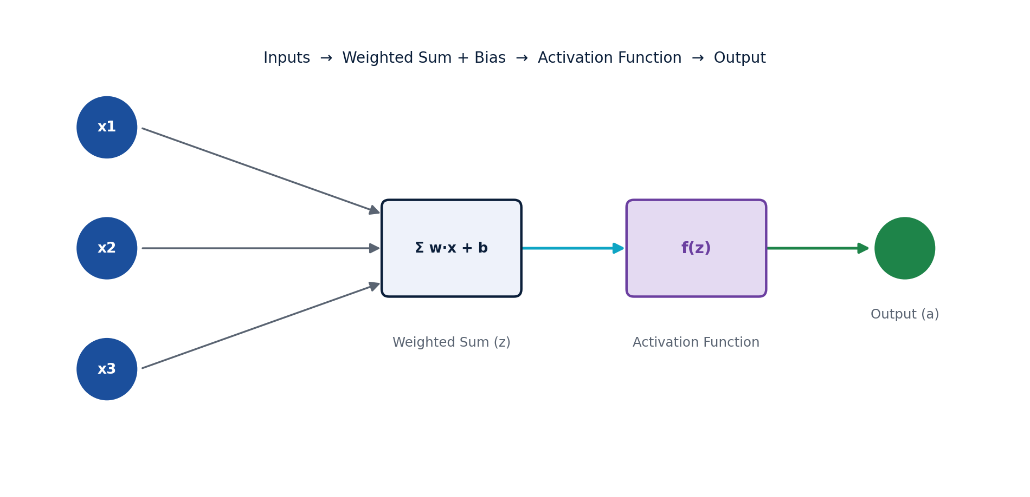
Figure 4: Artificial Neuron — Inputs, Weighted Sum, Activation, Output

Sigmoid Activation Function
The Sigmoid (logistic) function is one of the earliest activation functions used in neural networks. It is defined as:
σ(x) = 1 / (1 + e⁻ˣ)

Key Properties
- Output range: (0, 1) — the curve approaches but never reaches 0 or 1.
- Shape: a smooth, S-shaped (sigmoidal) curve, symmetric about x = 0, where σ(0) = 0.5.
- Differentiability: Sigmoid is smooth and differentiable everywhere, which is essential for gradient-based training.
- Probability interpretation: because its output always lies between 0 and 1, Sigmoid output can be directly interpreted as a probability.
- Common use: widely used in the output layer of binary classification models.
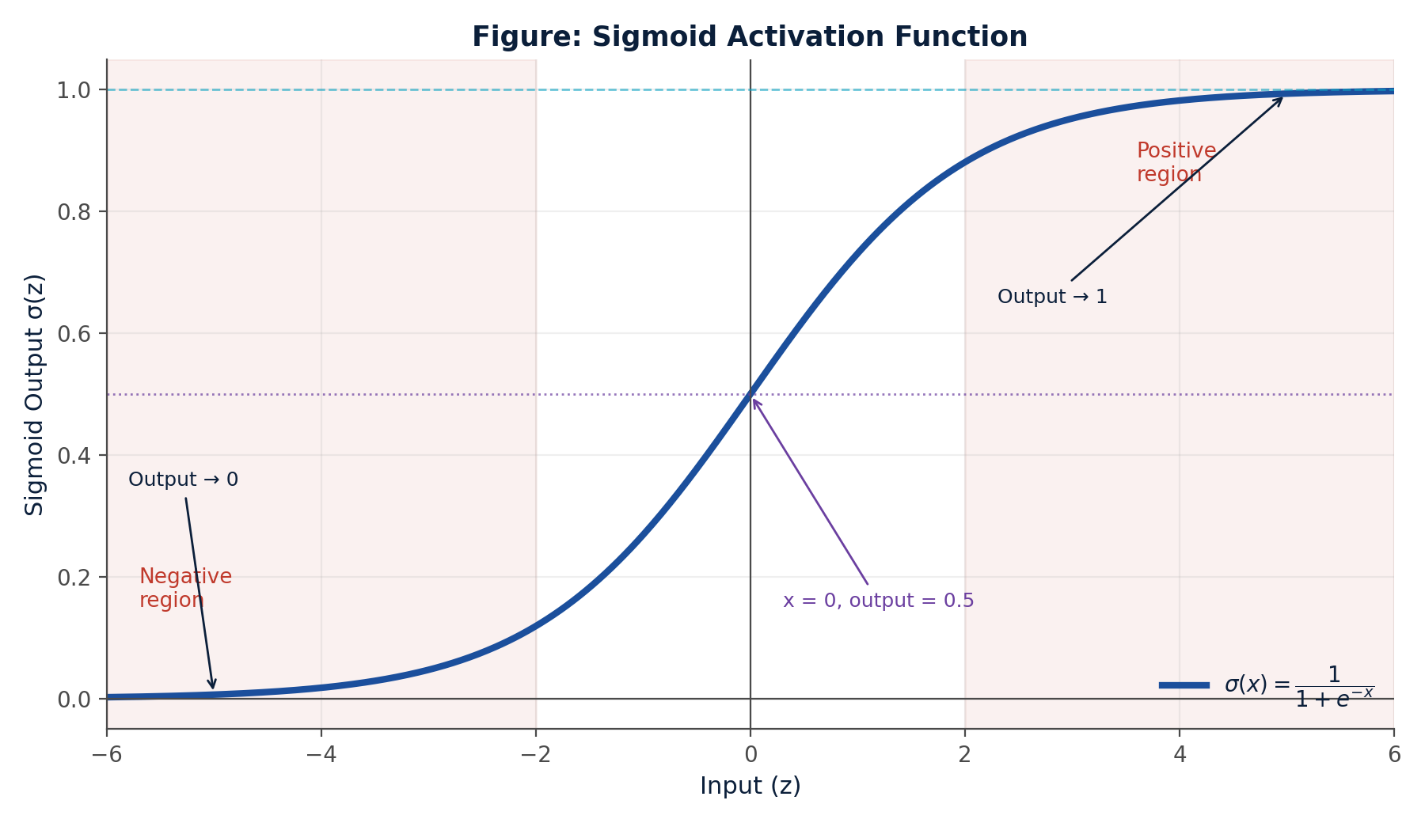
Figure 5: Sigmoid Activation Function, showing negative region, x = 0, and positive region

The Slow-Learning Problem: Vanishing Gradient
When Sigmoid is used in the hidden layer, the network in this scenario was observed to learn very slowly. The cause is the vanishing gradient problem:
The derivative of Sigmoid is σ'(x) = σ(x)·(1 − σ(x)). This derivative reaches its maximum value of only 0.25 at x = 0, and shrinks rapidly toward 0 as x moves toward large positive or large negative values, because the curve flattens ('saturates') in both directions.
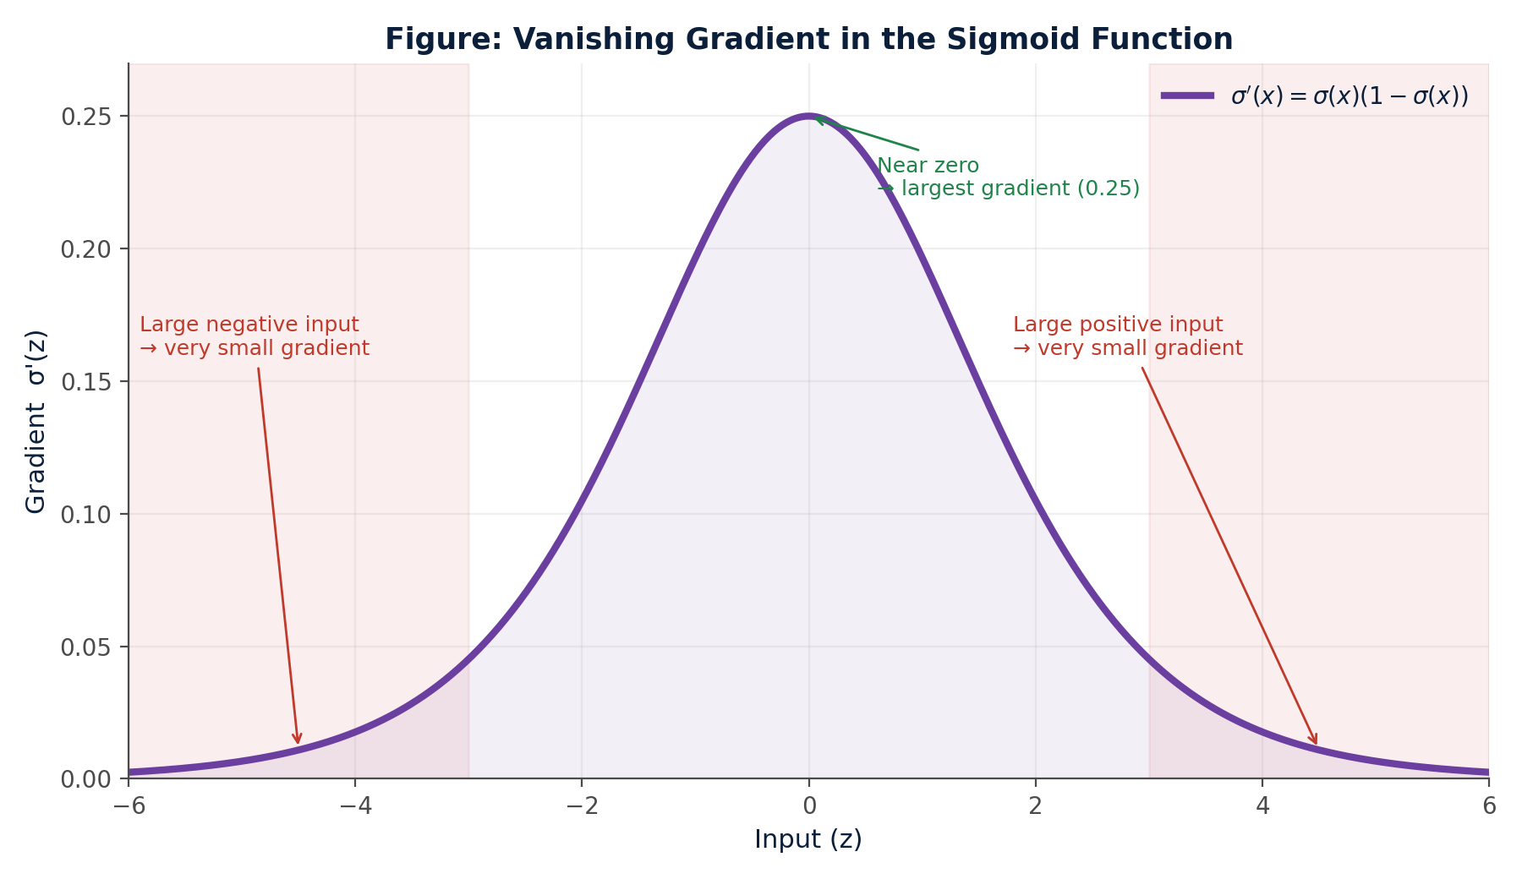
Figure 6: Vanishing Gradient — Sigmoid Derivative Approaches Zero at Extreme Inputs
During backpropagation, gradients are multiplied layer by layer. When several hidden layers each produce a small Sigmoid gradient, the overall gradient reaching the earlier layers becomes extremely small — sometimes near zero. As a result, weight updates in those layers become negligible, and training slows down dramatically, which directly explains the slow-learning behaviour observed in the scenario.

ReLU Activation Function
The Rectified Linear Unit (ReLU) is the most widely used activation function in modern hidden layers. It is defined as:
ReLU(x) = max(0, x)

Key Properties
- Negative input (x < 0): output is always 0.
- Positive input (x ≥ 0): output equals the input value x, unchanged.
- Computational simplicity: ReLU requires only a comparison with zero, making it far cheaper to compute than exponential functions like Sigmoid.
- Faster training: because the gradient is exactly 1 for all positive inputs, there is no saturation on the positive side, allowing gradients to flow strongly through many layers.
- Strong gradient for positive inputs: this largely avoids the vanishing gradient problem for active neurons.
- Widespread use: ReLU's simplicity and efficiency make it the default choice for hidden layers in most modern deep networks.
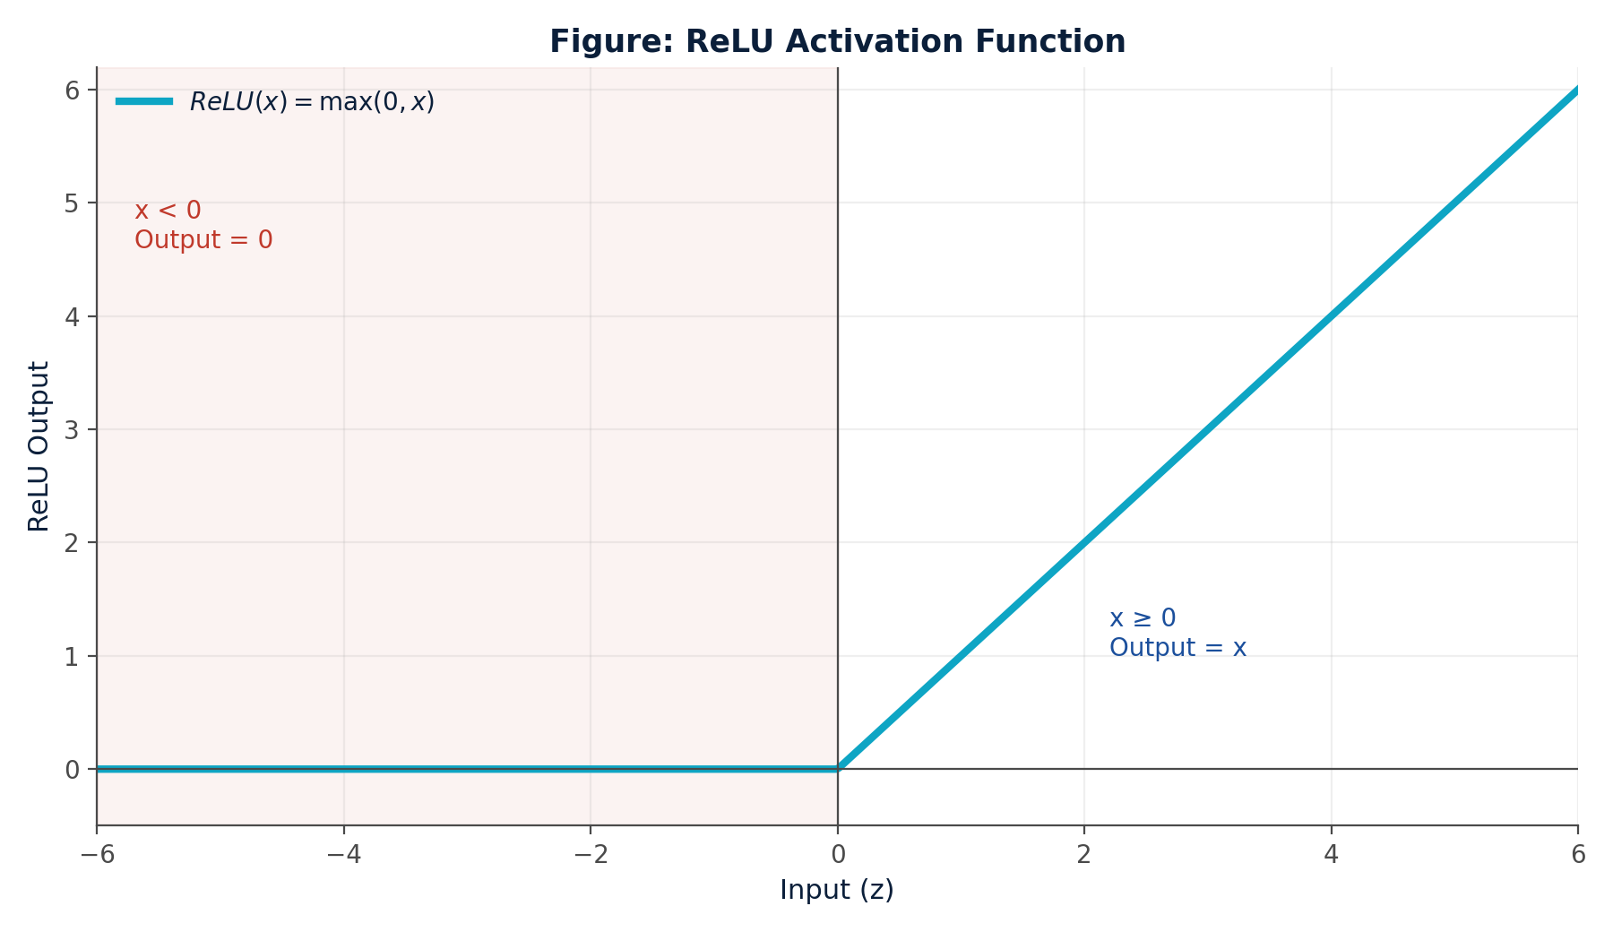
Figure 7: ReLU Activation Function — Zero for Negative Inputs, Linear for Positive Inputs

Sigmoid vs ReLU — Comparative Summary
Property | Sigmoid | ReLU
Output Range | 0 to 1 | 0 to ∞
Negative Input | Small positive value (never 0) | Exactly 0
Positive Input | Approaches 1 (always < 1) | Same as input value
Main Issue | Vanishing gradient | Dying ReLU
Typical Usage | Binary output layer | Hidden layers

Dying ReLU Problem

Definition
The Dying ReLU Problem occurs when a ReLU neuron continuously receives negative weighted-sum inputs. Because ReLU(x) = 0 for all x < 0, the neuron's output becomes permanently 0. Since the derivative of ReLU is also 0 for x < 0, no gradient flows back through that neuron during backpropagation — its weights are never updated again, and the neuron effectively "dies," contributing nothing to the network for the rest of training. This directly matches the second problem observed in the scenario, where several hidden-layer neurons using ReLU consistently output zero.
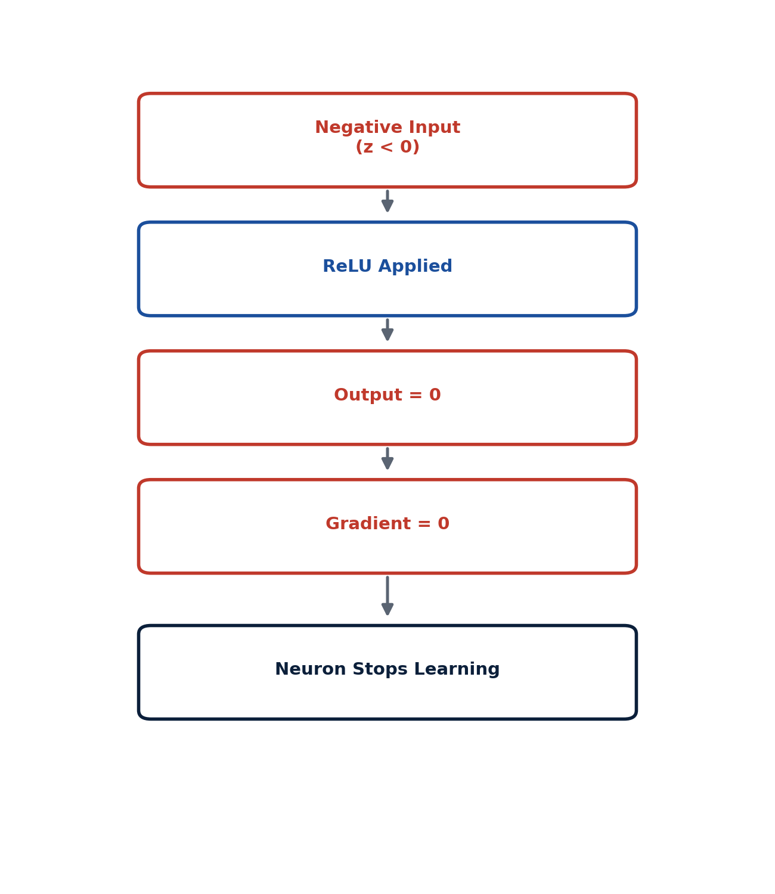
Figure 8: Dying ReLU Problem — From Negative Input to a Permanently Inactive Neuron

Common Causes
- Large negative bias: a strongly negative bias term shifts the weighted sum into negative territory for most inputs.
- Large learning rate: an aggressive weight update can push a neuron's weights into a region where it always produces negative sums.
- Poor weight initialization: weights initialized with unsuitable values can cause many neurons to start in, and remain in, the negative-output region.
- Repeated negative inputs: if the data distribution frequently produces negative weighted sums for a neuron, it may never recover a positive output.

Healthy vs Dying Neuron Behaviour
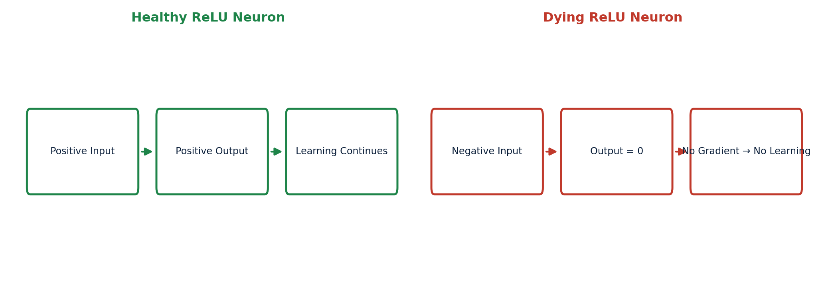
Figure 9: Comparison of a Healthy ReLU Neuron and a Dying ReLU Neuron

Leaky ReLU
To overcome the dying ReLU problem, the Leaky ReLU activation function introduces a small, non-zero slope for negative inputs instead of flattening them to exactly zero. It is defined as:
Leaky ReLU(x) = x, if x > 0
Leaky ReLU(x) = αx, if x ≤ 0
where α (alpha) is a small positive constant, commonly α = 0.01, used throughout this report unless another value is explicitly specified.

Key Properties
- Positive region: behaves exactly like standard ReLU — output equals input.
- Negative region: output is a small fraction (αx) of the input, rather than zero.
- Prevents zero gradient: the derivative for negative inputs is α (e.g., 0.01), not 0, so gradients never fully vanish.
- Keeps neurons learning: even neurons that frequently receive negative sums continue to receive small weight updates, preventing them from dying permanently.
- Useful for negative inputs: Leaky ReLU allows the network to retain a small amount of information from negative activations instead of discarding it entirely.
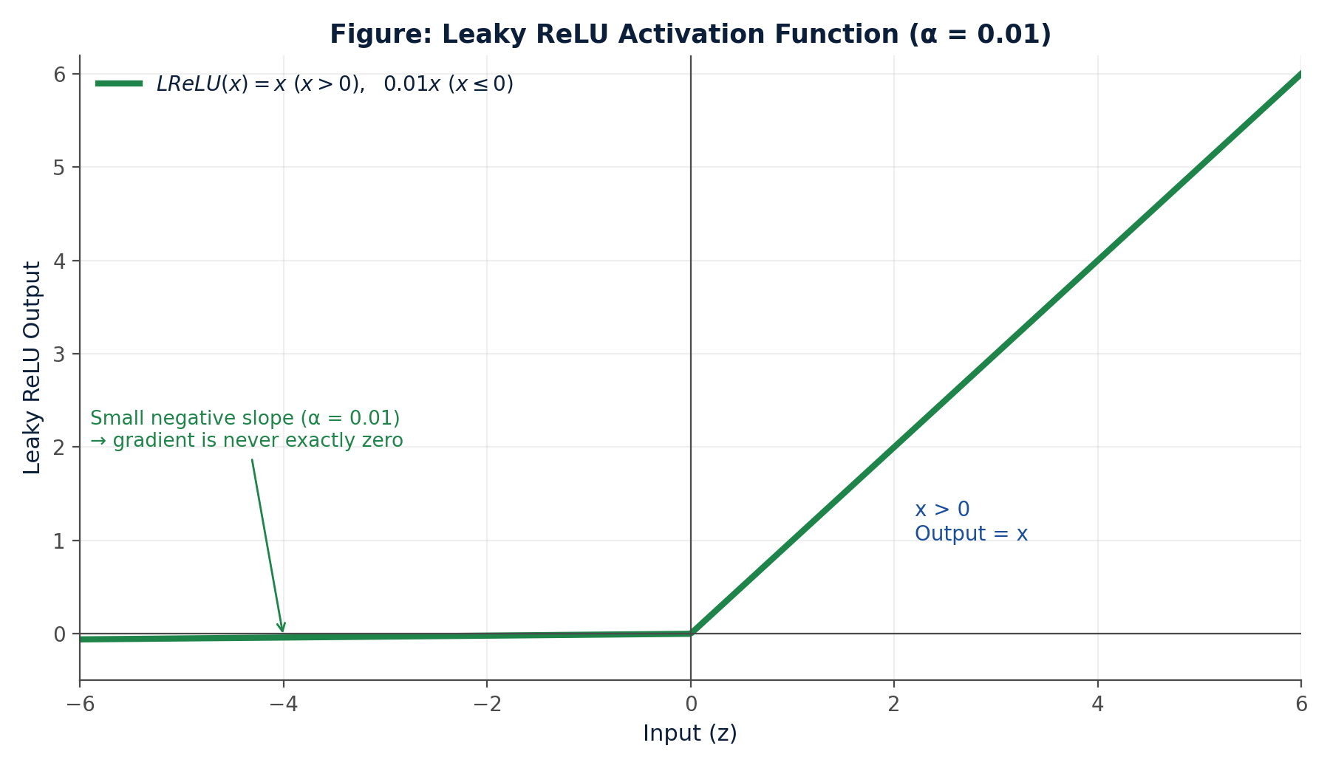
Figure 10: Leaky ReLU Activation Function (α = 0.01)

ReLU vs Leaky ReLU
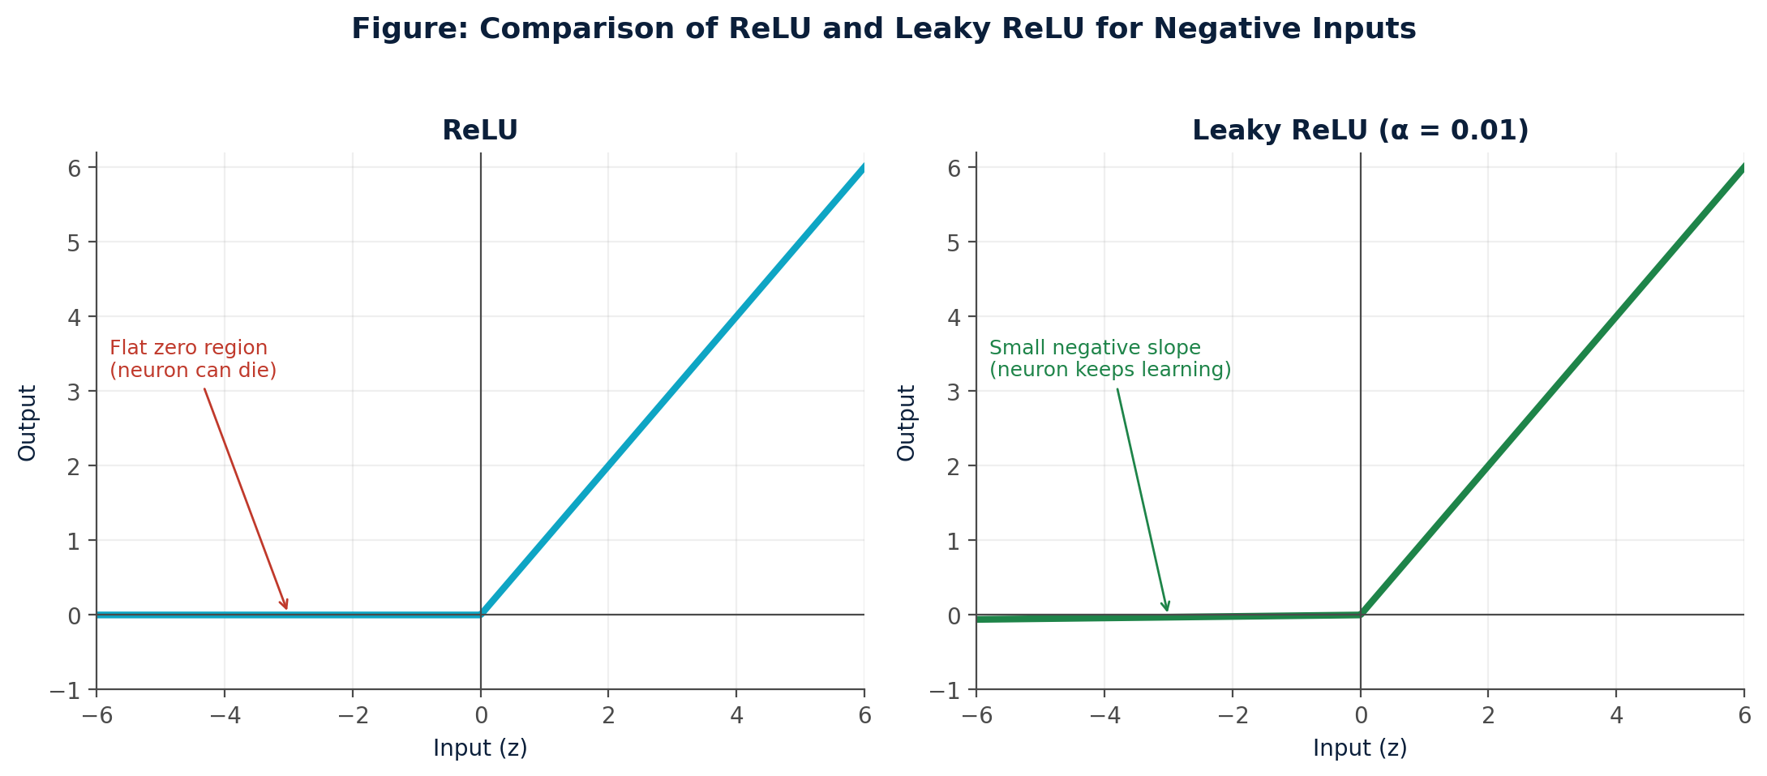
Figure 11: Side-by-Side Comparison — ReLU's Flat Zero Region vs Leaky ReLU's Small Negative Slope

Output Layer Activation Selection
Question A: Which activation function should be recommended for the output layer? Explain why.
Recommended activation function: Sigmoid

Justification
The Student Pass/Fail model is a binary classification problem — the network must decide between exactly two outcomes, Pass or Fail. Sigmoid is the natural choice for the output layer in this setting because:
- Sigmoid produces an output strictly between 0 and 1, matching the requirement that the output represent a probability.
- The output can be directly interpreted as P(Pass | Internal Marks, Attendance, Assignment Marks) — the probability that a given student will pass.
- Sigmoid is smooth and differentiable, which is required for the network to be trained using gradient descent with a binary cross-entropy loss function.
- Unlike ReLU, whose output is unbounded (0 to ∞), Sigmoid guarantees a bounded, probability-like output regardless of how large the incoming weighted sum becomes.

Example Interpretation
Suppose the output neuron produces:
Sigmoid Output = 0.82
This is interpreted as: approximately 82% probability that the student will Pass. A simple decision rule then converts this probability into a class label:
If P(Pass) ≥ 0.5 → Predict "Pass"
Otherwise → Predict "Fail"

Why ReLU Is Unsuitable for the Output Layer
ReLU is unsuitable here because its output range is 0 to ∞, not 0 to 1. A ReLU output of, say, 3.7 has no direct probabilistic meaning — it cannot be interpreted as "370% probability of passing." Using ReLU at the output would require an additional transformation to produce a valid probability, whereas Sigmoid provides this behaviour natively.
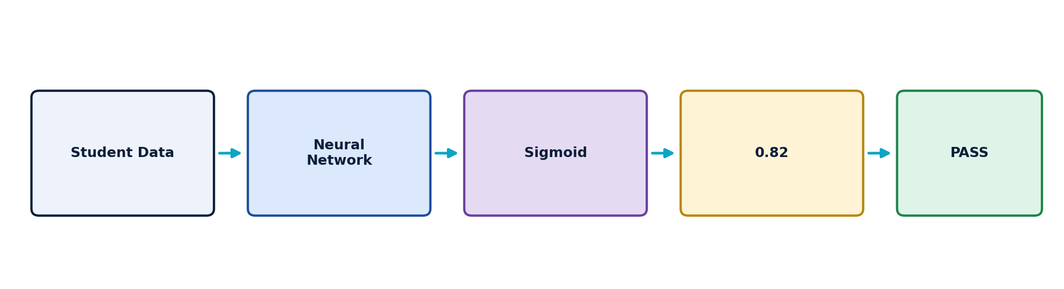
Figure 12: Output Layer Flow — Student Data → Network → Sigmoid → Probability 0.82 → PASS

Hidden Layer Activation Selection
Question B: Which activation function should be recommended for the hidden layer to overcome the slow-learning problem associated with Sigmoid?
Recommended activation function: ReLU

Why ReLU Is Preferred Over Sigmoid in Hidden Layers
- Computationally simple: requires only a max(0, x) comparison, unlike Sigmoid's exponential computation.
- Reduces saturation: positive inputs pass through unchanged, avoiding the flattening behaviour seen in Sigmoid's extremes.
- Better gradient flow: the derivative is exactly 1 for all positive inputs, so gradients do not shrink as they propagate backward.
- Faster training: stronger, more consistent gradients lead to quicker convergence than Sigmoid's small, saturating gradients.
- Supports deep networks: ReLU scales well to networks with many hidden layers, where vanishing gradients would otherwise compound.
- Sparse activations: neurons with negative input output exactly zero, producing a sparse, efficient internal representation.
Question C: What is the problem called when ReLU neurons continuously produce zero?
This is called the Dying ReLU Problem — described in detail in the previous section. It occurs when a neuron's weighted sum remains negative across most or all training examples, causing the neuron's output and gradient to remain permanently at zero.
Question D: Suggest one activation function that can overcome this problem.
The recommended solution is Leaky ReLU (with α = 0.01), which replaces the flat zero region of standard ReLU with a small non-zero slope, ensuring that even neurons receiving negative inputs continue to receive a (small) gradient and remain capable of learning.

Recommended Decision Strategy for the Hidden Layer
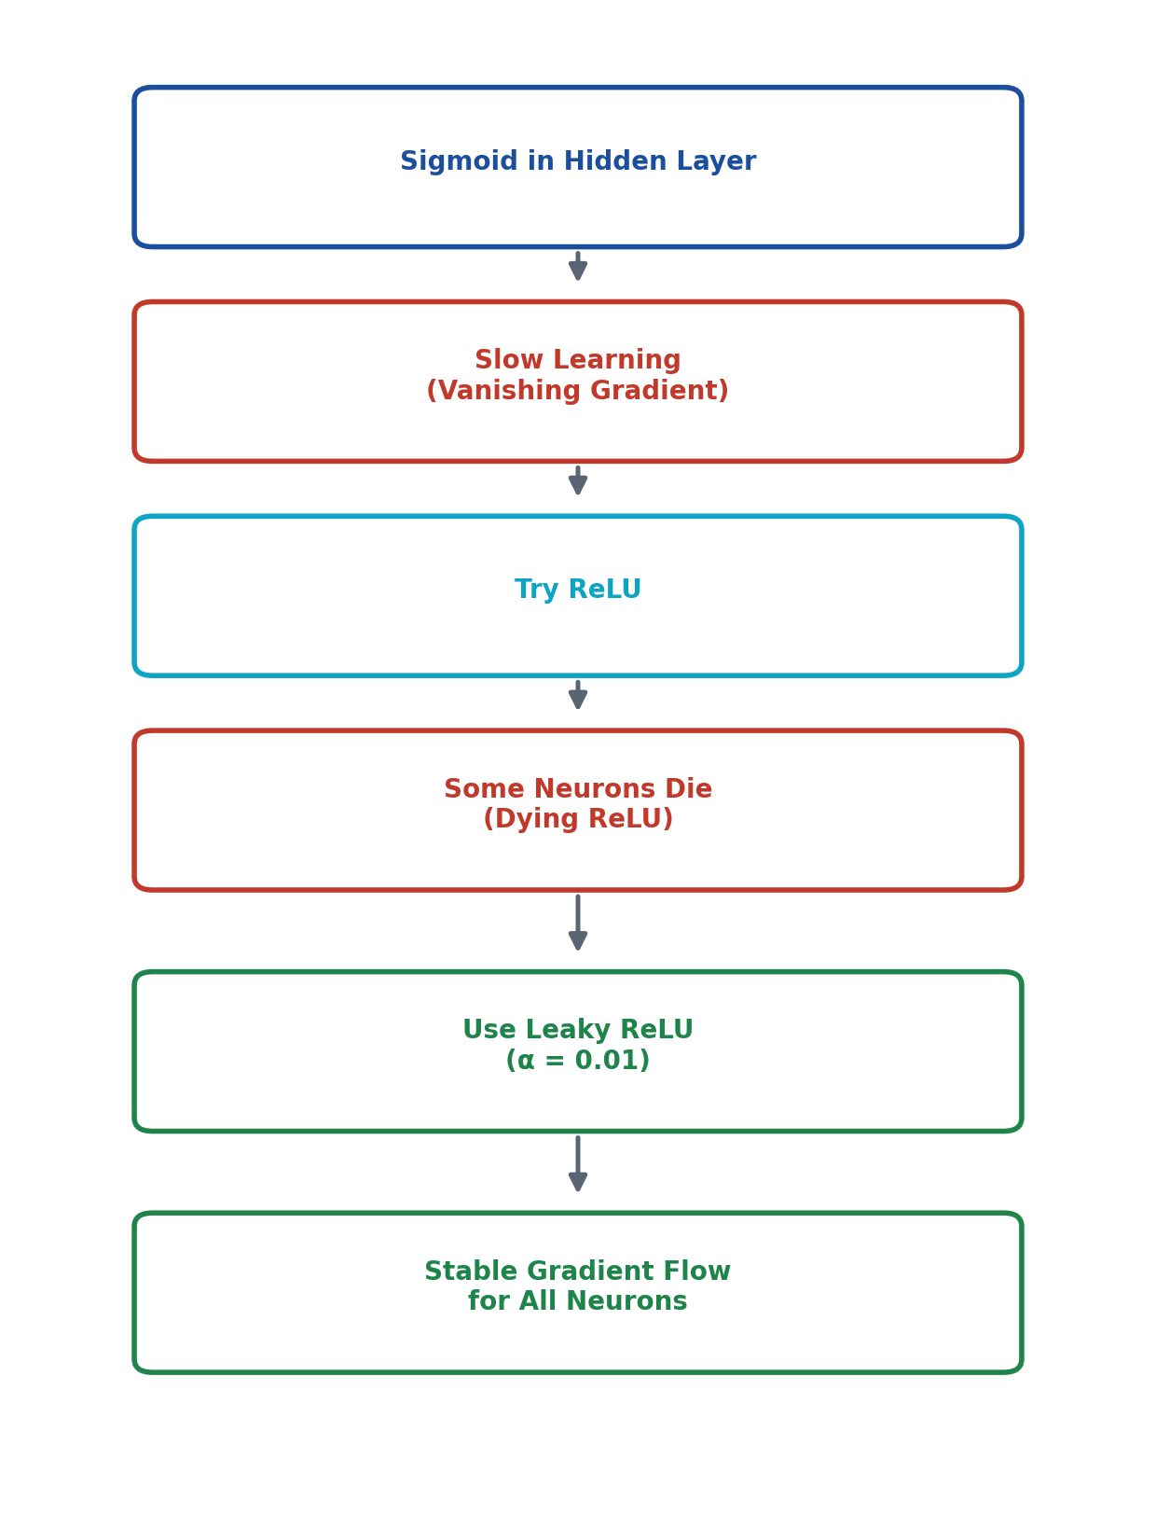
Figure 13: Decision Flow for Selecting the Hidden Layer Activation Function

Numerical Calculations
Question E: Calculate the output of a neuron using ReLU, Leaky ReLU, and Sigmoid.
The scenario provided in the assignment does not specify the exact numerical input or weighted-sum value for the neuron. To demonstrate the calculation method with full mathematical rigour, an illustrative example is used below, clearly labelled as such. The same step-by-step method applies directly to any specific value supplied in class.
Illustrative Example — Assume a hidden-layer neuron's weighted sum (after combining Internal Marks, Attendance, and Assignment Marks with their respective weights and bias) evaluates to:
z = w₁x₁ + w₂x₂ + w₃x₃ + b = −2

1. ReLU Calculation
ReLU(z) = max(0, z)
Substituting z = −2:
ReLU(−2) = max(0, −2) = 0
Result: ReLU output = 0 — since z is negative, the neuron produces zero output (this illustrates exactly how a dying-ReLU scenario begins).

2. Leaky ReLU Calculation (α = 0.01)
Leaky ReLU(z) = αz, for z ≤ 0
Substituting z = −2 and α = 0.01:
Leaky ReLU(−2) = 0.01 × (−2) = −0.02
Result: Leaky ReLU output = −0.02 — a small negative value, instead of exactly zero.

3. Sigmoid Calculation
σ(z) = 1 / (1 + e⁻ᶻ)
Substituting z = −2:
σ(−2) = 1 / (1 + e⁻⁽⁻²⁾) = 1 / (1 + e²)
Since e² ≈ 7.389:
σ(−2) = 1 / (1 + 7.389) = 1 / 8.389 ≈ 0.1192
Result: Sigmoid output ≈ 0.1192 (approximately 11.92%).

Summary of Results (z = −2)
Activation Function | Formula | Calculated Output
ReLU | max(0, z) | 0.0000
Leaky ReLU (α = 0.01) | αz | −0.0200
Sigmoid | 1 / (1 + e⁻ᶻ) | 0.1192

Comparative Analysis
Question F: Based on the calculated values, explain why Leaky ReLU can be useful compared with ReLU for negative inputs.
From the calculation above, for the negative input z = −2, standard ReLU produced an output of exactly 0, while Leaky ReLU produced −0.02. Although both values are small, this difference is critical during training:
- With ReLU, the output and the gradient are both exactly zero, so no learning signal passes back through this neuron — its weights cannot be updated for this example.
- With Leaky ReLU, the output is a small but non-zero value, and its gradient (α = 0.01) is also non-zero, so a small weight update does occur, keeping the neuron active in the learning process.
- Over many training iterations, this small but consistent gradient prevents the neuron from becoming permanently inactive — directly addressing the dying ReLU problem observed in the scenario.

Sigmoid vs ReLU vs Leaky ReLU — Full Comparison
Property | Sigmoid | ReLU | Leaky ReLU
Formula | 1/(1+e⁻ˣ) | max(0,x) | x (x>0); αx (x≤0)
Output Range | (0, 1) | [0, ∞) | (−∞, ∞)
Negative Input | Small positive (>0) | Exactly 0 | Small negative (αx)
Positive Input | Approaches 1 | Equals input | Equals input
Gradient Behaviour | Saturates, → 0 at extremes | 1 (x>0); 0 (x≤0) | 1 (x>0); α (x≤0)
Main Advantage | Probabilistic output | Fast, simple, strong gradient | Prevents dead neurons
Main Disadvantage | Vanishing gradient | Dying ReLU | Slightly more tuning (α)
Typical Application | Binary output layer | Hidden layers | Hidden layers (many dead neurons)
Effect on Learning | Can be slow in deep nets | Fast, may destabilise some neurons | Fast and stable
Hidden Layer Suitability | Limited (saturates) | Good (default choice) | Good (best if dying occurs)
Output Layer Suitability | Excellent (binary prob.) | Poor (unbounded) | Poor (unbounded)

Visual Comparison of All Three Curves
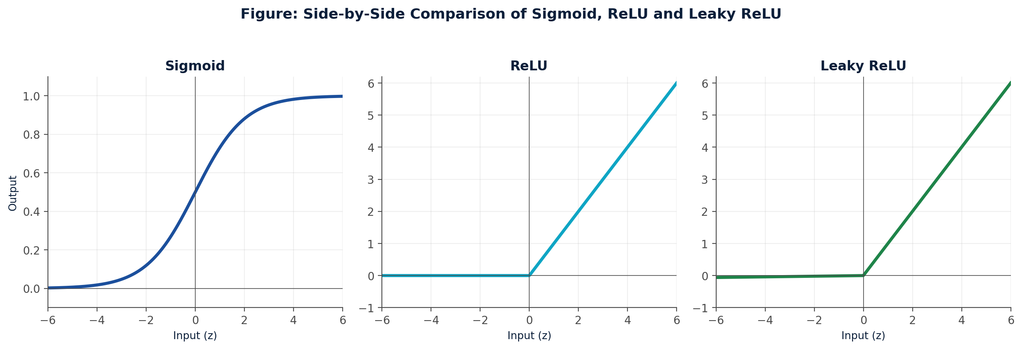
Figure 14: Sigmoid, ReLU, and Leaky ReLU Plotted Together for Direct Visual Comparison

Application to the Student Pass/Fail System
Combining the recommendations above, the complete Deep Learning workflow for the college's Pass/Fail prediction system proceeds through the following stages:
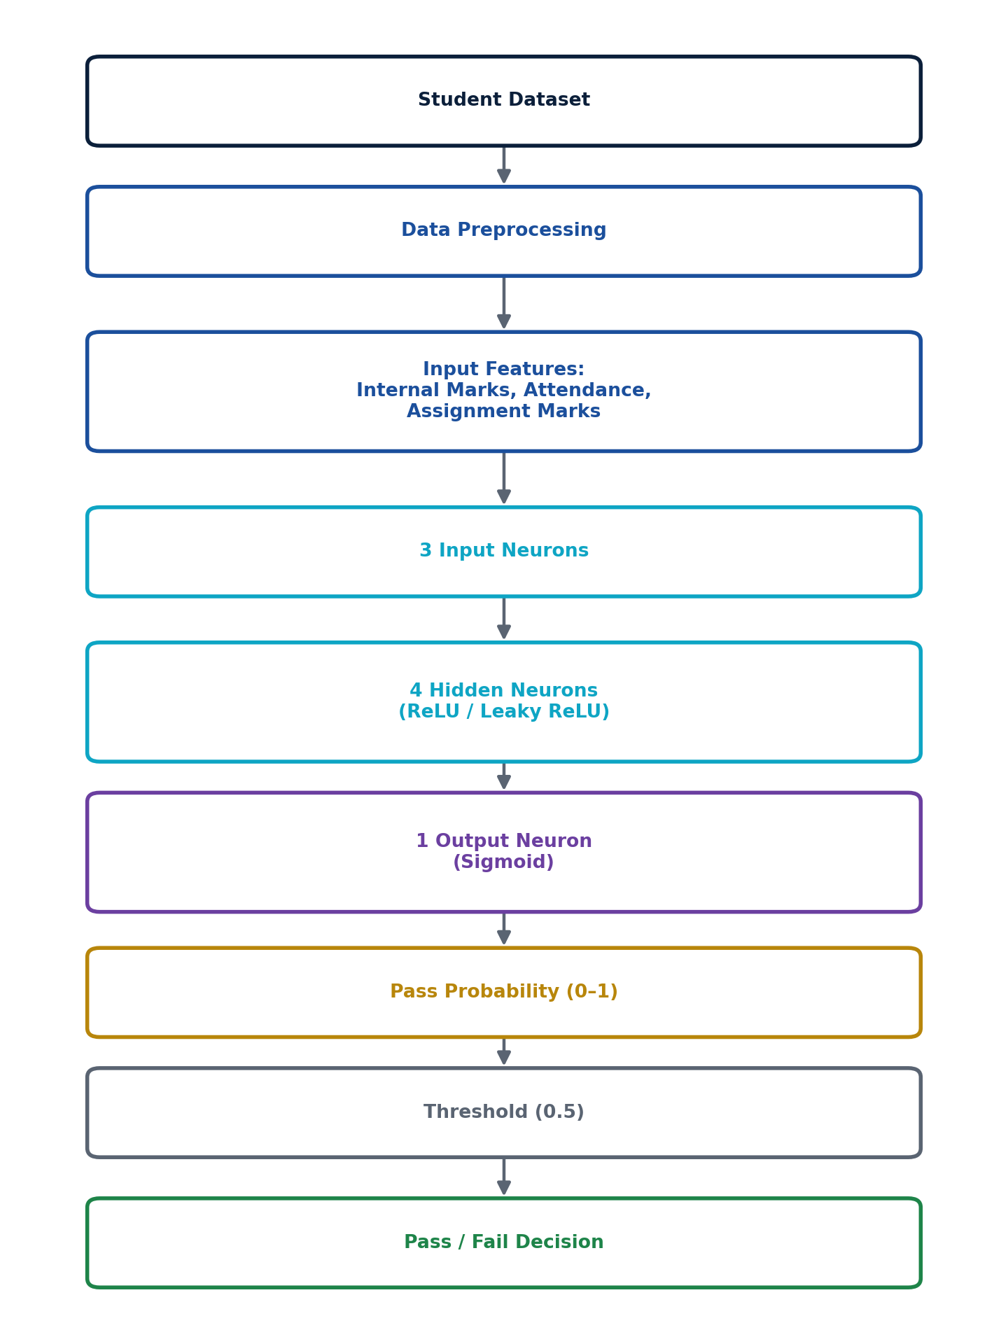
Figure 15: Complete Prediction Pipeline for the Student Pass/Fail Classification System

Stage-by-Stage Explanation
- Student Dataset: historical records of internal marks, attendance, and assignment marks, each labelled with the actual Pass/Fail outcome.
- Data Preprocessing: cleaning and normalising the three input features so they are on comparable numerical scales before training.
- Input Layer (3 neurons): receives the normalised Internal Marks, Attendance, and Assignment Marks.
- Hidden Layer (4 neurons, ReLU / Leaky ReLU): learns intermediate, non-linear combinations of the three features. ReLU is used by default; Leaky ReLU is substituted if dead neurons are detected during training.
- Output Layer (1 neuron, Sigmoid): compresses the final weighted sum into a probability between 0 and 1.
- Threshold (0.5): converts the probability into a discrete class label — Pass if ≥ 0.5, Fail otherwise.

Illustrative Sample Predictions
The following table presents illustrative example predictions to demonstrate how the pipeline output would be interpreted. These are conceptual, hand-constructed values for demonstration only, not results from an experimentally trained model.
Student | Internal | Attendance | Assignment | Pass Probability | Prediction
A | 85 | 90 | 88 | 0.94 | Pass
B | 45 | 60 | 50 | 0.18 | Fail
C | 72 | 80 | 75 | 0.81 | Pass

Conclusion
- Sigmoid is the appropriate choice for the output layer, since it produces a bounded probability (0 to 1) representing the likelihood of a student passing.
- ReLU is generally the preferred choice for hidden layers due to its computational efficiency and strong gradient flow for positive inputs.
- Sigmoid can suffer from the vanishing gradient problem, causing slow learning when used extensively in hidden layers.
- ReLU can suffer from the dying ReLU problem, where neurons permanently output zero and stop learning.
- Leaky ReLU resolves this by allowing a small negative gradient (α = 0.01), keeping neurons active even for negative inputs.
- Ultimately, activation-function selection depends on the role of the layer — hidden layers prioritise gradient flow and training speed, while the output layer prioritises meaningful, bounded interpretation of the result.

Learning Outcomes
This scenario-based assessment demonstrates the student's ability to:
- Select activation functions appropriate to a given layer and task.
- Calculate activation outputs manually, using ReLU, Leaky ReLU, and Sigmoid formulas.
- Identify vanishing-gradient problems and explain their effect on training speed.
- Identify the dying ReLU problem and its underlying causes.
- Explain Leaky ReLU as a targeted correction for dead neurons.
- Apply activation-function theory to a real-world academic classification problem.

References
[1] Goodfellow, I., Bengio, Y., & Courville, A. (2016). Deep Learning. MIT Press.
[2] Nair, V., & Hinton, G. E. (2010). Rectified Linear Units Improve Restricted Boltzmann Machines. Proc. 27th ICML.
[3] Maas, A. L., Hannun, A. Y., & Ng, A. Y. (2013). Rectifier Nonlinearities Improve Neural Network Acoustic Models. ICML Workshop on Deep Learning for Audio, Speech and Language Processing.
[4] Glorot, X., Bordes, A., & Bengio, Y. (2011). Deep Sparse Rectifier Neural Networks. Proc. 14th AISTATS.
[5] Nielsen, M. A. (2015). Neural Networks and Deep Learning. Determination Press.
[6] Stanford University CS231n Course Notes. Convolutional Neural Networks for Visual Recognition — Activation Functions. Stanford Computer Science Department.

