Agile Sprint Planning & User Story Workshop

Name | Department | Register Number | Faculty
Paleru Dharani Govardhan | Artificial Intelligence and Machine Learning | 192525280 | Anitadavamani K

1. Project Vision & Stakeholders
Project Vision
AgriTwin aims to build a live digital twin of the farm that pulls in data from soil sensors, weather stations, drones and satellite imagery, so problems like disease, pest attacks or nutrient loss are caught early instead of after the yield is already affected.
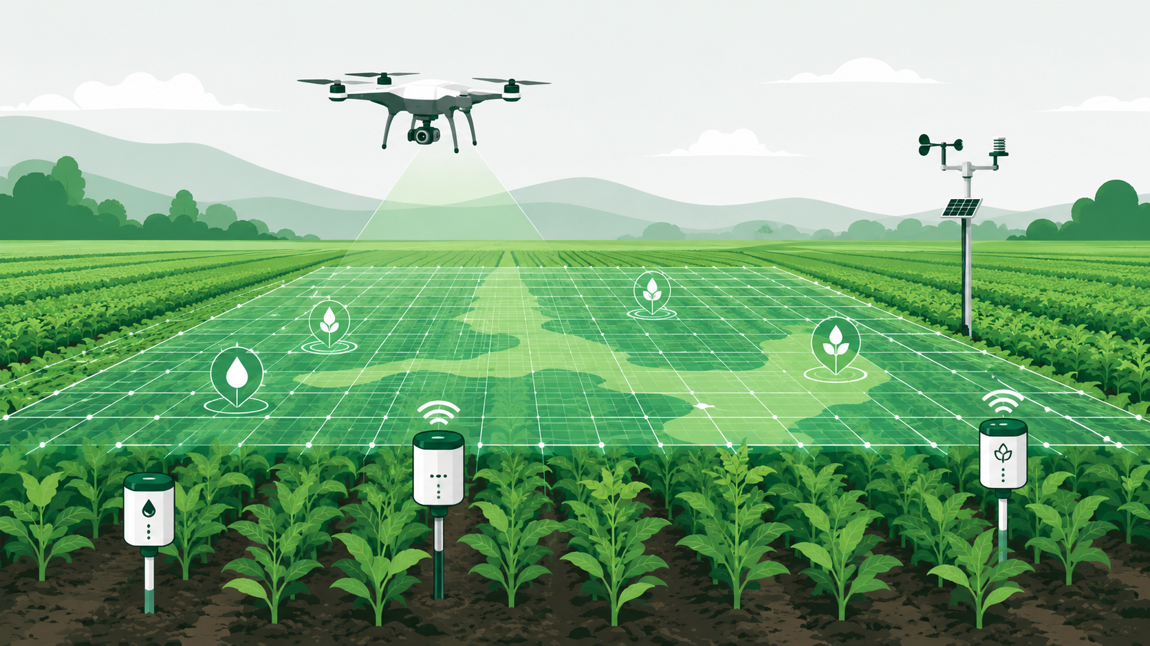
Key Stakeholders
Stakeholder | Role / Interest
Farmers / Farm Owners | Primary users; monitor field health and act on recommendations.
Farm Managers & Agronomists | Interpret Digital Twin insights and plan interventions.
IoT & Hardware Vendors | Supply and maintain soil sensors, weather stations, drones.
Data Scientists / AI Engineers | Build and refine crop health and disease prediction models.
Agribusiness & Cooperatives | Aggregate insights for supply-chain and yield planning.
Government / Agricultural Bodies | Use aggregated data for food-security and policy planning.
Product Owner | Owns the backlog and prioritizes business value.
Scrum Master / Development Team | Deliver working increments each sprint.

2. Epics and User Stories
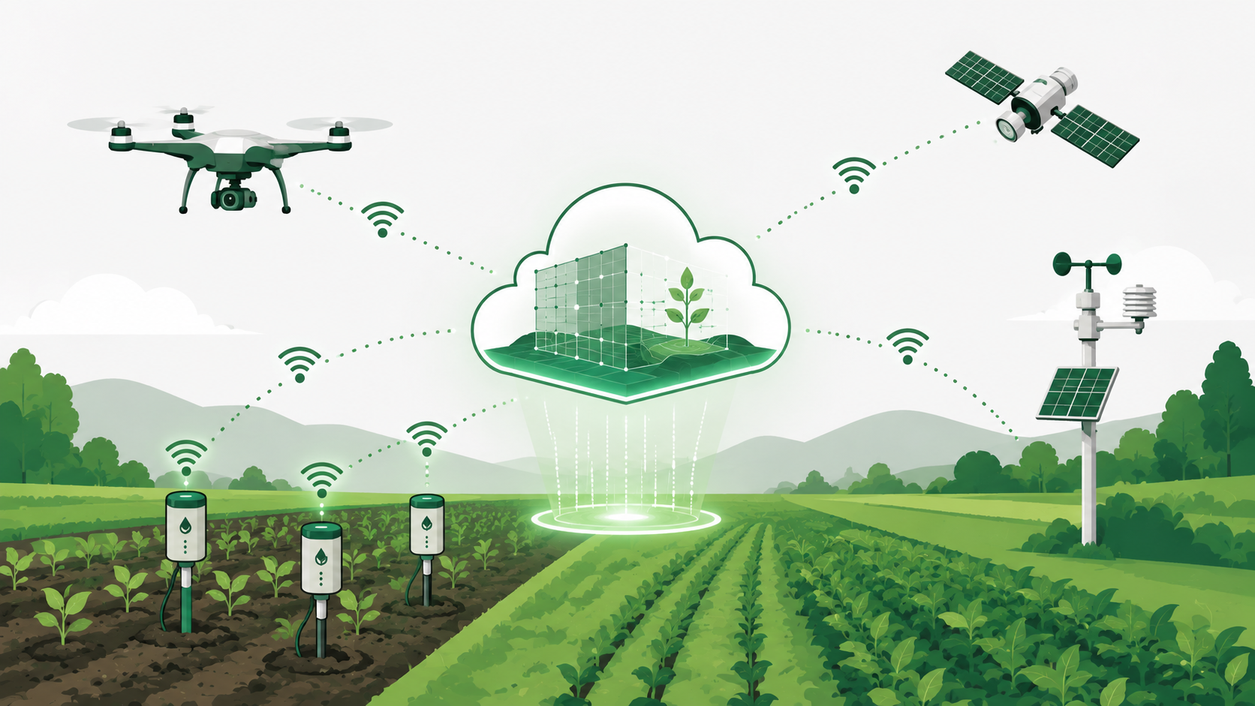
Epic 1 — Real-Time Data Integration & IoT Connectivity
US-01 As a farm data engineer, I want soil sensor readings to flow into the platform in real time, so that moisture and nutrient levels don't have to be checked manually.
US-02 As a farm manager, I want the weather station and satellite feeds synced with the system, so that I don't have to check three different apps to know my field's condition.
US-03 As a system administrator, I want drone images to get pulled in and processed automatically, so that canopy health gets checked on a regular schedule without someone triggering it manually.
Epic 2 — Digital Twin Simulation Engine
US-04 As a farmer, I want to see a virtual version of my field built from the live data, so that I can check on crop and soil conditions without physically being there.
US-05 As an agronomist, I want the twin to run "what-if" simulations of future crop growth, so that I can plan interventions ahead of time instead of reacting late.
Epic 3 — AI-Based Crop Health & Disease Prediction
US-06 As a farmer, I want the system to flag possible crop diseases early using AI, so that I can act before the whole field gets affected.
US-07 As a farmer, I want pest outbreak warnings based on past patterns and current weather, so that I can plan pest control instead of just reacting once I spot damage.
US-08 As an agronomist, I want the platform to pick up nutrient deficiencies from the sensor and image data, so that I know exactly where and what fertilizer is needed.
Epic 4 — Precision Recommendation Engine
US-09 As a farmer, I want irrigation suggestions based on current soil moisture and the weather forecast, so that I'm not over- or under-watering the field.
US-10 As a farmer, I want fertilizer advice that matches the crop's current growth stage, so that I'm not wasting money applying the wrong amount at the wrong time.
Epic 5 — Visualization & Dashboard
US-11 As a farm manager, I want one dashboard showing my farm's overall performance, so that I don't have to dig through separate reports to understand how things are going.
US-12 As a farmer, I want to get an alert on my phone when something critical is wrong with the crop, so that I can respond quickly even if I'm not at the field that day.
Epic 6 — Predictive Reporting
US-13 As a farm owner, I want a report that predicts yield and flags risks automatically, so that I can make business decisions without waiting on someone to compile the numbers.
Epic 7 — Sustainability & Resource Optimization
US-14 As a government agriculture officer, I want sustainability data pulled together across multiple farms, so that I can judge how efficiently resources are being used at a regional level.

3. Acceptance Criteria (Given–When–Then)
US-01 — Soil Sensor Data Integration
Given IoT soil sensors are installed and connected to the platform,
When a sensor transmits a new soil-moisture or nutrient reading,
Then the platform ingests the reading within 30 seconds and updates the field's live data record.
US-04 — Digital Twin Field Visualization
Given real-time and historical field data exists for a registered farm,
When the farmer opens the Digital Twin view for that farm,
Then the platform renders an up-to-date virtual model reflecting current soil, crop, and irrigation status.
US-06 — Early Disease Prediction
Given sensor and imagery data indicate abnormal crop stress patterns,
When the AI prediction engine analyses the latest data batch,
Then the system flags the affected zone with a disease-risk score and notifies the farmer within the same day.
US-09 — Irrigation Recommendation
Given soil-moisture readings and a 3-day weather forecast are available,
When the recommendation engine runs its scheduled analysis,
Then the platform suggests an irrigation schedule and quantity, and logs the recommendation for the farmer's review.
US-11 — Farm Performance Dashboard
Given a farm has at least one active monitoring cycle,
When the farm manager logs in and opens the dashboard,
Then the dashboard displays current yield estimate, soil health, irrigation status, and active alerts on a single screen.
US-13 — Predictive Yield Report
Given a sprint's worth of sensor, imagery, and prediction data has been collected,
When the farm owner requests or receives the scheduled report,
Then the platform generates a report with yield forecast, identified risks, and recommended actions, exportable as PDF.
US-02 — Weather & Satellite Data Sync
Given the weather API and satellite imagery source are configured for a farm,
When a new weather update or satellite pass becomes available,
Then the platform pulls the data automatically and reflects it in the farm's data record within the next sync cycle.
US-03 — Drone Imagery Ingestion
Given a drone completes a scheduled flyover of the field,
When the captured imagery is uploaded to the platform,
Then the system processes the images and updates the canopy-health status for that zone.
US-05 — Crop Growth Simulation
Given a field has enough historical growth data logged,
When the agronomist requests a future-growth simulation for a chosen date range,
Then the platform generates a projected growth curve along with any risk points it expects along the way.
US-07 — Pest Outbreak Forecasting
Given historical pest-incidence data and current environmental readings exist for a field,
When the forecasting model runs its scheduled analysis,
Then the system displays a pest-risk level for the field and suggests a monitoring or control window.
US-08 — Nutrient Deficiency Detection
Given sensor and imagery data for a field show unusual patterns in leaf colour or nutrient readings,
When the detection model processes the latest data,
Then the platform identifies the likely deficiency and suggests a corrective fertilizer action.
US-10 — Fertilization Guidance
Given the crop's current growth stage is known and nutrient data is available,
When the farmer opens the fertilization guidance feature,
Then the platform recommends a fertilizer type and quantity suited to that specific growth stage.
US-14 — Aggregated Sustainability Metrics
Given multiple farms are onboarded and reporting data to the platform,
When a government officer requests a regional sustainability summary,
Then the platform compiles water, fertilizer, and yield-efficiency metrics across those farms into a single report.

4. Product Backlog Prioritization
Stories are ranked mainly by how much business value they add and how urgent the problem is for the farmer, but dependency also matters a lot here - stories like disease prediction or irrigation recommendation can't really start until the data-integration stories (US-01, US-02) are working, so those had to be pushed up even though they aren't glamorous on their own.
ID | User Story | Business Value | Priority | Story Pts
US-01 | Soil sensor data integration | High | High | 5
US-02 | Weather & satellite data sync | High | High | 5
US-03 | Drone imagery ingestion | Medium | Medium | 8
US-04 | Digital Twin field visualization | High | High | 8
US-05 | Future growth simulation | Medium | Low | 13
US-06 | Early disease prediction | High | High | 13
US-07 | Pest outbreak forecasting | Medium | Medium | 8
US-08 | Nutrient deficiency detection | Medium | Medium | 8
US-09 | Irrigation recommendation | High | High | 5
US-10 | Fertilization guidance | Medium | Medium | 5
US-11 | Farm performance dashboard | High | High | 5
US-12 | Mobile critical alerts | High | High | 3
US-13 | Predictive yield report | Medium | Medium | 8
US-14 | Aggregated sustainability metrics | Low | Low | 13

5. Sprint Backlog — Sprint 1 (2 Weeks)
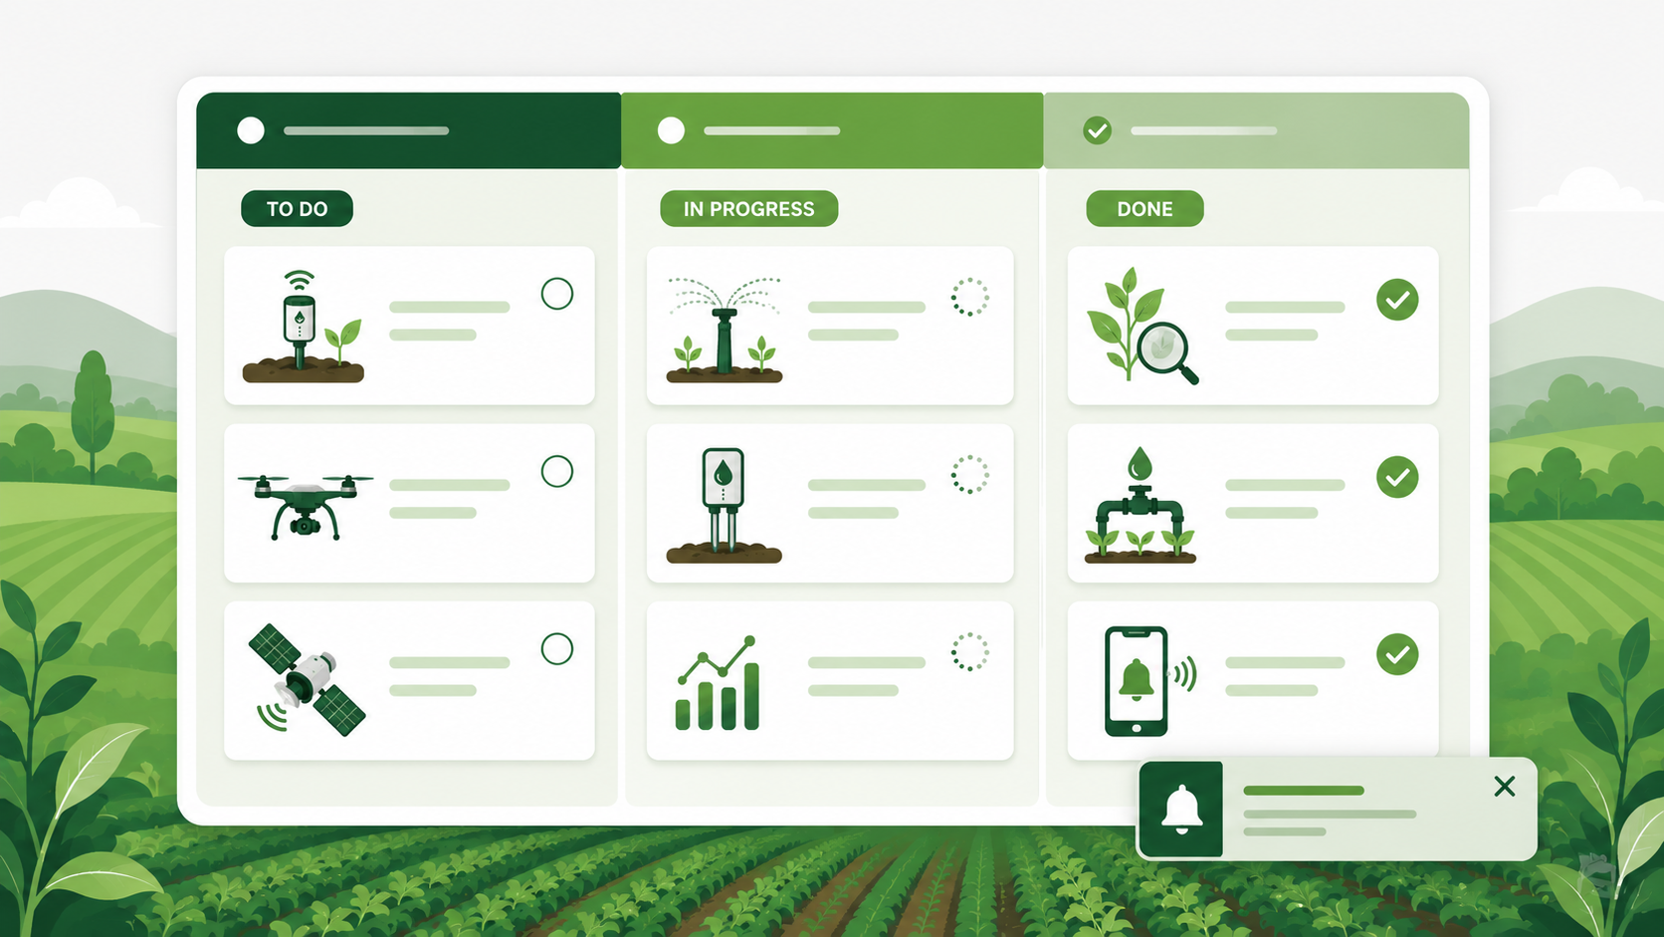
For the first sprint, the team picked six stories that form the base of the whole system - without the data pipeline and the Digital Twin view working, nothing else (dashboards, alerts, predictions) has anything to run on. So this sprint is more about getting the foundation right than shipping flashy features.
User Story | Development Tasks
US-01 Soil sensor integration | Define sensor data schema • Build IoT ingestion API • Validate & store readings • Unit test data pipeline
US-02 Weather & satellite sync | Integrate weather API • Set up satellite imagery feed • Normalize data formats • Schedule sync jobs
US-04 Digital Twin visualization | Design field data model • Build twin-rendering component • Bind live data feed • UI review with farmer persona
US-06 Early disease prediction | Prepare training dataset • Train baseline classification model • Integrate model into pipeline • Configure alert threshold
US-09 Irrigation recommendation | Build rule/ML recommendation logic • Integrate weather forecast input • Generate schedule output • Test edge cases (rain, drought)
US-12 Mobile critical alerts | Design alert rules engine • Build push-notification service • Integrate with dashboard events • Test delivery latency

6. Story Point Estimation (Planning Poker — Fibonacci)
The team used Planning Poker with the Fibonacci scale (1, 2, 3, 5, 8, 13) to estimate each story. The numbers here are less about exact hours and more about how complex or uncertain each story felt compared to the others - a 13 basically means "we're not fully sure how long this will take."
User Story | Points | Justification
US-01 Soil sensor integration | 5 | Fairly standard IoT setup, but reliability and edge cases (sensor drop-outs, bad readings) push it above a 3.
US-02 Weather & satellite sync | 5 | Two external APIs to integrate, but both are well-documented, so the effort is predictable.
US-03 Drone imagery ingestion | 8 | Image upload, storage, and processing pipeline is heavier than a normal data-sync task.
US-04 Digital Twin visualization | 8 | New rendering work plus hooking it up to live data - team hasn't built something like this before, so more effort expected.
US-05 Crop growth simulation | 13 | Simulation logic is still being scoped out; depends on how much historical data is actually usable.
US-06 Early disease prediction | 13 | Biggest unknown in the sprint - depends on getting good labeled data and tuning the model, which could take longer than planned.
US-07 Pest outbreak forecasting | 8 | Needs a working prediction model plus historical pest data, similar scale of effort to disease detection but slightly narrower scope.
US-08 Nutrient deficiency detection | 8 | Depends on both imagery and sensor data being combined correctly; moderate-high complexity.
US-09 Irrigation recommendation | 5 | Mostly rule-based logic with a forecast API plugged in; scope is clear so the estimate is fairly confident.
US-10 Fertilization guidance | 5 | Similar shape to irrigation recommendation, just a different data input and output.
US-11 Farm performance dashboard | 5 | Mostly about pulling already-available data into one screen; some UI work but no new logic.
US-12 Mobile critical alerts | 3 | Can reuse existing notification setup, so this is one of the simpler stories in the sprint.
US-13 Predictive yield report | 8 | Report generation logic plus PDF export adds a bit more effort than a plain dashboard view.
US-14 Aggregated sustainability metrics | 13 | Needs data from multiple farms to be standardized first, which is not fully solved yet.

7. Definition of Done
Before any user story from this sprint is marked complete, it needs to meet the following conditions. This keeps things consistent across the team instead of everyone deciding for themselves what counts as finished.
- Code is written, reviewed by at least one other team member, and merged into the main branch.
- Unit tests are written for the new logic and all tests are passing.
- The feature has been tested against its acceptance criteria (Given-When-Then) and works as expected.
- Any new API or data field is documented so the rest of the team can use it without asking around.
- The feature has been demoed to the Product Owner and accepted, or feedback has been logged for the next sprint.
- No known critical or high-severity bugs are left open against the story.

8. Sprint Ceremonies & Team Roles
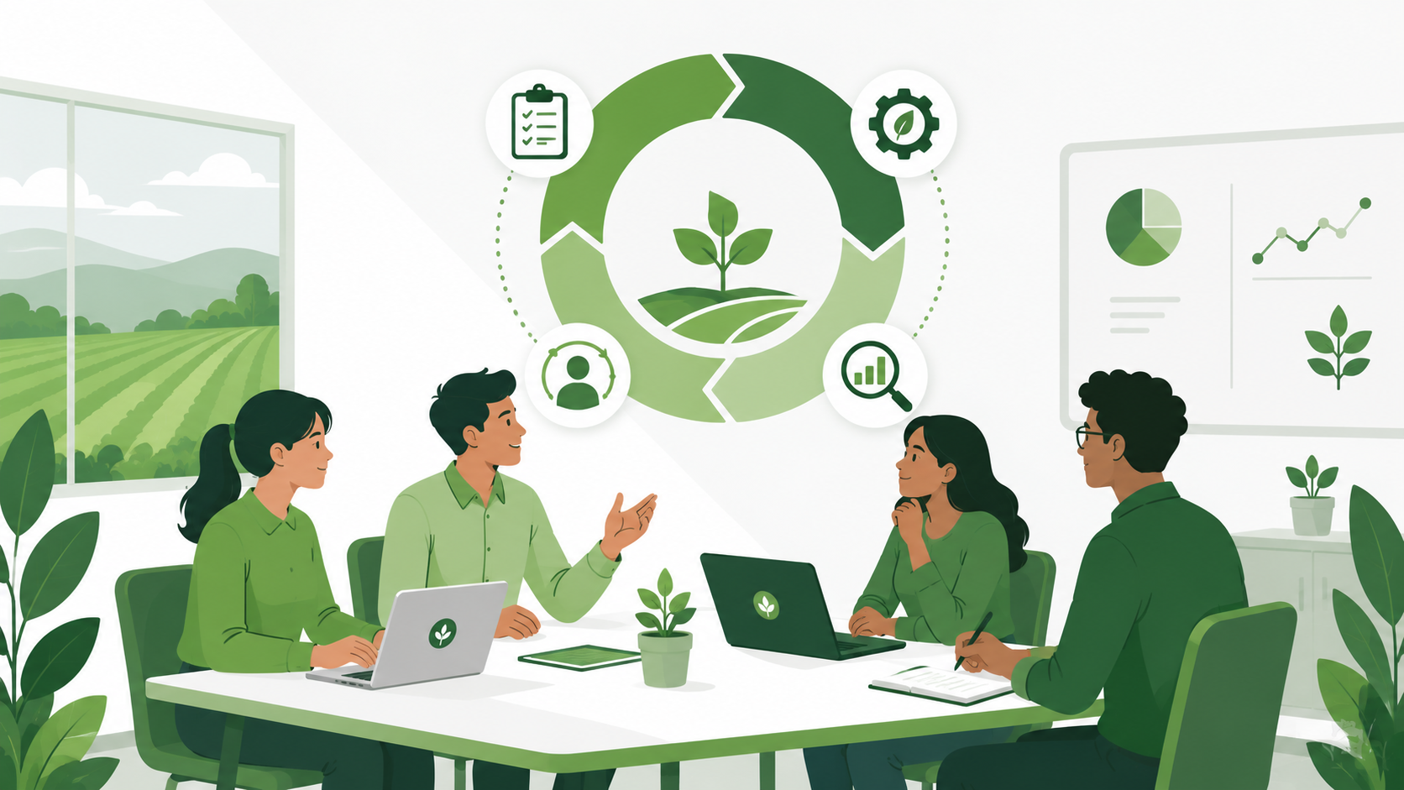
Roles
Role | Responsibility in This Project
Product Owner | Owns the AgriTwin backlog, prioritizes stories based on farmer value, and accepts completed work.
Scrum Master | Removes blockers, keeps ceremonies on track, and shields the team from scope creep mid-sprint.
Development Team | Builds the data pipelines, Digital Twin engine, AI models, and dashboard - self-organizes around the sprint backlog.
Agronomist (Domain Expert) | Validates that predictions and recommendations actually make agricultural sense before release.
Ceremonies
Ceremony | Purpose & Frequency
Sprint Planning | Select and estimate stories for the sprint; held on day 1 of each 2-week sprint.
Daily Stand-up | 15-minute check-in on progress, plans, and blockers; held every working day.
Sprint Review | Demo completed work (e.g. the Digital Twin view, disease alerts) to the Product Owner and stakeholders at the end of the sprint.
Sprint Retrospective | Reflect on what went well and what slowed the team down, and agree on one or two changes for the next sprint.
Backlog Refinement | Mid-sprint session to clarify and re-estimate upcoming stories so Sprint Planning doesn't run long.

9. Risks & Assumptions
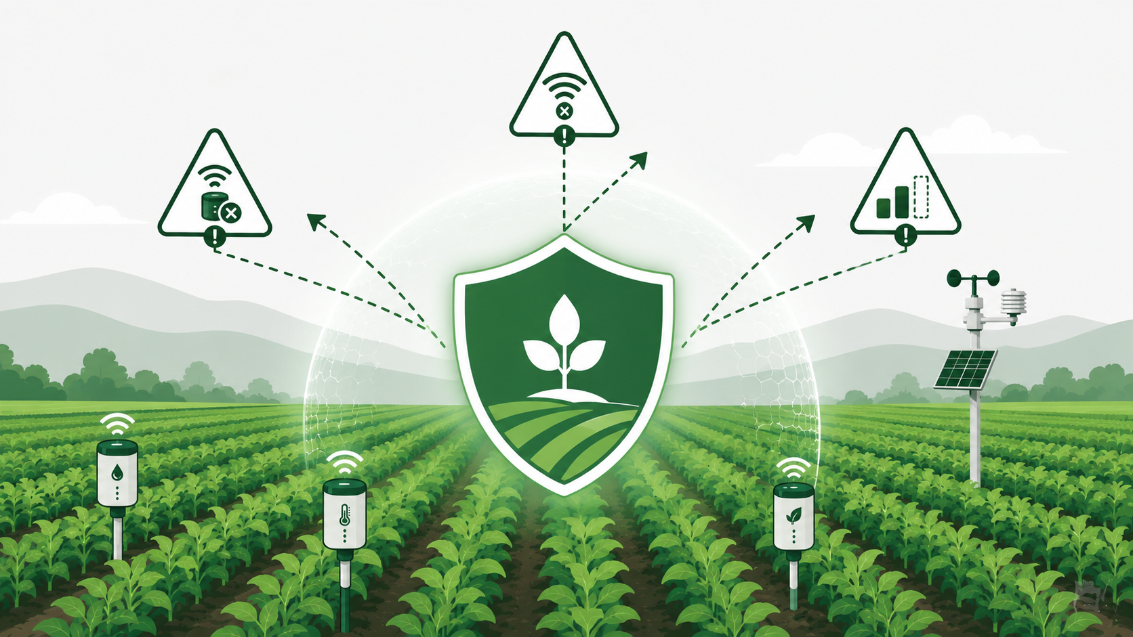
Key Risks
- Sensor or connectivity failures in the field could cause gaps in the data the Digital Twin depends on.
- The disease and pest prediction models need enough labeled data to be reliable - if the dataset is too small or biased, early predictions may not be accurate.
- Farmers with limited smartphone or internet access may not be able to use the mobile alerting feature effectively.
- Integrating multiple external data sources (weather, satellite, drone) means the platform is exposed to third-party API outages or format changes.
Assumptions
- Basic IoT sensor hardware and connectivity are already available or will be provisioned for the pilot farms.
- Farmers are willing to act on the recommendations generated by the platform, even when it differs from their usual practice.
- Historical farm data (previous seasons) is available in some usable form for training the initial AI models.

10. Sprint Goal & Expected Deliverables
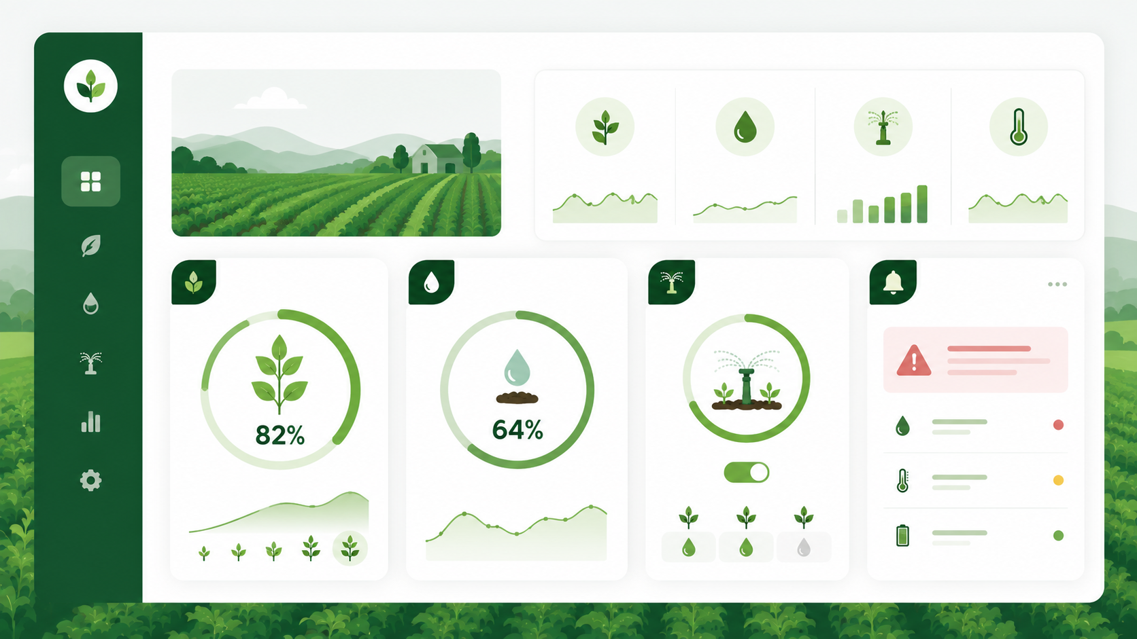
Sprint Goal
By the end of Sprint 1, get the core AgriTwin pipeline working end-to-end - real IoT, weather and satellite data flowing in, a live Digital Twin view a farmer can actually open, and an early version of disease alerts and irrigation suggestions running on top of that data. It doesn't have to be polished, but it has to be real and working, since everything planned in later sprints builds on this.
Expected Deliverables
- A working IoT and weather/satellite data-ingestion pipeline with validated, stored readings.
- A live Digital Twin visualization reflecting current field, soil, and crop status.
- A baseline AI model that flags early disease risk with an alert notification.
- An irrigation recommendation feature driven by soil moisture and forecast data.
- A performance dashboard summarizing key farm metrics in a single view.
- A mobile alerting mechanism for critical, time-sensitive crop-health notifications.

11. Glossary of Agile Terms Used
A quick reference for the Agile terms used throughout this document.
Term | Meaning
Epic | A large body of work (like "Precision Recommendation Engine") that is too big to build in one sprint, so it gets broken down into smaller user stories.
User Story | A short, plain-language description of a feature written from the user's point of view: "As a <user>, I want <feature>, so that <benefit>."
Acceptance Criteria | The specific conditions a user story must satisfy before it can be considered done, often written in Given-When-Then form.
Product Backlog | The full, prioritized list of everything that could be built for the product, maintained by the Product Owner.
Sprint Backlog | The subset of the product backlog the team commits to finishing within the current sprint.
Sprint | A fixed time-box (2 weeks here) during which the team builds, tests, and delivers a working increment.
Story Points | A relative measure of effort/complexity/uncertainty for a story, usually estimated using a Fibonacci-like scale (1, 2, 3, 5, 8, 13...).
Planning Poker | A group estimation technique where team members privately pick a story-point card and reveal it together, discussing gaps before agreeing.
Sprint Goal | A short statement describing what the team is trying to achieve by the end of the sprint, giving the individual stories a shared purpose.
Definition of Done | The checklist of conditions (tested, reviewed, documented, etc.) a story must meet before it's marked complete.
Velocity | The average number of story points a team completes per sprint, used to plan how much work fits in future sprints.
Retrospective | An end-of-sprint meeting where the team reflects on what worked and what didn't, and picks improvements for the next sprint.

