Author Component:

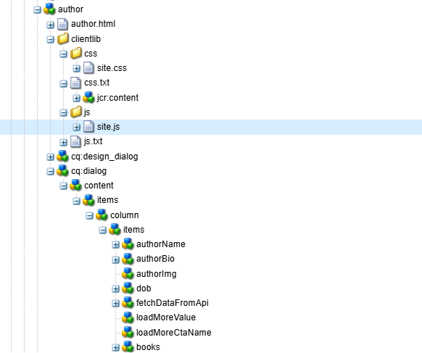

🡪Base Page:

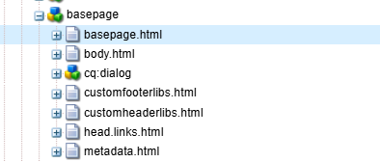

site.css:

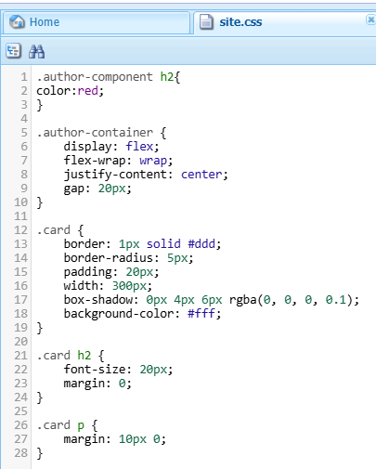

Header & Footer:

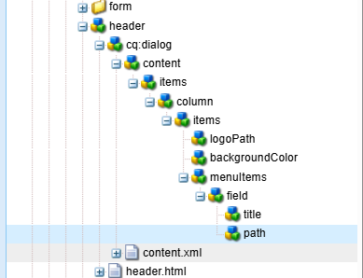

🡪Experience frahgment setup for both header & Footer:

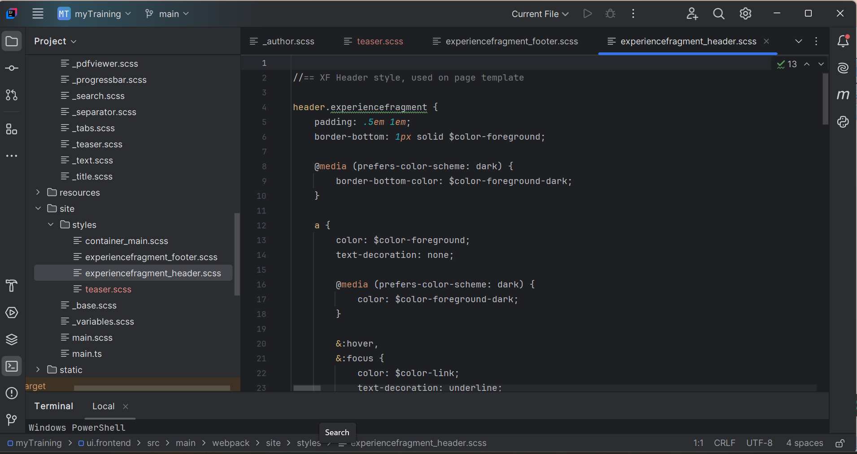  
  
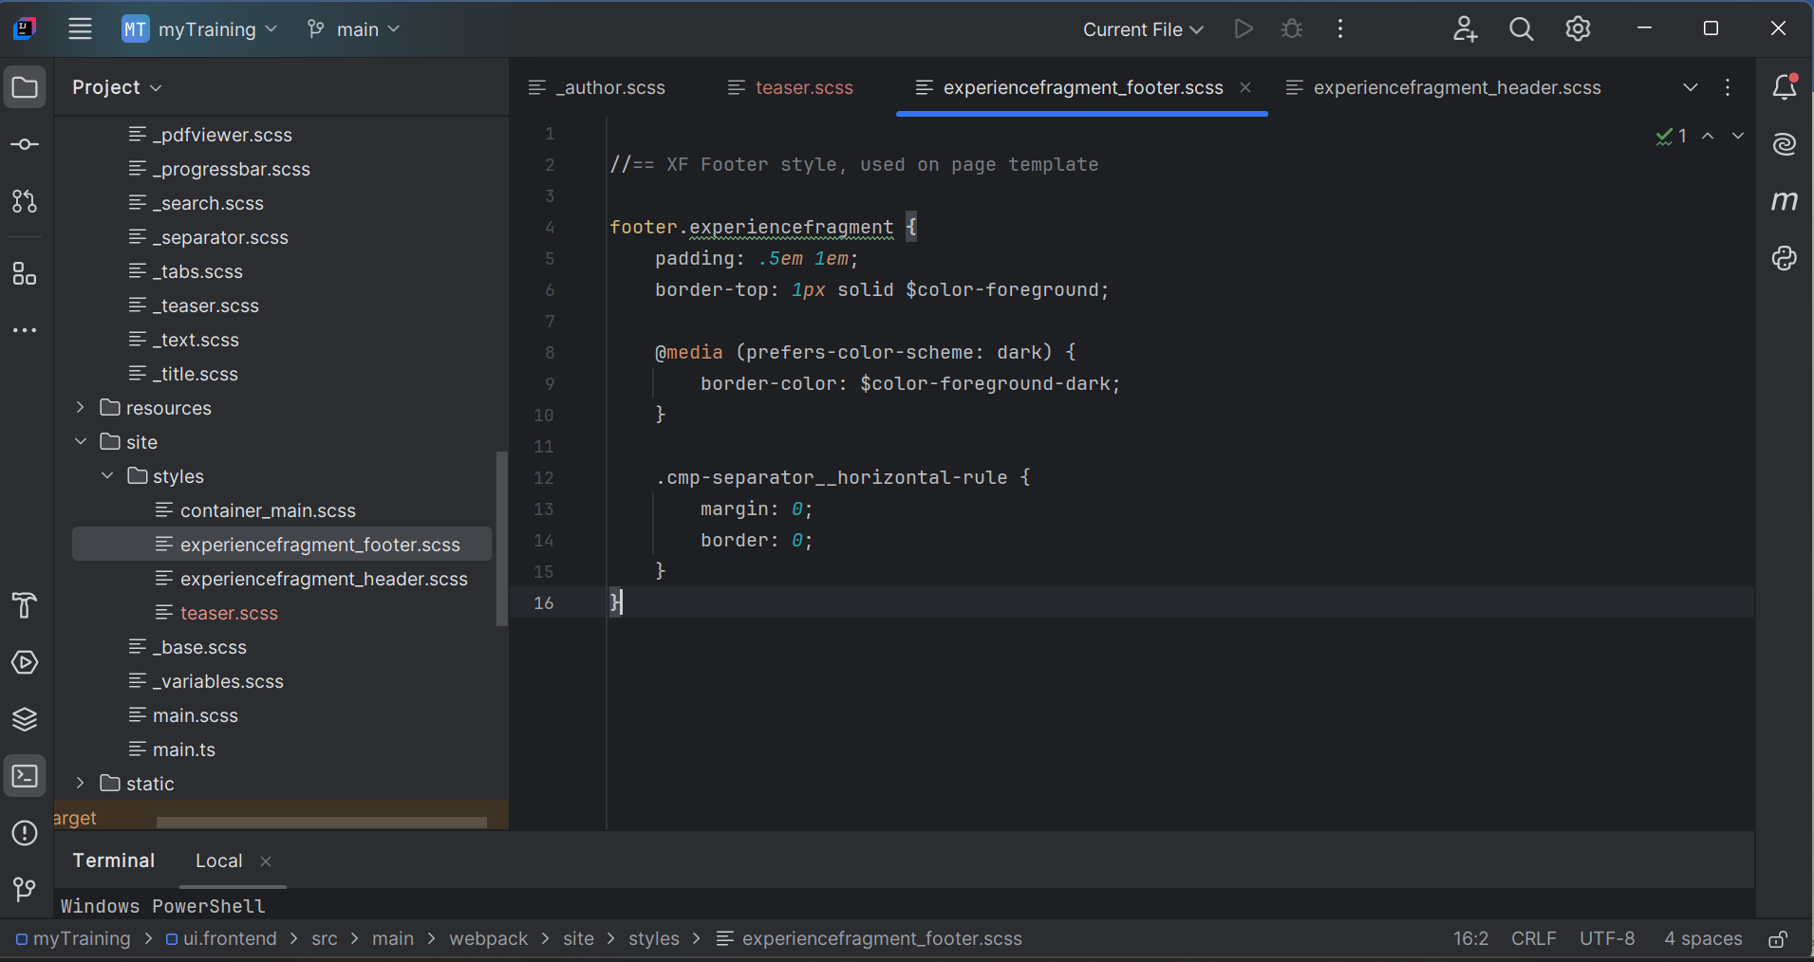

Style for book cards to fetch api:  
site.js:  
  
// Function to fetch data from the API

async function fetchData() {

try {

const response = await fetch('https://potterapi-fedeperin.vercel.app/en/books');

const data = await response.json();

return data;

} catch (error) {

console.error('Error fetching data:', error);

return [];

}

}

// Function to render data in cards

async function renderData() {

const container = document.querySelector('.author-container');

const loadMoreButton = document.getElementById('load-more');

if (!container || !loadMoreButton) {

console.error('Required elements not found!');

return;

}

const cardsToShow = parseInt(loadMoreButton.dataset.cardsToShow, 10) || 3;

let currentIndex = 0;

const data = await fetchData();

if (!data.length) {

console.error('No books found!');

return;

}

// Function to show a chunk of cards

function showCards(startIndex, endIndex) {

for (let i = startIndex; i < endIndex && i < data.length; i++) {

const book = data[i];

const card = document.createElement('div');

card.classList.add('card');

const img = document.createElement('img');

img.src = book.cover;

img.alt = book.title;

const title = document.createElement('h2');

title.textContent = book.title;

const description = document.createElement('p');

description.textContent = book.description;

card.appendChild(img);

card.appendChild(title);

card.appendChild(description);

container.appendChild(card);

}

}

// Initially show the first few cards

showCards(currentIndex, currentIndex + cardsToShow);

currentIndex += cardsToShow;

// Load more cards when the button is clicked

loadMoreButton.addEventListener('click', function () {

showCards(currentIndex, currentIndex + cardsToShow);

currentIndex += cardsToShow;

if (currentIndex >= data.length) {

loadMoreButton.style.display = 'none';

}

});

if (currentIndex >= data.length) {

loadMoreButton.style.display = 'none';

}

}

// Call the renderData function

renderData();  
Other CSS:  
body, html {

background: #ececec;

color: #202020;

font-family: Helvetica Neue, Helvetica, Arial, sans-serif;

font-size: 1pc;

line-height: 1.5;

margin: 0;

}

@media (prefers-color-scheme: dark) {

body, html {

background: #131313;

color: #dfdfdf;

}

}

a {

color: #2020e0;

}

@media (prefers-color-scheme: dark) {

a {

color: #dfdf1f;

}

}

button, input, optgroup, select, textarea {

font: inherit;

}

.author-component p {

color: blue;

}

.cmp-test123 {

color: red;

}

.cmp-helloworld__item-label {

margin-bottom: 0;

}

.cmp-helloworld__item-output {

margin-top: 0;

}

.cmp-list__item-title {

color: red;

}

.cmp-navigation__item--level-0:hover > .cmp-navigation__group {

background: #ececec;

}

main.container {

padding: 0.5em 1em;

}

footer.experiencefragment {

border-top: 1px solid #202020;

padding: 0.5em 1em;

}

@media (prefers-color-scheme: dark) {

footer.experiencefragment {

border-color: #dfdfdf;

}

}

footer.experiencefragment .cmp-separator__horizontal-rule {

border: 0;

margin: 0;

}

header.experiencefragment {

border-bottom: 1px solid #202020;

padding: 0.5em 1em;

}

@media (prefers-color-scheme: dark) {

header.experiencefragment {

border-bottom-color: #dfdfdf;

}

}

header.experiencefragment a {

color: #202020;

text-decoration: none;

}

@media (prefers-color-scheme: dark) {

header.experiencefragment a {

color: #dfdfdf;

}

}

header.experiencefragment a:focus,

header.experiencefragment a:hover {

color: #2020e0;

text-decoration: underline;

}

@media (prefers-color-scheme: dark) {

header.experiencefragment a:focus,

header.experiencefragment a:hover {

color: #dfdf1f;

}

}

header.experiencefragment .cmp-container {

display: grid;

grid-template-columns: 4fr 1fr 1fr;

}

header.experiencefragment .cmp-navigation__group {

list-style: none;

margin: 0;

padding: 0;

}

header.experiencefragment .cmp-navigation__item--level-0 {

display: grid;

grid-template-columns: 1fr 3fr;

}

header.experiencefragment .cmp-navigation__item--level-0 > .cmp-navigation__group {

display: grid;

grid-template-columns: repeat(3, 1fr);

}

header.experiencefragment .cmp-navigation__item-link {

display: block;

}

header.experiencefragment .cmp-navigation__item--active > .cmp-navigation__item-link {

font-weight: 700;

}

header.experiencefragment .cmp-languagenavigation {

position: relative;

}

header.experiencefragment .cmp-languagenavigation:before {

background-image: url('data:image/svg+xml;utf8,<svg xmlns="http://www.w3.org/2000/svg" viewBox="0 0 24 24"><path fill="rgb(32,32,32)" d="M12.1,0.2h-0.1c-3.1,0-6.1,1.3-8.3,3.5C1.4,6,0.2,8.9,0.2,12.1c0,3.1,1.3,6.1,3.5,8.3c2.2,2.2,5.1,3.4,8.3,3.4 c0,0,0,0,0.1,0c6.5,0,11.7-5.3,11.7-11.8C23.7,5.5,18.5,0.3,12.1,0.2z"/></svg>');

background-repeat: no-repeat;

content: " ";

display: block;

height: 1.5em;

}

@media (prefers-color-scheme: dark) {

header.experiencefragment .cmp-languagenavigation:before {

background-image: url('data:image/svg+xml;utf8,<svg xmlns="http://www.w3.org/2000/svg" viewBox="0 0 24 24"><path fill="rgb(223,223,223)" d="M12.1,0.2h-0.1c-3.1,0-6.1,1.3-8.3,3.5C1.4,6,0.2,8.9,0.2,12.1c0,3.1,1.3,6.1,3.5,8.3c2.2,2.2,5.1,3.4,8.3,3.4 c0,0,0,0,0.1,0c6.5,0,11.7-5.3,11.7-11.8C23.7,5.5,18.5,0.3,12.1,0.2z"/></svg>');

}

}