**AEM LOCAL SETUP**

**Prerequisites**

* **Java 11** installed (Ensure Java is added to the system path)
* AEM jar file (e.g., aem-author-p4502.jar)

**Steps to Set Up AEM Locally**

**1. Install Java 11 and Set Path**

* Download and install **Java 11** from the official [**Oracle JDK**](https://www.oracle.com/java/technologies/javase/jdk11-archive-downloads.html)
* Set the Java path:
  1. Open **Environment Variables**.
  2. Under **System Variables**, find **Path**, select it, and click **Edit**.
  3. Click **New** and add the path to the bin folder of Java installation (e.g., C:\Program Files\Java\jdk-11\bin).
  4. Click **OK** to save changes.
* Verify the installation by running:

java -version

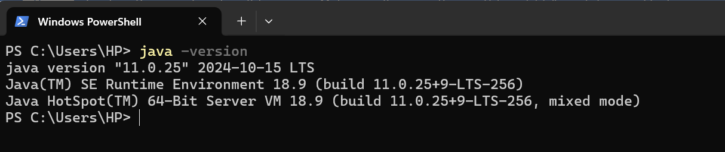

**2. Create a Directory**

* Navigate to **Local Disk (C:)**.
* Create a new folder named **AEM**.
* Place the **AEM jar file** inside this folder.

**3. Start AEM**

* Open **Command Prompt** and navigate to the AEM folder:

cd C:\AEM

* Run the following command to start AEM:

java -jar aem-author-p4502.jar

* This command will **unzip and initialize** the AEM instance.

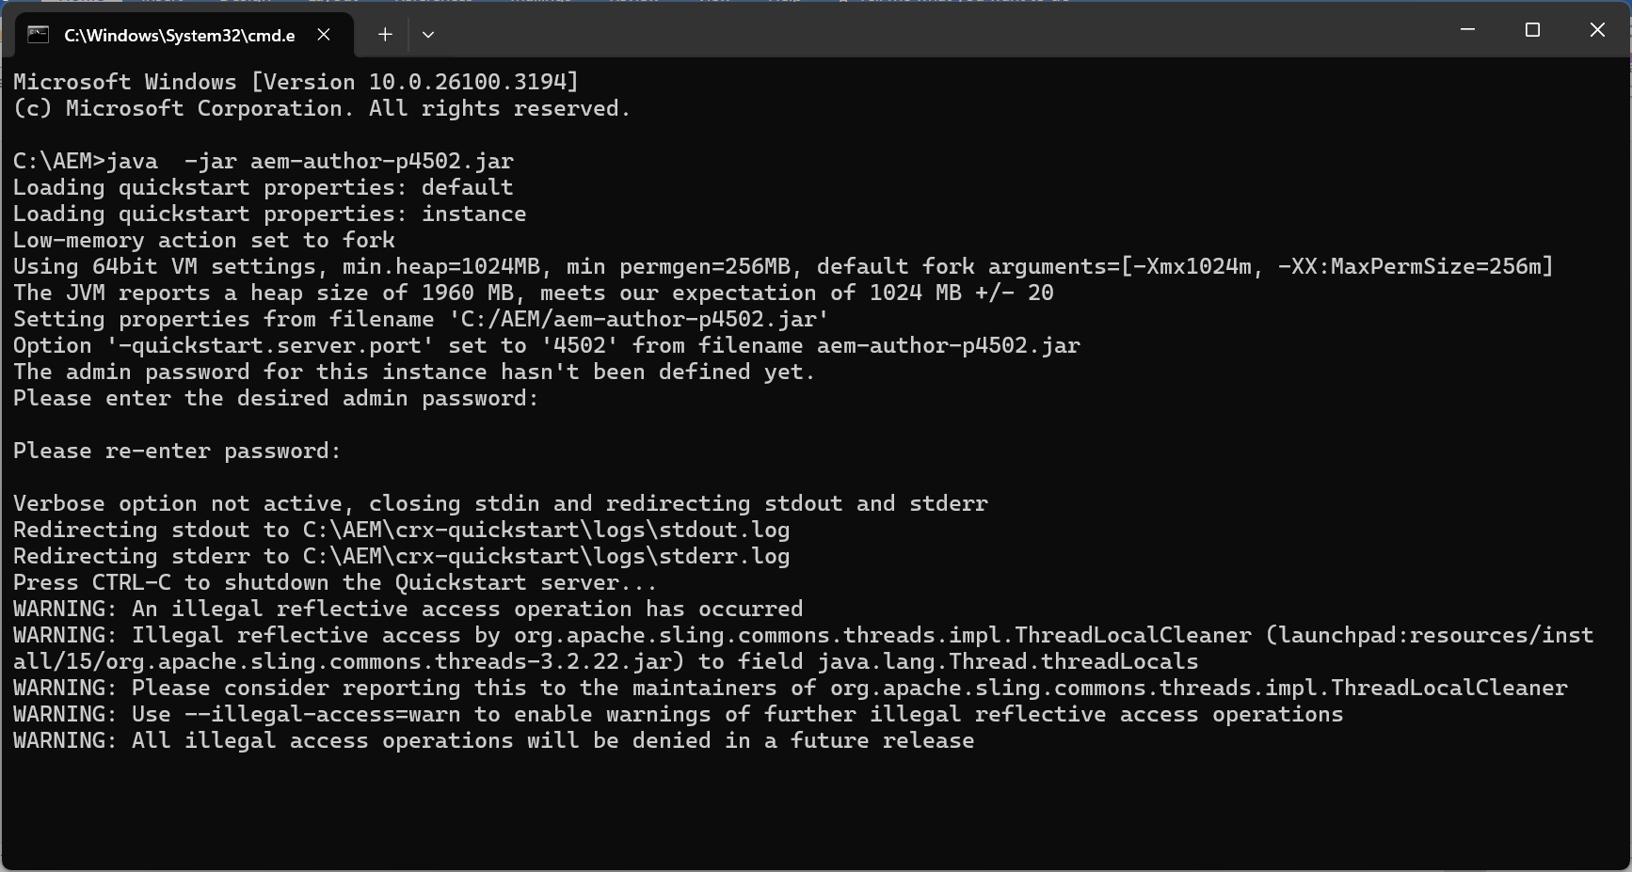

**4. Access AEM**

* Once the setup is complete, AEM will start, and you will be prompted to log in.
* Open a web browser and visit:

<http://localhost:4502>

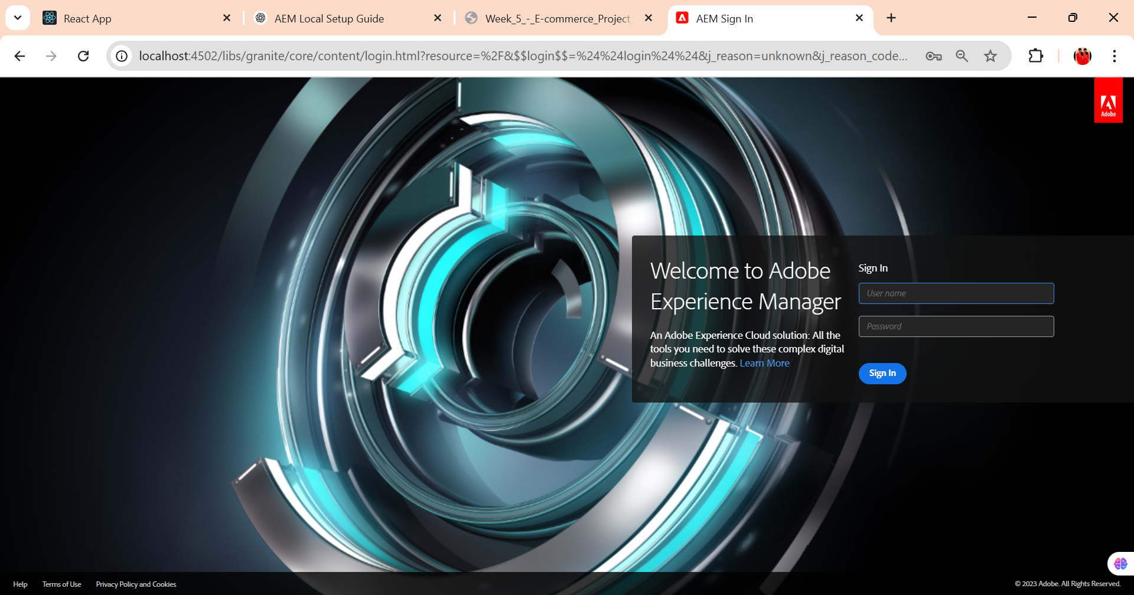

* Enter the credentials:
  + **Username:** admin
  + **Password:** admin
* After logging in, the AEM authoring environment will be available.

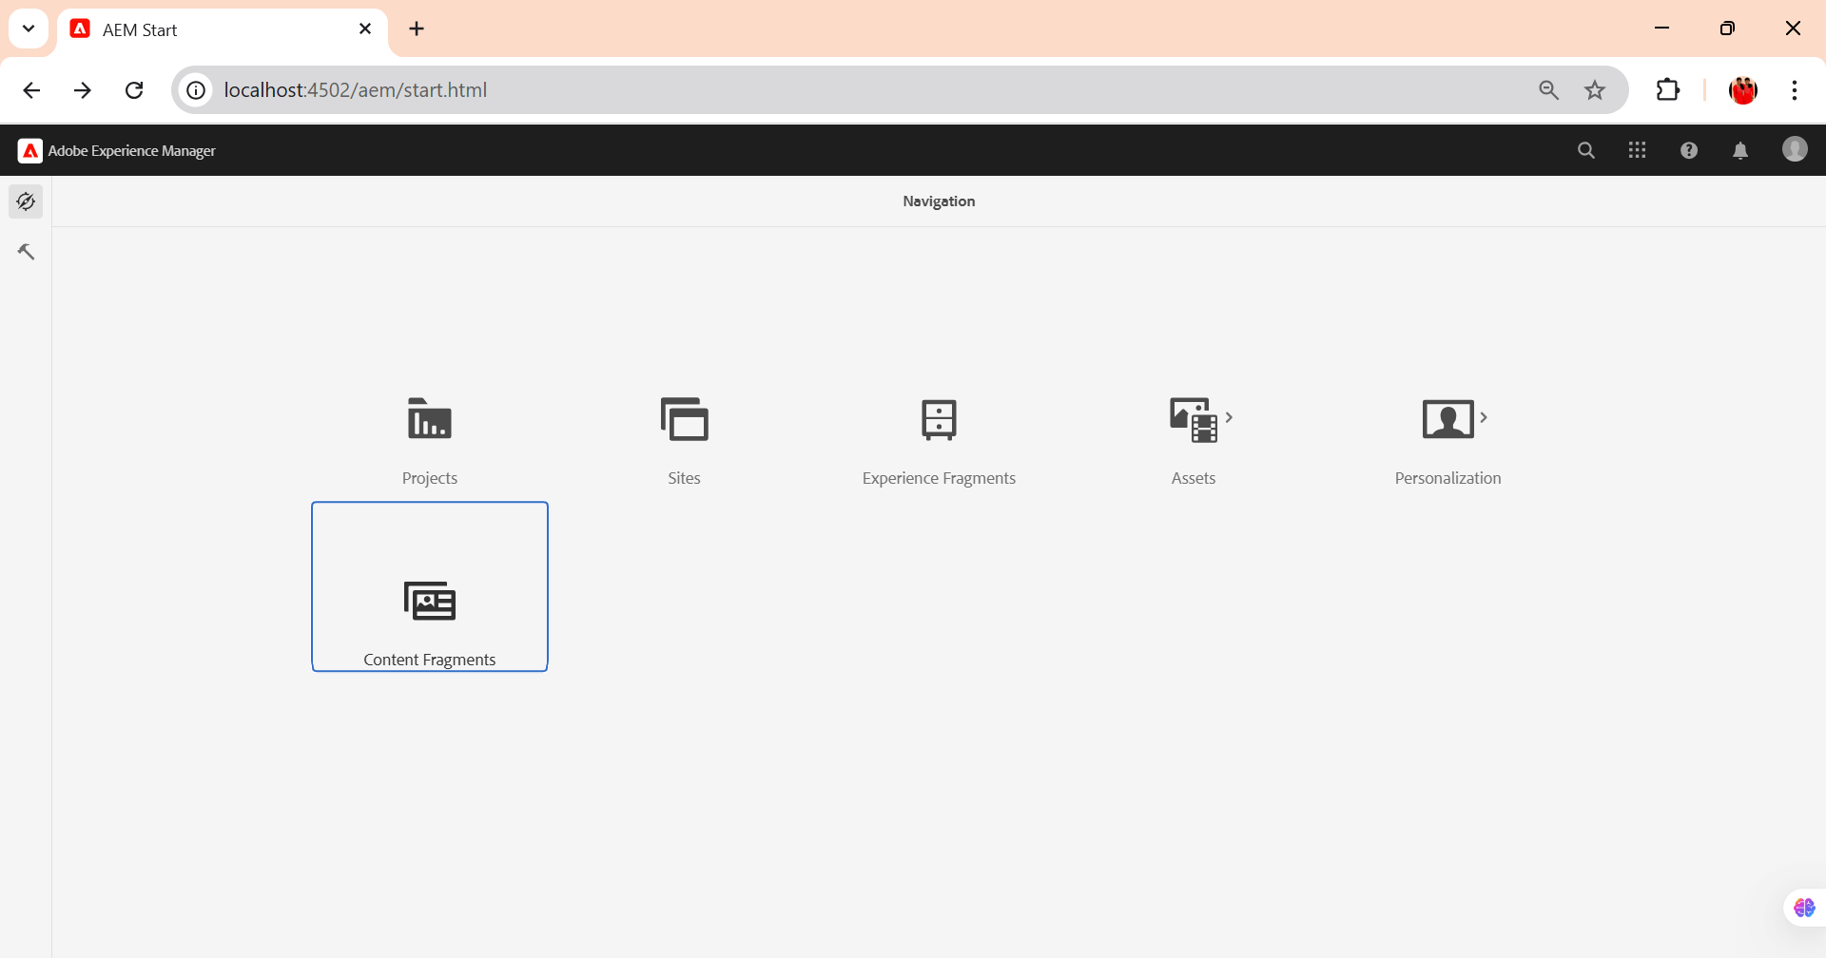

# AEM Project Structure

## Prerequisites

* **Java 11** installed and configured in the system path.
* **Adobe Experience Manager (AEM) 6.5.5** running locally.
* **Maven 3.9.9** installed.

## Step 1: Install Maven 3.9.9

1. Download Maven **3.9.9** from the official website:<https://maven.apache.org/download.cgi>
2. Extract the downloaded ZIP file to a preferred location
3. Set up the environment variables:
   * Click on **Environment Variables**.
   * Under **System Variables**, find **Path**, select it, and click **Edit**.
   * Click **New** and add the path to Maven’s bin directory (e.g., C:\Maven\bin).
4. Verify the installation by running the following command in **Command Prompt (Run as Administrator)**:

mvn -version

It should return something like:

## 

## Step 2: Create an AEM Project Structure

Run the following command in **Command Prompt (Run as Administrator)** to generate the AEM project structure:

### mvn -B org.apache.maven.plugins:maven-archetype-plugin:3.2.1:generate -D archetypeGroupId=com.adobe.aem -D archetypeArtifactId=aem-project-archetype -D archetypeVersion=39 -D appTitle="myTraining" -D appId="myTraining" -D groupId="com.myTraining" -D aemVersion=6.5.5 -D includeExamples=n -D includeErrorHandler=y

## Step 3: Navigate to the Project Folder

Once the project is generated, move into the newly created project directory:

cd myTraining

## Step 4: Build and Deploy the AEM Project

To build and deploy the project to AEM, run the following command:

mvn clean install