🡪Open AEM and move to sites  
 <http://localhost:4502/crx/de/index.jsp>  
🡪Move to   
 /apps/myTraining/components  
  
🡪In components create a new node and name as -> author

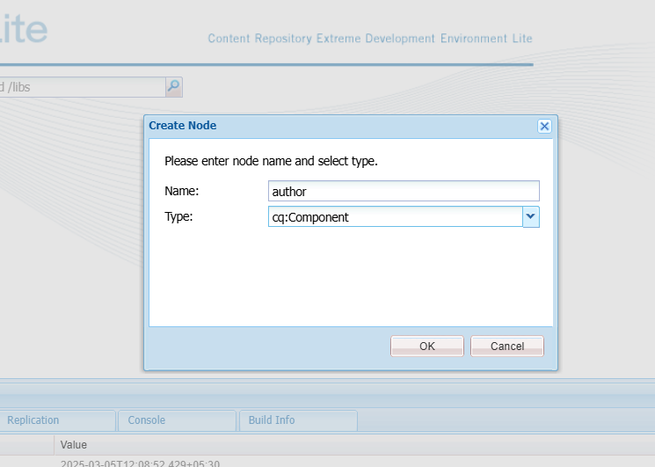

🡪In **author** node create dialog name as – cq:dialog

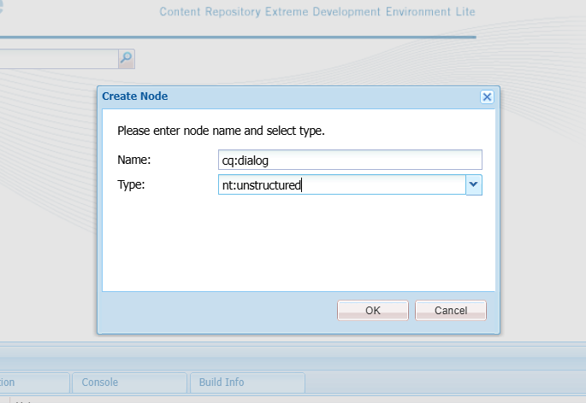

🡪In **cq:dialogue** create a node - content

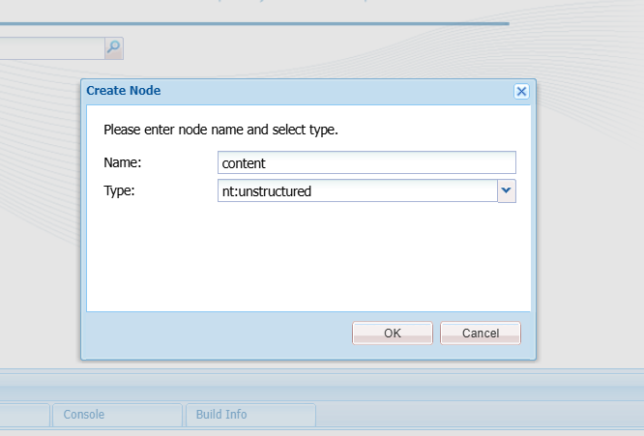

🡪In **content** add node – items

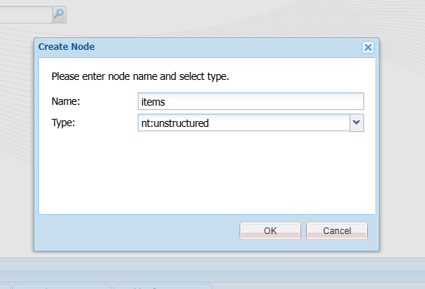

🡪In **items** should add nodes – authorName , authorBio , dob

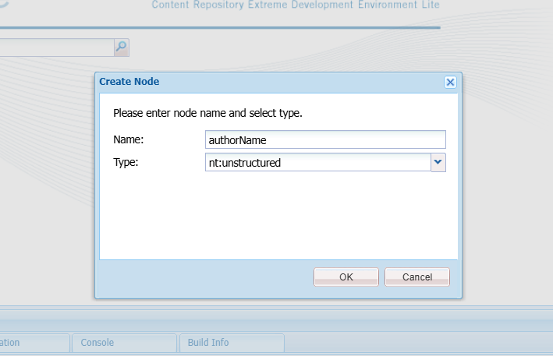

🡪Properties should add for the field  
  
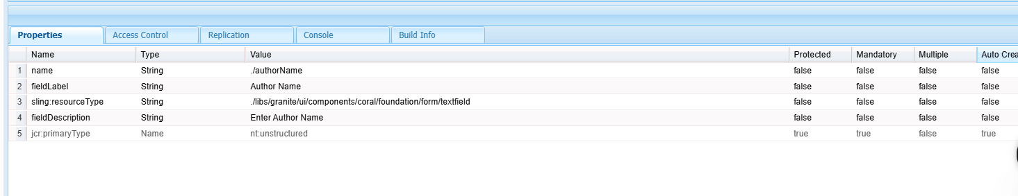

🡪node -> authorBio

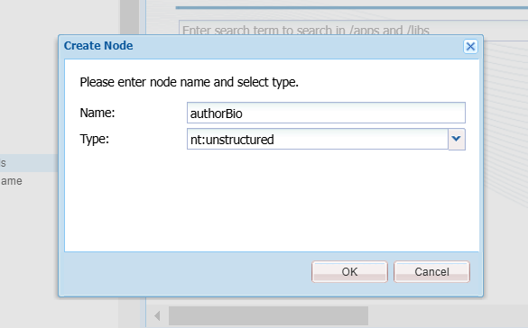

🡪property for **authorBio**

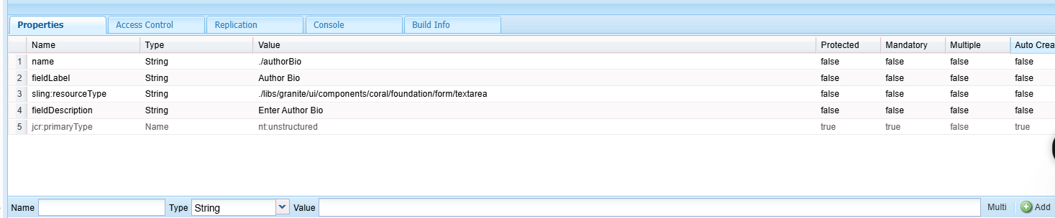

🡪node – dob

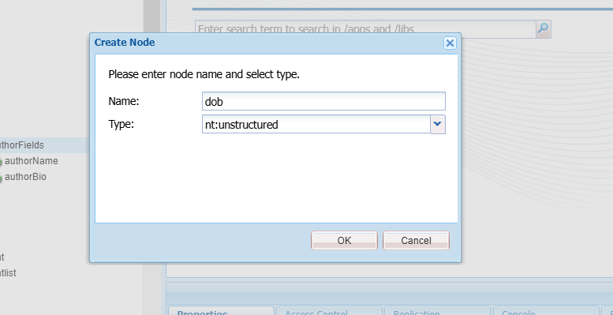

🡪properties to be set for the node  
  
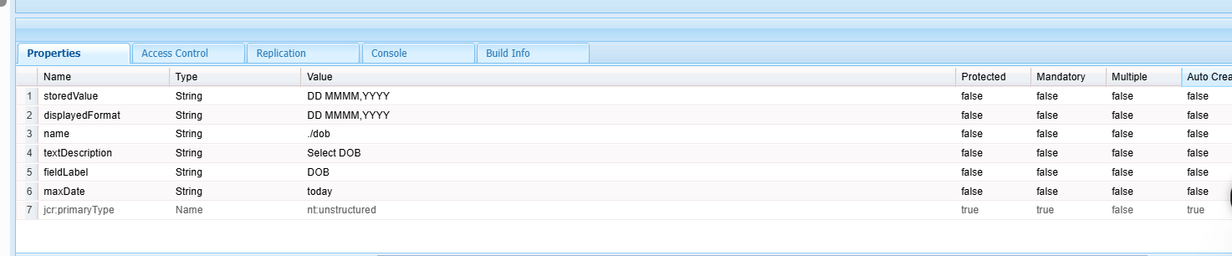  
  
🡪After creating nodes , Create a html file to validate and style,

🡪author.html in **author** node

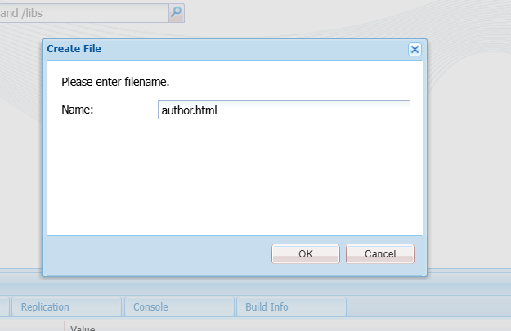

**🡪The author.html file contains**

<div class="cmp-helloworld" data-cmp-is="helloworld">

<h2 class="cmp-helloworld__title">Author</h2>

<div class="cmp-helloworld__item" data-sly-test="${properties.authorName}">

<p class="cmp-helloworld__item-label">Author name:</p>

<pre class="cmp-helloworld__item-output" data-cmp-hook-helloworld="property">${properties.authorName}</pre>

</div>

<div class="cmp-helloworld__item" data-sly-test="${properties.authorBio}">

<p class="cmp-helloworld__item-label">Author bio:</p>

<pre class="cmp-helloworld__item-output" data-cmp-hook-helloworld="property">${properties.authorBio}</pre>

</div>

<div class="cmp-helloworld__item" data-sly-test="${properties.dob}">

<p class="cmp-helloworld__item-label">Date of Birth:</p>

<pre>${properties.dob.time}</pre>

</div>

</div>  
  
  
🡪Now restart AEM and move to – sites – myTraining   
 🡪create a page in mytraining - myTraining

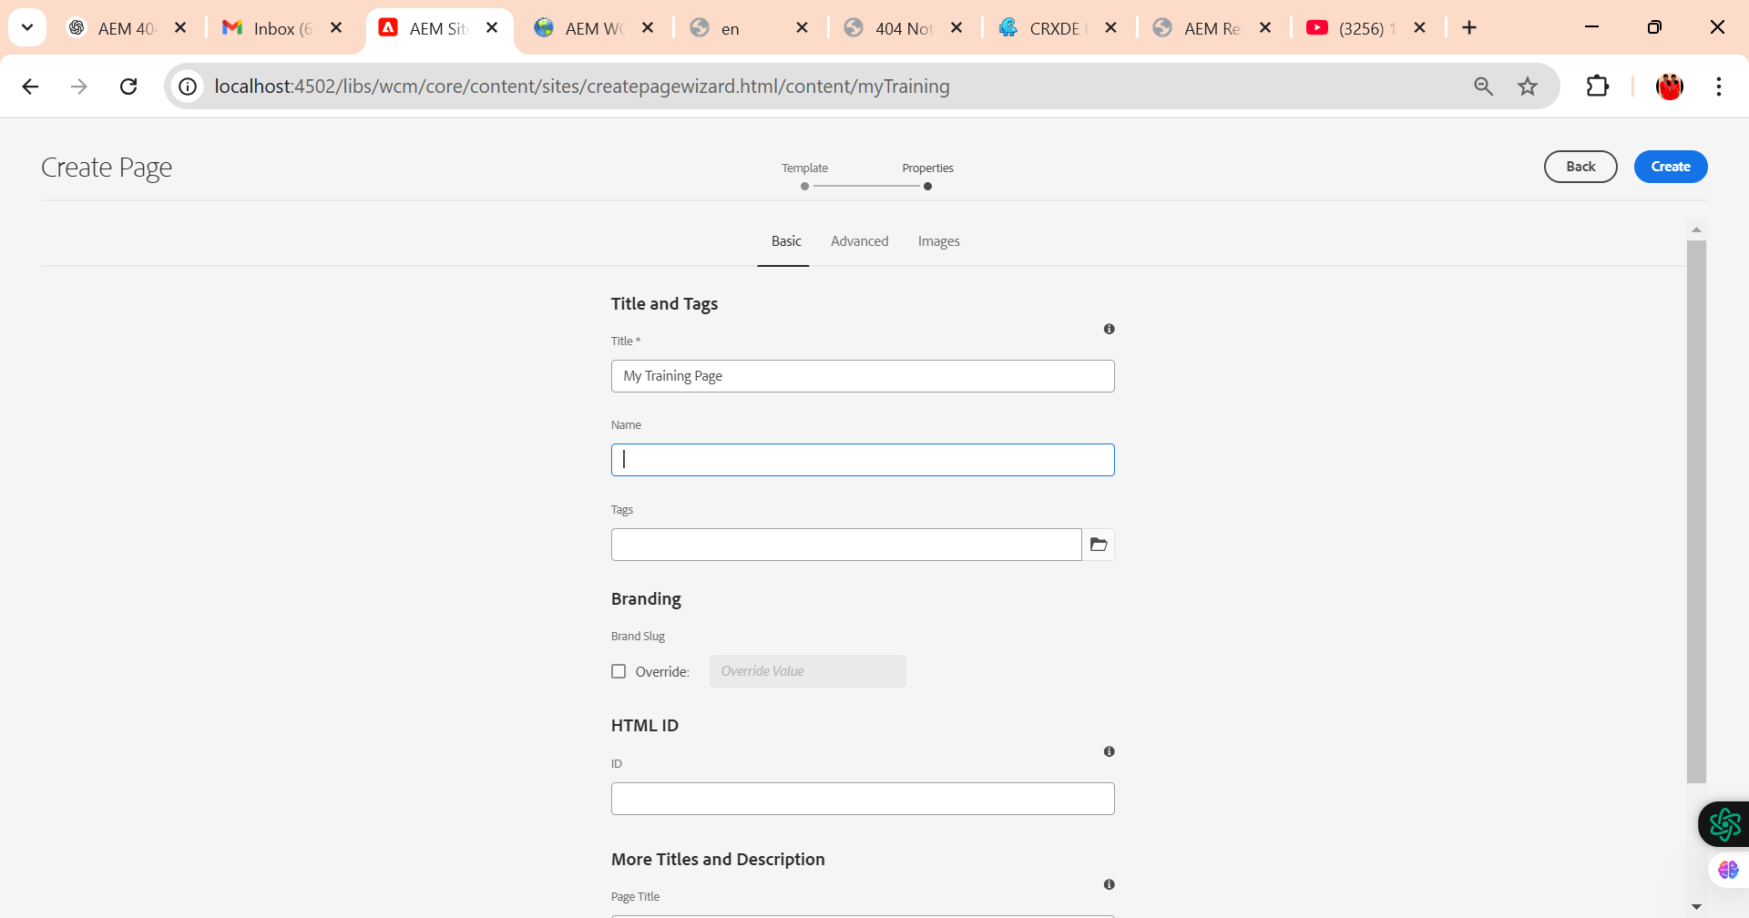

🡪Page created Successfully  
  
   
 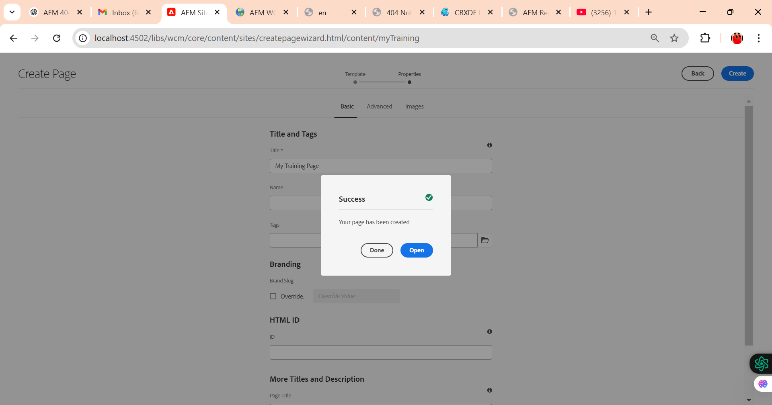

🡪This below page will be shown

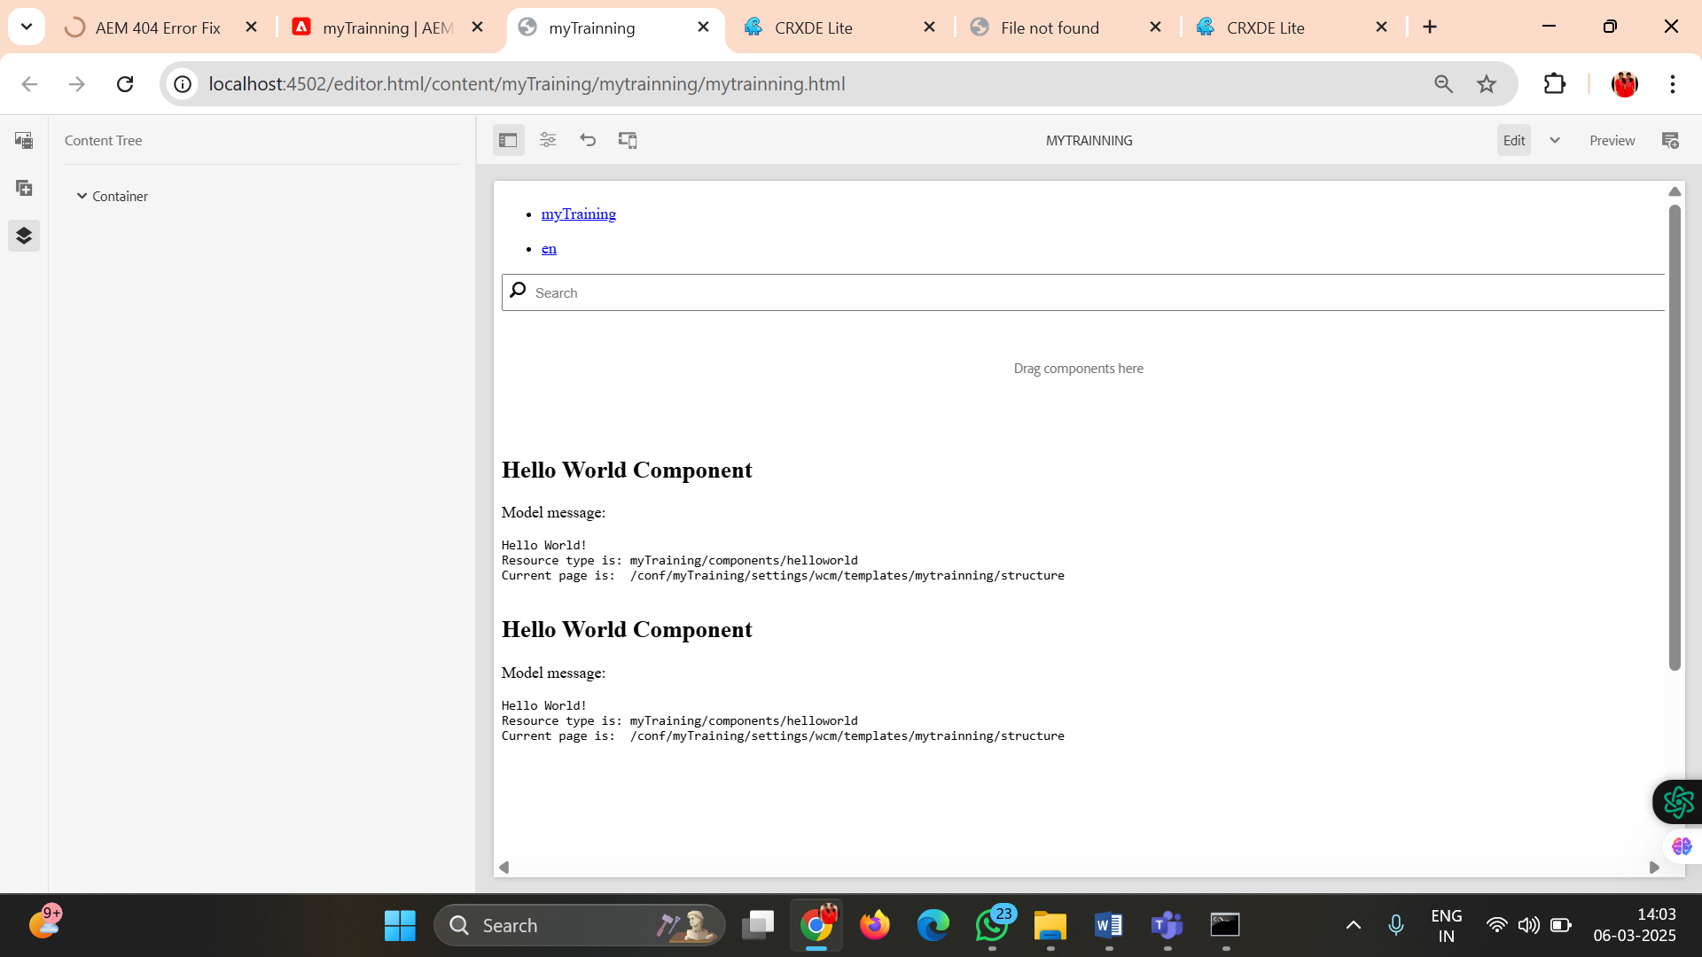

🡪Now open the page and drag and drop the component that we creates as – author

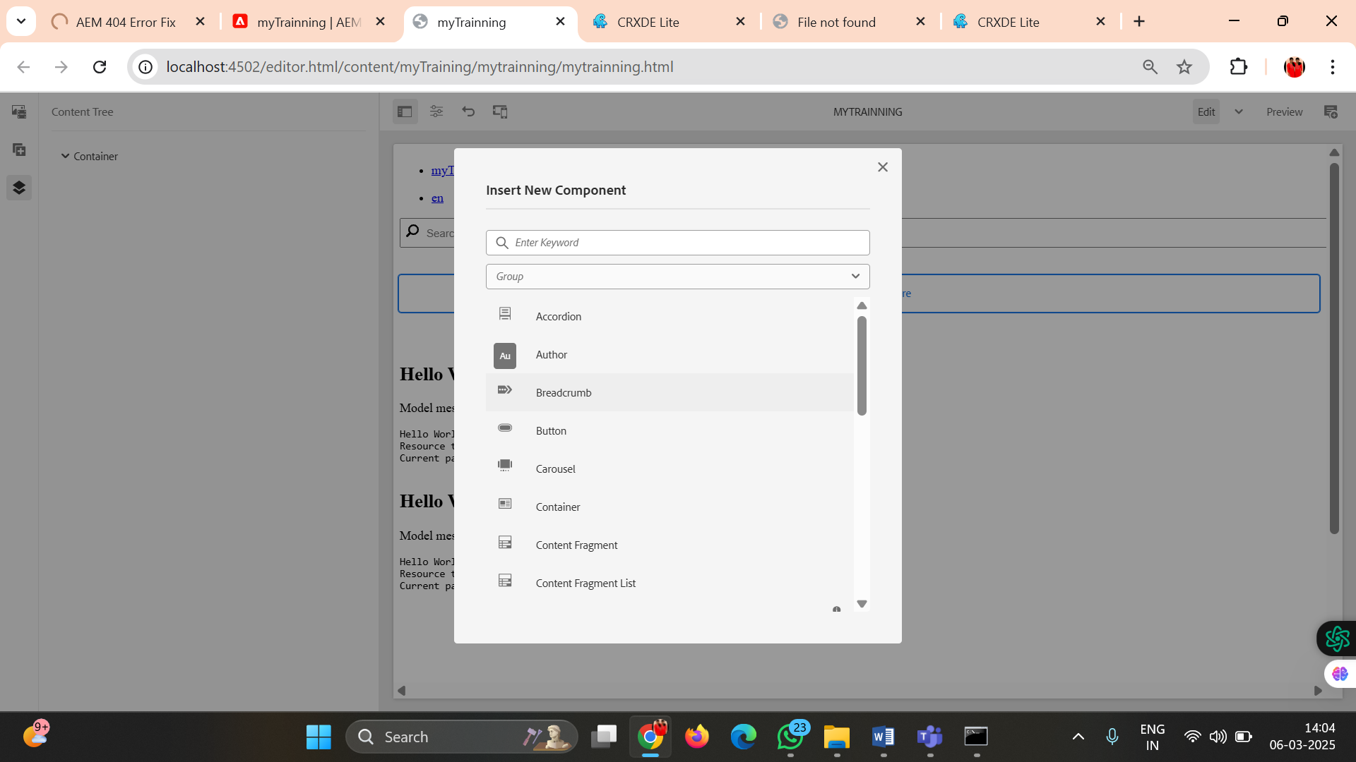

🡪Once author component is **clicked**

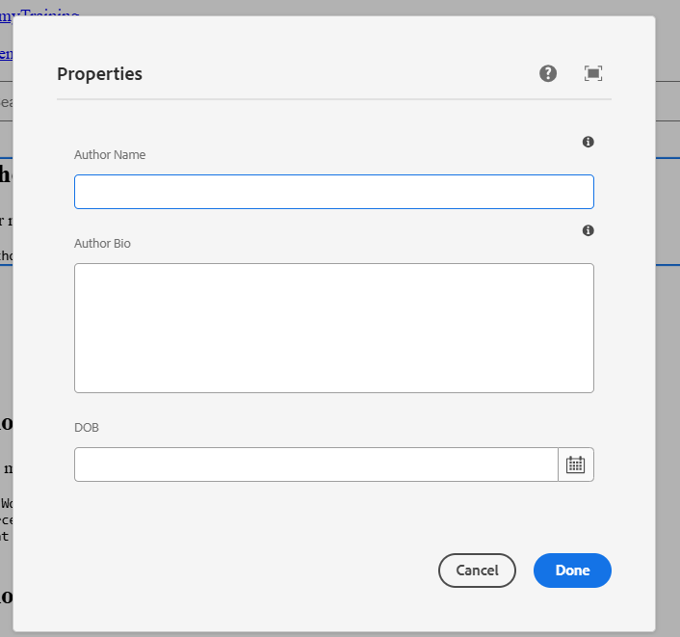

🡪Enter the details and submit  
🡪Created Successfully…

