Book Component:

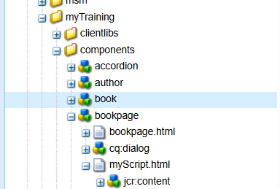

🡪rootPageComponent

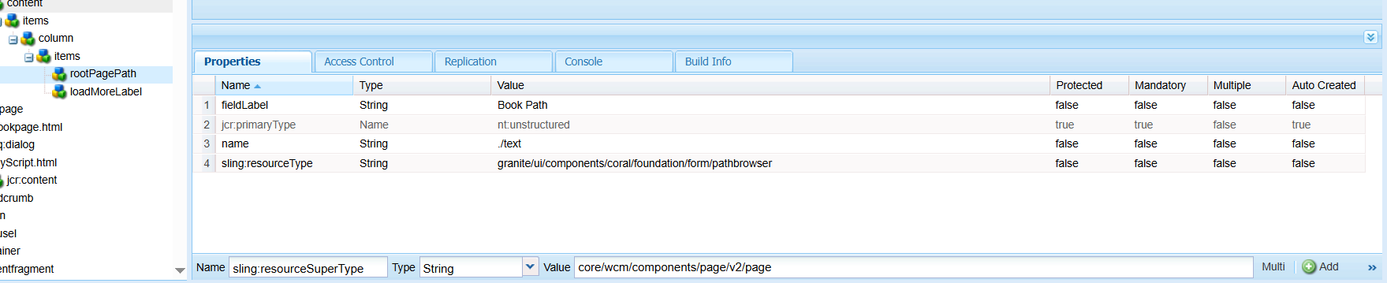

🡪loadMoreLabel

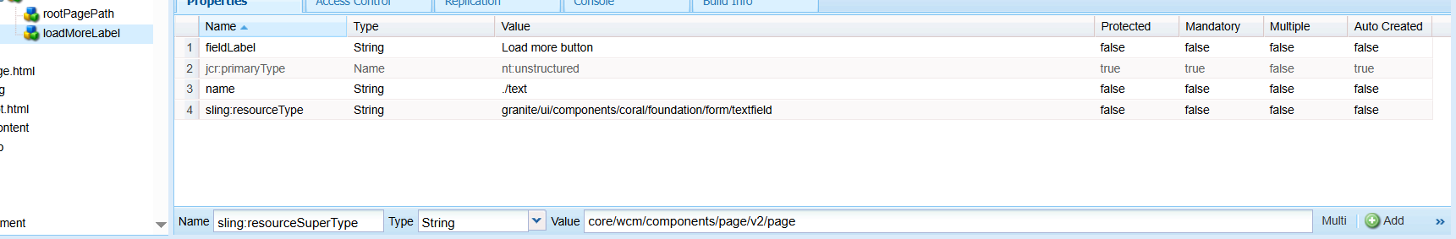

Book properties:

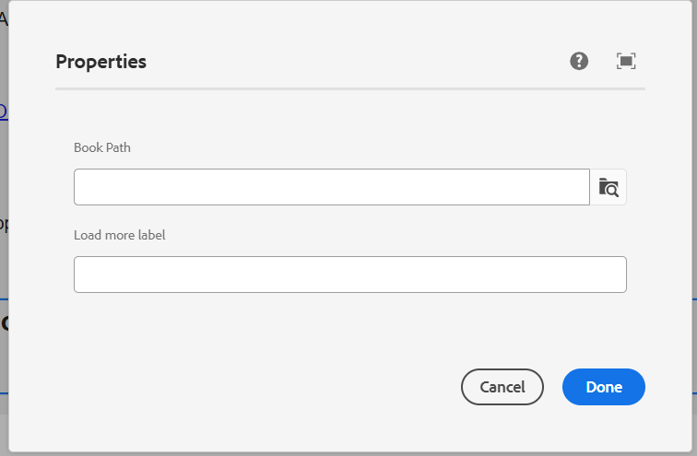

🡪Load more:

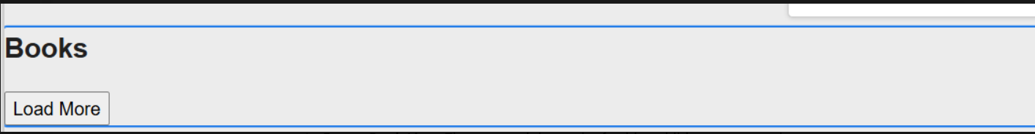

Book.html:

<sly data-sly-use.model="com.mytraining.core.models.BookModel" />

<div class="book-list">

<sly data-sly-list.book="${model.books}">

<div class="book-card">

<img src="${book.image}" alt="${book.title}">

<h3>${book.title}</h3>

<p>${book.description}</p>

<small>Published: ${book.publishDate}</small>

</div>

</sly>

</div>

<button class="load-more">${model.loadMoreLabel}</button>

BookModel.java

