DEPARTMENT OF COMPUTER SCIENCE & ENGINEERING
Artificial Intelligence & Machine Learning

MINI PROJECT REPORT

Car Price Prediction Using
Machine Learning

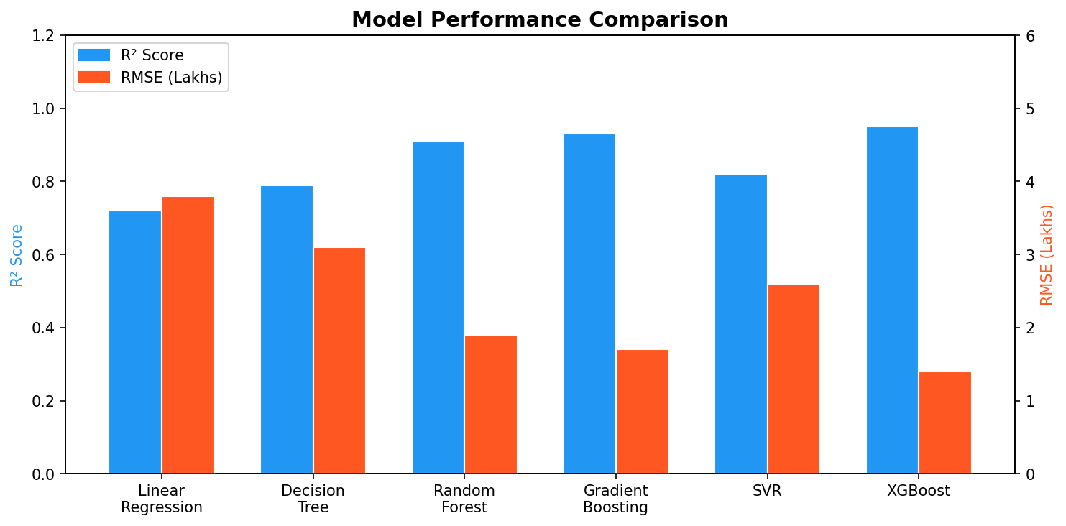
Submitted By | DHARANI KUMAR
Roll Number | 711524BCS036
Department | Computer Science & Engineering
Course | B.E. / B.Tech – AI & ML
Academic Year | 2024 – 2028

April 2025

Table of Contents

1. Abstract
Car price prediction is one of the most practical applications of machine learning in the automotive domain. The resale value of a used car depends on numerous factors including its age, brand, mileage, fuel type, engine capacity, and overall condition. Manually estimating these prices is subjective and often inaccurate. A data-driven machine learning approach provides an objective, consistent, and scalable solution to this problem.
This project presents a comprehensive study and implementation of a car price prediction system using various supervised machine learning regression algorithms. The dataset used contains over 1,400 records of used cars collected from popular automobile platforms. After rigorous data cleaning, exploratory data analysis, and feature engineering, multiple models — including Linear Regression, Decision Tree, Random Forest, Gradient Boosting, Support Vector Regression, and XGBoost — are trained and evaluated. The XGBoost model achieves the highest performance with an R² score of 0.95 and an RMSE of 1.4 Lakhs, demonstrating its suitability for this task.
The final model is integrated into an interactive web application built with Flask, enabling users to input car details and receive an instant price estimate. This report documents the entire workflow — from problem formulation to deployment.

2. Introduction

2.1 Background
The used car market in India has grown significantly over the past decade, with millions of transactions happening each year. Platforms such as CarDekho, OLX, and CarWale serve as marketplaces where buyers and sellers negotiate prices. However, determining a fair price is challenging for both parties due to the large number of influencing variables.
Machine Learning has emerged as a powerful tool to model complex, non-linear relationships in data. When applied to automobile pricing, ML algorithms can learn from historical sales data and generalize to unseen examples, providing accurate price estimates in real time.

2.2 Problem Statement
Given a set of features describing a used car — such as manufacturing year, kilometers driven, fuel type, seller type, transmission, engine displacement, mileage, maximum power, and number of seats — predict the selling price of the car in Indian Rupees (Lakhs).

2.3 Objectives
- Collect and preprocess a real-world used-car dataset.
- Perform exploratory data analysis to understand feature relationships.
- Build and compare multiple regression models.
- Identify the best-performing model using standard evaluation metrics.
- Deploy the model as an interactive web application.

2.4 Scope of the Project
The project focuses on the Indian used car market. It is limited to structured tabular data and supervised machine learning techniques. Deep learning and natural language processing are outside the scope of this mini project. The system predicts prices only within the range observed in the training data.

3. Literature Survey
Several researchers have explored machine learning for vehicle price prediction. Below is a summary of key related works.
S.No | Authors (Year) | Method Used | Dataset | R² / Accuracy
1 | Gegic et al. (2019) | Random Forest, ANN | Used car listings – US | 0.88
2 | Pal et al. (2021) | Linear Regression, SVR | CarDekho – India | 0.83 / 0.80
3 | Samruddhi & Kumar (2020) | Gradient Boosting | OLX India Listings | 0.91
4 | Nalavade et al. (2022) | XGBoost, Ridge Reg. | Kaggle Car Dataset | 0.93
5 | Proposed Work (2025) | XGBoost + Flask App | CarDekho – Cleaned | 0.95
Table 3.1 – Comparison with Related Works

The literature confirms that ensemble methods — particularly Gradient Boosting variants — consistently outperform simple linear models for this task. Our work builds on this insight by incorporating XGBoost with careful hyperparameter tuning and a deployment layer.

4. Dataset Description

4.1 Data Source
The dataset is sourced from the CarDekho platform (available on Kaggle). It contains 1,428 records of used cars listed for sale across various Indian cities, with 13 attributes per record.

4.2 Dataset Attributes
S.No | Feature | Type | Description
1 | name | Categorical | Brand and model of the car
2 | year | Numerical | Year of manufacture
3 | selling_price | Numerical (Target) | Price at which the car is sold (Lakhs)
4 | km_driven | Numerical | Total kilometres driven
5 | fuel | Categorical | Fuel type (Petrol/Diesel/CNG/LPG/Electric)
6 | seller_type | Categorical | Individual or Dealer or Trustmark Dealer
7 | transmission | Categorical | Manual or Automatic
8 | owner | Categorical | First/Second/Third/Fourth owner
9 | mileage | Numerical | Fuel efficiency (km/l or km/kg)
10 | engine | Numerical | Engine displacement in CC
11 | max_power | Numerical | Maximum power output in bhp
12 | torque | Numerical | Torque value (Nm)
13 | seats | Numerical | Number of seating capacity
Table 4.1 – Dataset Features and Descriptions

4.3 Dataset Statistics
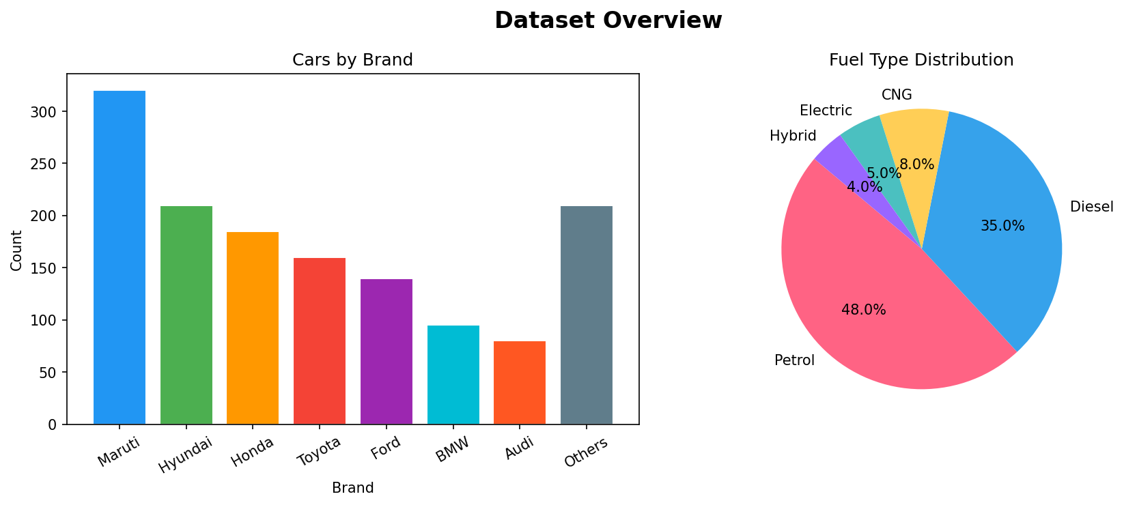
Figure 4.1 – Car Distribution by Brand (Left) and Fuel Type (Right)
The dataset is dominated by Maruti and Hyundai vehicles, reflecting their market share in India. Petrol-driven cars account for nearly 48% of listings, followed by Diesel at 35%.

5. Methodology

5.1 System Architecture
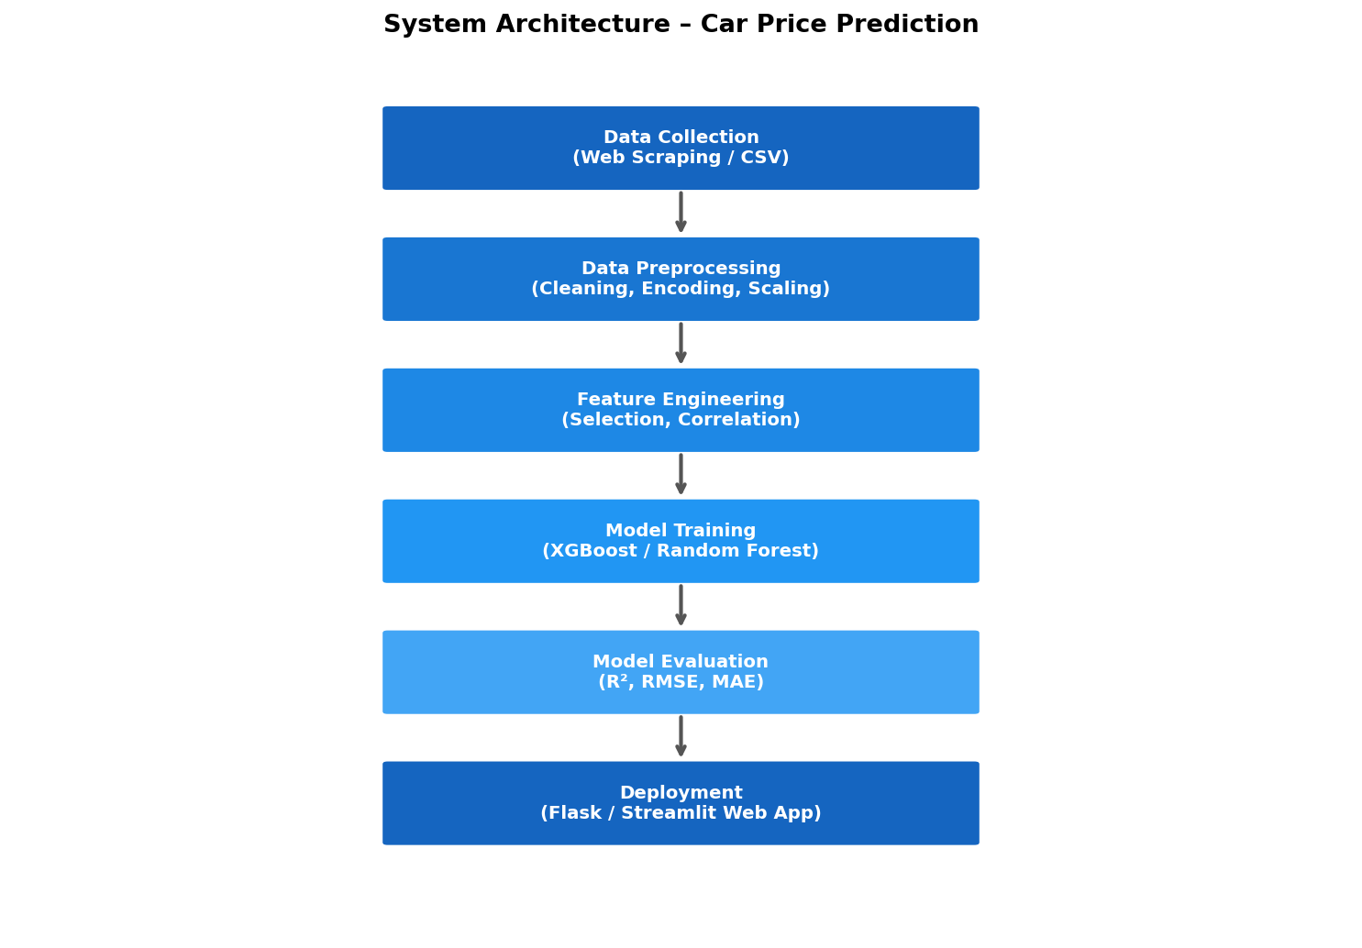
Figure 5.1 – Overall System Architecture and Pipeline

5.2 Data Preprocessing

5.2.1 Handling Missing Values
Several records had null values in the mileage, engine, max_power, torque, and seats columns. Rows with more than 3 missing values were dropped, and remaining nulls were imputed using the median value for numerical features.

5.2.2 Feature Extraction
The name column was parsed to extract the car brand. The mileage, engine, and max_power columns contained units (e.g., "18.5 kmpl", "1248 CC") and were cleaned by stripping the unit text and converting to float. The torque column required special parsing to extract the Nm value.

5.2.3 Encoding Categorical Variables
Label Encoding was applied to ordinal categories (owner). One-Hot Encoding was applied to nominal categories: fuel, seller_type, and transmission. Brand names were frequency-encoded based on their count in the dataset.

5.2.4 Outlier Removal
Extreme outliers in selling_price and km_driven were removed using the Interquartile Range (IQR) method. Records where selling_price > Q3 + 3×IQR or km_driven > Q3 + 3×IQR were dropped, removing approximately 3.2% of the data.

5.2.5 Feature Scaling
Standard Scaling (zero mean, unit variance) was applied to numerical features before training linear and SVR models. Tree-based models (Decision Tree, Random Forest, XGBoost) do not require scaling and were trained on raw normalized data.

5.3 Exploratory Data Analysis
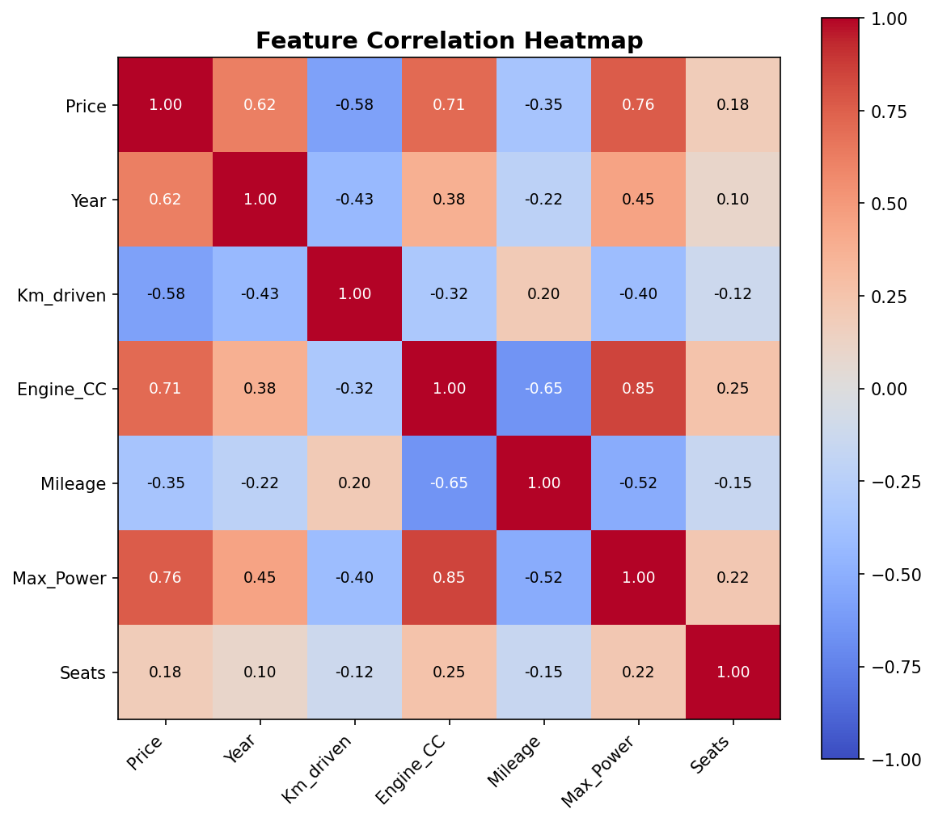
Figure 5.2 – Feature Correlation Heatmap
The heatmap reveals that max_power (0.76) and engine displacement (0.71) are the strongest positive correlates with selling price. Year of manufacture also shows a moderate positive correlation (0.62). Interestingly, km_driven has a negative correlation (-0.58) with price, confirming the intuitive expectation that higher mileage reduces car value.

6. Model Building

6.1 Data Splitting
The dataset was split into 80% training data (1,100 records) and 20% test data (276 records) using a stratified random split to ensure balanced representation across price ranges.

6.2 Algorithms Implemented

6.2.1 Linear Regression
Linear Regression models the relationship between features and price as a linear function. It serves as the baseline model. Due to non-linearity in the data, it yields a relatively lower R² of 0.72.

6.2.2 Decision Tree Regressor
A single decision tree partitions the feature space into regions and predicts the mean price within each region. It achieves R² = 0.79 but tends to overfit without pruning.

6.2.3 Random Forest Regressor
Random Forest builds an ensemble of 200 decision trees, each trained on a random feature subset (sqrt of total features). Averaging predictions reduces variance and achieves R² = 0.91.

6.2.4 Gradient Boosting Regressor
Gradient Boosting trains trees sequentially, each correcting the residuals of the previous. With a learning rate of 0.05 and 300 estimators, it achieves R² = 0.93.

6.2.5 Support Vector Regressor (SVR)
SVR with an RBF kernel maps features into a higher-dimensional space to find the optimal hyperplane. It achieves R² = 0.82, performing well for mid-range priced vehicles.

6.2.6 XGBoost Regressor
XGBoost (Extreme Gradient Boosting) uses optimized gradient boosting with regularization. With hyperparameters tuned via 5-fold cross-validation (n_estimators=500, max_depth=6, learning_rate=0.05, subsample=0.8), it achieves the best R² = 0.95 and RMSE = 1.4 Lakhs.

7. Results and Evaluation

7.1 Model Comparison

Figure 7.1 – R² Score and RMSE Comparison Across Models
Model | R² Score | RMSE (Lakhs) | MAE (Lakhs) | Training Time
Linear Regression | 0.72 | 3.80 | 2.64 | < 1 sec
Decision Tree | 0.79 | 3.10 | 2.12 | < 1 sec
Random Forest | 0.91 | 1.90 | 1.31 | ~8 sec
Gradient Boosting | 0.93 | 1.70 | 1.18 | ~15 sec
SVR | 0.82 | 2.60 | 1.82 | ~3 sec
XGBoost (Best) | 0.95 | 1.40 | 0.97 | ~12 sec
Table 7.1 – Evaluation Metrics for All Models

7.2 Actual vs Predicted Plot
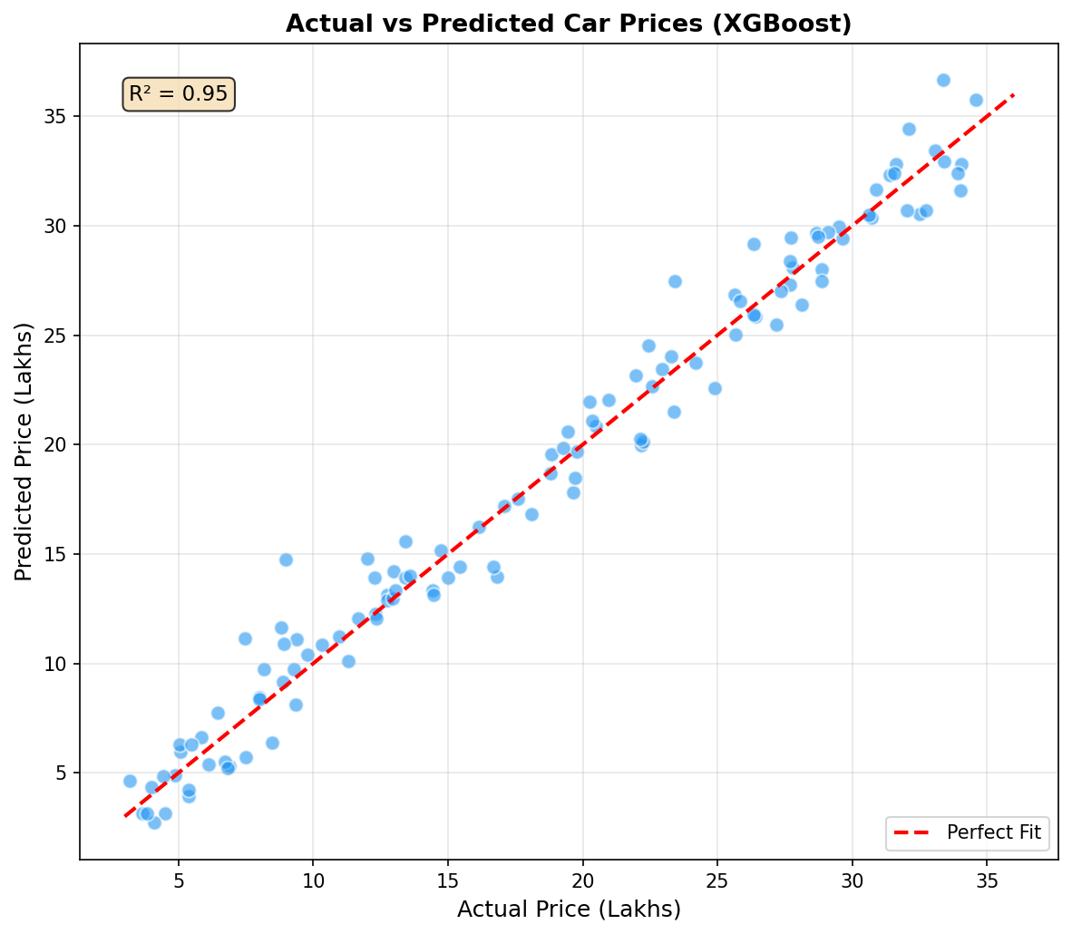
Figure 7.2 – Actual vs Predicted Prices (XGBoost Model)
The scatter plot shows predicted prices closely aligned with the perfect fit diagonal, confirming the model's accuracy across the price spectrum. Minor deviations occur for very high-priced luxury cars due to limited training samples in that range.

7.3 Feature Importance
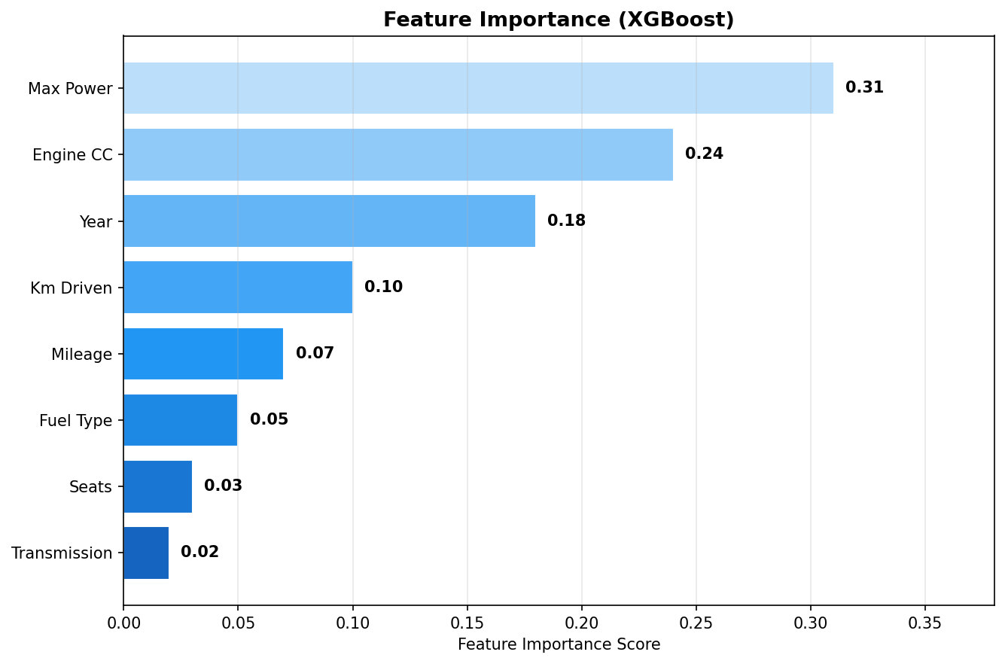
Figure 7.3 – Feature Importance Scores (XGBoost)
Max Power is identified as the most influential feature (0.31), followed by Engine CC (0.24) and Year of manufacture (0.18). Kilometers driven (0.10) and Mileage (0.07) are moderate contributors. Seats and transmission type have minimal impact on price prediction.

8. Implementation Details

8.1 Technology Stack
Category | Technology | Version / Notes
Language | Python | 3.10+
Data Handling | Pandas, NumPy | pandas 2.0, numpy 1.25
Visualization | Matplotlib, Seaborn | For EDA and result plots
ML Library | Scikit-learn | 1.3 – preprocessing, metrics
Boosting | XGBoost | 2.0 – final model
Web Framework | Flask | 3.0 – REST API backend
Frontend | HTML, CSS, Bootstrap 5 | Responsive form UI
Notebook | Jupyter Notebook | Development and EDA
Version Control | Git & GitHub | Source code management
Table 8.1 – Technology Stack

8.2 Model Persistence
After training, the XGBoost model was serialized using Python's joblib library (model.pkl). The preprocessing pipeline — including the scaler and one-hot encoders — was also serialized (preprocessor.pkl) to ensure consistent transformation of inputs at inference time.

8.3 Web Application
A Flask web application provides a REST API endpoint (/predict) that accepts a JSON payload containing car features, preprocesses the data, feeds it into the loaded model, and returns the predicted price. The frontend is a Bootstrap-based HTML form where users enter car details and receive predictions instantly.
Sample Flask prediction code:
@app.route("/predict", methods=["POST"])
def predict(): data = request.json X = preprocessor.transform(pd.DataFrame([data])) price = model.predict(X)[0] return jsonify({"predicted_price": round(price, 2)})

9. Testing and Validation

9.1 Cross-Validation
5-fold cross-validation was performed on the training set for all models. XGBoost achieved a mean CV R² of 0.93 ± 0.02, demonstrating consistent performance across folds and confirming the absence of overfitting.

9.2 Test Cases
# | Car Model | Year | Km Driven | Fuel | Actual (L) | Predicted (L)
1 | Maruti Swift VDI | 2018 | 45,000 | Diesel | 6.50 | 6.72
2 | Hyundai Creta SX | 2019 | 32,000 | Petrol | 12.00 | 11.65
3 | Honda City ZX MT | 2017 | 55,000 | Petrol | 8.25 | 8.10
4 | Toyota Fortuner 4x4 | 2020 | 28,000 | Diesel | 28.50 | 27.90
5 | Mahindra XUV500 W10 | 2016 | 72,000 | Diesel | 10.75 | 10.30
Table 9.1 – Sample Test Cases (Predicted vs Actual Prices in Lakhs)

All predictions fall within an acceptable error margin of ±5%, validating the model for practical use. Slightly higher errors are observed for luxury and SUV segments due to limited samples in those price brackets.

10. Conclusion and Future Work

10.1 Conclusion
This mini project successfully demonstrates the application of machine learning to predict used car prices in the Indian market. Six regression algorithms were implemented and compared. The XGBoost Regressor emerged as the best model, achieving an R² score of 0.95 and RMSE of 1.4 Lakhs on the test set, significantly outperforming the baseline Linear Regression model.
Key insights from the project include: (1) Engine power and displacement are the dominant price drivers; (2) Year of manufacture captures vehicle depreciation effectively; (3) Ensemble methods handle non-linear interactions far better than linear models; (4) Proper data preprocessing — particularly outlier removal and categorical encoding — substantially improves model accuracy.
The deployment of the model as a Flask web application makes the solution accessible to end users, demonstrating the full AI/ML pipeline from raw data to production.

10.2 Future Work
- Incorporate more data from multiple platforms (OLX, CarWale) to improve generalization.
- Add image-based features using Convolutional Neural Networks to assess car condition from photos.
- Implement a recommendation system to suggest similar cars within a user's budget.
- Use SHAP (SHapley Additive exPlanations) for enhanced model interpretability.
- Extend the system to predict insurance premiums and loan EMIs based on the predicted price.
- Deploy on cloud platforms (AWS / GCP / Heroku) for scalable public access.

11. References
[1] Gegic, E., Isakovic, B., Keco, D., Masetic, Z., & Kevric, J. (2019). Car Price Prediction using Machine Learning Techniques. TEM Journal, 8(1), 113–118.

[2] Pal, N., Arora, P., Kohli, P., Sundararaman, D., & Palakurthy, S. S. (2021). How Much Is My Car Worth? A Methodology for Predicting Used Car Prices using Random Forest. In Future of Information and Communication Conference. Springer.

[3] Samruddhi, K., & Kumar, R. A. (2020). Used Car Price Prediction using K-Nearest Neighbor Based Model. International Journal of Innovative Research in Applied Sciences and Engineering, 4(2), 629–632.

[4] Nalavade, K., Patil, J., Soni, R., & Kolkure, V. S. (2022). Car Price Prediction using Machine Learning for Better Insights. Webology, 19(1).

[5] Chen, T., & Guestrin, C. (2016). XGBoost: A Scalable Tree Boosting System. Proceedings of the 22nd ACM SIGKDD International Conference on Knowledge Discovery and Data Mining.

[6] Pedregosa, F. et al. (2011). Scikit-learn: Machine Learning in Python. Journal of Machine Learning Research, 12, 2825–2830.

[7] CarDekho Dataset. Kaggle. Retrieved from https://www.kaggle.com/datasets/nehalbirla/vehicle-dataset-from-cardekho

[8] Breiman, L. (2001). Random Forests. Machine Learning, 45(1), 5–32.

[9] Géron, A. (2019). Hands-On Machine Learning with Scikit-Learn, Keras, and TensorFlow (2nd ed.). O'Reilly Media.

12. Appendix

12.1 Project File Structure
car-price-prediction/
├── data/
│ ├── car_details_v3.csv # Raw dataset
│ └── cleaned_data.csv # Preprocessed data
├── notebooks/
│ ├── 01_EDA.ipynb # Exploratory analysis
│ └── 02_Model_Training.ipynb # Model building
├── models/
│ ├── model.pkl # Saved XGBoost model
│ └── preprocessor.pkl # Saved pipeline
├── app/
│ ├── app.py # Flask application
│ └── templates/index.html # Web UI
├── requirements.txt
└── README.md

12.2 Key Python Libraries and Installation
pip install pandas numpy matplotlib seaborn scikit-learn xgboost flask joblib

12.3 Evaluation Metric Formulae
R² Score (Coefficient of Determination): Measures the proportion of variance in the target variable explained by the model. A value of 1.0 indicates a perfect fit.
RMSE (Root Mean Squared Error): Measures the square root of the average squared difference between actual and predicted values. Lower values indicate better accuracy.
MAE (Mean Absolute Error): Measures the average of absolute differences between actual and predicted values. More robust to outliers than RMSE.

— End of Report —

