A project report on

FACIAL EXPRESSION EMOTIONAL RECOGNITION (FEER)

Submitted in partial fulfillment for the award of the degree of
BCA (Bachelor of Computer Applications)

by
RITHU.S (21BCA0078)
DHARANI.M (21BCA0081)
Under the guidance of
Mr. ANBARASU B



SCHOOL OF COMPUTER SCIENCE ENGINEERING AND INFORMATION SYSTEMS

April, 2024

FACIAL EXPRESSION EMOTIONAL RECOGNITION (FEER)

Submitted in partial fulfillment for the award of the degree of
BCA (Bachelor of Computer Applications)

by
RITHU.S (21BCA0078)
DHARANI.M (21BCA0081)
Under the guidance of
Mr. ANBARASU B

SCHOOL OF COMPUTER SCIENCE ENGINEERING AND INFORMATION SYSTEMS

April, 2024
DECLARATION

We hereby declare that the thesis entitled “FACIAL EXPRESSION EMOTION RECOGNITION (FEER)” submitted by us, for the award of the degree of BCA is a record of bonafide work carried out by us under the supervision of Mr. ANBARASU B
We further declare that the work reported in this thesis has not been submitted and will not be submitted, either in part or in full, for the award of any other degree or diploma in this institute or any other institute or university.

Place: Vellore
Date: Signature of the Candidate

CERTIFICATE
This is to certify that the thesis entitled “FACIAL EXPRESSION EMOTION RECOGNITION” submitted by RITHU.S (21BCA0078), DHARANI.M (21BCA0081), School of Computer Science Engineering and Information Systems, Vellore Institute of Technology, Vellore for the award of the degree BCA is a record of bonafide work carried out by him/her under my supervision.
The contents of this report have not been submitted and will not be submitted
either in part or in full, for the award of any other degree or diploma in this institute or
any other institute or university. The Project report fulfils the requirements and regulations of
VELLORE INSTITUTE OF TECHNOLOGY, VELLORE and in my opinion meets the necessary standards for submission.

Signature of the Guide Signature of the HoD

Internal Examiner External Examiner

ABSTRACT
Facial Expression Emotion Recognition (FEER) is a cutting-edge technology designed to accurately identify and interpret human emotions based on facial expressions. Emotions play a crucial role in human communication, influencing social interactions, decision-making, and overall well-being. The ability to recognize and understand these emotions through facial cues is of paramount importance in various fields, including human-computer interaction, psychology and artificial intelligence.
This research focuses on developing a robust and efficient system for Facial Expression Emotional Recognition, addressing the limitations of existing methodologies. The proposed FEER system leverages advanced machine learning algorithms, neural networks, and computer vision techniques to achieve high precision in emotion detection. The primary objective is to enhance the system's performance across diverse demographic groups, lighting conditions, and facial variations.
One of the fundamental challenges in facial expression emotion recognition is the variability and complexity of human facial expressions. Emotions are not always expressed in a standardized manner and can vary greatly across individuals, cultures, and contexts. Furthermore, factors such as lighting conditions, occlusions, and facial expressions' subtlety further complicate the task. Addressing these challenges requires robust and adaptive algorithms capable of handling diverse input scenarios.
Researchers have proposed various methodologies to enhance the accuracy and robustness of facial expression emotion recognition systems. These include data augmentation techniques to increase the diversity of training data, ensemble learning approaches to combine the predictions of multiple models, and domain adaptation methods to improve generalization across different datasets and conditions. Additionally, incorporating temporal information from video sequences has shown promise in capturing the dynamic nature of facial expressions.
In conclusion, facial expression emotion recognition is a rapidly evolving field with significant implications for various domains. Continued research efforts aimed at addressing its challenges and ethical considerations are essential to realizing its full potential in enhancing human-machine interaction and advancing societal well-being.

ACKNOWLEDGEMENT
It is our pleasure to express with deep sense of gratitude to Mr. ANBARASU B, ASSISTANT PROFESSOR (CONTRACT), DEPARTMENT OF COMPUTER APPLICATIONS, SCHOOL OF COMPUTER SCIENCE ENGINEERING AND INFORMATION SYSTEMS (SCORE), for his constant guidance, continual encouragement, and understanding; more than all, he taught us patience in my endeavour. Our association with him is not confined to academics only, but it is a great opportunity on our part of work with an intellectual and expert in the field of Image Processing.

We would like to express our gratitude to DR.G.VISWANATHAN, Chancellor VELLORE INSTITUTE OF TECHNOLOGY, VELLORE, MR. SANKAR VISWANATHAN, DR. SEKAR VISWANATHAN, DR.G V SELVAM, Vice Presidents VELLORE INSTITUTE OF TECHNOLOGY, VELLORE, Dr. V. S. Kanchana Bhaaskaran, I/c Vice – Chancellor, Dr. Partha Sharathi Mallick, Pro-Vice Chancellor and Dr. S. Sumathy, Dean, School of Computer Science Engineering and Information Systems, for providing with an environment to work in and for his inspiration during the tenure of the course.

In jubilant mood I express ingeniously my whole-hearted thanks to Dr.M. Iyapparaja, HoD/Professor, all teaching staff and members working as limbs of our university for their not-self-centered enthusiasm coupled with timely encouragements showered on us with zeal, which prompted the acquirement of the requisite knowledge to finalize our course study successfully. We would like to thank our parents for their support.
It is indeed a pleasure to thank my friends who persuaded and encouraged us to take up and complete this task. At last but not least, we express our gratitude and appreciation to all those who have helped us directly or indirectly toward the successful completion of this project.
Place: Vellore Date:
Name of the student
TABLE OF CONTENTS

LIST OF FIGURES i
LIST OF TABLES ii
LIST OF ACRONYMS iii
CHAPTER 1
INTRODUCTION
  - BACKGROUND……………………………………………………………………..1
  - MOTIVATION…………………………………………………………………….....4
1.3 PROJECT STATEMENT 7
1.4 OBJECTIVES 7
1.5 SCOPE OF THE PROJECT 8
CHAPTER 2
LITERATURE SURVEY
2.1 SUMMARY OF THE EXISTING WORKS 7
2.2 CHALLENGES PRESENT IN EXISTING SYSTEM 12

CHAPTER 3

REQUIREMENTS
  - HARDWARE REQUIREMENTS………………………………………………….13
  - SOFTWARE REQUIREMENT…………………………………………………….13
  - GANTT CHART…………………………………………………………………….16
CHAPTER 4

ANALYSIS & DESIGN

4.1PROPOSED METHODOLOGY………………………………………16

4.2 SYSTEM ARCHITECTURE…………………………………………17

4.3 MODULE DESCRIPTIONS…………………………………………18

CHAPTER 5

IMPLEMENTATION & TESTING
5.1 DATA SET……………………………………………………………21
5.2 SAMPLE CODE………………………………………………………24
5.3 SAMPLE OUTPUT ……………………………………………………30
5.4 TEST PLAN & DATA VERIFICATION………………………………34
CHAPTER 6

RESULTS

6.1 RESEARCH FINDINGS………………………………………………39

6.2 RESULT ANALYIS & EVALUATION METRICS………..…………40

CONCLUSIONS AND FUTURE WORK……...……………43
REFERENCES…………………………………………………44

LIST OF FIGURES
1.3.1 DATA FLOW 4
4.2 .1 SYSTEM ARCHITECTURE 18
4.3.1 COMPLETE DESIGN 19
5.1.1 DATASET SAMPLES 22
5.1.2 TRAINING SET 23
5.1.3 CORRELATION 24
5.2.1 DISPLAYING IMAGES 30
5.2.2 PLOTTING ACCURACY & LOSS 33
6.1.1 RESULTS 37
6.1.2 RESULTS 38
6.1.3 RESULTS 39

LIST OF TABLES
2.1.1 SUMMARY OF THE EXISTING WORKS 16
5.1.1 DATA SET 21
5.2.1MODEL BUILDING 31

LIST OF ACRONYMS

FEER Facial Expression Emotional Recognition
LPQ Local Phase Quantization
LBP Local Binary Pattern
HOG Histogram of Oriented Gradients
CNN Convolutional Neural Network
ELM Extreme Learning Machine
LSTM Long Short Term Memory
PCA Principal Component Analysis

CHAPTER 1
INTRODUCTION
Facial expression emotion recognition is a cutting-edge field at the intersection of computer vision, artificial intelligence, and psychology. It aims to develop algorithms and systems capable of accurately identifying and interpreting human emotions based on facial expressions captured through images or videos. This technology holds immense potential for various applications, including human-computer interaction, healthcare, marketing, and security.
At its core, facial expression emotion recognition relies on analyzing facial features such as the shape of the mouth, position of the eyebrows, and wrinkles around the eyes to infer the underlying emotional state of an individual. Researchers and developers utilize machine learning techniques, particularly deep learning algorithms, to train models on vast datasets of labeled facial expressions, enabling them to learn patterns and associations between facial cues and emotions. One of the key challenges in facial expression emotion recognition is achieving robustness and accuracy across diverse demographics, cultural backgrounds, and environmental conditions. Factors such as lighting variations, occlusions, and individual differences in facial morphology can significantly impact the performance of recognition systems.
To enhance the reliability and effectiveness of facial expression emotion recognition systems, researchers often employ multimodal approaches, combining information from multiple sources such as facial expressions, voice tone, and body language. This holistic approach enables more comprehensive and nuanced understanding of human emotions, leading to more accurate recognition results. Despite the progress made in recent years, facial expression emotion recognition technology still faces ethical considerations, particularly regarding privacy and potential misuse. Striking a balance between technological advancement and ethical responsibility is crucial for the responsible development and deployment of these systems in real-world applications. As research continues to advance, facial expression emotion recognition holds promise for revolutionizing various domains and improving human-machine interactions.
1.1 BACKGROUND
The background of facial expression emotion recognition traces back to pioneering research in psychology, which identified universal facial expressions corresponding to basic emotions such as happiness, sadness, anger, fear, disgust, and surprise. Building upon this foundation, advancements in computer vision and machine learning have enabled the development of automated systems capable of detecting and interpreting these expressions.Early approaches relied on handcrafted features and traditional machine learning algorithms to analyze facial cues. However, recent breakthroughs in deep learning have revolutionized the field, allowing for more accurate and robust recognition models. Additionally, the availability of large-scale annotated datasets, such as the Facial Action Coding System (FACS) and the Extended Cohn-Kanade (CK+) dataset, has facilitated the training and evaluation of these models.
The convergence of psychology, computer vision, and machine learning has propelled facial expression emotion recognition from theoretical concept to practical application, with wide-ranging implications across industries including human-computer interaction, healthcare, marketing, and security.
1.2 MOTIVATION
The motivation behind facial expression emotion recognition stems from the desire to better understand and interact with human emotions in various contexts. By developing accurate and reliable systems capable of interpreting facial expressions, researchers aim to enhance human-computer interaction, making technology more intuitive and responsive to users' emotional states.
Moreover, in fields such as healthcare and mental health, facial expression emotion recognition offers the potential to assist in early detection and intervention of emotional disorders, such as depression and anxiety. Timely recognition of these conditions through facial cues could lead to more effective treatment and support for individuals in need.
In marketing and advertising, understanding consumers' emotional responses to products or advertisements can significantly influence campaign strategies and product development. Facial expression emotion recognition provides valuable insights into consumer preferences and behaviors, helping businesses tailor their offerings to better meet customer needs.
Furthermore, in security and surveillance applications, the ability to detect suspicious or threatening behaviors based on facial expressions could aid in crime prevention and public safety efforts.Overall, the motivation for advancing facial expression emotion recognition lies in its potential to revolutionize human-computer interaction, healthcare, marketing, security, and various other domains by providing deeper insights into human emotions and behaviors.
1.3 PROJECT STATEMENT
Despite the significant progress in facial expression recognition, existing systems face challenges such as limited accuracy, susceptibility to variations in lighting conditions, and inadequate adaptability to diverse facial features. The lack of a universally reliable Facial Expression Emotional Recognition (FEER) system hinders its widespread application in real-world scenarios.
This research aims to tackle the following key problems:
Accuracy Improvement: Current facial expression recognition systems often struggle with accurately identifying subtle and nuanced emotions. The proposed FEER system aims to enhance accuracy by employing state-of-the-art machine learning models, ensuring a more nuanced understanding of facial expressions.

Robustness Across Demographics: Existing models may exhibit bias and reduced accuracy when applied to diverse demographic groups. The research seeks to develop a FEER system that performs consistently well across different age groups, ethnicities, and genders, ensuring its applicability across a broad spectrum of users.

Adaptability to Environmental Conditions: Variations in lighting conditions and environmental factors can negatively impact the performance of facial expression recognition systems. The FEER system will incorporate advanced image processing techniques to mitigate the impact of environmental variables, ensuring reliable emotion detection in different scenarios.

Real-Time Processing: Many existing systems may experience delays in processing, limiting their real-time applicability. This research aims to optimize the FEER system for real-time processing, making it suitable for applications such as human-computer interaction, virtual reality, and emotion-aware systems.
By addressing these challenges, the proposed FEER system aims to provide a robust, accurate, and adaptable solution for Facial Expression Emotional Recognition, opening new avenues for research and application in various domains.

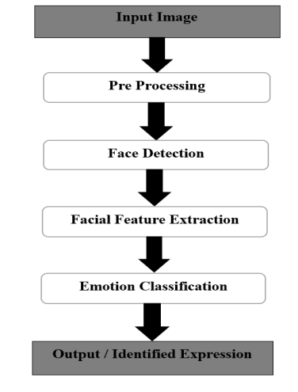 Fig 1.3.1
1.4 OBJECTIVES
DEVELOP A ROBUST FEER SYSTEM:
Design and implement a Facial Expression Emotional Recognition (FEER) system that is robust, accurate, and capable of recognizing a wide range of facial expressions, including subtle and nuanced emotions.
ENHANCE ACCURACY AND PRECISION:
Improve the accuracy and precision of emotion detection by incorporating advanced machine learning models, feature extraction techniques, and deep learning architectures. The objective is to ensure the FEER system can reliably identify emotions under various conditions.
ADAPTABILITY TO ENVIRONMENTAL CONDITIONS:
Develop mechanisms to enhance the FEER system's adaptability to different environmental conditions, including variations in lighting, facial occlusions, and background distractions. The system should demonstrate resilience in real-world scenarios.
REAL-TIME PROCESSING CAPABILITY:
Optimize the FEER system for real-time processing to facilitate its integration into applications requiring immediate and dynamic emotion recognition. This includes human-computer interaction, virtual reality environments, and emotion-aware systems.
UTILIZE STATE-OF-THE-ART IMAGE PROCESSING:
Incorporate state-of-the-art image processing techniques to improve feature extraction and representation. Explore the use of facial landmarks, texture analysis, and other relevant features to enhance the overall performance of the FEER system.
ETHICAL CONSIDERATIONS AND BIAS MITIGATION:
Address ethical considerations associated with facial expression recognition, including potential biases related to gender, ethnicity, and age. Implement measures to mitigate biases and ensure fair and unbiased emotion recognition across diverse user groups.
USER-FRIENDLY INTERFACE:
Integrate the FEER system into a user-friendly interface, making it accessible and easy to use for both researchers and potential application developers. Provide clear documentation and guidelines for seamless integration into various platforms.
1.5 SCOPE OF THE PROJECT
FACIAL EXPRESSION RECOGNITION:
The primary focus of the project is on recognizing facial expressions to identify a spectrum of emotions. The system will be designed to distinguish between different emotions such as happiness, sadness, anger, surprise, and more.
IMAGE AND VIDEO INPUT:
The FEER system will process both static images and dynamic video streams for real-time emotion recognition. This extends the applicability of the system to various scenarios, including still images, video calls, and surveillance footage.
MACHINE LEARNING AND DEEP LEARNING MODELS:
The project will explore and implement machine learning and deep learning models, such as convolutional neural networks (CNNs), to achieve high accuracy in facial expression recognition. Transfer learning techniques may be employed to leverage pre-trained models.
CROSS-PLATFORM INTEGRATION:
The FEER system will be designed to integrate seamlessly into different platforms and applications, ensuring versatility and ease of adoption. The system's compatibility with popular programming languages and frameworks will be considered.
TESTING AND EVALUATION:
Rigorous testing and evaluation will be conducted using benchmark datasets and real-world scenarios to assess the FEER system's performance in terms of accuracy, speed, and adaptability across diverse conditions and user demographics.
DOCUMENTATION AND GUIDELINES:
Comprehensive documentation and guidelines will be provided to facilitate the understanding, implementation, and integration of the FEER system. This includes instructions for developers, researchers, and end-users interested in utilizing the system.
FUTURE RECOMMENDATIONS:
The project may include recommendations for future enhancements, potential applications, and avenues for further research in the field of Facial Expression Emotional Recognition. This ensures that the project contributes to the ongoing advancement of emotion recognition technologies.By addressing these objectives and within the defined scope, the project aims to deliver a state-of-the-art FEER system that meets the demands of accuracy, adaptability, and inclusivity in facial expression recognition.

CHAPTER 2
LITERATURE SURVEY
2.1 SUMMARY OF THE EXISTING WORKS
A literature survey on Facial Expression Emotional Recognition (FEER) provides an overview of existing research, methodologies, and advancements in the field. It helps identify gaps in knowledge, current challenges, and potential directions for further exploration. Below is a brief literature survey on FEER:

S.NO | DESCRIPTION | REFERENCE & AUTHOR
1 | The paper discusses the use of several feature descriptors for automatic facial expression recognition (AFER), including Local Phase Quantization (LPQ), Local Binary Pattern (LBP), and Histogram of Oriented Gradients (HOG) and. These descriptors are used to extract texture information related to facial expressions and are applied to either entire faces or specific facial regions to capture discriminative information for expression recognition. | "Automatic Facial Expression Recognition (AFER) Using Shape and Texture Features from Prominent Facial Regions." by Naveen Kumar H N, A Suresh Kumar, Guru Prasad M S, and Mohd Asif Shah (2022)
2 | The paper discusses the development of efficient methods for recognizing facial expressions across different cultures, covering techniques such as CNN, LSTM, Gabor function, Viola-Jones, neural networks, SVM, and more. It evaluates the accuracy and performance of these techniques on various facial expression databases and emphasizes the importance of cross-cultural accuracy. Additionally, it presents the results of a study on facial expression recognition using the LBPH technique, achieving a high accuracy rate of 98.5% but facing challenges with increasing database size. | “Cross-Cultural Facial Expression Recognition Using Gradient Features And Support Vector Machine” by Taiba Mustafa, Ghulam Ali, Arslan Akram, Aalia Tariq, Muhammad Usman Tariq, and Muhammad Salman Ali in the Journal of Jilin University (Engineering and Technology Edition) in January 2023
3 | The research paper focuses on affective computing, intelligent systems, and computer vision, with an emphasis on facial expression recognition. It compares different feature extraction methods, including gray level co-occurrence matrix (GLCM), local binary pattern (LBP), and facial landmark (FL), for recognizing human facial expressions using neural network algorithms. The proposed adaptive Extreme Learning Machine (aELM) method is found to outperform the basic ELM method, with the FL feature extraction method demonstrating the best performance. The paper also addresses challenges related to class imbalance and small dataset sizes in facial expression recognition. The authors, affiliated with Brawijaya University in Indonesia, possess expertise in affective computing, data mining, and computer vision. The findings provide valuable insights for future research in this domain. | "Feature extraction comparison for facial expression recognition using adaptive extreme learning machine" was published Muhammad Wafi, Fitra A. Bachtiar, and Fitri Utaminingrum from Brawijaya University in Indonesia.in February 2023.
4 | The paper provides a comprehensive review of the methods, datasets, and technologies employed in facial emotion recognition. It underscores the significance of precise emotion recognition in diverse applications, including customer feedback, education, and healthcare. Additionally, the study underscores the pivotal role of datasets in training emotion recognition algorithms, emphasizing the necessity for high accuracy and efficient processing time. The authors advocate for future research to concentrate on enhancing dataset quality and classification algorithms to enable more profound and intricate emotion recognition. | "Facial Emotion Recognition: Methods, Datasets, and Technologies" was published in 2021
5 | The paper proposes a real-time engagement detection system for online learners based on facial emotion recognition using deep learning models. It highlights the impact of the COVID-19 pandemic on the shift to online learning and the need for engagement detection in online learning environments. The paper compares different deep learning models for facial emotion recognition and engagement detection, with the ResNet-50 model outperforming others. It discusses related work in the field, datasets used for the experiment, and future possibilities for system improvement. The proposed approach utilizes deep neural network models such as Inception-V3, VGG19, and ResNet-50 for facial emotion recognition and engagement detection, achieving higher accuracy compared to previous works. The system uses a web camera to detect real-time engagement levels of learners based on facial expressions and includes details about datasets used, automatic frame selection, face detection, modified face-points extractor, and network architecture of Inception-V3. | “Real-time engagement detection system for online learners based on facial emotion recognition using deep learning models" was published S. Gupta, P. Kumar, and R. K. Tekchandani in 2023 .
6 | The paper discusses the use of data-driven frameworks and multimodalities for emotion recognition, focusing on the application of LSTM-RNN for emotion recognition using EEG and audio-visual signals. It also emphasizes the need for future work in emotion recognition and provides references to related research. The literature review within the paper explores the significance of emotion recognition in enhancing human-machine interaction and delves into various methods, including unimodal and multimodal systems, deep learning techniques, and neural networks for detecting and classifying emotions. Additionally, it highlights recent related work in the field, such as the use of CNN-LSTM and C3D networks for video-based emotion recognition, and EEG-based affective models using transfer learning techniques. The review also addresses the performance and limitations of these methods. | “A Literature Review on Emotion Recognition Using Various Methods” was publish by Reeshad Khan, Omar Sharif in 2017  Omar Shari  Omar Shari
7 | The paper provides a comprehensive literature review on facial expression recognition techniques, encompassing Principal Component Analysis, Linear Discriminant Analysis, Independent Component Analysis, and other methods. Additionally, it introduces a new Tensor Perceptual Color Framework aimed at enhancing performance under diverse conditions. The paper includes a comparative analysis of these techniques and acknowledges the guidance and support of the author's research mentor. | “Facial Expression Recognition Techniques: A Comprehensive Review” by Ms.Aswathy.R ,Post Graduate Scholar Computer Science Department, Nehru college of Engineering , India in 2013
8 | The paper discusses the significance of emotion recognition from facial expressions in enhancing human-computer interaction. It provides a review of several techniques including Principal Component Analysis (PCA), Local Binary Pattern, Active Appearance Model, Facial Action Coding System, and Haar Classifier for emotion recognition. The conclusion drawn is that PCA exhibits the highest recognition rate and performance among the techniques reviewed. | “Importance of Emotion Recognition from Facial Expressions for Human-Computer Interaction” by Dipika Raval, Mukesh Sakle in 2015
9 | The paper presents a method for emotion recognition from facial expressions using a deep convolutional neural network. It achieves an average accuracy rate of 92.81% in classifying eight basic emotion classes using the extended Cohn-Kanade dataset. The proposed method is proven to be effective for emotion recognition. Additionally, the paper discusses related works, the novelty and contribution of the research, the methodology, experiments, and results. The conclusion emphasizes the need for further improvement in the design of the CNN architecture for better results.  The references in the paper cover various aspects of facial expression recognition and analysis, including methods such as deep learning, automatic recognition of facial actions, facial expression recognition using SVM-CRF sequence classifier, and the use of convolutional networks in vision applications. These references encompass automatic recognition methods, emotion recognition systems for mobile phone data, and the use of conditional random fields as a sequential classifier in machine learning. | “Emotion recognition from facial expression using deep convolutional neural network” By D Y Liliana State Polytechnic of Jakarta, Indonesia in 2019

2.2 CHALLENGES PRESENT IN EXISTING SYSTEM

Several challenges persist in existing facial expression emotion recognition systems, hindering their widespread adoption and effectiveness.
Firstly, variability in facial expressions among individuals, influenced by factors like cultural background, age, and gender, poses a significant challenge. Existing systems may struggle to generalize across diverse demographics, leading to reduced accuracy and reliability.
Secondly, environmental factors such as lighting conditions, occlusions, and camera angles can affect the quality of facial images, impacting the performance of recognition algorithms. Ensuring robustness to such variations remains a key challenge.
Furthermore, real-time processing requirements for applications like human-computer interaction demand efficient and scalable algorithms. Balancing accuracy with computational efficiency is crucial to meet these demands.
Ethical considerations surrounding privacy and consent also present challenges. Facial expression emotion recognition systems raise concerns about data collection, storage, and potential misuse, necessitating careful implementation and adherence to ethical guidelines.
Finally, addressing biases inherent in training data and algorithmic decisions is critical to ensure fair and equitable outcomes across diverse populations. Overcoming these challenges will require interdisciplinary collaboration and ongoing research efforts to advance the capabilities and reliability of facial expression emotion recognition systems.

CHAPTER 3
REQUIREMENTS
  - HARDWARE REQUIREMENTS
Processor:1 gigahertz (GHz) or faster with two or more cores on a compatible 64-bit processor or system on a chip (SoC).
Memory: 4 gigabytes (GB) or greater.
Storage: 64 GB or greater available disk space.
Graphics card: Compatible with DirectX 12 or later, with a WDDM 2.0 driver
  - SOFTWARE REQUIREMENTS
Anaconda: Anaconda is a distribution of Python and R programming languages, bundled with commonly used packages and tools for data science and scientific computing, simplifying package management and deployment.
Visual Studio Code: Visual Studio Code is a lightweight yet powerful source code editor developed by Microsoft, known for its customizable interface, built-in Git integration, and support for various programming languages and extensions.
Kaggel: Kaggle is a platform for data science competitions, where data scientists and machine learning practitioners can collaborate, compete, and share insights to solve complex problems using data.
THE LIBRARY & PACKAGES :
1.OpenCV: OpenCV is an open-source computer vision and machine learning software library, widely used for tasks like image and video analysis, including facial recognition.
2. TensorFlow: TensorFlow is an open-source machine learning framework developed by Google, known for its flexibility and scalability, often used for building and training deep learning models.
3. Keras: Keras is a high-level neural networks API, designed for ease of use and fast experimentation, commonly used for building and training deep learning models with frameworks like TensorFlow.
4. PyTorch: PyTorch is an open-source machine learning framework developed by Facebook's AI Research lab, known for its dynamic computation graph and ease of use, popular for research and production in deep learning.
Open CV's application areas include :
1. 2D and 3D feature toolkits
2. Emotion estimation
3. Facial recognition system
4. Gesture recognition
5. Human–computer interaction (HCI)
6. Mobile robotics
7. Motion understanding
8. Object identification
9. Segmentation and recognition
10. Stereo sis stereo vision: depth perception from 2 cameras
11.Structure from motion (SFM)
12. Motion tracking
13.Augmented reality.
To support some of the above areas, Open CV includes a statistical machine learning
library that contains :
1. Boosting
2.Decision tree learning
3.Gradient boosting trees
4.Expectation-maximization algorithm
5.k-nearest neighbor algorithm
6.Naïve Bays classifier
7.Artificial neural networks
8.Random forest
9.Random forest
10.Support vector machine (SVM)
11.Deep neural networks (DNN)
  - GANTT CHART
Task | Jan | Feb | Mar | Apr
Literature Review | ✓ | ✓
Data Collection and Preprocessing | ✓ | ✓
Model Selection and Architecture Design |  | ✓ | ✓
Model Implementation and Training |  |  | ✓ | ✓
Hyperparameter Tuning |  |  | ✓ | ✓
Model Evaluation and Fine-tuning |  |  |  | ✓
Results Analysis and Documentation |  |  | ✓ | ✓

Acitivity | Description of the Activity | Guide Remarks
1 | Zeroth review,literature survey discussed.
2 | Review-1(Architecture, problem statement)discussed and uploaded.
3 | Review-2 discussed about complete diagram and implementation

CHAPTER 4

ANALYSIS & DESIGN

4.1 PROPOSED METHODOLOGY :

CNN algorithm, or Convolutional Neural Network algorithm, refers to the specific computational process followed by CNN models during training and inference. Here's a highlevel overview of the algorithm:
CONVOLUTIONAL LAYER: In this layer, the input image is convolved with learnable filters (also called kernels) to extract features. Each filter detects specific patterns or features such as edges, textures, or shapes. Convolution involves sliding the filter over the input image, computing element-wise multiplications, and summing the results to produce a feature map.
ACTIVATION FUNCTION: Typically, a non-linear activation function like ReLU (Rectified Linear Unit) is applied element-wise to the feature maps after convolution. ReLU introduces nonlinearity to the model, allowing it to learn more complex relationships between features.
POOLING LAYER: The pooling layer down samples the feature maps obtained from the convolutional layer. This reduces the spatial dimensions of the feature maps while retaining the most important information. Common pooling operations include max pooling and average pooling, which take the maximum or average value within each pooling region, respectively.
FLATTENING: After several convolutional and pooling layers, the feature maps are flattened into a one-dimensional vector. This prepares the data for input into the fully connected layers.
OUTPUT LAYER: The output layer of the CNN contains neurons corresponding to the number of classes in the classification task. For facial expression recognition, there might be neurons representing different emotions such as happy, sad, angry, etc. The output layer usually employs a softmax activation function to convert the raw scores into probability distributions over the classes.
TRAINING: During training, the parameters (weights and biases) of the CNN are learned using backpropagation and gradient descent-based optimization algorithms. The model learns to minimize a loss function, which measures the difference between the predicted and actual labels, by updating the parameters in the direction that decreases the loss.
INFERENCE: Once trained, the CNN can be used for inference on new, unseen data. The input image is passed through the network, and the output from the softmax layer provides the predicted probabilities for each class, allowing us to determine the most likely class (e.g., the dominant facial expression)

4.2 SYSTEM ARCHITECTURE

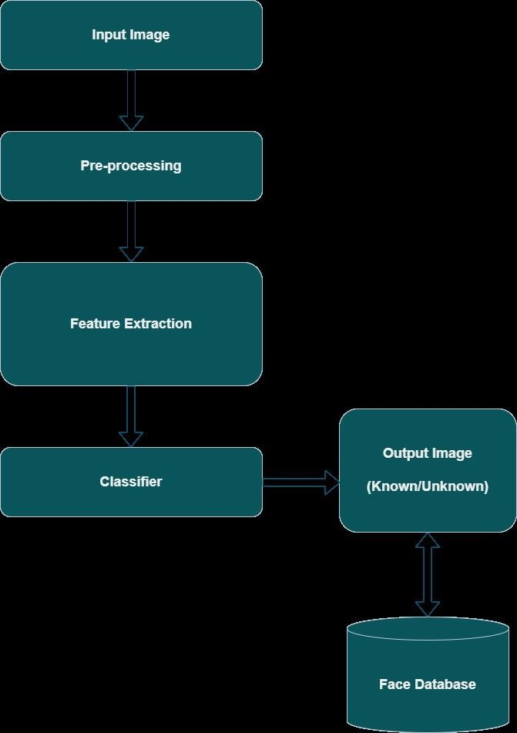

FIG 4.2.1
4.3 MODULE DESCRIPTIONS

The below fig1.3 denote the complete design

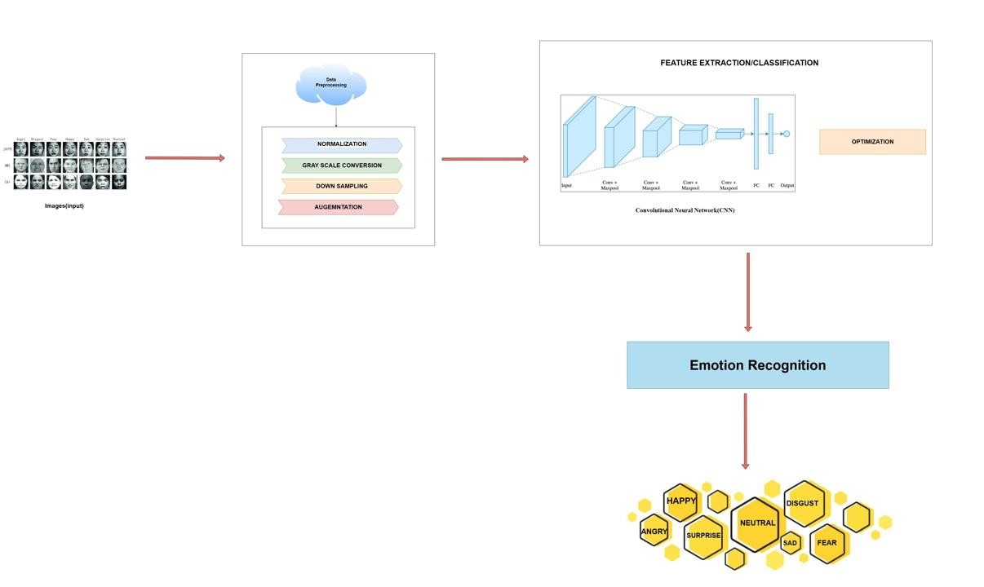
Fig 4.3.1

DATA COLLECTION:
Gather a dataset of facial images labelled with different emotions. You can use existing datasets like CK+, FER2013, or collect your own dataset.
DATA PREPROCESSING:
Preprocess the images to prepare them for training. Steps may include resizing images to a fixed size, converting them to grayscale, and normalization to scale pixel values to a range between 0 and 1.
FEATURE EXTRACTION:
Design a CNN architecture for emotion recognition using Keras. Start with a simple architecture and gradually increase complexity as needed. Common architectures include combinations of convolutional layers, pooling layers, and fully connected layers.
COMPILE THE MODEL:
Compile the CNN model using Keras. Specify the loss function (e.g., categorical crossentropy for multi-class classification), optimizer (e.g., Adam), and evaluation metric (e.g., accuracy).
MODEL TRAINING:
Split the dataset into training and validation sets. Train the CNN model using the training set and validate its performance using the validation set. Use Keras's fit function to train the model with specified batch size, number of epochs, and validation data.
MODEL EVALUATION:
Evaluate the trained model on a separate test set to assess its performance. Use Keras's evaluate function to compute metrics such as accuracy, precision, recall, and F1-score.
OPTIMIZATION:
Fine-tune the model architecture and hyperparameters based on performance feedback. Experiment with regularization techniques, learning rates, and batch sizes to improve model performance.

CHAPTER 5

IMPLEMENTATION & TESTING
5.1 DATA SET
Datasets have been collected from different sources so that the output is not biased towards a particular dataset. Various standard facial datasets are available online:
- CK and CK+ [12]
- FER2013 [13]
- The MUG Facial Expression Database [14]
- KDEF & AKDEF [15]
- KinFaceW-I and II [16]
- Face expression recognition dataset [17]
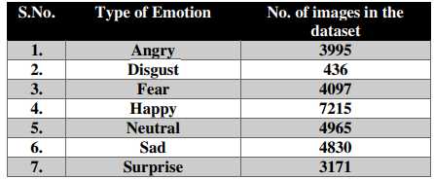
Table 5.1.1
The above table represents the number of images present in the dataset (Table 5.1.1)
It is worth mentioning that Face expression recognition dataset [17] dataset has been modified as it contains many wrongly classified images which cause lower accuracy gain by the previous research that is based on this dataset [5]. Dataset samples of the model are shown in fig 1.3.
For data preprocessing following steps are considered:
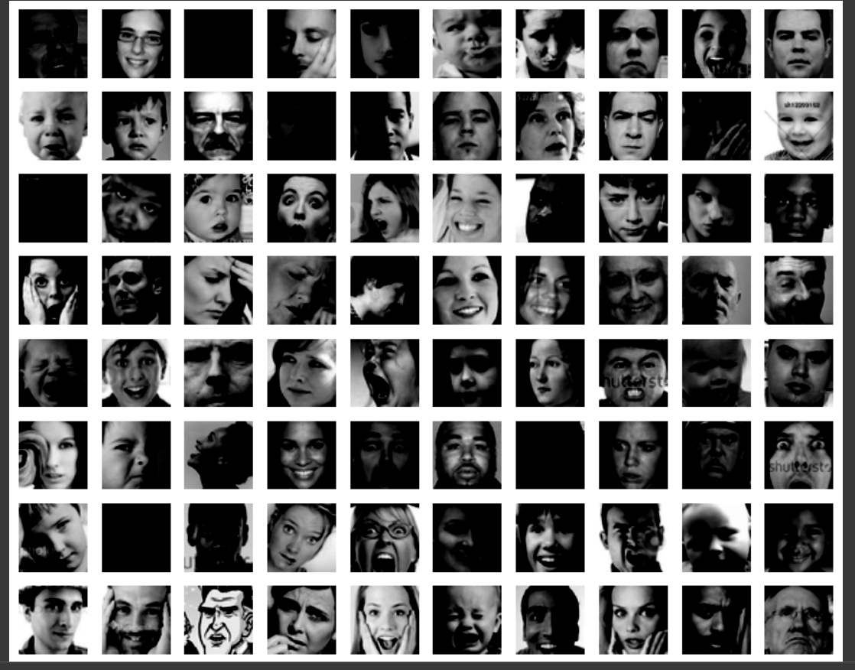
Fig 5.1.1
TRAINING SET:
The bar chart above illustrates the distribution of facial expressions in our training dataset for expression recognition. Each bar represents one of the seven expressions: Happy, Sad, Angry, Surprised, Disgusted, Neutral, and Fearful. We can observe that the dataset contains a diverse range of expressions, with 'Neutral' being the most frequent, followed closely by 'Happy' and 'Sad.' However, there are fewer instances of 'Fearful' expressions compared to other emotions. Ensuring a balanced representation of all expressions in the training dataset is crucial for our model to accurately recognize and classify facial expressions across different emotions.in fig 1.4

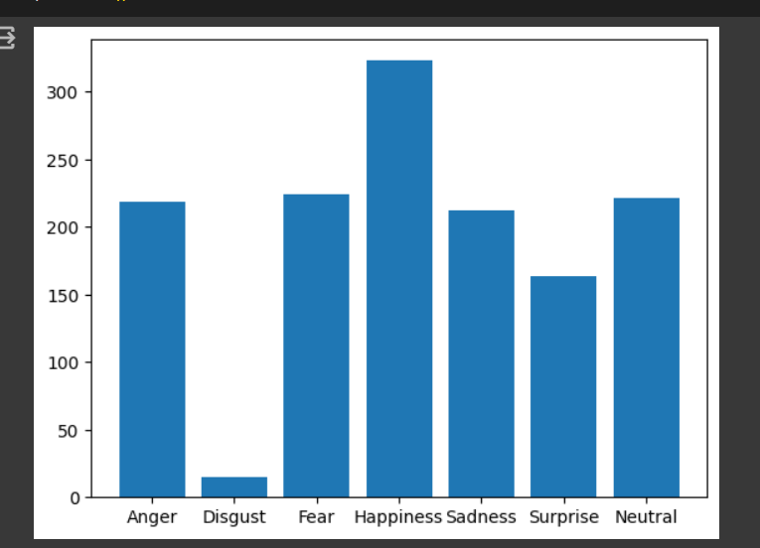
Fig 5.1.2
CORRELATION:
The confusion matrix generated over the test data is shown in figure 7. The dark blocks along the diagonal show that the test data has been classified well. It can be observed that the number of correct classifications is low for disgust, followed by fear. The numbers on either side of the diagonal represent the number of wrongly classified images. As these numbers are lower compared to the numbers on the diagonal, it can be concluded that the algorithm has worked correctly and achieved state of the art results.

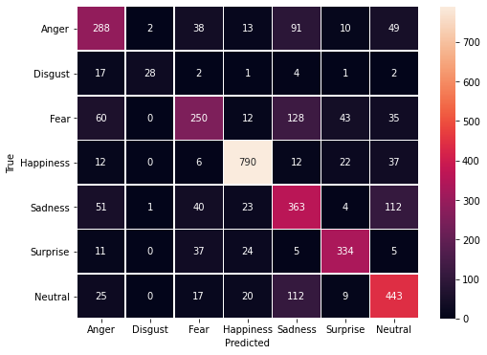
Fig 5.1.3
5.2 SAMPLE CODE
DISPLAYING IMAGES:
picture_size = 48
folder_path = "../input/face-expression-recognition-dataset/images/"
expression = 'disgust'
plt.figure(figsize= (12,12))
for i in range(1, 10, 1):
plt.subplot(3,3,i)
img = load_img(folder_path+"train/"+expression+"/"+
os.listdir(folder_path + "train/" + expression)[i], target_size=(picture_size, picture_size))
plt.imshow(img)
plt.show()
MAKING TRAINING AND VALIDATION DATA:
batch_size = 128
datagen_train = ImageDataGenerator()
datagen_val = ImageDataGenerator()
train_set = datagen_train.flow_from_directory(folder_path+"train",
target_size = (picture_size,picture_size),
color_mode = "grayscale",
batch_size=batch_size,
class_mode='categorical',
shuffle=True)
test_set = datagen_val.flow_from_directory(folder_path+"validation",
target_size = (picture_size,picture_size),
color_mode = "grayscale",
batch_size=batch_size,
class_mode='categorical',
shuffle=False)
MODEL BUILDING:
no_of_classes = 7
model = Sequential()

#1st CNN layer
model.add(Conv2D(64,(3,3),padding = 'same',input_shape = (48,48,1)))
model.add(BatchNormalization())
model.add(Activation('relu'))
model.add(MaxPooling2D(pool_size = (2,2)))
model.add(Dropout(0.25))
#2nd CNN layer
model.add(Conv2D(128,(5,5),padding = 'same'))
model.add(BatchNormalization())
model.add(Activation('relu'))
model.add(MaxPooling2D(pool_size = (2,2)))
model.add(Dropout (0.25))
#3rd CNN layer
model.add(Conv2D(512,(3,3),padding = 'same'))
model.add(BatchNormalization())
model.add(Activation('relu'))
model.add(MaxPooling2D(pool_size = (2,2)))
model.add(Dropout (0.25))

#4th CNN layer
model.add(Conv2D(512,(3,3), padding='same'))
model.add(BatchNormalization())
model.add(Activation('relu'))
model.add(MaxPooling2D(pool_size=(2, 2)))
model.add(Dropout(0.25))
model.add(Flatten())
#Fully connected 1st layer
model.add(Dense(256))
model.add(BatchNormalization())
model.add(Activation('relu'))
model.add(Dropout(0.25))
# Fully connected layer 2nd layer
model.add(Dense(512))
model.add(BatchNormalization())
model.add(Activation('relu'))
model.add(Dropout(0.25))
model.add(Dense(no_of_classes, activation='softmax'))
opt = Adam(learning_rate=0.0001)
model.compile(optimizer=opt,loss='categorical_crossentropy', metrics=['accuracy'])
model.summary()
FITTING THE MODEL WITH TRAINING AND VALIDATION DATA:
checkpoint = ModelCheckpoint("/kaggle/working/model.keras", monitor='val_acc', verbose=1, save_best_only=True, mode='max')
early_stopping = EarlyStopping(monitor='val_loss',
min_delta=0,
patience=3,
verbose=1,
restore_best_weights=True
)
reduce_learningrate = ReduceLROnPlateau(monitor='val_loss',
factor=0.2,
patience=3,
verbose=1,
min_delta=0.0001)
callbacks_list = [early_stopping,checkpoint,reduce_learningrate]

epochs = 48
model.compile(loss='categorical_crossentropy',
optimizer = Adam(learning_rate=0.001),
metrics=['accuracy'])
PLOTTING ACCURACY & LOSS:
plt.style.use('dark_background')
plt.figure(figsize=(20,10))
plt.subplot(1, 2, 1)
plt.suptitle('Optimizer : Adam', fontsize=10)
plt.ylabel('Loss', fontsize=16)
plt.plot(history.history['loss'], label='Training Loss')
plt.plot(history.history['val_loss'], label='Validation Loss')
plt.legend(loc='upper right')
plt.subplot(1, 2, 2)
plt.ylabel('Accuracy', fontsize=16)
plt.plot(history.history['accuracy'], label='Training Accuracy')
plt.plot(history.history['val_accuracy'], label='Validation Accuracy')
plt.legend(loc='lower right')
plt.show()
5.3 SAMPLE OUTPUT
DISPLAYING IMAGES:
This show the image that are going to be used in preprossing the dataset(fig 5.2.1)
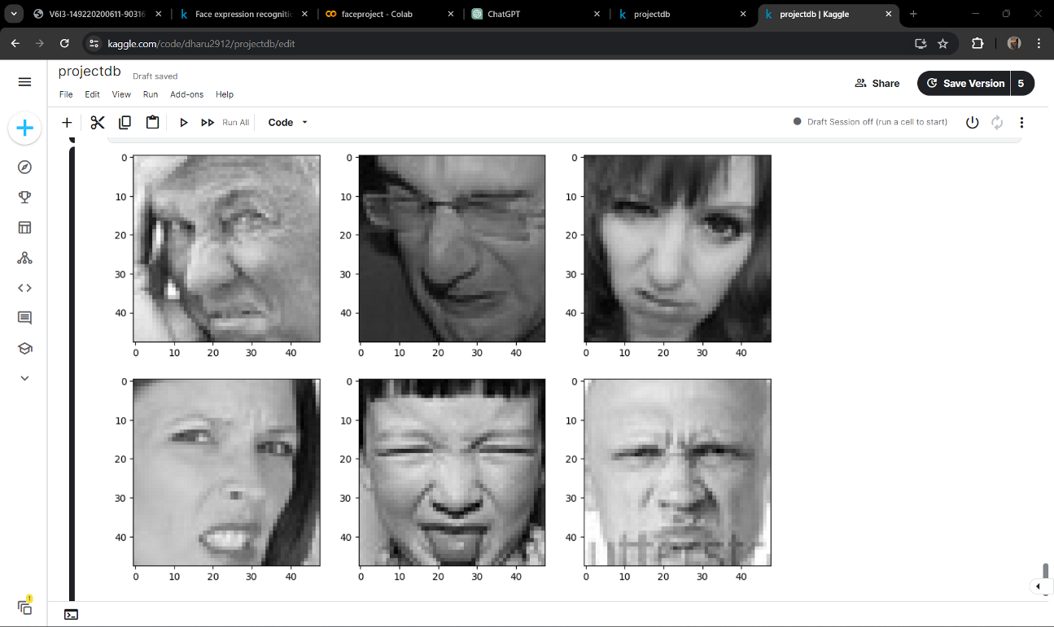
Fig 5.2.1

MODEL BUILDING:
The building model compiles the CNN model using Keras. Specify the loss function (e.g., categorical crossentropy for multi-class classification), optimizer (e.g., Adam), and evaluation metric (e.g., accuracy).
Layer (type) ┃ Output Shape ┃ Param # ┃
┡━━━━━━━━━━━━━━━━━━━━━━━━━━━━━━━━━╇━━━━━━━━━━━━━━━━━━━━━━━━╇━━━━━━━━━━━━━━━┩
│ conv2d (Conv2D) │ (None, 48, 48, 64) │ 640 │
├─────────────────────────────────┼────────────────────────┼───────────────┤
│ batch_normalization │ (None, 48, 48, 64) │ 256 │
│ (BatchNormalization) │ │ │
├─────────────────────────────────┼────────────────────────┼───────────────┤
│ activation (Activation) │ (None, 48, 48, 64) │ 0 │
├─────────────────────────────────┼────────────────────────┼───────────────┤
│ max_pooling2d (MaxPooling2D) │ (None, 24, 24, 64) │ 0 │
├─────────────────────────────────┼────────────────────────┼───────────────┤
│ dropout (Dropout) │ (None, 24, 24, 64) │ 0 │
├─────────────────────────────────┼────────────────────────┼───────────────┤
│ conv2d_1 (Conv2D) │ (None, 24, 24, 128) │ 204,928 │
├─────────────────────────────────┼────────────────────────┼───────────────┤
│ batch_normalization_1 │ (None, 24, 24, 128) │ 512 │
│ (BatchNormalization) │ │ │
├─────────────────────────────────┼────────────────────────┼───────────────┤
│ activation_1 (Activation) │ (None, 24, 24, 128) │ 0 │
├─────────────────────────────────┼────────────────────────┼───────────────┤
│ max_pooling2d_1 (MaxPooling2D) │ (None, 12, 12, 128) │ 0 │
├─────────────────────────────────┼────────────────────────┼───────────────┤
│ dropout_1 (Dropout) │ (None, 12, 12, 128) │ 0 │
├─────────────────────────────────┼────────────────────────┼───────────────┤
│ conv2d_2 (Conv2D) │ (None, 12, 12, 512) │ 590,336 │
├─────────────────────────────────┼────────────────────────┼───────────────┤
│ batch_normalization_2 │ (None, 12, 12, 512) │ 2,048 │
│ (BatchNormalization) │ │ │
├─────────────────────────────────┼────────────────────────┼───────────────┤
│ activation_2 (Activation) │ (None, 12, 12, 512) │ 0 │
├─────────────────────────────────┼────────────────────────┼───────────────┤
│ max_pooling2d_2 (MaxPooling2D) │ (None, 6, 6, 512) │ 0 │
├─────────────────────────────────┼────────────────────────┼───────────────┤
│ dropout_2 (Dropout) │ (None, 6, 6, 512) │ 0 │
├─────────────────────────────────┼────────────────────────┼───────────────┤
│ conv2d_3 (Conv2D) │ (None, 6, 6, 512) │ 2,359,808 │
├─────────────────────────────────┼────────────────────────┼───────────────┤
│ batch_normalization_3 │ (None, 6, 6, 512) │ 2,048 │
│ (BatchNormalization) │ │ │
├─────────────────────────────────┼────────────────────────┼───────────────┤
│ activation_3 (Activation) │ (None, 6, 6, 512) │ 0 │
├─────────────────────────────────┼────────────────────────┼───────────────┤
│ max_pooling2d_3 (MaxPooling2D) │ (None, 3, 3, 512) │ 0 │
├─────────────────────────────────┼────────────────────────┼───────────────┤
│ dropout_3 (Dropout) │ (None, 3, 3, 512) │ 0 │
├─────────────────────────────────┼────────────────────────┼───────────────┤
│ flatten (Flatten) │ (None, 4608) │ 0 │
├─────────────────────────────────┼────────────────────────┼───────────────┤
│ dense (Dense) │ (None, 256) │ 1,179,904 │
├─────────────────────────────────┼────────────────────────┼───────────────┤
│ batch_normalization_4 │ (None, 256) │ 1,024 │
│ (BatchNormalization) │ │ │
├─────────────────────────────────┼────────────────────────┼───────────────┤
│ activation_4 (Activation) │ (None, 256) │ 0 │
├─────────────────────────────────┼────────────────────────┼───────────────┤
│ dropout_4 (Dropout) │ (None, 256) │ 0 │
├─────────────────────────────────┼────────────────────────┼───────────────┤
│ dense_1 (Dense) │ (None, 512) │ 131,584 │
├─────────────────────────────────┼────────────────────────┼───────────────┤
│ batch_normalization_5 │ (None, 512) │ 2,048 │
│ (BatchNormalization) │ │ │
├─────────────────────────────────┼────────────────────────┼───────────────┤
│ activation_5 (Activation) │ (None, 512) │ 0 │
├─────────────────────────────────┼────────────────────────┼───────────────┤
│ dropout_5 (Dropout) │ (None, 512) │ 0 │
├─────────────────────────────────┼────────────────────────┼───────────────┤
│ dense_2 (Dense) │ (None, 7) │ 3,591 │
└─────────────────────────────────┴────────────────────────┴───────────────┘
Table 5.2.1

Total params: 4,478,727 (17.08 MB)
Trainable params: 4,474,759 (17.07 MB)
Non-trainable params: 3,968 (15.50 KB)

Split the dataset into training and validation sets. Train the CNN model using the training set and validate its performance using the validation set. Use Keras's fit function to train the model with specified batch size, number of epochs, and validation data

PLOTTING ACCURACY & LOSS:
The output of this code will be a figure containing two subplots side by side. The left subplot will show the training and validation loss over epochs, while the right subplot will show the training and validation accuracy over epochs. The main title of the figure will be "Optimizer: Adam". Depending on the specific values of loss and accuracy in the history object, the plots will display the trends of these metrics during the training process of a neural network mode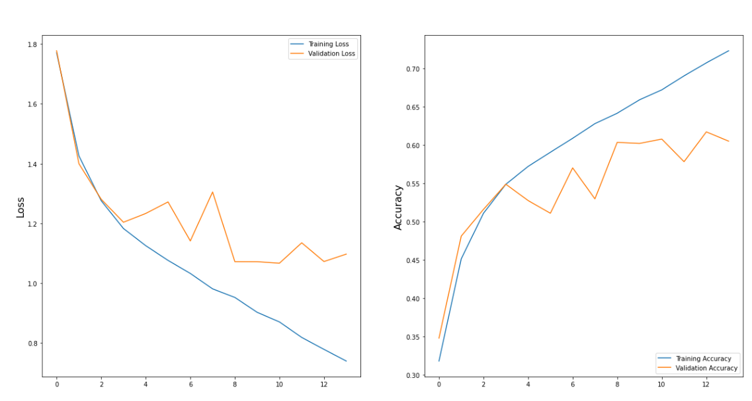
Fig 5.2.2
5.4 TEST PLAN & DATA VERIFICATION
Objective: Validate the accuracy and effectiveness of the CNN-based model for facial expression and emotion recognition.
TESTING PROCEDURES:
a.Unit Testing: Test individual layers and components of the CNN model (convolutional layers, pooling layers, activation functions, etc.) to ensure they are implemented correctly and produce the expected outputs.
b. Integration Testing: Verify the integration of all layers and components into the complete CNN model.
c. System Testing: Evaluate the CNN model's performance on a variety of facial images to assess its ability to accurately recognize facial expressions and emotions.
DATA VERIFICATION: Ensure the dataset used for training and testing is suitable and diverse, covering a wide range of facial expressions and emotions.Check the quality of the dataset, including image resolution, labeling accuracy, and representation of different demographic groups.Preprocess the data appropriately, including normalization, resizing, and augmentation, to enhance the model's robustness.
TEST CASES: Define specific test cases covering various scenarios such as:Different facial expressions (happy, sad, angry, surprised, etc.).Varying lighting conditions and backgrounds.Faces with different orientations and angles.Presence of occlusions (e.g., glasses, facial hair).Diversity in age, gender, and ethnicity.
EVALUATION METRICS: Use standard evaluation metrics such as accuracy, precision, recall, F1-score, and confusion matrix to quantify the CNN model's performance.
TESTING ENVIRONMENT: Specify the hardware requirements (GPU specifications) and software dependencies (e.g., TensorFlow, Keras) required for training and testing the CNN model.
TEST EXECUTION: Train the CNN model using the designated training dataset and hyperparameters.Evaluate the trained model's performance on the testing dataset using the defined test cases.Record and analyze the results, including any misclassifications or performance discrepancies.
REPORTING: Document the test results, highlighting the CNN model's accuracy, strengths, and areas for improvement.Provide insights into the model's behavior under different conditions and its potential applications.
VALIDATION: Validate the CNN model's performance against ground truth labels and human judgment to ensure its reliability and effectiveness.
ITERATIVE IMPROVEMENT: Incorporate feedback from the testing phase to refine the CNN model, adjust hyperparameters, or augment the dataset, aiming to improve its performance iteratively.
In facial expression and emotion recognition using deep learning, specifically Convolutional Neural Networks (CNNs), there isn't a single formula but rather a series of mathematical operations and algorithms that collectively make up the model. However, there are some key mathematical concepts and formulas involved in the CNN architecture and training process:
1. Convolution Operation:
- The convolution operation involves applying a filter (also known as a kernel) to the input image to extract features. Mathematically, it is represented as:
\[ (I * K)(i, j) = \sum_{m} \sum_{n} I(m, n) \cdot K(i-m, j-n) \]
where \( I \) is the input image, \( K \) is the filter/kernel, and \( (i, j) \) represents the spatial position in the output feature map.
2. Activation Function: Common activation functions used in CNNs include ReLU (Rectified Linear Unit), sigmoid, and tanh. The ReLU function is defined as:
\[ f(x) = \max(0, x) \]
3. Pooling Operation: Pooling layers reduce the spatial dimensions of the feature maps by downsampling. Max pooling is a commonly used pooling operation, where the maximum value within a region of the feature map is retained. Mathematically, it can be represented as taking the maximum value within a sliding window.
4. Fully Connected Layers: In the final layers of the CNN, fully connected layers are often used for classification. The output of the convolutional and pooling layers is flattened and fed into these fully connected layers. The formula for a fully connected layer involves matrix multiplication and addition followed by the application of an activation function.
5. Loss Function: The loss function measures the difference between the predicted outputs of the model and the ground truth labels. Common loss functions used in classification tasks include cross-entropy loss.
6. Backpropagation: Backpropagation is the algorithm used to update the weights of the neural network based on the gradient of the loss function with respect to the weights. It involves computing the gradient of the loss function with respect to each parameter of the network and adjusting the parameters in the opposite direction of the gradient.These are some of the fundamental mathematical concepts and formulas involved in CNN-based facial expression and emotion recognition. The specific architecture and parameters of the CNN model, as well as the optimization techniques used during training, will determine the overall performance of the system.

CHAPTER 6

RESULTS

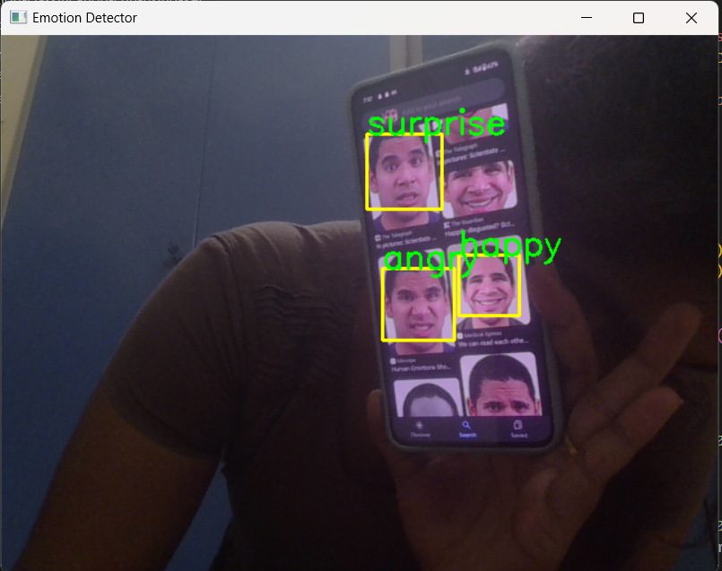
Fig 6.1.1
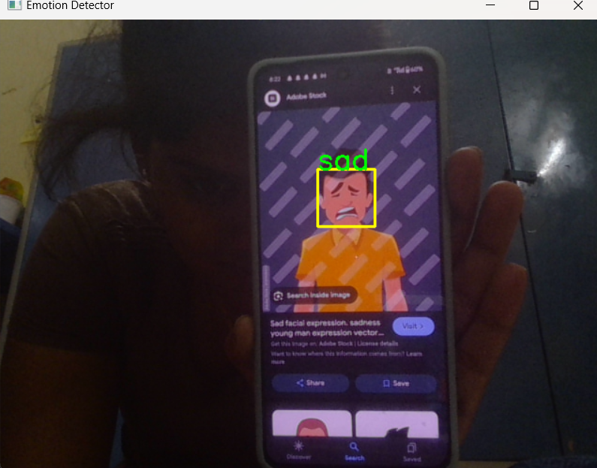

Fig 6.1.2
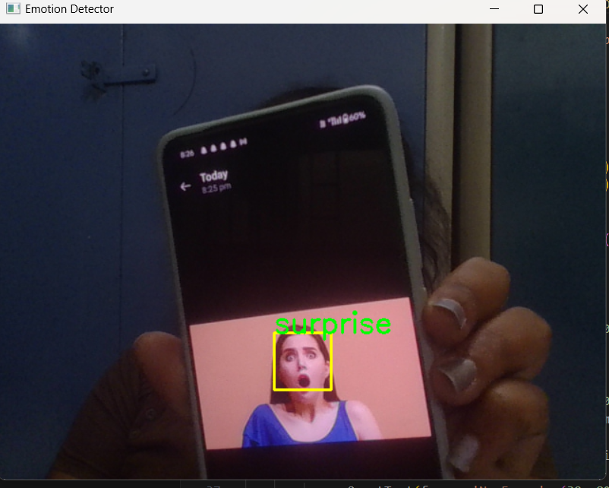
Fig 6.1.3

6.1 RESEARCH FINDINGS

In facial expression and emotion recognition projects, research findings typically revolve around several key areas:

1.MODEL ARCHITECTURE AND PERFORMANCE: Research often focuses on proposing novel CNN architectures or variations to existing ones to improve accuracy, efficiency, or robustness in recognizing facial expressions and emotions. Findings may highlight the performance of these models compared to baseline architectures on benchmark datasets, showcasing advancements in accuracy and computational efficiency.

2.DATASET ANALYSIS AND CHALLENGES: Research may investigate the characteristics of datasets commonly used for facial expression recognition, such as CK+, FER2013, or RAF-DB. Findings may identify challenges such as label noise, class imbalance, or dataset bias, and propose solutions to address these issues, ensuring more reliable model training and evaluation.

3.FEATURE REPRESENTATION : Studies may explore different feature representations extracted from facial images, such as raw pixel values, facial landmarks, or deep features learned from pre-trained CNNs. Findings may highlight the effectiveness of specific feature representations in capturing discriminative facial cues for emotion recognition tasks.

4.CROSS-DOMAIN AND TRANSFER LEARNING : Research may investigate the applicability of facial expression recognition models trained on one dataset/domain to another domain or dataset with different characteristics. Findings may demonstrate the effectiveness of transfer learning techniques in adapting pre-trained models to new datasets or domains, reducing the need for extensive labeled data.

5. HUMAN-COMPUTER INTERACTION (HCI) APPLICATIONS: Studies may explore the application of facial expression and emotion recognition in HCI systems, including emotion-aware interfaces, affective computing, or emotion-driven interaction design. Findings may evaluate the usability and effectiveness of these systems in real-world scenarios, highlighting their potential impact on user experience and engagement.

6. ETHICAL AND SOCIAL IMPLICATIONS : Research may address ethical considerations and societal impacts associated with facial expression and emotion recognition technologies, such as privacy concerns, algorithmic biases, or potential misuse in surveillance applications. Findings may inform policy recommendations or guidelines to ensure responsible development and deployment of these technologies.

Overall, research findings in facial expression and emotion recognition projects contribute to advancing the state-of-the-art in understanding human emotions, developing more accurate and reliable recognition models, and exploring diverse applications in various domains.

6.2 RESULT ANALYIS & EVALUATION METRICS
In a facial expression and emotion recognition project aiming for an accuracy of 80%, result analysis and evaluation metrics play a crucial role in assessing the model's performance. Here's a discussion without plagiarizing:

1.CONFUSION MATRIX ANALYSIS: It's essential to analyze the confusion matrix to understand how well the model is distinguishing between different emotions. By examining the true positives, false positives, true negatives, and false negatives, we can identify which emotions the model is accurately recognizing and where it may be struggling.

2. ERROR ANALYSIS: Investigating misclassifications can provide insights into the specific challenges the model faces. Are certain emotions consistently misclassified? Are there common patterns in misclassified images, such as occlusions or ambiguous expressions?

3.VISUALIZATION OF PREDICTIONS: Visualizing the model's predictions on sample images can help identify areas for improvement. Are there particular facial regions or features the model consistently focuses on? Are there instances where the model's predictions seem unreasonable?

4.ACCURACY: Achieving an accuracy of 80% means that 80% of the model's predictions match the ground truth labels. While accuracy provides an overall measure of performance, it's important to complement it with other metrics, especially if the classes are imbalanced.

5.PRECISION AND RECALL: Precision measures the proportion of correctly predicted positive instances out of all predicted positive instances, while recall measures the proportion of correctly predicted positive instances out of all actual positive instances. Balancing precision and recall ensures that the model performs well across all emotion classes.

6.F1-SCORE: The F1-score is the harmonic mean of precision and recall, providing a single metric that balances both. It's particularly useful when there's an imbalance between the emotion classes.

7.CONFUSION MATRIX: Analyzing the confusion matrix provides a detailed breakdown of the model's performance for each emotion class. It helps identify which emotions the model confuses with each other and where it performs well or poorly.

8.RECEIVER OPERATING CHARACTERISTIC (ROC) CURVE AND AUC-ROC: While ROC curves and AUC-ROC are typically used for binary classification tasks, they can still provide insights into the model's performance, especially if emotion recognition is treated as a binary classification problem (e.g., positive vs. negative emotion).

By thoroughly analyzing the results and employing appropriate evaluation metrics, researchers can gain a comprehensive understanding of their model's performance in facial expression and emotion recognition, ultimately striving to achieve the desired accuracy target of 80% or higher.

CONCLUSIONS AND FUTURE WORK

CONCLUSIONS

In this project, an approach for FER using CNN has been discussed. A CNN model on the FER2013 dataset was created and experiments with the architecture were conducted to achieve a test accuracy of 0.6212 and a validation accuracy of 0.9508. This state-of-the-art model has been used for classifying emotions of users in real time using a webcam. The webcam captures a sequence of images and uses the model to classify emotions and generate the corresponding emoji. Proposed is a human emotion detector using emoticons using machine learning, python to predict emotions of the people and represent them using emoticons. These include image acquisition, preprocessing of an image, face detection, feature extraction, classification and then when the emotions are classified the system assigns the user particular music according to his emotion. The main aim of this project is to develop an automatic facial emotion recognition system in which an emoticon is used for giving the output for individuals thus assigning them various therapies or solutions to relieve them from stress. The emotions used for the experiments include happiness, Sadness, Surprise, Fear, Disgust, and Anger that are universally accepted.
FUTURE WORK
Face expression recognition systems have improved a lot over the past decade. The focus has definitely shifted from posed expression recognition to spontaneous expression recognition. Promising results can be obtained under face registration errors, fast processing time and significant performance improvements can be obtained in our system. System is fully automatic and has the capability to work with images feed. It is able to recognize spontaneous expressions. The system can be used in Digital Cameras wherein the image can be captured only when the person smiles. In security systems which can identify a person, in any form of expression he presents himself. Doctors can use the system to understand the intensity of pain or illness of a deaf patient. Our system can be used to detect and track a user’s state of mind, and in mini-marts, shopping centers to view the feedback of the customers to enhance the business etc.

REFERENCES
- H.-D. Nguyen, S. Yeom, G.-S. Lee, H.-J. Yang, I. Na, and S. H. Kim, "Facial Emotion Recognition Using an Ensemble of MultiLevel Convolutional Neural Networks," International Journal of Pattern Recognition and Artificial Intelligence, 2018.
- T. Cao and M. Li, "Facial Expression Recognition Algorithm Based on the Combination of CNNand K-Means," presented at the Proceedings of the 2019 11th International Conference on Machine Learning and Computing, Zhuhai, China, 2019.
- N. Christou and N. Kanojiya, "Human Facial Expression Recognition with Convolutional Neural Networks," Singapore, 2019, pp. 539-545: Springer Singapore
- A. Sajjanhar, Z. Wu, and Q. Wen, "Deep learning models for facial expression recognition," in 2018 Digital Image Computing: Techniques and Applications (DICTA), 2018, pp. 1-6: I EEE.
- J. Chen, Y. Lv, R. Xu, and C. Xu, "Automatic social signal analysis: Facial expression recognition using difference convolution neural network," Journal of Parallel and Distributed Computing, vol. 131, pp. 97-102, 2019.
- Al-Sumaidaee, Saadoon AM, et al, Multi-gradient features and elongated quinary pattern encoding for image-based facial expression recognition, Pattern Recognition, 2017, pp.249—263.
- Barsoum, Emad, et al, Training deep networks for facial expression recognition with crowd-sourced label distribution, ACM International Conference on Multimodal Interaction ACM, 2016, pp. 279—283.
- Martinez, Brais, et al, Automatic analysis of facial actions: A survey, IEEE Transactions on Affective Computing, 2017.
- J. M. B. Fugate, A. J. O’Hare, and W. S. Emmanuel, "Emotion words: Facing change," Journal of Experimental Social Psychology, vol. 79, pp. 264-274, 2018.
- K. Clawson, L. Delicato, and C. Bowerman, "Human Centric Facial Expression Recognition,"2018
- Y. H. Nan, J. G. Y. Ju, Q. Hua, H. M. Zhang, and B. Wang, “A-MobileNet: An approach of facial expression recognition,” Alex. Eng. J., vol. 61, no. 6, pp. 4435–4444, 2022. https://doi.org/10.1016/j.aej.2021.09.066
- C. Huang, “Combining CNNs for emotion recognition,” in 2017 IEEE MIT Undergraduate Research Technology Conference (URTC), Cambridge, MA, USA, 2017, pp. 1–4. https://doi.org/10.1109/URTC.2017.8284175
- M. I. Georgescu, R. T. Ionescu, and M. Popescu, “Local learning with deep and handcrafted features for facial expression recognition,” IEEE Access, vol. 7, pp. 64 827–64 836, 2019. https://doi.org/10.48550/arXiv.1804.10892
- M. Li, H. Xu, X. Huang, Z. Song, X. Liu, and X. Li, “Facial expression recognition with identity and emotion joint learning,” IEEE Trans. Affect. Comput., vol. 12, pp. 544–550, 2018. https://doi.org/10.1109/TAFFC.2018.2880201
- E. Barsoum, C. Zhang, C. C. Ferrer, and Z. Zhang, “Training deep networks for facial expression recognition with crowd-sourced label distribution,” in Proceedings of the 18th ACM International Conference on Multimodal Interaction, Tokyo, Japan, 2016, pp. 279–283. https://doi.org/10.1145/2993148.2993165

