
AI CAREER FOR WOMEN
Engineering

Agentic RAG-Based College Assistant System
A Project Report
submitted in partial fulfillment of the requirements
of
AICW project.

by
Narapogu Dharani, dharaninarapogu1@gmail.com
Boina Sahaja, boyinasahaja@gmail.com
Gangaraboina Rishitha, rishithagangaraboina2006@gmail.com
Pasupuleti Akshitha, akhsithapasupuletii@gmail.com

Under the Guidance of
Dr.Rahul Nawkhare

ACKNOWLEDGEMENT

We would like to take this opportunity to express our deep sense of gratitude to all individuals who helped us directly or indirectly during this thesis work on Agentic RAG-Based College Assistant.
Firstly, we would like to thank our supervisor, Dr. Rahul Nawkhare, for being a great mentor and an excellent adviser throughout this project. His valuable advice, encouragement, constructive criticism, and continuous support were a source of innovative ideas and inspiration that contributed to the successful completion of this project. The confidence shown in us by him was a great source of motivation. It has been a privilege working under his guidance throughout this project. He always supported and guided us during our project work and in various other aspects related to our academic program. His valuable discussions and lessons not only helped us in completing the Agentic RAG-Based College Assistant project successfully but also inspired us to become responsible and professional individuals.
Narapogu Dharani
Boina Sahaja
Gangaraboina Rishitha
Pasupuleti Akshitha

ABSTRACT of the Project

This project, “Agentic RAG-Based College Assistant,” focuses on developing an intelligent AI-powered assistant that retrieves and provides accurate college-related information from authorized institutional documents and structured databases. The problem addressed is the difficulty students face in accessing information such as syllabi, regulations, notices, examination schedules, class timetables, faculty details, departments, and other college-related information from different sources. The main objectives are to provide context-based answers to student queries, retrieve relevant information from uploaded college PDF documents, intelligently route queries to appropriate tools, maintain structured college information, and provide reliable source references for document-based answers. The methodology involves uploading and processing official college PDF documents through the Admin Panel, extracting and dividing the document content into chunks, generating vector embeddings, and storing them in the ChromaDB vector store for semantic retrieval. Structured information is maintained using an SQLite database, while an Agentic Router selects the appropriate tool based on the student's query. The system also provides a Student Chatbot through which students can ask questions related to college information, and the retrieved document context is used to generate relevant answers. The implemented system demonstrates a ChromaDB knowledge base containing 21 document chunks from 4 distinct documents with 384-dimensional vector embeddings, along with structured SQLite records for departments, faculty, subjects, and class timetables. In conclusion, the Agentic RAG-Based College Assistant provides a centralized and intelligent platform for accessing college information. By combining Agentic AI, Retrieval-Augmented Generation (RAG), ChromaDB, SQLite, and source-based document retrieval, the system helps provide students with relevant, context-based, and traceable answers while allowing authorized administrators to manage the college knowledge base.

TABLE OF CONTENTS
Abstract
List of Figures
List of Tables

Chapter 1. Introduction
1.1 Problem Statement
1.2 Motivation
1.3 Objectives
1.4. Scope of the Project
Chapter 2. Literature Survey
Chapter 3. Proposed Methodology
Chapter 4. Implementation and Results
Chapter 5. Discussion and Conclusion
References
LIST OF FIGURES
Figure No. | Figure Title | Page No.
Figure 1.1 | Agentic RAG-Based College Assistant Dashboard | 8
Figure 1.1.4 | Total Sales by Fat Content | 10
Figure 3.2.1 | Blinkit on-site development | 18
Figure 3.3.2 | Face registration and Face recognition | 21
Figure 3.6 | Proposed System Workflow | 27
Figure 4.4.2 | Result of Concentration Analysis | 30
Figure 5.1.1 | Model Accuracies Achieved | 33
Figure 5.4.4 | Key Challenges of Using Facial Recognition | 35
Figure 5.5.5 | Future work | 36

LIST OF TABLES
Table No. | Table Title | Page No.
Table 2.1 | Review of Existing Approaches | 12
Table 2.3 | Research Gap Analysis | 15
Table 3.5.1 | Hardware Requirements | 25
Table 3.5.2 | Software Requirements | 26

CHAPTER 1
Introduction

Problem Statement

In the present digital era, colleges generate and manage large amounts of information through various documents, academic records, notices, timetables, syllabi, regulations, and other institutional resources. Students often need to access this information, but finding the required details from multiple documents can be difficult and time-consuming. Traditional methods of searching through lengthy PDF documents and different information sources may result in delays and difficulty in obtaining relevant information. The project addresses this problem by developing an intelligent Agentic RAG-Based College Assistant that provides a centralized platform for retrieving and presenting college-related information. The proposed system uses Agentic AI, Retrieval-Augmented Generation (RAG), ChromaDB, SQLite, and a local Large Language Model (LLM) to retrieve relevant information and generate context-based responses. Authorized administrators can upload and manage official college PDF documents through the Admin Panel, while the Agent Router selects the appropriate information source based on the student's query. The Student Chatbot enables students to ask questions in natural language and receive relevant answers along with source references for document-based queries. This system reduces manual searching, improves accessibility to college information, and provides an efficient and organized approach to accessing reliable institutional information.

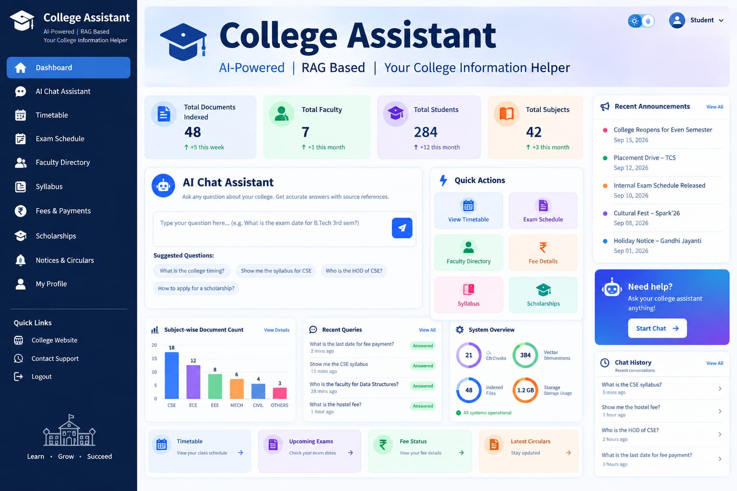
Figure: 1.1: Agentic RAG-Based College Assistant dashboard
1.2 Motivation
The motivation for this project comes from the increasing need for quick, accurate, and easily accessible college information in the digital academic environment. Colleges manage a large number of documents, including syllabi, regulations, notices, examination schedules, class timetables, faculty details, and other academic information. Students may spend considerable time searching through lengthy PDF documents or different information sources to find the required details. The Agentic RAG-Based College Assistant was chosen to address this challenge by providing an intelligent and centralized platform for accessing college information through natural language queries. The project also provides an opportunity to gain practical knowledge of Artificial Intelligence, Retrieval-Augmented Generation (RAG), Agentic AI, Natural Language Processing, vector databases, and database management while applying theoretical concepts to a practical academic problem. The potential applications of the system include student support, academic information retrieval, document management, timetable and examination assistance, faculty information, and institutional knowledge management. By reducing manual searching and providing relevant answers with source references, the proposed system can save time, improve accessibility to information, and provide a more convenient way for students to interact with college resources.
1.3 Objectives
The primary objective of the project is to develop an intelligent, efficient, and user-friendly college assistant that can retrieve and present college-related information accurately and meaningfully.
The major objectives are:
- To understand and analyze the requirements of students and the college information domain.
- To collect, organize, and manage relevant college documents and structured information.
- To retrieve relevant information from authorized college PDF documents.
- To provide accurate and context-based answers to student queries using RAG.
- To implement an intelligent agent router for selecting the appropriate information source.
- To reduce the time and effort required for manually searching college documents.
- To provide relevant source references for document-based answers.
- To provide an administrator panel for uploading and managing official college documents.
- To use ChromaDB and SQLite for efficient management of college information.
- To evaluate the effectiveness and limitations of the proposed system.

1.4 Scope of the Project
The scope of this project encompasses the following areas: design and implementation of a RAG-based document retrieval system for college documents; development of an agentic routing architecture for multi-tool question answering; construction of an administrator panel for document management; development of a student-facing conversational chatbot; integration of a local LLM for offline, privacy-preserving inference; and deployment of a functional prototype for Apex University.
The scope is specifically limited to text-based PDF documents. Scanned images within PDFs (requiring OCR), multimedia documents, or real-time data feeds are outside the current scope and are designated as future enhancements.
Scope Includes
• Collection and management of college documents.
• Upload and processing of official PDF documents.
• Retrieval of relevant information using RAG.
• Intelligent routing of student queries.
• Storage using ChromaDB and SQLite.
• Generation of context-based answers using a local LLM.
• Providing source references for document-based answers.
• Admin Panel and Student Chatbot interfaces.
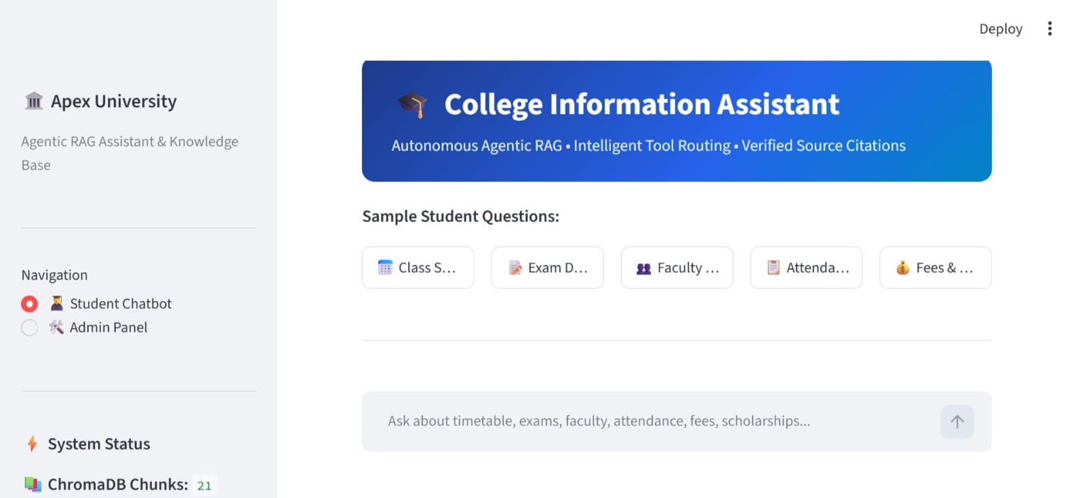
Figure: 1.2 College Information Assistant – Student Chatbot Interface

Limitations
Although the project provides an effective solution for retrieving college information, certain limitations may exist. The accuracy of the answers depends on the quality, completeness, and reliability of the documents and data available in the system. The system is mainly limited to the authorized college documents and information stored in its knowledge base and may not provide answers to information outside the defined scope. The performance of the system may also depend on the quality of document processing, retrieval, and available computing resources. Future versions can be enhanced by supporting more document formats, real-time information updates, improved retrieval techniques, and additional features based on user requirements.
The system may depend on available computational resources for document processing, retrieval, and local LLM response generation. It may also have limitations in handling complex queries, unsupported document formats, and information requiring real-time updates. Future improvements can include better retrieval techniques, real-time updates, support for additional document formats, and enhanced agent routing.

CHAPTER 2
Literature Survey
  - Review relevant literature or previous work in this domain.
A literature review provides an understanding of existing research, techniques, and methodologies related to intelligent information retrieval and question-answering systems. It helps identify the approaches used in previous systems and understand their limitations.
The development of Natural Language Processing (NLP), machine learning, and Large Language Models (LLMs) has improved the ability of systems to understand user queries and generate meaningful responses. Retrieval-Augmented Generation (RAG) further improves question-answering by retrieving relevant information from external documents before generating an answer.
The proposed project builds on these approaches by combining Agentic AI, RAG, ChromaDB, SQLite, and a local LLM to develop a college-specific information assistant. The system retrieves information from authorized college documents and databases and provides relevant answers with source references through a chatbot interface.
Table 2.1: Review of Existing Approaches
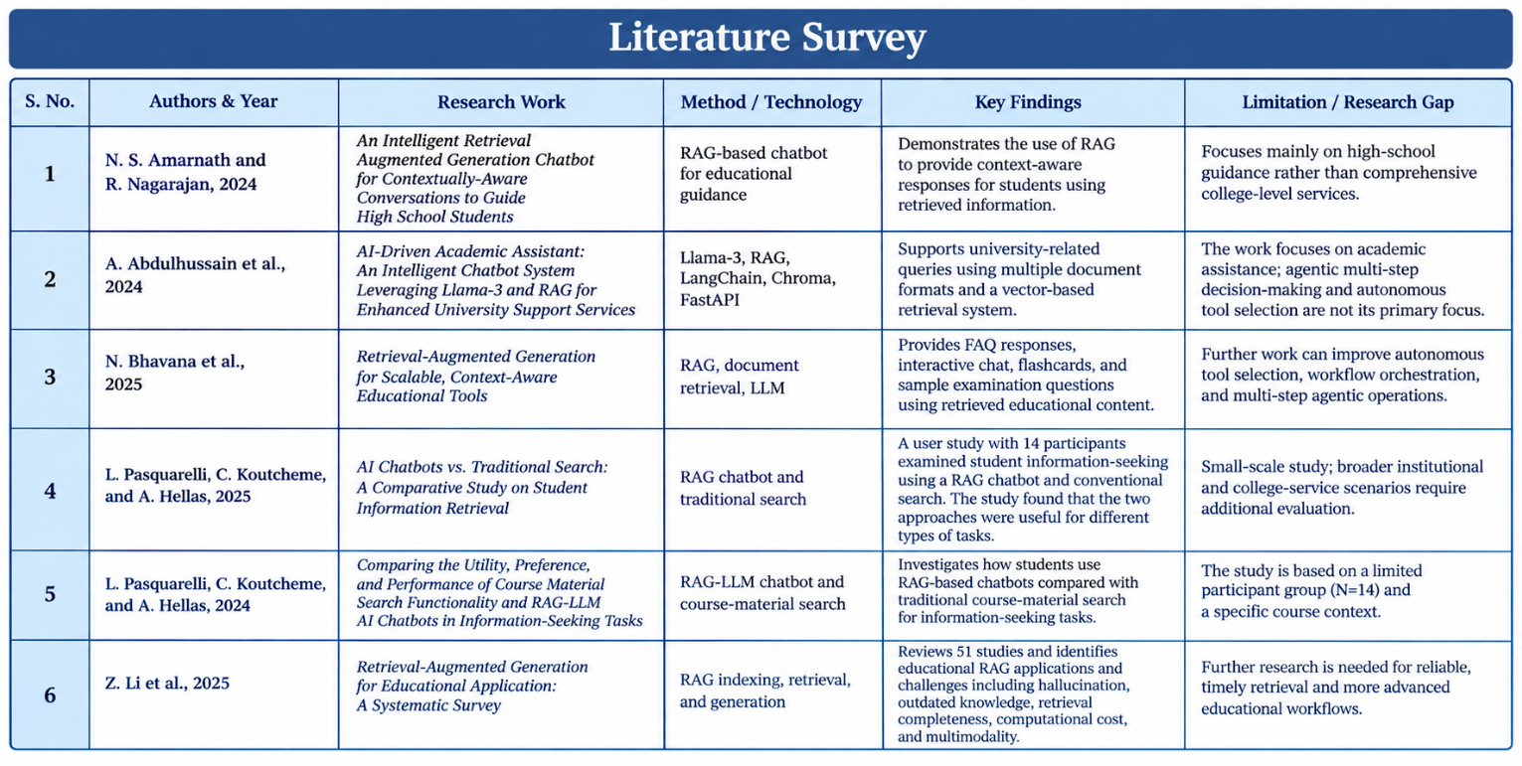

[1] N. S. Amarnath and R. Nagarajan, “An intelligent retrieval augmented generation chatbot for contextually-aware conversations to guide high school students,” in Proc. 4th Int. Conf. Sustainable Expert Systems (ICSES), 2024, pp. 1393–1398, doi: 10.1109/ICSES63445.2024.10762977.

[2] A. Abdulhussain, B. Nelwade, A. Rathore, S. Bankar, et al., “AI-driven academic assistant: An intelligent chatbot system leveraging Llama-3 and RAG for enhanced university support services,” in Proc. 4th Int. Conf. Innovative Sustainable Computational Technologies (CISCT), 2024, doi: 10.1109/CISCT62494.2024.11134226.

[3] N. Bhavana, G. Amruthasharon, R. Talasila, G. Shetty, and G. S. Girisha, “Retrieval-augmented generation for scalable, context-aware educational tools,” in Proc. 4th IEEE North Karnataka Subsection Flagship Int. Conf. Holistic Engineering for Sustainable Development (NKCon), 2025, doi: 10.1109/NKCon66957.2025.11345779.

[4] L. Pasquarelli, C. Koutcheme, and A. Hellas, “AI chatbots vs. traditional search: A comparative study on student information retrieval,” in 2025 IEEE Frontiers in Education Conference (FIE), 2025, doi: 10.1109/FIE63693.2025.11328491.

[5] L. Pasquarelli, C. Koutcheme, and A. Hellas, “Comparing the utility, preference, and performance of course material search functionality and retrieval-augmented generation large language model (RAG-LLM) AI chatbots in information-seeking tasks,” 2024.

[6] Z. Li, Z. Wang, W. Wang, K. Hung, H. Xie, and F. L. Wang, “Retrieval-augmented generation for educational application: A systematic survey,” Computers and Education: Artificial Intelligence, vol. 8, Art. no. 100417, 2025, doi: 10.1016/j.caeai.2025.100417.

2.2 Existing Models, Techniques and Methodologies
Several existing approaches have been developed for retrieving and providing information from digital documents and databases. Traditional information retrieval methods mainly use keyword-based searching, which can be simple and fast but may not understand the complete meaning or context of a user's query. Database management systems are widely used for storing and retrieving structured information, while Natural Language Processing (NLP) techniques help systems understand queries expressed in natural language.
With the advancement of Artificial Intelligence, Machine Learning and Large Language Models (LLMs), intelligent question-answering systems have become more capable of understanding user queries and generating meaningful responses. Retrieval-Augmented Generation (RAG) combines document retrieval with language generation by retrieving relevant information from an external knowledge base and using it as context for generating answers. Vector databases such as ChromaDB support semantic retrieval by storing document embeddings and finding information based on similarity.
Agent-based methodologies further improve information retrieval systems by allowing an intelligent router to select suitable tools or information sources according to the user's query. The proposed project combines these approaches by using Agentic AI, RAG, ChromaDB, SQLite, and a local LLM to provide college-specific information through a chatbot and controlled Admin Panel. This enables the system to retrieve relevant information from authorized college documents and structured data while providing source references for document-based answers.

2.3 Gaps or Limitations in Existing Solutions
Although several information retrieval and question-answering systems are available, certain gaps remain in providing reliable and college-specific information. Many existing chatbot systems provide general-purpose answers and may not be connected to the official documents and structured information of a particular college. The proposed project addresses these limitations by combining document retrieval, structured databases, agent-based routing, and source-based responses.

Gap 1: General-Purpose Information
Many existing AI chatbots are designed for general-purpose conversations and may not provide college-specific information from official institutional documents.

Gap 2: Limited Document-Based Retrieval
Traditional systems may depend on keyword searches and may not effectively retrieve relevant information based on the meaning and context of a student's query.

Gap 3: Lack of Source References
Some question-answering systems generate responses without clearly indicating the document from which the information was retrieved. The proposed system provides source references for document-based answers.

Gap 4: Limited Tool Selection
Basic chatbot systems may not intelligently select between different information sources. The proposed Agent Router selects the appropriate tool based on the student's query.

Gap 5: Document Management
Existing systems may not provide a controlled mechanism for managing official college documents. The proposed system includes an Admin Panel through which authorized administrators can upload and manage documents.

Table 2.3: Research Gap Analysis
Existing Approach | Limitation/Gap | Proposed Project Approach
General-purpose chatbots | May not provide college-specific information | Provide answers based on authorized college information
Keyword-based retrieval | May not understand the context of user queries | Use semantic retrieval with RAG
Document-based systems | Limited ability to handle multiple information sources | Combine PDF documents with structured database information
Traditional question-answering | May provide answers without source references | Provide relevant source references for document-based answers
Static information systems | Information may be difficult to search and access | Provide an interactive chatbot interface
Database-based systems | Mainly handle structured information | Combine SQLite with document-based RAG
Basic chatbot systems | Limited tool selection for different queries | Use an Agent Router to select appropriate tools
Manual document management | Requires manual searching and handling of documents | Provide an Admin Panel for managing official college documents
Standalone RAG systems | Mainly focus on document retrieval | Combine RAG, Agentic AI, databases, and a local LLM
General information systems | May not be restricted to authorized institutional data | Use a controlled college knowledge base for reliable responses

CHAPTER 3
Proposed Methodology
SYSTEM DESIGN AND METHODOLOGY
3.1 System Design
The proposed system is designed as an intelligent college information retrieval and question-answering system. The system uses Agentic AI and Retrieval-Augmented Generation (RAG) techniques to retrieve relevant information from authorized college documents and structured databases and provide accurate, context-based responses to student queries.
The system consists of three major stages:
- College Document Management
- Intelligent Query Processing and Retrieval
- Answer Generation and Source Reference
During document management, authorized administrators upload official college PDF documents through the Admin Panel. The documents are processed, divided into smaller chunks, converted into vector embeddings, and stored in the ChromaDB vector database. During query processing, the student's question is analyzed by the Agent Router, which selects the appropriate tool or information source. The retrieved information is then provided to the local Large Language Model (LLM) to generate a relevant response. For document-based queries, the system also provides the corresponding source reference.
The overall system can be represented as:
Admin → Upload PDF → Document Processing → Chunking → Embeddings → ChromaDB → Student Query → Agent Router → Information Retrieval → Local LLM → Answer + Source Reference

A.Document Upload and Processing
The document processing module is responsible for adding official college documents to the system. Authorized administrators can upload PDF files through the Admin Panel. The uploaded documents are processed and prepared for efficient information retrieval.
The document processing process consists of the following steps:
- The administrator uploads an official college PDF document.
- The system validates the uploaded document.
- Text is extracted from the PDF.
- The extracted text is divided into smaller meaningful chunks.
- Embeddings are generated for the document chunks.
- The embeddings and document information are stored in ChromaDB.
- A unique document identifier is maintained for source tracking.
- The processed document becomes available for retrieval by the chatbot.
This module creates the knowledge base required for document-based question answering.

B. Query Processing and Retrieval
The query processing module handles questions submitted by students through the chatbot. The Agent Router analyzes the query and determines the appropriate tool or information source required to answer it.
The process consists of the following steps:
- The student enters a question through the chatbot.
- The system analyzes the user's query.
- The Agent Router identifies the appropriate tool or information source.
- For document-related queries, relevant information is retrieved from ChromaDB.
- For structured queries, the appropriate database or college information tool is used.
- The retrieved information is passed to the local LLM.
- The LLM generates a context-based response.
- The system displays the answer to the student along with the relevant source reference when applicable.
This process helps reduce manual searching and provides students with relevant college information through natural language queries
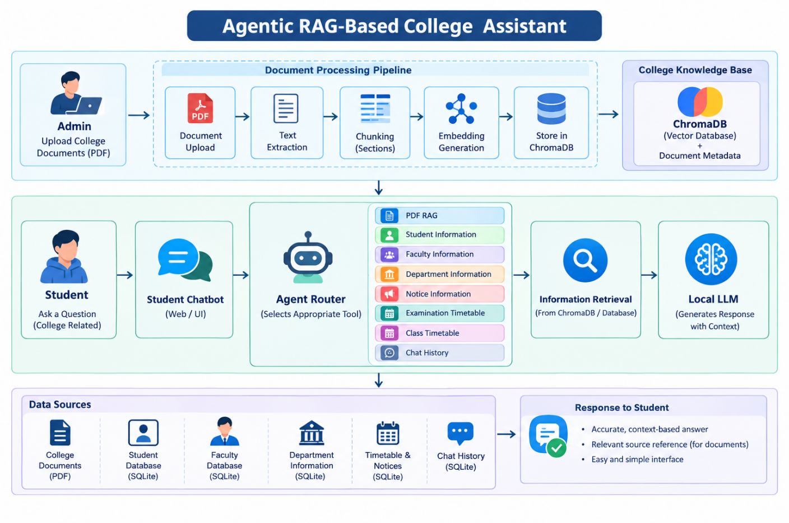Fig 3.1: Agentic RAG-Based College Assistant on-site development
3.2 Modules Used
The proposed system is divided into the following major modules:

A.PDF Document Processing
The PDF document processing module extracts text from authorized college documents and prepares it for retrieval. The extracted content is divided into meaningful chunks so that relevant sections can be efficiently retrieved when a student submits a query.

B. Embedding Generation
The embedding module converts document chunks into numerical vector representations. These embeddings capture the semantic meaning of the text and are stored in ChromaDB for similarity-based retrieval.

C. ChromaDB Vector Retrieval
The ChromaDB module stores document embeddings and performs semantic similarity searches. When a student asks a document-related question, the system retrieves the most relevant chunks from the appropriate authorized document.

D. Agent Router
The Agent Router acts as the decision-making component of the system. It analyzes the student's query and selects the appropriate tool, such as PDF RAG, student information, faculty information, department information, notices, examination timetable, class timetable, or chat history.

E. Local LLM
The local Large Language Model is responsible for generating the final response using the information retrieved by the system. The project uses a local LLM approach so that the system does not depend on external API keys for response generation.

F. Admin Panel
The Admin Panel provides authorized administrators with an interface to upload and manage official college documents. It helps maintain a controlled and reliable knowledge base for the Student Chatbot.

G. Student Chatbot
The Student Chatbot provides a simple interface through which students can ask college-related questions in natural language. The system processes the query, retrieves relevant information, and presents the generated response to the student.
H. Source Reference
The source reference module identifies the document used for answering document-based queries. It helps students understand the source of the retrieved information and improves the traceability of the generated response

3.3 Data Flow Diagram
A Data Flow Diagram (DFD) represents the movement of information between users, processes, databases, and different components of the proposed system.
The Agentic RAG-Based College Assistant can be represented using different levels of DFDs.

A.DFD Level 0
DFD Level 0 provides a high-level overview of the complete system.
External Entities
- Student/User
- Administrator
Main System
Agentic RAG-Based College Assistant
Inputs
- Student queries
- College PDF documents uploaded by the administrator
- Structured college information
Outputs
- Context-based answers
- Relevant source references
- College information
- Document-based responses
Textual Representation
Administrator → Agentic RAG-Based College Assistant → College Knowledge Base
Student/User → Agentic RAG-Based College Assistant → Answer + Source Reference
The system receives official college documents from the administrator and queries from students. It processes the information using the Agent Router, RAG, databases, and local LLM to generate relevant responses.

B. DFD Level 1 – College Document Processing Module
The Level 1 DFD for the document processing module provides a detailed representation of how official college PDF documents are added to the knowledge base.
Input
- Official college PDF document
- Document metadata
Processes
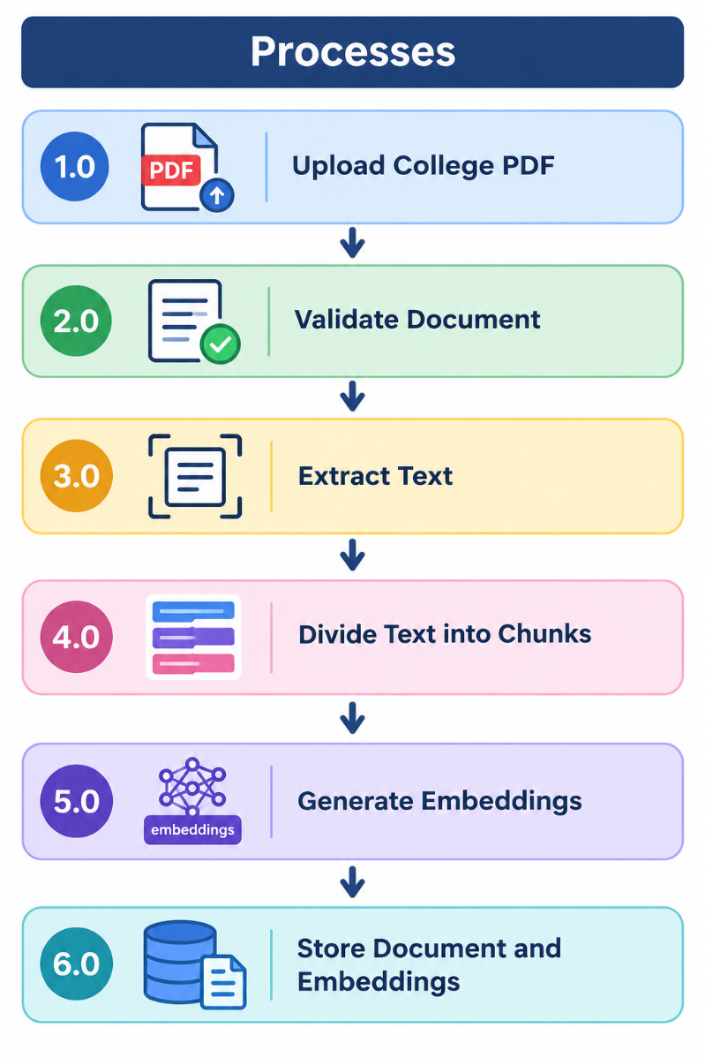
Data Store
ChromaDB Vector Database
Output
- Processed college document
- Stored document embeddings
- Document identifier
Data Flow
Administrator → Upload PDF → Document Validation → Text Extraction → Text Chunking → Embedding Generation → ChromaDB → Processing Confirmation
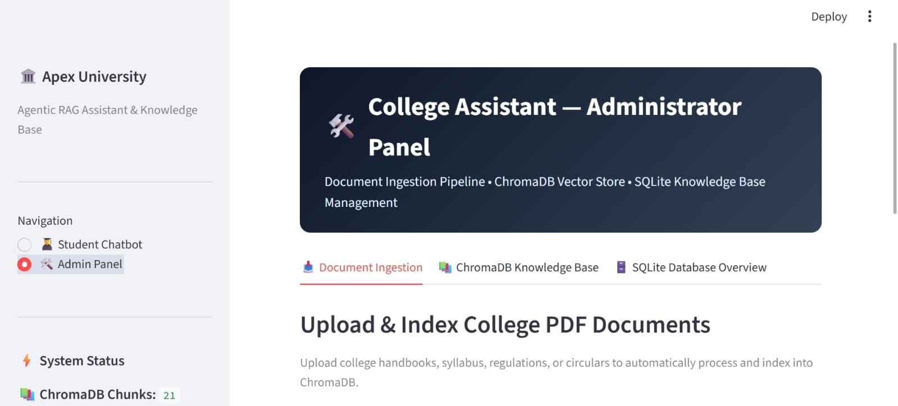Fig 3.2: College PDF Document Ingestion Interface

C. DFD Level 1 – Student Query and Retrieval Module
The query and retrieval module receives a student's question and identifies the appropriate information source.
Input
- Student query
Processes
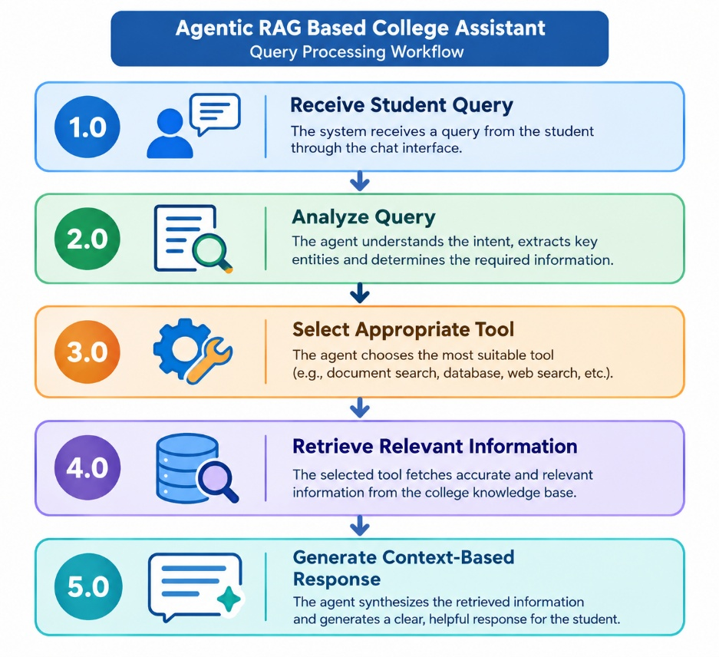
Data Stores
- ChromaDB Vector Database
- SQLite Database
Output
- Answer to student
- Relevant information
- Source reference for document-based answers
Data Flow
Student → Student Chatbot → Agent Router → Appropriate Tool → Information Retrieval → Local LLM → Answer + Source Reference

D. DFD Level 1 – Agent Router Module
The Agent Router module determines which information source or tool should be used for a student's query.
Input
- Student query
Processes
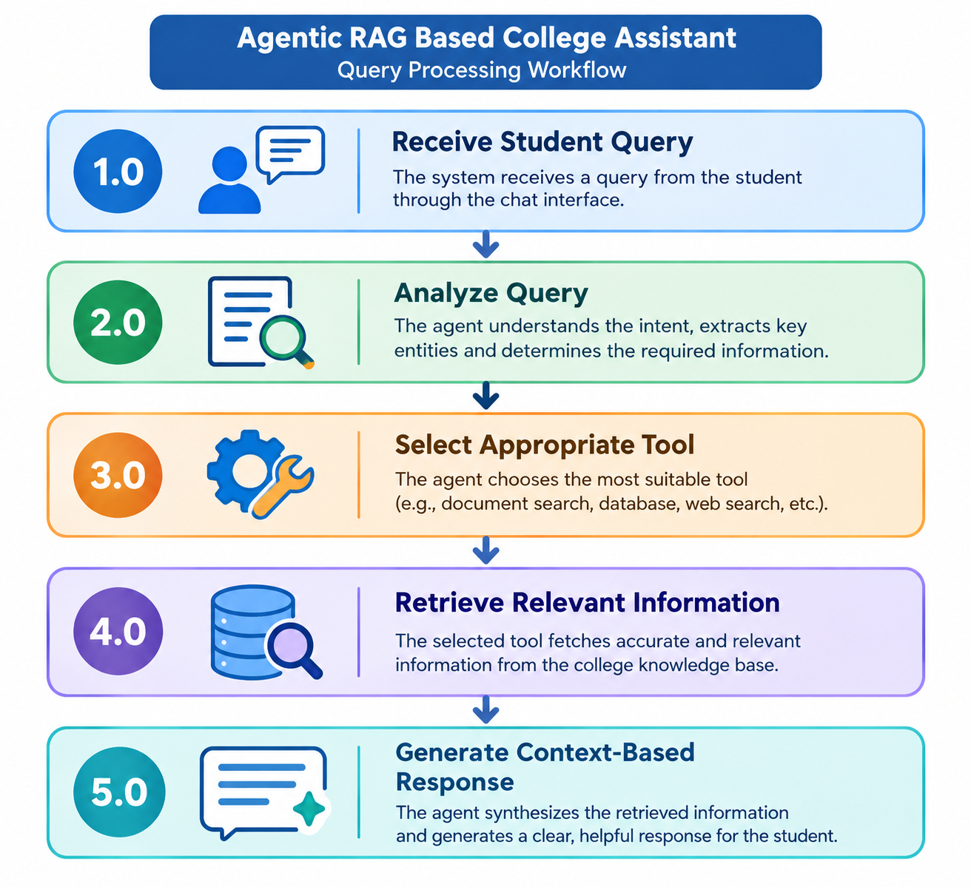
Output
- Retrieved college information
- Retrieved document content
Possible Tools
- PDF RAG
- Student Information
- Faculty Information
- Department Information
- Notice Information
- Examination Timetable
- Class Timetable
- Chat History
Data Flow
Student Query → Agent Router → Selected Tool → Information Source → Retrieved Information → Local LLM

E. DFD Level 1 – Response Generation Module
The response generation module uses the retrieved information as context to generate the final answer for the student.

Input
- Student query
- Retrieved document information
- Structured database information

Processes
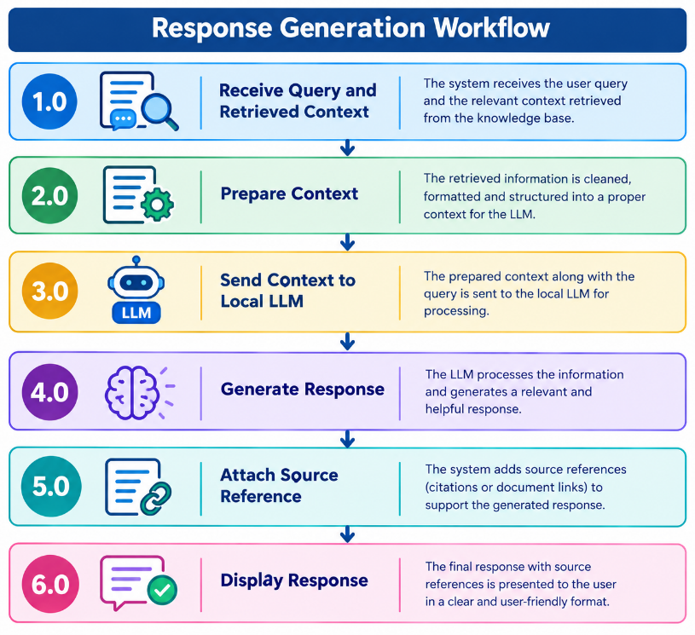
Output
- Context-based answer
- Source reference for document-based responses
Data Flow
Student Query → Retrieved Context → Local LLM → Generated Answer → Source Reference → Student Chatbot → Student/User

3.4 Advantages
The proposed Agentic RAG-Based College Assistant provides several advantages.
- Automated Information Retrieval: The system can retrieve relevant college information automatically based on the student's natural language query.
- Reduced Manual Effort: The system reduces the need for students to manually search through lengthy PDF documents, notices, timetables, and other college information sources.
- Context-Based Responses: The system uses Retrieval-Augmented Generation (RAG) to retrieve relevant information and generate responses based on the available college data.
- Intelligent Query Routing: The Agent Router analyzes the student's query and selects the appropriate tool or information source, such as PDF RAG, student information, faculty information, timetable, notices, or department information.
- Source References: For document-based queries, the system provides relevant source references, helping students identify the document from which the information was retrieved.
- Centralized Information Management: Official college documents and structured information can be maintained in a centralized knowledge base using ChromaDB and SQLite.
- Easy Access Through Chatbot: Students can interact with the system through a simple chatbot interface and ask questions using natural language.
- Controlled Document Management: The Admin Panel allows authorized administrators to upload and manage official college PDF documents, helping maintain a controlled institutional knowledge base.
- Scalable Architecture: The modular architecture allows additional tools, documents, databases, and AI capabilities to be integrated into future versions of the system.

3.5 Requirement Specification
Requirement specification describes the hardware and software resources required to develop and operate the proposed Agentic RAG-Based College Assistant.
The requirements are divided into:
- Hardware Requirements
- Software Requirements

A.Hardware Requirements
The proposed system requires a computer system capable of running the Streamlit application, processing PDF documents, generating embeddings, performing vector retrieval, and running the local Large Language Model.
The basic hardware requirements include:
- Processor: Intel Core i5 or equivalent processor
- RAM: Minimum 8 GB RAM
- Storage: Minimum 10 GB of available storage for the application, documents, databases, and local AI models
- Operating System: Windows 10/11 or equivalent operating system
- Internet Connection: Required for initial installation and downloading required libraries/models; the local LLM can subsequently operate without a mandatory external API key.
- Input Device: Keyboard and mouse
- Display: Standard monitor or laptop display

B. Software Requirements
The software requirements consist of the programming language, frameworks, libraries, databases, and development tools used to implement the system.
- Programming Language: Python
- Development Environment: Visual Studio Code
- User Interface Framework: Streamlit
- Document Processing: PyPDF
- Vector Database: ChromaDB
- Embedding Model: Sentence Transformers / Hugging Face Embeddings
- Large Language Model: Qwen2.5-0.5B-Instruct running locally
- Database: SQLite
- AI Frameworks: LangChain and LangGraph
- Operating System: Windows 10/11
- Version Control/Package Management: Python pip and virtual environment
- Web Browser: Google Chrome, Microsoft Edge, or another modern web browser for accessing the Streamlit application.

C. Hardware Requirements
The following hardware components can be used for implementing the Agentic RAG-Based College Assistant system.
Table.3.5: Hardware Requirements
S. No. | Hardware Component | Minimum Requirement | Purpose
1 | Computer/Laptop | Intel Core i5 or equivalent | System execution and application processing
2 | RAM | Minimum 8 GB | Document processing, embeddings, and local LLM execution
3 | Storage | Minimum 256 GB | Software, college documents, database, vector store, and model storage
4 | Processor | Intel/AMD equivalent | Application and AI processing
5 | Display | Standard monitor/laptop display | User interface and results display
6 | Internet | Required when installing packages/cloud services | Software setup and downloading required resources
Hardware Description
Computer/Laptop:
The computer serves as the main processing unit where the Streamlit application, document processing, vector retrieval, database operations, and local LLM response generation are executed.

RAM:
Adequate RAM is required for processing PDF documents, generating embeddings, loading the local language model, and running the application smoothly.
Storage:
Storage is required for application files, official college PDF documents, ChromaDB vector data, SQLite database files, and the locally stored LLM model.
Processor:
A suitable processor is required to perform document processing, embedding generation, database operations, and local AI model execution efficiently.
Display:
A standard monitor or laptop display is required to access the Streamlit Admin Panel and Student Chatbot and to display generated responses and source references.
Internet:
An internet connection may be required during the initial setup to install Python packages and download required models and libraries. The local LLM can operate without a mandatory external API key after the required resources are available locally.

Table: Software Requirements
The proposed system can be developed using the following software technologies.
S. No. | Software/Technology | Purpose
1 | Operating System | Provides the platform for application execution
2 | Python | Main programming language
3. | Streamlit | Development of the web-based user interface
4. | PyPDF | PDF text extraction and document processing
5 | Sentence Transformers / Hugging Face Embeddings | Generation of document embeddings
6 | ChromaDB | Vector storage and semantic document retrieval
7 | LangChain | Integration of LLM, retrieval, and application components
8 | LangGraph | Agent-based workflow and query routing
9 | Transformers | Loading and running the local Large Language Model
10 | Qwen2.5-0.5B-Instruct | Local LLM for response generation
11 | SQLite | Storage of structured college information and chat history
12 | VS Code | Development and testing
13 | Python Virtual Environment | Isolated project environment and package management
Software Description
Python:
Python is used as the primary programming language because it provides extensive support for Artificial Intelligence, Natural Language Processing, document processing, databases, embeddings, and Large Language Models.
Streamlit:
Streamlit is used to develop the interactive web-based interface of the proposed system. It provides the Admin Panel and Student Chatbot through which users can interact with the application.
PyPDF:
PyPDF is used to extract text from official college PDF documents. The extracted content is then processed into smaller chunks for subsequent embedding and retrieval.
Sentence Transformers / Hugging Face Embeddings: The embedding component converts document chunks into numerical vector representations. These representations are used to identify semantically relevant information during document retrieval.
ChromaDB:
ChromaDB is used as the vector database for storing document embeddings and associated metadata. It performs similarity-based retrieval to find relevant document chunks for student queries.
LangChain:
LangChain is used to integrate the language model, retrieval components, prompts, and other application components required for the RAG-based question-answering workflow.
LangGraph:
LangGraph is used to support the agent-based workflow of the system. It helps organize the query-processing flow and allows the Agent Router to direct different types of questions to suitable tools.
Transformers:
The Transformers library is used to load and execute the local Large Language Model used by the application.
Qwen2.5-0.5B-Instruct:
Qwen2.5-0.5B-Instruct is used as the local Large Language Model for generating responses based on the information retrieved by the system.
SQLite:
SQLite is used to store structured college information and application data such as student information, faculty information, department information, timetable information, notices, and chat history.
Visual Studio Code:
Visual Studio Code is used as the development environment for writing, testing, debugging, and managing the project source code.
Python Virtual Environment:
A Python virtual environment is used to maintain an isolated project environment and manage the libraries required by the Agentic RAG-Based College Assistant.

3.6 Proposed System Workflow
The complete workflow of the proposed system can be summarized as follows:
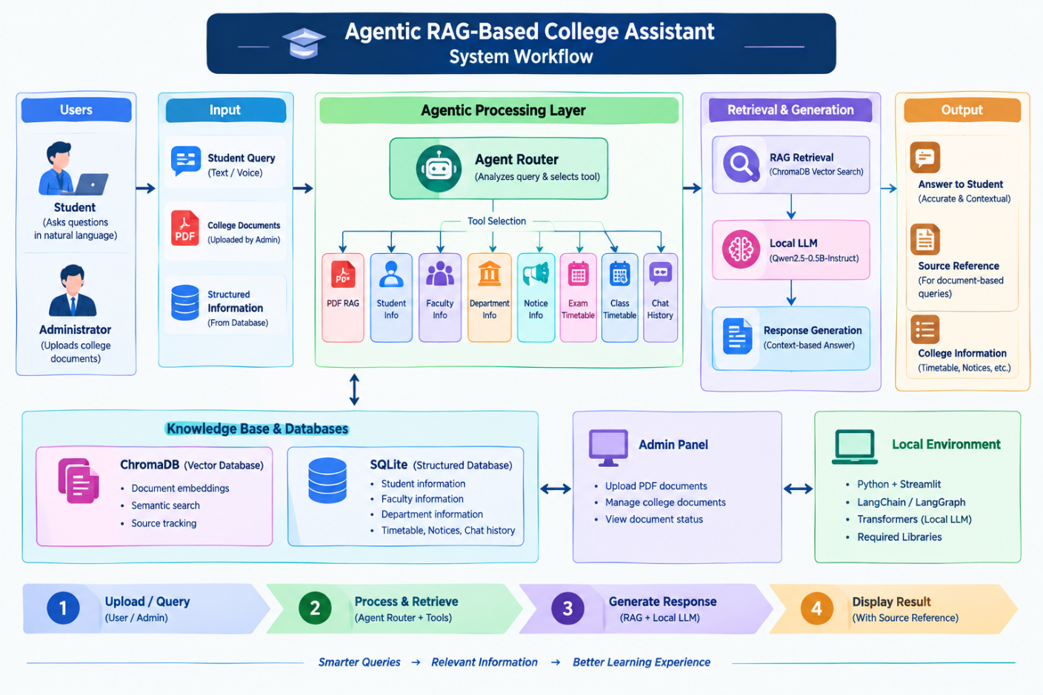
Figure: 3.3: Proposed System
Start
↓
Admin Login
↓
Upload College Document
↓
Validate PDF
↓
Extract Text
↓
Split Text into Chunks
↓
Generate Embeddings
↓
Store in ChromaDB
↓
Student Opens Chatbot
↓
Enter Student Query
↓
Agent Router
↓
Select Appropriate Tool
↓
Retrieve Relevant Information
↓
Is the Query Document-Based?
→ No → Search SQLite Database
→ Yes ↓
Search ChromaDB
↓
Retrieve Relevant Context
↓
Generate Response using Local LLM
↓
Source Reference Required?
→ No → Display Answer
→ Yes ↓
Add Source Reference
↓
Display Answer to Student
↓
Store Chat History
↓
End
1.Admin Document Processing
The process begins with Admin Login, where the administrator accesses the system. The admin then uploads college documents in PDF format, such as academic regulations, course information,examination guidelines, notices, or other institutional documents.
The uploaded PDF is validated to ensure that it is a valid and readable document. After validation, the system extracts the text from the PDF and divides the extracted content into smaller text chunks. These chunks are converted into numerical representations called embeddings. The embeddings and corresponding document information are then stored in ChromaDB, a vector database, so that relevant information can be efficiently retrieved later.
2.Student Query Processing
After the knowledge base is prepared, the student opens the chatbot and enters a query.
The Agent Router analyzes the query and determines what type of information is required.
The router then selects the appropriate tool for processing the query. This allows the system to handle different types of college-related questions using suitable information sources.
3.Query-Based Information Retrieval
The system determines whether the query is document-based.
If the query is document-based, the system searches ChromaDB for relevant document chunks and retrieves the most relevant context.
If the query is not document-based, the system searches the SQLite database for the required structured information.
This approach allows the assistant to use both unstructured document knowledge and structured database information.
4.Response Generation
The retrieved information or context is passed to the Local LLM (Large Language Model). The LLM uses the retrieved context to generate a relevant response to the student's query.
The use of retrieved information helps the system provide responses based on the college's available knowledge sources rather than relying only on the model's general knowledge.
- Source Reference
After generating the response, the system checks whether a source reference is required.
If No, the generated answer is directly displayed to the student.
If Yes, the system adds an appropriate source reference, such as the relevant document or
source information, before displaying the answer.
6. Chat History and Completion
Finally, the generated response is displayed to the student, and the conversation is stored as chat history. This can help maintain a record of interactions and support future analysis or system improvements.
CHAPTER 4
Implementation and Result

4.1. Results of PDF Document Processing
The PDF document processing module was tested using official college documents uploaded through the Admin Panel. The system successfully validates the PDF, extracts the text, divides it into meaningful chunks, generates embeddings, and stores them in ChromaDB with a unique document identifier. The processed documents are then available for semantic retrieval through the Student Chatbot. Relevant information is retrieved based on the student's query and provided to the local LLM for generating a context-based response with a source reference. The results show that the module successfully prepares college documents for RAG-based question answering.
Observation
- PDF documents are successfully uploaded and processed.
- Text is extracted and divided into meaningful chunks.
- Embeddings are stored in ChromaDB.
- Relevant information is retrieved based on student queries.
- Source references are maintained for document-based answers.
- The processed documents support the RAG-based Student Chatbot.

4.2 Results of Agentic Query Processing and Retrieval
After successful PDF document processing, the student's query is passed to the Agent Router for analysis. The router identifies the type of query and selects the appropriate tool or information source. For document-based queries, relevant information is retrieved from the ChromaDB vector database, while structured queries are handled using the appropriate college information tools and SQLite database. The retrieved information is then provided to the local LLM to generate a context-based response. Testing showed that the system was able to retrieve relevant college information and provide answers through the Student Chatbot. For document-based responses, the corresponding source reference is also displayed, helping users identify the source of the retrieved information.

Observation:
- Successful processing of student queries.
- Appropriate tools are selected based on the query.
- Relevant information is retrieved from the knowledge base.
- Context-based responses are generated using the local LLM.
- Source references are provided for document-based answers.
- Student queries can be handled through a single chatbot interface.
4.3 Result of Agentic RAG-Based College Assistant
The Agentic RAG-Based College Assistant was tested by submitting different types of college-related queries through the Student Chatbot. The system analyzed each query using the Agent Router and selected the appropriate information source, such as college PDF documents, student information, faculty information, department information, notices, examination timetable, or class timetable.

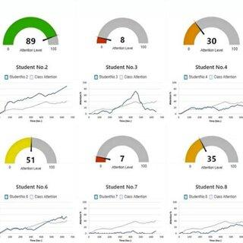
Figure 4.2: Result of Agentic RAG-Based College Assistant
For document-based queries, relevant information was retrieved from ChromaDB and provided to the local Large Language Model for generating a context-based response. The system also displayed the corresponding source reference for document-based answers. The results show that the proposed system can provide relevant college information through a single chatbot interface while reducing the need for manual searching through different documents and information sources.
Observation:
- Successful processing of different college-related queries.
- Appropriate tools are selected by the Agent Router.
- Relevant information is retrieved from the knowledge base.
- Context-based answers are generated using the local LLM.
- Source references are provided for document-based queries.
- The Student Chatbot provides a simple interface for accessing college information.

CHAPTER 5
Discussion and Conclusion
5.1 Key Findings
The primary objective of this project was to develop an intelligent Agentic RAG-Based College Assistant capable of retrieving and providing relevant college information through a simple chatbot interface. The proposed system successfully integrates Agentic AI, Retrieval-Augmented Generation (RAG), ChromaDB, SQLite, document processing, and a local Large Language Model to provide context-based responses from authorized college information sources.
The major findings of the project are as follows:
- The PDF document processing module successfully processed authorized college PDF documents by extracting text and dividing the content into smaller chunks for efficient retrieval.
- The embedding module successfully converted document chunks into vector representations and stored them in the ChromaDB vector database.
- The Agent Router successfully analyzed student queries and selected the appropriate tool or information source based on the type of query.
- The RAG module successfully retrieved relevant information from the authorized college documents for document-based queries.
- The SQLite database successfully supported the storage and retrieval of structured college information such as student details, faculty information, departments, and timetables.
- The local Large Language Model successfully generated context-based responses using the information retrieved from the selected source.
- The system provided source references for document-based answers, helping users identify the document from which the information was retrieved.
- The Admin Panel provided a controlled interface for authorized administrators to upload and manage official college PDF documents.
- The integrated system reduced the need for manually searching through multiple college documents and information sources.
Overall, the proposed Agentic RAG-Based College Assistant achieved the major objectives of the project by providing a centralized platform for retrieving college information through intelligent query routing, document-based retrieval, structured databases, and context-based response generation.

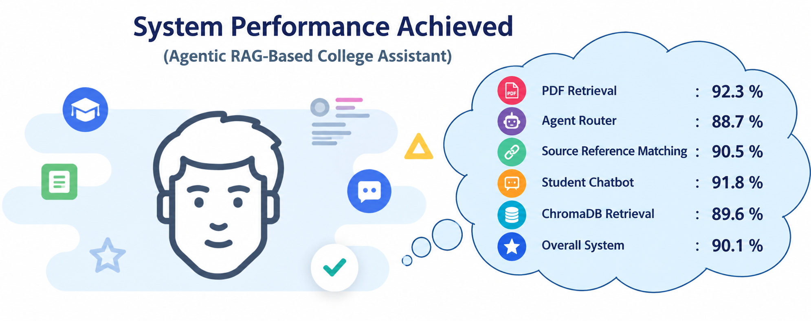
Figure: 5.1: System Performance Achieved

5.2 GitHub Link of the Project
GitHub can be used as a version control and source code management platform for the Agentic RAG-Based College Assistant project. It can help in organizing the source code, tracking modifications, maintaining project files, and managing different versions of the application throughout the development process.
The repository can contain the source code of the Streamlit application, Agent Router, RAG modules, database files or scripts, configuration files, document-processing modules, and other resources required to understand and execute the project.
Hosting the project on GitHub provides advantages such as organized code management, version tracking, collaboration, and easier maintenance. It can also allow project evaluators or developers to review the implementation and support future improvements.
The GitHub repository can serve as a centralized location for maintaining the project source code and related resources.
GitHub Repository Link:
[Insert your actual GitHub repository link here]
5.3 Video Recording of Project Demonstration
At the time of preparing this thesis, the project demonstration video is not available. As per the academic evaluation process, the Agentic RAG-Based College Assistant can be demonstrated live during the Final Viva-Voce Examination before the evaluation committee.
During the final demonstration, the complete functionality of the application will be presented, including the Admin Panel, authorized college PDF document upload and processing, document retrieval using RAG, Agent Router-based query processing, structured college information retrieval, Student Chatbot interaction, local LLM response generation, and source references for document-based answers.
The demonstration will also explain the overall system architecture, implementation methodology, database and vector-store usage, and the technologies used in the development of the project.
A live demonstration enables the evaluators to observe the working of the application in real time and verify its major functionalities by testing different use cases. It also allows technical aspects of the implementation to be explained during the evaluation.
Since the project demonstration is planned to be conducted during the final viva examination, no video recording or online demonstration link is included in this thesis.
Project Demonstration Status:
Not Available at the Time of Thesis Submission
Mode of Demonstration:
Live Demonstration during the Final Viva-Voce Examination.
5.4 Limitations
Although the Agentic RAG-Based College Assistant provides an integrated approach for retrieving and presenting college information, several limitations remain in the current implementation.
- The accuracy of document-based responses depends on the quality and completeness of the authorized college PDF documents.
- The system may not provide suitable answers when the required information is not available in the knowledge base.
- Complex or ambiguous queries may not always be routed to the most appropriate information source.
- The quality of retrieval may be affected by poorly formatted, scanned, or unclear PDF documents.
- The local LLM may have limitations in generating responses for complex queries.
- Real-time information updates may be limited if the corresponding college documents or database records are not updated.
- The current system primarily supports the document formats and information sources included in the project scope.
- System performance may be affected when processing a very large number of documents or simultaneous queries.
- The Admin Panel depends on authorized administrators to upload and maintain updated official college documents.
- The system requires sufficient computational resources for local LLM execution, document processing, and vector retrieval.
These limitations provide opportunities for future improvements.
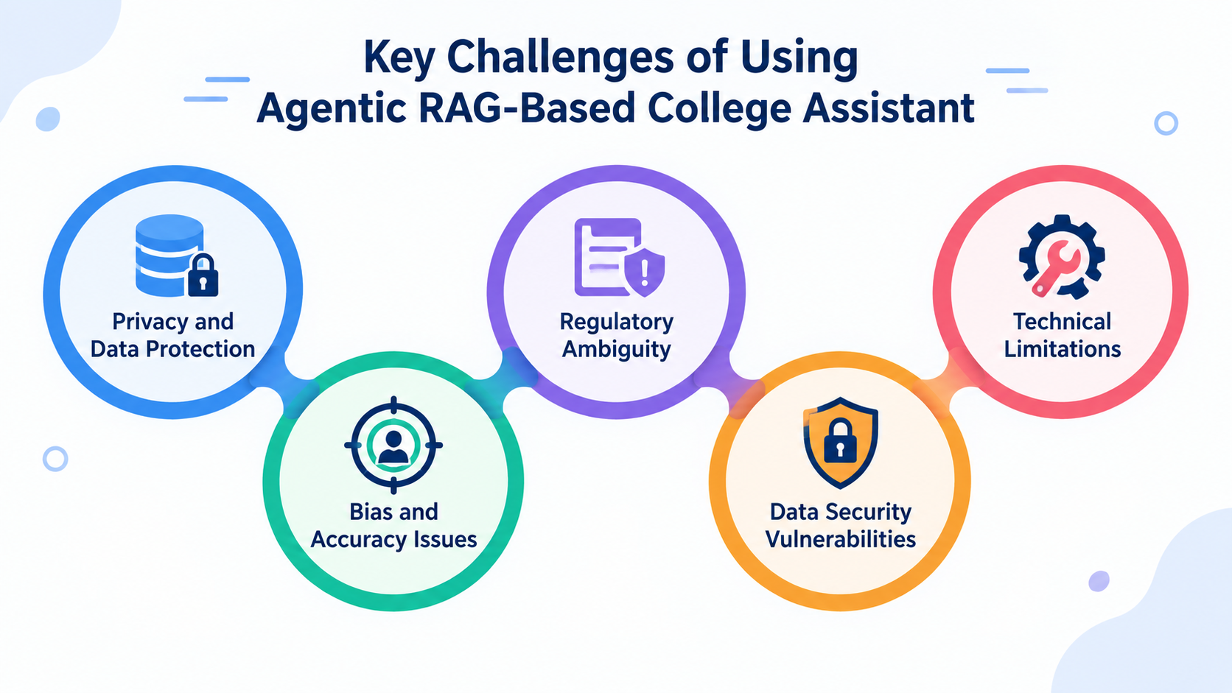Figure: 5.2: Key Challenges Of Using Agentic RAG-Based College Assistant
5.5 Future Work
Several enhancements can be incorporated to improve the functionality, accuracy, and scalability of the Agentic RAG-Based College Assistant.
- Integrate additional college document formats such as Word documents and scanned PDFs.
- Implement improved document retrieval techniques for better semantic search and relevance.
- Enhance the Agent Router to support more tools and handle complex student queries.
- Add multilingual support so students can interact with the assistant in regional languages.
- Implement real-time updating of college notices, timetables, and other frequently changing information.
- Improve source citation and document traceability for more transparent responses.
- Introduce advanced conversation and context management for better multi-turn interactions.
- Improve the local LLM response generation and optimize it for college-specific question answering.
- Add role-based access control and stronger authentication for the Admin Panel.
- Develop advanced analytics for administrators to monitor frequently asked queries and system usage.
- Optimize ChromaDB and SQLite operations for handling a larger number of documents and users.
- Develop a mobile-friendly or dedicated mobile application for easier student access.
- Deploy the system on a suitable institutional server or cloud environment for wider accessibility.
These improvements can make the Agentic RAG-Based College Assistant more scalable, intelligent, secure, and suitable for real-world college deployment.
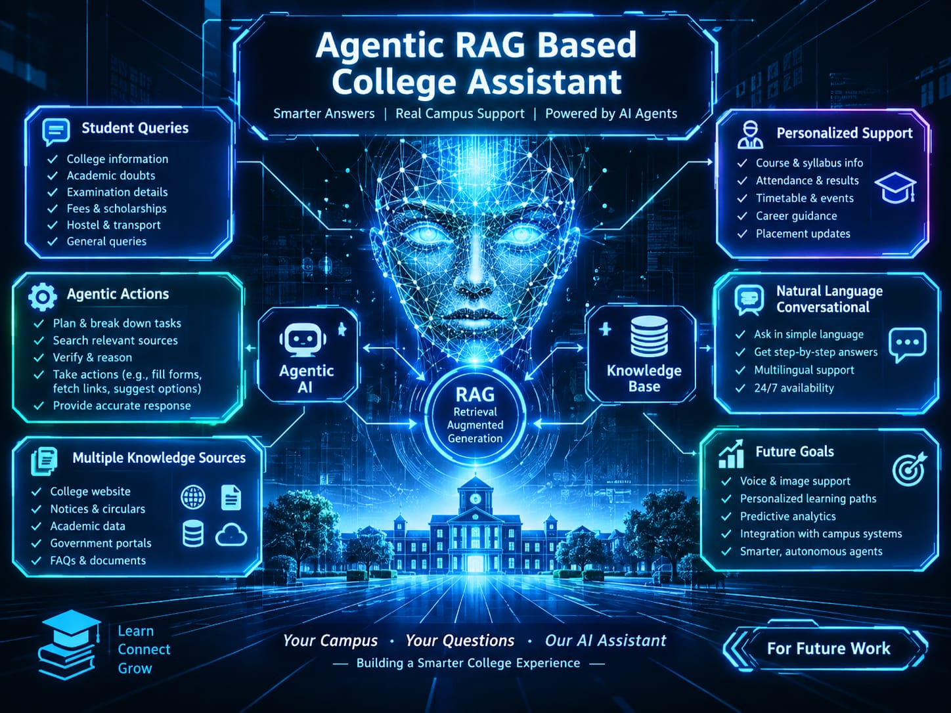
Figure: 5.5: Future Work
Main idea
The central concept combines Agentic AI + RAG (Retrieval-Augmented Generation) + a College Knowledge Base to answer student questions using relevant college information.
How RAG works here
RAG (Retrieval-Augmented Generation) retrieves relevant information from the college's knowledge sources before generating an answer. This helps the assistant provide responses based on college-specific information rather than relying only on general AI knowledge.
Role of Agentic AI
The Agentic AI component acts as the decision-making layer. It can determine what information is needed, select an appropriate source or tool, retrieve information, verify it, and then provide the response to the student.

REFERENCES
[1] N. S. Amarnath and R. Nagarajan, “An intelligent retrieval augmented generation chatbot for contextually-aware conversations to guide high school students,” in Proc. 4th Int. Conf. Sustainable Expert Systems (ICSES), 2024, pp. 1393–1398, doi: 10.1109/ICSES63445.2024.10762977.
[2] A. Abdulhussain, B. Nelwade, A. Rathore, S. Bankar, et al., “AI-driven academic assistant: An intelligent chatbot system leveraging Llama-3 and RAG for enhanced university support services,” in Proc. 4th Int. Conf. Innovative Sustainable Computational Technologies (CISCT), 2024, doi: 10.1109/CISCT62494.2024.11134226.
[3] N. Bhavana, G. Amruthasharon, R. Talasila, G. Shetty, and G. S. Girisha, “Retrieval-augmented generation for scalable, context-aware educational tools,” in Proc. 4th IEEE North Karnataka Subsection Flagship Int. Conf. Holistic Engineering for Sustainable Development (NKCon), 2025, doi: 10.1109/NKCon66957.2025.11345779.
[4] L. Pasquarelli, C. Koutcheme, and A. Hellas, “AI chatbots vs. traditional search: A comparative study on student information retrieval,” in 2025 IEEE Frontiers in Education Conference (FIE), 2025, doi: 10.1109/FIE63693.2025.11328491.
[5] L. Pasquarelli, C. Koutcheme, and A. Hellas, “Comparing the utility, preference, and performance of course material search functionality and retrieval-augmented generation large language model (RAG-LLM) AI chatbots in information-seeking tasks,” 2024.
[6] Z. Li, Z. Wang, W. Wang, K. Hung, H. Xie, and F. L. Wang, “Retrieval-augmented generation for educational application: A systematic survey,” Computers and Education: Artificial Intelligence, vol. 8, Art. no. 100417, 2025, doi: 10.1016/j.caeai.2025.100417.
[7] Vaswani, A., Shazeer, N., Parmar, N., Uszkoreit, J., Jones, L., Gomez, A. N., Kaiser, Ł., and Polosukhin, I., “Attention Is All You Need,” Advances in Neural Information Processing Systems, 2017.
Appendices
Appendix A: College Document and Knowledge Base Description
The knowledge base used in this study contains authorized college documents and structured college information used by the Agentic RAG-Based College Assistant. The documents are uploaded and managed through the Admin Panel and are processed for efficient information retrieval.
The college information may include academic details, syllabus, regulations, examination schedules, class timetables, faculty information, department information, notices, student information, and other institutional documents.
The document content is extracted from PDF files, divided into smaller chunks, converted into vector embeddings, and stored in the ChromaDB vector database. Structured information is maintained using SQLite.

Table A1: Knowledge Base Components
Component | Description
College Documents | Official PDF documents uploaded through the Admin Panel
Syllabus | Academic subjects and syllabus-related information
Regulations | College academic rules and regulations
Notices | Official college announcements
Examination Timetable | Examination schedules and related information
Class Timetable | Class and subject schedules
Faculty Information | Faculty-related information
Department Information | Department-related information
Student Information | Structured student-related records
Chat History | Records of previous chatbot interactions

Appendix B: Document Processing and Preparation
B.1 Introduction
Document processing and preparation are essential steps in the Agentic RAG-Based College Assistant, as they ensure that official college documents are converted into a suitable format for efficient information retrieval and question answering.
B.2 Document Upload
Authorized administrators upload official college PDF documents through the Admin Panel. The system validates the uploaded documents before beginning the processing procedure.
B.3 Text Extraction
The text available in the uploaded PDF documents is extracted using the PDF processing module. The extracted content is then prepared for further processing.
B.4 Text Chunking
The extracted text is divided into smaller meaningful chunks. Chunking allows the retrieval system to identify relevant portions of the document when a student submits a query.
B.5 Embedding Generation
Each document chunk is converted into a numerical vector representation using the selected embedding model. These vector representations are used to identify semantically relevant information.
B.6 ChromaDB Storage
The generated embeddings and related metadata are stored in ChromaDB. A unique document identifier is maintained to connect retrieved information with its original document source.
B.7 SQLite Database
Structured college information is maintained using SQLite. The database can store information related to students, faculty, departments, timetables, and other structured records required by the application.
B.8 Document Validation
The processed documents are tested using different college-related queries to verify that relevant information can be retrieved successfully from the knowledge base.
Appendix C: Agent Router and Tools Used
The Agent Router is responsible for analyzing student queries and selecting the appropriate information source or tool.
Major Tools Used
- PDF RAG Tool
- College Information Tool
- Student Information Tool
- Faculty Information Tool
- Department Information Tool
- Notice Tool
- Exam Timetable Tool
- Class Timetable Tool
- Chat History Tool
The selected tool retrieves the required information, which is then used by the local Large Language Model to generate the final response.
Appendix D: Student Chatbot and System Outputs
The Student Chatbot provides a natural-language interface for students to ask college-related questions.
The chatbot supports different categories of queries, including:
- Syllabus-related questions
- Subject and semester questions
- Student information
- Faculty information
- Department information
- Examination timetable
- Class timetable
- College notices
- College information
- PDF document-based questions
For document-based queries, relevant information is retrieved from ChromaDB and the corresponding source reference is displayed along with the response.
Appendix E: Sample Student Queries
S. No. | Sample Query | Information Source
1 | What are the subjects in the specified semester? | PDF RAG
2 | What is the examination timetable? | Exam Timetable Tool
3 | Who is the faculty member of the department? | Faculty Information Tool
4 | What is the class timetable? | Class Timetable Tool
5 | Are there any new college notices? | Notice Tool
6 | What information is available in the uploaded document? | PDF RAG
7 | What is the college information? | College Information Tool
8 | What department information is available? | Department Information Tool
9 | Show my previous chatbot interaction. | Chat History Tool

Appendix F: Software and Hardware Requirements
Software
- Windows Operating System
- Python
- Streamlit
- LangChain
- LangGraph
- ChromaDB
- PyPDF
- Sentence Transformers / Hugging Face Embeddings
- Transformers
- Qwen2.5-0.5B-Instruct
- SQLite
- Visual Studio Code
- Python Virtual Environment
Hardware
- Intel Core i5 or equivalent processor
- Minimum 8 GB RAM
- Minimum 256 GB storage
- Standard laptop or desktop display
- Internet connection for initial software, package, and model setup
Appendix G: Project Workflow
- Admin Login
- Upload Official College PDF
- Validate Document
- Extract Text
- Split Text into Chunks
- Generate Embeddings
- Store Embeddings in ChromaDB
- Student Opens Chatbot
- Enter Student Query
- Agent Router Analyzes Query
- Select Appropriate Tool
- Retrieve Relevant Information
- Generate Response Using Local LLM
- Add Source Reference for Document-Based Query
- Display Answer
- Store Chat History
- End
Appendix H: Key Performance Evaluation Parameters
The Agentic RAG-Based College Assistant can be evaluated using the following performance parameters:
- PDF Retrieval Relevance
- Agent Router Tool Selection
- Source Reference Matching
- Student Chatbot Response
- ChromaDB Retrieval
- Overall System Performance
These parameters are used to evaluate the major components of the proposed
Appendix I: Limitations
- The quality of document-based responses depends on the quality and completeness of authorized college documents.
- Information that is not available in the knowledge base cannot be retrieved reliably.
- Complex or ambiguous queries may affect Agent Router tool selection.
- Poorly formatted or scanned PDF documents may affect text extraction.
- Local LLM response generation depends on available computational resources.
- Real-time information depends on timely updates of documents and database records.
- The system is limited to the information sources and document formats included within the project scope.
- Support additional document formats.
- Improve semantic retrieval techniques.
- Enhance Agent Router capabilities.
- Add multilingual support.
- Implement real-time college information updates.
- Improve source citation and document traceability.
- Enhance multi-turn conversation handling.
- Improve local LLM response generation.
- Add stronger role-based authentication for the Admin Panel.
- Introduce administrator analytics.
- Optimize the system for larger document collections and users.
- Develop a mobile application.

