1. What is RTM and its use in testing life cycle?

* RTM means Requirement Traceability Matrix. It is a document which ensures that every requirement has a test case. After Writing Testcases we will prepare RTM to make sure that we have not missed any requirements.

1. When should we run a regression test on an application?

Testing the unchanged features to make sure that it is not broken because of the changes (changes means – addition, modification, deletion or defect fixing).

In Agile perspective:

* Every start and end of the sprint except first.
* Before any patches or minor releases.
* Before production release.
* **Automated regression suite for post-production.**

1. What is Database Testing and when should we consider testing database?

* Database testing is one of the major testing which requires tester to expertise in checking tables, writing queries and procedures. Testing can be performed in web application or desktop and database can be used in the application like SQL or Oracle.
* If you have any dependency on database or use case story.

1. What do you mean by Absolute and Relative xPaths? Which one should we consider to create our automation test scripts?

* Xpath starts with single slash and it will be created to start selection from the start node is called Absolute Xpath.
* Xpath starts with double slash and it will be created to start selection anywhere within the document is called Relative Xpath.
* Always Relative Xpaths are preferred as they are not the complete paths from the Root element. Because in future any of the web element when added/Removed then Absolute Xpath changes. So Always use Relative Xpaths in our Automation.

1. What do you mean by Iterative and Incremental development approach?

* **Incremental –** adding new functionality in small chunks
* **Iterative –** performing repeatedly, i.e. adding new functionality in a repetitive or cyclic manner

1. Write Positive and at least 3 Negative test scenarios for below:
2. Description - User should be able to Log into the app using Facebook Actor - User Trigger - User launches the app and tries to log in

Positive:

* Enter valid Email address and valid password and click on Login button.
* Enter valid Mobile number and valid password and click on Login button.
* Enter valid Email address and click on Forgot password link.
* Enter valid Mobile number and click on Forgot password link.
* Check all the links in the login page whether navigating properly or not.
* Check the language specific to user/Country.
* Check all the fields /Objects displayed correctly or not in different devices without any scattered content, overlapping and colour.

Negative:

* Enter invalid Mobile number or valid password and login button and vice versa.
* Enter invalid Email address or valid password and login button and vice versa.
* Check with special characters or blank or null or numeric based on the requirement.

Description - User should be able to do a successful transaction using a Payment Gateway (Example -PayPal) Actor - User Trigger - User is on store screen and selects a product to pay.

* Change the language of the payment gateway during the payment process.
* Check whether the important components are retrieved or not after the payment.
* Check the response if the payment gateway stops responding.
* Check what happens in the back end and if the session ends.
* Check what happens if the payment fails.
* Check if the database stores the card details or not.
* Check the errors during the payment process.
* Check the response after turning the pop up blocker on and off.
* Check the buffer page between the payment gateway and application.
* Check what happens after successful payment.
* Verify the transaction process.
* Check the messages and verify it after successful payment process.
* Check the currency format of the payment.
* Check if the payment option opens the respective payment gateway after selection.
* Verify the default debit card option.
* Verify that refund or void amount (from payment processor admin portal) is same as the transaction amount. In no case, the refund/void amount should exceed the transaction amount. User Data transmitted to the gateway must be set over a secured(HTTPS or other) channel.
* ask User to store Card information. In that case, system should store Card information in applicencrypted format.
* Check for Some all mandatory fields validation. System should not go ahead with payment process if any data for any field is missing.
* Test with Valid Card Number + Valid Expiry Date + Invalid CVV Number.
* Test with Valid Card Number + Invalid Expiry Date + Valid CVV Number.
* Test with Invalid Card Number + Valid Expiry Date + Valid CVV Number.
* Test all Payment Options. Each payment option should trigger respective payment flow.
* Test with multiple currency formats(if available).
* Test with a Blocked Card Information.
* Try to submit the Payment information after Session Timeout.
* From Payment Gateway Confirmation page try to click on Back button of browser to check Session is still active or not.
* Change Payment Language during Payment process.
* Check the behaviour when payment gateway stops responding to the request. Stop the process and verify if payment is debited or not.

Login functionality for Android(Version 6.1.1) and iOS(11.0):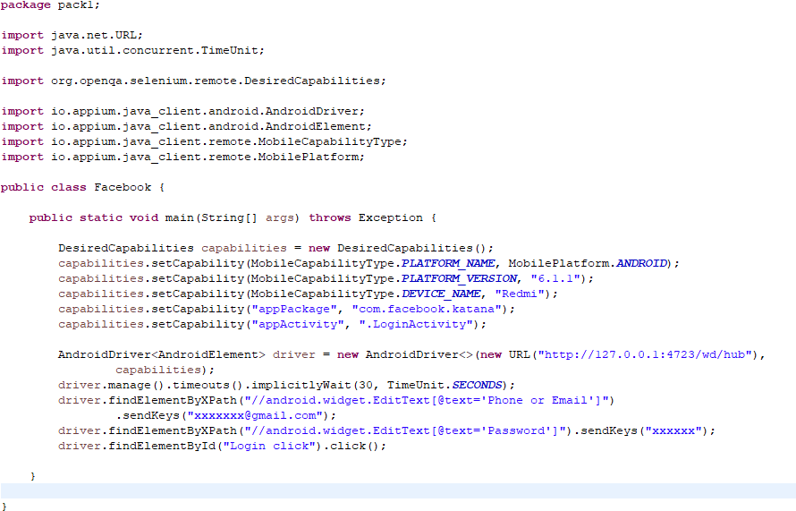

DesiredCapabilities capabilities = **new** DesiredCapabilities();

capabilities.setCapability(MobileCapabilityType.***PLATFORM_NAME***, MobilePlatform.***iOS***);

capabilities.setCapability(MobileCapabilityType.***PLATFORM_VERSION***, "11.0");

capabilities.setCapability(MobileCapabilityType.***DEVICE_NAME***, "iPhone6");

capabilities.setCapability("appPackage", "com.facebook.katana");

capabilities.setCapability("appActivity", ".LoginActivity");

capabilities.setCapability(“XcodeOrgId”,”*****”);

capabilities.setCapability(“XcodeSignInId”,iphone developer”);

capabilities.setCapability(“udid”,””);

capabilities.setCapability(“updateWDABundleId”,”****”);

IOSDriver<IOSElement> driver = **new** IOSDriver<>(**new** URL("http://127.0.0.1:4723/wd/hub"),

capabilities);

driver.manage().timeouts().implicitlyWait(30, TimeUnit.***SECONDS***);

driver.findElementByXPath("//*[@text='Phone or Email']")

.sendKeys("xxxxxxx@gmail.com");

driver.findElementByXPath("//*[@text='Password']").sendKeys("xxxxxx");

driver.findElementById("Login click").click();