# Assignment

# QUERIES - I

1. Find out the SELLING COST AVERAGE for the packages developed in PASCAL?

select avg(scost) from sql_queries.software where dev_in like 'pascal';

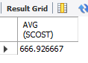

1. Display the names and ages of all programmers.

select name as name,floor(datediff(current_date,dob)/365) as age from sql_queries.programmer;

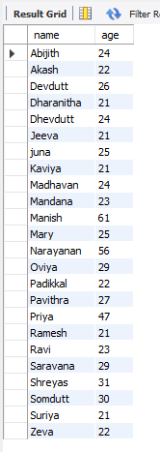

1. Display the names and ages of all the programmers who have undergone training in DCS course.

select p.name,floor(datediff(current_timestamp,dob)/365)as age,course from programmer p,studies st where p.name=st.name and course like 'dcs';

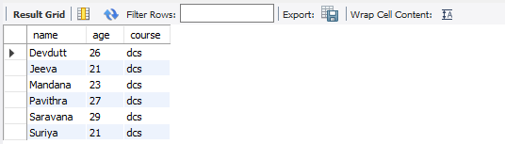

1. What is the highest numbers of copies sold by a package?

select max(sold) from sql_queries.software;

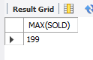

1. Display the names and date of birth of all the programmer born in JANUARY.

select dob,name from programmer where month(dob)=1;

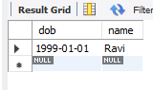

1. Display lowest course fee.

select min(ccost) from sql_queries.studies;

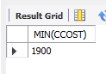

1. How many programmer has done PGDCA course.

select name from sql_queries.studies where course like "pgdca";

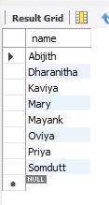

1. How much revenue has been earned through sales of packages in C?

select sum(sold*scost) from sql_queries.software where dev_in like 'c';

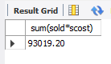

1. Display the details of software developed by Ramesh?

select * from sql_queries.software where name='ramesh';

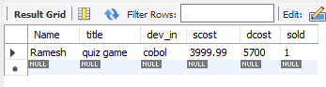

1. How many programmers studied at SABHARI?

select count(name) from sql_queries.studies where splace='sabhari';

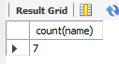

1. Display the details of PACKAGES whose sales crossed the 20000 mark.

select * from sql_queries.software where sold*scost>20000;

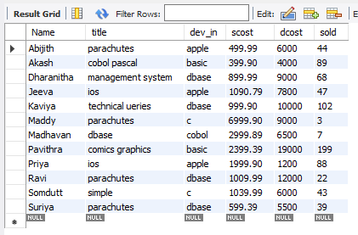

1. Find out the number of copies which should be sold in order to recover the development cost of each package.

select *,round(dcost/scost) from sql_queries.software where scost*sold<dcost;

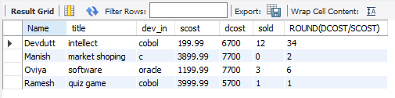

1. What is the price of the costliest software developed in BASIC?

select max(scost) as maximum from sql_queries.software where dev_in like 'basic';

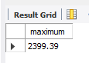

1. Display the details of packages for which development cost has been recovered.

select * from sql_queries.software where (sold*scost)>dcost;

x 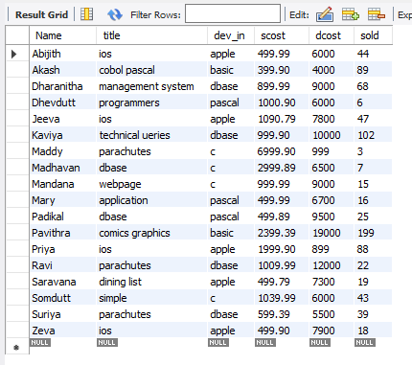

1. How many packages were developed in dbase?

select count(title) as total from sql_queries.software where dev_in='dbase';

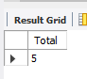

1. How many programmers studies at Pragathi?

select count(name) as count from sql_queries.studies where splace='pragathi';

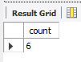

1. How many programmers paid 5000 to 10000 for their course?

select count(name) as programmers from sql_queries.studies where ccost>=5000 and ccost<=10000;

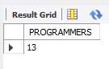

1. What is the average course fee?

select avg(ccost) as averagecost from sql_queries.studies;

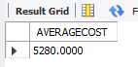

1. Display the details of programmers knowing c?

select * from sql_queries.programmer where prof1='c' or prof2='c';

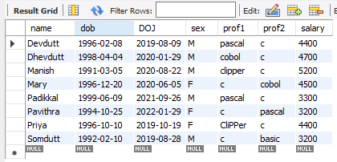

1. How many programmers know either Cobol or Pascal?

select count(name) as programmers from sql_queries.programmer where prof1 in ('cobol' ,'pascal' ) or prof2 in ('cobol' ,'pascal' );

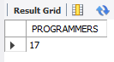

1. How many programmers don't know Pascal & C?

select count(name) as programmers from sql_queries.programmer where prof1 not in ('c','pascal') and prof2 not in ('c','pascal');

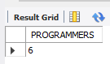

1. How old is the oldest male programmers?

select max(floor(datediff(current_date,dob)/365)) age from sql_queries.programmer where sex='m';

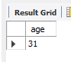

1. What is the average age of female programmers?

select avg(floor(datediff(current_date,dob)/365)) as averageage from sql_queries.programmer where sex='F';

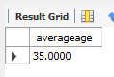

1. Calculate the experience in years for each programmers and display along with the names in descending order?

select name,floor(datediff(current_date,doj)/365) as experience from sql_queries.programmer order by name desc ;

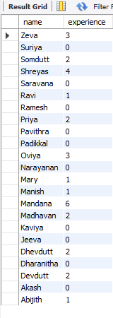

1. Who are the programmers who celebrate their birthday during the current month?

select name as current_month_birthday from programmer where month(dob)=month(current_date());

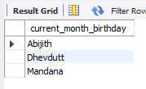

1. How many female programmers are there?

select count(name) female_progammer from sql_queries.programmer where sex='f';

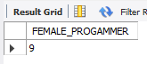

1. What are the languages known by the male programmers?

select distinct prof1 from sql_queries.programmer where sex='m' union select distinct prof2 from sql_queries.programmer where sex='m';

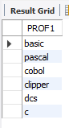

1. What is the Average salary?

select avg(salary) as avgsal from sql_queries.programmer;

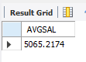

1. How many people draw 2000 to 4000?

select name from programmer where salary between 2000 and 4000;

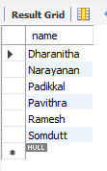

1. Display the details of those who don't know Clipper, Cobol or Pascal?

select name from sql_queries.programmer where prof1 not in ('clipper','cobol','pascal') and prof2 not in ('clipper','cobol','pascal');

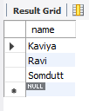

1. How many Female programmers knowing C are above 24 years of age?

select count(name) from sql_queries.programmer where sex='f' and (prof1='c' or prof2='c') and (floor(datediff(current_date,dob)/365)) > 24;

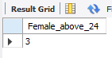

1. Who are the programmers who will be celebrating their Birthday within a week?

select name from programmer where week(dob) = week(curdate());

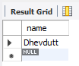

1. Display the details of those with less than a year's experience?

select * from sql_queries.programmer where floor(datediff(current_date,doj)/365)<1;

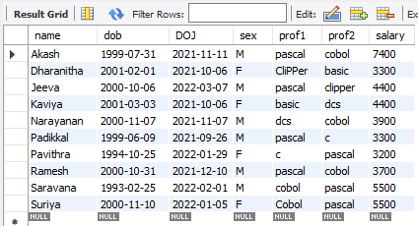

1. Display the details of those who will be completing 2 years of service this year?

select name from sql_queries.programmer where floor(datediff(current_date,doj)/365)=2;

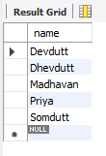

1. Calculate the amount to be recovered for those packages whose development cost has not been recovered?

select (dcost-(scost*sold)), title from sql_queries.software where (scost*sold)<dcost;

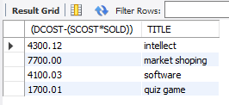

1. List the packages which have not been sold so far?

select * from sql_queries.software where sold=0;

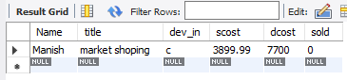

1. Find out the cost of the software developed by Mary?

select title,scost from sql_queries.software where name='mary';

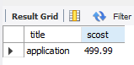

1. Display the institute’s names from the studies table without duplicates?

select distinct splace from sql_queries.studies;

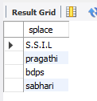

1. How many different courses are mentioned in the studies table?

select distinct course from sql_queries.studies;

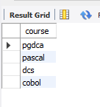

1. Display the names of the programmers whose names contain 2 occurrences of the letter A?

select name from sql_queries.programmer where name like '%A%A%';

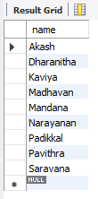

1. Display the names of programmers whose names contain unto 5 characters?

SELECT NAME FROM sql_queries.PROGRAMMER WHERE LENGTH(NAME)=5;

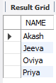

1. How many female programmers knowing COBOL have more than 2 years experience?

SELECT NAME FROM sql_queries.PROGRAMMER WHERE sex='F' and (prof1='cobol'or prof2='cobol') and floor(datediff(current_date,doj)/365)>2;

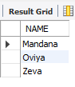

1. What is the length of the shortest name in the programmer table?

select min(length(name)) as shortestname from sql_queries.programmer;

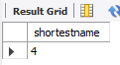

1. What is the average development cost of a package developed in COBOL?

select avg(dcost) from sql_queries.software where dev_in='cobol';

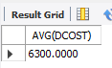

1. Display the name, sex, dob (DD/MM/YY format), doj for all the programmers without using conversion function?
2. Who are the programmers who were born on the last day of the month?

select name from programmer where last_day(dob) = dob;

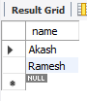

1. What is the amount paid in salaries of the male programmers who do not know Cobol?

select name,salary from programmer where sex='m' and (prof1!='cobol' or prof2!='cobol');

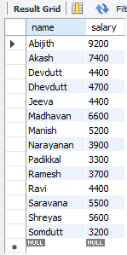

48) Display the title, scost, dcost and difference between scost and dcost in descending order of difference?

select title, scost, dcost, dcost-scost as diff from software order by diff desc;

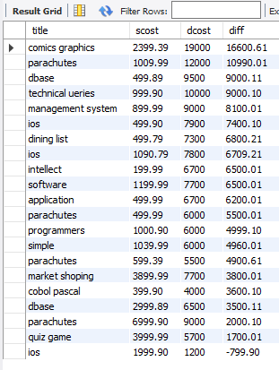

1. Display the name, dob, doj of those month of birth and month of joining are same?

select name from programmer where month(dob)=month(doj);

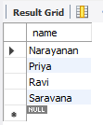

1. Display the names of the packages whose names contain more than 1 word?

select title from software where title like '% %';

