# QUERY - IV

1. Display the details of THOSE WHO are drawing the same salary.

select name, salary from programmer where salary = any(select salary from programmer p group by salary having salary=p.salary and count(*)>1);

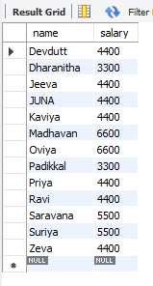

1. Display the details of software developed by male programmers earning MORE than 3000.

select * from software,programmer where programmer.name=software.name and salary>3000 and sex='m';

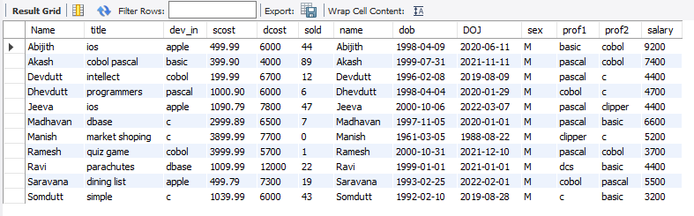

1. Display details of packages developed in PASCAL by female programmers.

select * from programmer p,software s where p.name=s.name and sex='f' and dev_in='pascal';

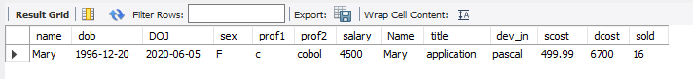

1. Display the details of the programmer WHO joined BEFORE 1990.

select * from programmer where year(doj)<=1990;

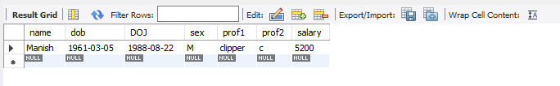

1. Display details of software developed in C by female programmers of PRAGATHI.

select * from software s,studies st,programmer p where s.name=st.name and p.name=s.name and p.sex='f' and st.splace='pragathi';



1. Display NUMBER of packages NUMBER of copies sold and sales value of EACH programmer Institute-wise.

select st.splace,count(s.dev_in),count(s.sold),sum(s.sold*s.scost) from SOFTWARE S,studies st where s.name = st.name group by st.splace;

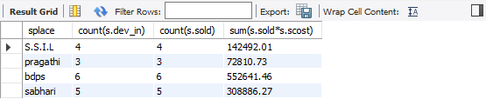

1. Display details of software developed in DBASE by male programmers WHO belong to the institute on which MOST NUMBER OF programmer’s studies.

select * from programmer p,software s where s.name=p.name and sex='m' and year(dob)<1964 and sex='f' and year(dob)>75;

1. Display the details of the software that was developed by male programmers born BEFORE 1965 and female programmers born AFTER 1975.

select s.* from PROGRAMMER P,software s where s.name=p.name and (sex='m' and year(dob)<1964 ) and (sex='f' and year(dob)>1975);

1. Display the details of the software that was developed in the language that is NOT the programmer’s first proficiency.

select s.* from programmer p,software s where s.name=p.name and s.dev_in <> p.prof1;

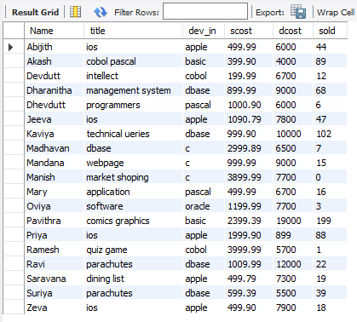

1. Display details of software that was developed in the language which is NEITHER first NOR second proficiency of the programmer.

select s.* from programmer p,software s,studies st where p.name=s.name and s.name=st.name and sex='m' and splace='Sabhari';

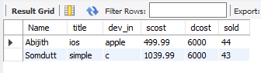

1. Display details of software developed by male students of SABHARI.

select p.*,st.splace,s.dev_in from software s, programmer p,studies st where s.name=p.name and s.name=st.name and st.name=p.name and sex='m' and splace='sabhari';

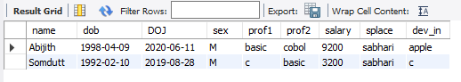

1. Display the names of programmers WHO HAVE NOT developed any package.

select name from programmer where name not in(select name from software);

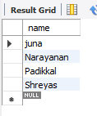

1. What is the total cost of the software developed by the programmers by APPLE?

select sum(scost) from software s,studies st where s.name=st.name and dev_in='apple';

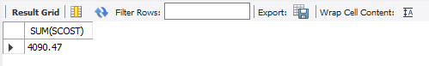

1. Who are the programmers WHO JOINED in the same day?

select a.name,a.doj from programmer a,programmer b where a.doj=b.doj and a.name <> b.name;

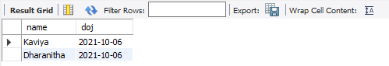

1. Who are the programmers WHO HAVE THE SAME PROF2?

select name,doj,prof2 from programmer where day(doj)=any(select day(doj) from programmer group by day(doj) having count(*)>1);

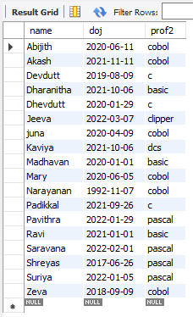

1. Display the total sales values of software, institutes-wise.

select studies.splace,sum(software.sold*software.scost) from software,studies where studies.name=software.name group by studies.splace;

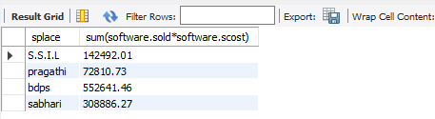

1. In which institutes did the person who developed the COSTLIEST package study?

select splace from software st,studies s where s.name=st.name group by splace,dcost having max(dcost)=(select max(dcost) from software);

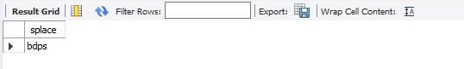

1. Which language listed in prof1 and prof2 HAS NOT BEEN used to develop any package?

select prof1 from programmer where prof1 not in(select dev_in from software) union select prof2 from programmer where prof2 not in(select dev_in from software);

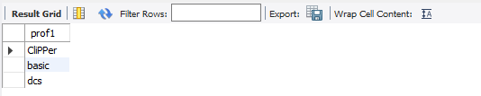

1. How much does the person WHO developed the HIGHEST selling package earn and WHAT course did he/she undergo?

select p.salary,st.course from programmer p,software s,studies st where p.name=s.name and s.name=st.name and st.name=p.name and scost=(select max(scost) from software);

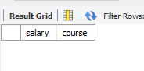

1. How many months will it take for each programmer to recover the cost of the course underwent?

select p.name,round(ccost/salary) from programmer p,studies s where s.name=p.name;

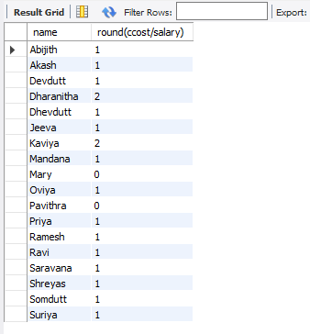

1. Which is the COSTLIEST package developed by a person with under 3 year’s expenences?

select s.title from software s, programmer p where (datediff(curdate(),p.doj)/365) > 3 and p.name=s.name;

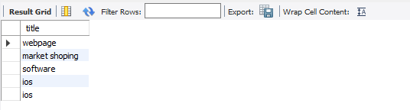

1. What is the AVERAGE salary for those WHOSE software's sales value is more than 50,000?

select avg(salary) from programmer p,software s where p .name=s.name and sold*scost>50000;

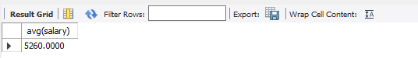

23)How many packages were developed by the students WHO studied in the institute that Charge the LOWEST course fee?

select count(s.name) from software s,studies st where s.name=st.name group by s.name,ccost having min(ccost)=(select min(ccost) from studies);

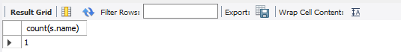

1. How many packages were developed by the person WHO developed the CHEAPEST package? Where did he\she study?

select count(*) from programmer p,software s where s .name=p.name group by dev_in having min(dcost)=(select min(dcost) from software);

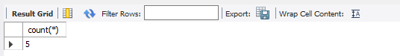

1. How many packages were developed by female programmers earning MORE than the HIGHEST paid male programmer?

select count(dev_in) from programmer p,software s where s.name=p.name and sex='f' and salary>(select max(salary) from programmer p,software s where s.name=p.name and sex='m');

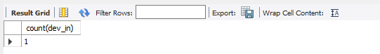

1. How many packages were developed by the MOST experienced programmers from BDPS?

select count(*) from software s,programmer p where p.name=s.name group by doj having max(doj)=(select max(doj) from studies st,programmer p, software s where p.name=s.name and st.name=p.name and (splace='bdps'));

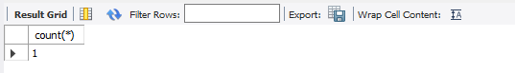

1. List the programmers (from software table) and institutes they studied, including those WHO DIDN'T develop any package.

select name,splace from studies where name not in(select name from software);

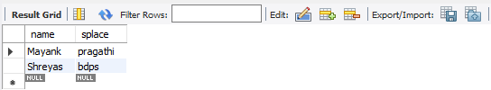

1. List each profit with the number of programmers having that prof1 and the number of packages developed in that prof1.

select dev_in,count(*),sum(scost*sold-dcost) "PROFIT" from software where dev_in in (select prof1 from programmer) group by dev_in;

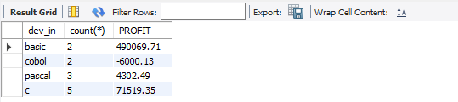

1. List programmer names (from programmer table) and number of packages EACH developed.

select s.name,count(dev_in) from programmer p1,software s where p1.name=s.name group by s.name;

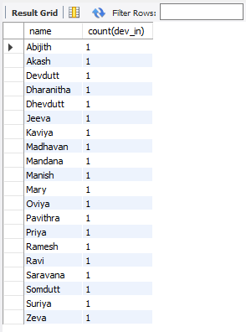

1. List all the details of programmers who have done a course at S.S.I.L.

select programmer.* from programmer,software,studies where splace='S.S.I.L' and programmer.name=software.name and programmer.name=studies.name and studies.splace='s.s.i.l';

